By the end of this activity, you will be able to:

1. Filter rows in a spreadsheet
2. Perform aggregate operations such as average and sum

**Step 1.** **Open a terminal shell.** Open a terminal shell by clicking on the square black box on the top left of the screen.

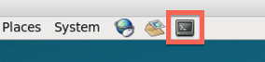

**Step 2. Open spreadsheet application.** Run *oocalc* to start the spreadsheet application.

1

oocalc

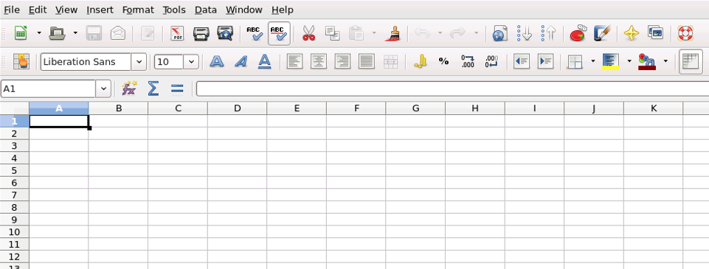

**Step 3. Import CSV to spreadsheet.** Let's import the CSV file to the spreadsheet by clicking on *File:*

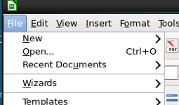

Next, click *Open:*

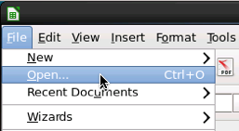

Next, click*Downloads*in the Places pane:

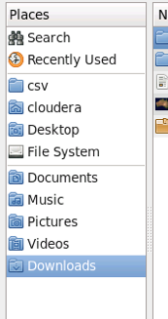

Next, double-click *big-data-2*in the file pane:

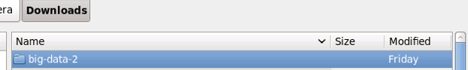

Next, double-click*csv*:

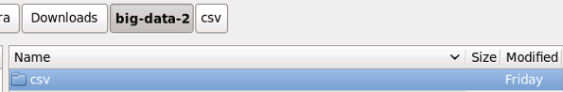

Next, double-click *census.csv*:

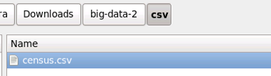

In the Text Import dialog, click *OK:*

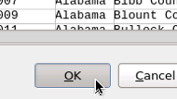

The CSV data is now loaded into the spreadsheet.

**Step 4. Filter rows in the data.**We can perform a select operation on the data to show only the counties in the state of California containing more than one million people. To perform the select operation, first select the column F, which contains the state name, through column H, which contains the 2010 population:

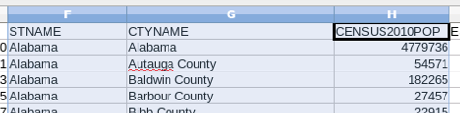

Next, click *Data*:

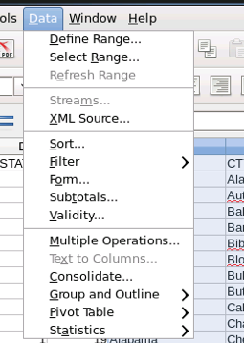

Next, select *Filter*:

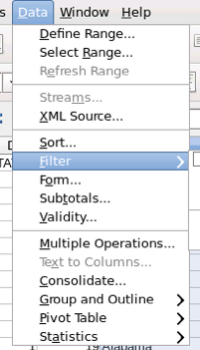

Next, click *Standard Filter*:

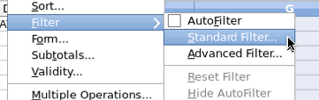

We can create the filter by first changing the Field name to *STNAME*:

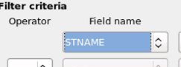

Next, enter *California* in the Value:

https://d3c33hcgiwev3.cloudfront.net/imageAssetProxy.v1/GRgxVQWkEeafYA6MxTJr4Q_de41df31b459e70e565483d0c27e0a56_value-ca.png?expiry=1574640000000&hmac=9R3hIrMvIe1_lUDYu9IA47PmVgZAGlNUnlMgx8TdAKM

Next, change the Operator to *AND*:

https://d3c33hcgiwev3.cloudfront.net/imageAssetProxy.v1/WD-kwgWkEea72QqIV6G4Sw_b81ad2cd2b1c07281f96b6d7712ebeeb_operator-and.png?expiry=1574640000000&hmac=3LOhRR_6dQx80Xvm0fx5h3cWYMGWfjLYLF2RiNUX46M

Next, change the Field name in the second row to *CENSUS2010POP*:

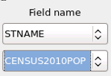

Next, change the Condition in the second row to *>*:

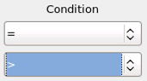

Next, set the Value in the second row to *1000000*:

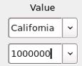

The dialog should look like this when you're done:

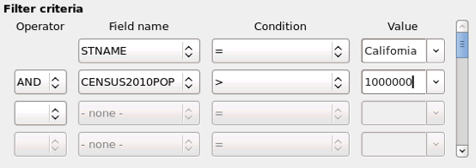

Click *OK* to perform the operation. The spreadsheet will look like the following, showing only the counties in California with a population above one million people:

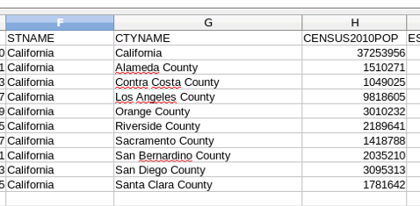

**Step 5. Reset the filter.** The select operation we performed in the previous steps hides the rows in the data that do not match the criteria we entered in the filter dialog. Let's reset the filter to show all the data. Click on *Data*, *Filter*, and then*Reset Filter*:

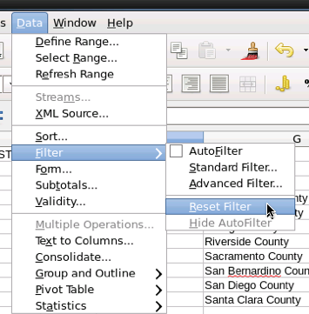

**Step 6. Add a new sheet.** We can perform aggregate operations on the data in the spreadsheet. Let's display the results of these calculations in a different sheet since Sheet 1 is full of the census data. Create a new sheet by clicking on the green plus button at the bottom left:

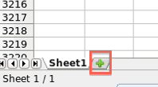

**Step 7. Calculate average.** Let's calculate the average of several counties in Alabama. First, click on a cell in Sheet 2, and enter *=average(*

https://d3c33hcgiwev3.cloudfront.net/imageAssetProxy.v1/MdV6dQWnEea-2xKMba84Ww_bcc381745bf7eb892ec762dc6fd9e4a4_enter-average.png?expiry=1574640000000&hmac=3JQNf0rsNVEnqybv4vW5TOe2F0zQ1hA0zbhWQ7pSPbo

Next, click on Sheet 1:

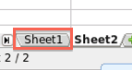

Select rows 5-13 in column H:

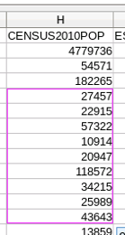

Press the *enter* key to compute the average:

https://d3c33hcgiwev3.cloudfront.net/imageAssetProxy.v1/ZIae8gWnEeap7RJsurEyGw_6763de1e94971c635154e1ae220cbcce_average.png?expiry=1574640000000&hmac=3j19jqtj5eE5HUkhJ9D3Dck9y7lhOsjPXr2VrsIY-Ng

**Step 8. Calculate sum.** Now let's calculate the sum. Click on an empty cell in Sheet 2 and enter *=sum(*

https://d3c33hcgiwev3.cloudfront.net/imageAssetProxy.v1/lDH9XAWnEea72QqIV6G4Sw_6ca24fe68e35f589a251f3977a9224d1_enter-sum.png?expiry=1574640000000&hmac=RWEEHnzVYto-H-XZCG3ES0lCnZsN7tWjcbV9zsQdmEc

Click on Sheet 1:



Select rows 16-25 in column H:

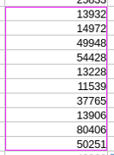

Press the *enter* key to compute the sum:

https://d3c33hcgiwev3.cloudfront.net/imageAssetProxy.v1/1JC30gWnEeafYA6MxTJr4Q_d51fe68f9cb5ef4c941a8f655a3e42ed_sum.png?expiry=1574640000000&hmac=OyAUTyIy_QsV_CgKid1uOs54_MDb9QSernfnMC_OkNg