By the end of this activity, you will be able to:

1. Display an image
2. View the dimensions and pixel values in a image.

**Step 1.** **Open a terminal shell.** Open a terminal shell by clicking on the square black box on the top left of the screen.

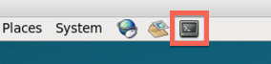

Change into the image directory:

1

cd Downloads/big-data-2/image

Run *ls* to see the image and scripts:

1

ls

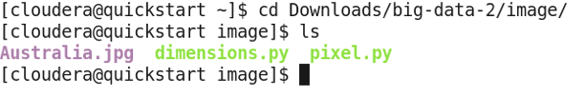

**Step 2. Display the image.** Display the image by running *eog Australia.jpg*. eog stands for Eye of Gnome and is a common image viewer on Linux systems.

1

eog Australia.jpg

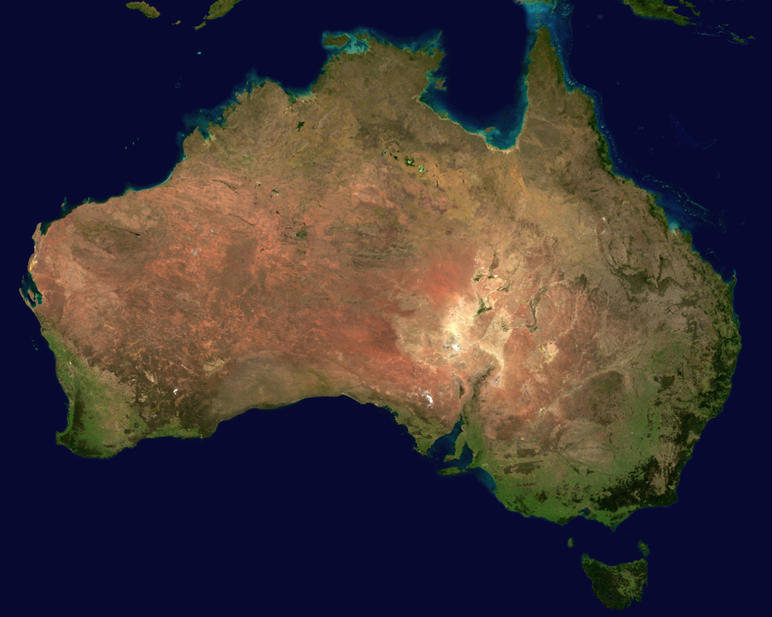

Next, click on the terminal window, and enter *control-z* and *bg* to run eog in the background.

**Step 3. View the dimensions.** We can view the dimensions of the image by running:

1

./dimensions.py Australia.jpg



This says that the image has 5250 columns and 4320 rows, and each cell is comprised of three 8-bit pixels for Red, Green, and Blue.

**Step 4. View pixel values.**We can view pixel values at different locations in the image by running the pixel.py script. To view the pixel value at location 0, 0, run:

1

./pixel.py Australia.jpg 0 0

https://d3c33hcgiwev3.cloudfront.net/imageAssetProxy.v1/dD0_YwWxEeap7RJsurEyGw_eeaa3a69f3bd3317cd056f0a908aa0f9_pixel-0-0.png?expiry=1574640000000&hmac=ULEC-JRFR-lIZKEr5ar5SMV3YK6KGngeY0_cun9-DSk

This says the values for Red = 11, Green = 10, and Blue = 50. The corners of the image are ocean, so we expect a high value for Blue, and low values for Red and Green.

To view the pixel value at another corner of the image, run:

1

./pixel.py Australia.jpg 5000 0

https://d3c33hcgiwev3.cloudfront.net/imageAssetProxy.v1/ikE75QWxEeap7RJsurEyGw_155e905b6f7b55a31759b5527c25d029_pixel-5000-0.png?expiry=1574640000000&hmac=PmsUo7nhpfXTWjRSF6qVCuY8nLXW-cd9VK7Z1Nm7EAA

This is the same result since location 5000 0 is also ocean.

Now let's look at a pixel value of land near the middle of the image:

1

./pixel.py Australia.jpg 2000 2000

https://d3c33hcgiwev3.cloudfront.net/imageAssetProxy.v1/tiTkVwWxEeaaqg5MSeYjIQ_c56f260908c1ba914b371a6011d5cbf1_pixel-2000-2000.png?expiry=1574640000000&hmac=FPaJ53cLF2Acvk19NQ_GBVm3hAcHFvGFEy2QNWti5yg

This says the values for Red = 118, Green = 89, and Blue = 57. The land is orange and yellow, so we expect higher values for Red and Green than Blue.