This Reading describes the steps to download the datasets and scripts necessary for the Hands On exercises in this course.

Step 1.**Start the Cloudera VM.** Most of the Hands On exercises in this course use the Cloudera Virtual Machine, so we will download the datasets onto the VM. Start the VM in VirtualBox and perform the remaining steps in the VM.

Step 2.**Open a web browser.** Open a web browser by clicking on the web browser icon in the top toolbar.

https://d3c33hcgiwev3.cloudfront.net/imageAssetProxy.v1/Zc2s0wpTEea72QqIV6G4Sw_c49276790fe7fd0f65defdbcb24b12e9_web-icon.png?expiry=1575417600000&hmac=UrdBtwCA9VI7xBOnyDpJErjGGZ-nlOhSwiXetkU0Vkc

In the web browser, enter the following for the URL:

1

http://github.com/words-sdsc/coursera

Step 3.**Download the datasets.** Click on *big-data-3.zip*:

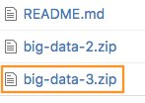

Click on the *Download* button:

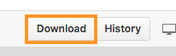

In the dialog, select *Save* *File*:

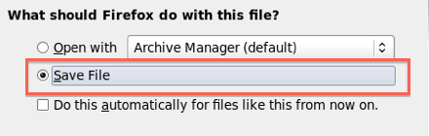

Click *OK*, and the file big-data-3.zip file will be downloaded to the Downloads directory.

Step 4. **Uncompress the datasets.** Open a terminal shell by clicking on the terminal shell icon in the top toolbar.

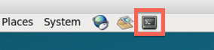

In the terminal, run:

1

2

cd Downloads

unzip -o big-data-3.zip

Open a Browser in Cloudera VM and go directly to "<http://repo.continuum.io/archive/Anaconda3-4.0.0-Linux-x86_64.sh>" and download it -- tell your browser to save the file, not run it. (Note that there is an underscore between 86 and 64: ...x86_64.sh)

Navigate to the downloads folder inside Cloudera VM, and manually move Anaconda into the big-data-3 folder. (Not into the ZIP file, but into the folder you've already extracted).

Open a terminal and type "cd Downloads/big-data-3" and hit Enter.

Step 5. **Install tools.** Change directories to *big-data-3* and run *setup.sh* to install tools and libraries.

1

2

cd big-data-3

./setup.sh

During the setup process, Anaconda will give you a series of prompts. First, press *enter* to continue the installation:

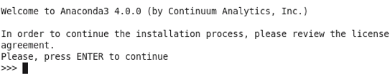

Next, read and accept the license:

https://d3c33hcgiwev3.cloudfront.net/imageAssetProxy.v1/RuD-OlXEEeaX4QpLJOK7gQ_725952c670089d2d9619ed65513b1dfa_anaconda-license.png?expiry=1575417600000&hmac=LkiFTwewQC2boAK_KbbEAdCnt774QjG0xwv0rFJfdv8

Next, press *enter* to accept the default installation location:

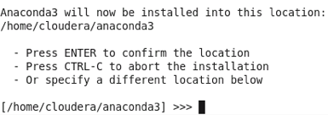

Next, enter *yes* when it asks if you want to prepend the install location to PATH:

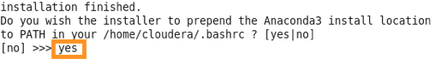

The setup of tools and datasets should continue.

Finally, source $HOME/.bashrc:

1

source $HOME/.bashrc