1) On the Virtual Machine, opened a Firefox and went manually to

<http://repo.continuum.io/archive/Anaconda3-4.0.0-Linux-x86_64.sh>

On the box that automatically opened, I chose Save File and clicked on Save. The file started to be downloaded.

2) After the Download finished, I clicked on the icon "Display the progress of ongoing downloads" (up right corner of the firefox screen) and then chose to open the Downloads Folder

3) At the Downloads folder, I moved the File just downloaded ([Anaconda3-4.0.0-Linux-x86_64.sh) into the folder big-data-3](http://repo.continuum.io/archive/Anaconda3-4.0.0-Linux-x86_64.sh)

4) After that go back to the Terminal and typed again ./setup.sh

5) The instalation started once again and this time Anaconda got properly installed

6/ Open a new terminal and type pyspark

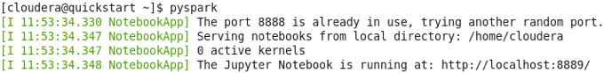

This will start Firefox (if not already running), and open a new tab showing the current directory:

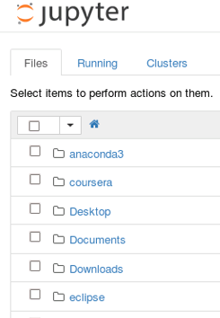

You can find the notebooks for this course in the *Downloads/big-data-3* directory. Click on *Downloads* and then click on *big-data-3*.

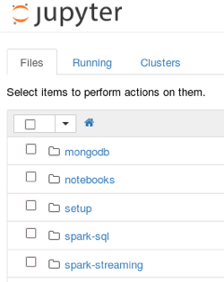

You can open Jupyter Notebooks by clicking on the *.ipynb* files.

When you are done, Jupyter can be stopped by entering *control-c* in the terminal window and then entering *yes.*