The completed KNIME workflows for this course are available here:

[KNIME-workflows.zip](https://d3c33hcgiwev3.cloudfront.net/_add64f7371181431f240cd2de17a778a_KNIME-workflows.zip?Expires=1576195200&Signature=dWdxwlRPXKIzw9YcRh0YW10X9bdDYShDwwIrnBv8bIasSwLQpv7CNyrIuHVnfw2u3gJgfNEy-uqsh9cEtYDqUa~3ORelZpMB7eTjq68L5Yip6Ks6KEa2AdSSJsMEPJqsfJJpaaFeJF9HHlxr~qx6fCkYT4lKNOTZBZ3zw-s~L70_&Key-Pair-Id=APKAJLTNE6QMUY6HBC5A)

To load these in KNIME, select *File -> Import KNIME Workflow*:

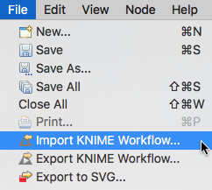

Next, click on the *Browse* button and select the workflow to import:

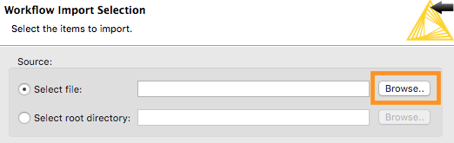

Finally, click on *Finish.*The workflow will be added to your *LOCAL* Workspace, and you can load it by double-clicking on the name:

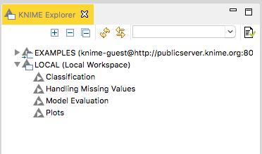

Finally, double-click on the *File Reader*Node and change the *valid URL* parameter to the location of *daily_weather.csv* on your computer:

