This Reading describes the steps to download the dataset and scripts necessary for the Spark Hands On exercises in this course. Before proceeding, make sure have you downloaded and installed VirtualBox and the Cloudera virtual machine. Instructions for this process can be found in the Reading called *Downloading and Installing the Cloudera VM*.

Step 1. **Download data for KNIME.** Download the weather data to use with the KNIME hands on activities.

[daily\_weather.csv](https://d3c33hcgiwev3.cloudfront.net/_6ccdb1ada9b0f3e110e90d1eb0fea594_daily_weather.csv?Expires=1576108800&Signature=Ts6oDyCzONIyXzlZNcwbnCXi~TBwYZAg3BKMwMLAZzROtCNDzMMxI07SxCXq0muMBeIXu5zdRU~BQOnFJigWUDOKzRo89DsIDFQfqExD8zisDsctIJl1aXs2g2pp~vFcLWlY8UopZqWRrHjjWtz107WppmNLMgb1q7IoW~mbJTc_&Key-Pair-Id=APKAJLTNE6QMUY6HBC5A" \t "_blank)

Step 2.**Start the Cloudera VM.** The Spark Hands On exercises in this course use the Cloudera Virtual Machine, so we will download the weather data onto the VM. Start the VM in VirtualBox and perform the remaining steps in the VM.

Step 3.**Open a web browser.** Open a web browser by clicking on the web browser icon in the top toolbar.

https://d3c33hcgiwev3.cloudfront.net/imageAssetProxy.v1/Zc2s0wpTEea72QqIV6G4Sw_c49276790fe7fd0f65defdbcb24b12e9_web-icon.png?expiry=1576108800000&hmac=wA9i3dgtDObqmIferNZBVcenABifCVxOKF5fRG12RKg

In the web browser, enter the following for the URL:

1

http://github.com/words-sdsc/coursera

Some browsers in the Cloudera VM may not be displaying the Generic code blocks. If you do not see a URL above, please enter the following URL:

[http://github.com/words-sdsc/coursera](http://github.com/words-sdsc/coursera" \t "_blank)

Step 4.**Download the dataset.** Click on *big-data-4.zip*:

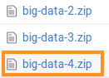

Click on the *Download* button:

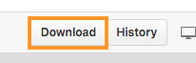

In the dialog, select *Save* *File*:

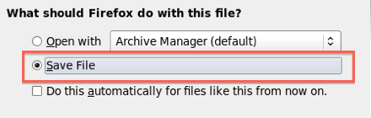

Click *OK*, and the file big-data-4.zip file will be downloaded to the Downloads directory.

Step 5. **Uncompress the dataset.** Open a terminal shell by clicking on the terminal shell icon in the top toolbar.

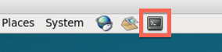

In the terminal, run:

1

2

cd Downloads

unzip -o big-data-4.zip

cd Downloads

Step 6. **Install tools.** Change directories to *big-data-4* and run *setup.sh* to install tools and libraries.

1

2

cd big-data-4

./setup.sh

cd big-data-4

./setup.sh

During the setup process, Anaconda will give you a series of prompts. First, press *enter* to continue the installation:

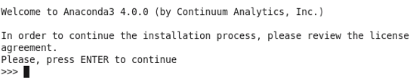

Next, read and accept the license:

https://d3c33hcgiwev3.cloudfront.net/imageAssetProxy.v1/RuD-OlXEEeaX4QpLJOK7gQ_725952c670089d2d9619ed65513b1dfa_anaconda-license.png?expiry=1576108800000&hmac=b68M-5vWvQYWZBORevv-wIyyAdPh5xslkjNi0cNej0w

Next, press *enter* to accept the default installation location:

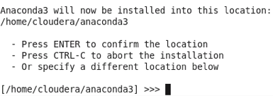

Next, enter *yes* when it asks if you want to prepend the install location to PATH:

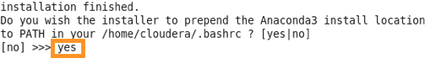

The setup of tools and datasets should continue.

Finally, source $HOME/.bashrc:

1

source $HOME/.bashrc

source $HOME/.bashrc