**INSTALL TP JUIN**

**Prérequis** :

Avoir installé virtualbox, git bash et vangrant.

**Faire dans un dossier (MONDOSSIER) en cli**:

git clone <https://github.com/arnauddegez/tp_juin_ci-cd.git>

**Dans MONDOSSIER/tp_juin_ci-cd/jenkins en git bash faire :**

vagrant up

**Dans MONDOSSIER/tp_juin_ci-cd/kubernetes en git bash faire :**

vagrant up

Dans un navigateur saisir <http://192.168.44.11:8080>

Copier et coller le mot de passe jenkins à récupérer dans la console vagrant du jenkins:



Cliquez sur **continuer**

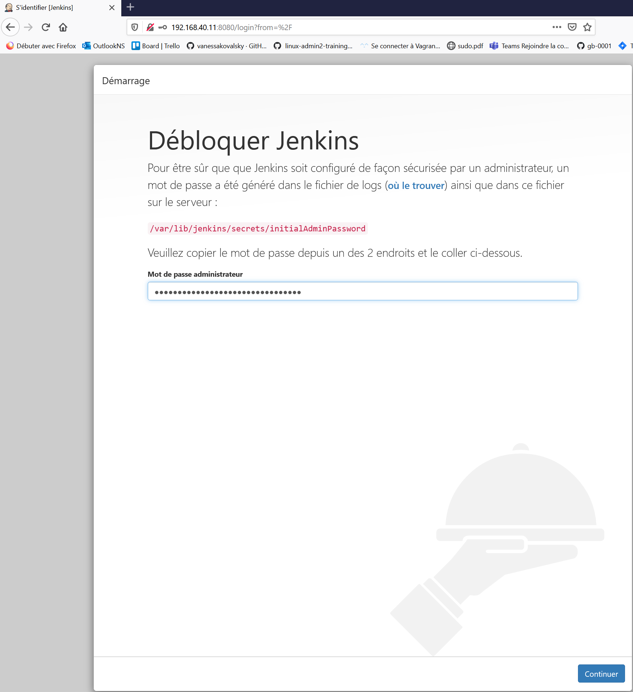

Cliquez sur **installer les plugins suggérés** :

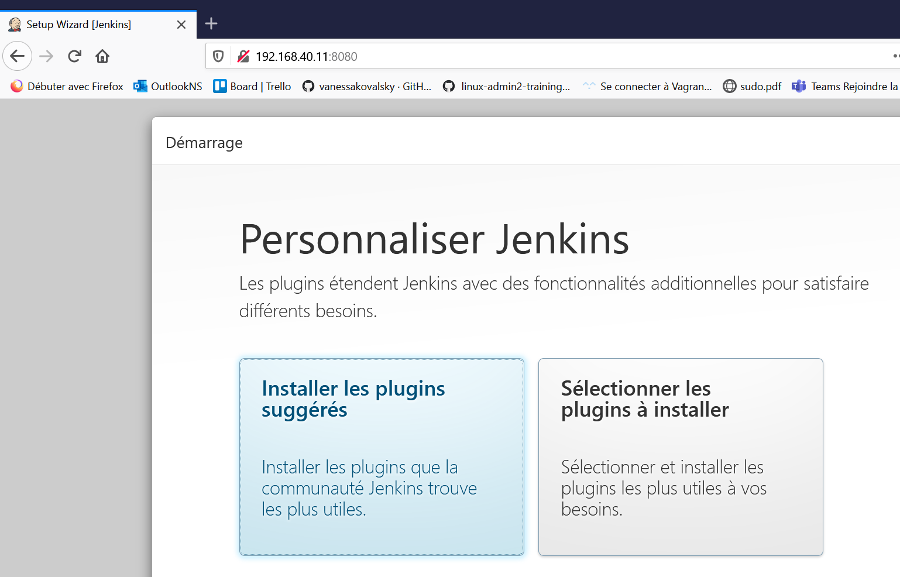

Saisir les informations puis cliquez sur **sauvez et continuer** :

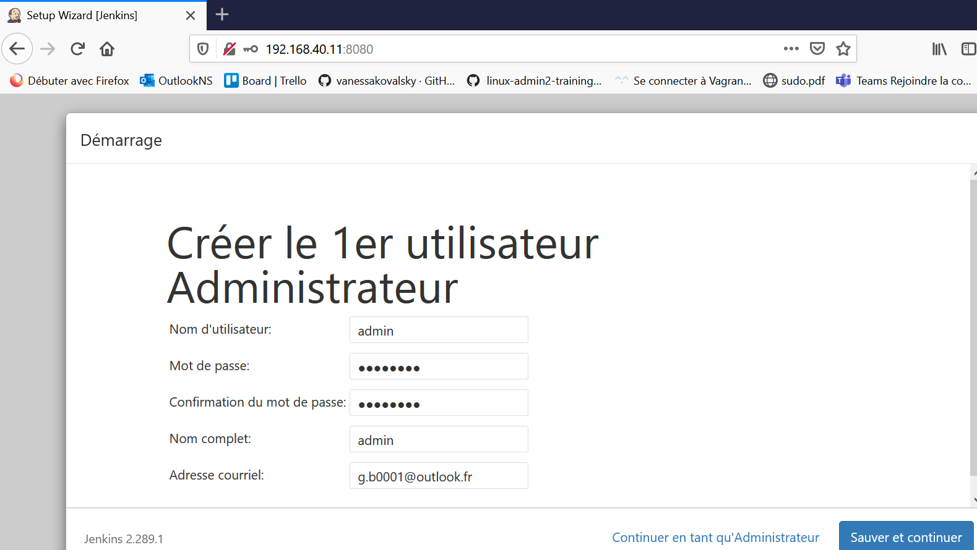

Cliquez sur **sauver et terminer** :

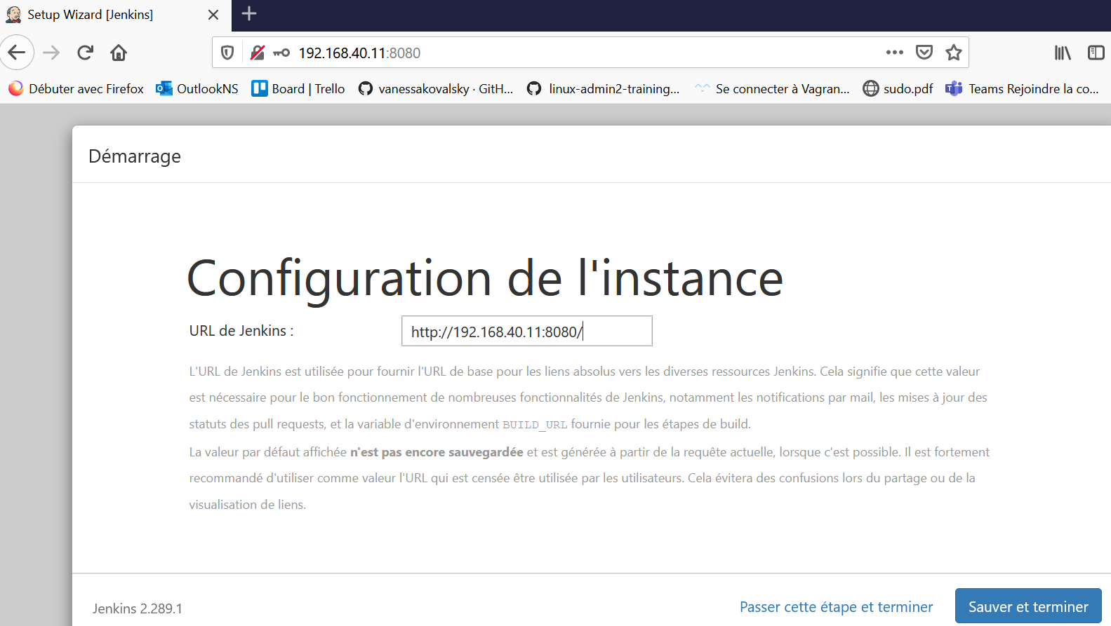

Cliquez sur **Commencer à utiliser jenkins** :

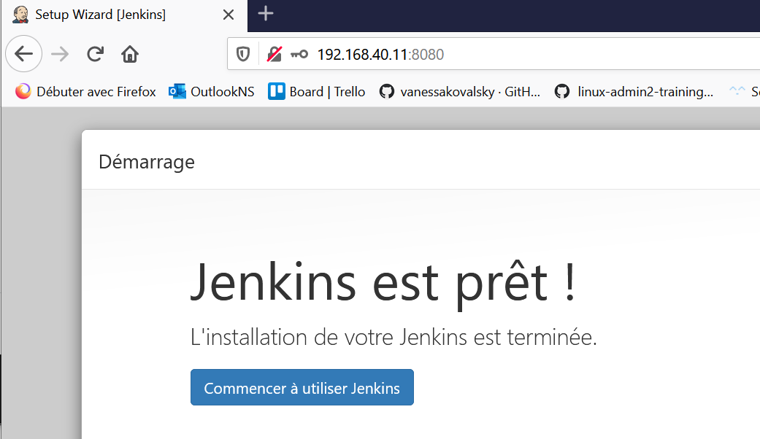

Cliquez sur créer un job :

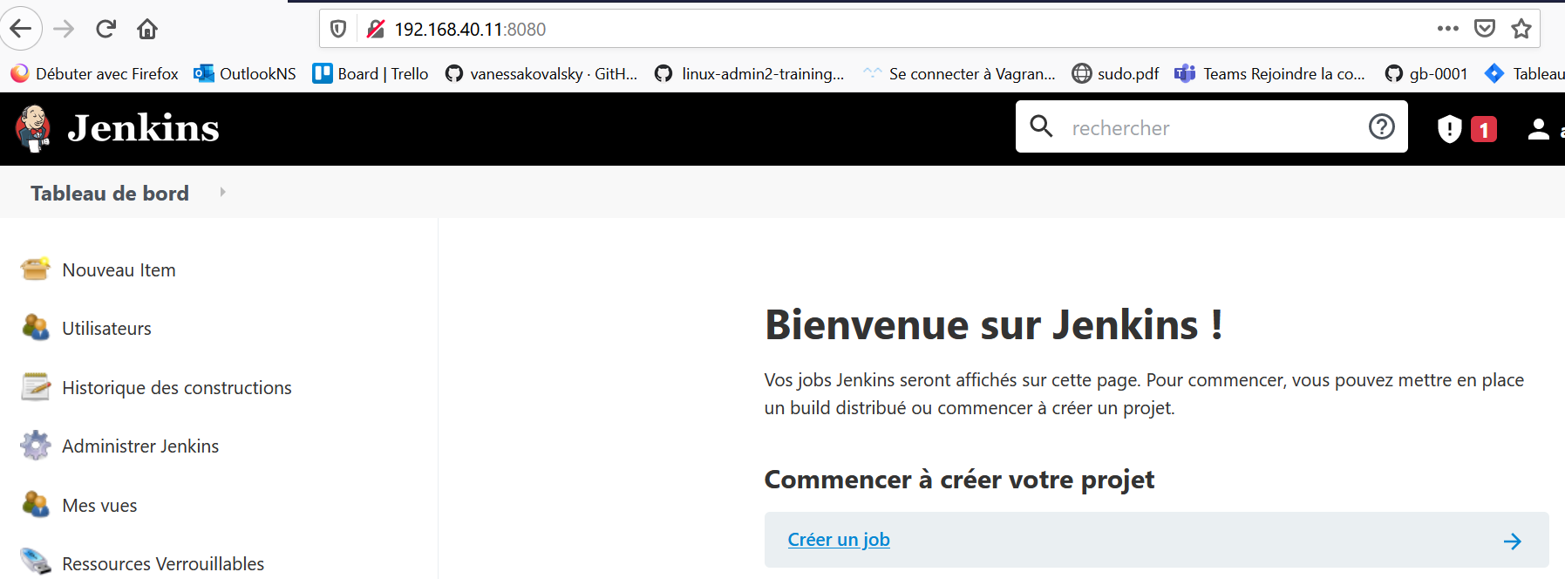

Cliquez sur **administrer jenkins**

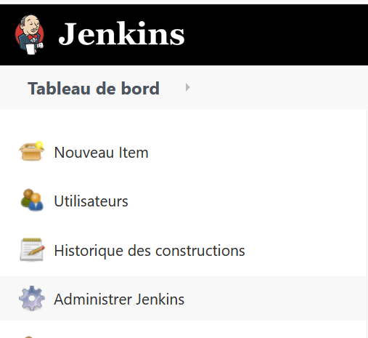

Cliquez sur **gestion des plugins** :

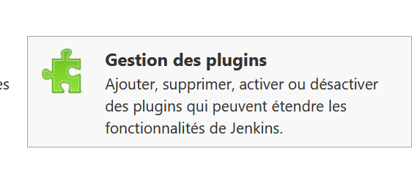

Cliquez sur l’onglet disponibles :

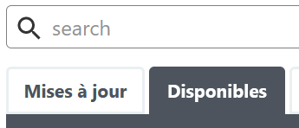

Dans la berre de recherche chercher docker :

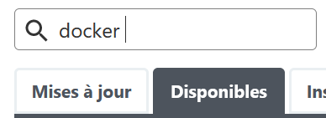

Sélectionner docker et cliquez sur download and install after :

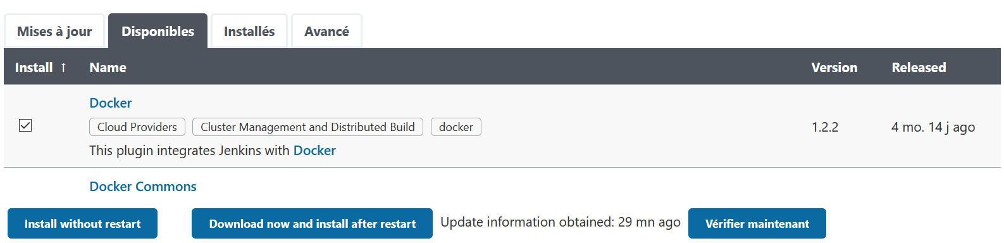

Et cochez :



Idem pour cloudees docker build ans publish cochez:

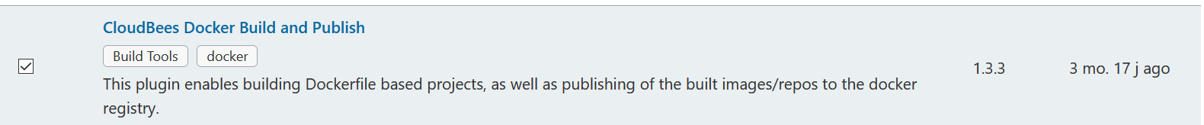

et cliquez sur download and install after :

Et cochez :



Idem pour docker piepeline :



et cliquez sur download and install after :

Et cochez :



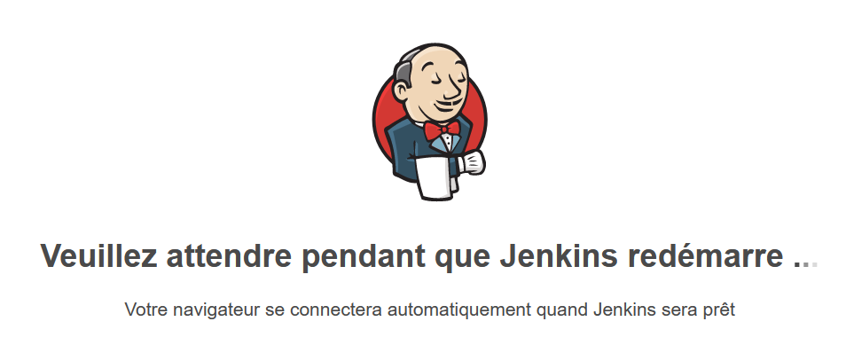

Se connecter avec les identifiants déjà définit :

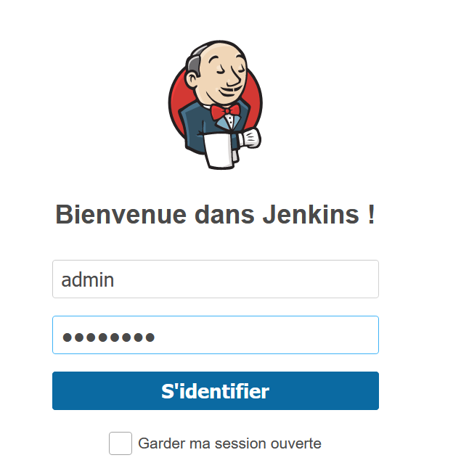

Cliquez sur **administrer jenkins**



Cliquez sur :

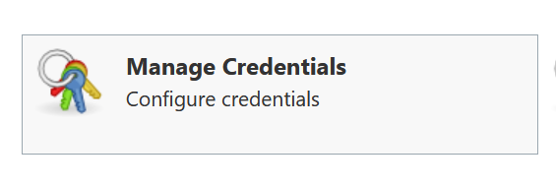

Cliquez sur global :



Cliquez sur :



Puis saisir les identifiants puis OK :

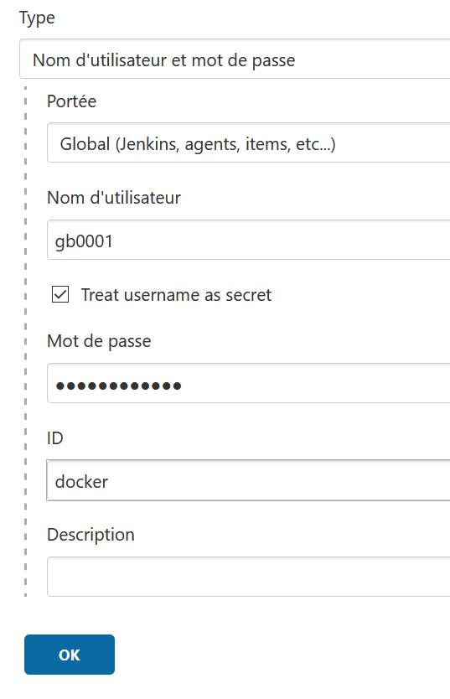

Retour attendu :

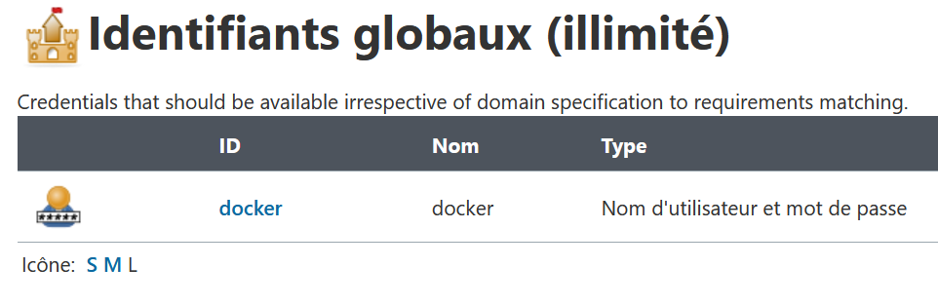

Saisir le nom deployapp et cliquez sur pipeline puis OK

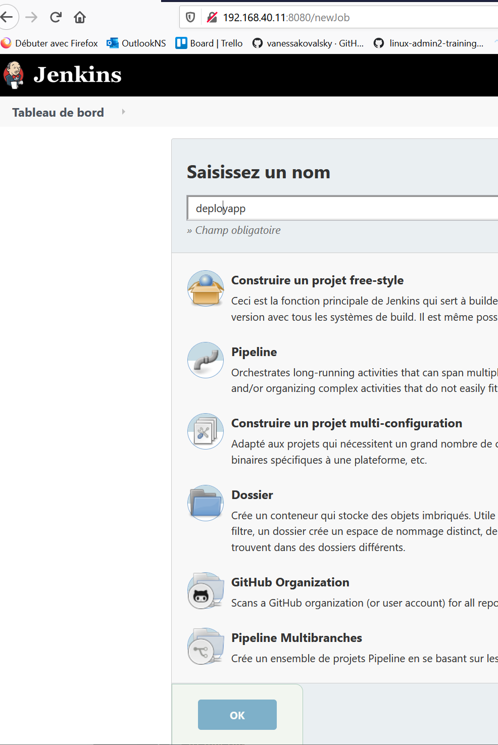

Copier le script jenkinsfile du git dans la definition de pipeline puis APPLY et sauver

Cliquer sur lancer le build

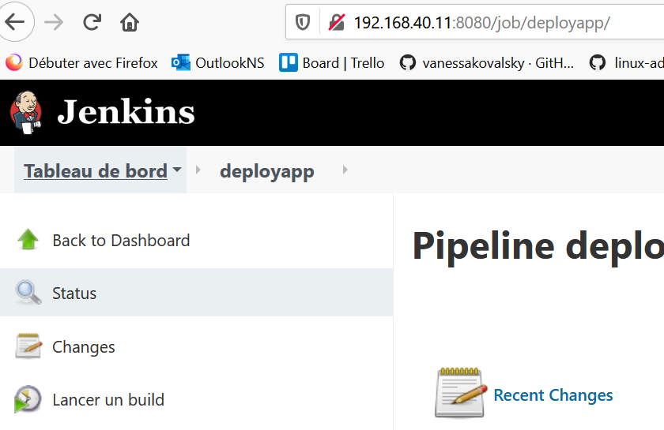

RETOUR du pipeline :

Started by user admin

Running in Durability level: MAX_SURVIVABILITY

[Pipeline] Start of Pipeline

[Pipeline] node

Running on Jenkins in /var/lib/jenkins/workspace/deployapp

[Pipeline] {

[Pipeline] withEnv

[Pipeline] {

[Pipeline] stage

[Pipeline] { (clone source)

[Pipeline] sh

+ rm -rf tp_juin_ci-cd

[Pipeline] sh

+ git clone https://github.com/arnauddegez/tp_juin_ci-cd.git

Cloning into 'tp_juin_ci-cd'...

[Pipeline] }

[Pipeline] // stage

[Pipeline] stage

[Pipeline] { (build)

[Pipeline] sh

+ cd ./tp_juin_ci-cd/docker

+ docker build -t gb0001/apptpjuin .

Sending build context to Docker daemon 2.048kB

Step 1/9 : FROM python:3.10.0b1-alpine3.13

---> 601f2e53be88

Step 2/9 : RUN apk add --update

---> Using cache

---> c125a2902e57

Step 3/9 : RUN pip install flask python-logstash-async

---> Using cache

---> 7f435e315c98

Step 4/9 : RUN apk add wget

---> Using cache

---> 07a8424f2d13

Step 5/9 : WORKDIR APP

---> Using cache

---> ef07c8fde384

Step 6/9 : RUN wget -O /APP/main.py https://github.com/vanessakovalsky/example-python/raw/master/vagrant/src/main.py

---> Using cache

---> 27bb29124af8

Step 7/9 : RUN chmod +x /APP/main.py

---> Using cache

---> 8660335aab7b

Step 8/9 : EXPOSE 3002

---> Using cache

---> 2c623e21e6eb

Step 9/9 : ENTRYPOINT FLASK_APP=/APP/main.py flask run --host=0.0.0.0 --port=3002

---> Using cache

---> 332766a5a9ec

Successfully built 332766a5a9ec

Successfully tagged gb0001/apptpjuin:latest

[Pipeline] }

[Pipeline] // stage

[Pipeline] stage

[Pipeline] { (run)

[Pipeline] sh

+ docker run -d --name apptp -p 3002:3002 --rm gb0001/apptpjuin

d84aa52ff422a0c04a66d6b54ab28533297d6efe6f07969557674fe31420385e

[Pipeline] }

[Pipeline] // stage

[Pipeline] stage

[Pipeline] { (test)

[Pipeline] sh

+ sleep 15s

[Pipeline] sh

+ curl http://192.168.40.11:3002

% Total % Received % Xferd Average Speed Time Time Time Current

Dload Upload Total Spent Left Speed

0 0 0 0 0 0 0 0 --:--:-- --:--:-- --:--:-- 0

100 19 100 19 0 0 19000 0 --:--:-- --:--:-- --:--:-- 19000

Hello world DevOps!

[Pipeline] }

[Pipeline] // stage

[Pipeline] stage

[Pipeline] { (push Image)

[Pipeline] script

[Pipeline] {

[Pipeline] withEnv

[Pipeline] {

[Pipeline] withDockerRegistry

$ docker login -u gb0001 -p ******** https://index.docker.io/v1/

WARNING! Using --password via the CLI is insecure. Use --password-stdin.

WARNING! Your password will be stored unencrypted in /var/lib/jenkins/workspace/deployapp@tmp/f2f0c642-2db4-498f-9722-f653ad138391/config.json.

Configure a credential helper to remove this warning. See

https://docs.docker.com/engine/reference/commandline/login/#credentials-store

Login Succeeded

[Pipeline] {

[Pipeline] sh

+ docker push gb0001/apptpjuin

Using default tag: latest

The push refers to repository [docker.io/gb0001/apptpjuin]

56f887e86d14: Preparing

8891c6a424a4: Preparing

c075a255db37: Preparing

85ac5868b6e7: Preparing

9d6887afbeb1: Preparing

4f90d61d7e31: Preparing

2562e0849b30: Preparing

b1b29cb68bc2: Preparing

7bca446e9243: Preparing

ff362123de14: Preparing

b2d5eeeaba3a: Preparing

4f90d61d7e31: Waiting

2562e0849b30: Waiting

b1b29cb68bc2: Waiting

7bca446e9243: Waiting

ff362123de14: Waiting

b2d5eeeaba3a: Waiting

c075a255db37: Pushed

56f887e86d14: Pushed

8891c6a424a4: Pushed

b1b29cb68bc2: Layer already exists

7bca446e9243: Layer already exists

2562e0849b30: Mounted from library/python

ff362123de14: Layer already exists

b2d5eeeaba3a: Layer already exists

85ac5868b6e7: Pushed

4f90d61d7e31: Pushed

9d6887afbeb1: Pushed

latest: digest: sha256:6cb9258418326241f1298d378bf132d5232228c9f0c73c2412fb54951c6ac9ab size: 2621

[Pipeline] }

[Pipeline] // withDockerRegistry

[Pipeline] }

[Pipeline] // withEnv

[Pipeline] }

[Pipeline] // script

[Pipeline] }

[Pipeline] // stage

[Pipeline] stage

[Pipeline] { (deploy)

[Pipeline] sh

+ ansible-playbook -i /home/vagrant/ansible/hosts /home/vagrant/ansible/playbook.yml

PLAY [k8sapp] ******************************************************************

TASK [Gathering Facts] *********************************************************

ok: [192.168.40.12]

TASK [Creates directory "~/k8sapp"] ********************************************

changed: [192.168.40.12]

TASK [copy] ********************************************************************

changed: [192.168.40.12]

TASK [copy] ********************************************************************

changed: [192.168.40.12]

TASK [include_tasks] ***********************************************************

included: /home/vagrant/ansible/maj_k8sfile.yml for 192.168.40.12 => (item=[{'CLI1': 'client-dev'}, {'PORTA': '3202', 'TARGETPORTA': '3002', 'PORTNA': '30002'}])

included: /home/vagrant/ansible/maj_k8sfile.yml for 192.168.40.12 => (item=[{'CLI1': 'client-test'}, {'PORTA': '3203', 'TARGETPORTA': '3002', 'PORTNA': '30003'}])

included: /home/vagrant/ansible/maj_k8sfile.yml for 192.168.40.12 => (item=[{'CLI1': 'client-prod'}, {'PORTA': '3204', 'TARGETPORTA': '3002', 'PORTNA': '30004'}])

TASK [init file] ***************************************************************

changed: [192.168.40.12]

TASK [MAJ FICHIER deploiement] *************************************************

[WARNING]: The loop variable 'item' is already in use. You should set the

`loop_var` value in the `loop_control` option for the task to something else to

avoid variable collisions and unexpected behavior.

changed: [192.168.40.12] => (item=apiVersion: apps/v1)

changed: [192.168.40.12] => (item=kind: Deployment)

changed: [192.168.40.12] => (item=metadata:)

changed: [192.168.40.12] => (item= name: client-dpl-client-dev)

changed: [192.168.40.12] => (item=spec:)

changed: [192.168.40.12] => (item= replicas: 1)

changed: [192.168.40.12] => (item= selector:)

changed: [192.168.40.12] => (item= matchLabels:)

changed: [192.168.40.12] => (item= app: client-dev)

changed: [192.168.40.12] => (item= template: # template de pod)

changed: [192.168.40.12] => (item= metadata:)

changed: [192.168.40.12] => (item= name: client-pod)

changed: [192.168.40.12] => (item= labels:)

changed: [192.168.40.12] => (item= app: client-dev)

changed: [192.168.40.12] => (item= spec:)

changed: [192.168.40.12] => (item= containers:)

changed: [192.168.40.12] => (item= - name: client-dev)

changed: [192.168.40.12] => (item= image: gb0001/apptpjuin:latest)

TASK [mise en palce du deploiement] ********************************************

[WARNING]: The loop variable 'item' is already in use. You should set the

`loop_var` value in the `loop_control` option for the task to something else to

avoid variable collisions and unexpected behavior.

changed: [192.168.40.12] => (item=sudo -H -u root sh -c "kubectl apply -f /root/k8sapp/client-dpl.yml")

[WARNING]: Consider using 'become', 'become_method', and 'become_user' rather

than running sudo

TASK [init file] ***************************************************************

changed: [192.168.40.12]

TASK [MAJ FICHIER deploiement] *************************************************

[WARNING]: The loop variable 'item' is already in use. You should set the

`loop_var` value in the `loop_control` option for the task to something else to

avoid variable collisions and unexpected behavior.

changed: [192.168.40.12] => (item=apiVersion: apps/v1)

changed: [192.168.40.12] => (item=kind: Deployment)

changed: [192.168.40.12] => (item=metadata:)

changed: [192.168.40.12] => (item= name: client-dpl-client-test)

changed: [192.168.40.12] => (item=spec:)

changed: [192.168.40.12] => (item= replicas: 1)

changed: [192.168.40.12] => (item= selector:)

changed: [192.168.40.12] => (item= matchLabels:)

changed: [192.168.40.12] => (item= app: client-test)

changed: [192.168.40.12] => (item= template: # template de pod)

changed: [192.168.40.12] => (item= metadata:)

changed: [192.168.40.12] => (item= name: client-pod)

changed: [192.168.40.12] => (item= labels:)

changed: [192.168.40.12] => (item= app: client-test)

changed: [192.168.40.12] => (item= spec:)

changed: [192.168.40.12] => (item= containers:)

changed: [192.168.40.12] => (item= - name: client-test)

changed: [192.168.40.12] => (item= image: gb0001/apptpjuin:latest)

TASK [mise en palce du deploiement] ********************************************

[WARNING]: The loop variable 'item' is already in use. You should set the

`loop_var` value in the `loop_control` option for the task to something else to

avoid variable collisions and unexpected behavior.

changed: [192.168.40.12] => (item=sudo -H -u root sh -c "kubectl apply -f /root/k8sapp/client-dpl.yml")

TASK [init file] ***************************************************************

changed: [192.168.40.12]

TASK [MAJ FICHIER deploiement] *************************************************

[WARNING]: The loop variable 'item' is already in use. You should set the

`loop_var` value in the `loop_control` option for the task to something else to

avoid variable collisions and unexpected behavior.

changed: [192.168.40.12] => (item=apiVersion: apps/v1)

changed: [192.168.40.12] => (item=kind: Deployment)

changed: [192.168.40.12] => (item=metadata:)

changed: [192.168.40.12] => (item= name: client-dpl-client-prod)

changed: [192.168.40.12] => (item=spec:)

changed: [192.168.40.12] => (item= replicas: 1)

changed: [192.168.40.12] => (item= selector:)

changed: [192.168.40.12] => (item= matchLabels:)

changed: [192.168.40.12] => (item= app: client-prod)

changed: [192.168.40.12] => (item= template: # template de pod)

changed: [192.168.40.12] => (item= metadata:)

changed: [192.168.40.12] => (item= name: client-pod)

changed: [192.168.40.12] => (item= labels:)

changed: [192.168.40.12] => (item= app: client-prod)

changed: [192.168.40.12] => (item= spec:)

changed: [192.168.40.12] => (item= containers:)

changed: [192.168.40.12] => (item= - name: client-prod)

changed: [192.168.40.12] => (item= image: gb0001/apptpjuin:latest)

TASK [mise en palce du deploiement] ********************************************

[WARNING]: The loop variable 'item' is already in use. You should set the

`loop_var` value in the `loop_control` option for the task to something else to

avoid variable collisions and unexpected behavior.

changed: [192.168.40.12] => (item=sudo -H -u root sh -c "kubectl apply -f /root/k8sapp/client-dpl.yml")

TASK [include_tasks] ***********************************************************

included: /home/vagrant/ansible/maj_svck8sfile.yml for 192.168.40.12 => (item=[{'CLI1': 'client-dev'}, {'PORTA': '3202', 'TARGETPORTA': '3002', 'PORTNA': '30002'}])

included: /home/vagrant/ansible/maj_svck8sfile.yml for 192.168.40.12 => (item=[{'CLI1': 'client-test'}, {'PORTA': '3203', 'TARGETPORTA': '3002', 'PORTNA': '30003'}])

included: /home/vagrant/ansible/maj_svck8sfile.yml for 192.168.40.12 => (item=[{'CLI1': 'client-prod'}, {'PORTA': '3204', 'TARGETPORTA': '3002', 'PORTNA': '30004'}])

TASK [init file] ***************************************************************

changed: [192.168.40.12]

TASK [MAJ FICHIER SERVICE] *****************************************************

[WARNING]: The loop variable 'item' is already in use. You should set the

`loop_var` value in the `loop_control` option for the task to something else to

avoid variable collisions and unexpected behavior.

changed: [192.168.40.12] => (item=apiVersion: v1)

changed: [192.168.40.12] => (item=kind: Service)

changed: [192.168.40.12] => (item=metadata:)

changed: [192.168.40.12] => (item= name: client-srv-client-dev)

changed: [192.168.40.12] => (item=spec:)

changed: [192.168.40.12] => (item= type: NodePort)

changed: [192.168.40.12] => (item= selector:)

changed: [192.168.40.12] => (item= app: client-dev)

changed: [192.168.40.12] => (item= ports:)

changed: [192.168.40.12] => (item= - port: 3202)

changed: [192.168.40.12] => (item= targetPort: 3002)

changed: [192.168.40.12] => (item= nodePort: 30002)

TASK [mise en place du service] ************************************************

[WARNING]: The loop variable 'item' is already in use. You should set the

`loop_var` value in the `loop_control` option for the task to something else to

avoid variable collisions and unexpected behavior.

changed: [192.168.40.12] => (item=sudo -H -u root sh -c "kubectl apply -f /root/k8sapp/svc.yml")

TASK [init file] ***************************************************************

changed: [192.168.40.12]

TASK [MAJ FICHIER SERVICE] *****************************************************

[WARNING]: The loop variable 'item' is already in use. You should set the

`loop_var` value in the `loop_control` option for the task to something else to

avoid variable collisions and unexpected behavior.

changed: [192.168.40.12] => (item=apiVersion: v1)

changed: [192.168.40.12] => (item=kind: Service)

changed: [192.168.40.12] => (item=metadata:)

changed: [192.168.40.12] => (item= name: client-srv-client-test)

changed: [192.168.40.12] => (item=spec:)

changed: [192.168.40.12] => (item= type: NodePort)

changed: [192.168.40.12] => (item= selector:)

changed: [192.168.40.12] => (item= app: client-test)

changed: [192.168.40.12] => (item= ports:)

changed: [192.168.40.12] => (item= - port: 3203)

changed: [192.168.40.12] => (item= targetPort: 3002)

changed: [192.168.40.12] => (item= nodePort: 30003)

TASK [mise en place du service] ************************************************

[WARNING]: The loop variable 'item' is already in use. You should set the

`loop_var` value in the `loop_control` option for the task to something else to

avoid variable collisions and unexpected behavior.

changed: [192.168.40.12] => (item=sudo -H -u root sh -c "kubectl apply -f /root/k8sapp/svc.yml")

TASK [init file] ***************************************************************

changed: [192.168.40.12]

TASK [MAJ FICHIER SERVICE] *****************************************************

[WARNING]: The loop variable 'item' is already in use. You should set the

`loop_var` value in the `loop_control` option for the task to something else to

avoid variable collisions and unexpected behavior.

changed: [192.168.40.12] => (item=apiVersion: v1)

changed: [192.168.40.12] => (item=kind: Service)

changed: [192.168.40.12] => (item=metadata:)

changed: [192.168.40.12] => (item= name: client-srv-client-prod)

changed: [192.168.40.12] => (item=spec:)

changed: [192.168.40.12] => (item= type: NodePort)

changed: [192.168.40.12] => (item= selector:)

changed: [192.168.40.12] => (item= app: client-prod)

changed: [192.168.40.12] => (item= ports:)

changed: [192.168.40.12] => (item= - port: 3204)

changed: [192.168.40.12] => (item= targetPort: 3002)

changed: [192.168.40.12] => (item= nodePort: 30004)

TASK [mise en place du service] ************************************************

[WARNING]: The loop variable 'item' is already in use. You should set the

`loop_var` value in the `loop_control` option for the task to something else to

avoid variable collisions and unexpected behavior.

changed: [192.168.40.12] => (item=sudo -H -u root sh -c "kubectl apply -f /root/k8sapp/svc.yml")

TASK [nettoyage] ***************************************************************

changed: [192.168.40.12] => (item=/home/vagrant/majsvck8sfile.yml)

changed: [192.168.40.12] => (item=/home/vagrant/majk8sfile.yml)

PLAY RECAP *********************************************************************

192.168.40.12 : ok=29 changed=22 unreachable=0 failed=0

[Pipeline] }

[Pipeline] // stage

[Pipeline] }

[Pipeline] // withEnv

[Pipeline] }

[Pipeline] // node

[Pipeline] End of Pipeline

Finished: SUCCESS

Vérifier le retour sur les 3 url :

Dev :

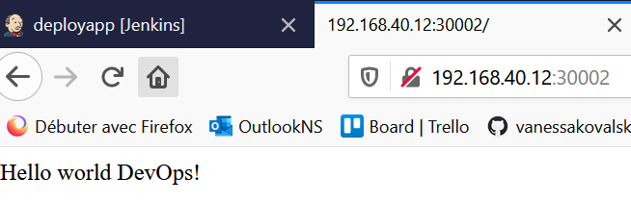

Test :

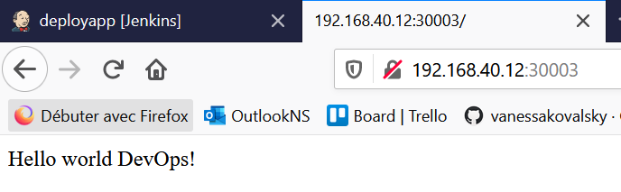

Prod :

