

X



CEWPMOD 2 – Introduction to Web Programming – Deliverable D1

Creation and thinking around a basic CRUD website

Kevin D. YAKER // Arnak TOVMASSIAN // Arnaud SAULOU1*

Instructor: Mr. KAMTHAN, Pankaj

*1Department of Computer Science and Engineering, EFREI Paris, Villejuif - France*

*(*Authors for correspondence :* [*Kevin.yaker@efrei.net*](mailto:Kevin.yaker@efrei.net) *&* [*Arnak.tovmassian@efrei.net*](mailto:Arnak.tovmassian@efrei.net) *&* [*Arnaud.saulou@efrei.net*](mailto:Arnaud.saulou@efrei.net) *)*

(Received and approved in its final form the 16th February 2020)

Groupe A – Team “Dubai Cartel”

Contents

I. Description of the project (Diamond Rims) 3

II. The Importance of a Mind Map 3

III. Introduction to the Web Design process 4

IV. Database 6

V. Member’s Contributions 7

VI. Conclusion and current state of the website 7

Table of Figures

Figure 1. Mind Map generated for the Diamond Rims Project. 3

# Description of the project (Diamond Rims)

Diamond Rims is an online luxury car dealer that puts buyers in relation to vendors. Firstly, there will be only one vendor. Costumers that are looking for a luxury car came on the website where they will be able to search for their dream car. The project is a basic CRUD web application with two type of access:

- A “client type” user that can just visualize the cars, switch from page to page, search for a specific car and see the details. Some filters to precise their research will be available, examples would be sorting by brands, model or even mileage.

- An “administrator type” user that can do everything a “client type” user can do , except that , the “admin type” will also have access to a connection page that will allow him to add , delete and modify informations’ about the cars available on the website. Those features will arrive with the second release.

The application will have to be linked to a database to store different information about all the cars like their model name, brand, color, motor, description, images and price.

We decided to take this theme because we all like luxury and rare cars.

# The Importance of a Mind Map

The principle of mind mapping is here mostly as a data filter; what we could consider as a more refined “brainstorming session”. Every information in a mind map will start from a “seed” or main idea, that will be the conductive wire for the entire project.   
For this project, a mind map was generated using the software “Xmind ZEN”; where from our main seed, different ideas and possible paths got generated.

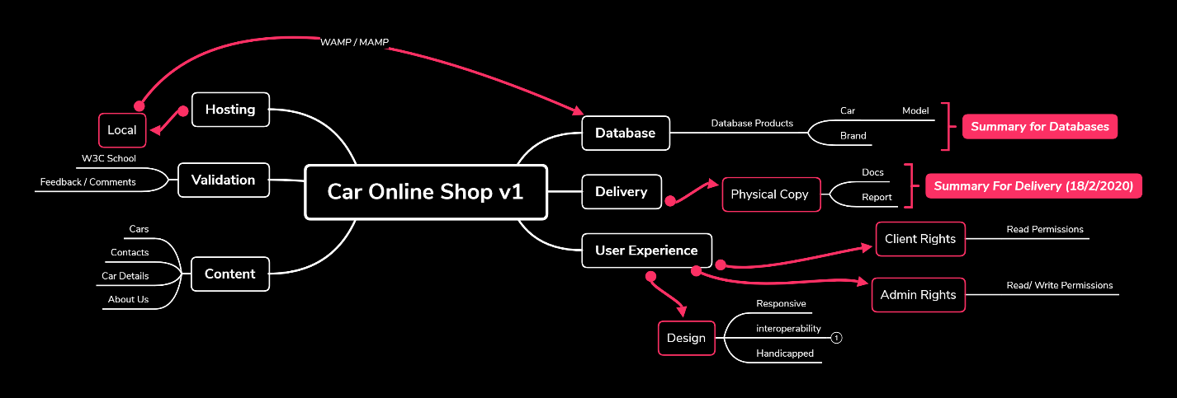

Figure . Mind Map generated for the Diamond Rims Project.

# Introduction to the Web Design process

Web Design process can be an extremely wide and complicated topic; it was decided through a common agreement to go for a more “enterprise-like” approach. Through the use of HTML mockups, the first step in this project was to generate a static mockup of the website with no CSS nor JS. (Mockups are available in the attachments in the ZIP archive). The mockup has been created with a software call “Balsamiq”. This one will allow a quick and concise mockup that will please the customer. To stay on a professional mindset, almost no picture will be added in the report to not clog the overall feel and look of it.

In order to quickly have a nice user interface, we decided to use the bootstrap framework. To do so, we have worked with the Bootstrap Studio software most of the time; and then fixed the details by hand. Luckily, we have found a nice template to start with. That has allowed us to focus on the user experience and code quality. Furthermore, we made sure that the entire product code did not contain any warning or error once passed through the W3C Validator.

Because the project will have database interaction, we choose to use the scripting language PHP. Thus, allows us to “construct” page and avoid code duplication. This has to say that, based on the URL asked by the user, a web page will be constructed by including a standard header and footer and, then, the appropriate body. Moreover, we opted for the Model View Controller design pattern to help us among this project. This is how we ended up with this type of architecture:

WebApp  
|  
|_______assets (External resources necessary for the operation of the web application)  
| |______css (Cascading Style Sheets folder, describe how HTML elements should be displayed).  
| |______icon (Icons used into the web application)  
| |______img (Images used into the web application)  
| |______js (Javascript folder, scripts that makes web pages interactive)  
|  
|_______classes (Models and Controller of the MVC design pattern)  
| |______Brand.class.php (Brand object reflecting the Brand table of the database)  
| |______BrandManager.class.php (Controller that allow operations on/with brand objects, gateway between PHP object and the database)  
| |______Car.class.php  
| |______CarManager.class.php  
| |______Model.class.php  
| |______ModelManager.class.php  
| |______MyPDO.class.php (Custom class that inherit of PHP Data Object, to connect to the database)  
| |______Picture.class.php  
| |______PictureManager.class.php  
|  
|_______include (Pages or code fragment that are used to construct a page)  
| |______pages (Views of the MVC design pattern)  
| | |_____About.inc.php (About us page body)  
| | |_____Connection.inc.php (Connection page body)  
| | |_____Home.inc.php (Home page body)  
| | |_____Products.inc.php (Product page body)  
| |  
| |______autoLoad.inc.php (Include automatically Classes if they are not)  
| |______CONFIG.INC.php (Config settings used to connect to the database)  
| |______footer.inc.php (The standard footer foreach page)  
| |______header.inc.php (The standard header foreach page)  
| |______text.inc.php (Depending on the URL asked, include the right pages body)  
|  
|_______public (Public folder that allow the admin to add external resources , only car picture for the v1 )  
| |______carPictures (Folder that contains all pictures of the car on sales)  
| |_________1_1.jpg (idCar_numPicture.jpg, here: car number 1 , picture number 1)  
| |_________1_2.jpg (car number 1 , picture number 2)  
| |_________2_1.jpg (car number 2 , picture number 1)  
| |_________ ...  
|  
|_______index.php (Basic structure of each page, includes requested code fragment and initialized controllers)

# Database

To create the database, we have used the MERISE technics to be able to collect data, save them, treat them and broadcast them. We first identified the CDM (Conceptual Data Model) by:

* Implementing the management rules (if these are not given to you).
* Developing the data dictionary.
* Searching for functional dependencies between these data.
* Creating entities and associations, then calculation of cardinalities.

We end up with this CDM:

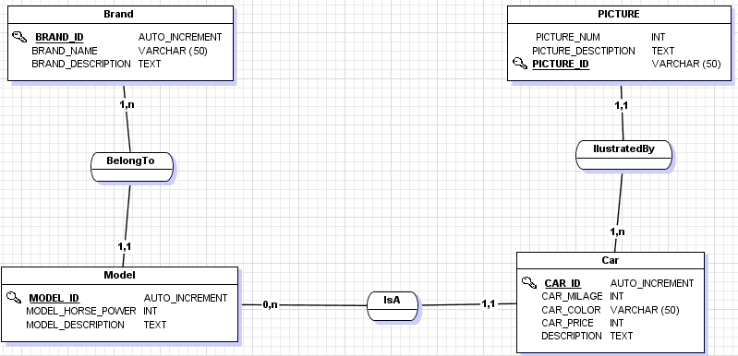

Once the CDM done it was easy to convert it into a LDM (Logical Data Model):

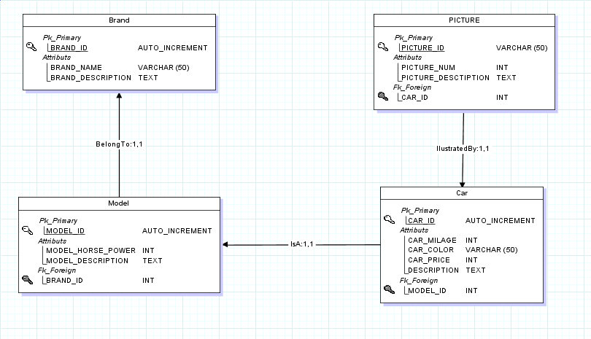

You can find the SQL script obtained in the annex attached to this document.

# Member’s Contributions

|  |  |
| --- | --- |
| **Group/Team/Unit Member** | **Contributions** |
| Arnaud SAULOU | * Database generation (using MCD). * WebApp Architecture and structure * Filling up the main database with entries |
| Arnak TOVMASSIAN | * Products page creation (catalog of products) * W3C Validation for the pages * Creation and handling of “Product details” dynamics pages |
| Kevin D. YAKER | * Finding and using BootStrap template * Creation of design elements for the website (Logo / Motto) * Creation of the “Contacts Us” and “Home” |
| All Members | * Creating and maintaining a GIT * Putting in place responsive design for every page * Mind map generation |

# Conclusion and current state of the website

We started working on our project and we already have an idea of what we want to do. Diamond Rims is going to be a luxury car selling website that will show all the available vehicles with the specific details about each one of them.

For the coming version, we want to add an add/modify page and a connection page in order for the administrator of the website to work on the inputs of the database. We also want to add a basket/bin option for the customers.