Playing Games at AAAI
By David M. Kaiser

General Game Playing

I was extremely interested when I first read about the General Game Playing Competition to be held at the Twentieth National Conference on Artificial Intelligence (AAAI-05). I’ve read a lot about computer game playing since 1999 when Dr. Alex Pelin suggested that I do my Master’s Thesis in this area. The thought of entering this competition was very exciting.
Computer Game Playing has a long and distinguished history within computer science. Arthur Samuel wrote the first checker playing program back in the 1950’s. Since then Deep Blue has beaten the world chess champion, and there are computer programs capable of beating human champions in checker, backgammon, scrabble and many other games. These champion level programs each specialize in a single game. But Deep Blue can’t play tic-tac-toe.
Why? Because mastering a single game domain is hard enough; playing many games is an order of magnitude more challenging. Only a handful of authors have published papers that describe systems designed to play more than a single game. One of those authors is Barney Pell, and although he suggested it back in 1992, no one has actually had a general game playing competition. Not even at the Computer Olympiads. Not until now.

The Language

If you are going to be playing many games, you need a way to describe them. For this purpose the Game Description Language was developed by Micheal Genesereth and Nathaniel Love at Stanford University. The language is a subset of first order logic and uses relational logic, along with a set of distinguished relational predicates, to describe perfect information, deterministic games. So games like tic-tac-toe and checkers are in, but games like poker and backgammon are out.

(role white)

(init (cell 1 1 b))

(<= (legal white (mark ?x ?y))
(true (cell ?x ?y b)))

(<= (next (cell ?m ?n x))
(does white (mark ?m ?n))
(true (cell ?m ?n b)))

(<= (goal white 100)
(true (cell 1 1 x)))

(<= (terminal)
(true (cell 1 1 x)))

Figure 1 – A very short game in the Game Description Language.
The shortest game I could think of is described in Figure 1. There is only one player (white), one initially true state (cell 1 1 b), and one legal move (does white (mark 1 1)). The game is over when the player makes their first move so it’s rather boring, but tic-tac-toe is three pages long.
The competition is structured so that computer systems have some time to examine the game before play begins. During the competition the time ranged from 10 to 40 minutes. But we didn’t know for sure how much time we’d have while we crafted our systems.
All players move simultaneously. This seems rather strange at first, but it simplifies the implementation of games like Rock-Paper-Scissors, and games that alternate moves can be implemented by giving one player “control” and forcing the other player to “pass” during the controlling players turn.

Goblin

At the core of Goblin is the Java Theorem Prover, a forward-chaining inference engine developed (by Gleb Frank et. al.) at Stanford. JTP is used to parse the GDL language, determine the game states, legal moves and game termination condition.
Since GDL allows multiplayer games, Goblin uses a variant of Min-Max with Alpha-Beta pruning called Paranoid search. This basically assumes that all your opponents will gang up on you and choose the single worst possible combination of moves (from your perspective) to attack you. In practice this would probably never happen, but the assumption makes it possible to implement the basic Min-Max with Alpha-Beta pruning algorithm without much modification.
Iterative Deepening and a transposition table are two further “standard” enhancements used to improve performance.
Implementation of the transposition table was not complicated; however it failed to improve Goblin’s performance on several games. The idea behind a transposition table is to use a hashing function to store a game state and its associated evaluation (win, lose, whatever) in a hash table. If the position is found in the table it is not necessary to search further in the game tree. Unfortunately, some of the sample games contain turn counters.
For example one game “pancake” allowed you to “flip” a pancake each turn. The game ends after 100 turns or if the player flips the pancakes into the correct order (i.e. 1, 2, 3, 4, 5, 6,). To keep track of what turn it is this game has a counter. The counter is part of the game state. So the game state [6,5,4,3,2,1, turn 8] hashes to a different location in the transposition table than game state [6,5,4,3,2,1, turn 12]. To make the transposition table effective it was necessary to “find” this turn counter and remove it before hashing the game state. I say find because there is no guarantee that any new game presented to the system will define the “counter” in exactly the same way. Sure [turn 1, turn 2, turn 3] makes sense but [blob funny, blob sunny, blob runny] is not so clearly a turn counter.
Identifying features of a game was the centrally difficult challenge in this domain. Every team attempted to recognize common structures in the sample games such as grids, pieces, or distance. Every team had difficulty with this problem.

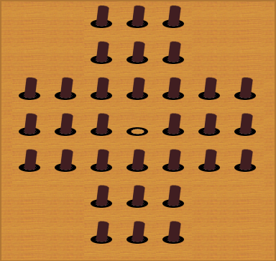
The Qualification Round

Seven teams entered the competition. A qualification round, consisting of three games, was held the first day. This was to verify that each player could communicate correctly, respond within the given time limits, and submit legal moves.
The first game was single player game (a.k.a. a puzzle) that many people will be familiar with called Pegs (Figure 2).
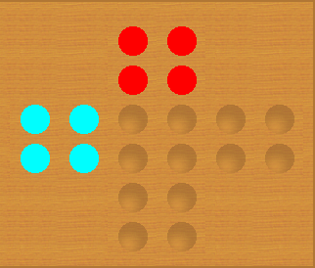
Pieces are removed by “hoping” over them into an empty location. Diagonal moves are not allowed so there are only four legal moves at the start. The goal is to remove as many pieces as possible. To get the highest score a player must remove all but one piece and leave that one in the center. Players received lower scores if more than one piece was left. Each player was given ten minutes to examine the game, before playing. After the game started, players had 90 seconds to make each move.
Figure 2 - Starting position for Pegs
The second game was a two player game called CrissCross (Figure 3). For the qualification round the opponent for each contestant was a random player. The object was simply to move your pieces to the opposite side first, by moving one space or hoping over pieces. The random player was allowed to move first.
The third qualifier game (Figure 4) was also played against a random player. Each player had one piece. The goal was to get your piece to the other side first. During your turn you were allowed to move one space, or place a wall to block your opponent. None of the players reached a winning state before the end of the game.
Figure 3 - The objective is to be the first player to move your marbles to the opposite side.
The final results of the qualification round are shown in Table 1.
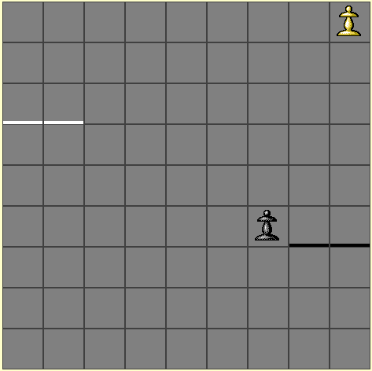
Table 1
 | Pegs | CrissCross | Hallway
Fluxplayer | 70 | 100 | 50
UTexas | 60 | 100 | 50
Goblin | 60 | 25 | 50
Cluneplayer | 20 | 25 | 50
York | 0 | 100 | 50
Semsyn | * | * | *
Ncsuremote | * | * | *

Figure 4 - The objective is to get your piece to the opposite side first.

The Competition – Round 1

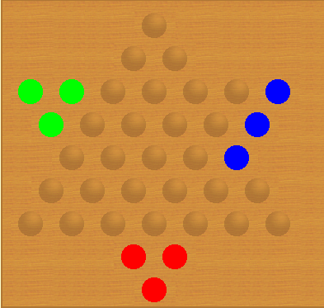
Five players made it to the competition. Two contestants (Semsyn and NCSUremote) did not complete the qualification rounds successfully.
The first game was a similar to Chinese Checkers. The objective was to get your pieces to the opposite side. The player who got all their pieces in first would win. Each player was given 30 minutes before the game started and two minutes for each move.
Having come in first and second in the qualifiers, Fluxplayer (Dresden) and UTexas played against a random opponent, while Goblin, Cluneplayer and York competed against each other.
Figure 5 - Final position for round one. York (blue) has three pieces "trapped" in a line.
One rule, quite different from regular Chinese Checkers, did not allow pieces to move sideways. This meant it was possible to get into a position where a player could not move all their pieces into the target zone. This is exactly what happened to York, knocking it out of the competition.
York (from the University of York England) was written in C++ and used Min-Max search with Iterative deepening and a transposition table to improve search performance.

Round 2

During the second round Goblin (FIU) played against Fluxplayer (Dresden), a program written in Prolog and based on FLUX, a programming system for the design of agents that reason logically about their environment.
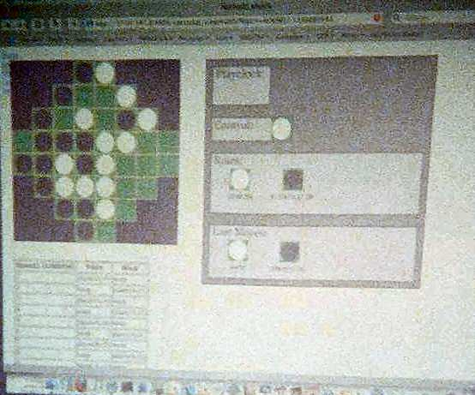
Simultaneously, Cluneplayer (UCLA) played against UTexas. UTexas is written in Java by Greg Kuhlmann, Peter Stone and Kurt Dresner from the University of Texas. It runs on 200 networked computers. Each computer determines the best move using a different strategy and then a master controller makes the final decision.
The semifinal round game was Nothello. Similar to Othello except that the corners are cut off and the player with the most pieces at the end loses instead of wins. So the strategy is completely different. Players were given 40 minutes before the game and two minutes for each move.
Figure 6 - Because of technical problems, this game was stopped. Goblin is white.
One of the sample games on the Stanford website is Othello and it is rather difficult for Goblin. About a week before the conference Goblin took up to 20 seconds just to determine the legal moves for a single game position. A few axioms for determining a legal move in Othello are shown in Figure 7. To make things less predictable, the moderators changed all non-dedicated terms in the game definitions to nonsense words. Anyone who was hoping to see a specific term like “flip” or “column” was sadly disappointed. Some obfuscated code for Nothello is shown in Figure 8.
There are several problems with playing general games. One of them is identifying good heuristics. Fortunately there wasn’t enough time to implement one heuristic I had planned, which was counting pieces. In games like checkers and chess more material is better. But a heuristic that counted more of “our” pieces as a better would not have helped in Nothello.

(<= (legal black (place ?m ?n))
(true (control black))
(true (cell ?m ?n green))
(flip ?i ?j black ?m ?n))

(<= (flip ?i ?j white ?m ?n)
(onalinep ?i ?j black ?m ?n white ?dir)
(opp ?dir ?odir)
(onaline ?i ?j black ?x ?y white ?odir))

(<= (onaline ?i ?j ?c1 ?m ?n ?c2 ?dir)
(true (cell ?i ?j ?c1))
(true (cell ?m ?n ?c2))
(adj ?dir ?i ?j ?m ?n))

Figure 7 - Some of the axioms for determining a legal move for black in the game Othello.

(<= (legal himenoing (dukepse ?thartsee ?warries))
(true (camosto himenoing))
(true (welcoul ?thartsee ?warries lorenchise))
(isheard ?lethings ?whavirius himenoing ?thartsee ?warries))

(<= (isheard ?lethings ?whavirius himenoing ?thartsee ?warries)
(fronchat ?lethings ?whavirius tookines ?thartsee ?warries himenoing ?lethealst)
(shathat ?lethealst ?ragaing)
(pathave ?lethings ?whavirius tookines ?deviorn ?linguall himenoing ?ragaing))

(<= (pathave ?lethings ?whavirius ?memplarm ?thartsee ?warries ?tindegg ?lethealst)
(true (welcoul ?lethings ?whavirius ?memplarm))
(true (welcoul ?thartsee ?warries ?tindegg))
(pettered ?lethealst ?lethings ?whavirius ?thartsee ?warries))

Figure 8 - Some of the obfuscated axioms from Nothello.

Round 3

The final game “RaceTrack” was played between Goblin and ClunePlayer. Movement in this game was simultaneous, unlike checkers where players alternate taking turns. The goal was to be the first player to get to the bottom.
ClunePlayer was written in CAML by Jim Clune from UCLA. Like Goblin, uses paranoid search with Iterative Deepening and a Transposition table. Jim Clune included several heuristics, like material balance and mobility, to improve performance.
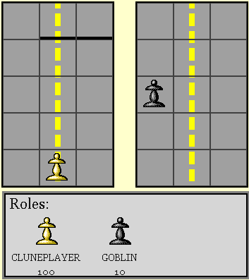
We had plenty of time to talk while the systems played, but I didn’t take any notes so I’ve probably butchered some names and fractured a few facts relating to the other players. I’m told that an article will appear in a future issue of AI magazine describing the event in some detail so look for that at your local newsstands.

AAAI

After the competition I had some time to attend conference lectures and exhibits. Unsurprisingly I focus my attention on seminars related to games and search but the available topics ranged from Knowledge Representation to Machine Learning and from Multi-Agent systems to Robotics. I found the robots exhibits most entertaining. The soccer playing robot dogs were my favorite.
Figure 9 – RaceTrack

Hundreds of researchers attended the conference, and I was able to meet several people whose papers I have read.

More

You can (and should) read more about the General Game Playing Competition at <http://games.stanford.edu/>. They even have an “arcade” where you can view or play games, examine game rules and test your game playing program.
The next competition, which I plan to enter, will be at AAAI-06 in Boston next year <http://www.aaai.org/Conferences/National/2006/aaai06.html>.

Bio

David Michael Kaiser is a happily married father of two. He works at Miami-Dade College as a Web Analyst, and has been attending Florida International University for … well … forever. <http://faculty.mdc.edu/dkaiser/>

