Burduniuc Olga

Arnaut Oleg

04 01 2022

df <- read_excel("C:/Users/Rwork/OneDrive/Desktop/Greta Balan/Burduniuc Olga/Burduniuc_Olga.xlsx")  
  
# Variables transformation in factor  
df$Factor <- as.factor(df$Factor)  
df$Blocks <- as.factor(df$Blocks)  
df$`Nr/p.` <- as.factor(df$`Nr/p.`)

# Descriptive statistics table  
library(table1)  
  
table1::table1(~. | df$Factor, data = df[, c(2:7)],   
 render.continuous=c(.="Mean (SD)",   
 .="Median (IQR)",   
 .="[Min, Max]"),  
 topclass="Rtable1-grid"  
)

##   C1 C1+N1 C1+N2 C2  
## 1 (N=12) (N=12) (N=12) (N=12)  
## 2 DAM, µM/L   
## 3   Mean (SD) 7.49 (0.518) 4.94 (0.403) 4.08 (0.233) 5.51 (0.560)  
## 4   Median (IQR) 7.55 (0.725) 4.85 (0.725) 4.00 (0.325) 5.55 (0.825)  
## 5   [Min, Max] [6.60, 8.20] [4.50, 5.50] [3.80, 4.50] [4.60, 6.30]  
## 6 PPOA, µM/L   
## 7   Mean (SD) 47.7 (1.79) 34.5 (3.03) 34.4 (4.93) 37.5 (2.49)  
## 8   Median (IQR) 47.7 (2.65) 34.6 (4.48) 33.4 (4.30) 37.9 (3.60)  
## 9   [Min, Max] [44.5, 50.6] [29.4, 38.6] [29.2, 48.0] [32.8, 40.9]  
## 10 SOD, u/c   
## 11   Mean (SD) 817 (21.3) 982 (5.83) 1020 (3.57) 823 (7.52)  
## 12   Median (IQR) 819 (12.1) 983 (6.38) 1020 (4.10) 823 (4.88)  
## 13   [Min, Max] [758, 844] [970, 992] [1010, 1030] [812, 839]  
## 14 Catalaza, µM/s.L   
## 15   Mean (SD) 13.0 (0.711) 21.6 (1.57) 33.5 (0.619) 18.4 (0.607)  
## 16   Median (IQR) 13.0 (0.875) 21.9 (2.40) 33.7 (0.725) 18.3 (0.750)  
## 17   [Min, Max] [11.7, 14.3] [19.7, 24.7] [32.1, 34.2] [17.5, 19.4]  
## 18 AAT cu ABTS, µM/L   
## 19   Mean (SD) 149 (3.19) 138 (4.61) 152 (1.96) 158 (4.98)  
## 20   Median (IQR) 150 (3.88) 138 (6.00) 152 (1.80) 158 (3.08)  
## 21   [Min, Max] [143, 154] [130, 146] [150, 157] [144, 162]  
## 22 G-S-T, nM/s.L   
## 23   Mean (SD) 44.5 (2.33) 44.4 (2.41) 46.0 (1.85) 42.5 (2.29)  
## 24   Median (IQR) 44.7 (4.88) 45.2 (4.33) 46.6 (3.18) 42.3 (3.60)  
## 25   [Min, Max] [41.1, 47.1] [41.0, 47.1] [43.1, 48.5] [39.7, 46.6]  
## C2+N1 C2+N2 Martor N1 N2  
## 1 (N=12) (N=12) (N=12) (N=12) (N=12)  
## 2   
## 3 4.37 (0.314) 3.41 (0.297) 5.14 (0.425) 4.23 (0.362) 3.27 (0.460)  
## 4 4.40 (0.525) 3.35 (0.500) 5.10 (0.675) 4.25 (0.450) 3.10 (0.725)  
## 5 [4.00, 4.90] [3.00, 3.90] [4.60, 5.80] [3.70, 4.90] [2.80, 4.00]  
## 6   
## 7 34.7 (2.85) 33.5 (1.92) 35.7 (2.91) 34.6 (2.86) 34.2 (5.03)  
## 8 34.6 (4.43) 33.6 (1.68) 35.3 (4.45) 34.6 (4.68) 32.8 (4.73)  
## 9 [29.8, 39.0] [31.2, 38.5] [30.8, 40.2] [30.0, 39.1] [29.1, 47.8]  
## 10   
## 11 985 (6.09) 1020 (5.91) 850 (6.57) 994 (7.17) 1040 (7.37)  
## 12 984 (8.48) 1020 (6.03) 851 (7.53) 991 (9.28) 1040 (7.05)  
## 13 [977, 995] [1010, 1030] [839, 860] [984, 1010] [1020, 1050]  
## 14   
## 15 37.0 (1.84) 40.1 (1.07) 17.7 (0.481) 37.5 (1.96) 48.1 (1.05)  
## 16 37.1 (2.58) 39.8 (0.450) 17.8 (0.600) 37.1 (2.48) 47.9 (1.38)  
## 17 [34.2, 39.9] [39.3, 43.3] [16.8, 18.3] [34.8, 40.7] [46.8, 50.1]  
## 18   
## 19 139 (1.62) 159 (2.32) 137 (4.29) 142 (3.88) 154 (3.39)  
## 20 139 (0.800) 160 (1.88) 138 (5.23) 141 (5.63) 153 (6.23)  
## 21 [137, 144] [153, 162] [130, 145] [137, 149] [150, 160]  
## 22   
## 23 44.0 (1.14) 46.2 (2.02) 44.1 (2.53) 45.1 (2.19) 46.3 (1.91)  
## 24 44.4 (1.73) 46.2 (3.60) 44.7 (4.80) 45.8 (4.15) 46.9 (3.23)  
## 25 [42.1, 45.2] [43.1, 49.7] [40.0, 46.9] [41.7, 47.5] [43.4, 48.5]  
## Overall  
## 1 (N=108)  
## 2   
## 3 4.71 (1.28)  
## 4 4.50 (1.40)  
## 5 [2.80, 8.20]  
## 6   
## 7 36.3 (5.24)  
## 8 35.0 (5.58)  
## 9 [29.1, 50.6]  
## 10   
## 11 948 (86.6)  
## 12 987 (174)  
## 13 [758, 1050]  
## 14   
## 15 29.6 (11.6)  
## 16 33.7 (21.3)  
## 17 [11.7, 50.1]  
## 18   
## 19 148 (8.93)  
## 20 149 (14.5)  
## 21 [130, 162]  
## 22   
## 23 44.8 (2.35)  
## 24 44.9 (3.63)  
## 25 [39.7, 49.7]

table1::table1(~. | df$Factor, data = df[, c(8:13)],   
 render.continuous=c(.="Mean (SD)",   
 .="Median (IQR)",   
 .="[Min, Max]"),  
 topclass="Rtable1-grid"  
)

##   C1 C1+N1 C1+N2 C2  
## 1 (N=12) (N=12) (N=12) (N=12)  
## 2 GPO, nM/s.L   
## 3   Mean (SD) 316 (10.0) 397 (14.1) 451 (16.9) 334 (14.0)  
## 4   Median (IQR) 319 (13.6) 399 (4.75) 462 (30.0) 339 (4.53)  
## 5   [Min, Max] [301, 329] [357, 416] [422, 467] [296, 346]  
## 6 GR, nM/s.L   
## 7   Mean (SD) 31.7 (10.8) 61.0 (6.26) 117 (4.15) 52.7 (10.0)  
## 8   Median (IQR) 29.8 (9.23) 59.3 (3.33) 117 (2.25) 50.4 (5.45)  
## 9   [Min, Max] [21.2, 61.3] [55.8, 79.5] [111, 127] [41.7, 78.8]  
## 10 IL-1, pg/ml   
## 11   Mean (SD) 51.4 (2.82) 49.6 (1.42) 47.5 (1.47) 47.7 (1.46)  
## 12   Median (IQR) 51.0 (1.35) 50.1 (2.33) 47.8 (1.38) 48.1 (2.23)  
## 13   [Min, Max] [48.2, 59.4] [46.7, 51.1] [44.2, 49.2] [44.7, 49.5]  
## 14 TNF, pg/ml   
## 15   Mean (SD) 101 (6.23) 96.1 (4.69) 82.9 (4.50) 96.8 (6.37)  
## 16   Median (IQR) 102 (6.08) 97.6 (8.58) 81.3 (2.35) 97.1 (5.70)  
## 17   [Min, Max] [92.6, 115] [89.5, 103] [79.8, 95.6] [88.2, 111]  
## 18 IL-6, pg/ml   
## 19   Mean (SD) 150 (3.19) 132 (3.94) 122 (3.00) 130 (3.87)  
## 20   Median (IQR) 150 (3.70) 133 (6.48) 121 (3.28) 130 (4.95)  
## 21   [Min, Max] [144, 156] [126, 139] [117, 127] [125, 137]  
## 22 IL-10, pg/ml   
## 23   Mean (SD) 58.1 (2.05) 69.4 (2.12) 83.6 (1.02) 60.5 (0.932)  
## 24   Median (IQR) 58.4 (2.73) 69.8 (2.03) 83.8 (0.750) 60.5 (1.58)  
## 25   [Min, Max] [54.2, 61.3] [64.3, 72.1] [80.8, 84.7] [59.3, 61.9]  
## C2+N1 C2+N2 Martor N1 N2  
## 1 (N=12) (N=12) (N=12) (N=12) (N=12)  
## 2   
## 3 446 (14.5) 438 (10.6) 333 (15.1) 451 (15.9) 470 (6.06)  
## 4 449 (1.38) 437 (2.03) 337 (6.75) 452 (8.45) 470 (3.43)  
## 5 [402, 462] [430, 471] [288, 346] [403, 462] [454, 479]  
## 6   
## 7 89.8 (4.66) 150 (5.05) 50.4 (10.9) 95.5 (10.3) 169 (5.67)  
## 8 91.5 (2.70) 149 (4.00) 47.8 (5.83) 97.4 (11.8) 169 (4.85)  
## 9 [80.1, 93.2] [146, 164] [38.6, 78.6] [75.9, 107] [158, 178]  
## 10   
## 11 47.7 (1.25) 46.6 (0.997) 48.5 (1.53) 47.7 (1.60) 47.2 (1.50)  
## 12 47.6 (1.40) 46.9 (0.425) 48.6 (2.20) 47.6 (1.40) 47.5 (1.58)  
## 13 [45.1, 49.8] [44.0, 47.3] [45.1, 50.4] [44.2, 50.0] [44.0, 49.0]  
## 14   
## 15 80.5 (6.83) 82.0 (2.40) 99.3 (6.63) 80.0 (6.73) 79.2 (4.52)  
## 16 80.2 (4.50) 81.6 (1.43) 99.1 (6.28) 79.2 (4.33) 78.6 (2.28)  
## 17 [72.0, 95.2] [80.4, 89.2] [90.3, 113] [71.6, 94.7] [72.3, 91.5]  
## 18   
## 19 113 (3.20) 109 (3.28) 132 (3.84) 110 (3.25) 106 (3.11)  
## 20 112 (3.28) 108 (4.30) 132 (5.85) 111 (5.28) 106 (3.80)  
## 21 [108, 120] [104, 114] [125, 137] [105, 115] [101, 111]  
## 22   
## 23 74.8 (0.375) 102 (3.36) 58.8 (1.58) 89.1 (1.73) 106 (3.73)  
## 24 74.9 (0.600) 102 (3.10) 58.9 (2.45) 89.0 (2.43) 106 (5.13)  
## 25 [74.2, 75.4] [98.9, 111] [55.8, 61.1] [86.5, 92.3] [99.7, 110]  
## Overall  
## 1 (N=108)  
## 2   
## 3 404 (58.8)  
## 4 432 (112)  
## 5 [288, 479]  
## 6   
## 7 90.8 (45.3)  
## 8 90.1 (67.0)  
## 9 [21.2, 178]  
## 10   
## 11 48.2 (2.09)  
## 12 48.0 (2.28)  
## 13 [44.0, 59.4]  
## 14   
## 15 88.6 (10.4)  
## 16 88.3 (17.6)  
## 17 [71.6, 115]  
## 18   
## 19 123 (14.2)  
## 20 121 (22.5)  
## 21 [101, 156]  
## 22   
## 23 78.0 (17.4)  
## 24 74.9 (30.3)  
## 25 [54.2, 111]

level_order <- c('Martor', 'C1', 'C2', 'N1', 'N2', 'C1+N1', 'C1+N2', 'C2+N1', 'C2+N2')   
  
p <- ggplot(df, aes(x = factor(Factor, level = level_order), y = `DAM, µM/L`, fill = Factor))+  
 geom_jitter(fill='black', color="black", width=0.1)+  
 geom_boxplot(width=0.7) +   
 theme_minimal()+  
 theme(legend.position="none")+  
 xlab("Medicatie")+  
 ylab("DAM, µM/L")+  
 ylim(0,10)  
  
p + scale_fill_discrete(name = "Medicatie")

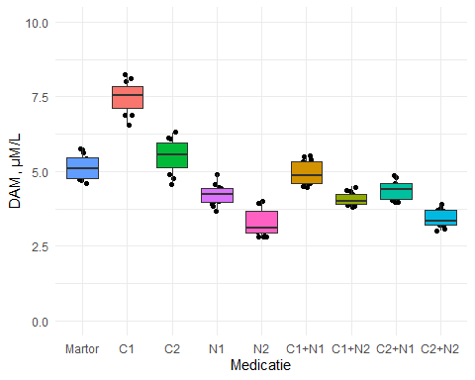

p <- ggplot(df, aes(x = factor(Factor, level = level_order), y = df$ `PPOA, µM/L`, fill = Factor))+  
 geom_jitter(fill='black', color="black", width=0.1)+  
 geom_boxplot(width=0.7) +   
 theme_minimal()+  
 theme(legend.position="none")+  
 xlab("Medicatie")+  
 ylab("PPOA, µM/L")+  
 ylim(0, 60)  
  
p + scale_fill_discrete(name = "Medicatie")

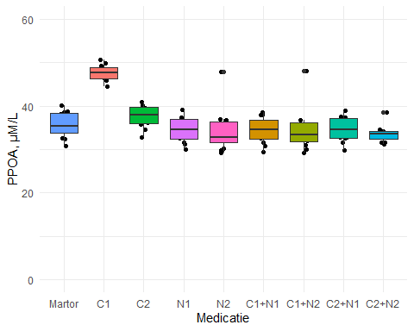

p <- ggplot(df, aes(x = factor(Factor, level = level_order), y = df$ `SOD, u/c`, fill = Factor))+  
 geom_jitter(fill='black', color="black", width=0.1)+  
 geom_boxplot(width=0.7) +   
 theme_minimal()+  
 theme(legend.position="none")+  
 xlab("Medicatie")+  
 ylab("SOD, u/c")+  
 ylim(600, 1200)  
  
p + scale_fill_discrete(name = "Medicatie")

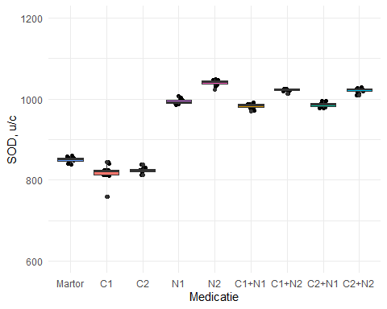

p <- ggplot(df, aes(x = factor(Factor, level = level_order), y = `Catalaza, µM/s.L`, fill = Factor))+  
 geom_jitter(fill='black', color="black", width=0.1)+  
 geom_boxplot(width=0.7) +   
 theme_minimal()+  
 theme(legend.position="none")+  
 xlab("Medicatie")+  
 ylab("Catalaza, µM/s.L")+  
 ylim(0,60)  
  
p + scale_fill_discrete(name = "Medicatie")

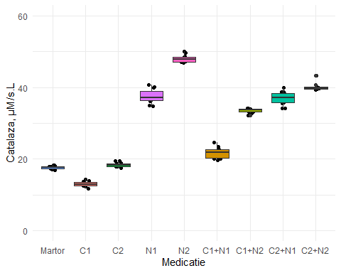

p <- ggplot(df, aes(x = factor(Factor, level = level_order), y = `AAT cu ABTS, µM/L`, fill = Factor))+  
 geom_jitter(fill='black', color="black", width=0.1)+  
 geom_boxplot(width=0.7) +   
 theme_minimal()+  
 theme(legend.position="none")+  
 xlab("Medicatie")+  
 ylab("AAT cu ABTS, µM/L")+  
 ylim(0,200)  
  
p + scale_fill_discrete(name = "Medicatie")

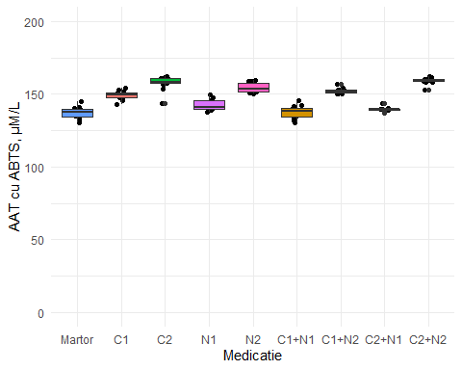

p <- ggplot(df, aes(x = factor(Factor, level = level_order), y = `G-S-T, nM/s.L`, fill = Factor))+  
 geom_jitter(fill='black', color="black", width=0.1)+  
 geom_boxplot(width=0.7) +   
 theme_minimal()+  
 theme(legend.position="none")+  
 xlab("Medicatie")+  
 ylab("G-S-T, nM/s.L")+  
 ylim(0,60)  
  
p + scale_fill_discrete(name = "Medicatie")

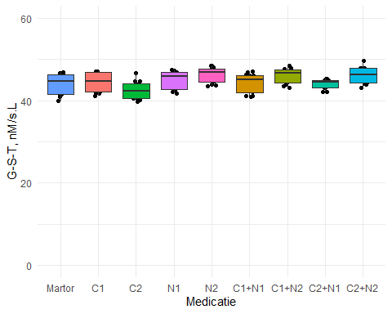

p <- ggplot(df, aes(x = factor(Factor, level = level_order), y = `GPO, nM/s.L`, fill = Factor))+  
 geom_jitter(fill='black', color="black", width=0.1)+  
 geom_boxplot(width=0.7) +   
 theme_minimal()+  
 theme(legend.position="none")+  
 xlab("Medicatie")+  
 ylab("GPO, nM/s.L")+  
 ylim(0,500)  
  
p + scale_fill_discrete(name = "Medicatie")

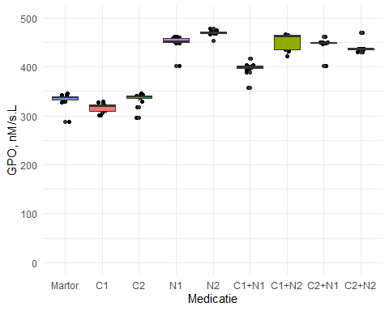

p <- ggplot(df, aes(x = factor(Factor, level = level_order), y = `GR, nM/s.L`, fill = Factor))+  
 geom_jitter(fill='black', color="black", width=0.1)+  
 geom_boxplot(width=0.7) +   
 theme_minimal()+  
 theme(legend.position="none")+  
 xlab("Medicatie")+  
 ylab("GR, nM/s.L")+  
 ylim(0,200)  
  
p + scale_fill_discrete(name = "Medicatie")

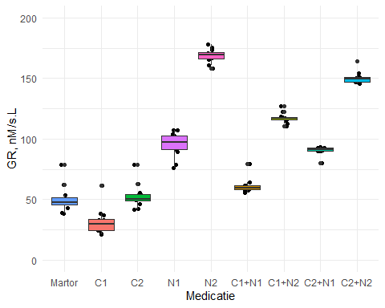

p <- ggplot(df, aes(x = factor(Factor, level = level_order), y = `TNF, pg/ml`, fill = Factor))+  
 geom_jitter(fill='black', color="black", width=0.1)+  
 geom_boxplot(width=0.7) +   
 theme_minimal()+  
 theme(legend.position="none")+  
 xlab("Medicatie")+  
 ylab("TNF, pg/ml")+  
 ylim(0,150)  
  
p + scale_fill_discrete(name = "Medicatie")

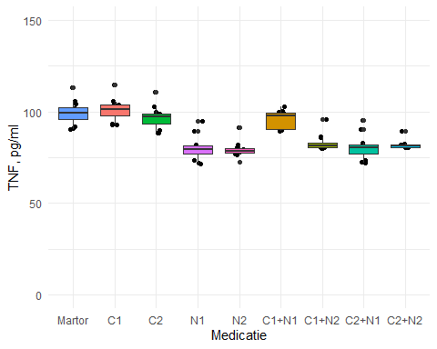

p <- ggplot(df, aes(x = factor(Factor, level = level_order), y = `IL-6, pg/ml`, fill = Factor))+  
 geom_jitter(fill='black', color="black", width=0.1)+  
 geom_boxplot(width=0.7) +   
 theme_minimal()+  
 theme(legend.position="none")+  
 xlab("Medicatie")+  
 ylab("IL-6, pg/ml")+  
 ylim(0,200)  
  
p + scale_fill_discrete(name = "Medicatie")

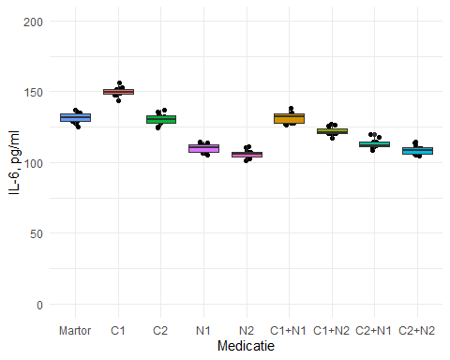

p <- ggplot(df, aes(x = factor(Factor, level = level_order), y = `IL-10, pg/ml`, fill = Factor))+  
 geom_jitter(fill='black', color="black", width=0.1)+  
 geom_boxplot(width=0.7) +   
 theme_minimal()+  
 theme(legend.position="none")+  
 xlab("Medicatie")+  
 ylab("IL-10, pg/ml")+  
 ylim(0,130)  
  
p + scale_fill_discrete(name = "Medicatie")

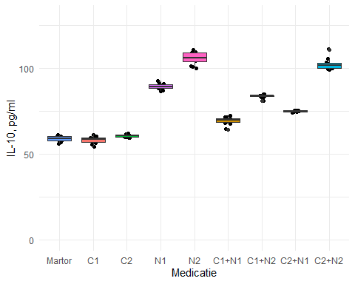

p <- ggplot(df, aes(x = factor(Factor, level = level_order), y = `IL-1, pg/ml`, fill = Factor))+  
 geom_jitter(fill='black', color="black", width=0.1)+  
 geom_boxplot(width=0.7) +   
 theme_minimal()+  
 theme(legend.position="none")+  
 xlab("Medicatie")+  
 ylab("IL-1, pg/ml")+  
 ylim(0,60)  
  
p + scale_fill_discrete(name = "Medicatie")

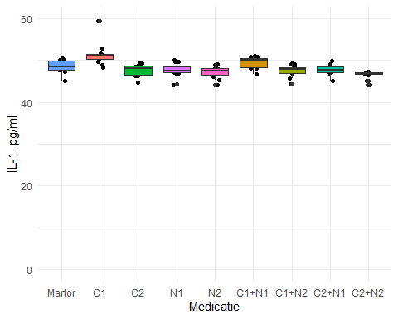

result <- friedman.test(`DAM, µM/L` ~ Factor | Blocks, data = df)  
result

##   
## Friedman rank sum test  
##   
## data: DAM, µM/L and Factor and Blocks  
## Friedman chi-squared = 92.703, df = 8, p-value < 2.2e-16

pairwise.wilcox.test(df$`DAM, µM/L`, df$Factor, p.adjust.method = "BH", paired = T)

##   
## Pairwise comparisons using Wilcoxon signed rank test with continuity correction   
##   
## data: df$`DAM, µM/L` and df$Factor   
##   
## C1 C1+N1 C1+N2 C2 C2+N1 C2+N2 Martor N1   
## C1+N1 0.0031 - - - - - - -   
## C1+N2 0.0031 0.0031 - - - - - -   
## C2 0.0031 0.0039 0.0031 - - - - -   
## C2+N1 0.0031 0.0031 0.0198 0.0031 - - - -   
## C2+N2 0.0031 0.0031 0.0031 0.0031 0.0031 - - -   
## Martor 0.0031 0.0064 0.0031 0.0054 0.0031 0.0031 - -   
## N1 0.0031 0.0031 0.1260 0.0031 0.0417 0.0031 0.0031 -   
## N2 0.0031 0.0031 0.0031 0.0031 0.0031 0.0342 0.0031 0.0031  
##   
## P value adjustment method: BH

df %>% friedman_effsize(`DAM, µM/L` ~ Factor | Blocks)

## # A tibble: 1 x 5  
## .y. n effsize method magnitude  
## * <chr> <int> <dbl> <chr> <ord>   
## 1 DAM, µM/L 12 0.966 Kendall W large

result <- friedman.test(`PPOA, µM/L` ~ Factor | Blocks, data = df)  
result

##   
## Friedman rank sum test  
##   
## data: PPOA, µM/L and Factor and Blocks  
## Friedman chi-squared = 71.057, df = 8, p-value = 3.027e-12

pairwise.wilcox.test(df$`PPOA, µM/L`, df$Factor, p.adjust.method = "BH", paired = T)

##   
## Pairwise comparisons using Wilcoxon signed rank exact test   
##   
## data: df$`PPOA, µM/L` and df$Factor   
##   
## C1 C1+N1 C1+N2 C2 C2+N1 C2+N2 Martor N1   
## C1+N1 0.0018 - - - - - - -   
## C1+N2 0.0018 0.1022 - - - - - -   
## C2 0.0057 0.0018 0.0615 - - - - -   
## C2+N1 0.0018 0.4363 0.0681 0.0057 - - - -   
## C2+N2 0.0057 0.1287 0.7030 0.0057 0.0586 - - -   
## Martor 0.0018 0.0057 0.0615 0.0018 0.0018 0.0069 - -   
## N1 0.0018 0.6456 0.0996 0.0018 0.5809 0.0681 0.0057 -   
## N2 0.0018 0.1579 0.0774 0.0615 0.0774 0.9063 0.0615 0.0853  
##   
## P value adjustment method: BH

df %>% friedman_effsize(`PPOA, µM/L` ~ Factor | Blocks)

## # A tibble: 1 x 5  
## .y. n effsize method magnitude  
## * <chr> <int> <dbl> <chr> <ord>   
## 1 PPOA, µM/L 12 0.740 Kendall W large

result <- friedman.test(`SOD, u/c` ~ Factor | Blocks, data = df)  
result

##   
## Friedman rank sum test  
##   
## data: SOD, u/c and Factor and Blocks  
## Friedman chi-squared = 93.511, df = 8, p-value < 2.2e-16

pairwise.wilcox.test(df$`SOD, u/c`, df$Factor, p.adjust.method = "BH", paired = T)

##   
## Pairwise comparisons using Wilcoxon signed rank exact test   
##   
## data: df$`SOD, u/c` and df$Factor   
##   
## C1 C1+N1 C1+N2 C2 C2+N1 C2+N2 Martor N1   
## C1+N1 0.00063 - - - - - - -   
## C1+N2 0.00275 0.00275 - - - - - -   
## C2 0.39124 0.00063 0.00063 - - - - -   
## C2+N1 0.00063 0.02420 0.00063 0.00063 - - - -   
## C2+N2 0.00063 0.00063 0.48001 0.00063 0.00063 - - -   
## Martor 0.00121 0.00063 0.00063 0.00063 0.00063 0.00063 - -   
## N1 0.00063 0.00275 0.00063 0.00063 0.00063 0.00063 0.00063 -   
## N2 0.00063 0.00063 0.00063 0.00063 0.00063 0.00063 0.00275 0.00063  
##   
## P value adjustment method: BH

df %>% friedman_effsize(`SOD, u/c` ~ Factor | Blocks)

## # A tibble: 1 x 5  
## .y. n effsize method magnitude  
## * <chr> <int> <dbl> <chr> <ord>   
## 1 SOD, u/c 12 0.974 Kendall W large

result <- friedman.test(`Catalaza, µM/s.L` ~ Factor | Blocks, data = df)  
result

##   
## Friedman rank sum test  
##   
## data: Catalaza, µM/s.L and Factor and Blocks  
## Friedman chi-squared = 95.338, df = 8, p-value < 2.2e-16

pairwise.wilcox.test(df$`Catalaza, µM/s.L`, df$Factor, p.adjust.method = "BH", paired = T)

##   
## Pairwise comparisons using Wilcoxon signed rank exact test   
##   
## data: df$`Catalaza, µM/s.L` and df$Factor   
##   
## C1 C1+N1 C1+N2 C2 C2+N1 C2+N2 Martor N1   
## C1+N1 0.0010 - - - - - - -   
## C1+N2 0.0027 0.0010 - - - - - -   
## C2 0.0010 0.0027 0.0010 - - - - -   
## C2+N1 0.0010 0.0027 0.0027 0.0010 - - - -   
## C2+N2 0.0010 0.0027 0.0027 0.0027 0.0010 - - -   
## Martor 0.0027 0.0010 0.0027 0.0041 0.0010 0.0010 - -   
## N1 0.0027 0.0027 0.0010 0.0010 0.0279 0.0061 0.0010 -   
## N2 0.0010 0.0027 0.0027 0.0010 0.0027 0.0027 0.0027 0.0010  
##   
## P value adjustment method: BH

df %>% friedman_effsize(`Catalaza, µM/s.L` ~ Factor | Blocks)

## # A tibble: 1 x 5  
## .y. n effsize method magnitude  
## * <chr> <int> <dbl> <chr> <ord>   
## 1 Catalaza, µM/s.L 12 0.993 Kendall W large

result <- friedman.test(`AAT cu ABTS, µM/L` ~ Factor | Blocks, data = df)  
result

##   
## Friedman rank sum test  
##   
## data: AAT cu ABTS, µM/L and Factor and Blocks  
## Friedman chi-squared = 90.16, df = 8, p-value = 4.315e-16

pairwise.wilcox.test(df$`AAT cu ABTS, µM/L`, df$Factor, p.adjust.method = "BH", paired = T)

##   
## Pairwise comparisons using Wilcoxon signed rank exact test   
##   
## data: df$`AAT cu ABTS, µM/L` and df$Factor   
##   
## C1 C1+N1 C1+N2 C2 C2+N1 C2+N2 Martor N1   
## C1+N1 0.00093 - - - - - - -   
## C1+N2 0.03845 0.00093 - - - - - -   
## C2 0.00176 0.00093 0.01938 - - - - -   
## C2+N1 0.00093 0.11954 0.00336 0.00093 - - - -   
## C2+N2 0.00093 0.00093 0.00093 0.11954 0.00093 - - -   
## Martor 0.00093 0.01293 0.00093 0.00093 0.05948 0.00336 - -   
## N1 0.00093 0.00336 0.00093 0.00336 0.00517 0.00093 0.00093 -   
## N2 0.00439 0.00336 0.00336 0.06773 0.00336 0.00093 0.00093 0.00093  
##   
## P value adjustment method: BH

df %>% friedman_effsize(`AAT cu ABTS, µM/L` ~ Factor | Blocks)

## # A tibble: 1 x 5  
## .y. n effsize method magnitude  
## * <chr> <int> <dbl> <chr> <ord>   
## 1 AAT cu ABTS, µM/L 12 0.939 Kendall W large

result <- friedman.test(`G-S-T, nM/s.L` ~ Factor | Blocks, data = df)  
result

##   
## Friedman rank sum test  
##   
## data: G-S-T, nM/s.L and Factor and Blocks  
## Friedman chi-squared = 79.474, df = 8, p-value = 6.237e-14

pairwise.wilcox.test(df$`G-S-T, nM/s.L`, df$Factor, p.adjust.method = "BH", paired = T)

##   
## Pairwise comparisons using Wilcoxon signed rank test with continuity correction   
##   
## data: df$`G-S-T, nM/s.L` and df$Factor   
##   
## C1 C1+N1 C1+N2 C2 C2+N1 C2+N2 Martor N1   
## C1+N1 0.6749 - - - - - - -   
## C1+N2 0.0045 0.0045 - - - - - -   
## C2 0.0045 0.0065 0.0045 - - - - -   
## C2+N1 0.3943 0.4225 0.0063 0.0215 - - - -   
## C2+N2 0.0045 0.0045 0.6086 0.0045 0.0063 - - -   
## Martor 0.0236 0.0922 0.0045 0.0045 0.8501 0.0045 - -   
## N1 0.0207 0.0045 0.0045 0.0045 0.0465 0.0109 0.0045 -   
## N2 0.0045 0.0045 0.0086 0.0045 0.0045 0.3941 0.0045 0.0045  
##   
## P value adjustment method: BH

df %>% friedman_effsize(`G-S-T, nM/s.L` ~ Factor | Blocks)

## # A tibble: 1 x 5  
## .y. n effsize method magnitude  
## * <chr> <int> <dbl> <chr> <ord>   
## 1 G-S-T, nM/s.L 12 0.828 Kendall W large

result <- friedman.test(`GPO, nM/s.L` ~ Factor | Blocks, data = df)  
result

##   
## Friedman rank sum test  
##   
## data: GPO, nM/s.L and Factor and Blocks  
## Friedman chi-squared = 88.812, df = 8, p-value = 8.102e-16

pairwise.wilcox.test(df$`GPO, nM/s.L`, df$Factor, p.adjust.method = "BH", paired = T)

##   
## Pairwise comparisons using Wilcoxon signed rank exact test   
##   
## data: df$`GPO, nM/s.L` and df$Factor   
##   
## C1 C1+N1 C1+N2 C2 C2+N1 C2+N2 Martor N1   
## C1+N1 0.00076 - - - - - - -   
## C1+N2 0.00076 0.00076 - - - - - -   
## C2 0.00424 0.00076 0.00076 - - - - -   
## C2+N1 0.00076 0.00076 0.21523 0.00076 - - - -   
## C2+N2 0.00076 0.00076 0.10067 0.00076 0.17963 - - -   
## Martor 0.00814 0.00076 0.00076 0.09599 0.00076 0.00324 - -   
## N1 0.00076 0.00324 0.79102 0.00076 0.00076 0.10067 0.00324 -   
## N2 0.00076 0.00076 0.00076 0.00076 0.00076 0.00324 0.00076 0.00324  
##   
## P value adjustment method: BH

df %>% friedman_effsize(`GPO, nM/s.L` ~ Factor | Blocks)

## # A tibble: 1 x 5  
## .y. n effsize method magnitude  
## * <chr> <int> <dbl> <chr> <ord>   
## 1 GPO, nM/s.L 12 0.925 Kendall W large

result <- friedman.test(`GR, nM/s.L` ~ Factor | Blocks, data = df)  
result

##   
## Friedman rank sum test  
##   
## data: GR, nM/s.L and Factor and Blocks  
## Friedman chi-squared = 94.667, df = 8, p-value < 2.2e-16

pairwise.wilcox.test(df$`GR, nM/s.L`, df$Factor, p.adjust.method = "BH", paired = T)

##   
## Pairwise comparisons using Wilcoxon signed rank exact test   
##   
## data: df$`GR, nM/s.L` and df$Factor   
##   
## C1 C1+N1 C1+N2 C2 C2+N1 C2+N2 Martor N1   
## C1+N1 0.00063 - - - - - - -   
## C1+N2 0.00063 0.00063 - - - - - -   
## C2 0.00063 0.00430 0.00266 - - - - -   
## C2+N1 0.00063 0.00063 0.00266 0.00063 - - - -   
## C2+N2 0.00063 0.00063 0.00063 0.00266 0.00063 - - -   
## Martor 0.00063 0.00182 0.00063 0.00266 0.00063 0.00266 - -   
## N1 0.00063 0.00063 0.00063 0.00063 0.03418 0.00063 0.00063 -   
## N2 0.00063 0.00063 0.00063 0.00063 0.00063 0.00063 0.00063 0.00063  
##   
## P value adjustment method: BH

df %>% friedman_effsize(`GR, nM/s.L` ~ Factor | Blocks)

## # A tibble: 1 x 5  
## .y. n effsize method magnitude  
## * <chr> <int> <dbl> <chr> <ord>   
## 1 GR, nM/s.L 12 0.986 Kendall W large

result <- friedman.test(`IL-1, pg/ml` ~ Factor | Blocks, data = df)  
result

##   
## Friedman rank sum test  
##   
## data: IL-1, pg/ml and Factor and Blocks  
## Friedman chi-squared = 80.717, df = 8, p-value = 3.506e-14

pairwise.wilcox.test(df$`IL-1, pg/ml`, df$Factor, p.adjust.method = "BH", paired = T)

##   
## Pairwise comparisons using Wilcoxon signed rank test with continuity correction   
##   
## data: df$`IL-1, pg/ml` and df$Factor   
##   
## C1 C1+N1 C1+N2 C2 C2+N1 C2+N2 Martor N1   
## C1+N1 0.0045 - - - - - - -   
## C1+N2 0.0045 0.0045 - - - - - -   
## C2 0.0045 0.0045 0.3436 - - - - -   
## C2+N1 0.0045 0.0045 0.4834 0.9063 - - - -   
## C2+N2 0.0045 0.0045 0.0045 0.0077 0.0045 - - -   
## Martor 0.0045 0.0058 0.0045 0.0058 0.0058 0.0045 - -   
## N1 0.0045 0.0045 0.3300 0.8615 0.9063 0.0058 0.0045 -   
## N2 0.0045 0.0045 0.0080 0.0381 0.0396 0.0336 0.0045 0.0336  
##   
## P value adjustment method: BH

df %>% friedman_effsize(`IL-1, pg/ml` ~ Factor | Blocks)

## # A tibble: 1 x 5  
## .y. n effsize method magnitude  
## * <chr> <int> <dbl> <chr> <ord>   
## 1 IL-1, pg/ml 12 0.841 Kendall W large

result <- friedman.test(`TNF, pg/ml` ~ Factor | Blocks, data = df)  
result

##   
## Friedman rank sum test  
##   
## data: TNF, pg/ml and Factor and Blocks  
## Friedman chi-squared = 85.951, df = 8, p-value = 3.077e-15

pairwise.wilcox.test(df$`TNF, pg/ml`, df$Factor, p.adjust.method = "BH", paired = T)

##   
## Pairwise comparisons using Wilcoxon signed rank test with continuity correction   
##   
## data: df$`TNF, pg/ml` and df$Factor   
##   
## C1 C1+N1 C1+N2 C2 C2+N1 C2+N2 Martor N1   
## C1+N1 0.0035 - - - - - - -   
## C1+N2 0.0035 0.0035 - - - - - -   
## C2 0.0035 0.9697 0.0014 - - - - -   
## C2+N1 0.0035 0.0014 0.0410 0.0014 - - - -   
## C2+N2 0.0014 0.0014 0.7544 0.0035 0.5124 - - -   
## Martor 0.0035 0.0035 0.0014 0.0014 0.0014 0.0014 - -   
## N1 0.0035 0.0014 0.0384 0.0014 0.0051 0.2269 0.0035 -   
## N2 0.0035 0.0035 0.0014 0.0014 0.2626 0.0144 0.0035 0.5649  
##   
## P value adjustment method: BH

df %>% friedman_effsize(`TNF, pg/ml` ~ Factor | Blocks)

## # A tibble: 1 x 5  
## .y. n effsize method magnitude  
## * <chr> <int> <dbl> <chr> <ord>   
## 1 TNF, pg/ml 12 0.895 Kendall W large

result <- friedman.test(`IL-6, pg/ml` ~ Factor | Blocks, data = df)  
result

##   
## Friedman rank sum test  
##   
## data: IL-6, pg/ml and Factor and Blocks  
## Friedman chi-squared = 90.578, df = 8, p-value = 3.55e-16

pairwise.wilcox.test(df$`IL-6, pg/ml`, df$Factor, p.adjust.method = "BH", paired = T)

##   
## Pairwise comparisons using Wilcoxon signed rank test with continuity correction   
##   
## data: df$`IL-6, pg/ml` and df$Factor   
##   
## C1 C1+N1 C1+N2 C2 C2+N1 C2+N2 Martor N1   
## C1+N1 0.0031 - - - - - - -   
## C1+N2 0.0008 0.0008 - - - - - -   
## C2 0.0008 0.0751 0.0031 - - - - -   
## C2+N1 0.0031 0.0008 0.0015 0.0008 - - - -   
## C2+N2 0.0008 0.0008 0.0031 0.0008 0.0077 - - -   
## Martor 0.0008 0.6221 0.0008 0.0031 0.0008 0.0008 - -   
## N1 0.0008 0.0008 0.0008 0.0008 0.0031 0.1557 0.0008 -   
## N2 0.0008 0.0008 0.0008 0.0008 0.0039 0.0131 0.0008 0.0077  
##   
## P value adjustment method: BH

df %>% friedman_effsize(`IL-6, pg/ml` ~ Factor | Blocks)

## # A tibble: 1 x 5  
## .y. n effsize method magnitude  
## * <chr> <int> <dbl> <chr> <ord>   
## 1 IL-6, pg/ml 12 0.944 Kendall W large

result <- friedman.test(`IL-10, pg/ml` ~ Factor | Blocks, data = df)  
result

##   
## Friedman rank sum test  
##   
## data: IL-10, pg/ml and Factor and Blocks  
## Friedman chi-squared = 94.711, df = 8, p-value < 2.2e-16

pairwise.wilcox.test(df$`IL-10, pg/ml`, df$Factor, p.adjust.method = "BH", paired = T)

##   
## Pairwise comparisons using Wilcoxon signed rank exact test   
##   
## data: df$`IL-10, pg/ml` and df$Factor   
##   
## C1 C1+N1 C1+N2 C2 C2+N1 C2+N2 Martor N1   
## C1+N1 0.00073 - - - - - - -   
## C1+N2 0.00073 0.00073 - - - - - -   
## C2 0.00344 0.00073 0.00275 - - - - -   
## C2+N1 0.00073 0.00275 0.00073 0.00073 - - - -   
## C2+N2 0.00073 0.00073 0.00073 0.00275 0.00073 - - -   
## Martor 0.05443 0.00073 0.00073 0.00275 0.00073 0.00073 - -   
## N1 0.00275 0.00275 0.00073 0.00073 0.00275 0.00073 0.00073 -   
## N2 0.00073 0.00073 0.00275 0.00275 0.00073 0.02120 0.00073 0.00073  
##   
## P value adjustment method: BH

df %>% friedman_effsize(`IL-10, pg/ml` ~ Factor | Blocks)

## # A tibble: 1 x 5  
## .y. n effsize method magnitude  
## * <chr> <int> <dbl> <chr> <ord>   
## 1 IL-10, pg/ml 12 0.987 Kendall W large