Plesacov

Oleg Arnaut

2023-10-31

# Dataset formation

df <- read_excel("Baza de date Plesacov TURP.xlsx")  
  
  
df %>% select(!c("Nr.", "Cod")) -> df   
   
  
# Identify character variables  
character_vars <- sapply(df, is.character)  
  
# Convert character variables to factors  
df[character_vars] <- lapply(df[character_vars], as.factor)  
  
names(df)

## [1] "Vîrsta"   
## [2] "Statut ECOG"   
## [3] "Durata spitalizării"   
## [4] "Maladii CV"   
## [5] "Maladii TGI"   
## [6] "Maladii TU"   
## [7] "DZ"   
## [8] "Alfa adrenoblocante"   
## [9] "Inhibitorii 5 Alfa reductaza"   
## [10] "Inhibitorii 5 Alfa fosfodiesteraza"   
## [11] "Durata bolii"   
## [12] "Tratament chirurgical"   
## [13] "Durata intervenției"   
## [14] "Prezența cateturului urinar la spitaliare"  
## [15] "VP, preoperator"   
## [16] "VP, 3 luni"   
## [17] "VP, 6 luni"   
## [18] "VP, 12 luni"   
## [19] "UR, preoperator"   
## [20] "UR, 3 luni"   
## [21] "UR,6 luni"   
## [22] "UR, 12 luni"   
## [23] "Qmax, preoperator"   
## [24] "Qmax,3 luni"   
## [25] "Qmax, 6 luni"   
## [26] "Qmax, 12 luni"   
## [27] "Qmean, preoperator"   
## [28] "Qmean, 3 luni"   
## [29] "Qmean, 6 luni"   
## [30] "Qmean, 12 luni"   
## [31] "IPSS, preoperator"   
## [32] "IPSS,3 luni"   
## [33] "IPSS, 6 luni"   
## [34] "IPSS, 12 luni"   
## [35] "QoL, preoperator"   
## [36] "Qol, 3 luni"   
## [37] "Qol, 6 luni"   
## [38] "QoL, 12 luni"   
## [39] "IIEF-5, preoperator"   
## [40] "IIEF-5, 3 luni"   
## [41] "IIEF-5, 6 luni"   
## [42] "IIEF-5, 12 luni"   
## [43] "PSA, preoperator"   
## [44] "PSA, 3 luni"   
## [45] "PSA, 6 luni"   
## [46] "PSA, 12 luni"   
## [47] "Leucociturie, preoperator"   
## [48] "Leucociturie, 3 luni"   
## [49] "Leucociturie, 6 luni"   
## [50] "Leucociturie, 12 luni"   
## [51] "Hb, preoperator"   
## [52] "Hb, 1 zi postoperator"   
## [53] "Urocultura"   
## [54] "Germen patogent"   
## [55] "Perioada aparitiei complicațiilor"   
## [56] "Uretrita"   
## [57] "Prostatita"   
## [58] "Orhoepididimita"   
## [59] "Strictura uretrei"   
## [60] "Scleroza de col a vezicii urinare"   
## [61] "Hemoragie ce necesita hemotransfuzie"   
## [62] "Recateterizare"   
## [63] "Grad"   
## [64] "Durata hematuriei"   
## [65] "Durata cateterizării"   
## [66] "Disurie, preoperator"   
## [67] "Disurie,3 luni"   
## [68] "Disurie, 6 luni"   
## [69] "Disurie, 12 luni"   
## [70] "PZ, preoperator"   
## [71] "PZ, 3 luni"   
## [72] "PZ, 6 luni"   
## [73] "PZ, 12 luni"   
## [74] "PN, preoperator"   
## [75] "PN, 3 luni"   
## [76] "PN, 6 luni"   
## [77] "PN, 12 luni"   
## [78] "DT, preoperator"   
## [79] "DT, 3 luni"   
## [80] "DT, 6 luni"   
## [81] "DT, 12 luni"   
## [82] "GI, preoperator"   
## [83] "GI, 3 luni"   
## [84] "GI, 6 luni"   
## [85] "GI, 12 luni"   
## [86] "UM, preoperator"   
## [87] "UM, 3 luni"   
## [88] "UM, 6 luni"   
## [89] "UM, 12 luni"   
## [90] "RAU, preoperator"   
## [91] "RAU, 3 luni"   
## [92] "RAU, 6 luni"   
## [93] "RAU, 12 luni"

# General characteristics tables

df$`Statut ECOG` <- as.factor(df$`Statut ECOG`)  
  
#names(df[, 1:12])  
  
df %>%   
 select("Vîrsta", "Statut ECOG", "Durata spitalizării", "Maladii CV",   
 "Maladii TGI", "Maladii TU", "DZ", "Alfa adrenoblocante",   
 "Inhibitorii 5 Alfa reductaza", "Inhibitorii 5 Alfa fosfodiesteraza",  
 "Durata bolii", "Tratament chirurgical" ) %>%  
 tbl_summary(by = "Tratament chirurgical",  
 statistic = list(all_categorical() ~ "{n} ({p}%)",  
 all_continuous() ~ "{mean} ({sd})\n {median} ({IQR})\n {min} {max} "),  
 digits = list(all_categorical() ~ c(0, 1),  
 all_continuous() ~ c(1, 1))) %>%  
 modify_header(label = "**Variable**") %>%  
 modify_caption("Participant characteristics") %>%  
 bold_labels()%>%add_ci()%>%add_p()

## Table printed with {flextable}, not {gt}. Learn why at  
## https://www.danieldsjoberg.com/gtsummary/articles/rmarkdown.html  
## To suppress this message, include `message = FALSE` in the code chunk header.

Participant characteristics

| **Variable** | **ThuVEP**, N = 591 | **95% CI**2 | **TUR-P**, N = 251 | **95% CI**2 | **p-value**3 |
| --- | --- | --- | --- | --- | --- |
| **Vîrsta** | 69.5 (6.7) 69.0 (9.0) 57.0 85.0 | 68, 71 | 64.8 (5.4) 65.0 (5.0) 54.0 78.0 | 63, 67 | 0.003 |
| **Statut ECOG** |  |  |  |  | >0.9 |
| 0 | 24 (40.7%) | 28%, 54% | 10 (40.0%) | 22%, 61% |  |
| 1 | 35 (59.3%) | 46%, 72% | 15 (60.0%) | 39%, 78% |  |
| **Durata spitalizării** | 7.6 (3.3) 7.0 (5.0) 3.0 20.0 | 6.7, 8.5 | 5.3 (2.3) 5.0 (2.0) 3.0 14.0 | 4.4, 6.3 | <0.001 |
| **Maladii CV** |  |  |  |  | 0.002 |
| Da | 51 (86.4%) | 74%, 94% | 14 (56.0%) | 35%, 75% |  |
| Nu | 8 (13.6%) | 6.4%, 26% | 11 (44.0%) | 25%, 65% |  |
| **Maladii TGI** |  |  |  |  | >0.9 |
| Da | 2 (3.4%) | 0.59%, 13% | 1 (4.0%) | 0.21%, 22% |  |
| Nu | 57 (96.6%) | 87%, 99% | 24 (96.0%) | 78%, 100% |  |
| **Maladii TU** |  |  |  |  | 0.6 |
| Da | 2 (3.4%) | 0.59%, 13% | 2 (8.0%) | 1.4%, 28% |  |
| Nu | 57 (96.6%) | 87%, 99% | 23 (92.0%) | 72%, 99% |  |
| **DZ** |  |  |  |  | 0.047 |
| Da | 3 (5.1%) | 1.3%, 15% | 5 (20.0%) | 7.6%, 41% |  |
| Nu | 56 (94.9%) | 85%, 99% | 20 (80.0%) | 59%, 92% |  |
| **Alfa adrenoblocante** |  |  |  |  | 0.042 |
| Da | 46 (78.0%) | 65%, 87% | 14 (56.0%) | 35%, 75% |  |
| Nu | 13 (22.0%) | 13%, 35% | 11 (44.0%) | 25%, 65% |  |
| **Inhibitorii 5 Alfa reductaza** |  |  |  |  | 0.2 |
| Da | 18 (30.5%) | 20%, 44% | 4 (16.0%) | 5.3%, 37% |  |
| Nu | 41 (69.5%) | 56%, 80% | 21 (84.0%) | 63%, 95% |  |
| **Inhibitorii 5 Alfa fosfodiesteraza** |  |  |  |  | 0.086 |
| Da | 0 (0.0%) | 0.00%, 7.6% | 2 (8.0%) | 1.4%, 28% |  |
| Nu | 59 (100.0%) | 92%, 100% | 23 (92.0%) | 72%, 99% |  |
| **Durata bolii** |  |  |  |  | 0.8 |
| > 1 an | 36 (61.0%) | 47%, 73% | 16 (64.0%) | 43%, 81% |  |
| 1 an | 3 (5.1%) | 1.3%, 15% | 0 (0.0%) | 0.00%, 17% |  |
| 6 luni | 1 (1.7%) | 0.09%, 10% | 0 (0.0%) | 0.00%, 17% |  |
| Acut | 19 (32.2%) | 21%, 46% | 9 (36.0%) | 19%, 57% |  |
| 1Mean (SD)  Median (IQR)  Minimum Maximum ; n (%) | | | | | |
| 2CI = Confidence Interval | | | | | |
| 3Wilcoxon rank sum test; Pearson's Chi-squared test; Fisher's exact test | | | | | |

# General characteristic graphs

for (i in names(df[, c(2, 4, 5, 6, 7, 8, 9, 10, 11)]) ) {  
   
p <- ggbarstats(df, x = "Tratament chirurgical", y = {{ i }})  
  
p <- p +  
 theme(  
 text = element_text(family = "Roboto", size = 14, color = "black"),  
 plot.title = element_text(  
 family = "Lobster Two",  
 size = 12,  
 face = "bold",  
 color = "#2a475e"  
 ),  
 plot.subtitle = element_text(  
 family = "Roboto",  
 size = 12,  
 face = "bold",  
 color = "#1b2838"  
 ),  
 plot.title.position = "plot",  
 axis.text = element_text(size = 10, color = "black"),  
 axis.title = element_text(size = 12),  
 legend.text = element_text(size = 10),  
 legend.title = element_text(size = 12)  
 )  
  
print(p)  
  
}

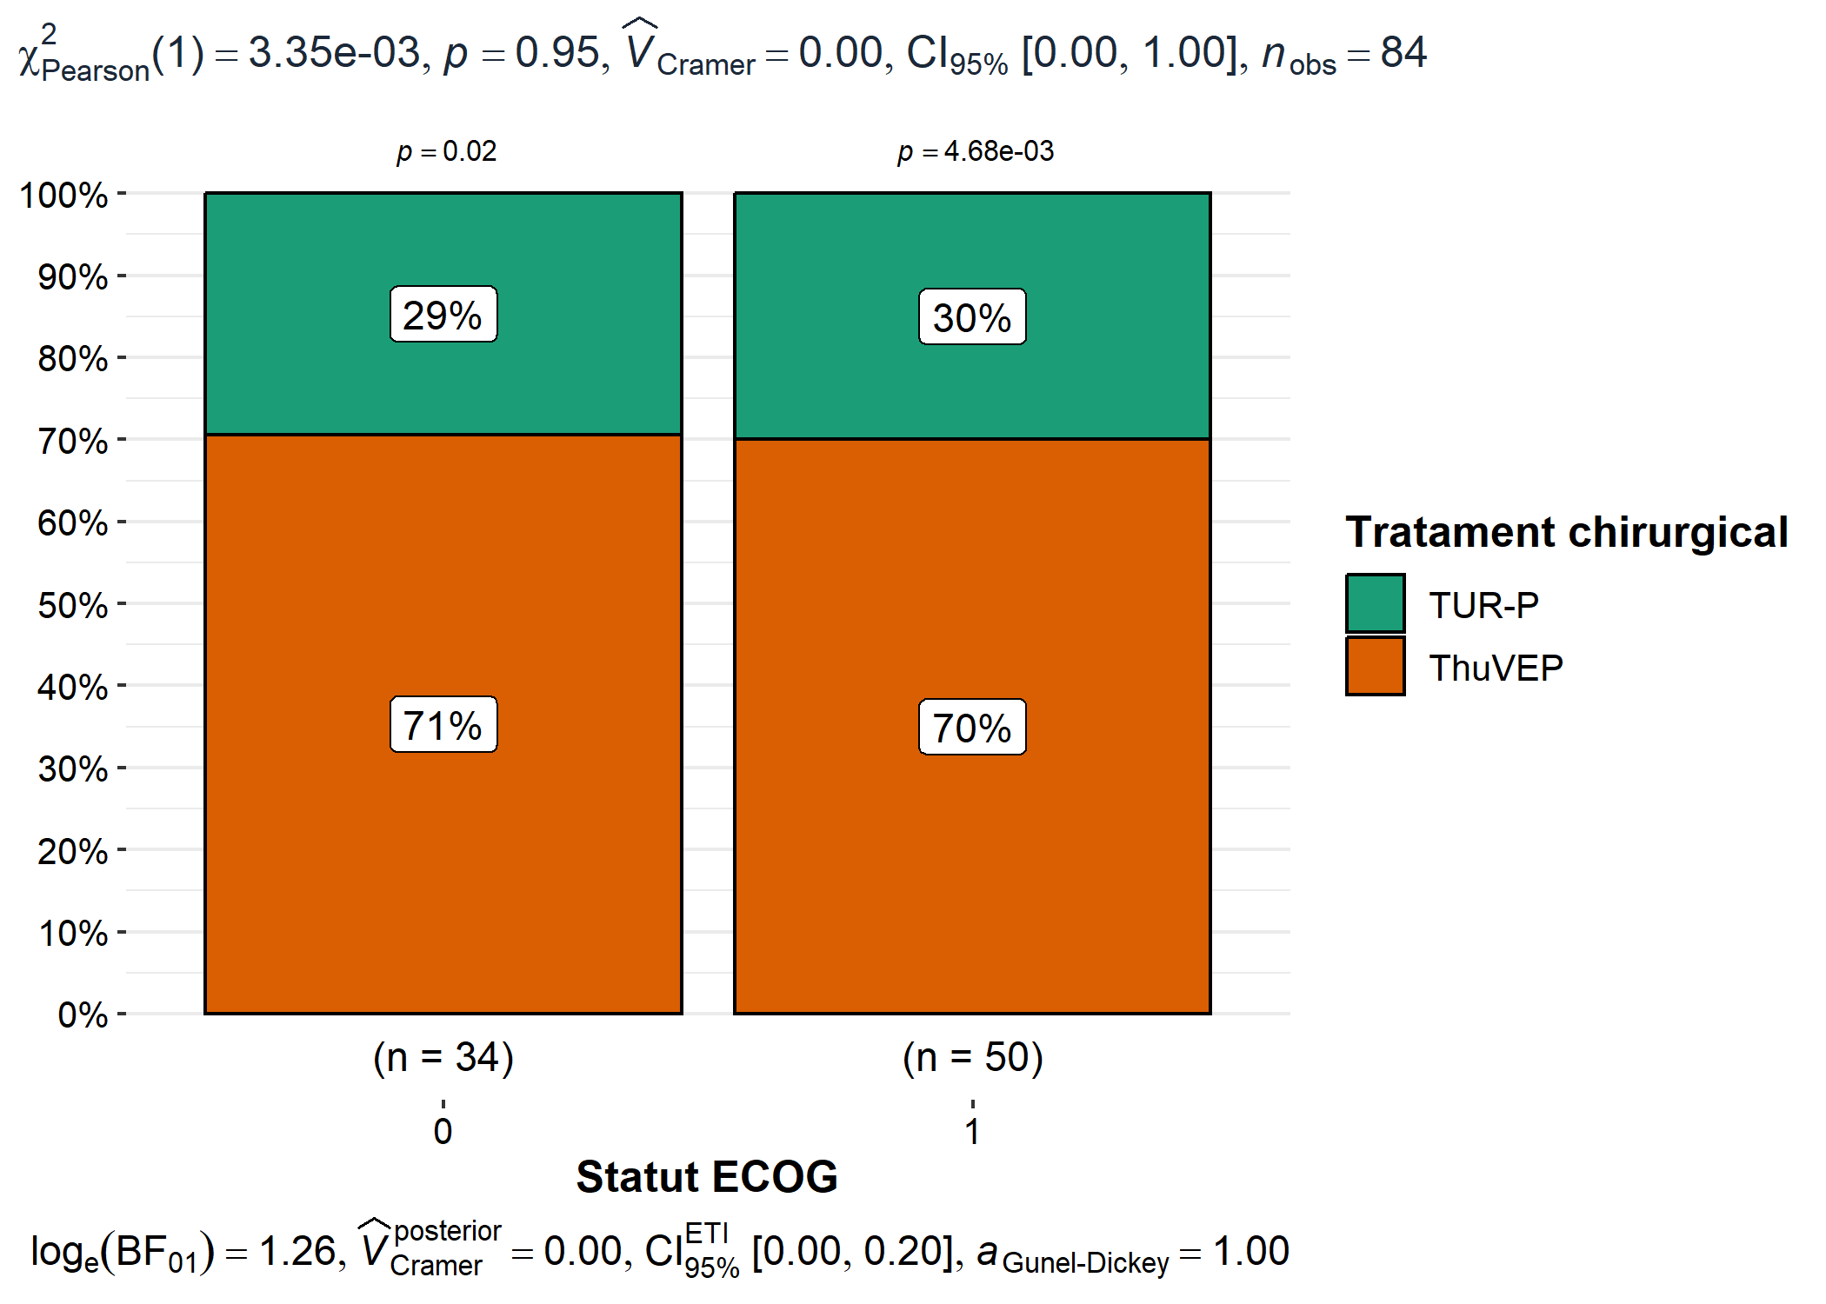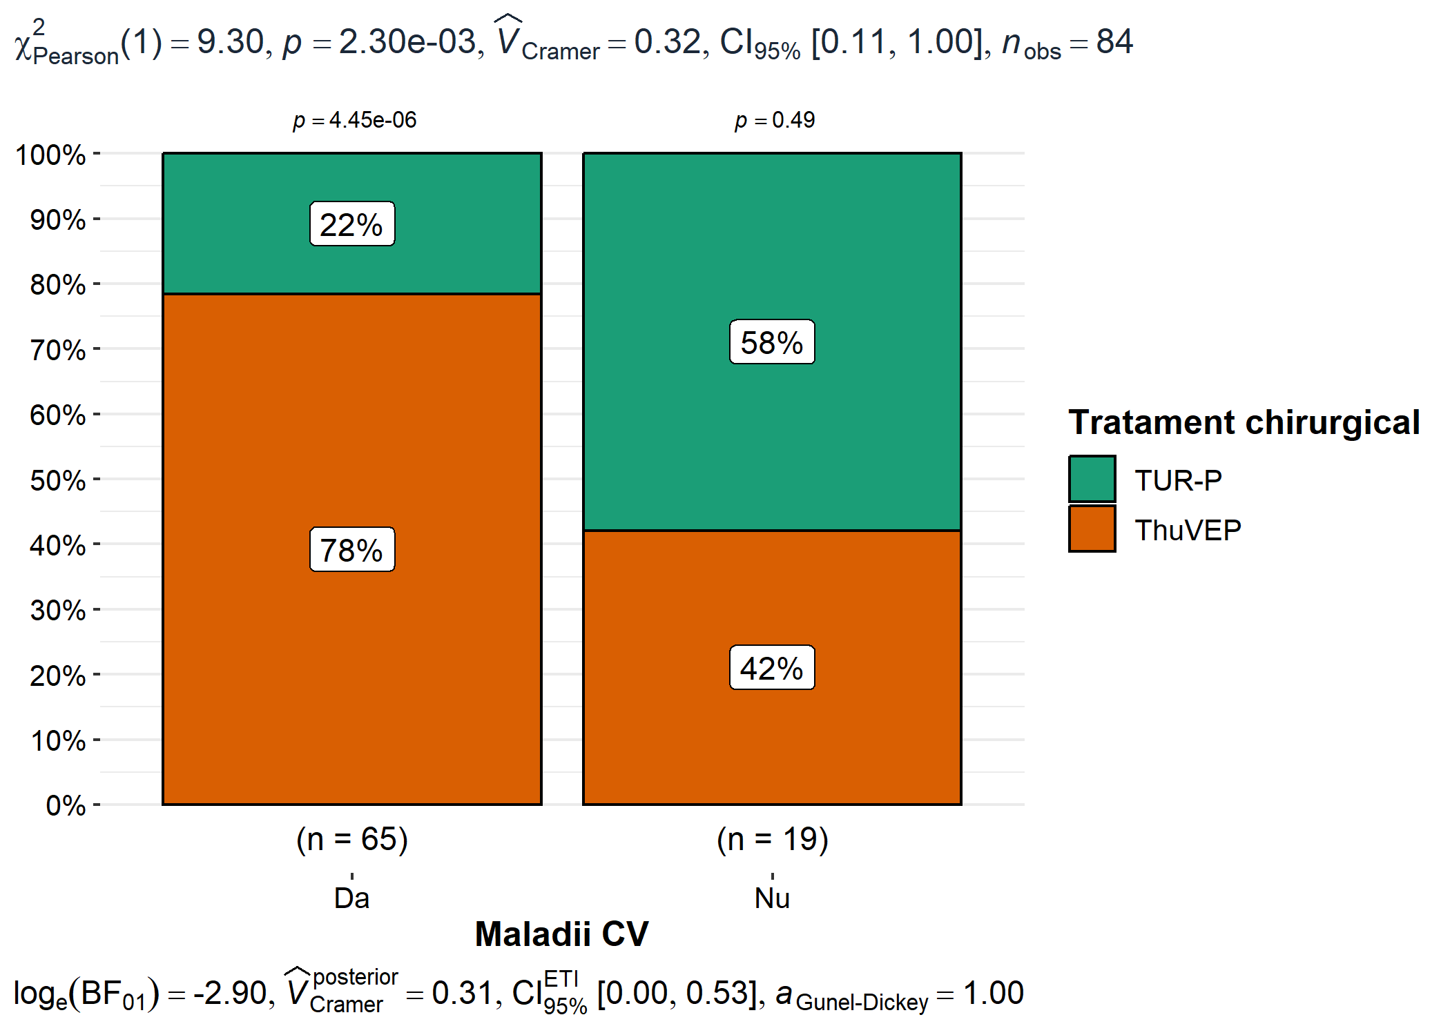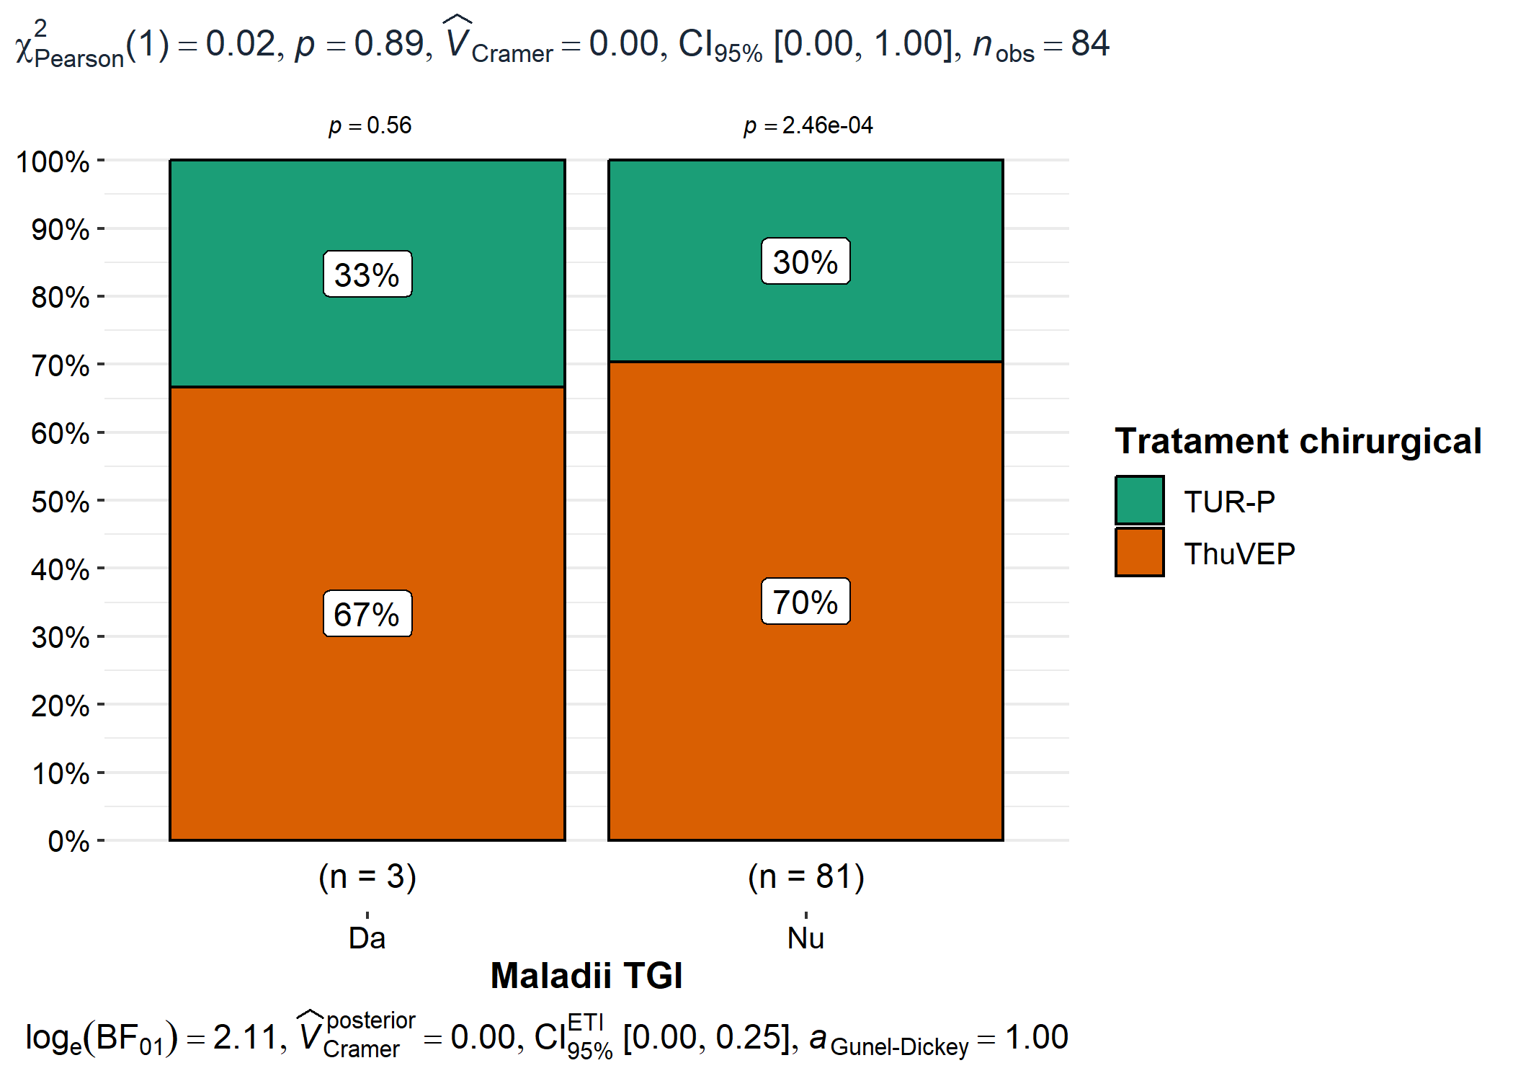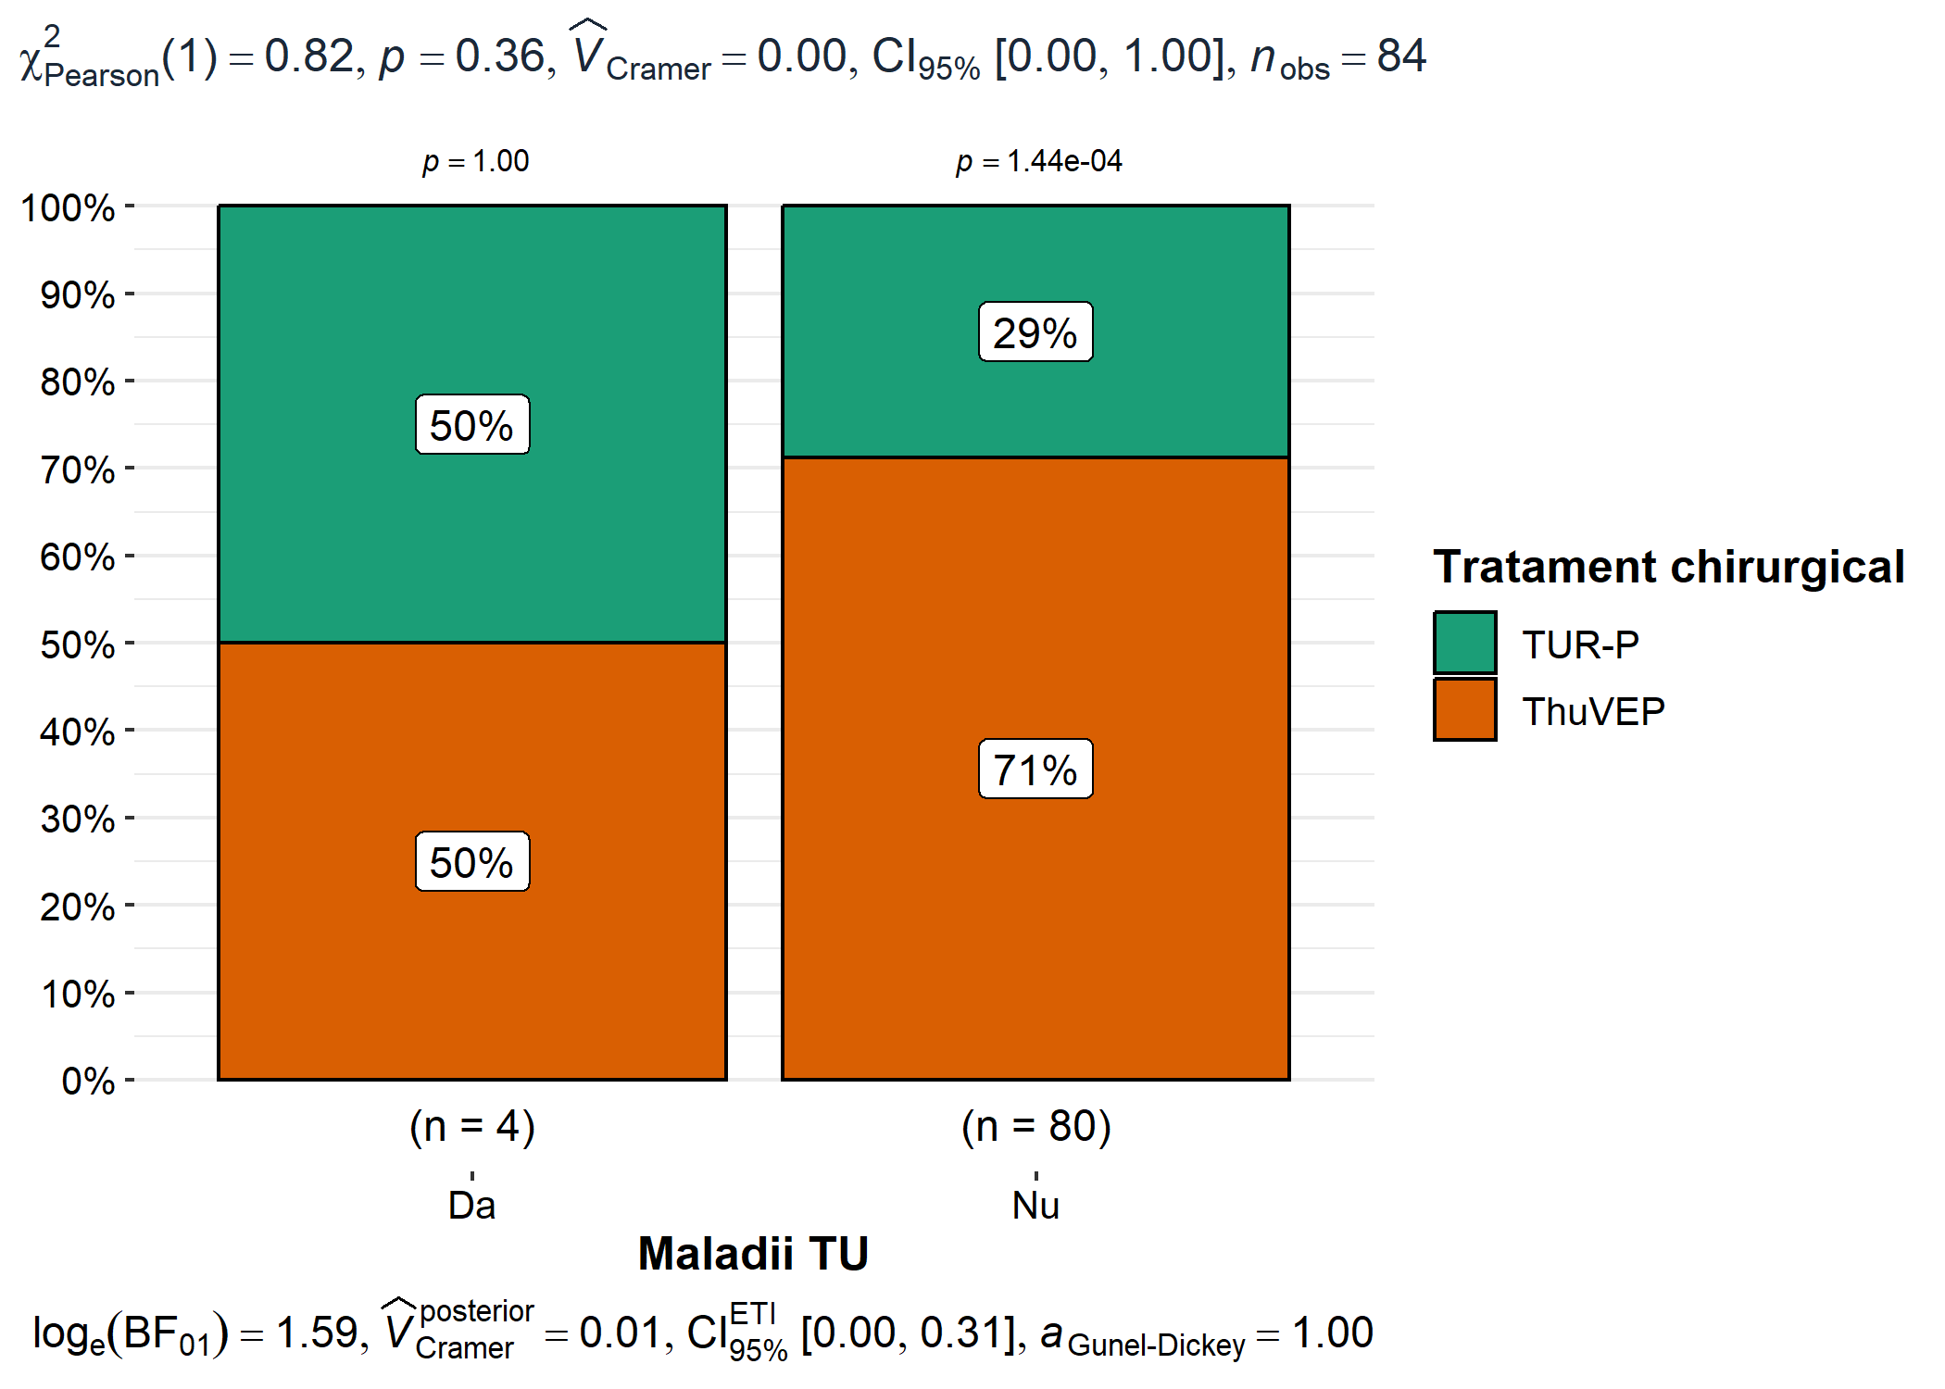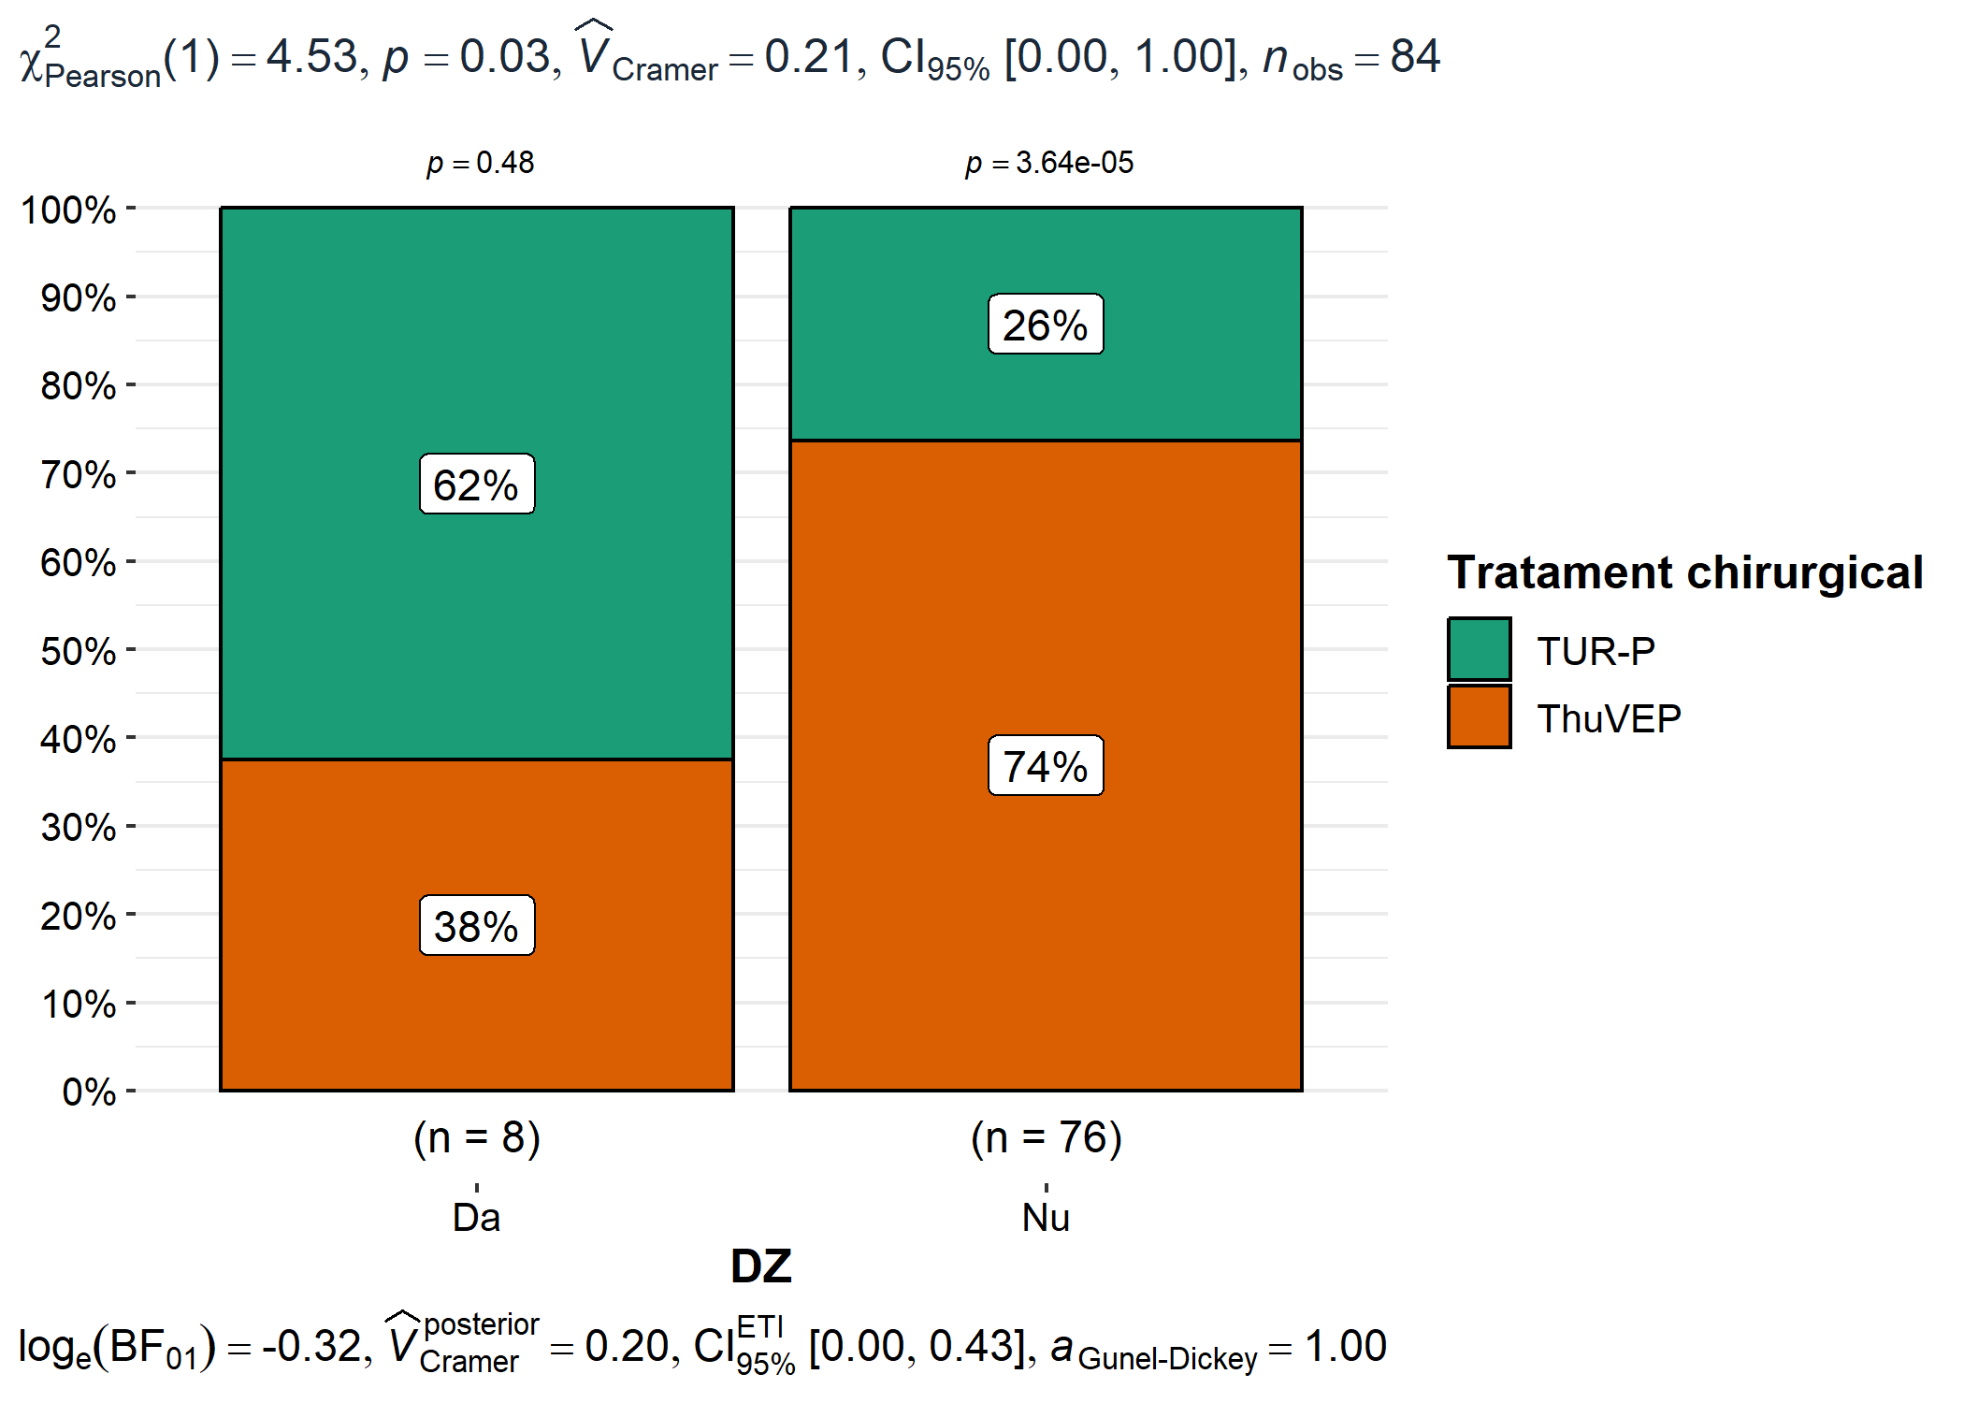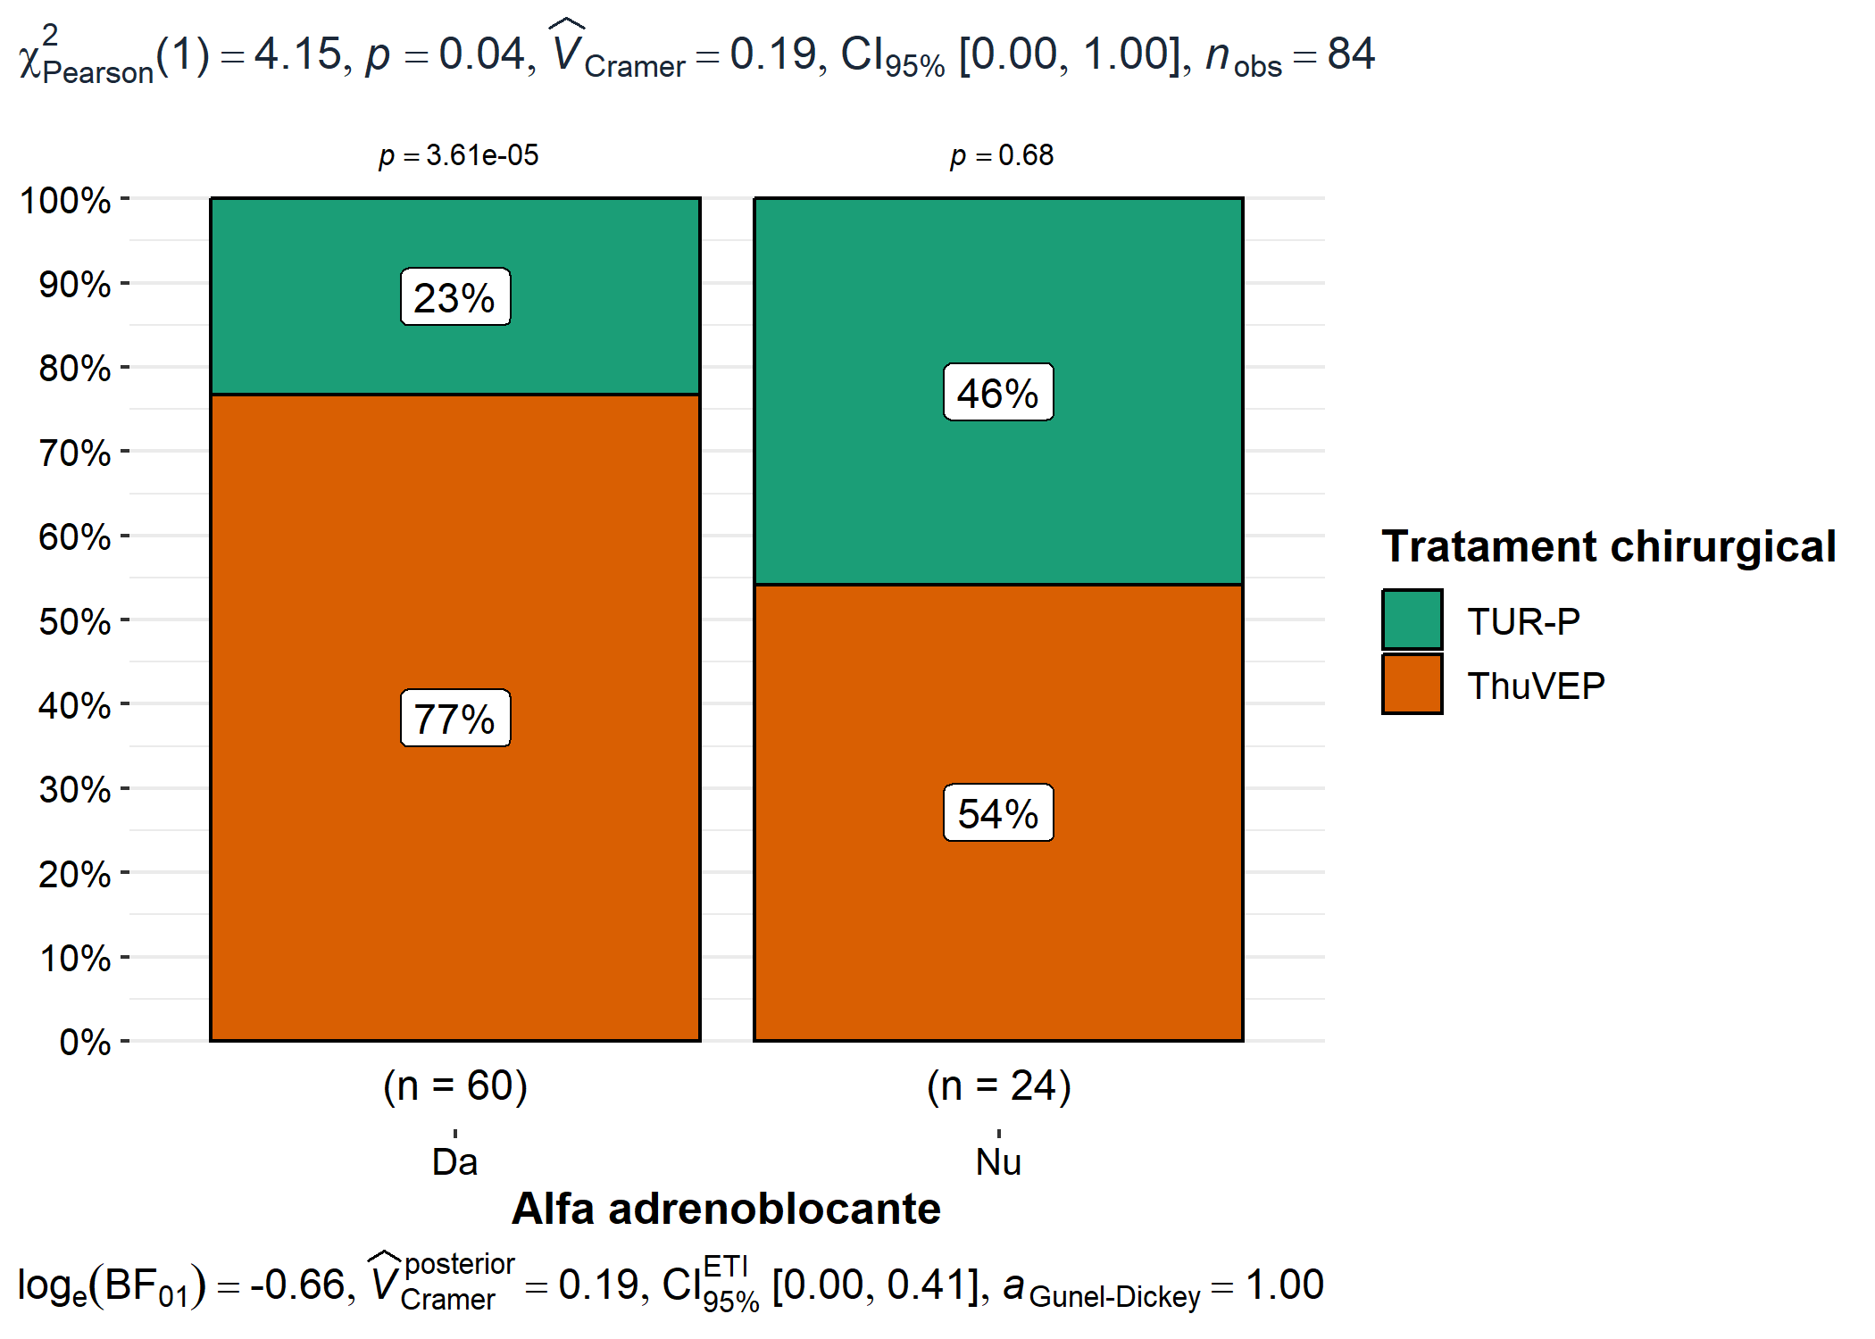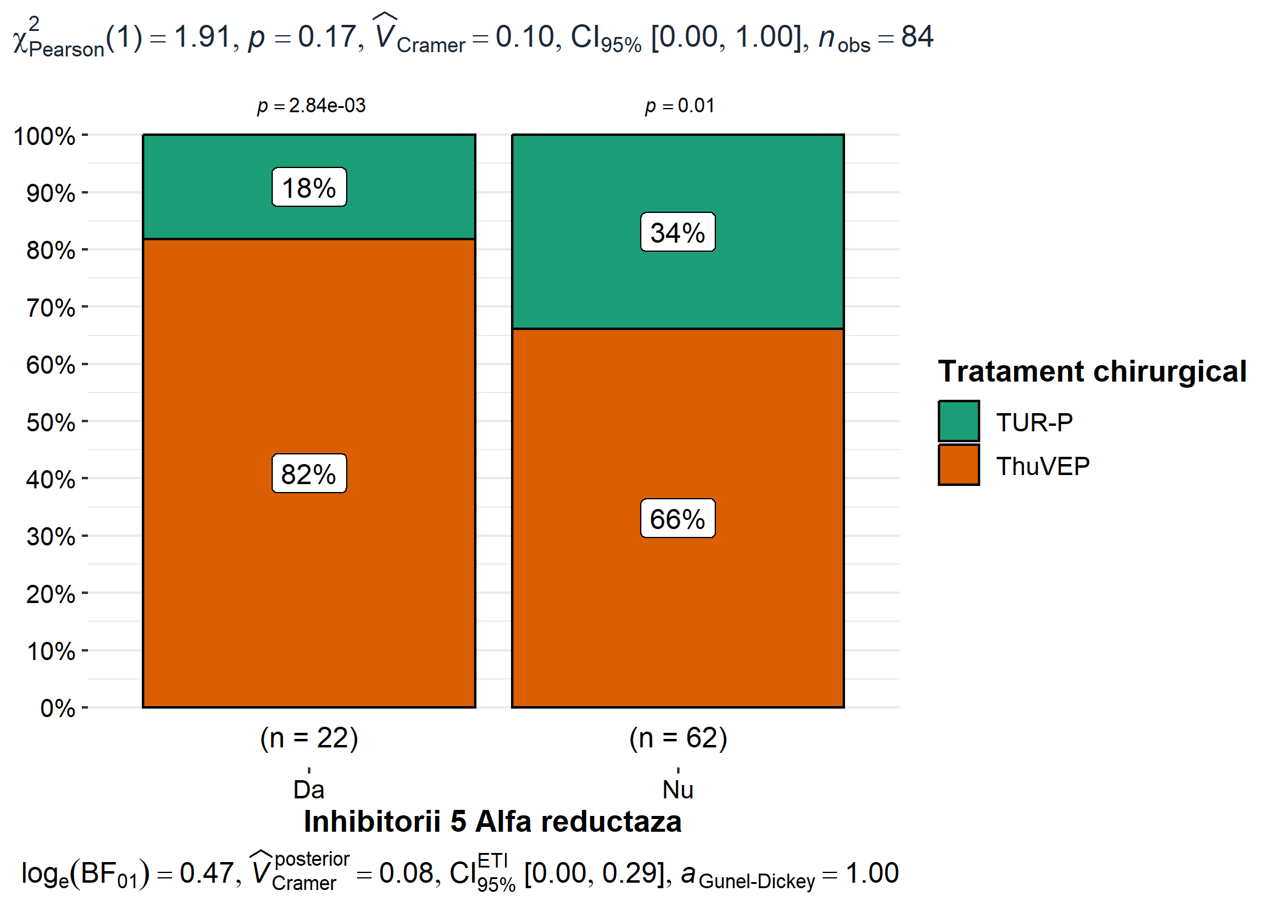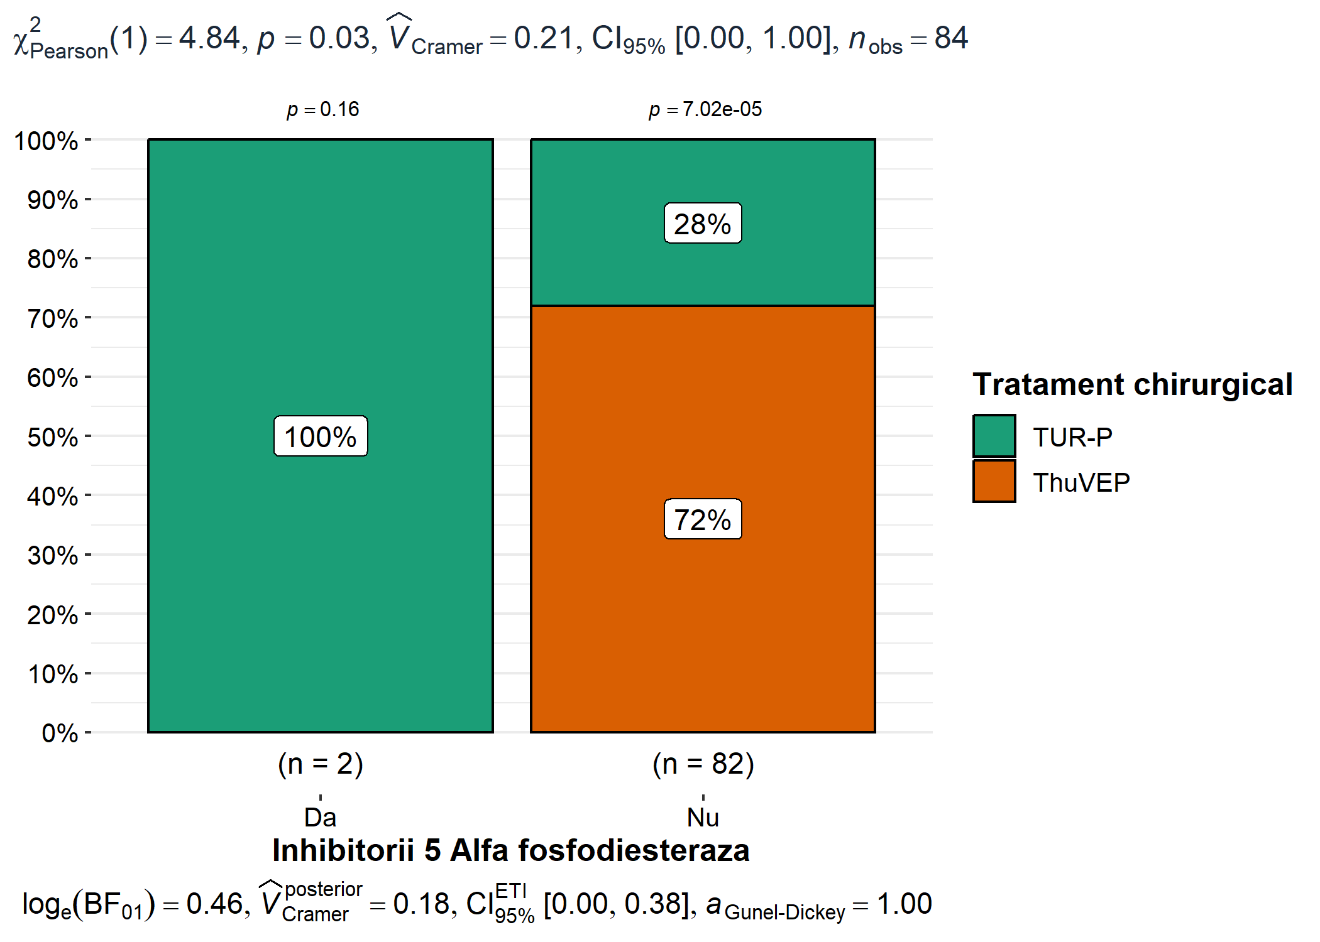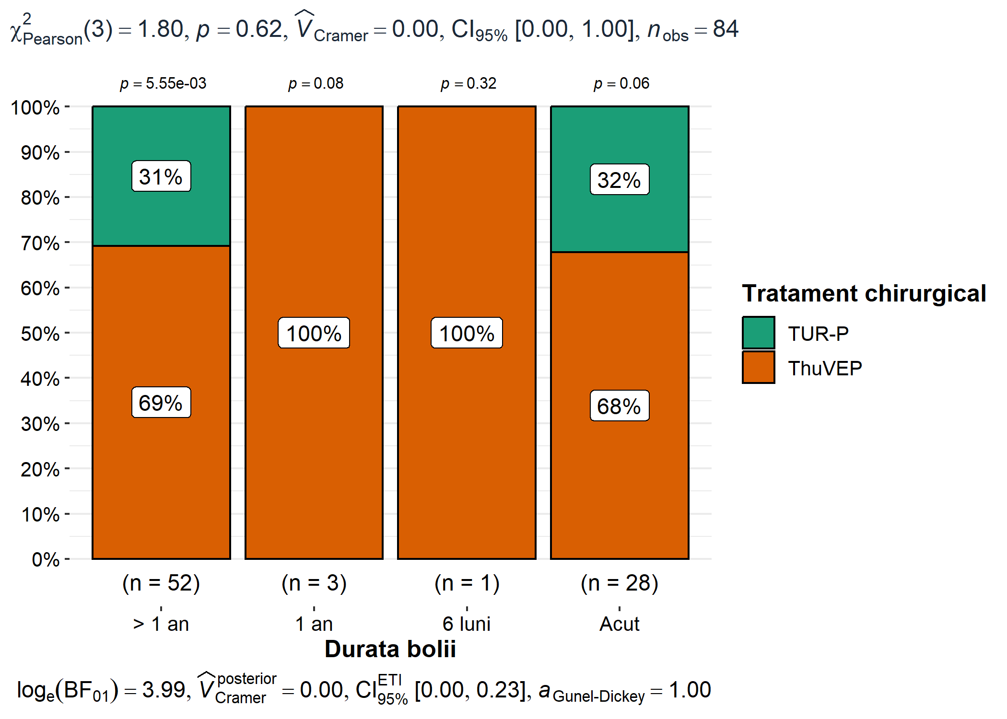

#names(df[, c(1, 3, 11, 12)])  
  
create_grouped_boxplot(df, "Tratament chirurgical", "Vîrsta" , 'Tratament', 'Varsta, ani')

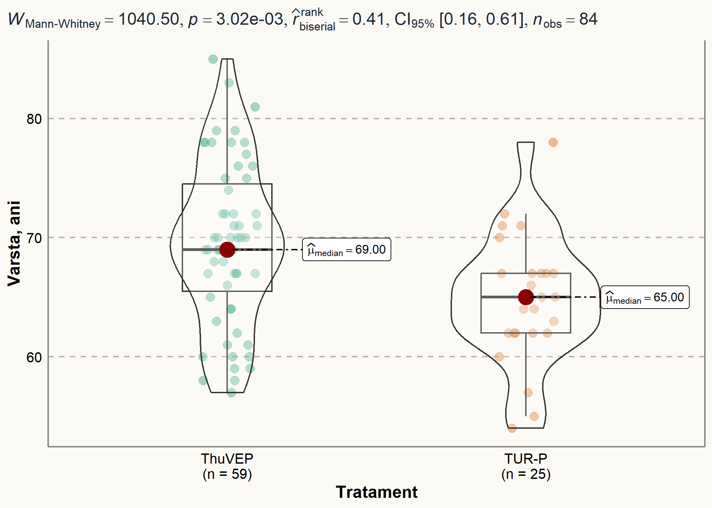

create_grouped_boxplot(df, "Tratament chirurgical", "Durata spitalizării" ,  
 'Tratament', 'Spitalizarea, zile')

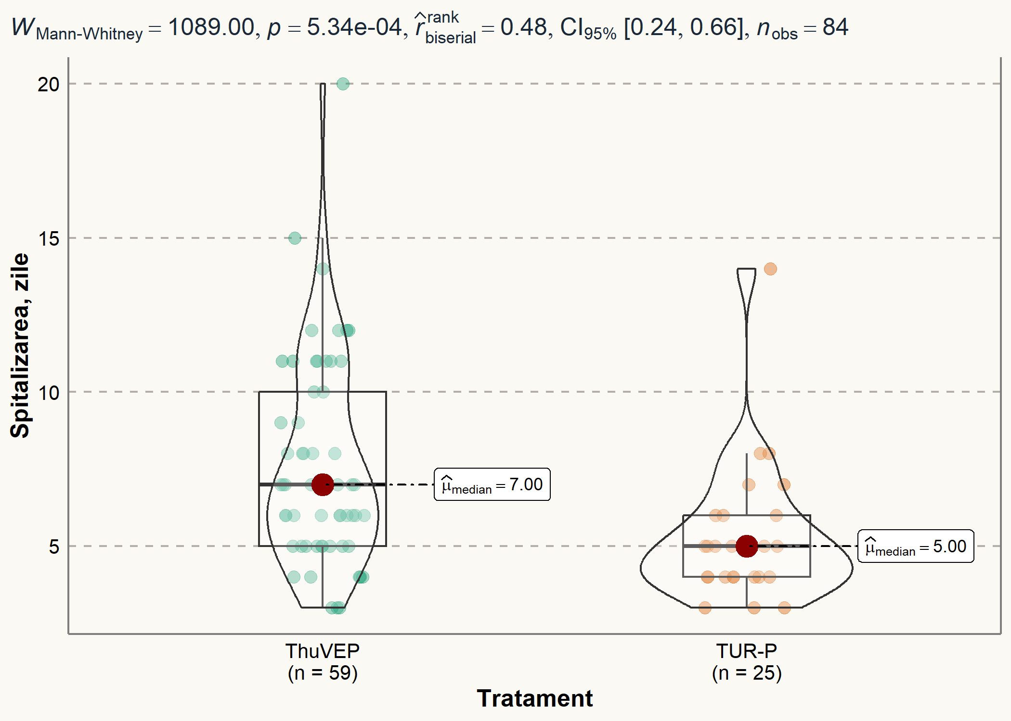

# Outcomes graphs

# https://indrajeetpatil.github.io/ggstatsplot/index.html  
  
# names(df[, 66:93])   
  
for (i in names(df[, 66:93]) ) {  
   
p <- ggbarstats(df, x = "Tratament chirurgical", y = {{ i }})  
  
p <- p +  
 theme(  
 text = element_text(family = "Roboto", size = 14, color = "black"),  
 plot.title = element_text(  
 family = "Lobster Two",  
 size = 12,  
 face = "bold",  
 color = "#2a475e"  
 ),  
 plot.subtitle = element_text(  
 family = "Roboto",  
 size = 12,  
 face = "bold",  
 color = "#1b2838"  
 ),  
 plot.title.position = "plot",  
 axis.text = element_text(size = 10, color = "black"),  
 axis.title = element_text(size = 12),  
 legend.text = element_text(size = 10),  
 legend.title = element_text(size = 12)  
 )  
  
print(p)  
  
}

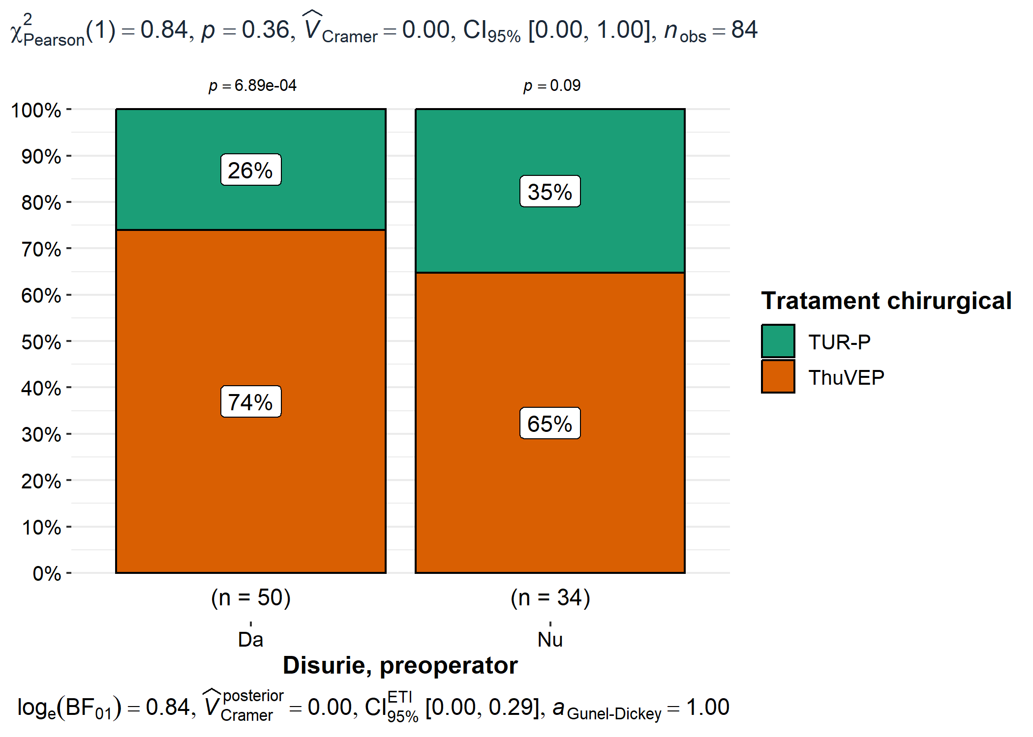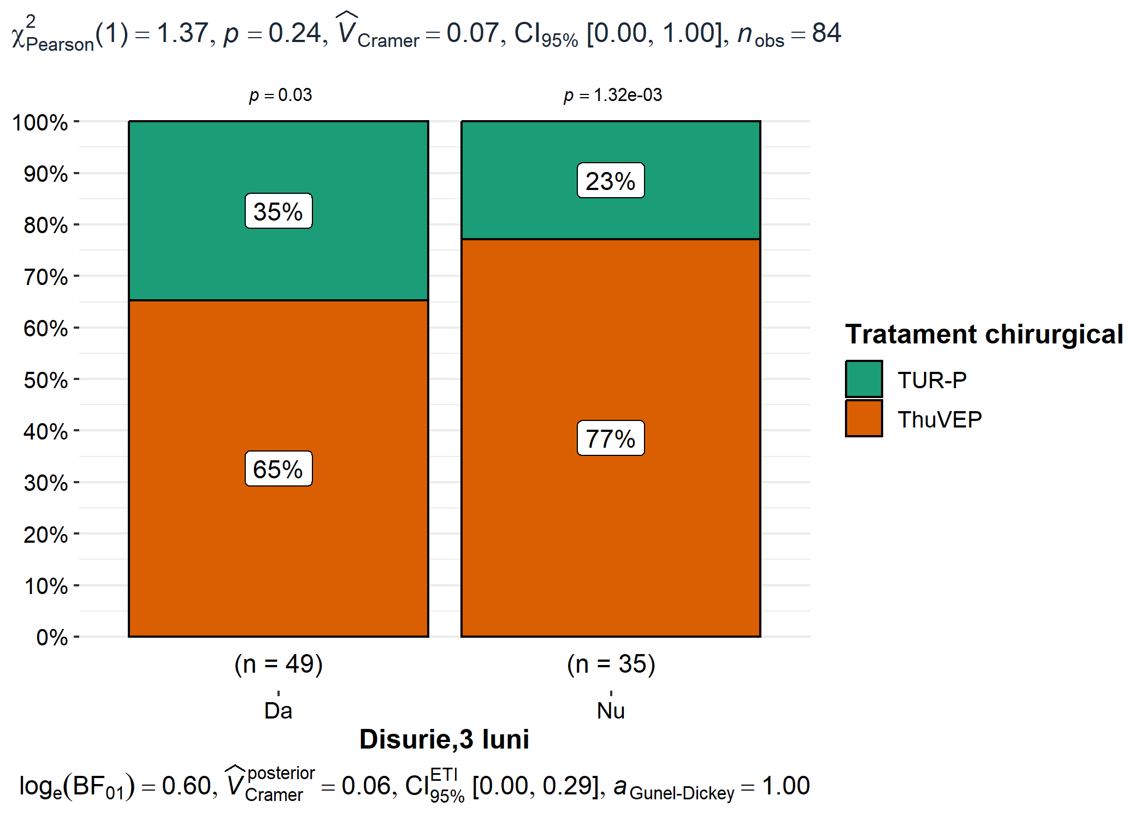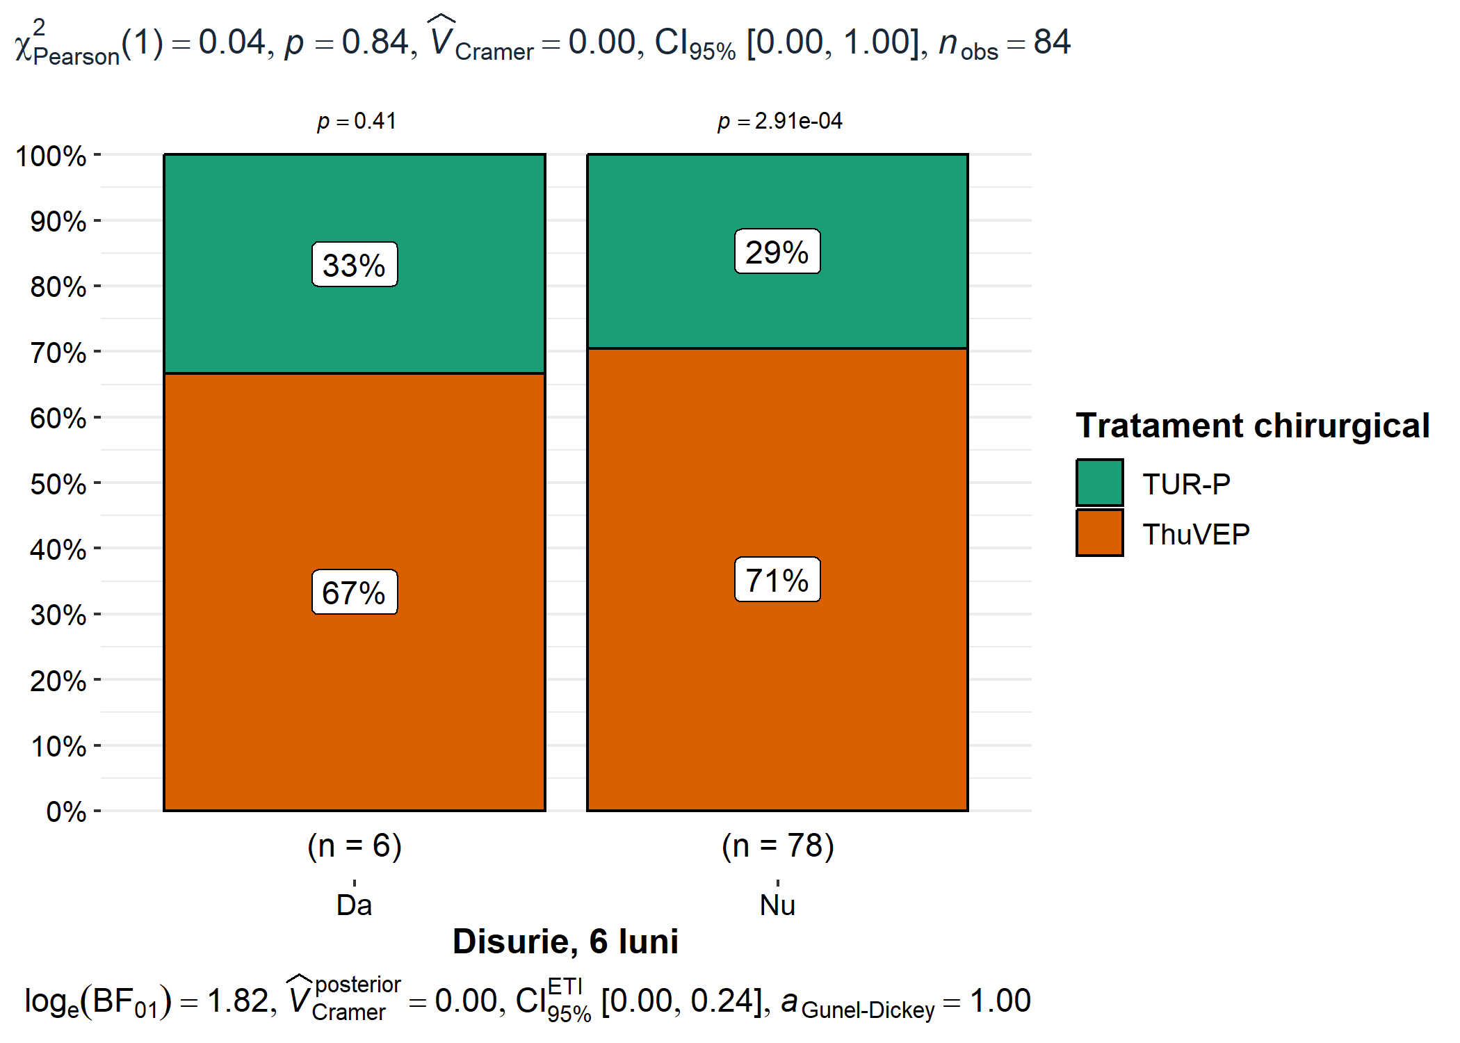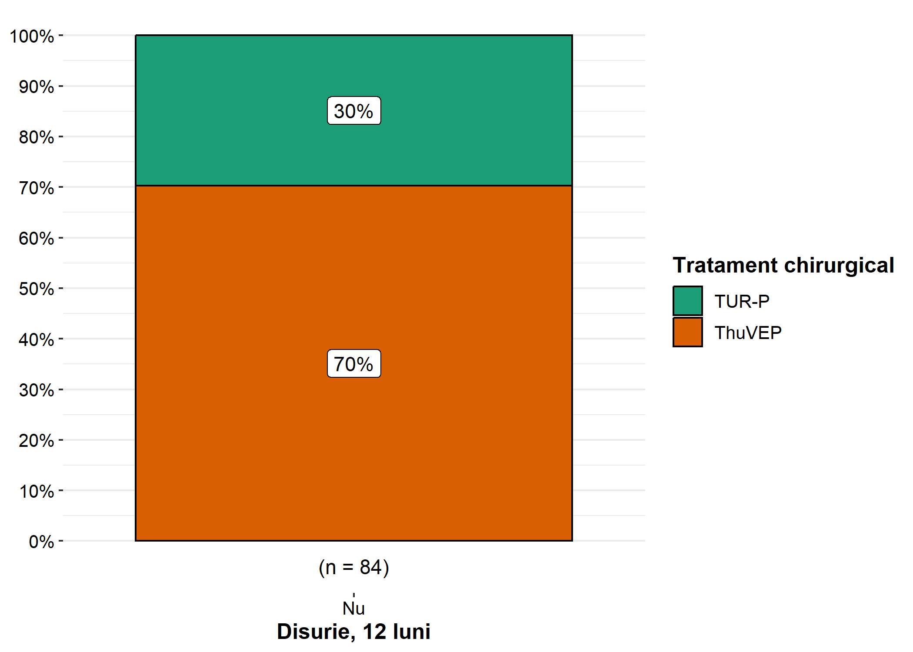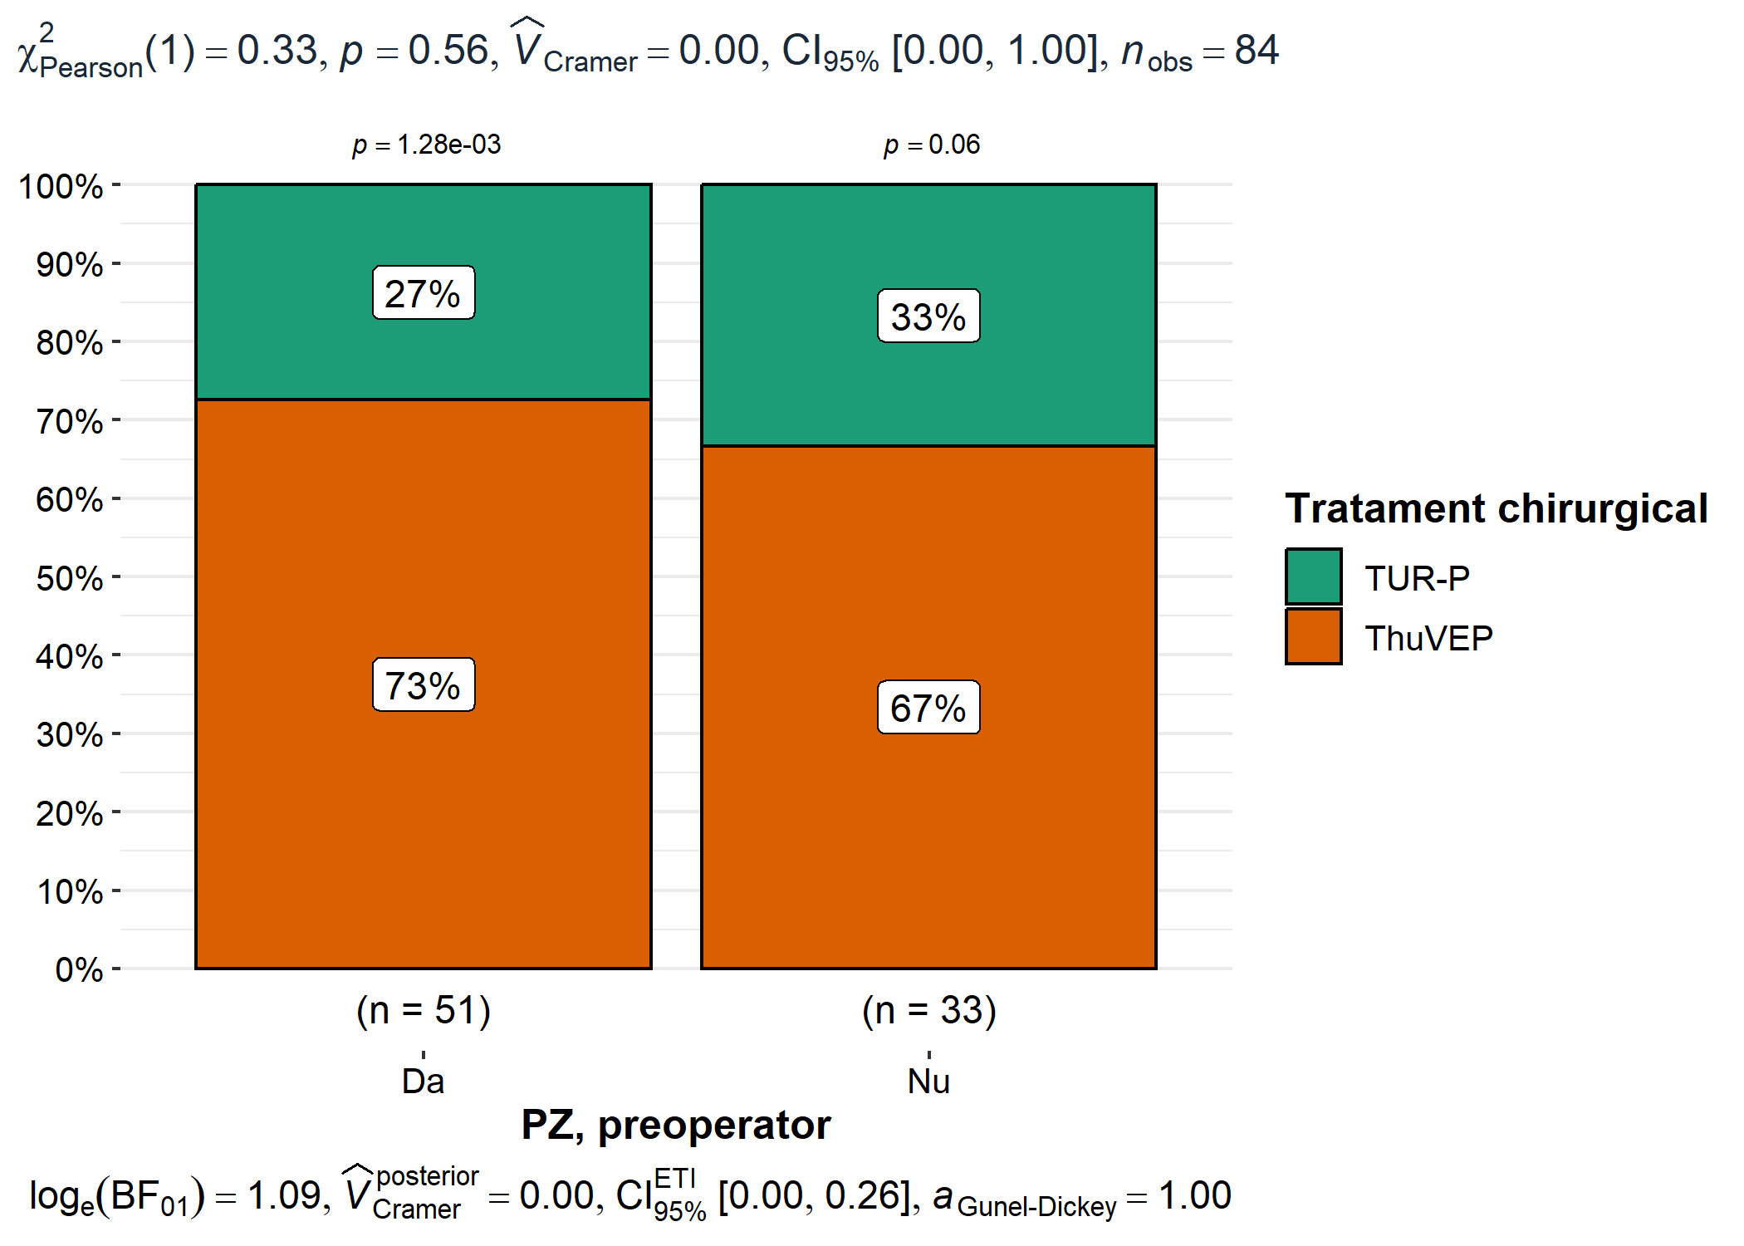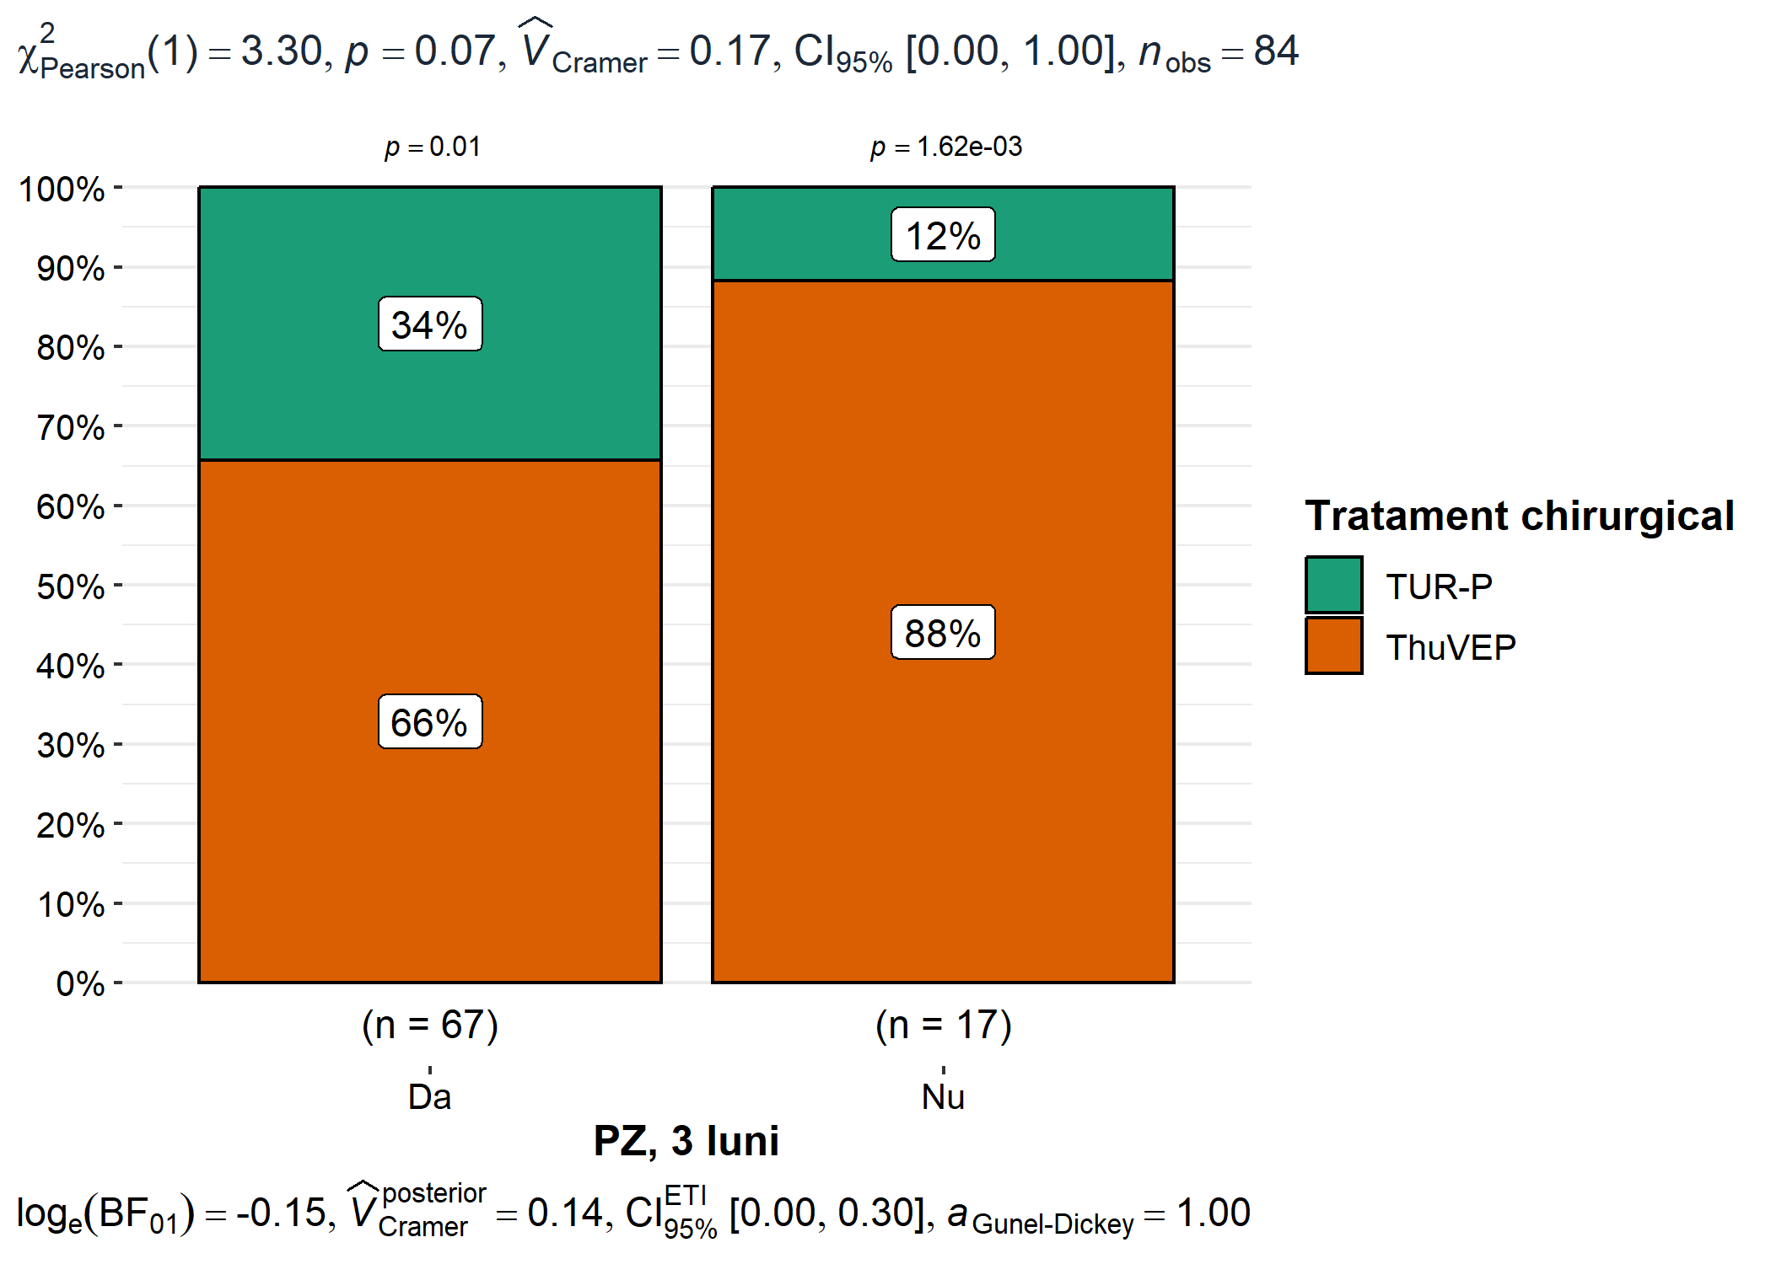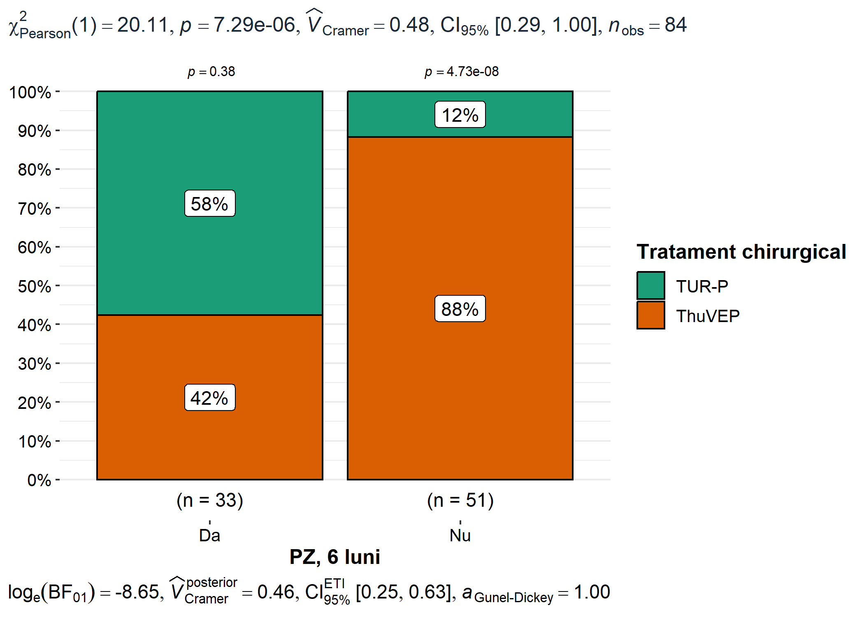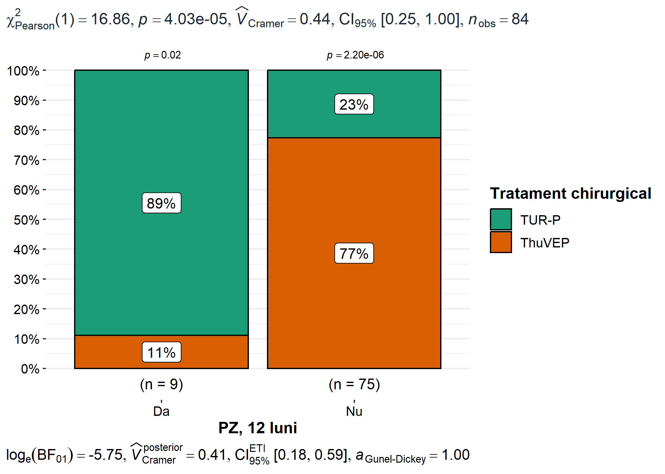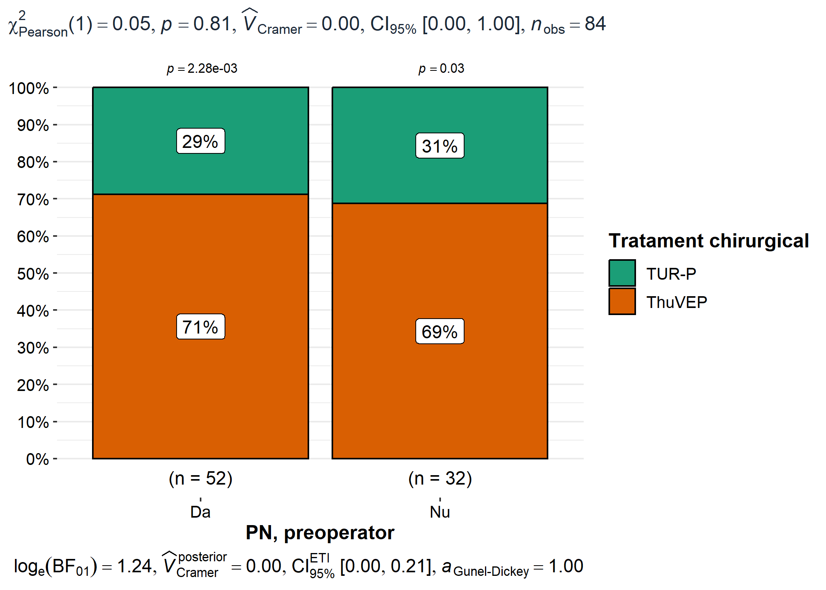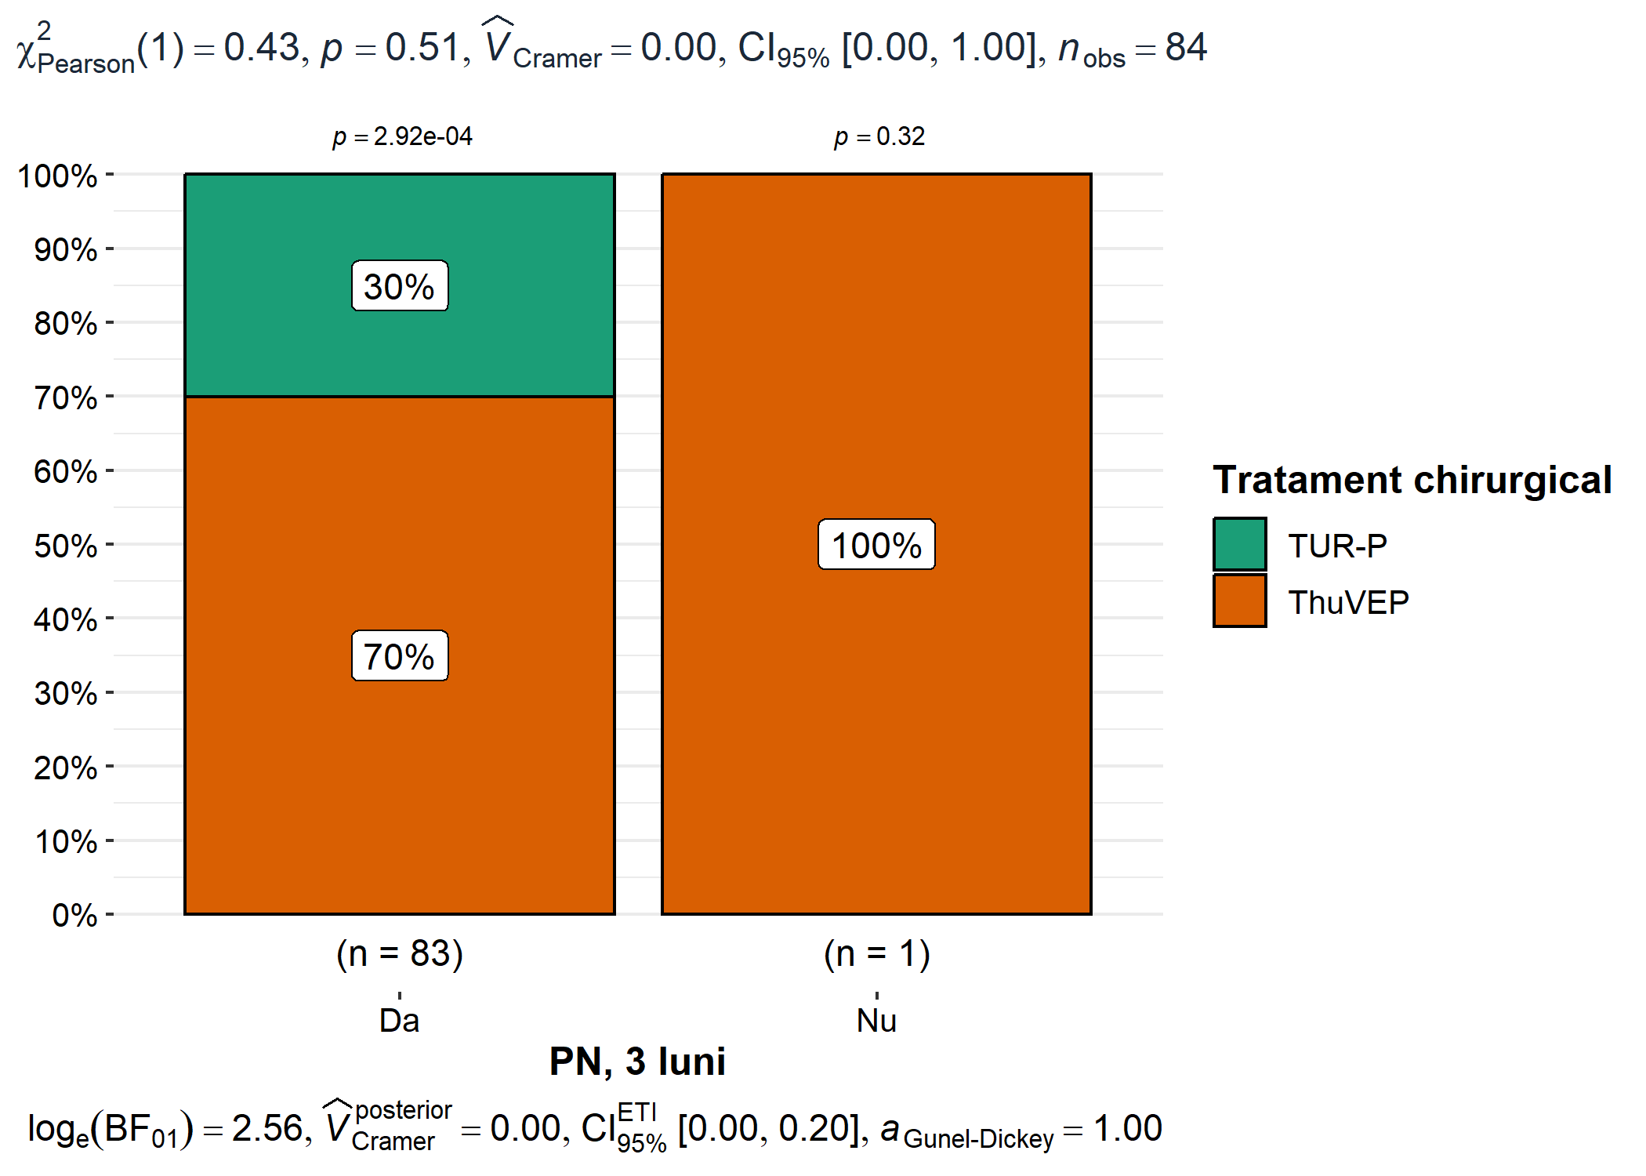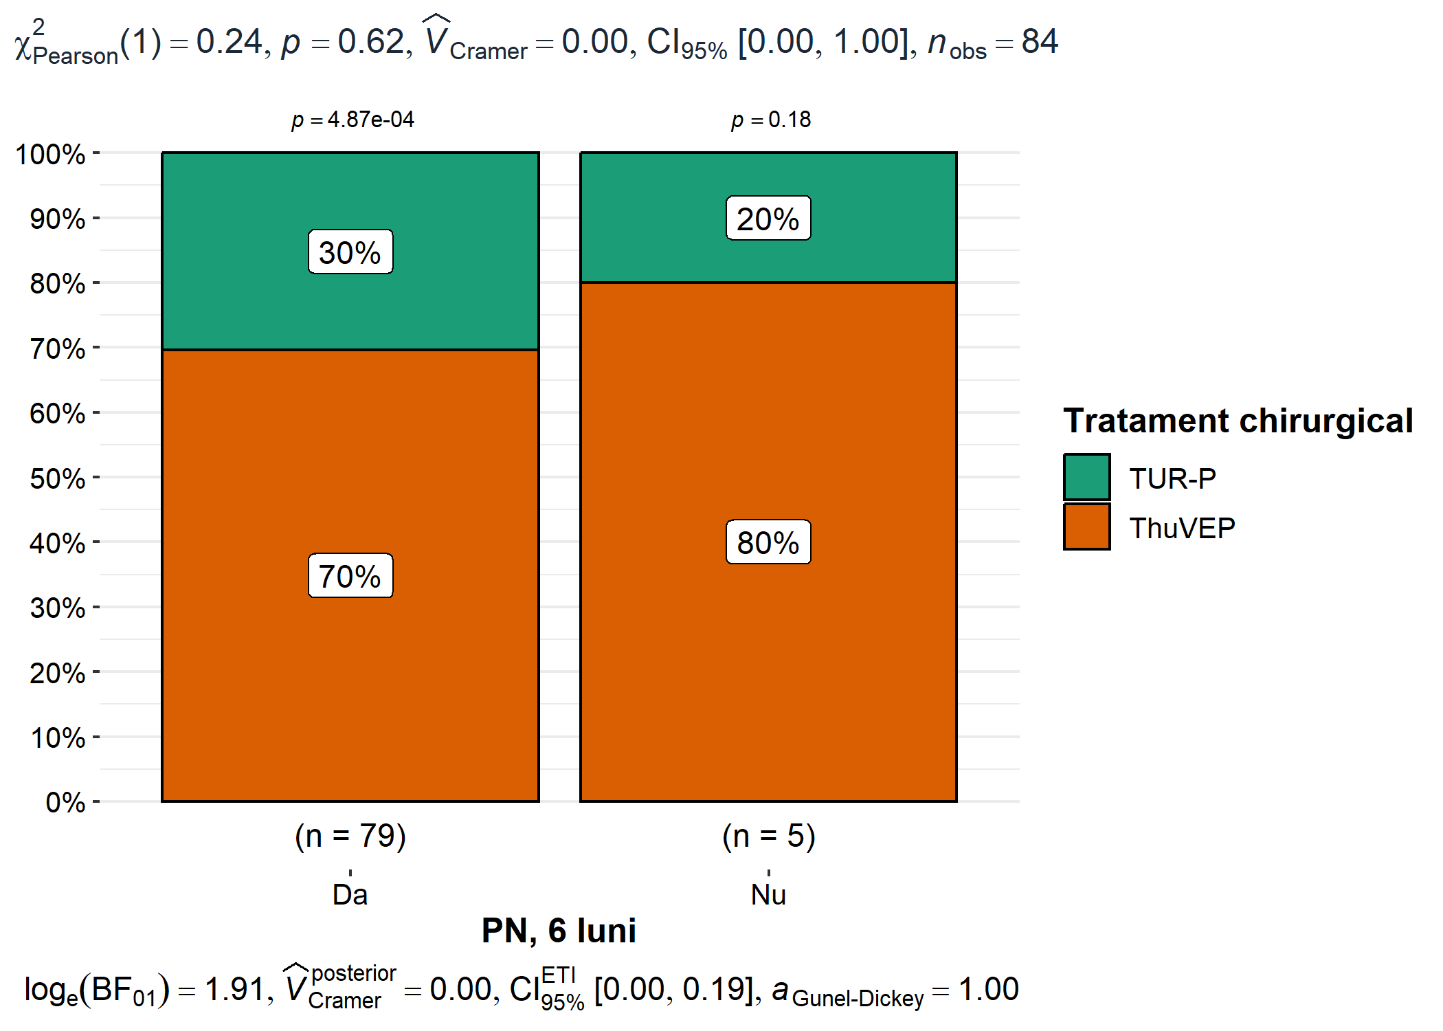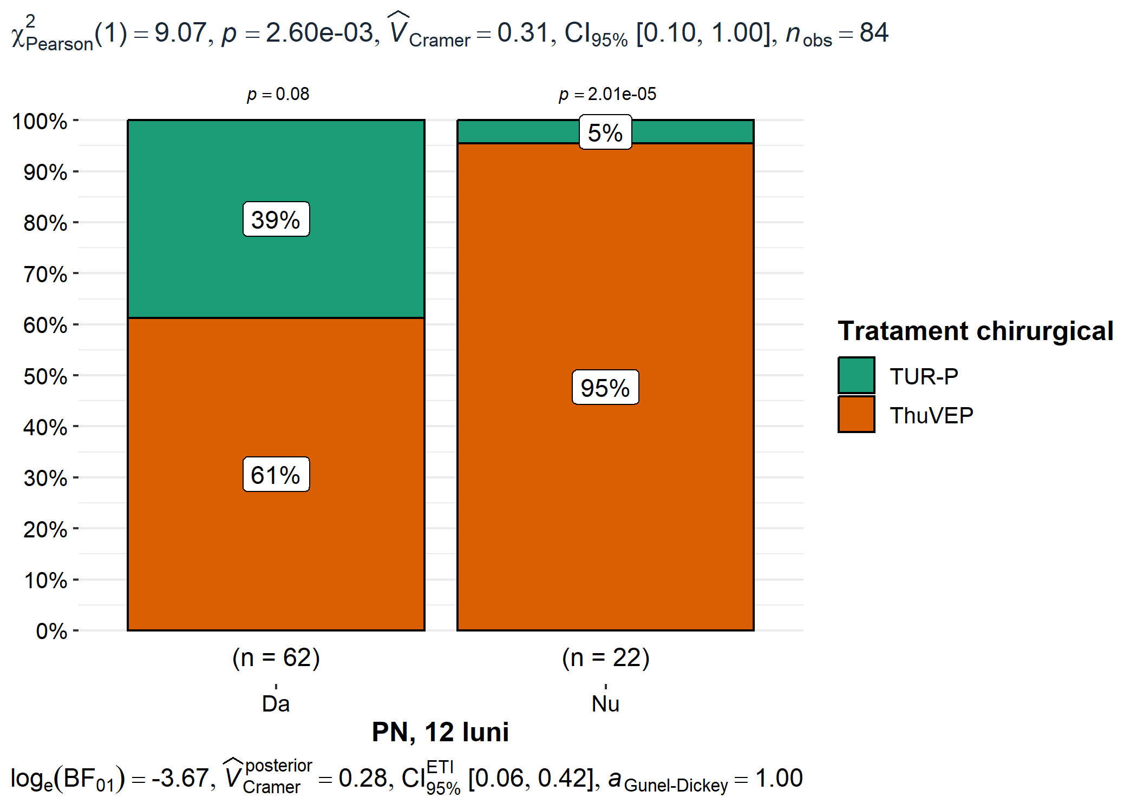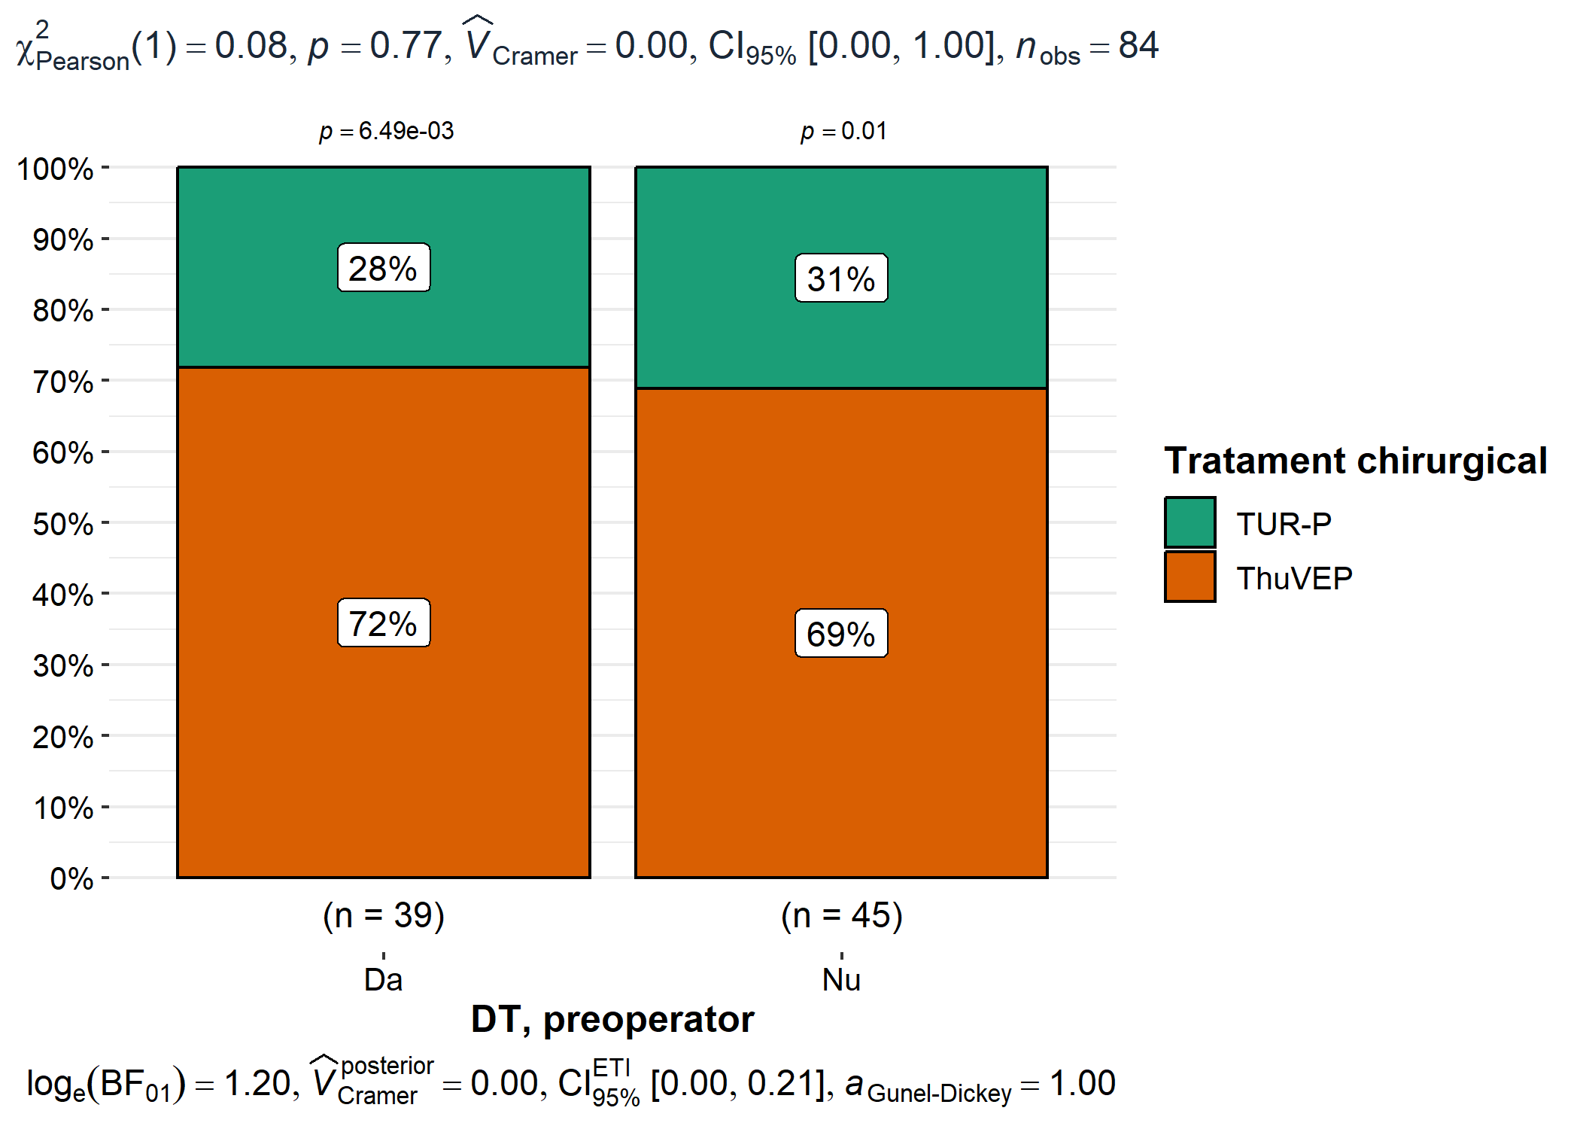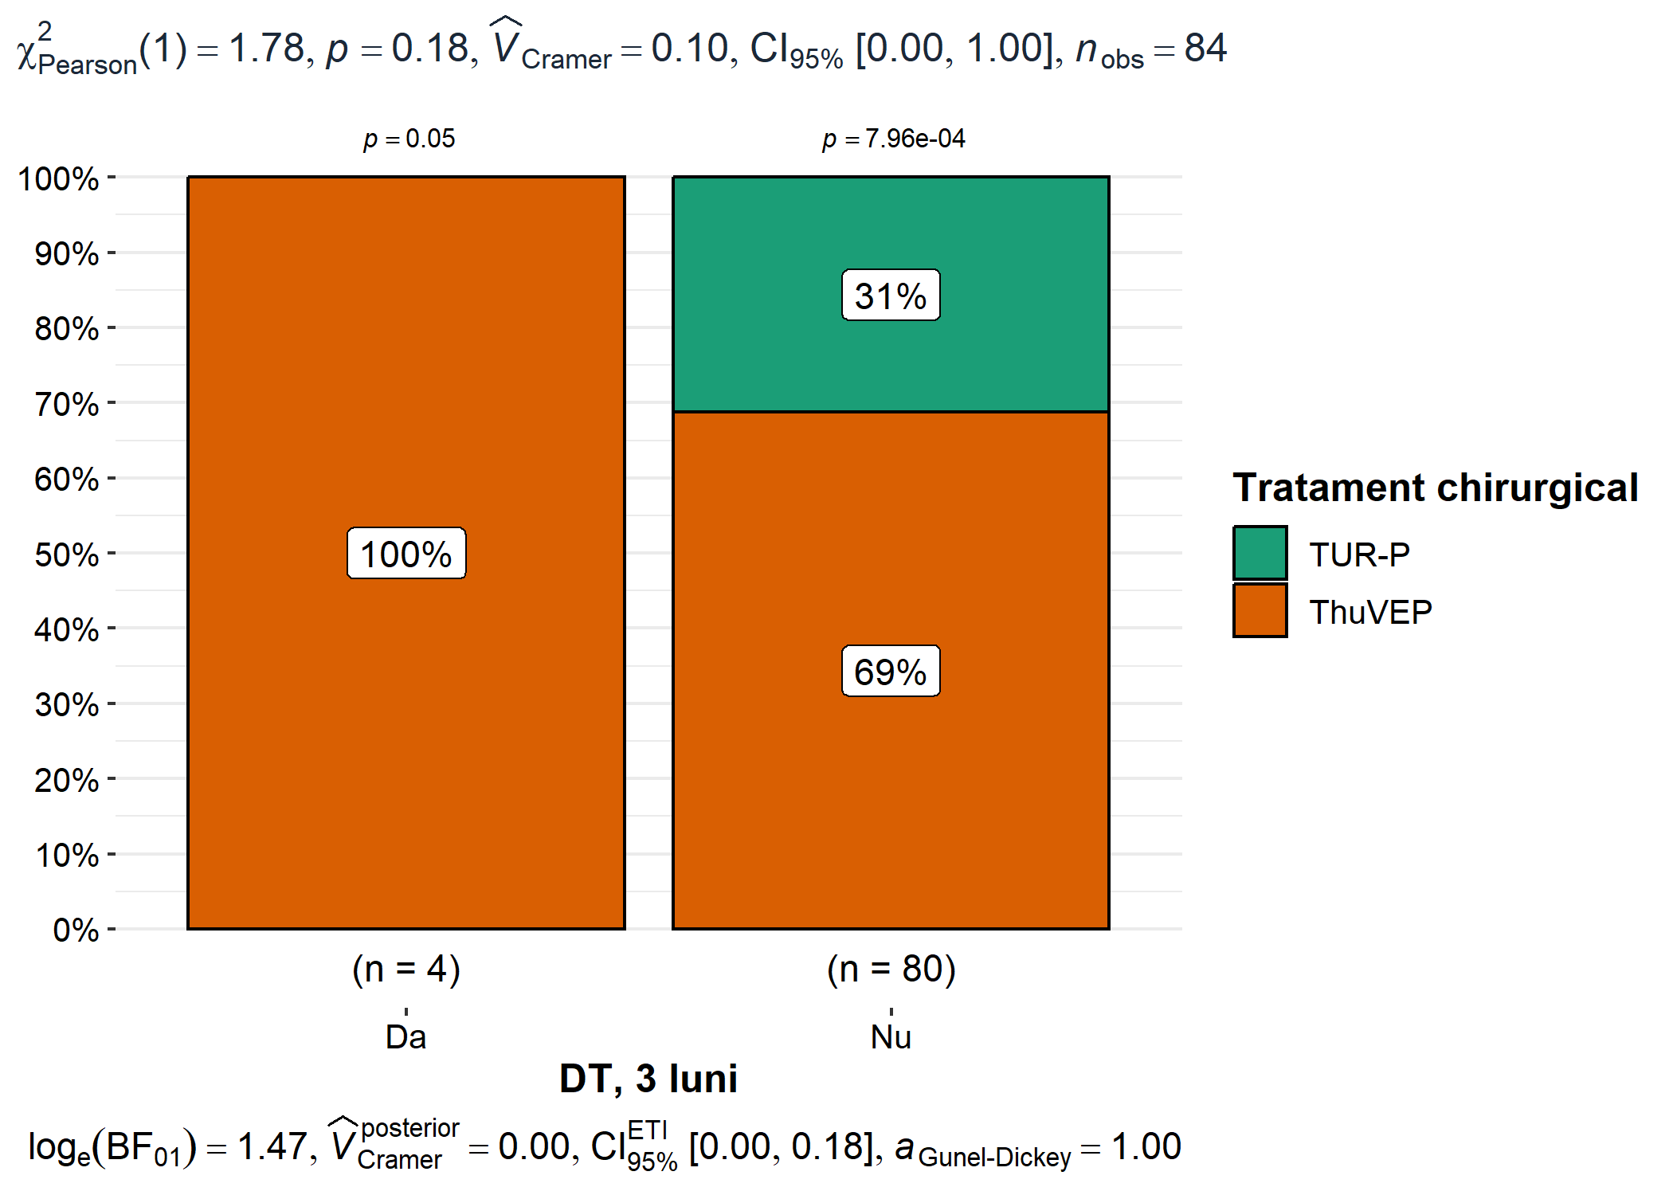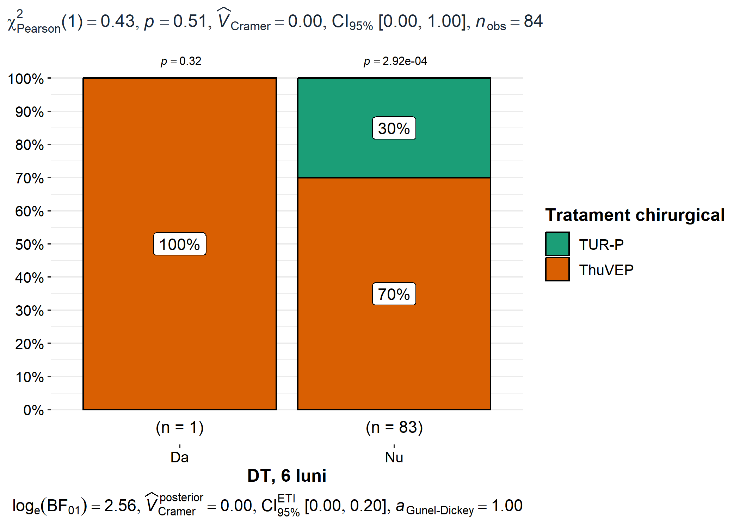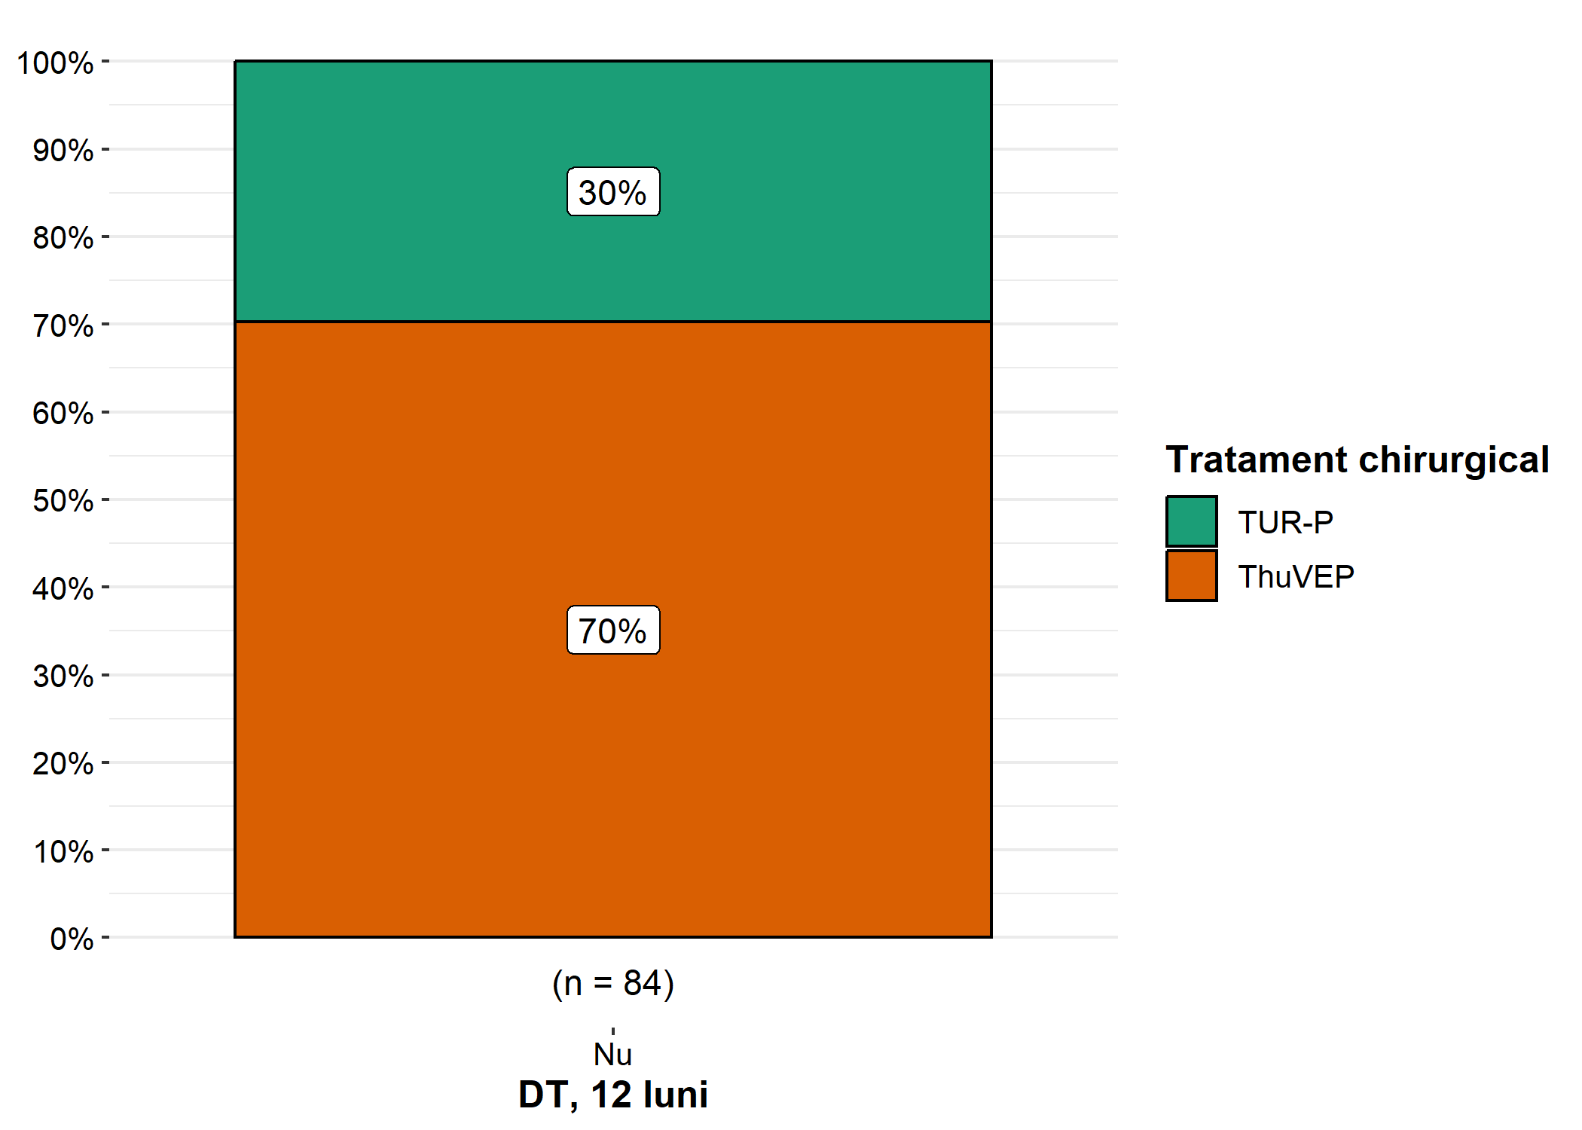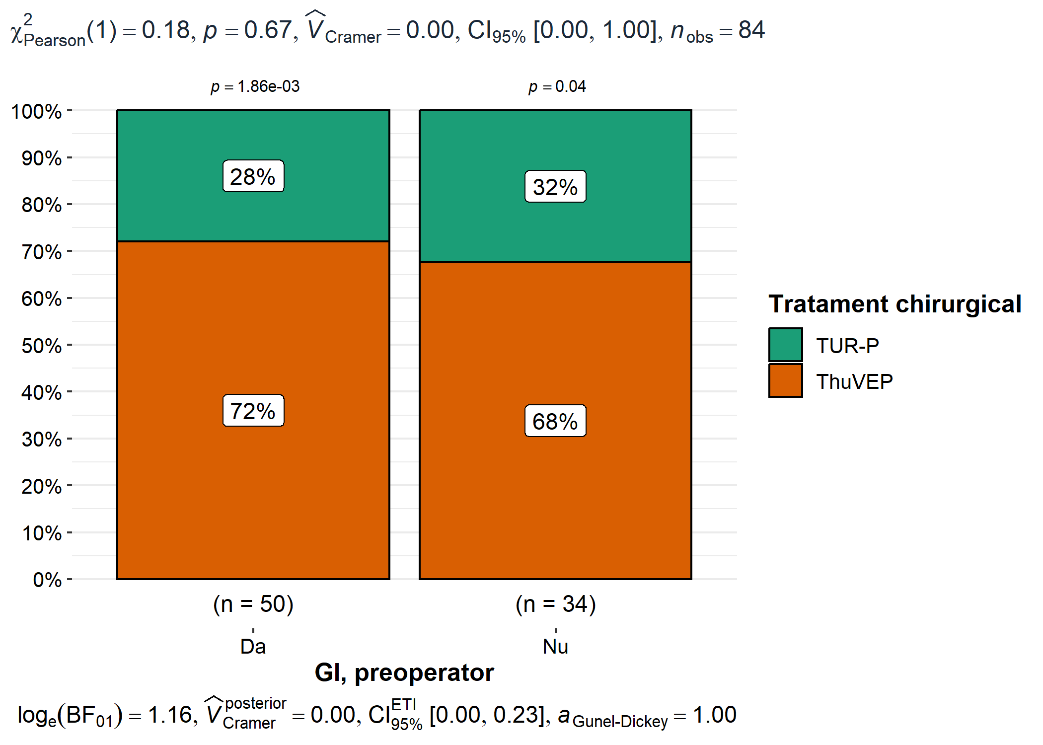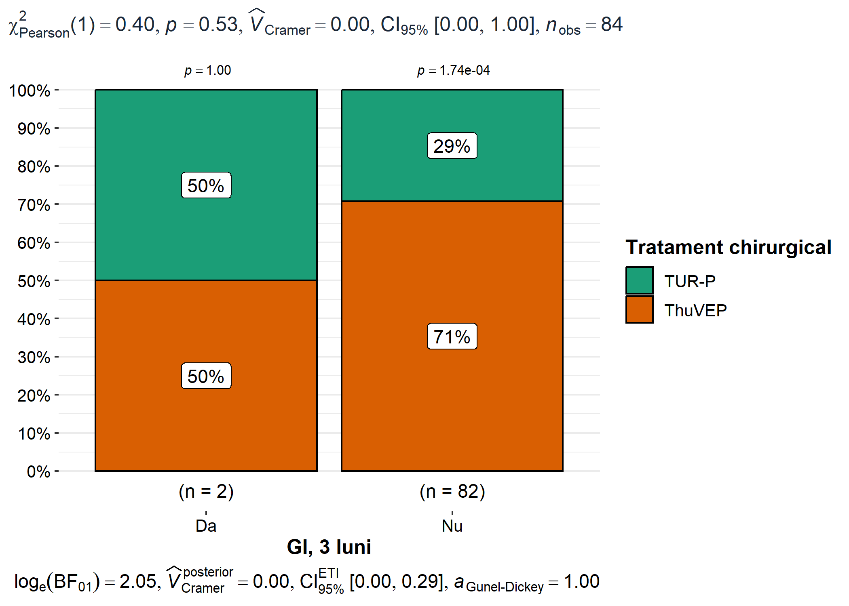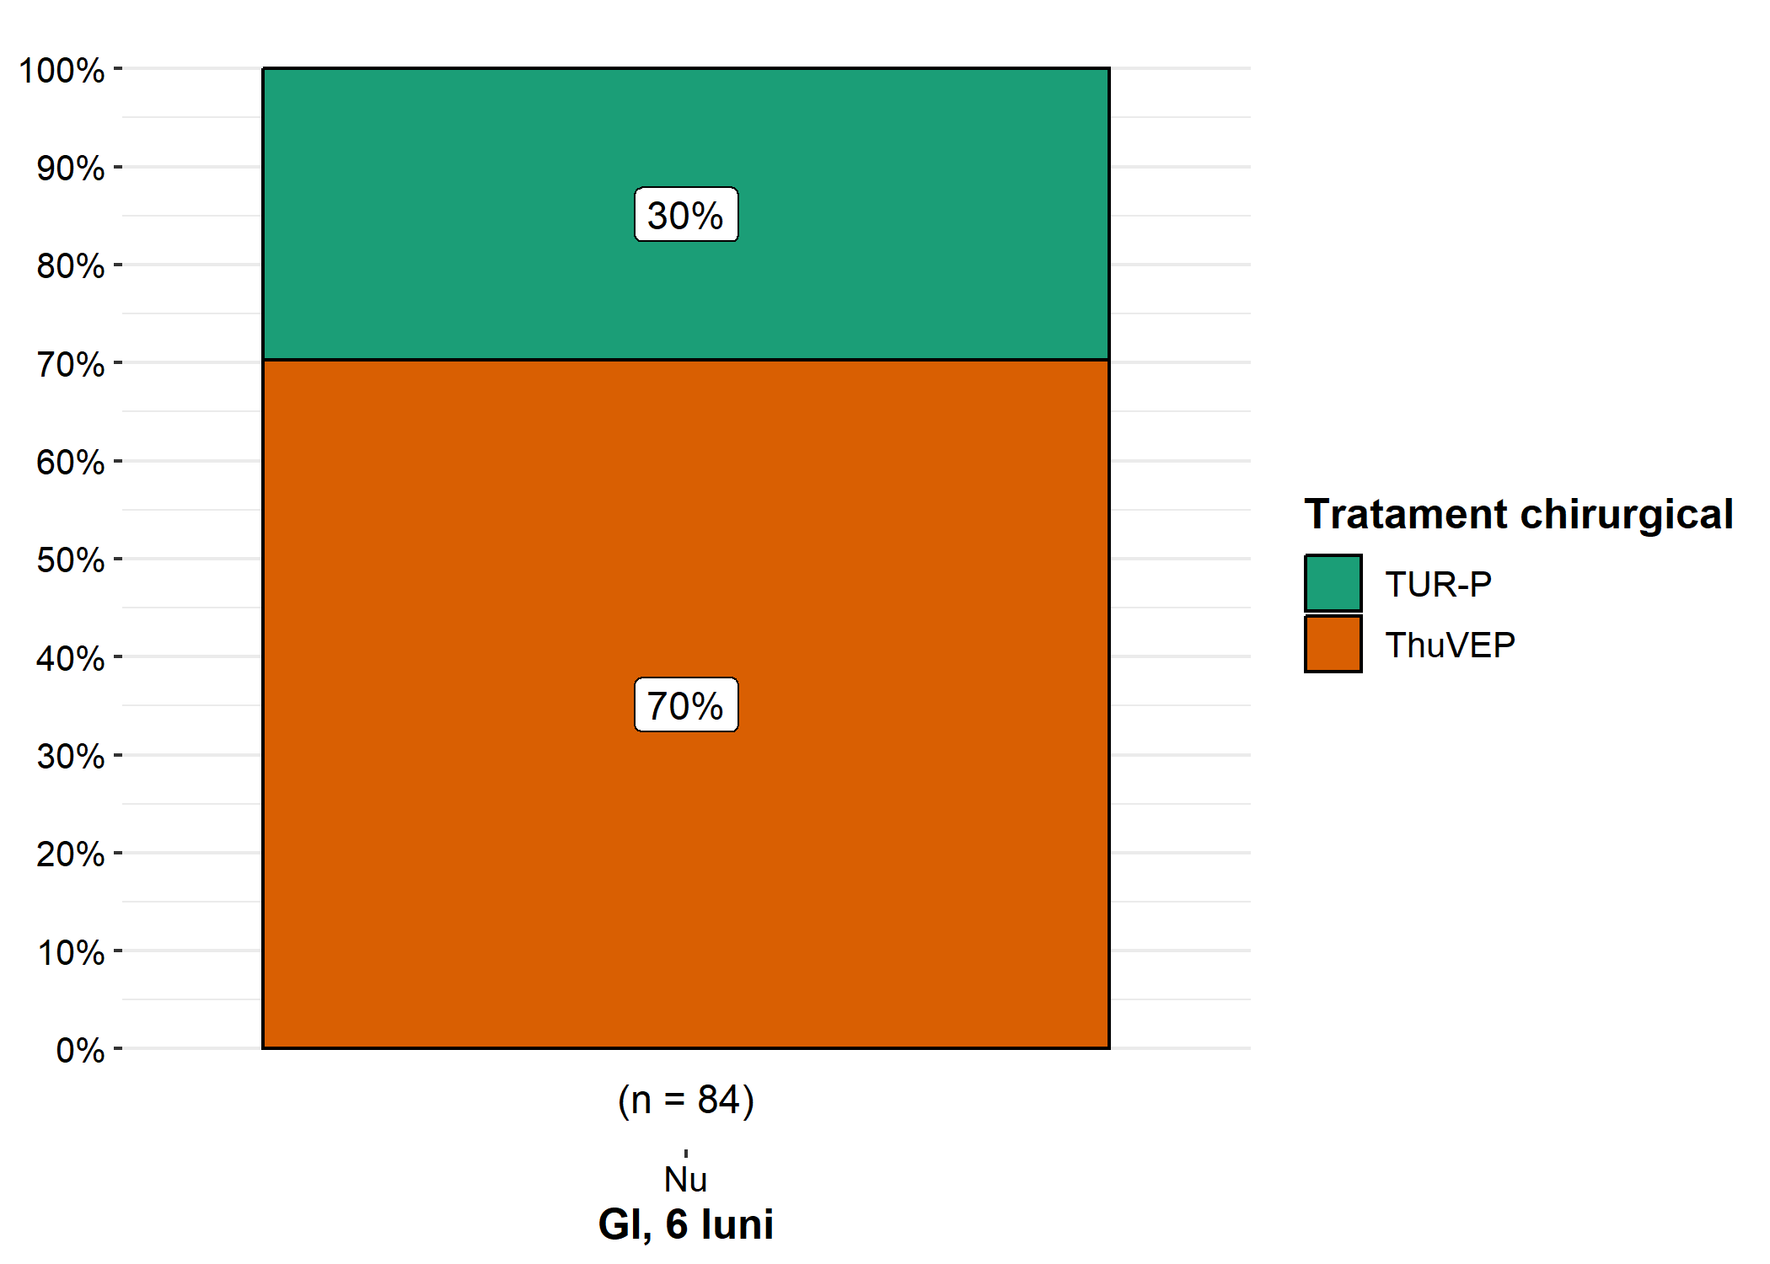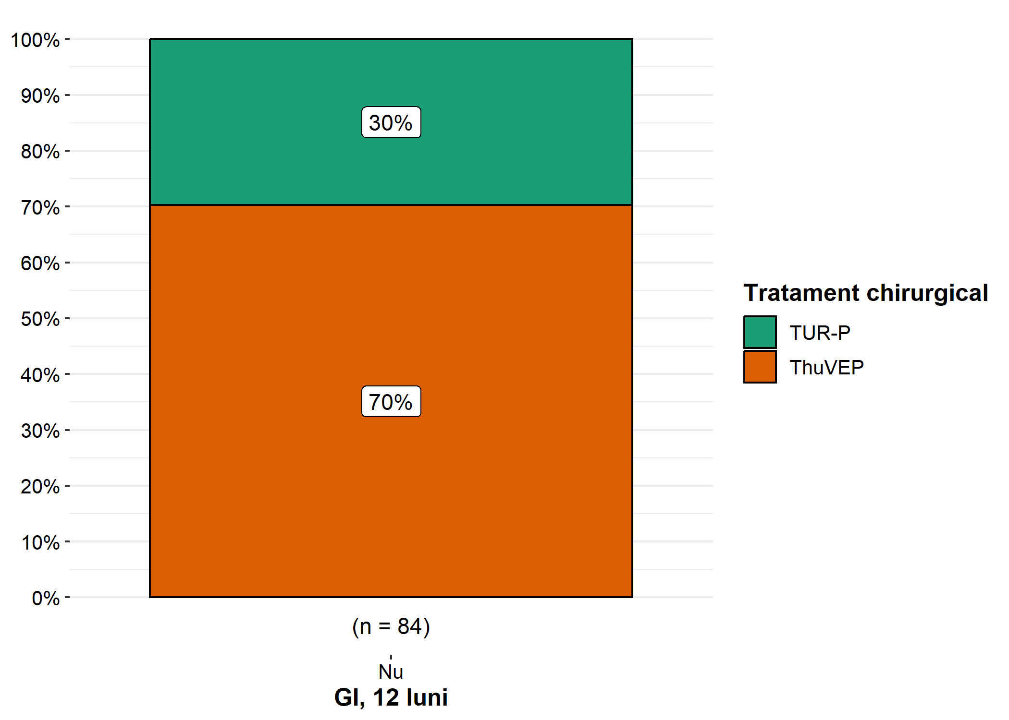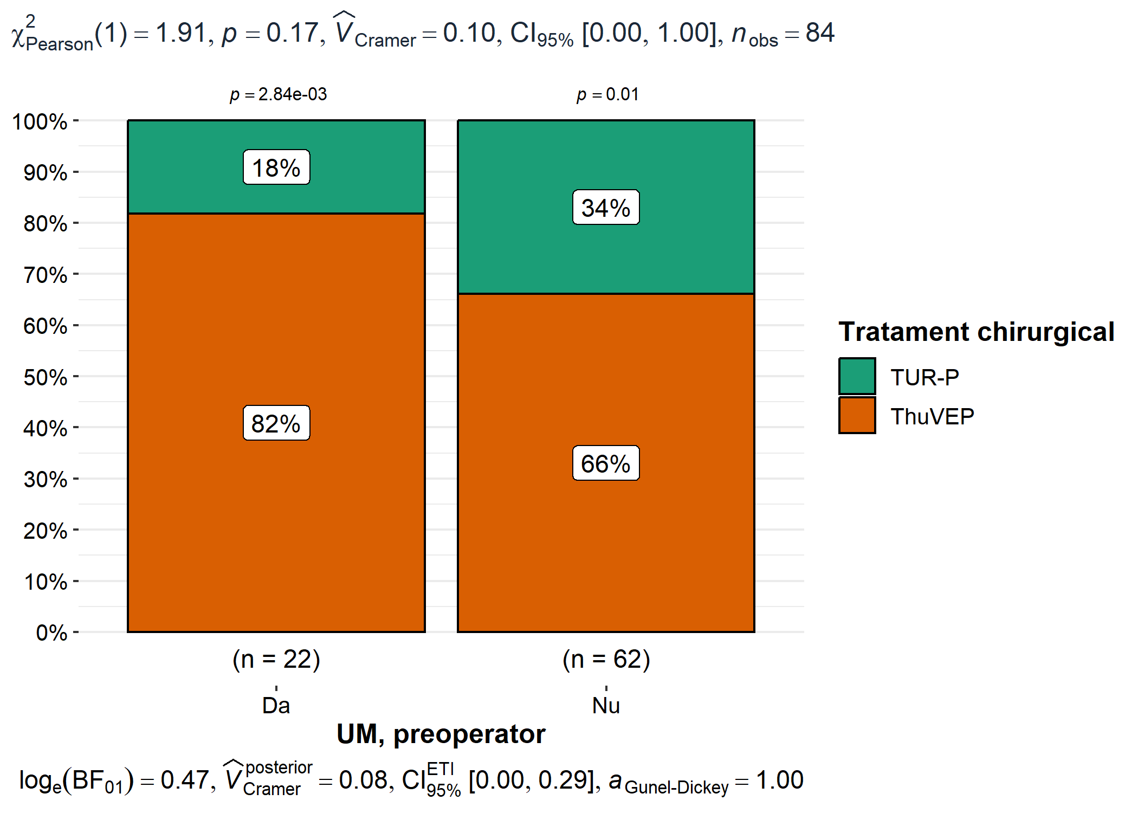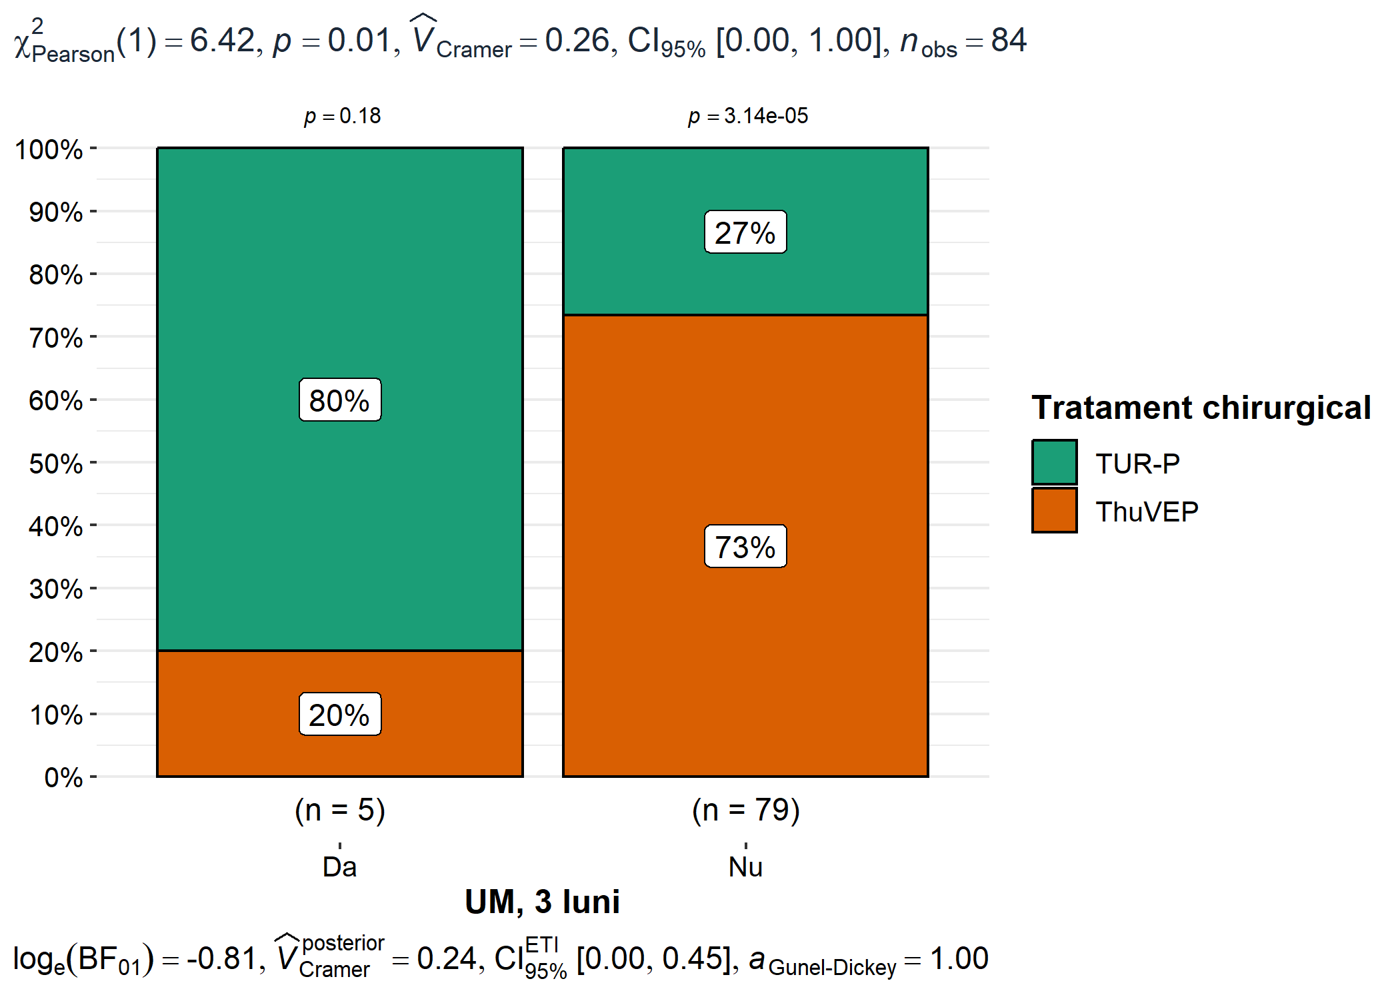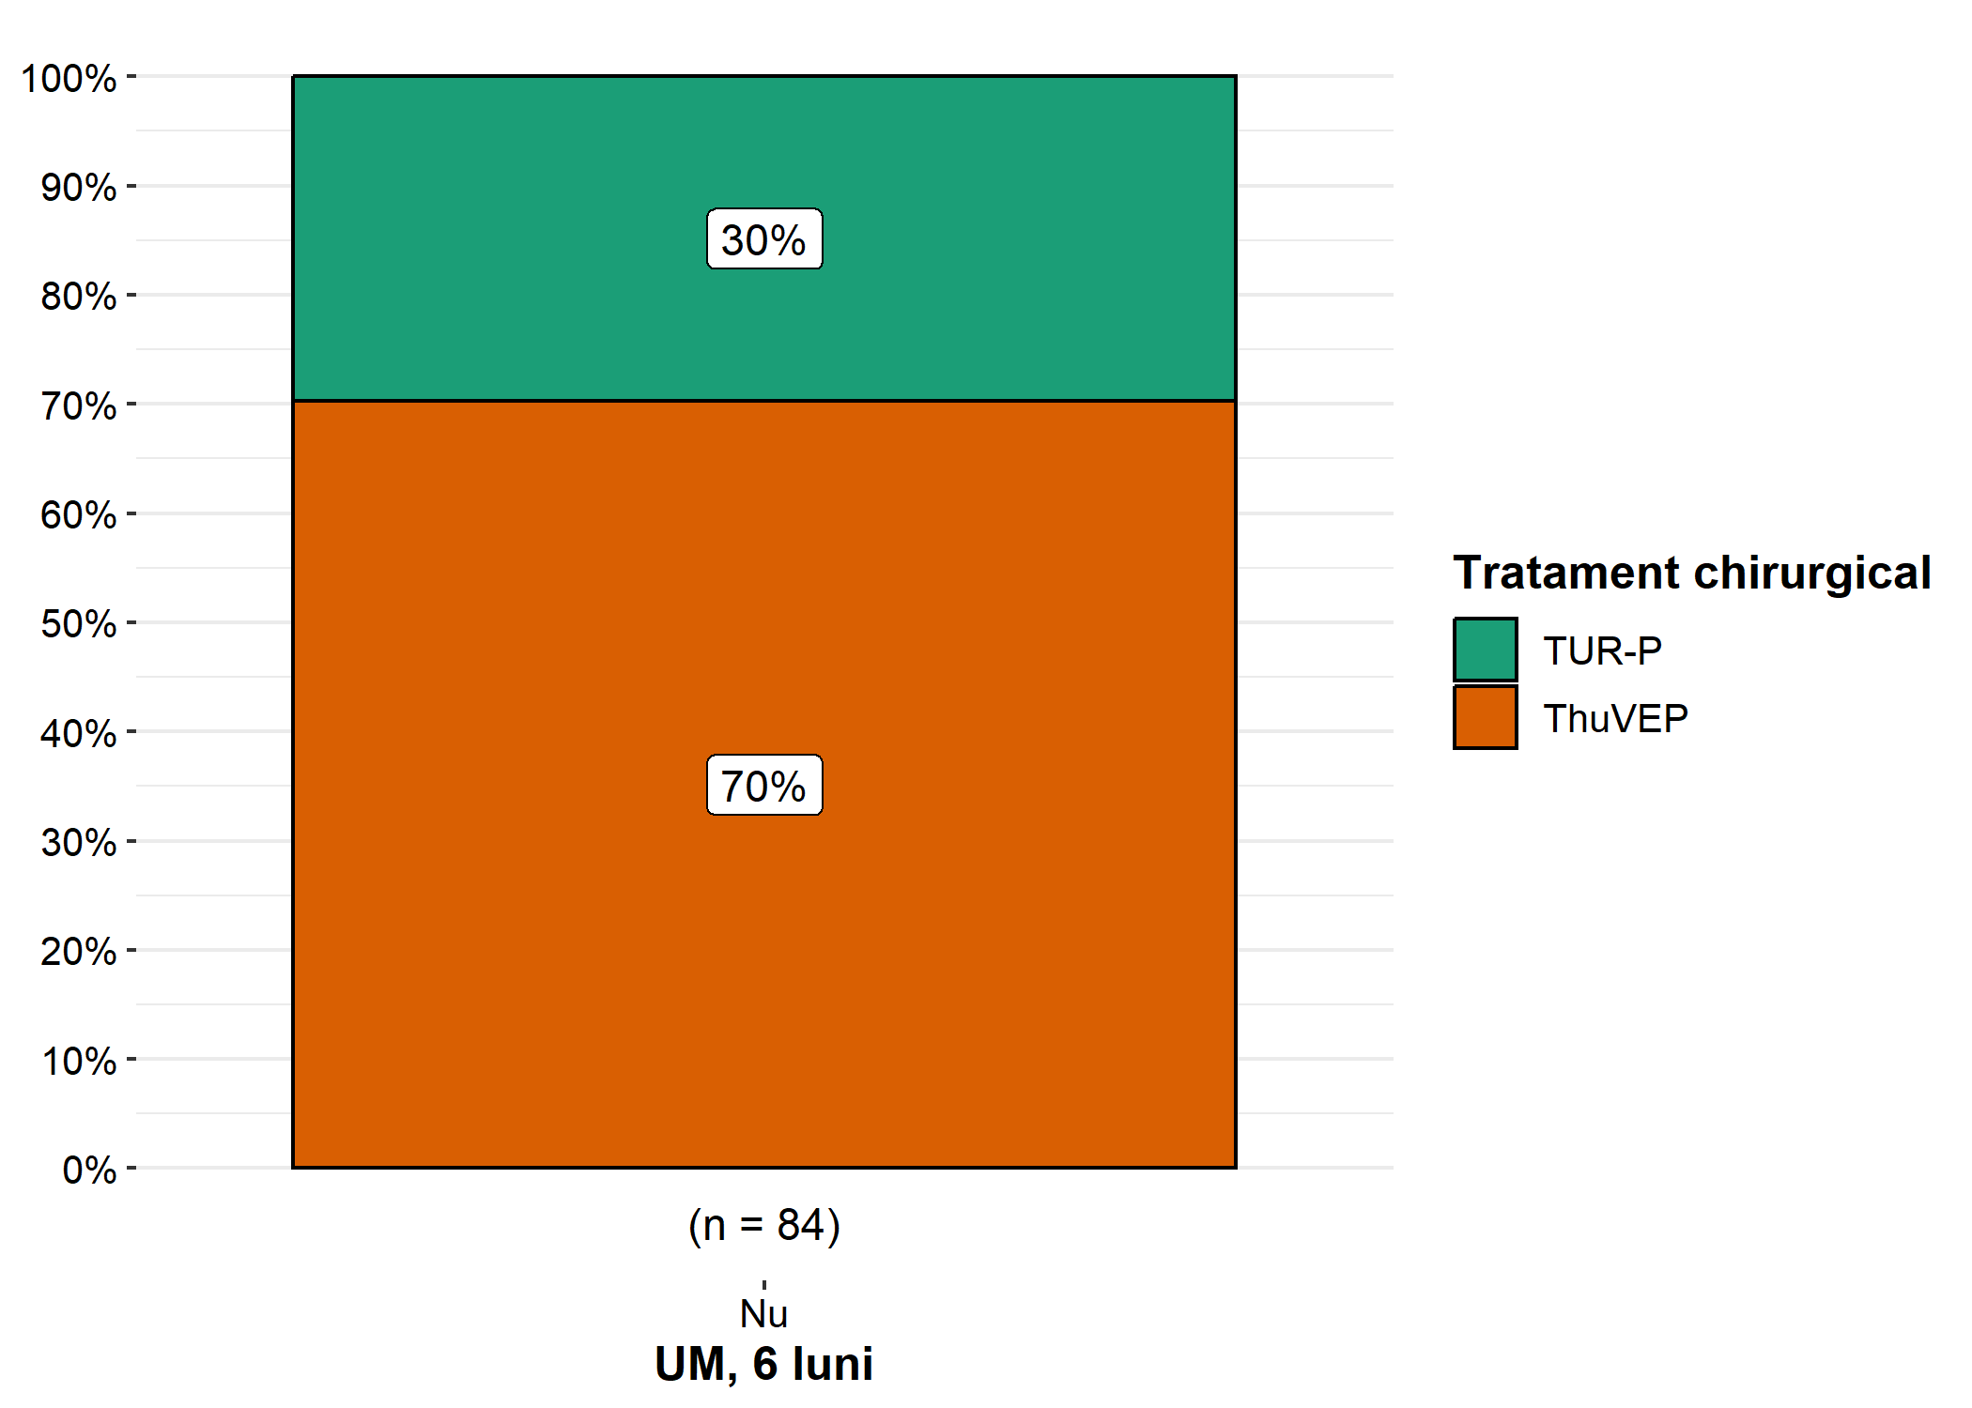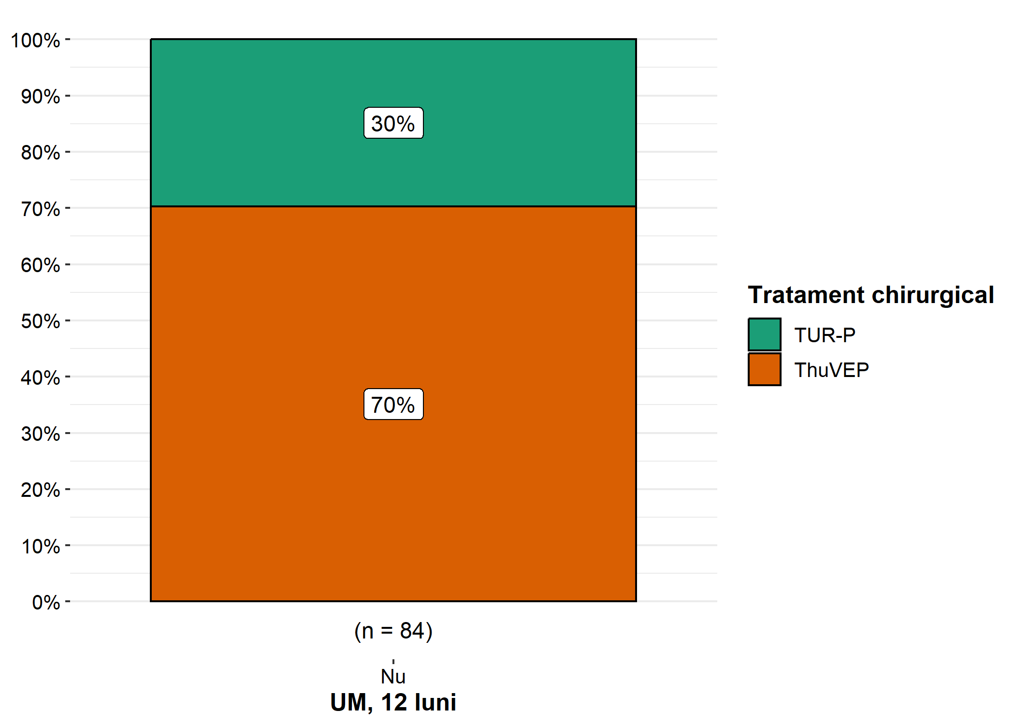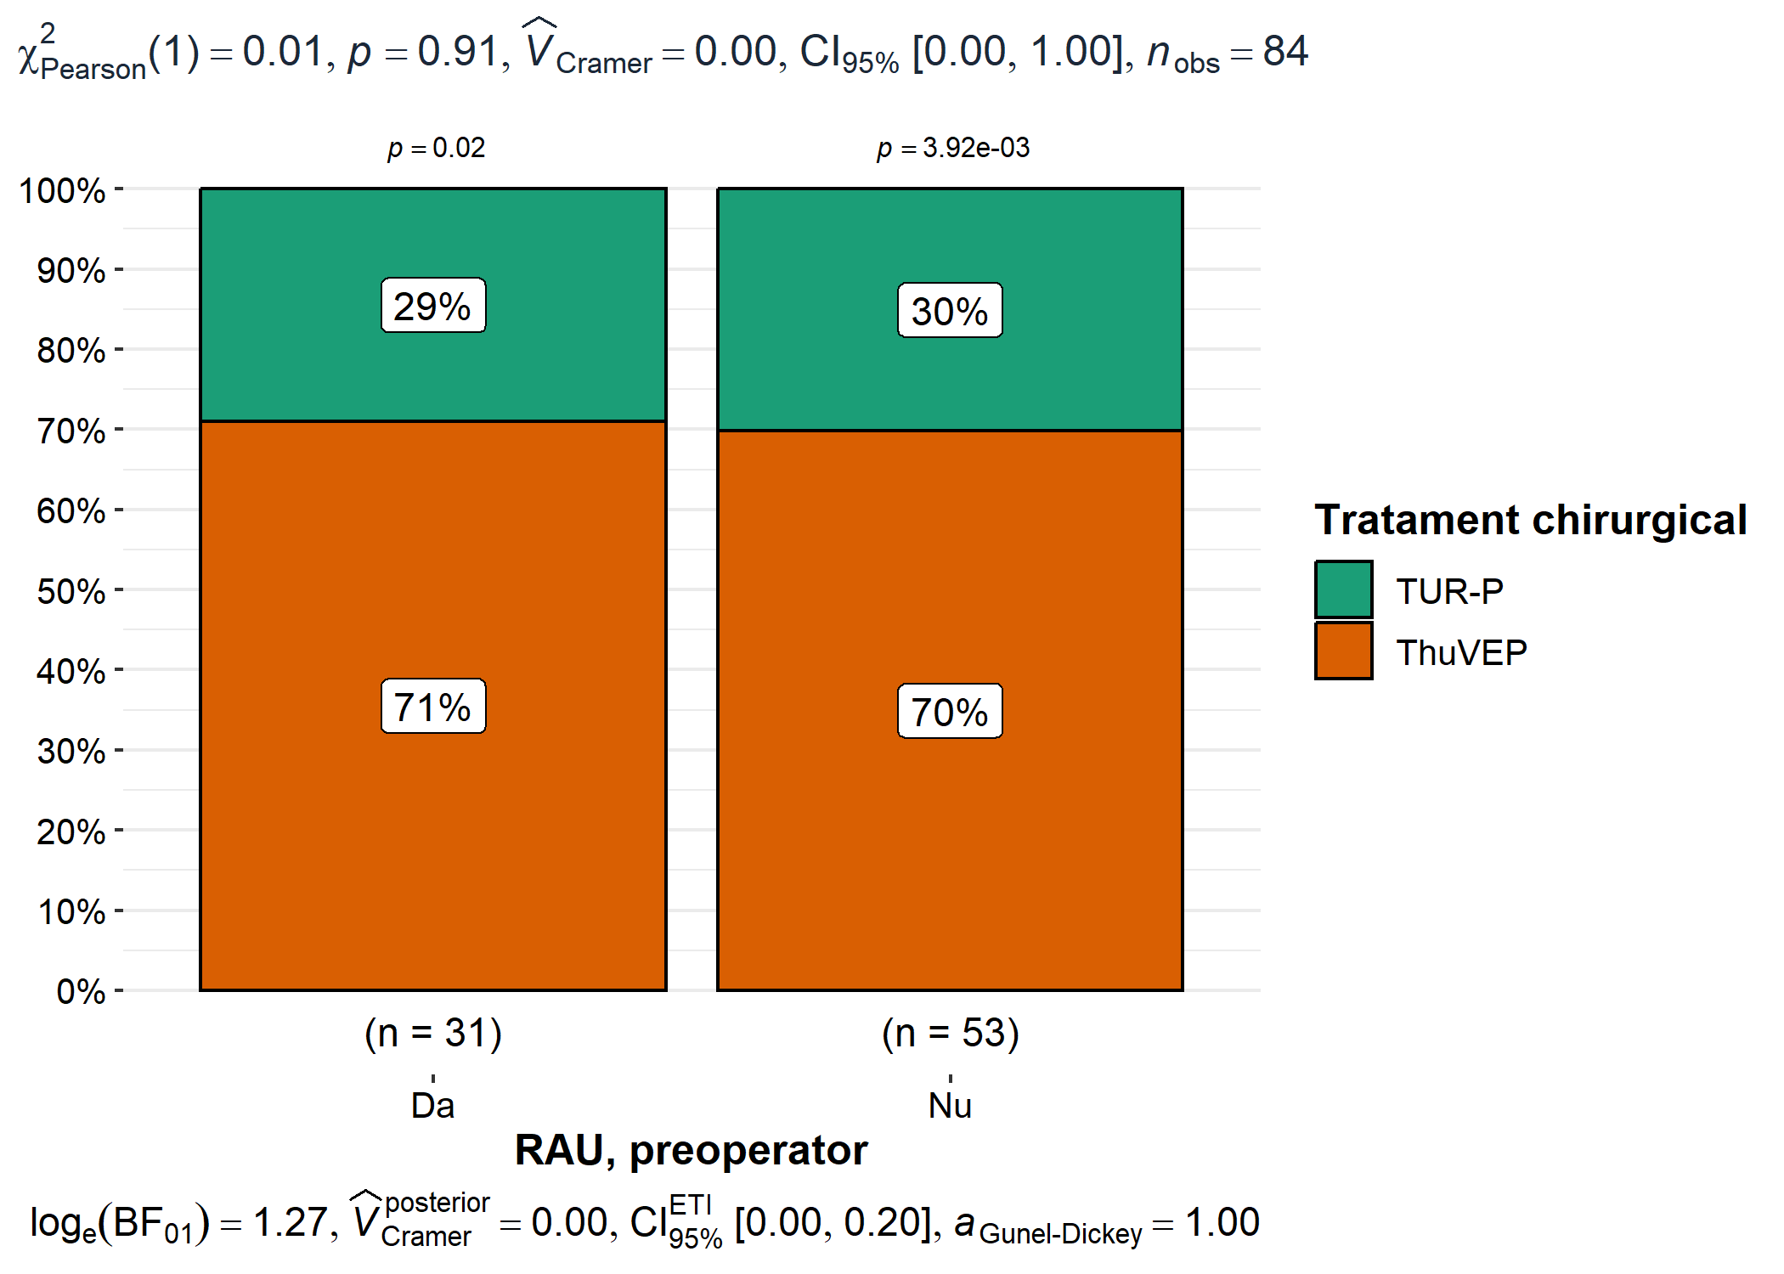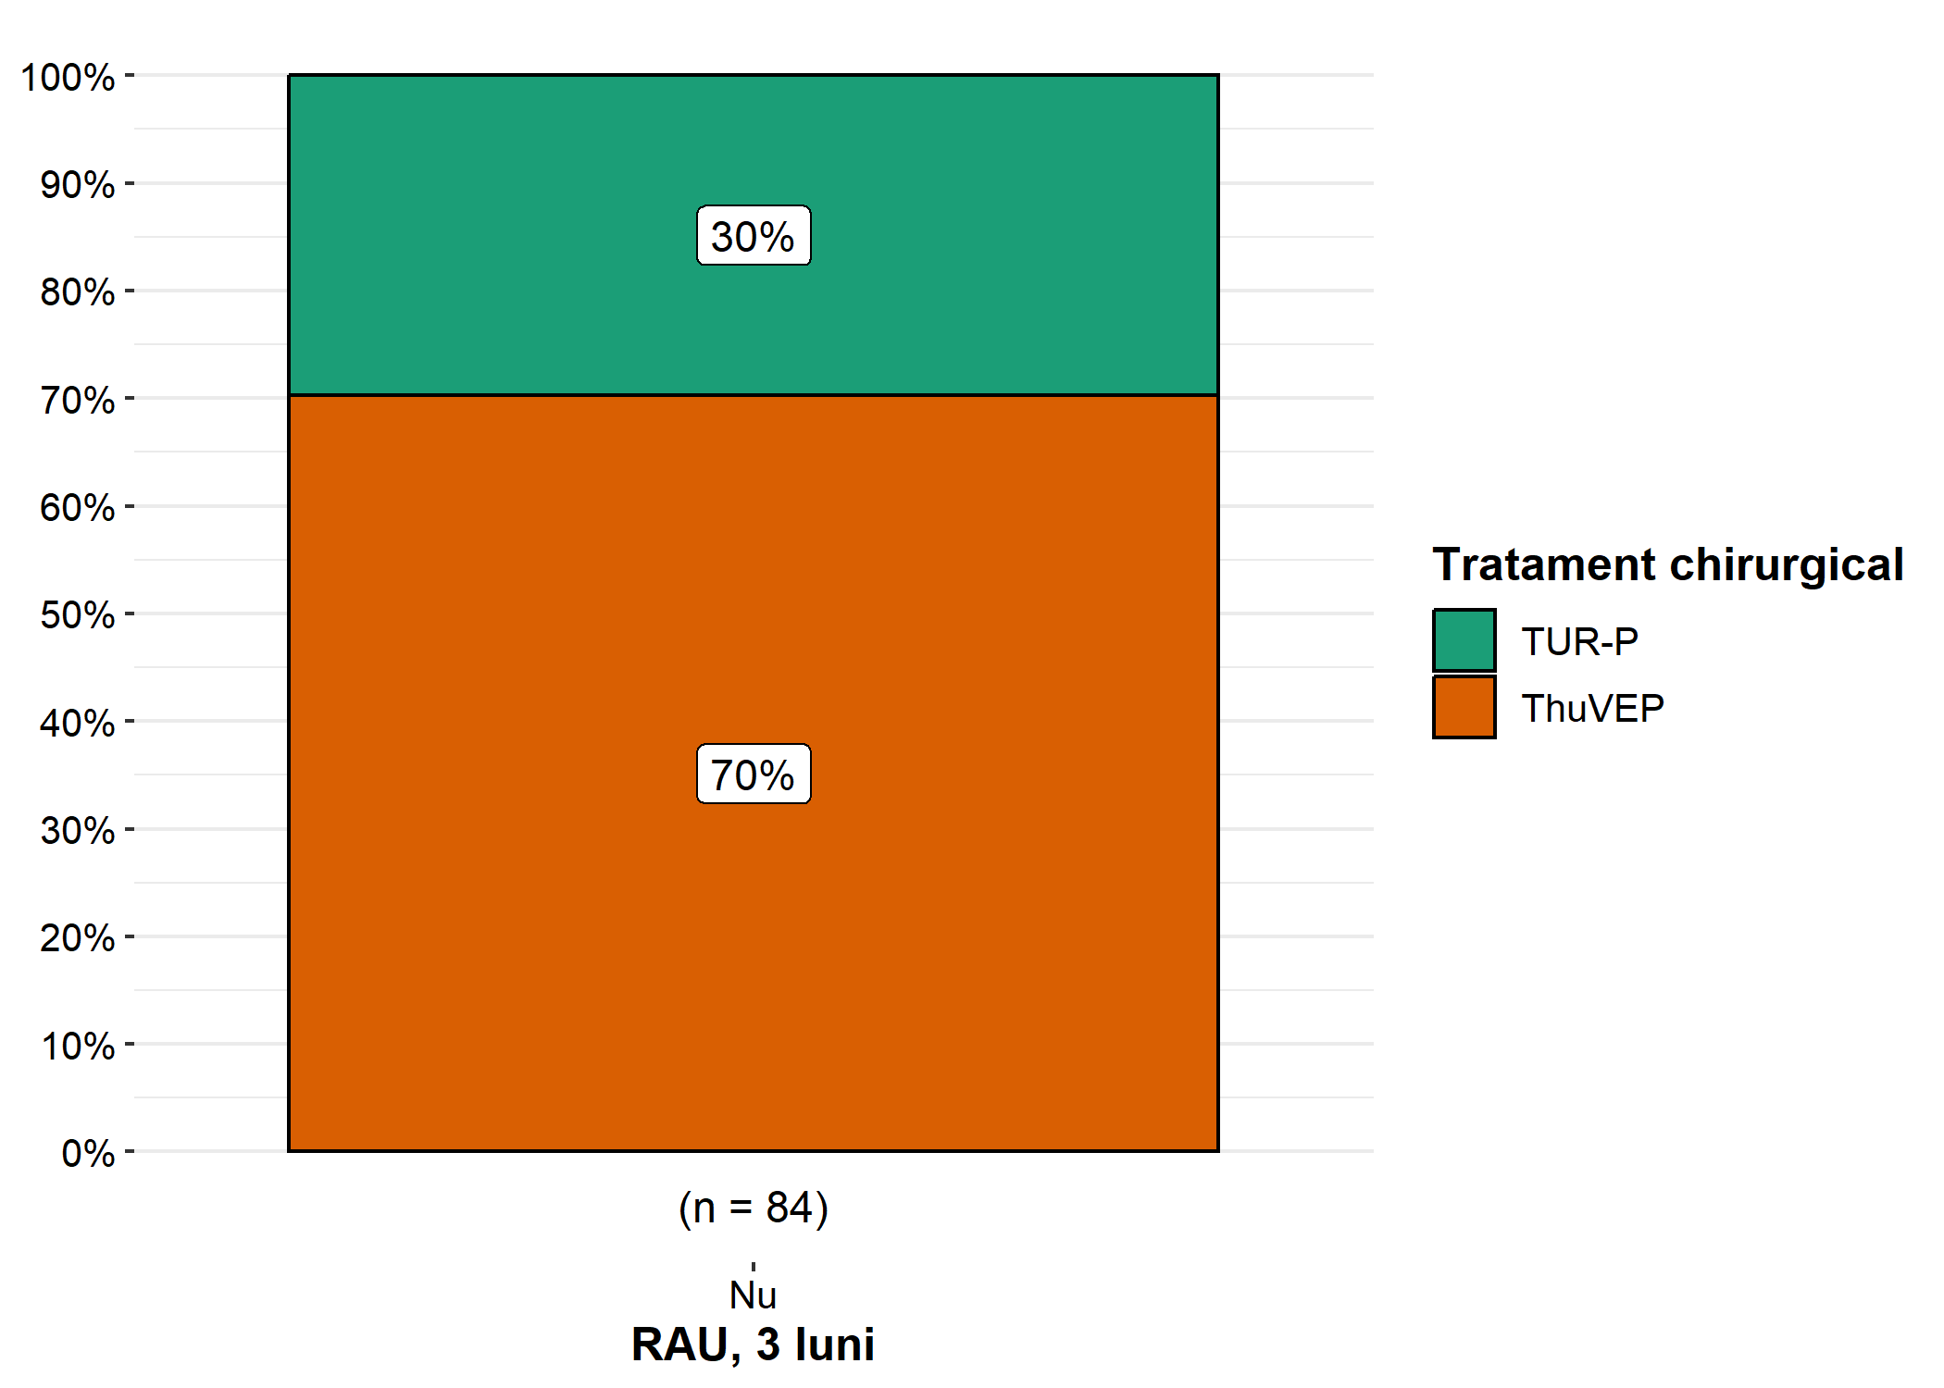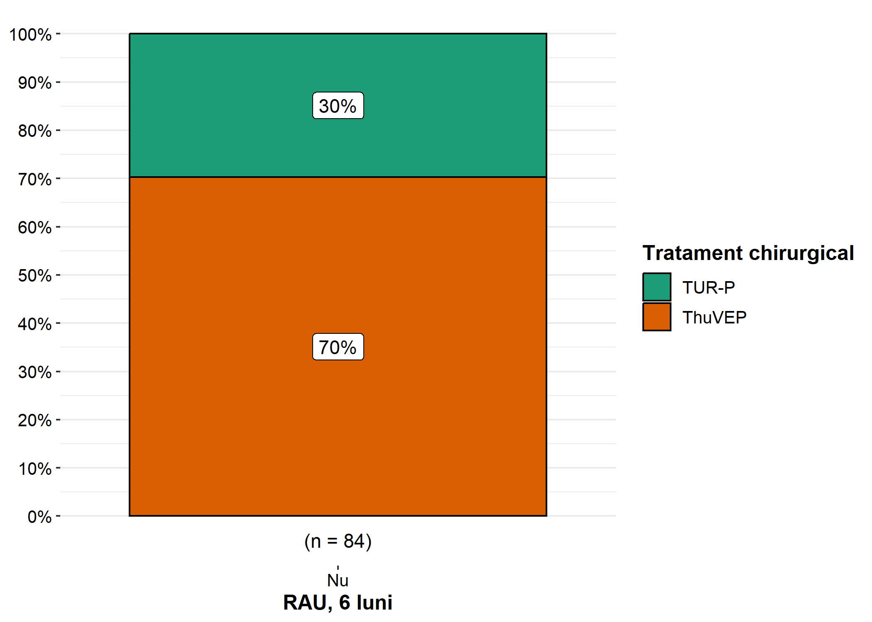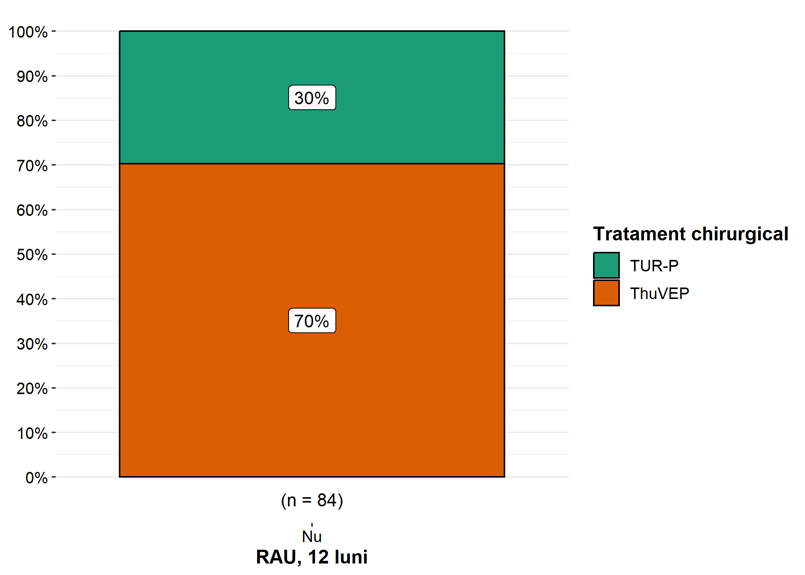

# Outcomes Odds Ratio

library(epitools)  
  
  
for (i in names(df[, 66:93]) ) {  
   
 var <- i  
 print('______________________________________________________________')  
 print(var)  
   
 if (table(df[[var]])['Nu'] != 84) {  
   
 contingency_table <- table(df$"Tratament chirurgical", df[[var]])  
 print(oddsratio.fisher(contingency_table, rev = c("both"))$measure)  
   
 }  
   
}

## [1] "______________________________________________________________"  
## [1] "Disurie, preoperator"  
## odds ratio with 95% C.I.  
## estimate lower upper  
## TUR-P 1.000000 NA NA  
## ThuVEP 1.544114 0.538996 4.426832  
## [1] "______________________________________________________________"  
## [1] "Disurie,3 luni"  
## odds ratio with 95% C.I.  
## estimate lower upper  
## TUR-P 1.0000000 NA NA  
## ThuVEP 0.5615746 0.1799722 1.635847  
## [1] "______________________________________________________________"  
## [1] "Disurie, 6 luni"  
## odds ratio with 95% C.I.  
## estimate lower upper  
## TUR-P 1.0000000 NA NA  
## ThuVEP 0.8382167 0.110976 9.871404  
## [1] "______________________________________________________________"  
## [1] "Disurie, 12 luni"  
## [1] "______________________________________________________________"  
## [1] "PZ, preoperator"  
## odds ratio with 95% C.I.  
## estimate lower upper  
## TUR-P 1.000000 NA NA  
## ThuVEP 1.316965 0.4541694 3.772728  
## [1] "______________________________________________________________"  
## [1] "PZ, 3 luni"  
## odds ratio with 95% C.I.  
## estimate lower upper  
## TUR-P 1.0000000 NA NA  
## ThuVEP 0.2585018 0.02645111 1.267182  
## [1] "______________________________________________________________"  
## [1] "PZ, 6 luni"  
## odds ratio with 95% C.I.  
## estimate lower upper  
## TUR-P 1.0000000 NA NA  
## ThuVEP 0.1016752 0.02747331 0.3273227  
## [1] "______________________________________________________________"  
## [1] "PZ, 12 luni"  
## odds ratio with 95% C.I.  
## estimate lower upper  
## TUR-P 1.00000000 NA NA  
## ThuVEP 0.03836005 0.000818128 0.318278  
## [1] "______________________________________________________________"  
## [1] "PN, preoperator"  
## odds ratio with 95% C.I.  
## estimate lower upper  
## TUR-P 1.000000 NA NA  
## ThuVEP 1.119674 0.3790409 3.220691  
## [1] "______________________________________________________________"  
## [1] "PN, 3 luni"  
## odds ratio with 95% C.I.  
## estimate lower upper  
## TUR-P 1 NA NA  
## ThuVEP 0 0 91.90926  
## [1] "______________________________________________________________"  
## [1] "PN, 6 luni"  
## odds ratio with 95% C.I.  
## estimate lower upper  
## TUR-P 1.0000000 NA NA  
## ThuVEP 0.5763178 0.01117914 6.235576  
## [1] "______________________________________________________________"  
## [1] "PN, 12 luni"  
## odds ratio with 95% C.I.  
## estimate lower upper  
## TUR-P 1.00000000 NA NA  
## ThuVEP 0.07706125 0.001756342 0.5434582  
## [1] "______________________________________________________________"  
## [1] "DT, preoperator"  
## odds ratio with 95% C.I.  
## estimate lower upper  
## TUR-P 1.000000 NA NA  
## ThuVEP 1.147656 0.4063383 3.301944  
## [1] "______________________________________________________________"  
## [1] "DT, 3 luni"  
## odds ratio with 95% C.I.  
## estimate lower upper  
## TUR-P 1 NA NA  
## ThuVEP Inf 0.2795933 Inf  
## [1] "______________________________________________________________"  
## [1] "DT, 6 luni"  
## odds ratio with 95% C.I.  
## estimate lower upper  
## TUR-P 1 NA NA  
## ThuVEP Inf 0.0108803 Inf  
## [1] "______________________________________________________________"  
## [1] "DT, 12 luni"  
## [1] "______________________________________________________________"  
## [1] "GI, preoperator"  
## odds ratio with 95% C.I.  
## estimate lower upper  
## TUR-P 1.00000 NA NA  
## ThuVEP 1.22675 0.4240395 3.501341  
## [1] "______________________________________________________________"  
## [1] "GI, 3 luni"  
## odds ratio with 95% C.I.  
## estimate lower upper  
## TUR-P 1.0000000 NA NA  
## ThuVEP 0.4187283 0.005192163 33.82298  
## [1] "______________________________________________________________"  
## [1] "GI, 6 luni"  
## [1] "______________________________________________________________"  
## [1] "GI, 12 luni"  
## [1] "______________________________________________________________"  
## [1] "UM, preoperator"  
## odds ratio with 95% C.I.  
## estimate lower upper  
## TUR-P 1.000000 NA NA  
## ThuVEP 2.283858 0.636488 10.46913  
## [1] "______________________________________________________________"  
## [1] "UM, 3 luni"  
## odds ratio with 95% C.I.  
## estimate lower upper  
## TUR-P 1.00000000 NA NA  
## ThuVEP 0.09352719 0.001813931 1.013727  
## [1] "______________________________________________________________"  
## [1] "UM, 6 luni"  
## [1] "______________________________________________________________"  
## [1] "UM, 12 luni"  
## [1] "______________________________________________________________"  
## [1] "RAU, preoperator"  
## odds ratio with 95% C.I.  
## estimate lower upper  
## TUR-P 1.000000 NA NA  
## ThuVEP 1.056378 0.363708 3.20328  
## [1] "______________________________________________________________"  
## [1] "RAU, 3 luni"  
## [1] "______________________________________________________________"  
## [1] "RAU, 6 luni"  
## [1] "______________________________________________________________"  
## [1] "RAU, 12 luni"

# Inf in CI means that there is no way to estimate OR

# Outcomes tables

df %>%   
 select("Tratament chirurgical", "Disurie, preoperator", "Disurie,3 luni", "Disurie, 6 luni", "Disurie, 12 luni") %>%  
 tbl_summary(by = "Tratament chirurgical",  
 statistic = list(all_categorical() ~ "{n} ({p}%)",  
 all_continuous() ~ "{mean} ({sd})\n {median} ({IQR})\n {min} {max} "),  
 digits = list(all_categorical() ~ c(0, 1),  
 all_continuous() ~ c(1, 1))) %>%  
 modify_header(label = "**Variable**") %>%  
 modify_caption("Participant characteristics") %>%  
 bold_labels()%>%add_ci()%>%add_p()

## There was an error in 'add_p()/add_difference()' for variable 'Disurie, 12 luni', p-value omitted:  
## Error in stats::chisq.test(x = structure(c(1L, 1L, 1L, 1L, 1L, 1L, 1L, : 'x' and 'y' must have at least 2 levels

## Table printed with {flextable}, not {gt}. Learn why at  
## https://www.danieldsjoberg.com/gtsummary/articles/rmarkdown.html  
## To suppress this message, include `message = FALSE` in the code chunk header.

Participant characteristics

| **Variable** | **ThuVEP**, N = 591 | **95% CI**2 | **TUR-P**, N = 251 | **95% CI**2 | **p-value**3 |
| --- | --- | --- | --- | --- | --- |
| **Disurie, preoperator** |  |  |  |  | 0.4 |
| Da | 37 (62.7%) | 49%, 75% | 13 (52.0%) | 32%, 72% |  |
| Nu | 22 (37.3%) | 25%, 51% | 12 (48.0%) | 28%, 68% |  |
| **Disurie,3 luni** |  |  |  |  | 0.2 |
| Da | 32 (54.2%) | 41%, 67% | 17 (68.0%) | 46%, 84% |  |
| Nu | 27 (45.8%) | 33%, 59% | 8 (32.0%) | 16%, 54% |  |
| **Disurie, 6 luni** |  |  |  |  | >0.9 |
| Da | 4 (6.8%) | 2.2%, 17% | 2 (8.0%) | 1.4%, 28% |  |
| Nu | 55 (93.2%) | 83%, 98% | 23 (92.0%) | 72%, 99% |  |
| **Disurie, 12 luni** |  |  |  |  |  |
| Nu | 59 (100.0%) | 92%, 100% | 25 (100.0%) | 83%, 100% |  |
| 1n (%) | | | | | |
| 2CI = Confidence Interval | | | | | |
| 3Pearson's Chi-squared test; Fisher's exact test | | | | | |

# Error because it is not possible to estimate significance for constant variables

df %>%   
 select("Tratament chirurgical", "PZ, preoperator", "PZ, 3 luni", "PZ, 6 luni", "PZ, 12 luni") %>%  
 tbl_summary(by = "Tratament chirurgical",  
 statistic = list(all_categorical() ~ "{n} ({p}%)",  
 all_continuous() ~ "{mean} ({sd})\n {median} ({IQR})\n {min} {max} "),  
 digits = list(all_categorical() ~ c(0, 1),  
 all_continuous() ~ c(1, 1))) %>%  
 modify_header(label = "**Variable**") %>%  
 modify_caption("Participant characteristics") %>%  
 bold_labels()%>%add_ci()%>%add_p()

## Table printed with {flextable}, not {gt}. Learn why at  
## https://www.danieldsjoberg.com/gtsummary/articles/rmarkdown.html  
## To suppress this message, include `message = FALSE` in the code chunk header.

Participant characteristics

| **Variable** | **ThuVEP**, N = 591 | **95% CI**2 | **TUR-P**, N = 251 | **95% CI**2 | **p-value**3 |
| --- | --- | --- | --- | --- | --- |
| **PZ, preoperator** |  |  |  |  | 0.6 |
| Da | 37 (62.7%) | 49%, 75% | 14 (56.0%) | 35%, 75% |  |
| Nu | 22 (37.3%) | 25%, 51% | 11 (44.0%) | 25%, 65% |  |
| **PZ, 3 luni** |  |  |  |  | 0.069 |
| Da | 44 (74.6%) | 61%, 85% | 23 (92.0%) | 72%, 99% |  |
| Nu | 15 (25.4%) | 15%, 39% | 2 (8.0%) | 1.4%, 28% |  |
| **PZ, 6 luni** |  |  |  |  | <0.001 |
| Da | 14 (23.7%) | 14%, 37% | 19 (76.0%) | 54%, 90% |  |
| Nu | 45 (76.3%) | 63%, 86% | 6 (24.0%) | 10%, 46% |  |
| **PZ, 12 luni** |  |  |  |  | <0.001 |
| Da | 1 (1.7%) | 0.09%, 10% | 8 (32.0%) | 16%, 54% |  |
| Nu | 58 (98.3%) | 90%, 100% | 17 (68.0%) | 46%, 84% |  |
| 1n (%) | | | | | |
| 2CI = Confidence Interval | | | | | |
| 3Pearson's Chi-squared test; Fisher's exact test | | | | | |

df %>%   
 select("Tratament chirurgical", "PN, preoperator", "PN, 3 luni", "PN, 6 luni", "PN, 12 luni") %>%  
 tbl_summary(by = "Tratament chirurgical",  
 statistic = list(all_categorical() ~ "{n} ({p}%)",  
 all_continuous() ~ "{mean} ({sd})\n {median} ({IQR})\n {min} {max} "),  
 digits = list(all_categorical() ~ c(0, 1),  
 all_continuous() ~ c(1, 1))) %>%  
 modify_header(label = "**Variable**") %>%  
 modify_caption("Participant characteristics") %>%  
 bold_labels()%>%add_ci()%>%add_p()

## Table printed with {flextable}, not {gt}. Learn why at  
## https://www.danieldsjoberg.com/gtsummary/articles/rmarkdown.html  
## To suppress this message, include `message = FALSE` in the code chunk header.

Participant characteristics

| **Variable** | **ThuVEP**, N = 591 | **95% CI**2 | **TUR-P**, N = 251 | **95% CI**2 | **p-value**3 |
| --- | --- | --- | --- | --- | --- |
| **PN, preoperator** |  |  |  |  | 0.8 |
| Da | 37 (62.7%) | 49%, 75% | 15 (60.0%) | 39%, 78% |  |
| Nu | 22 (37.3%) | 25%, 51% | 10 (40.0%) | 22%, 61% |  |
| **PN, 3 luni** |  |  |  |  | >0.9 |
| Da | 58 (98.3%) | 90%, 100% | 25 (100.0%) | 83%, 100% |  |
| Nu | 1 (1.7%) | 0.09%, 10% | 0 (0.0%) | 0.00%, 17% |  |
| **PN, 6 luni** |  |  |  |  | >0.9 |
| Da | 55 (93.2%) | 83%, 98% | 24 (96.0%) | 78%, 100% |  |
| Nu | 4 (6.8%) | 2.2%, 17% | 1 (4.0%) | 0.21%, 22% |  |
| **PN, 12 luni** |  |  |  |  | 0.003 |
| Da | 38 (64.4%) | 51%, 76% | 24 (96.0%) | 78%, 100% |  |
| Nu | 21 (35.6%) | 24%, 49% | 1 (4.0%) | 0.21%, 22% |  |
| 1n (%) | | | | | |
| 2CI = Confidence Interval | | | | | |
| 3Pearson's Chi-squared test; Fisher's exact test | | | | | |

df %>%   
 select("Tratament chirurgical", "GI, preoperator", "GI, 3 luni", "GI, 6 luni", "GI, 12 luni" ) %>%  
 tbl_summary(by = "Tratament chirurgical",  
 statistic = list(all_categorical() ~ "{n} ({p}%)",  
 all_continuous() ~ "{mean} ({sd})\n {median} ({IQR})\n {min} {max} "),  
 digits = list(all_categorical() ~ c(0, 1),  
 all_continuous() ~ c(1, 1))) %>%  
 modify_header(label = "**Variable**") %>%  
 modify_caption("Participant characteristics") %>%  
 bold_labels()%>%add_ci()%>%add_p()

## There was an error in 'add_p()/add_difference()' for variable 'GI, 6 luni', p-value omitted:  
## Error in stats::chisq.test(x = structure(c(1L, 1L, 1L, 1L, 1L, 1L, 1L, : 'x' and 'y' must have at least 2 levels

## There was an error in 'add_p()/add_difference()' for variable 'GI, 12 luni', p-value omitted:  
## Error in stats::chisq.test(x = structure(c(1L, 1L, 1L, 1L, 1L, 1L, 1L, : 'x' and 'y' must have at least 2 levels

## Table printed with {flextable}, not {gt}. Learn why at  
## https://www.danieldsjoberg.com/gtsummary/articles/rmarkdown.html  
## To suppress this message, include `message = FALSE` in the code chunk header.

Participant characteristics

| **Variable** | **ThuVEP**, N = 591 | **95% CI**2 | **TUR-P**, N = 251 | **95% CI**2 | **p-value**3 |
| --- | --- | --- | --- | --- | --- |
| **GI, preoperator** |  |  |  |  | 0.7 |
| Da | 36 (61.0%) | 47%, 73% | 14 (56.0%) | 35%, 75% |  |
| Nu | 23 (39.0%) | 27%, 53% | 11 (44.0%) | 25%, 65% |  |
| **GI, 3 luni** |  |  |  |  | 0.5 |
| Da | 1 (1.7%) | 0.09%, 10% | 1 (4.0%) | 0.21%, 22% |  |
| Nu | 58 (98.3%) | 90%, 100% | 24 (96.0%) | 78%, 100% |  |
| **GI, 6 luni** |  |  |  |  |  |
| Nu | 59 (100.0%) | 92%, 100% | 25 (100.0%) | 83%, 100% |  |
| **GI, 12 luni** |  |  |  |  |  |
| Nu | 59 (100.0%) | 92%, 100% | 25 (100.0%) | 83%, 100% |  |
| 1n (%) | | | | | |
| 2CI = Confidence Interval | | | | | |
| 3Pearson's Chi-squared test; Fisher's exact test | | | | | |

# Error because it is not possible to estimate significance for constant variables

df %>%   
 select("Tratament chirurgical", "UM, preoperator", "UM, 3 luni", "UM, 6 luni", "UM, 12 luni") %>%  
 tbl_summary(by = "Tratament chirurgical",  
 statistic = list(all_categorical() ~ "{n} ({p}%)",  
 all_continuous() ~ "{mean} ({sd})\n {median} ({IQR})\n {min} {max} "),  
 digits = list(all_categorical() ~ c(0, 1),  
 all_continuous() ~ c(1, 1))) %>%  
 modify_header(label = "**Variable**") %>%  
 modify_caption("Participant characteristics") %>%  
 bold_labels()%>%add_ci()%>%add_p()

## There was an error in 'add_p()/add_difference()' for variable 'UM, 6 luni', p-value omitted:  
## Error in stats::chisq.test(x = structure(c(1L, 1L, 1L, 1L, 1L, 1L, 1L, : 'x' and 'y' must have at least 2 levels

## There was an error in 'add_p()/add_difference()' for variable 'UM, 12 luni', p-value omitted:  
## Error in stats::chisq.test(x = structure(c(1L, 1L, 1L, 1L, 1L, 1L, 1L, : 'x' and 'y' must have at least 2 levels

## Table printed with {flextable}, not {gt}. Learn why at  
## https://www.danieldsjoberg.com/gtsummary/articles/rmarkdown.html  
## To suppress this message, include `message = FALSE` in the code chunk header.

Participant characteristics

| **Variable** | **ThuVEP**, N = 591 | **95% CI**2 | **TUR-P**, N = 251 | **95% CI**2 | **p-value**3 |
| --- | --- | --- | --- | --- | --- |
| **UM, preoperator** |  |  |  |  | 0.2 |
| Da | 18 (30.5%) | 20%, 44% | 4 (16.0%) | 5.3%, 37% |  |
| Nu | 41 (69.5%) | 56%, 80% | 21 (84.0%) | 63%, 95% |  |
| **UM, 3 luni** |  |  |  |  | 0.026 |
| Da | 1 (1.7%) | 0.09%, 10% | 4 (16.0%) | 5.3%, 37% |  |
| Nu | 58 (98.3%) | 90%, 100% | 21 (84.0%) | 63%, 95% |  |
| **UM, 6 luni** |  |  |  |  |  |
| Nu | 59 (100.0%) | 92%, 100% | 25 (100.0%) | 83%, 100% |  |
| **UM, 12 luni** |  |  |  |  |  |
| Nu | 59 (100.0%) | 92%, 100% | 25 (100.0%) | 83%, 100% |  |
| 1n (%) | | | | | |
| 2CI = Confidence Interval | | | | | |
| 3Pearson's Chi-squared test; Fisher's exact test | | | | | |

# Error because it is not possible to estimate significance for constant variables

df %>%   
 select("Tratament chirurgical", "RAU, preoperator", "RAU, 3 luni", "RAU, 6 luni", "RAU, 12 luni" ) %>%  
 tbl_summary(by = "Tratament chirurgical",  
 statistic = list(all_categorical() ~ "{n} ({p}%)",  
 all_continuous() ~ "{mean} ({sd})\n {median} ({IQR})\n {min} {max} "),  
 digits = list(all_categorical() ~ c(0, 1),  
 all_continuous() ~ c(1, 1))) %>%  
 modify_header(label = "**Variable**") %>%  
 modify_caption("Participant characteristics") %>%  
 bold_labels()%>%add_ci()%>%add_p()

## There was an error in 'add_p()/add_difference()' for variable 'RAU, 3 luni', p-value omitted:  
## Error in stats::chisq.test(x = structure(c(1L, 1L, 1L, 1L, 1L, 1L, 1L, : 'x' and 'y' must have at least 2 levels

## There was an error in 'add_p()/add_difference()' for variable 'RAU, 6 luni', p-value omitted:  
## Error in stats::chisq.test(x = structure(c(1L, 1L, 1L, 1L, 1L, 1L, 1L, : 'x' and 'y' must have at least 2 levels

## There was an error in 'add_p()/add_difference()' for variable 'RAU, 12 luni', p-value omitted:  
## Error in stats::chisq.test(x = structure(c(1L, 1L, 1L, 1L, 1L, 1L, 1L, : 'x' and 'y' must have at least 2 levels

## Table printed with {flextable}, not {gt}. Learn why at  
## https://www.danieldsjoberg.com/gtsummary/articles/rmarkdown.html  
## To suppress this message, include `message = FALSE` in the code chunk header.

Participant characteristics

| **Variable** | **ThuVEP**, N = 591 | **95% CI**2 | **TUR-P**, N = 251 | **95% CI**2 | **p-value**3 |
| --- | --- | --- | --- | --- | --- |
| **RAU, preoperator** |  |  |  |  | >0.9 |
| Da | 22 (37.3%) | 25%, 51% | 9 (36.0%) | 19%, 57% |  |
| Nu | 37 (62.7%) | 49%, 75% | 16 (64.0%) | 43%, 81% |  |
| **RAU, 3 luni** |  |  |  |  |  |
| Nu | 59 (100.0%) | 92%, 100% | 25 (100.0%) | 83%, 100% |  |
| **RAU, 6 luni** |  |  |  |  |  |
| Nu | 59 (100.0%) | 92%, 100% | 25 (100.0%) | 83%, 100% |  |
| **RAU, 12 luni** |  |  |  |  |  |
| Nu | 59 (100.0%) | 92%, 100% | 25 (100.0%) | 83%, 100% |  |
| 1n (%) | | | | | |
| 2CI = Confidence Interval | | | | | |
| 3Pearson's Chi-squared test | | | | | |

# Error because it is not possible to estimate significance for constant variables