covid_valid

Arnaut Oleg

17/09/2023

## Read data

## Parse data

# Merge data

## [1] 4180

# Filter rows

## [1] 4158

## [1] 4070

## [1] 3241

## [1] 3241

## [1] "id" "StartDate" "hospit_days_total"  
## [4] "OutcomeDate" "AnalysisDate" "analiza"   
## [7] "rezultat" "Age" "sex"   
## [10] "cicode" "Outcome"

##   
## FALSE TRUE   
## 579507 2329

## id StartDate hospit_days_total OutcomeDate AnalysisDate  
## 1 1040082 2020-03-30 17 days 2020-04-16 2020-03-30  
## 2 1040082 2020-03-30 17 days 2020-04-16 2020-03-30  
## 3 1040082 2020-03-30 17 days 2020-04-16 2020-03-31  
## 4 1040082 2020-03-30 17 days 2020-04-16 2020-03-30  
## 5 1040082 2020-03-30 17 days 2020-04-16 2020-03-30  
## 6 1040082 2020-03-30 17 days 2020-04-16 2020-03-30  
## analiza rezultat Age sex  
## 1 Dozarea a-amilazei in lichidele biologice (mat. cinetica) 52.0 61 F  
## 2 Dozarea clorului in serul sanguin 103.0 61 F  
## 3 Dozarea proteinei totale 59.0 61 F  
## 4 Dozarea potasiului in serul sanguin 4.5 61 F  
## 5 Dozarea sodiului in serul sanguin 146.0 61 F  
## 6 Dozarea aspartataminotransferazei (AST) in ser 33.0 61 F  
## cicode Outcome  
## 1 J128 0  
## 2 J128 0  
## 3 J128 0  
## 4 J128 0  
## 5 J128 0  
## 6 J128 0

## [1] 214

## [1] 192

## [1] "dozarea Clului in serul sanguin"   
## [2] "protein_total"   
## [3] "dozarea potasiului in serul sanguin"   
## [4] "dozarea sodiului in serul sanguin"   
## [5] "dozarea aspartataminotransferazei (ast) in ser"  
## [6] "bilirubina libera"   
## [7] "dozarea albuminei in ser"   
## [8] "dozarea creatininei in ser sau urina"   
## [9] "timpul de trombina (tt)"   
## [10] "glucose"   
## [11] "dozarea alaninaminotransferazei (alt) in ser"   
## [12] "dozarea bilirubina conjugata"   
## [13] "fibrinogen"   
## [14] "hg"   
## [15] "dozarea bilirubinei"   
## [16] "numaratoarea trombocitelor"   
## [17] "wbc"   
## [18] "urea"   
## [19] "raportul international normalizat (inr)"   
## [20] "aptt"   
## [21] "indexul protrombinic"   
## [22] "nesegmentate"   
## [23] "segmentate"   
## [24] "limfocite"   
## [25] "monocite"   
## [26] "eozinofile"   
## [27] "dozarea calciului in serul sanguin"   
## [28] "metamielocite"   
## [29] "mielocite"   
## [30] "celule plasmatice"   
## [31] "crp"   
## [32] "cl"   
## [33] "aspartal-aminotransferaza asat"   
## [34] "creatinina"   
## [35] "alanin-aminotransferaza alat"   
## [36] "k"   
## [37] "na"   
## [38] "proteina totala"   
## [39] "d-dimer"   
## [40] "bazofilei"   
## [41] "activitatea protrombinei dupa quick"   
## [42] "cl-"   
## [43] "bilirubina totala"   
## [44] "bilirubina directa"   
## [45] "bilirubina indirecta"   
## [46] "bilirubina conjugata"   
## [47] "inr"   
## [48] "glucoza din deget"   
## [49] "dozarea creatininei in ser"   
## [50] "dozarea bilirubinei conjugate"   
## [51] "dozarea alaninaminotransferazei(alt) in ser"   
## [52] "dozarea aspartataminotransferazei(ast) in ser"   
## [53] "bazofile"   
## [54] "albumine"   
## [55] "promielocite"   
## [56] "Cl"   
## [57] "calciu ionizat"   
## [58] "calciu total"   
## [59] "calciu"   
## [60] "dozarea alt (alaninaminotransferazei)"   
## [61] "dozarea ast (aspartataminotransferazei)"   
## [62] "hgb"   
## [63] "plt"   
## [64] "megaloblasti"   
## [65] "neutrofile %"   
## [66] "limfocite %"   
## [67] "dozarea creatininei"

## [1] "protein_total" "potasium" "sodium"   
## [4] "ASAT" "bilirubin_l" "creatinine"   
## [7] "tt" "glucose" "ALAT"   
## [10] "bilirubin_c" "fibrinogen" "hg"   
## [13] "bilirubin" "platelets" "wbc"   
## [16] "urea" "INR" "aptt"   
## [19] "prothrombin_index" "nesegmentate" "segmentate"   
## [22] "lymphocytes" "monocite" "eozinofils"   
## [25] "metamielocite" "mielocite" "plasmatic_cells"   
## [28] "crp" "d-dimer" "basophils"   
## [31] "prothrombin" "promielocite" "Cl"   
## [34] "megaloblasts" "neutrophils"

# Get final data (To wide + locf)

## # A tibble: 20,417 × 40  
## # Groups: id [3,231]  
## id StartDate OutcomeDate AnalysisDate Outcome ALAT ASAT INR aptt  
## <dbl> <date> <date> <date> <fct> <dbl> <dbl> <dbl> <dbl>  
## 1 1040082 2020-03-30 2020-04-16 2020-03-30 0 23 33 1.77 25  
## 2 1040082 2020-03-30 2020-04-16 2020-03-31 0 12 34 1.15 45  
## 3 1040082 2020-03-30 2020-04-16 2020-04-01 0 30 41 1.47 53  
## 4 1040082 2020-03-30 2020-04-16 2020-04-02 0 37 35 1.6 29  
## 5 1040082 2020-03-30 2020-04-16 2020-04-03 0 36 30 1.84 26  
## 6 1040082 2020-03-30 2020-04-16 2020-04-05 0 16 27 1.47 24  
## 7 1040082 2020-03-30 2020-04-16 2020-04-07 0 27 24 1.47 51  
## 8 1040083 2020-03-30 2020-04-17 2020-03-30 0 25 50 1.4 26  
## 9 1040083 2020-03-30 2020-04-17 2020-03-31 0 10 47 1.09 45  
## 10 1040083 2020-03-30 2020-04-17 2020-04-01 0 25 48 1.28 54  
## # ℹ 20,407 more rows  
## # ℹ 31 more variables: bilirubin <dbl>, bilirubin_c <dbl>, bilirubin_l <dbl>,  
## # creatinine <dbl>, fibrinogen <dbl>, glucose <dbl>, hg <dbl>,  
## # platelets <dbl>, potasium <dbl>, protein_total <dbl>,  
## # prothrombin_index <dbl>, sodium <dbl>, tt <dbl>, urea <dbl>, wbc <dbl>,  
## # eozinofils <dbl>, lymphocytes <dbl>, monocite <dbl>, nesegmentate <dbl>,  
## # segmentate <dbl>, mielocite <dbl>, plasmatic_cells <dbl>, …

## # A tibble: 18,291 × 41  
## # Groups: id [3,223]  
## id Outcome DaysBfOutcome DayOfHosp AnalysisDate ALAT ASAT INR aptt  
## <fct> <fct> <ord> <chr> <date> <dbl> <dbl> <dbl> <dbl>  
## 1 1040082 0 17 0 2020-03-30 23 33 1.77 25  
## 2 1040082 0 16 1 2020-03-31 12 34 1.15 45  
## 3 1040082 0 15 2 2020-04-01 30 41 1.47 53  
## 4 1040082 0 14 3 2020-04-02 37 35 1.6 29  
## 5 1040082 0 13 4 2020-04-03 36 30 1.84 26  
## 6 1040082 0 11 6 2020-04-05 16 27 1.47 24  
## 7 1040082 0 9 8 2020-04-07 27 24 1.47 51  
## 8 1040083 0 18 0 2020-03-30 25 50 1.4 26  
## 9 1040083 0 17 1 2020-03-31 10 47 1.09 45  
## 10 1040083 0 16 2 2020-04-01 25 48 1.28 54  
## # ℹ 18,281 more rows  
## # ℹ 32 more variables: bilirubin <dbl>, bilirubin_c <dbl>, bilirubin_l <dbl>,  
## # creatinine <dbl>, fibrinogen <dbl>, glucose <dbl>, hg <dbl>,  
## # platelets <dbl>, potasium <dbl>, protein_total <dbl>,  
## # prothrombin_index <dbl>, sodium <dbl>, tt <dbl>, urea <dbl>, wbc <dbl>,  
## # eozinofils <dbl>, lymphocytes <dbl>, monocite <dbl>, nesegmentate <dbl>,  
## # segmentate <dbl>, mielocite <dbl>, plasmatic_cells <dbl>, …

# Сделаем дубликат данных до проведения locf

## # A tibble: 18,291 × 41  
## # Groups: id [3,223]  
## id Outcome DaysBfOutcome DayOfHosp AnalysisDate ALAT ASAT INR aptt  
## <fct> <fct> <ord> <chr> <date> <dbl> <dbl> <dbl> <dbl>  
## 1 1040082 0 17 0 2020-03-30 23 33 1.77 25  
## 2 1040082 0 16 1 2020-03-31 12 34 1.15 45  
## 3 1040082 0 15 2 2020-04-01 30 41 1.47 53  
## 4 1040082 0 14 3 2020-04-02 37 35 1.6 29  
## 5 1040082 0 13 4 2020-04-03 36 30 1.84 26  
## 6 1040082 0 11 6 2020-04-05 16 27 1.47 24  
## 7 1040082 0 9 8 2020-04-07 27 24 NA 51  
## 8 1040083 0 18 0 2020-03-30 25 50 1.4 26  
## 9 1040083 0 17 1 2020-03-31 10 47 1.09 45  
## 10 1040083 0 16 2 2020-04-01 25 48 1.28 54  
## # ℹ 18,281 more rows  
## # ℹ 32 more variables: bilirubin <dbl>, bilirubin_c <dbl>, bilirubin_l <dbl>,  
## # creatinine <dbl>, fibrinogen <dbl>, glucose <dbl>, hg <dbl>,  
## # platelets <dbl>, potasium <dbl>, protein_total <dbl>,  
## # prothrombin_index <dbl>, sodium <dbl>, tt <dbl>, urea <dbl>, wbc <dbl>,  
## # eozinofils <dbl>, lymphocytes <dbl>, monocite <dbl>, nesegmentate <dbl>,  
## # segmentate <dbl>, mielocite <dbl>, plasmatic_cells <dbl>, …

## # A tibble: 18,291 × 42  
## # Groups: id [3,223]  
## id Outcome DaysBfOutcome DayOfHosp AnalysisDate ALAT ASAT INR aptt  
## <fct> <fct> <ord> <chr> <date> <dbl> <dbl> <dbl> <dbl>  
## 1 1040082 0 17 0 2020-03-30 23 33 1.77 25  
## 2 1040082 0 16 1 2020-03-31 12 34 1.15 45  
## 3 1040082 0 15 2 2020-04-01 30 41 1.47 53  
## 4 1040082 0 14 3 2020-04-02 37 35 1.6 29  
## 5 1040082 0 13 4 2020-04-03 36 30 1.84 26  
## 6 1040082 0 11 6 2020-04-05 16 27 1.47 24  
## 7 1040082 0 9 8 2020-04-07 27 24 1.47 51  
## 8 1040083 0 18 0 2020-03-30 25 50 1.4 26  
## 9 1040083 0 17 1 2020-03-31 10 47 1.09 45  
## 10 1040083 0 16 2 2020-04-01 25 48 1.28 54  
## # ℹ 18,281 more rows  
## # ℹ 33 more variables: bilirubin <dbl>, bilirubin_c <dbl>, bilirubin_l <dbl>,  
## # creatinine <dbl>, fibrinogen <dbl>, glucose <dbl>, hg <dbl>,  
## # platelets <dbl>, potasium <dbl>, protein_total <dbl>,  
## # prothrombin_index <dbl>, sodium <dbl>, tt <dbl>, urea <dbl>, wbc <dbl>,  
## # eozinofils <dbl>, lymphocytes <dbl>, monocite <dbl>, nesegmentate <dbl>,  
## # segmentate <dbl>, mielocite <dbl>, plasmatic_cells <dbl>, …

##   
## Call:  
## glm(formula = outcome ~ score, family = binomial(link = "logit"),   
## data = max_score)  
##   
## Coefficients:  
## Estimate Std. Error z value Pr(>|z|)   
## (Intercept) -5.266594 0.183332 -28.73 <2e-16 ***  
## score 0.265637 0.009531 27.87 <2e-16 ***  
## ---  
## Signif. codes: 0 '***' 0.001 '**' 0.01 '*' 0.05 '.' 0.1 ' ' 1  
##   
## (Dispersion parameter for binomial family taken to be 1)  
##   
## Null deviance: 3934.4 on 3222 degrees of freedom  
## Residual deviance: 2213.1 on 3221 degrees of freedom  
## AIC: 2217.1  
##   
## Number of Fisher Scoring iterations: 6

## # A tibble: 32 × 6  
## score n_dead n_surv freq_dead freq_surv N  
## <dbl> <int> <int> <dbl> <dbl> <int>  
## 1 0 1 386 0.3 99.7 387  
## 2 3 5 161 3 97 166  
## 3 4 3 194 1.5 98.5 197  
## 4 5 0 14 0 100 14  
## 5 6 3 113 2.6 97.4 116  
## 6 7 6 104 5.5 94.5 110  
## 7 8 10 65 13.3 86.7 75  
## 8 9 6 105 5.4 94.6 111  
## 9 10 9 142 6 94 151  
## 10 11 5 62 7.5 92.5 67  
## # ℹ 22 more rows

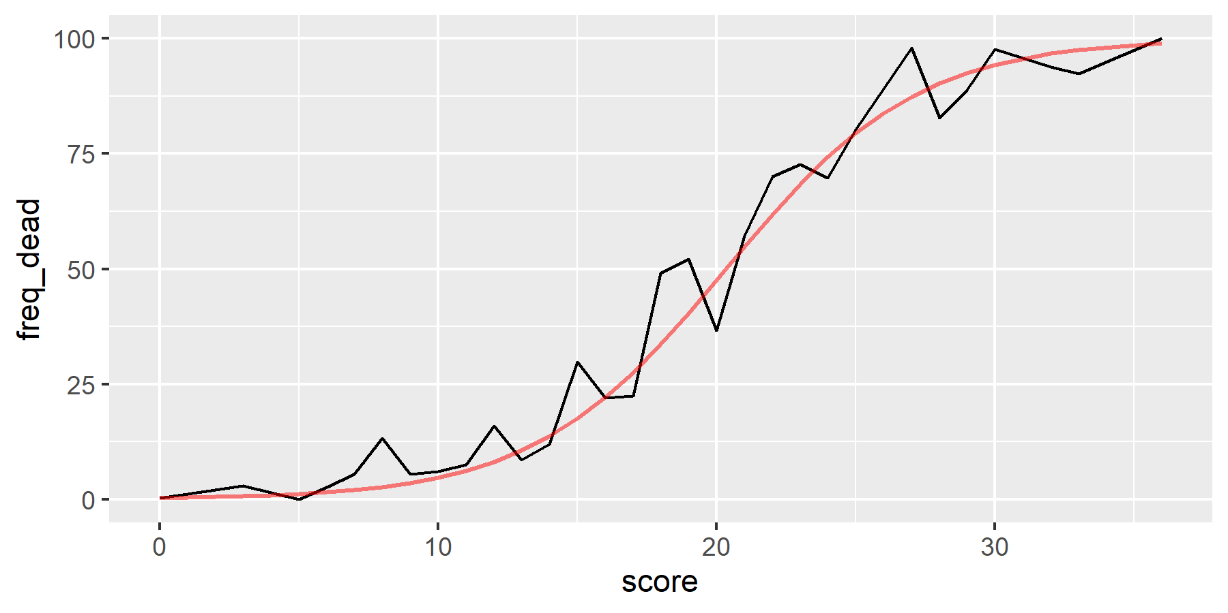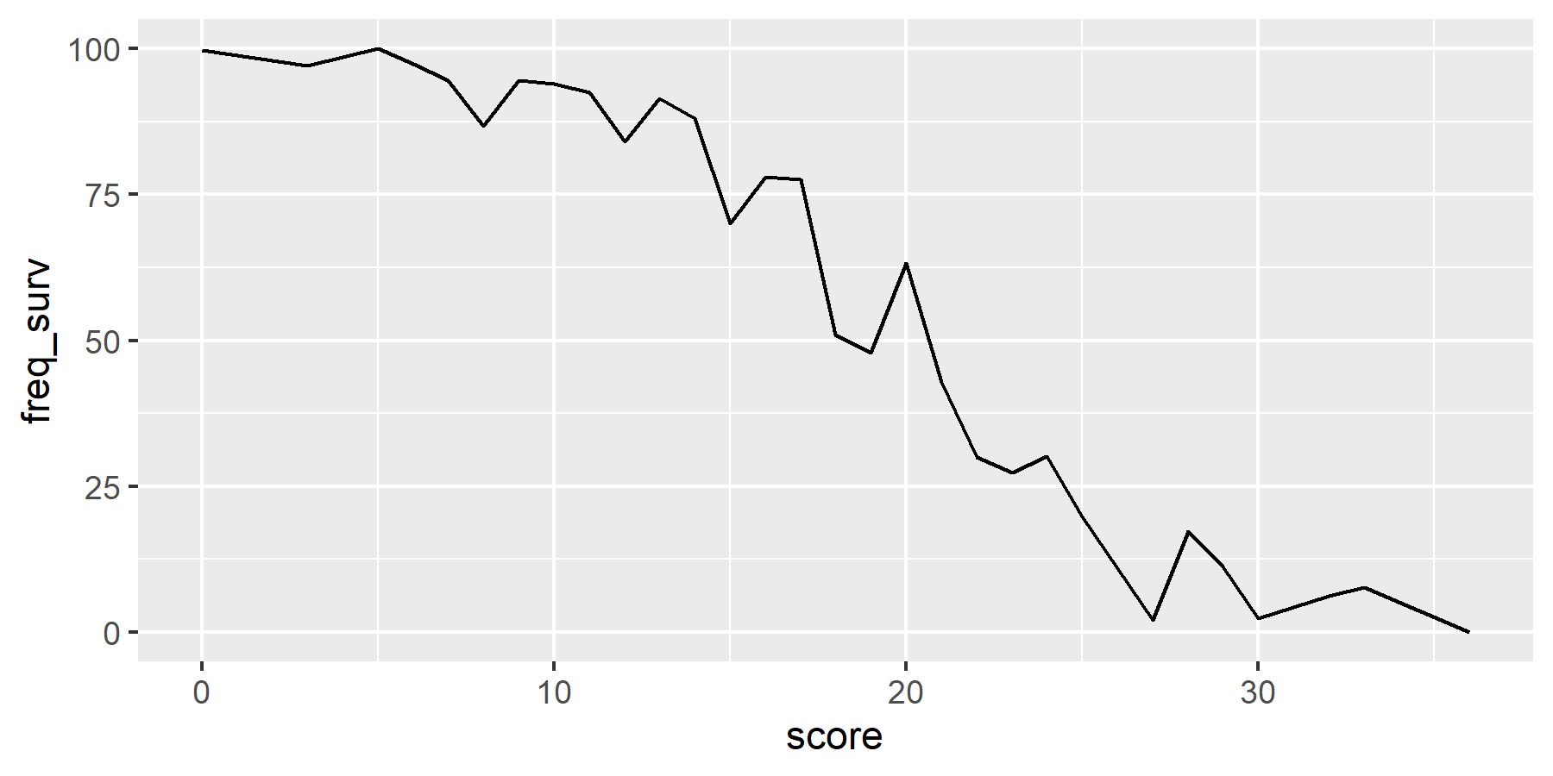

## # A tibble: 32 × 11  
## # Rowwise:   
## score TP FP TN FN Sensitivity Specificity LCL_Se UCL_Se LCL_Sp  
## <dbl> <int> <int> <int> <int> <dbl> <dbl> <dbl> <dbl> <dbl>  
## 1 0 964 1872 386 1 99.9 17.1 99.4 100. 15.6  
## 2 3 959 1711 547 6 99.4 24.2 98.7 99.8 22.5  
## 3 4 956 1517 741 9 99.1 32.8 98.2 99.6 30.9  
## 4 5 956 1503 755 9 99.1 33.4 98.2 99.6 31.5  
## 5 6 953 1390 868 12 98.8 38.4 97.8 99.4 36.4  
## 6 7 947 1286 972 18 98.1 43.0 97.1 98.9 41.0  
## 7 8 937 1221 1037 28 97.1 45.9 95.8 98.1 43.9  
## 8 9 931 1116 1142 34 96.5 50.6 95.1 97.5 48.5  
## 9 10 922 974 1284 43 95.5 56.9 94.0 96.8 54.8  
## 10 11 917 912 1346 48 95.0 59.6 93.5 96.3 57.6  
## # ℹ 22 more rows  
## # ℹ 1 more variable: UCL_Sp <dbl>

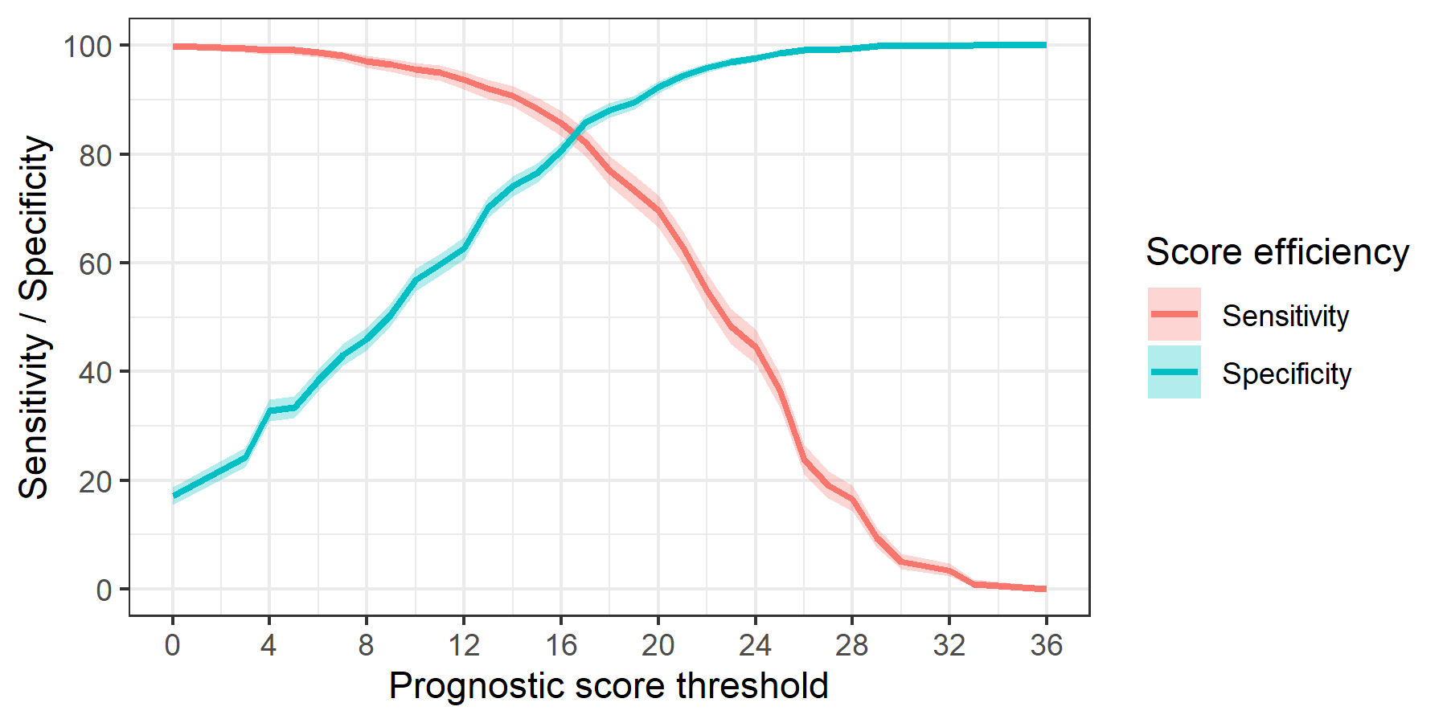

## score M LCL UCL  
## 1 0 8.776166 8.4377045 9.114627  
## 2 10 7.844253 7.5035543 8.184953  
## 3 4 8.563087 8.2250594 8.901114  
## 4 6 8.412134 8.0734818 8.750786  
## 5 9 8.062967 7.7231788 8.402755  
## 6 13 7.370575 7.0277861 7.713364  
## 7 17 6.528416 6.1763555 6.880476  
## 8 11 7.687636 7.3469988 8.028272  
## 9 7 8.332634 7.9958885 8.669379  
## 10 8 8.184794 7.8473791 8.522209  
## 11 15 6.877854 6.5330571 7.222651  
## 12 16 6.815944 6.4672302 7.164657  
## 13 22 5.028007 4.6637202 5.392293  
## 14 18 6.113493 5.7652951 6.461691  
## 15 14 7.068694 6.7253250 7.412062  
## 16 19 5.838493 5.4882593 6.188726  
## 17 25 4.296037 3.8961688 4.695906  
## 18 21 5.360656 5.0043883 5.716923  
## 19 3 8.639004 8.3013150 8.976693  
## 20 12 7.555071 7.2124366 7.897705  
## 21 23 4.673585 4.2991748 5.047995  
## 22 26 3.914773 3.5004393 4.329106  
## 23 20 5.701556 5.3419200 6.061192  
## 24 24 4.495708 4.1075540 4.883862  
## 25 5 8.444561 8.1061924 8.782929  
## 26 32 2.770833 1.9169047 3.624762  
## 27 29 3.387500 2.7970263 3.977974  
## 28 27 3.895652 3.4020398 4.389265  
## 29 33 2.696970 1.6462797 3.747660  
## 30 28 3.592391 3.0282949 4.156488  
## 31 30 3.258427 2.4769665 4.039887  
## 32 36 1.888889 0.1941351 3.583643

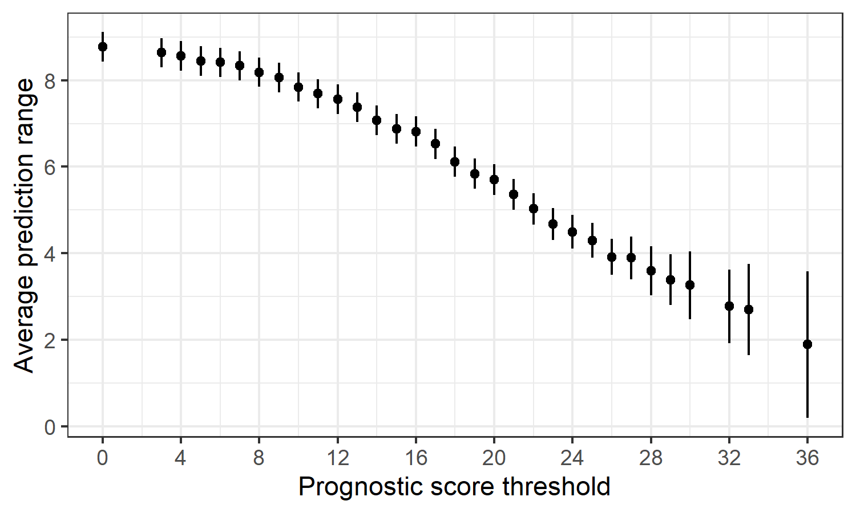

## # A tibble: 20 × 3  
## name `Patients with analysis` `%`  
## <chr> <int> <dbl>  
## 1 crp 2833 89.4  
## 2 d-dimer 2025 63.9  
## 3 eozinofils 2244 70.8  
## 4 glucose 3170 100.   
## 5 hg 3196 101.   
## 6 lymphocytes 3142 99.1  
## 7 metamielocite 1153 36.4  
## 8 mielocite 1309 41.3  
## 9 monocite 3140 99.1  
## 10 nesegmentate 3128 98.7  
## 11 plasmatic_cells 606 19.1  
## 12 platelets 3196 101.   
## 13 potasium 2915 92.0  
## 14 protein_total 3147 99.3  
## 15 prothrombin_index 2316 73.1  
## 16 segmentate 3142 99.1  
## 17 sodium 2921 92.2  
## 18 tt 2317 73.1  
## 19 urea 3161 99.7  
## 20 wbc 3196 101.

| **name** | **Outcome** | **Patients with analysis** | **%** |
| --- | --- | --- | --- |
| crp | 0 | 1,919 | 84.7 |
| 1 | 914 | 101.1 |
| d-dimer | 0 | 1,207 | 53.3 |
| 1 | 818 | 90.5 |
| eozinofils | 0 | 1,541 | 68.0 |
| 1 | 703 | 77.8 |
| glucose | 0 | 2,211 | 97.6 |
| 1 | 959 | 106.1 |
| hg | 0 | 2,234 | 98.6 |
| 1 | 962 | 106.4 |
| lymphocytes | 0 | 2,196 | 97.0 |
| 1 | 946 | 104.6 |
| metamielocite | 0 | 618 | 27.3 |
| 1 | 535 | 59.2 |
| mielocite | 0 | 962 | 42.5 |
| 1 | 347 | 38.4 |
| monocite | 0 | 2,194 | 96.9 |
| 1 | 946 | 104.6 |
| nesegmentate | 0 | 2,183 | 96.4 |
| 1 | 945 | 104.5 |
| plasmatic_cells | 0 | 452 | 20.0 |
| 1 | 154 | 17.0 |
| platelets | 0 | 2,234 | 98.6 |
| 1 | 962 | 106.4 |
| potasium | 0 | 1,997 | 88.2 |
| 1 | 918 | 101.5 |
| protein_total | 0 | 2,189 | 96.6 |
| 1 | 958 | 106.0 |
| prothrombin_index | 0 | 1,373 | 60.6 |
| 1 | 943 | 104.3 |
| segmentate | 0 | 2,196 | 97.0 |
| 1 | 946 | 104.6 |
| sodium | 0 | 2,001 | 88.3 |
| 1 | 920 | 101.8 |
| tt | 0 | 1,374 | 60.7 |
| 1 | 943 | 104.3 |
| urea | 0 | 2,203 | 97.3 |
| 1 | 958 | 106.0 |
| wbc | 0 | 2,234 | 98.6 |
| 1 | 962 | 106.4 |

Оценка шансов

## # A tibble: 3,223 × 3  
## # Groups: id [3,223]  
## id Outcome max_score  
## <fct> <fct> <dbl>  
## 1 1040082 0 10  
## 2 1040083 0 10  
## 3 1040084 1 17  
## 4 1040093 1 13  
## 5 1040103 0 9  
## 6 1040105 0 9  
## 7 1040133 0 13  
## 8 1040140 1 15  
## 9 1040141 0 0  
## 10 1040147 0 4  
## # ℹ 3,213 more rows

##   
## Call:  
## glm(formula = Outcome ~ max_score, family = binomial, data = score_9_max)  
##   
## Coefficients:  
## Estimate Std. Error z value Pr(>|z|)   
## (Intercept) -5.266594 0.183332 -28.73 <2e-16 ***  
## max_score 0.265637 0.009531 27.87 <2e-16 ***  
## ---  
## Signif. codes: 0 '***' 0.001 '**' 0.01 '*' 0.05 '.' 0.1 ' ' 1  
##   
## (Dispersion parameter for binomial family taken to be 1)  
##   
## Null deviance: 3934.4 on 3222 degrees of freedom  
## Residual deviance: 2213.1 on 3221 degrees of freedom  
## AIC: 2217.1  
##   
## Number of Fisher Scoring iterations: 6

## max_score outcome_pr ci_low_pr ci_up_pr odd ci_low_odd ci_up_odd  
## 1 1 0.006686493 0.004418291 0.008954695 0.00673 0.00444 0.00904  
## 2 2 0.008703228 0.005909850 0.011496606 0.00878 0.00594 0.01163  
## 3 3 0.011321304 0.007894393 0.014748214 0.01145 0.00796 0.01497  
## 4 4 0.014715249 0.010529744 0.018900754 0.01494 0.01064 0.01926  
## 5 5 0.019106983 0.014021170 0.024192796 0.01948 0.01422 0.02479  
## 6 6 0.024776459 0.018633542 0.030919377 0.02541 0.01899 0.03191  
## 7 7 0.032073192 0.024705115 0.039441270 0.03314 0.02533 0.04106  
## 8 8 0.041427547 0.032661906 0.050193188 0.04322 0.03376 0.05285  
## 9 9 0.053359756 0.043030573 0.063688940 0.05637 0.04497 0.06802  
## 10 10 0.068483218 0.056445906 0.080520530 0.07352 0.05982 0.08757  
## 11 11 0.087496856 0.073646660 0.101347052 0.09589 0.07950 0.11278  
## 12 12 0.111159484 0.095450695 0.126868274 0.12506 0.10552 0.14530  
## 13 13 0.140237950 0.122698363 0.157777536 0.16311 0.13986 0.18733  
## 14 14 0.175421857 0.156154019 0.194689694 0.21274 0.18505 0.24176  
## 15 15 0.217202929 0.196363211 0.238042647 0.27747 0.24434 0.31241  
## 16 16 0.265728331 0.243481186 0.287975476 0.36189 0.32184 0.40445  
## 17 17 0.320654025 0.297115705 0.344192345 0.47200 0.42271 0.52484  
## 18 18 0.381041253 0.356249528 0.405832977 0.61562 0.55340 0.68303  
## 19 19 0.445345708 0.419296532 0.471394884 0.80292 0.72205 0.89177  
## 20 20 0.511533614 0.484287056 0.538780172 1.04722 0.93906 1.16816  
## 21 21 0.577319546 0.549116125 0.605522967 1.36585 1.21787 1.53500  
## 22 22 0.640472673 0.611782734 0.669162612 1.78143 1.57588 2.02263  
## 23 23 0.699107840 0.670583717 0.727631963 2.32345 2.03567 2.67150  
## 24 24 0.751884786 0.724246672 0.779522901 3.03039 2.62643 3.53562  
## 25 25 0.798078298 0.771989971 0.824166626 3.95241 3.38577 4.68720  
## 26 26 0.837529973 0.813507871 0.861552076 5.15498 4.36216 6.22293  
## 27 27 0.870524060 0.848895999 0.892152122 6.72344 5.61796 8.27232  
## 28 28 0.897636697 0.878544401 0.916728993 8.76913 7.23346 11.00898  
## 29 29 0.919596254 0.903025698 0.936166810 11.43723 9.31201 14.66583  
## 30 30 0.937174636 0.922997881 0.951351391 14.91714 11.98666 19.55557  
## 31 31 0.951114219 0.939131005 0.963097433 19.45585 15.42873 26.09839  
## 32 32 0.962086036 0.952058779 0.972113293 25.37551 19.85888 34.85938  
## 33 33 0.970671296 0.962351303 0.978991289 33.09629 25.56134 46.59930  
## 34 34 0.977358257 0.970503495 0.984213018 43.16621 32.90232 62.34333  
## 35 35 0.982547998 0.976933894 0.988162102 56.30002 42.35366 83.47445  
## 36 36 0.986564545 0.981989584 0.991139506 73.42993 54.52342 111.86053

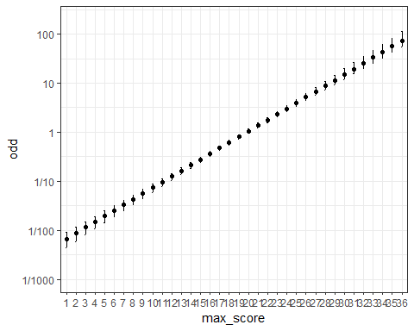

| **Score range** | **Expected death/discharge odds** | **Risk grade** |
| --- | --- | --- |
| <4 | < 1:100 | Very Low |
| [4, 8) | 1:100 - 1:25 | Low |
| [8, 14) | 1:25 - 1:5 | Average |
| [14, 20) | 1:5 - 1:1 | High |
| >=20 | >1:1 | Very High |

