Whodas

Oleg

14 12 2021

Whodas <- read_xlsx("date/Whodas.xlsx", sheet = "Unite for analysis")  
  
  
df <- Whodas

df_long <- df %>%  
 pivot_longer(c(2:15), names_to = "Parameters", values_to = "Value")  
print(df_long)  
#> # A tibble: 546 x 3  
#> ID Parameters Value  
#> <dbl> <chr> <dbl>  
#> 1 2 Do1 60   
#> 2 2 Do2 75   
#> 3 2 Do3 60   
#> 4 2 Do4 58.3  
#> 5 2 Do51 90   
#> 6 2 Do6 79.2  
#> 7 2 st_s32 70.6  
#> 8 2 Do1F 40   
#> 9 2 Do2F 50   
#> 10 2 Do3F 60   
#> # ... with 536 more rows

plt_0 <- ggwithinstats(  
 data = subset(df_long,Parameters == "Do1" | Parameters == "Do1F"),  
 type = "nonparametric",   
 x = Parameters,  
 y = Value,  
 xlab = "Measurements",  
 ylab = "Do1"  
)  
plt_0

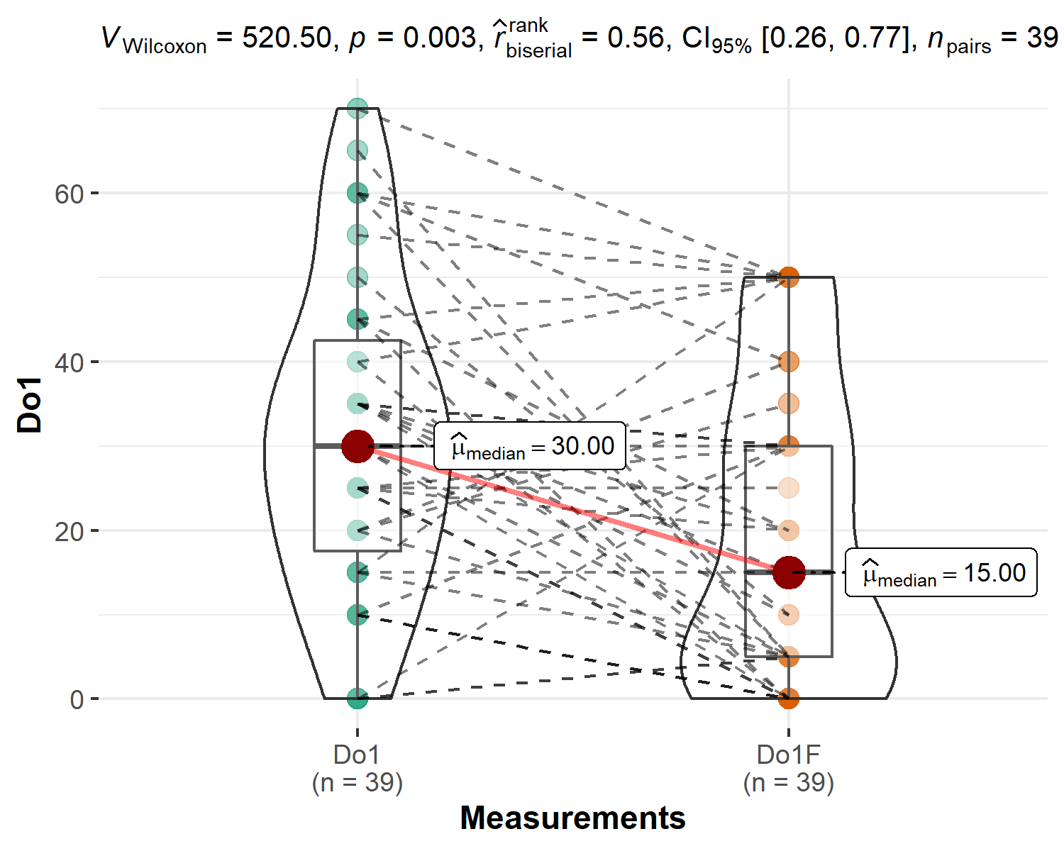

plt_0 <- ggwithinstats(  
 data = subset(df_long,Parameters == "Do2" | Parameters == "Do2F"),  
 type = "nonparametric",   
 x = Parameters,  
 y = Value,  
 xlab = "Measurements",  
 ylab = "Do2"  
)  
plt_0

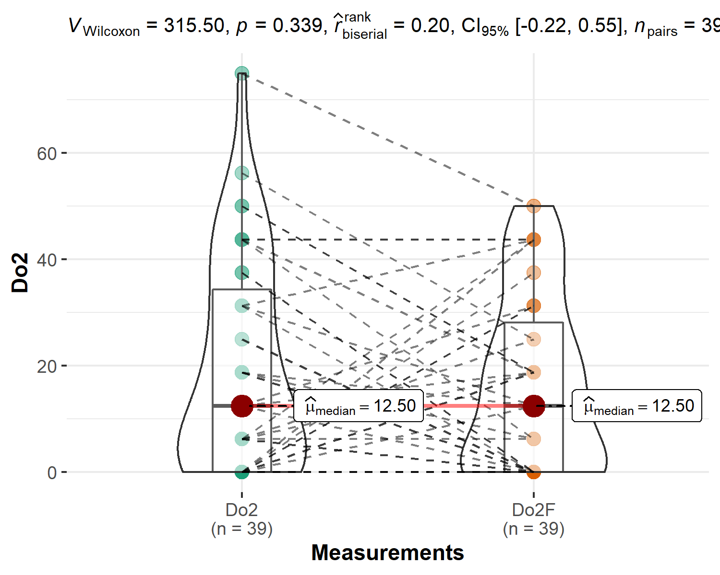

plt_0 <- ggwithinstats(  
 data = subset(df_long,Parameters == "Do3" | Parameters == "Do3F"),  
 type = "nonparametric",   
 x = Parameters,  
 y = Value,  
 xlab = "Measurements",  
 ylab = "Do3"  
)  
plt_0

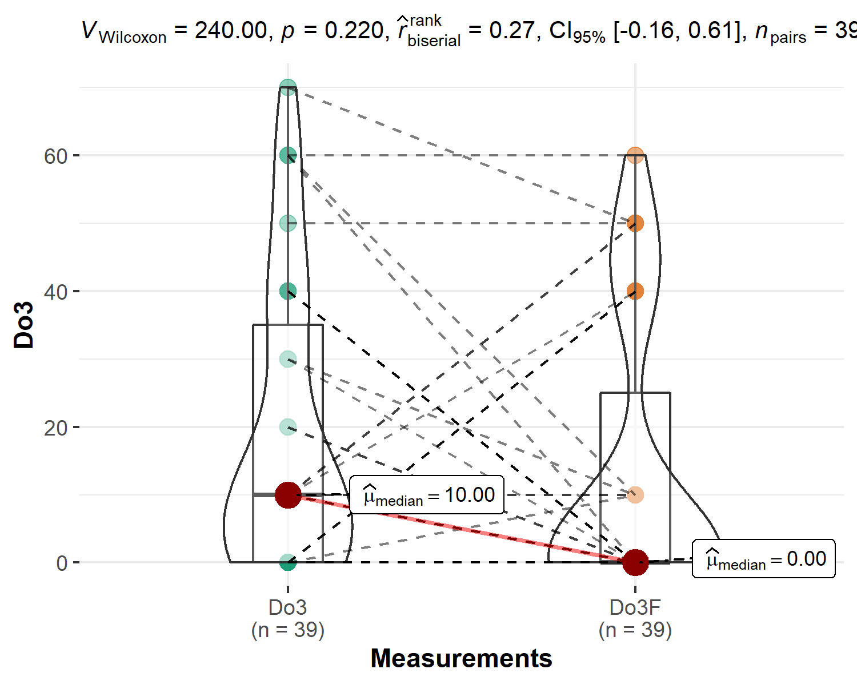

plt_0 <- ggwithinstats(  
 data = subset(df_long,Parameters == "Do4" | Parameters == "Do4F"),  
 type = "nonparametric",   
 x = Parameters,  
 y = Value,  
 xlab = "Measurements",  
 ylab = "Do4"  
)  
plt_0

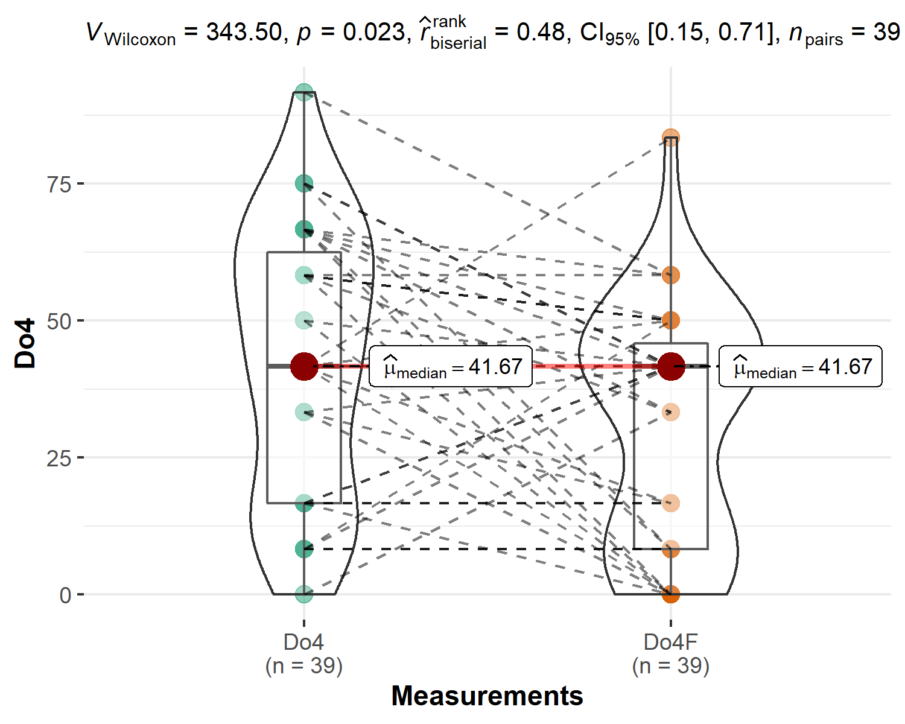

plt_0 <- ggwithinstats(  
 data = subset(df_long,Parameters == "Do51" | Parameters == "Do51F"),  
 type = "nonparametric",   
 x = Parameters,  
 y = Value,  
 xlab = "Measurements",  
 ylab = "Do51"  
)  
plt_0

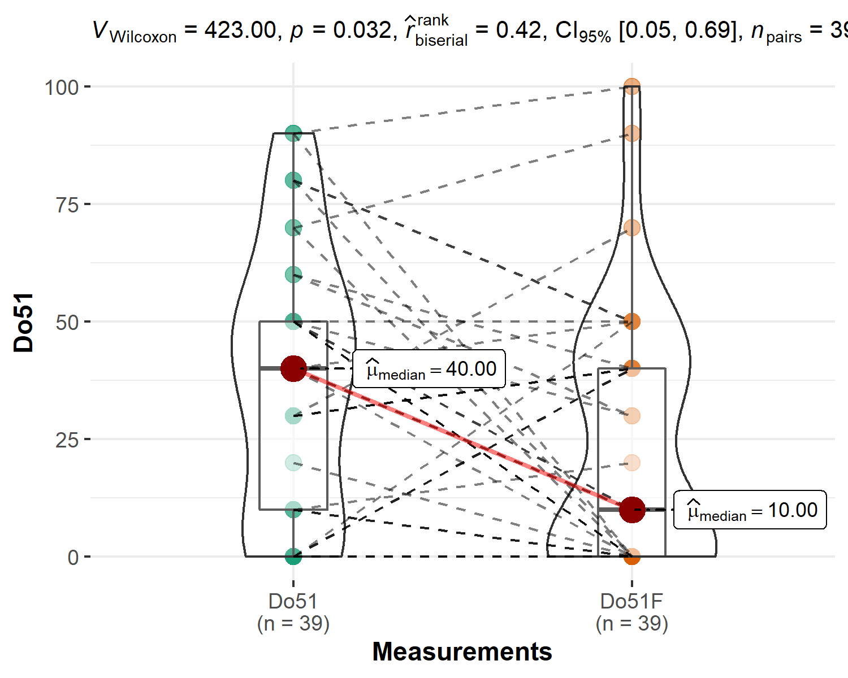

plt_0 <- ggwithinstats(  
 data = subset(df_long,Parameters == "Do6" | Parameters == "Do6F"),  
 type = "nonparametric",   
 x = Parameters,  
 y = Value,  
 xlab = "Measurements",  
 ylab = "Do6"  
)  
plt_0

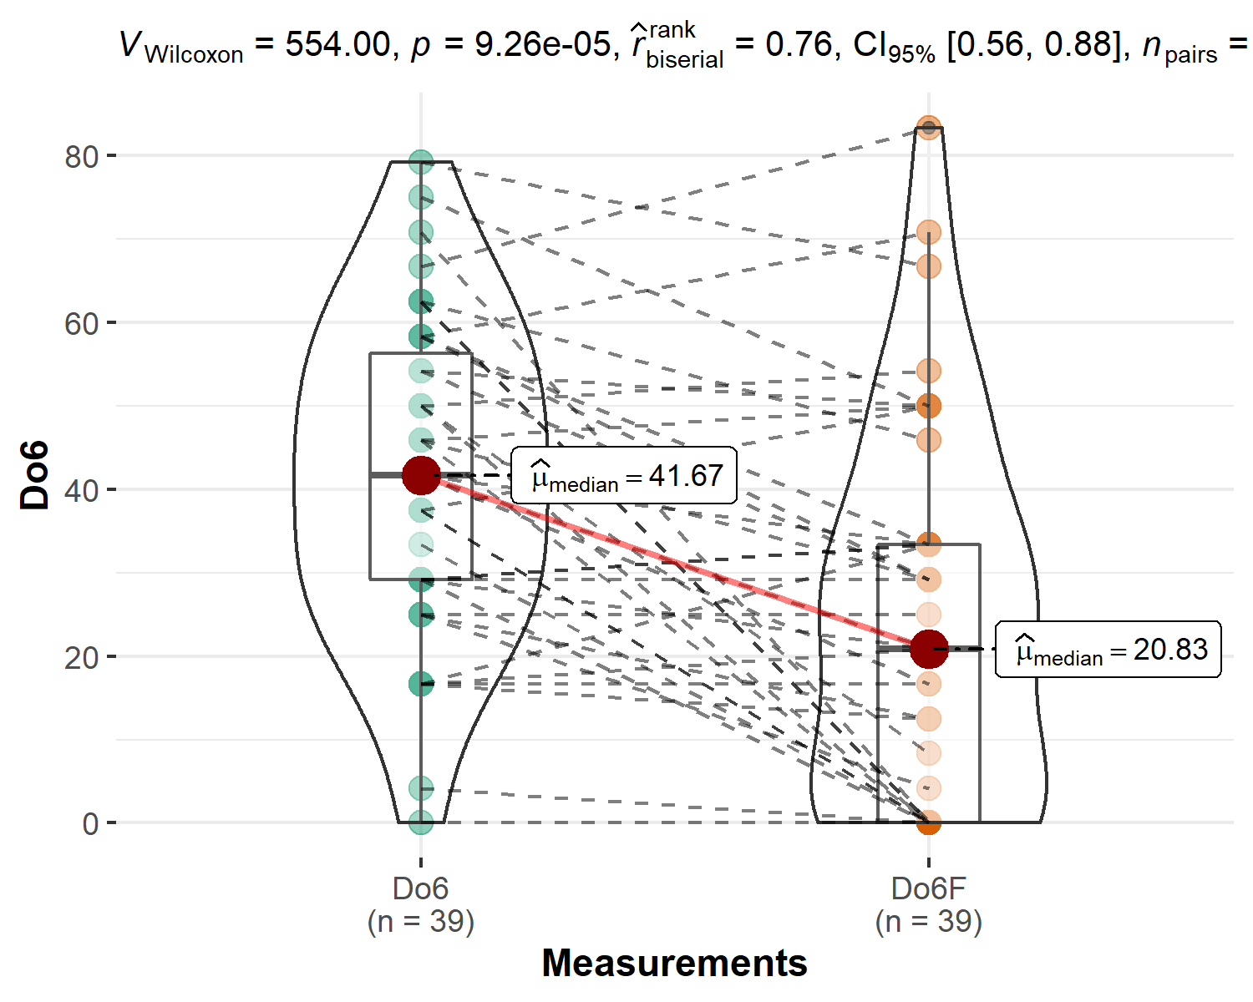

plt_0 <- ggwithinstats(  
 data = subset(df_long,Parameters == "st_s32" | Parameters == "st_s32F"),  
 type = "nonparametric",   
 x = Parameters,  
 y = Value,  
 xlab = "Measurements",  
 ylab = "st_s32"  
)  
plt_0

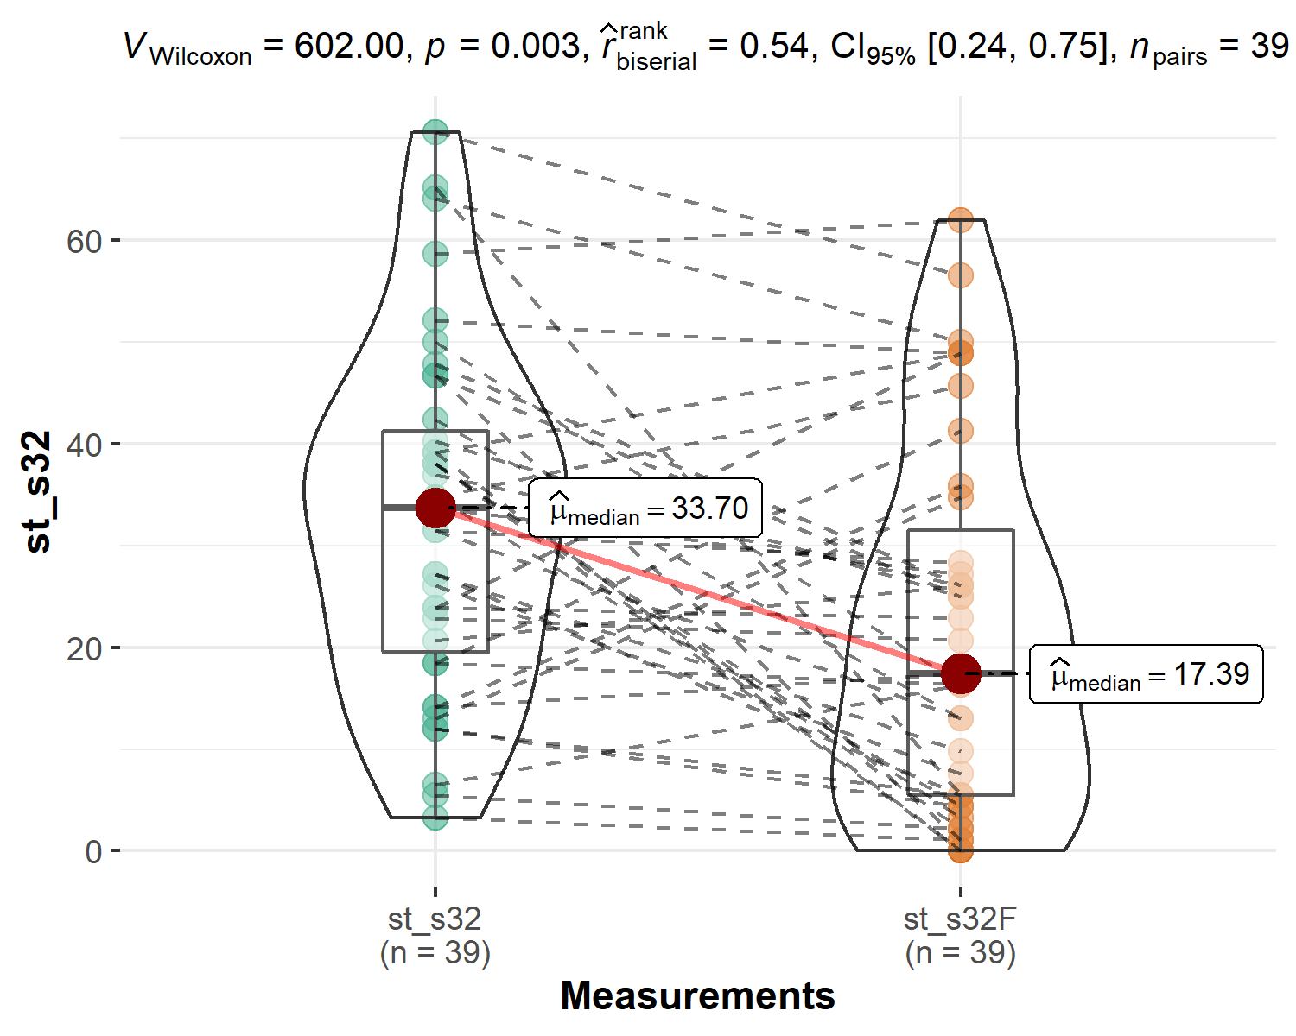

### Graphs dor initial situation  
  
df_long_alternativ <- df %>%  
 pivot_longer(c(2:8), names_to = "Parameters", values_to = "Value")  
  
df_long_alternativ$Parameters = as.factor(df_long_alternativ$Parameters)  
  
  
ggplot(df_long_alternativ, aes(x = Parameters, y = Value, fill=Parameters))+  
 geom_boxplot(alpha=0.6)+  
 ggtitle("Profilul initial indicatorilor Whodas")

