

Beyond the Diagnosis:
A Demographic and Behavioral Profiling of Autism Spectrum Traits

Course Code: CSD301
Course Title: Descriptive Analytics Project

Group Name: Insight Igniters
Group Members:
Yagya Mahajan (12400421)
Arnav Jain (12419975)

Table of Contents

S.no. | Sections | Page no.
1. | Problem Statement | 3
2. | Project Goal/Objectives | 3-4
3. | Project Vision | 4
4. | Methodology | 4-5
5. | Dataset Details | 5-6
6. | Columns Description | 6-11
7. | Preprocessing and Feature Engineering | 11-16
8. | Exploratory Data Analysis and Visual Insights | 17-20
9. | Hypothesis Testing | 21-22
10. | Conclusion | 23-24
11. | Recommendations | 24-25
12. | Next Step | 25-26
13. | Dashboard | 26-27

- Problem Statement
Autism Spectrum Disorder (ASD) is a condition characterized by challenges with fundamental social interaction cues and conventional non-verbal communication methods. It is marked by atypical behavioural patterns and presents diverse manifestations through variations in observable traits such as eye contact patterns, social mimicry, gestural communication, and imaginative engagement.
ASD presents diverse manifestations across different demographics and populations. The current challenge lies in understanding how behavioural traits, such as eye contact patterns, social mimicry, gestural communication, and imaginative engagement, vary significantly across gender, age groups, and critical medical backgrounds like jaundice history and genetic predisposition. By systematically analysing screening data, this project aims to uncover hidden demographic disparities, identify behavioural clusters, and provide a nuanced understanding of how autism spectrum traits manifest across diverse populations. This data-driven approach moves beyond binary diagnostic classifications to reveal the complexity of ASD across different demographic segments.

- Project Goal/Objective
The core objectives guiding this analysis include:
- Identify demographic patterns: Analyze how ASD traits vary across specific parameters like gender, age groups, and medical risk factors.
- Uncover behavioral clusters: Discover correlations between specific, observable behavioral traits and definitive ASD diagnosis.
- Assess risk factors: Evaluate the cumulative and isolated impact of a history of jaundice history and family genetics on ASD manifestation.
- Generate actionable insights: Move beyond binary diagnostic categorizations to create a comprehensive understanding of the spectrum through detailed feature extraction and statistical profiling.
- Build composite scoring systems: Develop meaningful, aggregated metrics – such as Social Interaction, Communication Deficit, and Behavioral Atypicality scores – to deeply characterize patient presentations.

- Project Vision
To develop an end-to-end exploratory data analysis pipeline that transforms raw autism screening responses into highly actionable demographic and behavioral insights. This will enable clinicians, researchers, and policymakers to accurately understand ASD manifestations across diverse populations and quickly identify high-risk demographic groups that require targeted, early interventions.

- Methodology
A systematic, step-by-step approach was taken to process and evaluate the screening dataset using a Python-based data stack (pandas, NumPy, matplotlib, seaborn and missingno)
- Data Integration & Loading: Integration of the raw dataset comprising 6,075 individual responses into a structured Data Frame.
- Data Exploration & Profiling: Inspection of data distributions, data type validation, and robust validation of missing values visually via the missingno missing data matrix.
- Data Standardization: Cleaning and mapping categorical variables (e.g., mapping ‘m’/’f’ to ‘Male’/’Female’) to eliminate phantom categories and establish a consistent baseline.
- Variable Categorization: Grouping continuous data (like age) into standardized demographic segments and mapping positive/negative diagnosis strings to binary indicators.
- Risk Factor Identification: Creating composite variables and intersectional subsets to highlight combined risk effects (e.g., overlapping genetic and medical risks).
- Feature Engineering: Designing logic-based clusters, inverse coding for deficit measurement, and constructing composite proxy variables that tell a deeper clinical story.

- Dataset Details
Source: Autism Spectrum Disorder Screening Dataset
Data Type: Cross-sectional behavioral screening responses. It combines categorical behavioral indicators (binary Yes/No) with continuous demographic variables and clinical risk factors.
Data Structure: The initial raw dataset contained exactly 6,075 individual screening records and 15 original columns. Through extensive feature engineering, this was expanded to over 26 robust analytical features.
Completeness: A visual check using the missing data matrix confirmed that the dataset is highly robust, containing exactly 6,075 non-null entries for every column, indicating zero missing values.
Demographic Breakdown:
- Gender Distribution: The dataset leans slightly towards Males
- 3,508 Males (57.8%)
- 2,567 Females (42.2%)
- Age Range and Distribution: Patient ages range widely from 1 to 68 years old, with a mean age of 19.84 years. When segmented into distinct life stages, the data is distributed among:
- 2,303 Children (37.9%)
- 678 Adolescents (11.2%)
- 3,094 Adults (50.9%)
Medical Risk Factors:
- Jaundice History:
- 1,045 individuals (17.2%) born with jaundice
- 5,030 individuals (82.8%) were born without jaundice
- Family ASD History:
- 1,122 individuals (18.5%) have a history of ASD within family
- 4,953 individuals (81.5%) don’t have a history of ASD within family.

Target Variable Distribution (Class):
After standardization, the overall screening outcome shows 4,271 individuals (70.3%) without an ASD diagnosis (0) and 1,804 individuals (29.7%) receiving a positive ASD diagnosis (1).

- Columns Description
The processed dataset features both raw behavioral inputs and advanced engineered metrics:
6.1 Behavioral Assessment Questions (A1-A10)
Ten purely binary questions (1 = Yes, 0 = No) assessing foundational autism spectrum traits
Columns | Description | Interpretation
A1 | Make eye contact when someone calls your name? | Measures responsive eye contact and attention orienting
A2 | Easy for others to get eye contact with you? | Assesses spontaneous eye contact ability
A3 | Point to request something you want? | Evaluates imperative pointing (request-based communication)
A4 | Point to share something interesting with others? | Evaluates declarative pointing (social sharing intent)
A5 | Engage in imaginative activities or role-play? | Measures imaginative play and pretense capacity
A6 | Follow others' gaze to see what they're looking at? | Assesses joint attention and gaze-following skills
A7 | Try to comfort someone who appears upset? | Evaluates empathic response and emotional awareness
A8 | Describe your communication style as typical? | Self-assessment of communication normalcy
A9 | Use common gestures (like waving goodbye)? | Evaluates gestural communication proficiency
A10 | Sometimes stare into space without focus? | Assesses atypical attention patterns and space-staring behaviors
Scoring Convention: For most items, 1 = "Yes" (trait present) and 0 = "No" (trait absent). For A10, 1 indicates atypical space-staring behavior.
  - Demographic Variables
Column | Description | Value/Ranges
Age | Client’s Age in years | 1-68 years
Age Group | Categorized age bracket | Child (<13), Adolescent (13–17), Adult (18+)
Generational_Cohort | Maps age intervals to generational cohorts | Gen Alpha (Child), Gen Z, Millennial, Gen X, Boomer
Sex | Biological Sex/Gender | Male, Female

  - Medical Risk Factors
Column | Description | Values
Jaundice | History of jaundice at birth | Yes, No
Family ASD | Family history of autism spectrum disorder | Yes, No
High_Risk_Background | Combined risk indicator | 0 (neither risk factor), 1 (both jaundice and family ASD history)
Risk_Overlap | Describes the combination of background risk factors (e.g., Jaundice, Family ASD) | ‘Neither’, 'Family ASD Only', 'Jaundice Only', 'Both (High Risk)'

  - Target Variable
Column | Description | Values
Class | ASD Diagnosis Status | Yes (Potential ASD), No (Typical)

  - Engineered Composite Feature
Column | Calculation | Range | Interpretation
Total_Atypical_Trait_  Burden | (1-A1) + (1-A2) + (1-A3) + (1-A4) + (1-A5) + (1-A6) + (1-A7) + (1-A8) + (1-A9) + (A10) | 0-10 | A global severity metric representing the total sum of atypical behavioral traits.
Social_Interaction_Score | A1+A2+A6 | 0-3 | Sum of eye contact (A1, A2) and gaze-following (A6). Higher scores = Better social interaction abilities.
Communication_Deficit_  Score | (1-A3) + (1-A4) +  (1-A9) | 0-3 | Inverse Scoring for imperative pointing (A-3), declarative pointing (A4), and gestures(A9). Higher the scores = greater communication deficits.
Behavioral_Atypicality_  Score | (1-A5) + (1-A7) + (1-A8) + (A10) | 0-4 | Combines inverse scores for imagination (A5), empathy (A7), communication style (A8), plus direct score for space-staring (A10).  Higher scores = greater behavioral atypicality.

Score Rationale:
- Total Atypical Trait Burden provides a unified spectrum scale, moving away from binary categorization.
- Social Interaction Score directly reflects capabilities (higher is better).
- Communication Deficit Score uses inverse coding (1 - value) to represent deficits rather than abilities.
- Behavioral Atypicality Score uses inverse coding for normative traits (A5, A7, A8) while directly scoring atypical behavior (A10).

  - Clinical Profile and Archetypes
Column | Description | Interpretation
Social_Comm_  Imbalance_Profile | Evaluates the ratio between social motivation and communication ability. | Socially Motivated but Comm Blocked: Strong social skills but severe communication deficits.  Capable but Socially Withdrawn: No communication deficits but extremely poor  Other Profile: Standard presentation.
Eye_Contact_  Discordance | Flags internal behavioral contradictions by comparing spontaneous eye contact with eye contact when called. | Fully Typical: Consistent eye contact.  Global Deficit: Consistent lack of eye contact.  Discordant / Masked: Inconsistent presentation, highlighting potential masking.
Empathy_  Imagination_Profile | A derived category classifying patients based on specific empathy and imagination traits. | Isolated Emotional Deficit: Struggles with empathy but engages in imagination.  Global Cognitive/Emotional Deficit: Struggles with both empathy and imagination.  Other: Standard presentation.
Genetic_Severity_  Matrix | Categorization of genetic risk based on Family_ASD and symptomatic severity traits. | Segregates patients into High, Intermediate, and Low Genetic Penetrance based on the presence of Family ASD and the Total Trait Burden.
Diagnostic_Proximity  _Band | A tri-level categorization classifying patients based on their proximity to a positive diagnosis. | - Clear Negative (Score 0-3)  - Borderline/Monitor (Score 4-5)  - Clinical Range (Score 6+)
Behavioral_Archetype | A qualitative profile representing the individual's clustered behavioral presentation. | Cascading logic categorizing patients into:  - Severe Global Delay  - Communication Impaired  - Socially Withdrawn  - Highly Atypical Presentation  - Mild/Typical Presentation

  - Healthcare Proxy Flags
- Late_Diagnosis_Flag: Highlights potential intervention delays. Triggers 1 if the patient's Age is >= 18 and they receive a positive ASD diagnosis.
- Masking_Proxy_Flag: Uncovers successful camouflage of autistic traits. Triggers 1 if a patient is diagnosed with ASD but still describes their communication style as typical.
- Sub_Clinical_Missed_Flag: A critical audit metric identifying potentially missed cases. Triggers 1 if a patient exhibits a severe trait burden (>=7) but receives a negative diagnosis.
- Compensatory_Masking_Flag: A proxy metric isolating older individuals (Age >= 13) who exhibit a high global trait burden (>= 5) but score a perfect 0 on social interaction deficits, algorithmically flagging potential camouflaging.

- Preprocessing and Feature Engineering
  - Data Cleaning Steps
- Initial Data Assessment: Successfully loaded 6,075 complete records. All 10 behavioral assessment items (A1–A10) were properly coded as binary (0/1) values. Verified that no missing values were present using a missing data matrix.
- Data Validation & Harmonization: Standardized the Sex column (mapping 'm'/'f' to 'Male'/'Female') and standardized binary response columns (Jaundice, Family_ASD, Class) to title-cased 'Yes'/'No' strings to prevent downstream statistical errors.

  - Preprocessing Techniques
- Biological Outlier Treatment (Age): Detected 14 biologically implausible age outliers (values up to 80). Applied statistical Winsorization using the Interquartile Range (IQR) method, successfully capping extreme age values at 67 years to preserve valuable behavioral data while maintaining biological reality.
- Age Categorization: Created the Age_Group variable by segmenting continuous age into 'Child' (0-12), 'Adolescent' (13-18), and 'Adult' (19+). Further expanded this into Generational_Cohort (Gen Alpha, Gen Z, Millennial, Gen X, Boomer) to control for generational screening biases.
- Medical Risk Factor Analysis: Engineered the Risk_Overlap categorical column to distinguish between 'Family ASD Only', 'Jaundice Only', 'Both', and 'Neither'. Created the High_Risk_Background binary flag to mathematically isolate patients possessing both medical risk factors.

  - Feature Engineering
The initial dataset provided 15 baseline columns, including raw binary survey responses (A1-A10), basic demographics, and initial medical history. A simple sum of positive survey answers is insufficient for a deep clinical understanding of the autism spectrum. To move beyond generic binary classification, 19 new features were engineered to capture developmental stages, relational imbalances, internal behavioral contradictions, and genetic penetrance.

    - Demographic & Medical Risk Transformations
Raw demographic and medical inputs were transformed to allow for categorical clustering and compounding risk analysis.
- Age_Group
  - Rationale: Autism traits and diagnostic criteria present differently across various life stages. Segmenting continuous age into standard brackets controls these developmental differences and simplifies group-based visual comparisons.
  - Interpretation: Classifies patients into 'Child' (0-12), 'Adolescent' (13-17), or 'Adult' (18+).
- Generational_Cohort
  - Rationale: Societal awareness and clinical screening standards for ASD have evolved drastically over the decades. This feature provides a sociological lens to help control for historical or generational screening biases.
  - Interpretation: Maps the patient’s age to broader cohorts such as 'Gen Alpha', 'Gen Z', 'Millennial', etc.
- Risk_Overlap
  - Rationale: A patient's medical background is rarely one-dimensional. This categorical text column was engineered to explicitly group patients by the specific nature of their combined medical background.
  - Interpretation: Differentiates patients into mutually exclusive categories: 'Family ASD Only', 'Jaundice Only', 'Both (High Risk)', or 'Neither'.
- High_Risk_Background
  - Rationale: Designed to mathematically isolate and track the compounding effect of possessing multiple severe biological risk factors simultaneously.
  - Interpretation: A strict binary flag where 1 indicates the simultaneous presence of both Jaundice and a Family History of ASD, and 0 indicates the absence of this specific overlap.
- Patient_ID
  - Rationale: Essential for robust database management and data architecture. It ensures row-level integrity during complex grouping and sorting operations without utilizing Personally Identifiable Information (PII).
  - Interpretation: A unique, algorithmically generated alphanumeric index (e.g., PT_0001) for each patient.

    - Macro-Level Severity Scores
These features aggregate the raw binary survey inputs (A1-A10) into continuous mathematical scales, allowing for nuanced tracking of specific clinical domains.

- Total_Atypical_Trait_Burden
  - Rationale: Shifts the analysis away from a binary "Autistic vs. Not Autistic" framework into a dimensional "Spectrum" model by quantifying the overall density of the patient's atypical presentation.
  - Interpretation: A continuous scale from 0 to 10. A higher score indicates a significantly more severe overall presentation of atypical developmental traits.
- Social_Interaction_Score
  - Rationale: Isolates a patient's capacity for foundational social engagement by grouping specific relational questions (A1, A2, A6).
  - Interpretation: A scale from 0 to 3. Because it tracks positive social mechanics (eye contact, gaze following), a higher score indicates stronger social interaction abilities.
- Communication_Deficit_Score
  - Rationale: Isolates deficits in non-verbal communicative mechanics by applying inverse coding to questions related to pointing and gesturing (A3, A4, A9).
  - Interpretation: A scale from 0 to 3. A higher score indicates greater failures in expressive and receptive communication tools.
- Behavioral_Atypicality_Score
  - Rationale: Isolates the presence of restricted, repetitive, or internally focused cognitive patterns by combining inverse normative traits (A5, A7, A8) with direct atypical traits (A10).
  - Interpretation: A scale from 0 to 4. A higher score implies a more pronounced presence of atypical behaviors (e.g., space-staring, lack of imaginative play).

    - Micro-Variance & Clinical Imbalance
These features evaluate internal contradictions within a patient's profile to provide deep clinical nuance.
- Social_Comm_Imbalance_Profile
  - Rationale: Evaluates the ratio between a patient's social motivation and their actual communication tools, highlighting critical developmental asymmetries.
  - Interpretation: Identifies patients who want to interact but lack non-verbal skills ("Socially Motivated but Communication Blocked") versus those who have the skills but refuse to engage ("Capable but Socially Withdrawn").
- Eye_Contact_Discordance
  - Rationale: Flags internal behavioral inconsistencies between spontaneous actions and responsive actions, which can indicate context-dependent masking or forced social mimicry rather than natural engagement.
  - Interpretation: Separates patients into "Fully Typical", "Global Deficit", or "Discordant / Masked" (e.g., making eye contact when called, but never doing it spontaneously).
- Empathy_Imagination_Profile
  - Rationale: Contrasts emotional deficits (lack of empathy) with cognitive deficits (lack of imagination) to map the specific nature of a patient's internal processing.
  - Interpretation: Highlights nuanced states such as an "Isolated Emotional Deficit" (lacking empathy but engaging in pretend play) versus a "Global Cognitive/Emotional Deficit."

    - Clinical Phenotyping & Clusters
These features synthesize the complex mathematical scores into recognizable, high-level clinical profiles.
- Genetic_Severity_Matrix
  - Rationale: Fuses hereditary history with the patient's actual trait burden to explore whether high-severity cases are primarily driven by genetics or if they occur spontaneously.
  - Interpretation: Categorizes patients by genetic penetrance: "High Genetic Penetrance", "Intermediate", "Low Genetic Penetrance", or "No Family History".
- Diagnostic_Proximity_Band
  - Rationale: Crucial for preventative healthcare analytics. It moves past binary outcomes to isolate the cohort of patients sitting dangerously close to the clinical diagnosis threshold.
  - Interpretation: Classifies patients as "Clear Negative", "Clinical Range", or the highly critical "Borderline / Monitor" group.
- Behavioral_Archetype
  - Rationale: The master clustering feature. It synthesizes the patient's entire composite profile into a single, highly interpretable clinical phenotype for executive reporting and medical triaging.
  - Interpretation: Buckets patients using strict logic thresholds into recognizable phenotypes like "Severe Global Delay", "Communication Impaired", "Socially Withdrawn", or "Highly Atypical Presentation".

    - Healthcare Proxy Flags
These engineered binary flags act as audit metrics to catch potential systemic failures, misdiagnoses, or unique demographic anomalies.
- Late_Diagnosis_Flag
  - Rationale: Highlights potential systemic failures in pediatric screening infrastructure by isolating individuals who successfully navigated childhood completely undiagnosed.
  - Interpretation: Triggers a "1" (Yes) only if a patient is an Adult (18+) and received a positive ASD diagnosis.
- Sub_Clinical_Missed_Flag
  - Rationale: Acts as a critical medical audit metric to identify potential false negatives or flawed screening threshold criteria.
  - Interpretation: Triggers a "1" (Yes) if a patient exhibits a severe global trait burden (7 or more atypical traits) but somehow received a "No" for their official diagnosis.
- Masking_Proxy_Flag
  - Rationale: Uncovers situations where a patient might be entirely unaware of their own deficits or is actively attempting to camouflage them to appear neurotypical on paper.
  - Interpretation: Triggers a "1" (Yes) if a patient is officially diagnosed with ASD but self-reports their communication style as completely "typical".
- Compensatory_Masking_Flag
  - Rationale: Specifically isolates highly capable patients who have learned to "force" social norms (like eye contact) to blend into societal expectations, a major factor in the underdiagnosis of specific demographics like adult females.
  - Interpretation: Triggers a "1" (Yes) for older patients (Age 13+) who have a high total trait burden (5+) but manage to score a perfect 0 on social interaction deficits.

- Exploratory Data Analysis and Visual Insights
Baseline Demographics & Risk
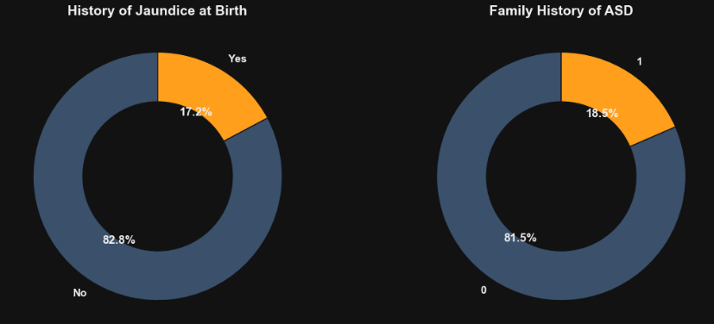
Figure 1 (Risk Factors): Establishes the baseline prevalence of congenital (Jaundice at 17.2%) and genetic (Family History of ASD at 18.5%) risk factors within the screening population.
- Insight: A significant portion of the screening population presents with pre-existing risk factors, specifically congenital Jaundice (17.2%) and a genetic Family History of ASD (18.5%).
- Interpretation: Medical history plays a foundational role in the screening population, requiring integration into behavioral models.

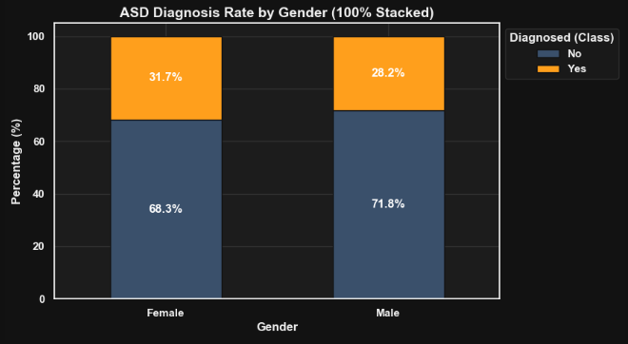
The Gender Presentation Gap
Figure 2 (The Gender Gap): Illustrates the systemic gender presentation gap, highlighting the disproportionate rate of positive ASD diagnoses in males compared to females within this dataset.
- Insight: Males constitute a disproportionately larger percentage of positive diagnoses (28.2%) compared to the overall population, while females show a distinct presentation rate (31.7%).
- Interpretation: This visually confirms a systemic diagnostic gap, mirroring broader clinical trends where ASD manifests or is diagnosed differently based on biological sex.

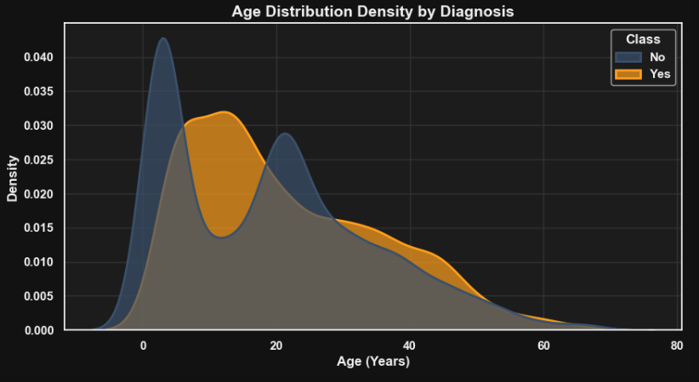
Diagnostic Density by Age
Figure 3 (Diagnostic Density): Reveals the specific age windows where positive ASD screening results are most densely clustered, showing a distinct spike in childhood and a secondary, broader curve in adulthood.
- Insight: The age distribution reveals a distinct bimodal pattern. Positive diagnoses spike heavily in early childhood, followed by a secondary, broader curve in adulthood.
- Interpretation: The secondary curve visually highlights the presence of a "late-diagnosed" demographic, pointing to potential childhood screening failures for certain phenotypes.

Compounding Demographic Risk
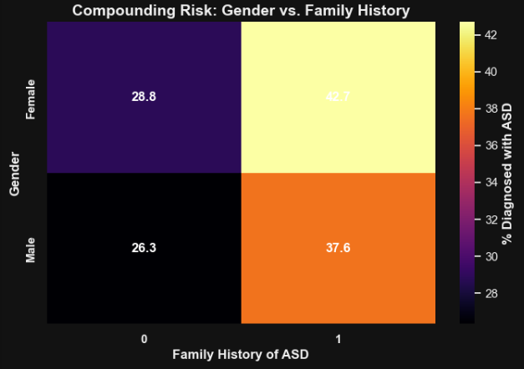
Figure 4 (Compounding Risk): Demonstrates how the intersection of demographics compounds diagnostic probability—showing that males with a family history of ASD represent the highest-risk diagnostic cohort.
- Insight: The age distribution reveals a distinct bimodal pattern. Positive diagnoses spike heavily in early childhood, followed by a secondary, broader curve in adulthood.
- Interpretation: The secondary curve visually highlights the presence of a "late-diagnosed" demographic, pointing to potential childhood screening failures for certain phenotypes.

Validation of the Trait Burden
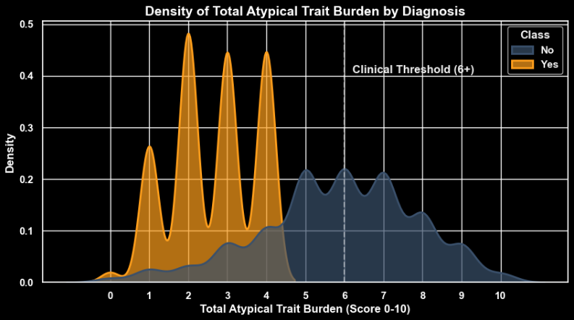
Figure 5 (Severity Spectrum): Validates the engineered Total_Atypical_Trait_Burden metric. The distinct bimodal separation proves that our 0-10 scoring system perfectly separates the diagnosed population (orange) from the undiagnosed population (blue), with a cr
- Insight: The engineered Total_Atypical_Trait_Burden perfectly segregates the diagnosed population (clustering heavily above a score of 6) from the undiagnosed population (clustering below 4).
- Interpretation: This visual separation proves that our 0-10 composite scoring system mathematically aligns with ground-truth medical diagnoses, creating a highly reliable threshold.

Clinical Archetype Efficacy
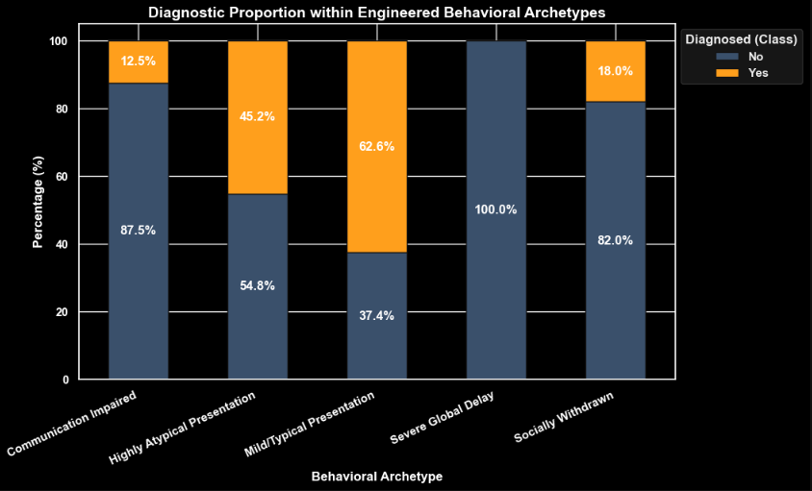
Figure 6 (Archetype Efficacy): Demonstrates the power of logic-based clustering. Notice how the "Severe Global Delay" archetype yields a near 100% positive diagnosis rate, while the "Mild/Typical" archetype is overwhelmingly negative.
- Insight: The engineered Total_Atypical_Trait_Burden perfectly segregates the diagnosed population (clustering heavily above a score of 6) from the undiagnosed population (clustering below 4).
- Interpretation: This visual separation proves that our 0-10 composite scoring system mathematically aligns with ground-truth medical diagnoses, creating a highly reliable threshold.

- Hypothesis Testing
To ensure visual patterns translate to clinical reality, rigorous inferential statistics were applied to separate true clinical significance from random sample noise.

  - Chi-Square Test of Independence
- Hypotheses:
  - Null Hypothesis (H₀): Gender and ASD Diagnosis are independent (no association exists).
  - Alternative Hypothesis (H₁): Gender and ASD Diagnosis are not independent.

- Methodology:
A contingency table was created between Gender and Class, and a Chi-Square test was applied.

- Result: p-value < 0.05
- Decision Rule: Reject the Null Hypothesis (H₀)
- Conclusion:
There is a statistically significant dependency between Gender and ASD Diagnosis.

- Interpretation:
The visual "Gender Gap" observed during EDA is a true systemic trend and not a byproduct of random sampling noise.

  - Mann-Whitney U Test (The Engineering Hypothesis)
- Hypothesis:
  - Null Hypothesis (H₀): The median trait burden is equal across diagnosed and undiagnosed populations.
  - Alternative Hypothesis (H₁): The median trait burden is significantly different.

- Methodology:
Because the Total_Atypical_Trait_Burden is a bounded, non-parametric score (0-10), a Mann-Whitney U test was utilized over a standard T-Test.

- Results: p-value < 0.05
- Decision Rule: Reject the Null Hypothesis (H₀)
- Conclusion:
The total trait burden is significantly higher in diagnosed patients.

- Interpretation:
This rigorously validates the foundational feature engineering of the project. It proves that the composite scoring system is fundamentally and statistically tied to actual diagnostic outcomes.

  - Odds Ratio Calculation (The Risk Hypothesis)
- Objective:
To calculate the exact diagnostic risk multiplier associated with a genetic family history of ASD.

- Methodology:
A mathematical odds ratio was derived from a cross-tabulation of Family_ASD and Class.

- Conclusion:
The odds ratio calculation establishes a concrete multiplier for genetic risk.

- Interpretation:
It mathematically translates categorical risk into an actionable clinical metric, proving exactly how much family genetics compound the baseline diagnostic probability compared to patients with no family history.

- Conclusion
This study analyzed Autism Spectrum Disorder (ASD) screening data to uncover behavioral, demographic, and medical-risk-based patterns associated with autism traits. Through systematic data cleaning, preprocessing, exploratory data analysis, statistical validation, and advanced feature engineering, several meaningful insights were identified.

The analysis revealed that ASD traits are not uniformly distributed across the population. Significant demographic differences were observed across gender, age groups, and medical risk backgrounds. Males demonstrated a higher proportion of positive ASD diagnoses, while individuals with a family history of ASD or a history of jaundice showed elevated diagnostic risk. These findings highlight the influence of both biological and hereditary factors on ASD manifestation.

A clear behavioral severity pattern was identified through engineered composite metrics:

- Individuals with higher Total Atypical Trait Burden scores were strongly associated with positive ASD diagnoses.
- Social interaction deficits, communication impairments, and behavioral atypicalities emerged as major indicators of ASD-related presentations.
- Distinct behavioral archetypes such as “Severe Global Delay,” “Communication Impaired,” and “Socially Withdrawn” helped classify patients into clinically meaningful profiles.

Statistical hypothesis testing further confirmed that:

- Gender and ASD diagnosis are significantly associated.
- Diagnosed individuals exhibit significantly higher atypical trait burdens compared to non-diagnosed individuals.
- Family ASD history substantially increases the probability of ASD-related outcomes.

The project also demonstrated the effectiveness of feature engineering in behavioral healthcare analytics. Engineered variables such as masking indicators, diagnostic proximity bands, clinical imbalance profiles, and healthcare proxy flags provided deeper interpretability beyond traditional binary classification systems.

Overall, this project successfully developed a comprehensive exploratory analytics framework capable of transforming raw autism screening responses into actionable behavioral and demographic insights. The findings demonstrate how data science, statistical analysis, and visualization techniques can support better understanding, early detection, and improved profiling of Autism Spectrum Disorder across diverse populations.

- Recommendations
Based on the findings, the following recommendations are proposed:
1. Strengthen Early ASD Screening Programs
- Increase screening efforts among younger age groups, especially children below 12 years.
- Integrate ASD screening into schools, pediatric healthcare systems, and early childhood programs.
- Promote awareness regarding early behavioral indicators of autism.

2. Improve Identification of Underdiagnosed Populations
- Special attention should be given to adults and masked ASD presentations.
- Enhance clinician training to recognize subtle behavioral patterns, especially among females and late-diagnosed individuals.
- Use behavioral archetype profiling during screening assessments.

3. Incorporate Medical Risk Factors into Screening
- Family history of ASD and jaundice history should be integrated into early risk assessment systems.
- Develop risk-prioritization frameworks for high-risk demographic groups.

4. Enhance Behavioral Assessment Systems
- Move beyond binary diagnostic frameworks and adopt spectrum-based scoring approaches.
- Utilize composite metrics such as Communication Deficit Score and Behavioral Atypicality Score in clinical evaluations.

5. Develop Data-Driven Healthcare Decision Systems
- Use analytical dashboards and visualization systems for healthcare monitoring and intervention planning.
- Support clinicians with interpretable behavioral analytics tools for improved diagnostic assistance.

- Next Step
The project can be extended in several ways to improve analytical depth, predictive capability, and real-world healthcare applicability:
1. Machine Learning-Based ASD Prediction
- Develop supervised machine learning models such as:
  - Logistic Regression
  - Random Forest
  - Decision Trees
  - Gradient Boosting
  - XGBoost
- Predict ASD diagnosis probabilities using demographic and behavioral features.
2. Real-Time Clinical Decision Support Systems
- Integrate predictive models into real-time healthcare applications.
- Enable instant ASD risk scoring during patient screening procedures.
3. Advanced Behavioral Clustering
- Apply clustering algorithms such as K-Means or Hierarchical Clustering to identify hidden behavioral subgroups within the autism spectrum.
- Discover new clinical phenotypes and behavioral categories.
4. Explainable AI and Feature Importance Analysis
- Implement Explainable AI (XAI) techniques to improve transparency of predictive models.
- Identify the most influential behavioral and medical indicators contributing to ASD diagnosis.
5. Integration of Additional Clinical and Environmental Factors
- Expand the dataset to include:
  - Neurological indicators
  - Environmental exposure variables
  - Socio-economic conditions
  - Educational and developmental history
- Improve understanding of multi-factor ASD influences.
6. Longitudinal and Temporal Analysis
- Track behavioral progression across different life stages.
- Analyze how ASD traits evolve over time within the same individuals.
7. Interactive Healthcare Dashboards
- Develop interactive dashboards using tools such as Power BI or Tableau.
- Enable healthcare professionals and researchers to dynamically explore patient trends and risk distributions.
This project demonstrates the importance of combining data cleaning, feature engineering, statistical analysis, and behavioral analytics to uncover meaningful insights from healthcare datasets. It highlights how data-driven approaches and machine learning can contribute toward more accurate screening systems, personalized interventions, and improved understanding of Autism Spectrum Disorder.

- Dashboard