AirWatch India — Architecture
Diagrams render natively on GitHub. The module graph below is extracted from the actual imports in backend/, not drawn from memory.

1. System context
Where data comes from, what the platform does with it, who consumes the result.
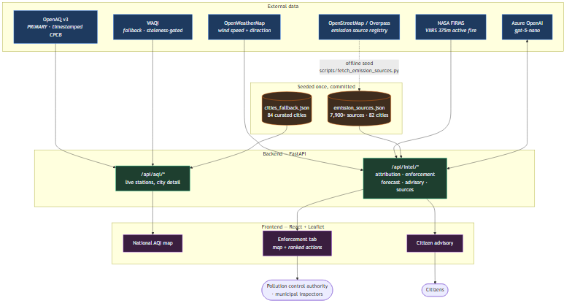

2. The enforcement chain
The core of the project. Note where the LLM sits: last, and only to narrate a shortlist it cannot alter.
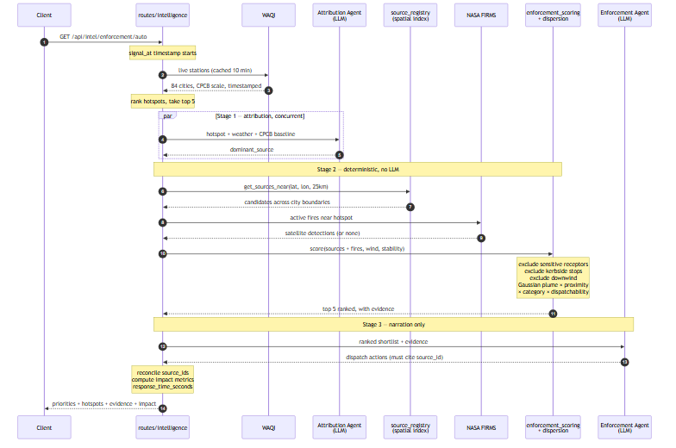

3. Module dependency graph
Extracted from the import statements in backend/.
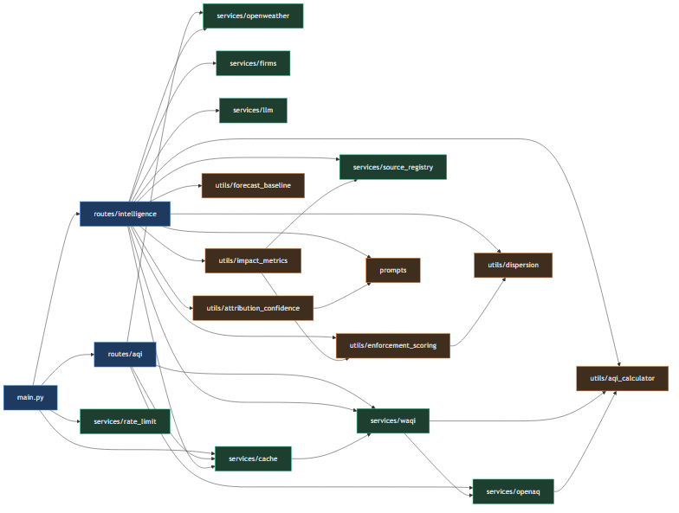
utils/ has no dependency on services/ except impact_metrics, which needs the registry to compute a denominator. That keeps the scoring and dispersion logic free of I/O, which is why 162 tests run without network access or API keys.

4. Evidence scoring pipeline
What happens to a single candidate source.
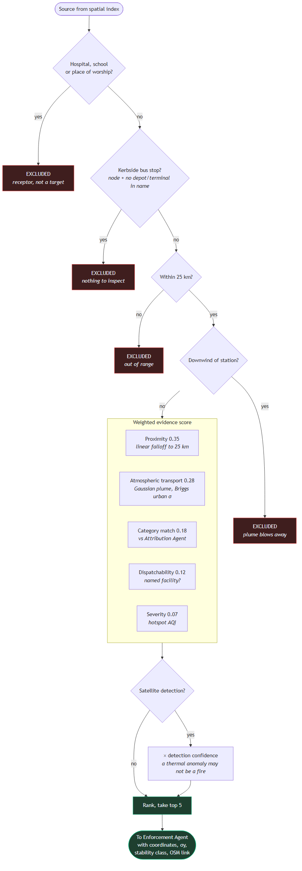

5. AQI scale conversion
Why every reading passes through a conversion before use.
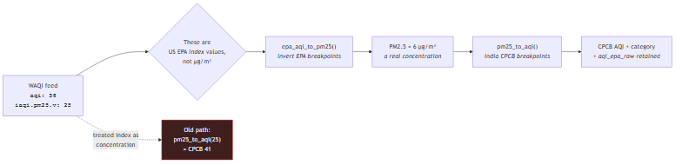
Live stations arrived on the EPA scale while static fallback cities sat on CPCB, and the hotspot ranking sorted both together — so the top-5 feeding the entire enforcement chain was ranked on mixed units. Mid-range readings were distorted roughly 4×: an EPA index of 100 (truly "Satisfactory", 35.4 μg/m³) rendered as CPCB 234 "Poor".

6. Deployment
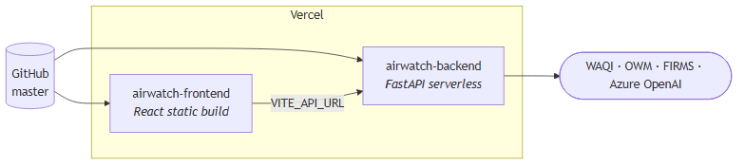
⚠️ Vercel builds from master. The enforcement work is on feature/enforcement-intelligence — merge before demoing, or the live URL serves none of it.
Per-process in-memory caches and the rate limiter do not survive serverless invocation boundaries. See [SCALABILITY.md](../SCALABILITY.md) for what that costs and what would replace them.

