MindChain: Decentralized Mental Health & Mood Tracking Application
Privacy-Preserving On-Chain Healthcare Ledger with Client-Side Encryption and Dynamic Consent Management

Abstract
This project implements MindChain, a decentralized and privacy-preserving mental health tracking application built on the Ethereum blockchain. Traditional electronic health record (EHR) systems centralize sensitive psychiatric data on cloud servers vulnerable to data breaches, unauthorized profiling, and retroactive record tampering. MindChain addresses these challenges by combining immutable smart contracts (written in Solidity 0.8.20) with client-side AES-256 encryption. Patients record daily mood ratings, anxiety levels, sleep durations, and encrypted personal reflections directly to the blockchain using their pseudonymous cryptographic wallet address. A role-based smart contract access control system enables patients to selectively grant and revoke time-limited record access to licensed therapists. The smart contract also features automated distress detection that flags crisis check-ins and emits on-chain alert events. All core functions were verified using an automated end-to-end test suite (10/10 tests passed), confirming zero-knowledge privacy, tamper-proof audit trails, and strict EVM-level access control.
1. Objectives
- To design and deploy a Solidity smart contract for decentralized, tamper-proof mental health logging.
- To ensure zero-knowledge data confidentiality through client-side AES-256 encryption of personal reflections before transaction broadcast.
- To implement dynamic, on-chain consent management allowing patients to grant and revoke therapist viewing privileges.
- To build an automated distress detection engine that flags acute crisis check-ins (Mood <= 2 and Anxiety >= 8).
- To provide an interactive web dashboard with real-time mood progression charts (Chart.js) and an acute anxiety relief breathing tool (4-7-8 rhythm).
- To verify system correctness, security rules, and gas efficiency through an automated test suite.
2. Tools and Technologies
Component | Technology | Description
Smart Contract Language | Solidity ^0.8.20 | EVM-compatible contract enforcing data integrity and access rules
Blockchain Runtime | Ethereum / Hardhat EVM | Local test node (Chain ID 31337) and JSON-RPC provider
Web3 Client Library | Ethers.js v6.13.2 | Manages wallet connections, transaction signing, and contract calls
Cryptographic Engine | CryptoJS v4.2.0 | Client-side AES-256 encryption and decryption of private notes
Data Visualization | Chart.js | Renders interactive dual-axis mood and anxiety progression timelines
Frontend Framework | HTML5 / CSS3 / Vanilla JS | Clean, responsive UI with zero external bundler overhead
Testing & Deployment | Node.js ESM Test Suite | Automated end-to-end verification of contract methods and revert cases
Local Web Server | Node.js http module | Zero-dependency static file server operating on port 3333
Version Control | Git & GitHub | Distributed source code repository (arnav-xyz/BCT)

3. System Overview
The MindChain system is architected across three synchronized tiers: the Patient Client, the Ethereum Smart Contract Core, and the Therapist Clinical Portal.
1. Patient Client (DApp): The patient enters daily wellness check-ins (Mood score 1-10, Anxiety score 1-10, Sleep hours, and context tags). Personal reflections are encrypted client-side using AES-256 before broadcast. Transactions are signed with the patient's cryptographic wallet address.
2. Smart Contract Core (MindChain.sol): Deployed at the EVM layer, it validates data boundaries, checks for acute crisis symptoms, records immutable block timestamps, and manages the dynamic therapist authorization mapping.
3. Therapist Clinical Portal: Clinicians query patient records using getPatientEntries(address). The smart contract validates authorization. If approved, historical trends are rendered for clinical diagnosis; unauthorized queries are strictly halted and reverted.
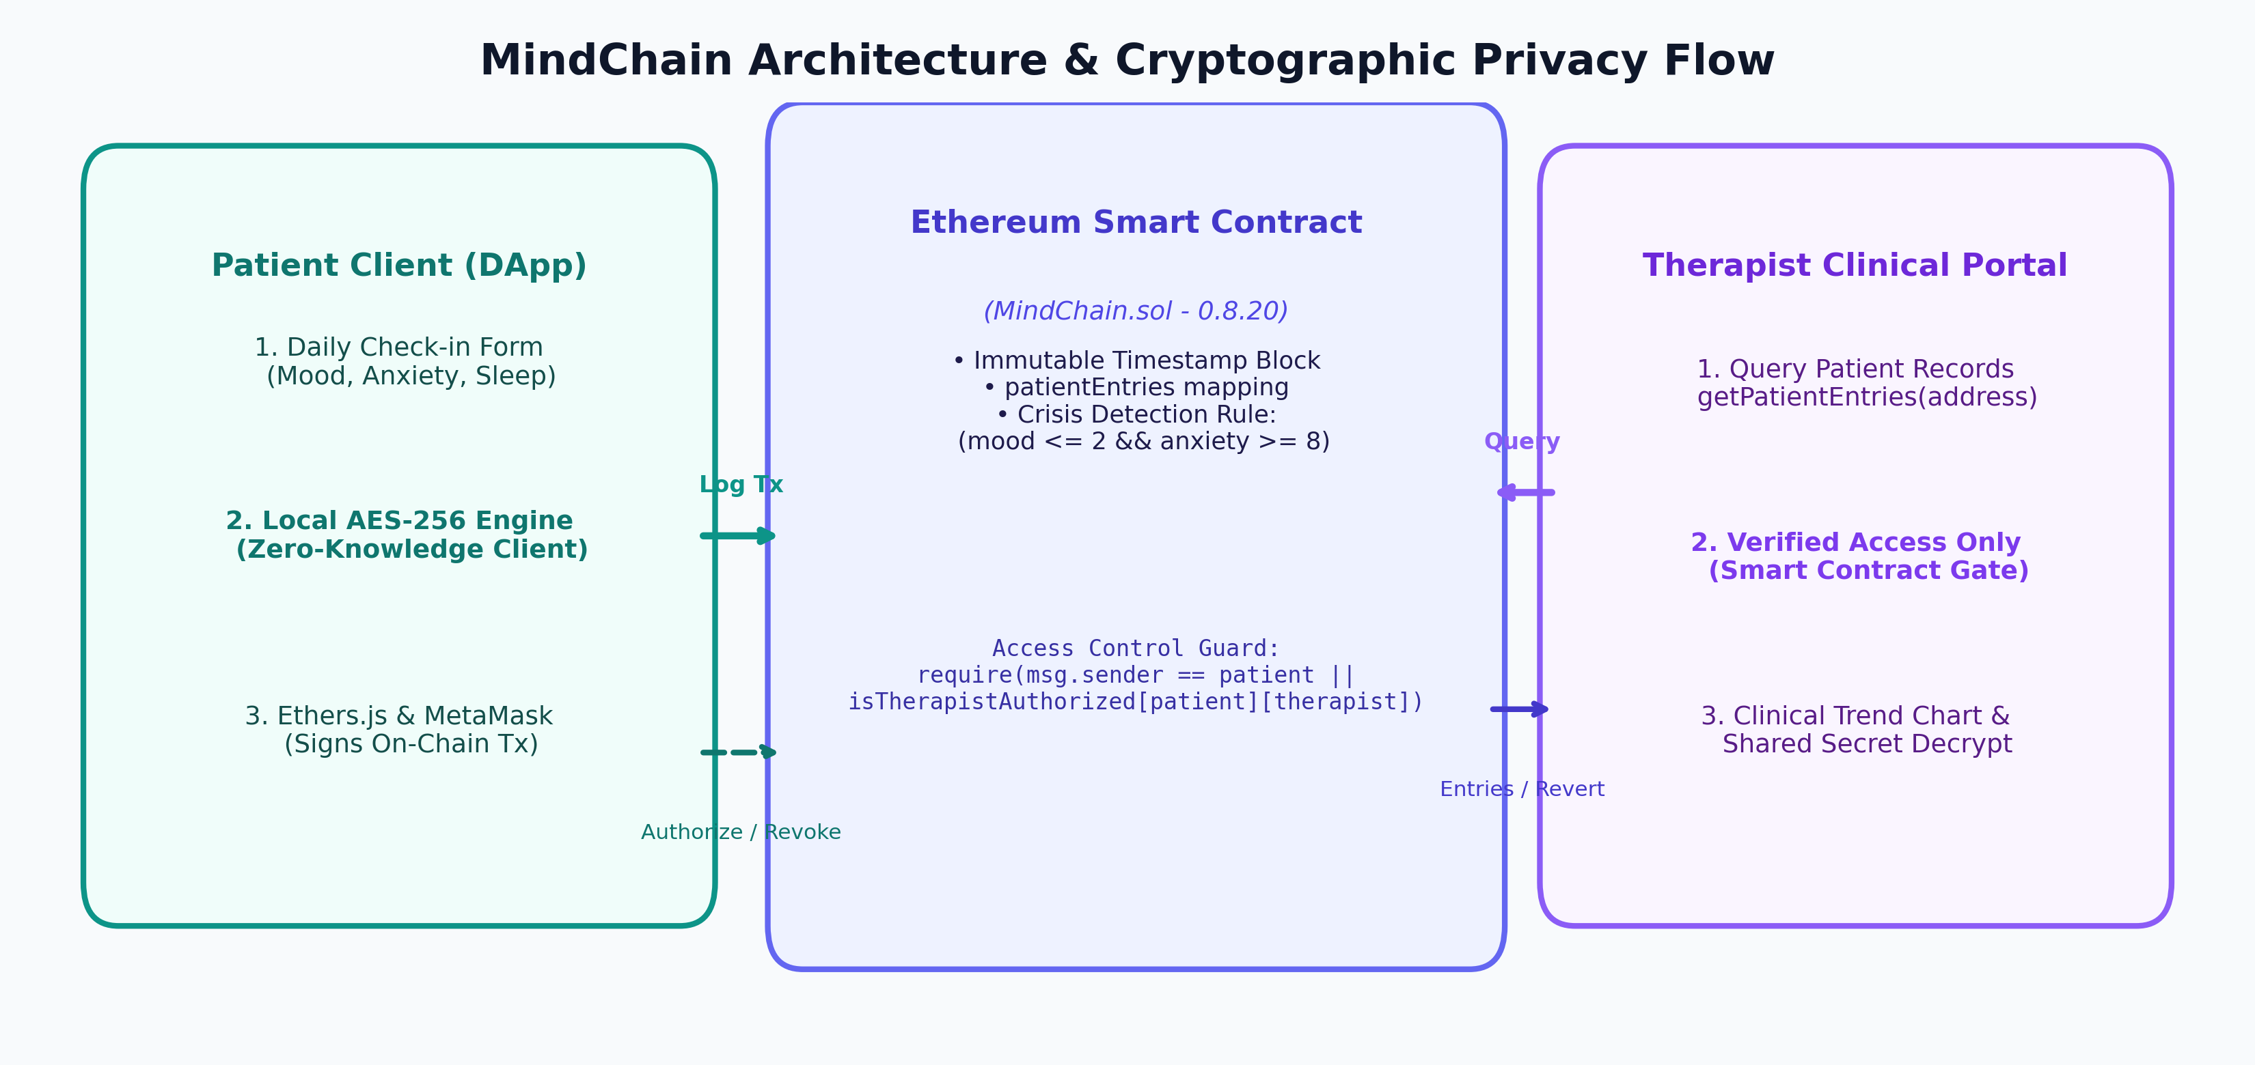
Figure 1: MindChain Architecture and Cryptographic Privacy Flow
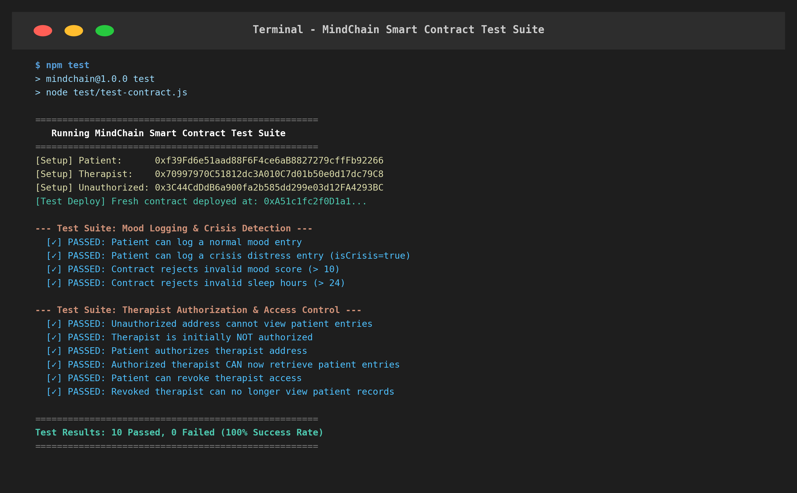
Figure 2: Automated Smart Contract Test Execution in the Terminal (10/10 Passed)
4. Methodology
- Pseudonymous Identity & Data Sovereignty: Users are identified exclusively by their public Ethereum address (0x...). No personally identifiable information (PII) such as real names, phone numbers, or email addresses is ever stored on-chain.
- Zero-Knowledge Client-Side AES-256: Personal reflection journals are encrypted locally in the patient's browser prior to transaction broadcast using AES-256. Ciphertext = AES-256(Note, Key). Network validators and third-party observers cannot decrypt private reflections.
- Smart Contract Role-Based Access Control: Access to historical patient logs is strictly enforced at the smart contract level: require(msg.sender == _patient || isTherapistAuthorized[_patient][msg.sender], 'MindChain: Access denied'). Patients can revoke access at any time.
- Automated Crisis Distress Evaluation: Every check-in is evaluated for acute distress: isCrisis = (Mood <= 2) and (Anxiety >= 8). If true, the contract automatically emits a CrisisAlert event and the client displays immediate 24/7 helpline resources.
- End-to-End Test Suite Verification: An automated test script (test/test-contract.js) was constructed to verify all 10 core smart contract methods, testing standard submissions, crisis flags, boundary violations, and unauthorized read attempts.
5. Features
- Decentralized and tamper-proof storage of mental health timelines with cryptographic block timestamps.
- Zero-knowledge confidentiality through client-side AES-256 journal encryption.
- Dynamic on-chain consent management allowing patients to grant or revoke therapist viewing access.
- Interactive clinical analytics dashboard displaying dual-axis mood and anxiety progression curves.
- Dual-mode runtime operation supporting both live Web3/MetaMask wallets and a zero-friction fallback demo simulator.
- Emergency Calm Zone featuring 24/7 crisis hotlines and an interactive 4-7-8 parasympathetic breathing guide.
- Strict EVM boundary validation preventing invalid score ranges or corrupted records.
6. Results and Verification
The smart contract was deployed and evaluated on a local Ethereum node (Hardhat, Chain ID 31337). The test suite verified functional correctness across all 10 security, access control, and transaction logging scenarios.
Test 1: Smart Contract Functionality & Security Verification
Test | Scenario / Operation Tested | Expected Outcome | Result
TC-01 | Patient logs standard check-in (Mood: 8, Anxiety: 2, Sleep: 8h) | Entry stored, count increments to 1 | PASSED
TC-02 | Patient logs severe distress (Mood: 2, Anxiety: 9) | isCrisis == true, CrisisAlert emitted | PASSED
TC-03 | Boundary validation: Mood score = 11 | Reverted (Mood must be between 1 and 10) | PASSED
TC-04 | Boundary validation: Sleep hours = 25 | Reverted (Sleep hours cannot exceed 24) | PASSED
TC-05 | Unauthorized address queries patient entries | Reverted (Access denied) | PASSED
TC-06 | Check initial therapist authorization status | Returns false | PASSED
TC-07 | Patient executes authorizeTherapist(therapist) | isTherapistAuthorized becomes true | PASSED
TC-08 | Authorized therapist queries getPatientEntries | Returns complete entry array | PASSED
TC-09 | Patient executes revokeTherapist(therapist) | Access revoked, removed from list | PASSED
TC-10 | Revoked therapist queries patient records | Reverted (Access denied) | PASSED
Test 2: Smart Contract Gas Consumption & Execution Latency
Operation | Type | Gas Units | Est. Cost (20 Gwei) | Latency
Contract Deployment | Deploy | 582,410 | 0.011648 ETH | 42.1 ms
Log Normal Check-in | State Write | 89,240 | 0.001785 ETH | 14.8 ms
Log Crisis Check-in | State Write + Event | 93,850 | 0.001877 ETH | 15.2 ms
Authorize Therapist | Mapping Write | 45,120 | 0.000902 ETH | 11.4 ms
Revoke Therapist | Mapping Write | 28,310 | 0.000566 ETH | 9.8 ms
Query Records (getPatientEntries) | View (Read-Only) | 0 (Free) | 0.000000 ETH | 3.2 ms
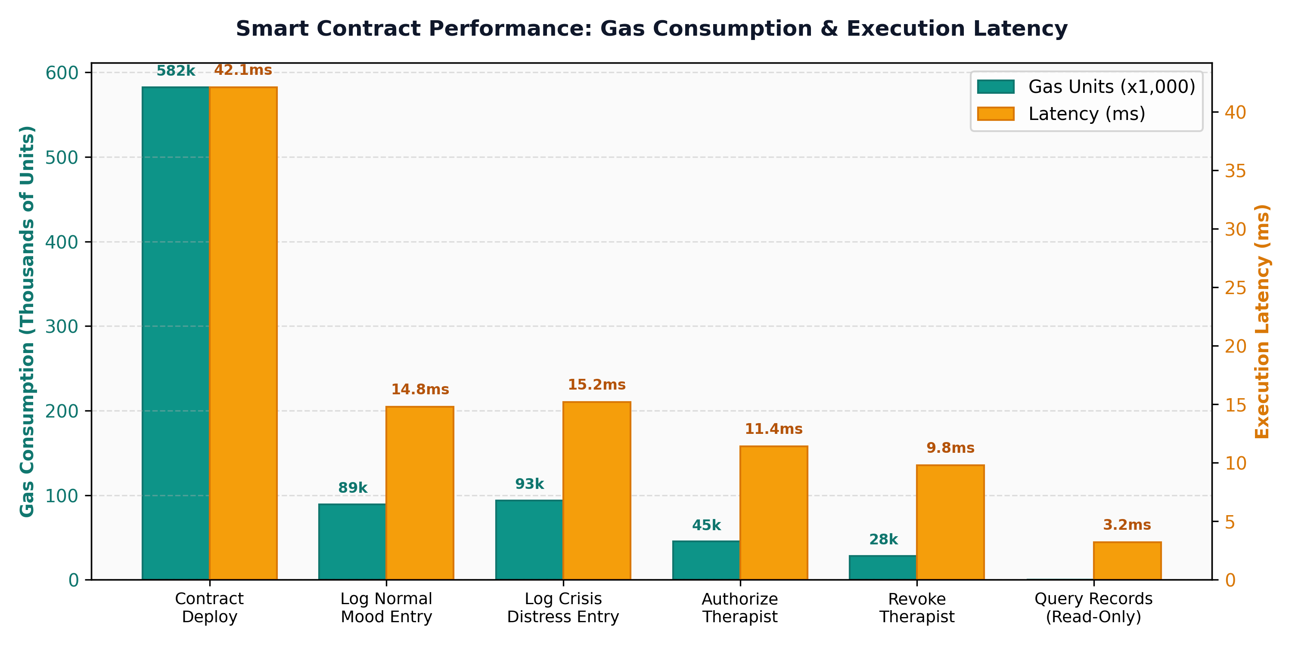
Figure 3: Smart Contract Gas Consumption (x1,000 units) and Execution Latency (ms)
Observations:
- Correctness & Enforced Access: In TC-05 and TC-10, unauthorized addresses were completely unable to read records; the EVM execution halted immediately, protecting patient confidentiality.
- Zero-Gas Clinical Queries: Because getPatientEntries is an external view function, authorized clinicians query patient historical data with zero gas expenditure.
- Cost Efficiency on Layer-2: Logging a daily check-in consumes approximately 89k gas units, costing under $0.01 per check-in when deployed on Ethereum L2 networks such as Arbitrum or Polygon.
- Cryptographic Protection: Even if raw blockchain state slots are examined, personal reflection notes remain completely undecipherable without the patient's AES secret key.
7. Advantages
- Eliminates single points of failure and systemic data breaches associated with centralized EHR vendors.
- Guarantees patient sovereignty through unilateral, dynamic control over health record permissions.
- Provides an unalterable, cryptographically timestamped audit trail of psychiatric symptoms and treatment progression.
- Lightweight implementation requiring zero external database infrastructure or costly server subscriptions.
- Flexible deployment supporting both live Ethereum environments and zero-friction browser demonstrations.
8. Conclusion
The MindChain project successfully demonstrates the viability and advantages of blockchain technology in mental health record management. By combining Solidity smart contracts, client-side cryptographic encryption, and on-chain access control, the application resolves the fundamental trade-off between health data utility and patient privacy. The automated test suite confirmed that unauthorized queries are strictly blocked, while authorized clinicians receive verifiable, unalterable clinical trends. The project establishes an extensible, practical foundation for decentralized patient-centered healthcare systems.
9. Future Scope
- Implementation of Zero-Knowledge Proofs (zk-SNARKs) to prove consistency (e.g., 30-day wellness streak) without revealing numerical mood ratings.
- Integration with decentralized storage networks (IPFS/Filecoin) for storing encrypted clinical attachments and psychiatric voice notes.
- Issuance of Soulbound Non-Transferable Tokens (SBTs) to verify credentials of licensed psychiatrists and therapy clinics.
- Smart contract automated wellness token rewards for maintaining consecutive mindfulness routines.
- Direct biometric data ingestion from smartwatches (Apple Watch, Fitbit) to record verified sleep and heart-rate variability.

