Concrete is as we know the heart of modern day construction. For a commoner, civil engineering means concrete. Its unique features make it the best choice as a material. Many people think all concrete is the same. This is not true! Concrete is no longer a simple grey mass, but it has made its way to become pervious (lighter with honey comb structures), more beautiful (architectural concrete), colored, stronger (high strength concrete), self-compacting etc. to name a few.

Today in India, we see that in cities like Mumbai storm-water runoff is a big challenge during monsoon. Storm water runoff increases both erosion and flooding influencing both water quality and quantity problems. A simple solution to avoiding these problems is to stop installing the impervious surfaces that block natural water infiltration into the soil. Rather than building them with conventional concrete or asphalt, more and more communities, municipalities, and businesses are switching to pervious concrete or porous pavement, a material that offers the inherent durability and low life-cycle costs of a typical concrete pavement while retaining storm water runoff and replenishing local watershed systems. Already one of the most happening topics in Research & Development, pervious concrete is rapidly gaining popularity in the industrial sector as well. CEA Fest’s Concreter Challenge offers the right platform to solve this problem from this aspect.

**Concrete challenge** returns this year with a problem statement that demands participants to design such pervious concrete mix which satisfies required strength and permeability requirements as well as is lightweight because of the abundance of pores. Achieving this through thorough research and presenting it to win the judges over is the ‘challenge’ Concrete Challenge has to offer you.

# The Challenge

To make two 100x150 mm (diameter 100mm, length 150mm) pervious concrete cylinders having

* High permeability
* Good compressive strength
* Minimal Density

Both the cylinders should be made out of same material and should satisfy all above conditions. The cylinders should be cast 7 days prior to the event.

# Registration procedure

1. Participants have to register on the CEA Fest website and get their unique CEA ID
2. After this online registration, they have send in following details via email to the email ID **cc15.ceaiitm@gmail.com**
   1. Name of each one in the team
   2. CEA ID’s of each participant
   3. College they belong to
   4. Guide details
3. All these details will be verified by the event coordinators and a registration confirmation email will be sent to the participants.
4. Participants have to carry a printout of this mail.
5. After the registration confirmation, participant team will have to send a TDP(team description paper) to the email ID **cc15.ceaiitm@gmail.com**.
6. Selection will be done on the basis of the TDP and selected teams will be asked to come and participate in CEA Fest 2015.
7. All the deadlines should be strictly followed by the participant team.

# Rules of the competition

* Student should form teams of exactly 4 members.
* Team participating in the event should find a guide, who is a registered faculty member of any engineering college recognized by Government of India.
* A single guide may work with many teams.
* The cylinders must be casted at the time specified by the event organizers. To ensure this they will have to put a piece of paper of dimension (10cm X 5cm) while casting inside each of the cylinder. The paper will be sent to the participants through email on the day of casting. Participants have to print this paper and cut it into the required size and put it half way inside the cylinder from the top.
* The cement to be used has to be **RAMCO Cement.** There are no other restrictions on the materials in the concrete. But every material that is used should be mentioned in the Report.
* One copy of report should be duly signed by the guide and emailed to the event email id before 9th March and participants should carry one hardcopy of the same on the day of evaluation 13th March 2014(Saturday) at Building Sciences Block IIT Madras.
* Participant team should carry a letter from the HoD confirming your participation and that you are bonafide students of the particular college.
* If report and the letter are not submitted in the prescribed format then, the team may get disqualified.
* Students must carry their college ID card throughout the fest.
* Please keep checking the website and emails for further updates.
* Failure to abide by any of the above rules will lead to disqualification from the competition.
* Event coordinators’ decision is final and binding.

# Evaluation Rules

Evaluation of each team will be done in two parts.

1. **Testing (Weightage 80%)**

* **Permeability**: Permeability will be tested using standard equipment. It will be measured in **cm/s (centimeters/second).**
* **Dimension Validity**: The dimensions of the cylinder should be **(10cm X 15cm).** Maximum error of 5mm is allowed.
* **Strength**: The measurement of compressive strength will be mechanized.
* **Density:** Density will be calculated after calculating the mass and volume (will be measured with vernier calipers).

**Marking scheme** –

If P is the permeability in cm/s, S is the compressive strength in MPa and D is the density in kg/m3 then,

Score1 = [{40x(P/Pmax)} + {30x(S/Smax)} + {10x(Dmin/D)}]

where, **Pmax** is the **maximum permeability** obtained among all participating teams, **Smax** is the **maximum compressive strength** obtained among all participating teams and **Dmin** is the **minimum density** obtained among all participating teams.

1. **Poster Presentation (Weightage 10%) (Score2)**

The team has to prepare an A3 size poster with details such as details regarding the mix design and related research done by them and present it to the judges. The poster will be judged on basis of the content, presentation skills and the poster design. This will be graded out of 10.

1. **Report (Weightage 10%) (Score3)**

The report will be graded by the event coordinators out of 10. The report should be submitted through email before 9th March.

**Final score will be the grand total of scores in the above categories in accordance with the weightage.(Score1 + Score2 + Score3)**

# Format of the Event

* The event is of ‘**preregistered’** category**.**
* Participation :
  1. **Problem Statement** will be released on the website before 25th January, 2015.
  2. **Registration:**  Teams will have to register themselves online.
  3. **TDP,** i.e. the team description paper has to be submitted by 20th February, 2015. The format of the TDP will be available on the website.
  4. The finalized teams will be declared on 4th March, 2015 and will be invited to participate during CEA between 13th to 14th March.
  5. Finalists have to cast their model **on** **5th** **March.**
* **Deadlines :**
  1. **Problem Statement release – 25/01/2015**
  2. **Last day to register – 28/02/2015**
  3. **TDP submission last date – 29/02/2015**
  4. **Declaration of finalists – 04/03/2015**
  5. **Casting of the sample – 05/03/2015**
  6. **Report submission - 09/03/2015**
  7. **Evaluation – 13/03/2015**

# Permeameter- The instrument which will be used is similar to this instrument (no the exact) The image is shown just to give the participants an idea of how the testing procedure will be.

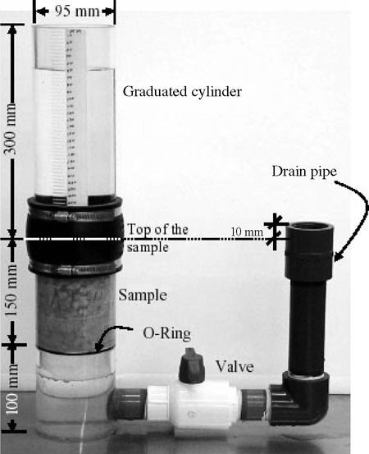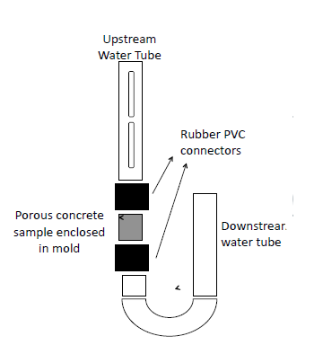

# Prizes