CIVIL ENGINEERING ASSOCIATION (CEA)

DEPARTMENT OF CIVIL ENGINEERING

IIT MADRAS

SUSTAINABLE DESIGN CHALLENGE

ACT RESPONSIBLE, THINK SUSTAINABLE

INTRODUCTION:

From the past years CEA has provided an opportunity to the students of this nation to showcase their skills in modeling energy efficient buildings. This year here is something bigger in dimension, the DESIGN OF A SMART CITY, the vision of government of India.

Today more than half the world’s population lives in cities. Although cities occupy just 2 per cent of the Earth’s landmass, they account for 60-80 per cent of energy consumption and 75 per cent of carbon emissions. We reached that stage where unhindered urbanization is exerting a negative impact on energy, water supply etc. and hence the entire living environment. The time has come for us to develop sustainable solutions to meet these challenges.

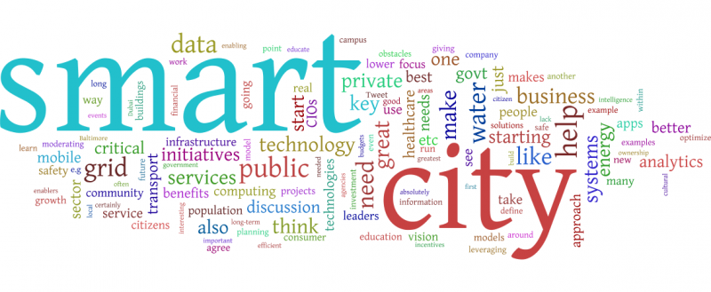DESCRIPTION:

The site given below is aimed to be developed as a smart city and is named as Bharat Nagar. The site details and requirements that the city should posses to be called smart are specified as follows

*Site:*

The area of the developed city should be around 400 sq.km. The population density and its growth rate are estimated around 16,000 per sq.km and 6% respectively. The climate is of tropical type with average temperatures 33°C in summer and 21 °C in winter. The site receives average annual rainfall of 110cm with 78% as average humidity. There are two zones of the city to be developed on either side of river with the ratio of their areas not exceeding 1.5.There is a lake in the south zone of area 5 sq.km. The wind rose diagram for the city is given in attachments. River makes an angle of 30°(approx.) with sea where it terminates. The soil is soft marine clay upto 750m from the sea coast through out its length.

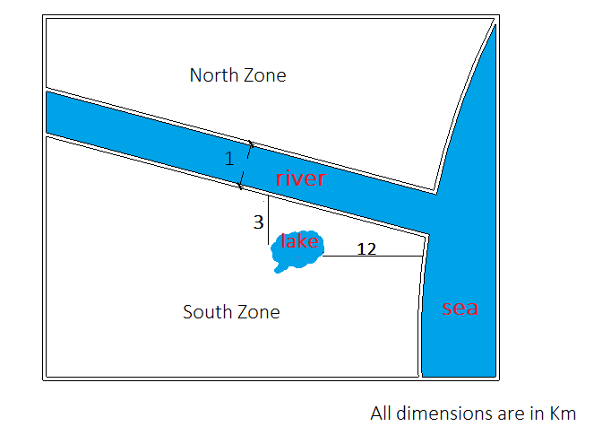

Though well organized Infrastructure is an important requirement,other aspects which help in maintaining the city sustainable need to be concentrated.

*Infrastructure:*

The Infrastructure designed should focus on residential buildings to tackle the growing population and their needs. This shall include educational facilities, government offices, recreational zones, industrial zones, hospitals etc. The interconnectivity of designed zones through Sustainable road and water ways is also essential. There is also an idea of increasing revenue by developing area as a tourist spot. The Infrastructure has to be proposed so that economy gets improved and remains citizen friendly as well.

*Energy generation:*

Sustainable energy solutions play a vital role in making the city self reliant. Severe shortage of power is experienced during summer with power cuts. Also,in the next 10 years, consumption of power will increase by a minimum of 15%. Innovative and feasible solutions to use the energy efficiently and to generate energy from renewable sources should be proposed. Also, plan a layout for these power sources within the city that optimizes the grid and reduces transmission losses.The average annual per capita energy consumption is about 750 KWh.

*Waste management:*

This is also a major issue in any locality. The per-capita solid waste generated is about 0.6 kg a day. In addition to this there is also the waste generated in Industrial zone which should carefully be disposed. So, propose the ways both to dispose and generate something useful out of this waste.

*Water treatment :*

In the current scenario, water poverty can be eradicated by waste water treatment. As the city should accommodate residential ,industrial hubs which generate lots of waste water , ideas to treat waste water and positioning of these treatment plants in this city are to be proposed.

*Efficient Transportation:*

It is a fact that the vehicles account for about 30% of the carbon emissions. The city requires efficient transportation connecting different zones to facilitate greater mobility between them. There is a need to take an integrated long term view of transport needs with in the region. Propose solutions for efficient transportation based on the population density of locality and other geographical conditions.

All the above mentioned issues should be addressed in the solution proposed. One may also come up with other measures (both technical and social innovations) to make the city environmentally, economically and socially sustainable.

EVALUATION:

The design should be such that it does minimum damage to the existing calm environment of the place. Factors like coordination of infrastructures, mobility, Power generation with low environmental load, Appropriate usage of land, extent of detailing, relevance of the problems addressed,technical details, feasibility of the ideas presented in solution will be taken into account. The teams are encouraged to deal with problem statement technically and provide statistical background for their solutions.

INSTRUCTIONS:

* The participants should register for the fest on CEA website and their team details with CEA Id s should be sent to [sdc.15ceaiitm@gmail.com](mailto:sdc.15ceaiitm@gmail.com) to get registered for the event.
* Report should contain team description paper (details of team members) on its first page.
* Report should be sent to sdc.15ceaiitm@gmail.com in pdf format (maximum of 30 pages) named <Teamname> and must be sent with in the time specified.
* Subject of the mail containing report should be <SDC_Team name>.
* The report should include the details of modifications done to the existing plan and should address all the issues mentioned above. Also include other measures that can be taken for the city to be sustainable and citizen friendly.
* The decision of coordinators at any stage of the competition is final and binding.
* The participants may assume necessary data for analysis which should be clearly stated in the report submitted.
* Please mail any of your queries to [sdc.15ceaiitm@gmail.com](mailto:sdc.15ceaiitm@gmail.com) with no hesitation. We will reply at the earliest.

DEADLINES:

Last date to submit report : 28-02-2015

Announcement of finalists : 06-03-2015

Final Presentations : During CEA fest

Attachment:

