**CS6640-Project 2**

**Atul Rungta**

**U0734304**

[**atul.rungta@utah.edu**](mailto:atul.rungta@utah.edu)

1. **Image Smoothing**
   1. **K\*K smoothing kernel with equal weights**

A cross-convolution scheme was implemented using a normalized filter (3x3 and 5x5). The matrix chosen was all ones (normalized according to dimensions). The results of smoothing:

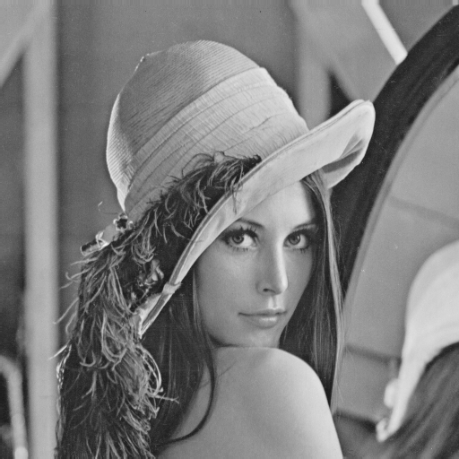

Original Image

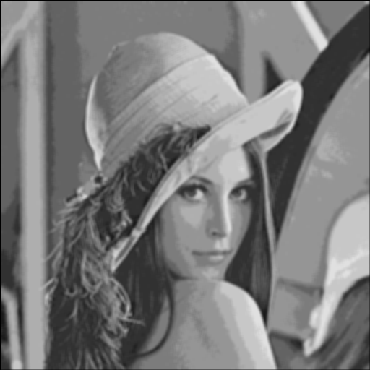 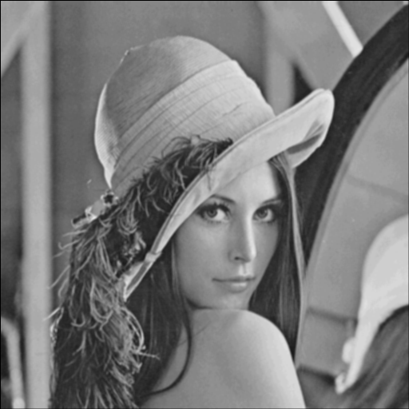

5x5 Smoothing Filter 3x3 Smoothing Filter

**b. Separable Filter**

The box filter used was separated into 2 unit vectors (of the appropriate dimension) and normalized accordingly. The image was first convolved with the horizontal filter followed by the vertical one. The results:

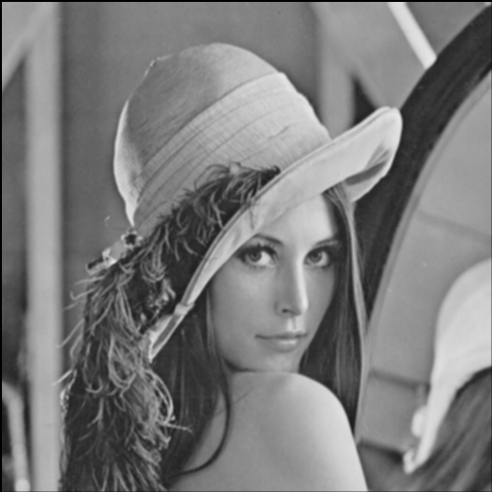 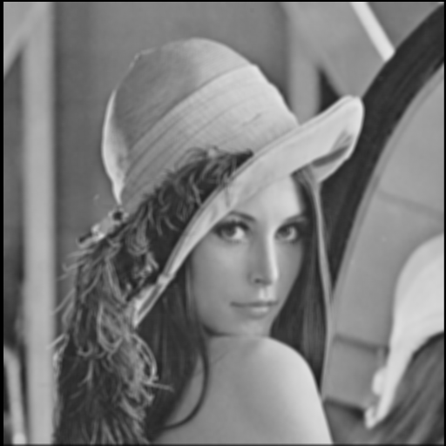 3x3 separable filter 5x5 separable filter

Although the results should match the ones for the box filter, there seems to be a slight difference in the intensity of the image. My guess would be that it is happening because of I am using convolution in case of separable filters while cross-correlation in case of box filters.

**c. Separable Gaussian filter**

The 2D Gaussian:

f(x,y)=1/(2pisigma^2)e^(-[(x-mu_x)^2+(y-mu_y)^2]/(2sigma^2)). 

where σ2 = variation, μx, μy are the means.

Can be separated into 2 1D Gaussians as:

f(x) = (1/((2 \* pi) ^ .5 \* σ)) \* e ^ (-(x-μ)^2/(2 σ2))

f(y) = (1/((2 \* pi) ^ .5 \* σ)) \* e ^ (-(y-μ)^2/(2 σ2))

σ was chosen to be 2, μ was 0 and ranges ±3 σ were chosen. The results:

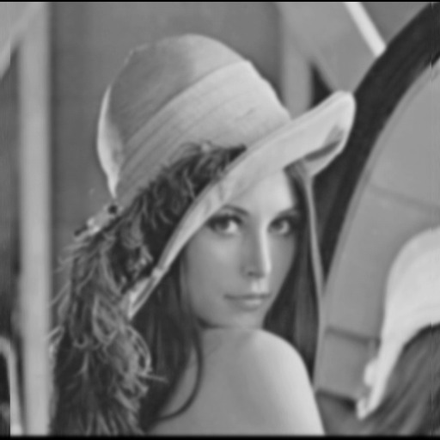

Separable Gaussian Filter ( ± 3σ)

The resulting image yields smoother image as compared to a 5x5 box filter.

**2. Edge Detection**

1. **Local Edge Filtering**

For the horizontal filtering, dx was chosen to be [-1 0 1] while dy was chosen to be [-1 0 1]T. The masks were not normalized as it killed the intensity. The results were obtained by convolving the mask with the image. The result

**Dx Dy**

**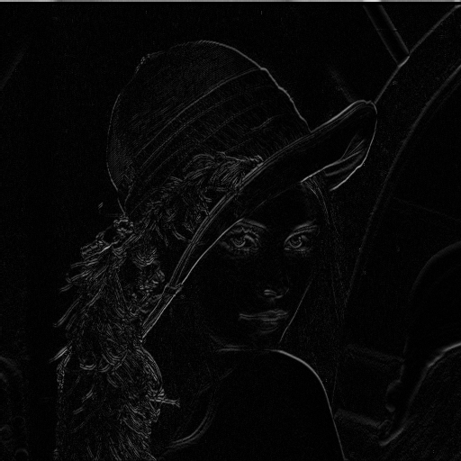 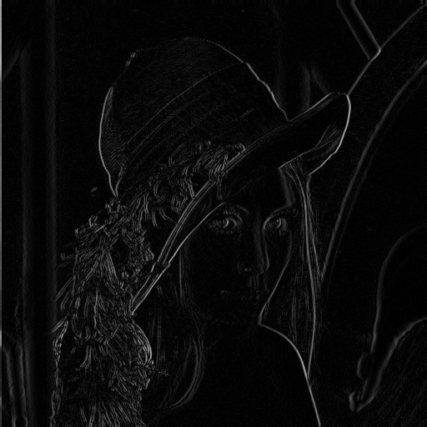**

**Edgemap Orientation Map**

**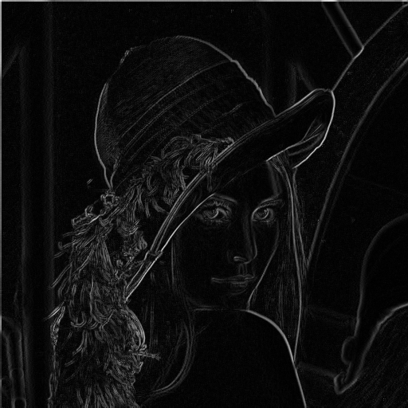** 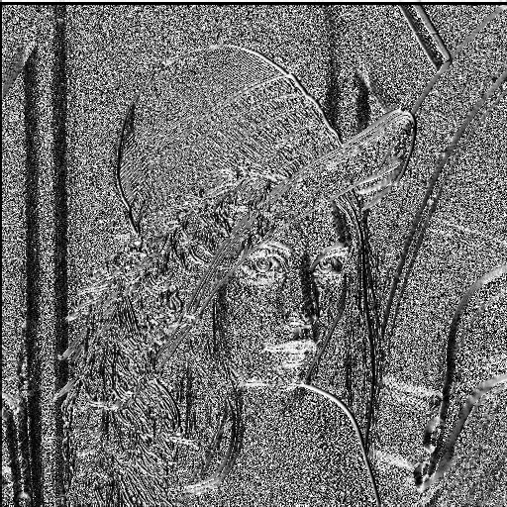

For the orientation map, the arctan values were converted to degrees and adjusted for values between 0 to 255.

1. **Edge Filtering at specific scales**

As mentioned in the assignment, the image was filtered using the Gaussian (σ =2) and then the edge map was calculated. The result is a much smoother edgemap as expected:

**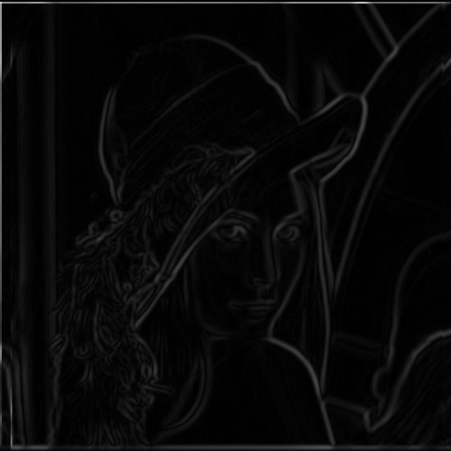**

**3. Template Matching**

The template matching didn’t quiet work as expected. As explained, a small segment (template) was chosen and made the filter. The image was cross-correlated with the filter and the resulting image was thresholded. The following equation was used for the cross-correlation (taken from <http://paulbourke.net/miscellaneous/correlate/>)

**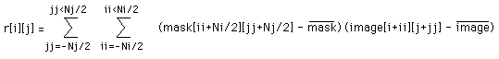**

where mask’ is the mean of the template and image’ is the mean of the image raster under the mask.

The threshold limit was set to 200 by looking at the histograms of the correlation images. Results:

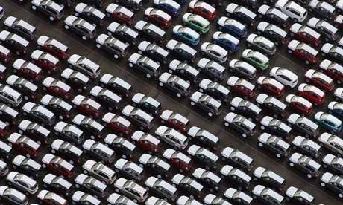

Original Image

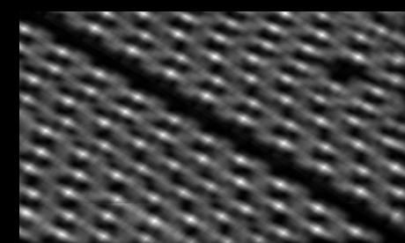

Segmented

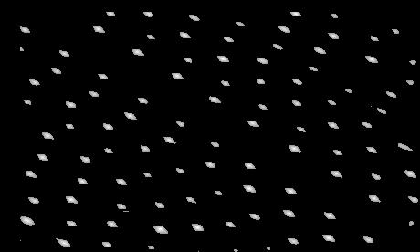

Thresholded Values

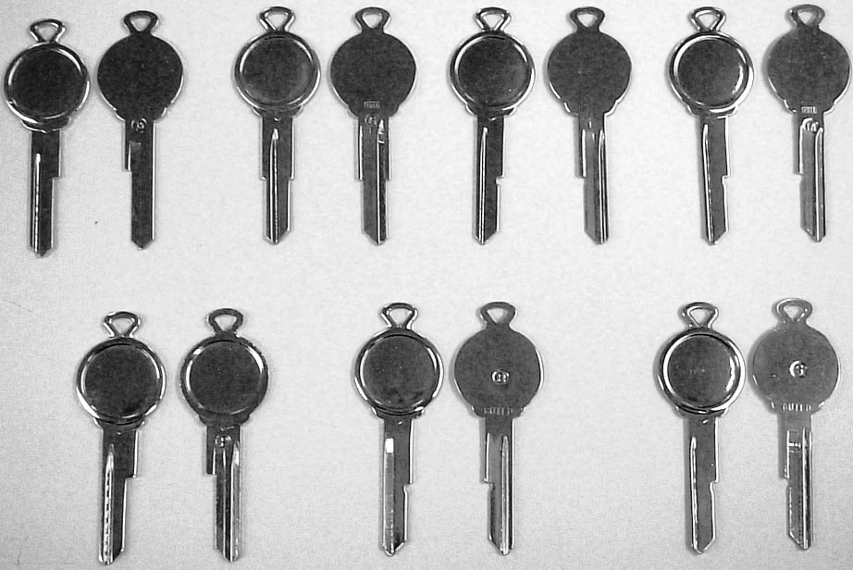

Original Image

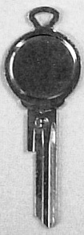 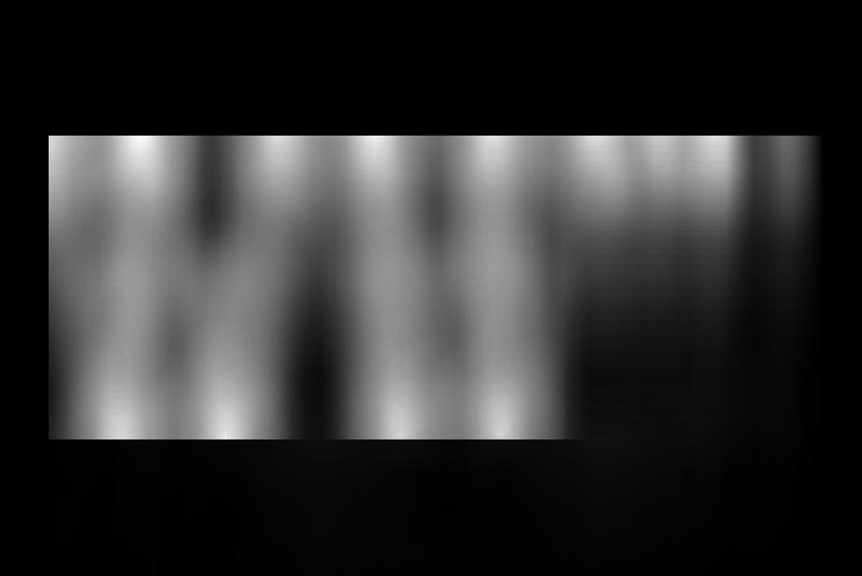

Key Segment Segmented Values

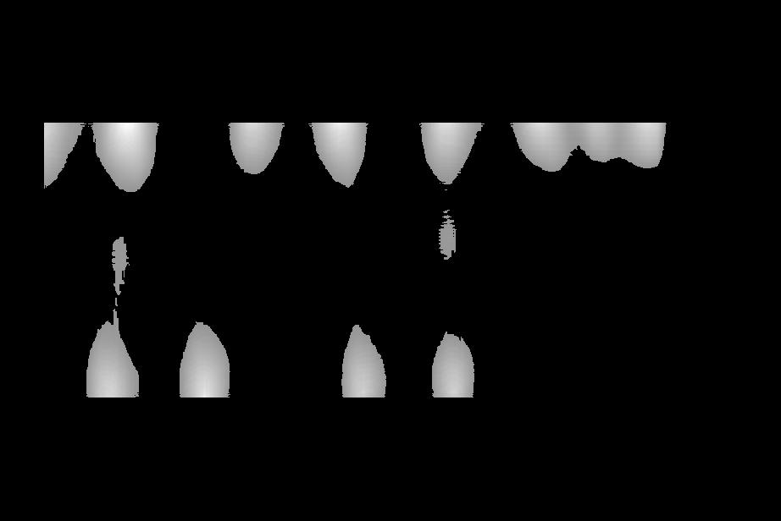 Thresholded Values

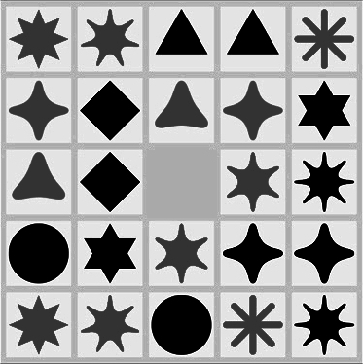

Original Image



Segment

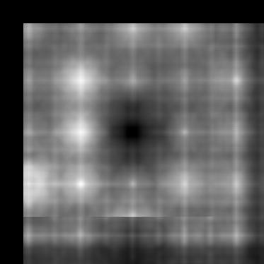

Segmented Values

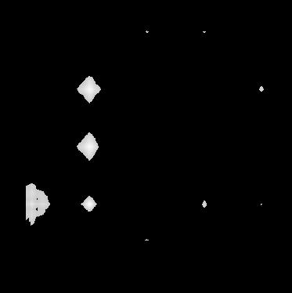

Thresholded Values (These are incorrect)

Template matching seems to work well in a few cases, but as seen above it gives the wrong answer (this could also be a glitch in my code).