

A
PROJECT REPORT
ON
StudyGenie
SUBMITTED TO:
SAVITRIBAI PHULE PUNE UNIVERSITY
FOR PARTIAL FULFILMENT OF
TYBBA(CA), SEMESTER VI

ASHOKA CENTER FOR BUSINESS AND
COMPUTER STUDIES,
2025-2026

PROJECT GUIDE:

PROF. KOMAL KADAM

SUBMITTED BY
ARNAV DEORE

Sr. No. | Topics | Pg. No.
1 | Title Page
2 | Declaration by Student
3 | Acknowledgement
4 | College Certificate
5 | Introduction
 | Motivation
 | Problem statement
 | Purpose/objective and goals
 | Literature survey
 | project scope and limitations
6 | System Analysis
 | Existing systems
 | Scope and limitations of existing systems
 | Project perspective, features
 | Stakeholders
7 | Requirement Analysis
 | Functional requirements
 | Performance requirements
 | Security requirements etc.
8 | System Design
 | Design constraints/Data Dictionary
 | Entity Relationship Diagram
 | DFD
 | UML Diagrams (Use Case, Activity, Sequence, State Chart)
9 | Implementation Details
 | Software/hardware specifications
10 | Input Output Reports
11 | Conclusion and Recommendations
12 | Future Scope
13 | Bibliography and References
INDEX

StudyGenie

Declaration by Student
I hereby declare that this project, titled “StudyGenie” is an original work carried out solely by me, the authors. This project has been developed through our dedicated efforts and in-depth research, fulfilling the academic requirements of the course for which it has been undertaken. All information, data, and findings presented in this document are genuine, accurately compiled, and reflect the results of our own work. The content, analysis, and solutions provided are derived from extensive study and careful consideration of the subject matter. I acknowledge that any external sources, references, or materials used in the creation of this project have been properly cited and credited, in compliance with academic standards. These resources have significantly contributed to the development of our work, and we have made every effort to ensure the authenticity and integrity of the information presented. The use of these external references has been clearly noted and duly acknowledged throughout the document.

Acknowledgment
We extend our heartfelt thanks to Dr. Harsha Patil, I/c Principal, for her valuable insights and assistance in coordinating various aspects of this project. Her dedication to fostering academic excellence has been instrumental in shaping our journey.
Our gratitude also goes to Mrs. Pratima Bhalekar, Head of the Department of BBA(CA), for her expert guidance and mentorship. Her expertise and commitment to our academic growth have been invaluable in shaping the direction of this project.
We would also like to thank our Project Guide Mrs. Komal Kadam, for their invaluable support and guidance at every step of this project. Their expertise, patience, and encouragement have been instrumental in helping us navigate through challenges and achieve our goals.
Finally, we extend our thanks to all faculty members and staff who have contributed to this project directly or indirectly. Their support and encouragement have been crucial in making this project a success.
Thank you all for your unwavering support and belief in our abilities.




Ashoka Education Foundation’s
ASHOKA CENTER FOR BUSINESS AND COMPUTER STUDIES
Ph: 0253-6689561 Ph: 0253-6689560
Certificate

2025-26

This is to certify that Arnav R Deore of Class Ty BBA(CA) Semester 6th Roll No. 4 & University Exam Seat No. 52545 has successfully completed his project work entitled StudyGenie as a partial fulfilment of the requirement of BBA. (Computer Application) Course, under Savitribai Phule Pune University during the academic year 2025-26.

Project Guide Head of department Principal, ACBCS

Internal Examiner External Examiner

Introduction
Motivation
In today’s fast-paced digital world, students are expected to learn efficiently while managing multiple academic responsibilities. However, traditional learning methods often fail to adapt to individual learning styles, making studying repetitive and less engaging. Many students struggle with organizing their study schedule, understanding complex topics, and maintaining consistency. With the rise of Artificial Intelligence, there is a strong opportunity to transform learning into a smarter, more personalized, and efficient experience. Study Genie is motivated by the idea of simplifying learning through automation, intelligent recommendations, and interactive tools.
Problem Statement
• Inefficient study planning methods
• Time-consuming manual note-making
• Lack of personalized content delivery
• Limited access to instant self-assessment tools
• Fragmented learning platforms
Purpose
The purpose of Study Genie is to develop an intelligent learning assistant that leverages Artificial Intelligence to enhance the overall study experience. The system aims to automate essential academic tasks such as note generation, quiz creation, and study planning. By combining these functionalities into a single platform, Study Genie reduces student workload and improves efficiency. It also encourages active learning by providing interactive and adaptive study materials tailored to user input.

Objectives
The primary objective of this project is to create a smart educational tool that supports students in their academic journey. The system is designed to simplify learning processes and make them more interactive and effective. By using AI technologies, the project focuses on delivering customized content, tracking progress, and encouraging continuous improvement. It aims to bridge the gap between traditional learning methods and modern intelligent systems.
• Develop AI-powered note generation
• Implement automated quiz generation
• Track user progress and performance
• Improve learning outcomes through personalization

Goal
• Make learning smarter and faster
• Reduce student workload and stress
• Increase engagement and consistency
• Promote self-learning and independence
• Provide a unified learning platform
Literature Review
The concept of integrating Artificial Intelligence in education has gained significant attention in recent years. Studies show that AI-based systems can enhance personalized learning, improve student engagement, and provide real-time feedback. Various platforms such as intelligent tutoring systems and adaptive learning tools have demonstrated the effectiveness of AI in education. However, most existing solutions focus on specific features like quizzes or notes, lacking a comprehensive approach. Study Genie aims to combine multiple AI-driven functionalities into a single system to provide a complete learning solution.
• AI improves personalized learning experiences
• Gamification and automation increase engagement
• Existing tools lack integration of features
• Need for unified intelligent learning systems
• Growing importance of AI in education

Project Scope and Limitation
Project Scope
• AI-based note generation
• Quiz and assessment creation
• Smart study planner
• Performance tracking dashboard
• User-friendly interface
Features Covered

1. User Authentication
- Secure registration and login system
- Personalized user accounts
- Session management for secure access

2. AI Notes Generator
- Generate structured notes from user input topics
- Summarize complex concepts into simple explanations
- Save notes for future reference

3. Quiz Generator
- Automatically generate quizzes based on topics
- Multiple-choice questions for self-assessment
- Instant feedback on answers

4. Dashboard & Analytics
- Track user progress and performance
- Display completed tasks and quizzes
- Provide insights into learning patterns

5. Data Management
- Store user data securely in database
- Maintain history of notes and quizzes
- Efficient data retrieval and updates

Project Limitations
• Requires internet for AI functionalities
• Accuracy depends on AI model responses
• Limited to basic academic features
• No offline support in current version
• Scalability constraints with current database
System Analysis
Existing Systems
In the current educational ecosystem, various digital platforms and tools are available to assist students in learning. Traditional e-learning platforms such as online courses and video-based tutorials provide structured content but lack personalization and real-time adaptability. Similarly, note-taking applications allow users to organize information but do not generate intelligent summaries. Quiz-based platforms offer practice questions but are not integrated with learning or planning systems. These fragmented tools create inefficiency as students need to switch between multiple applications for studying.

Project Perspectives & Features

Study Genie is designed as a comprehensive AI-powered learning assistant that integrates multiple functionalities into a single platform. It provides a seamless experience where users can generate notes, create quizzes, and plan their study schedule efficiently. The system uses intelligent algorithms to automate tasks and enhance learning productivity. Unlike traditional systems, Study Genie focuses on personalization, automation, and user engagement.

Stakeholders
• Primary Stakeholders – Students/Learners
Students are the main users of the system. They benefit from personalized learning, automated tools, and performance tracking.
• Secondary Stakeholders – Educators/Institutions
Teachers and institutions can use the platform to support student learning and monitor progress (future enhancement).
Requirement Analysis
Functional Requirements
The system must provide essential functionalities that allow users to interact with the platform effectively. These features ensure smooth operation and a complete learning experience. Each function is designed to automate tasks and improve usability.
Security Requirements
Security is an important aspect of the system as it handles user data. The system must ensure that user information is protected from unauthorized access. Proper authentication and secure data handling techniques must be implemented.
User Interface (UI) Requirements
• Simplicity and Clarity
The interface should be clean and uncluttered, avoiding unnecessary elements that may confuse users.
• Easy Navigation
Users should be able to move between pages like Dashboard, Notes, Quiz, and Planner easily.
• Consistency
Design elements such as colors, fonts, and buttons should remain uniform across all pages.
• Responsive Design
The system should work properly on desktops, tablets, and mobile devices.
• User-Friendly Forms
Input fields (like topic entry, login forms) should be simple and easy to use.
• Visual Feedback
The system should provide clear feedback such as success messages, errors, or loading indicators.
• Readable Content
Fonts should be clear, and spacing should be proper for better readability.
• Interactive Elements
Buttons, cards, and menus should be interactive and responsive to user actions.
System Design
Constraints:
• Developed using HTML, JAVASCRIPT, CSS & backend functionality is developed with Python & Flask.
• Accessible via modern web browsers (from both mobile & laptop)

Entity Relationship Diagram

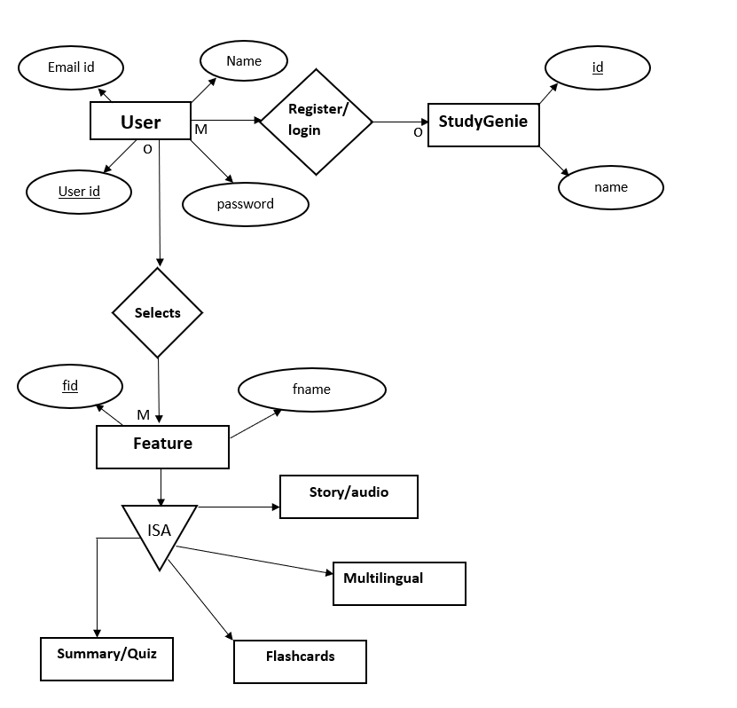

Data Flow Diagram
Level 0
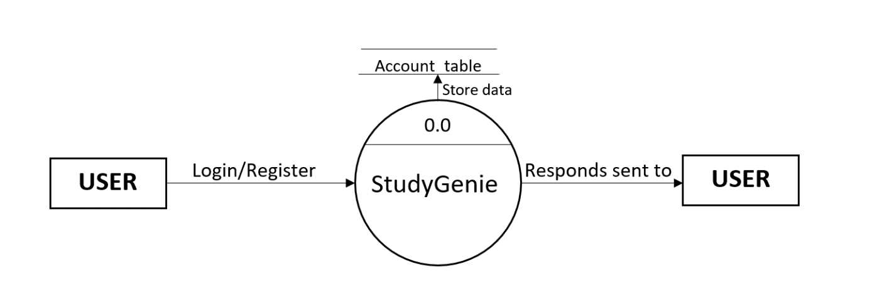

Level 1
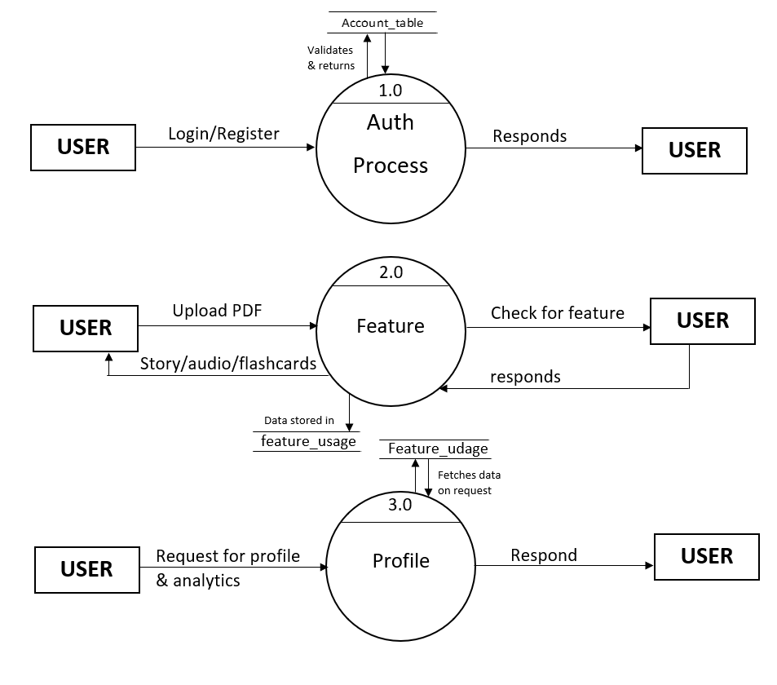

UML Diagrams
Use Case Diagram
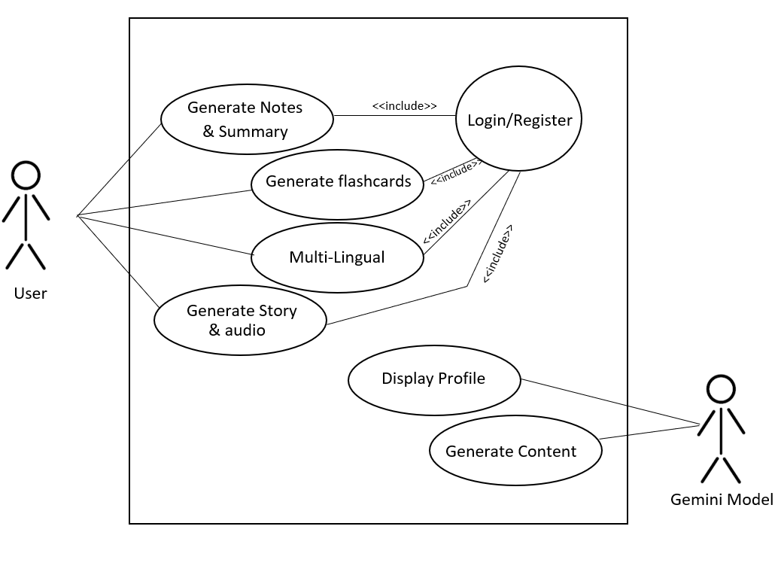

Activity Diagram

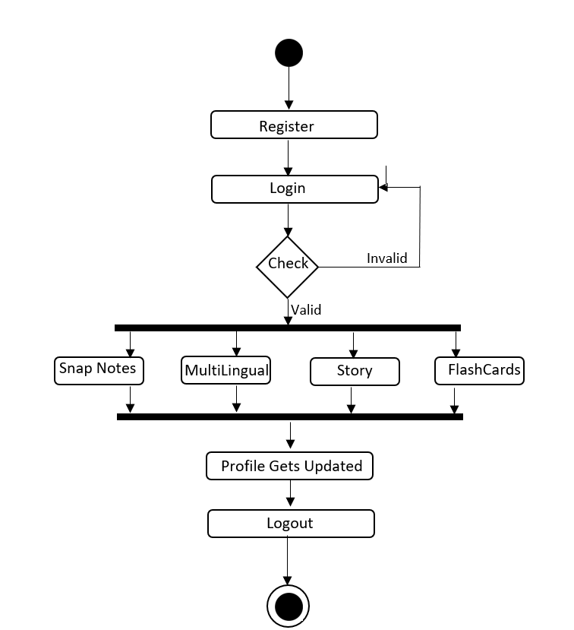

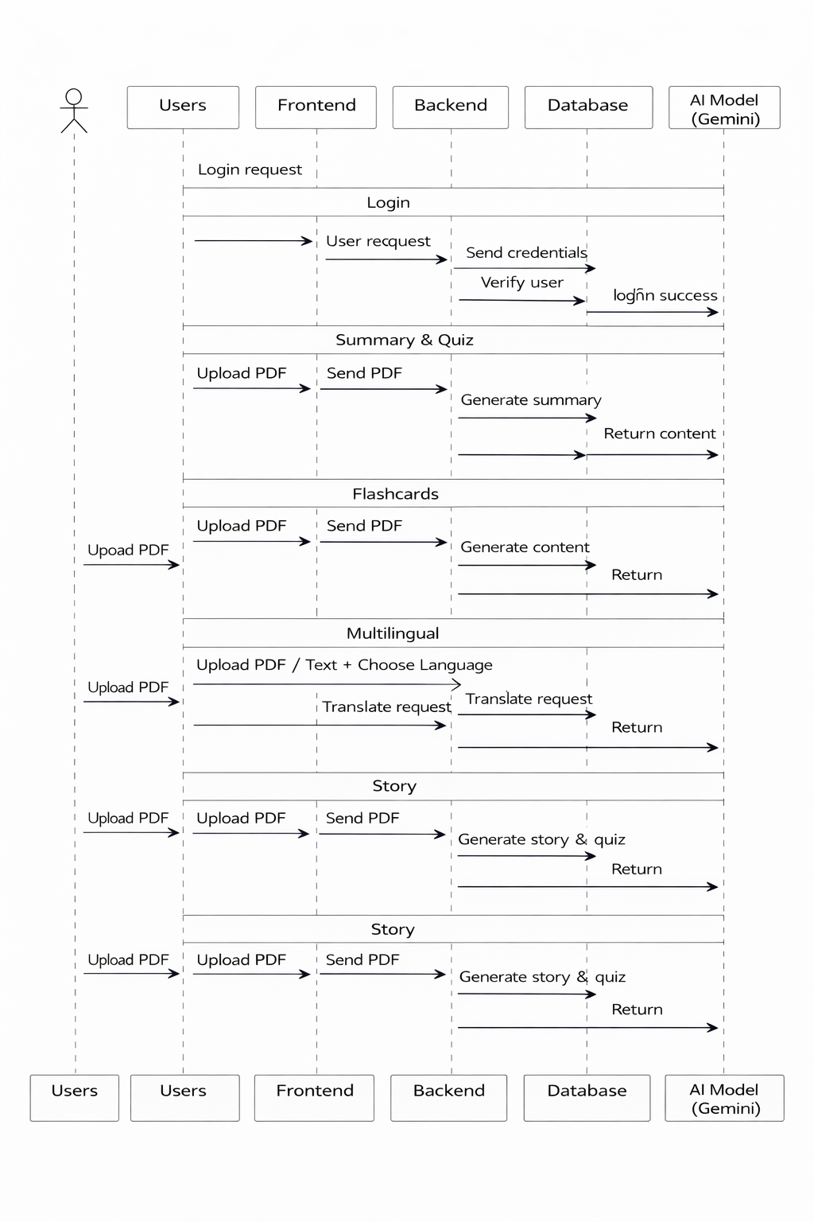






Sequence Diagram
State Chart
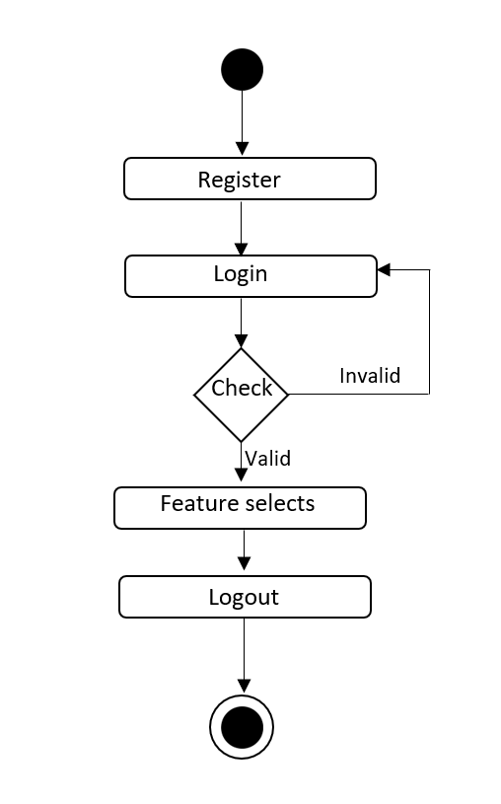

Input and Output Reports

Input Reports
- User Registration Form: Users input their name, username, email, and password to create an account.
- Login Form: Users enter their credentials to access the system.

Snap Notes Input: Users upload a PDF file to generate notes and quizzes.

Multilingual Input: Users upload content to convert it into another language.

Flashcards Input: Users upload a PDF to generate flashcards automatically.

Story Mode Input: Users upload a PDF to convert it into a story format with audio.

System Generated Input (Background Data): The system internally tracks user interactions.

Output Reports
- Results: Displays score after each module(correct/incorrect answers).
- Dashboard Report: Shows overall performance with tables

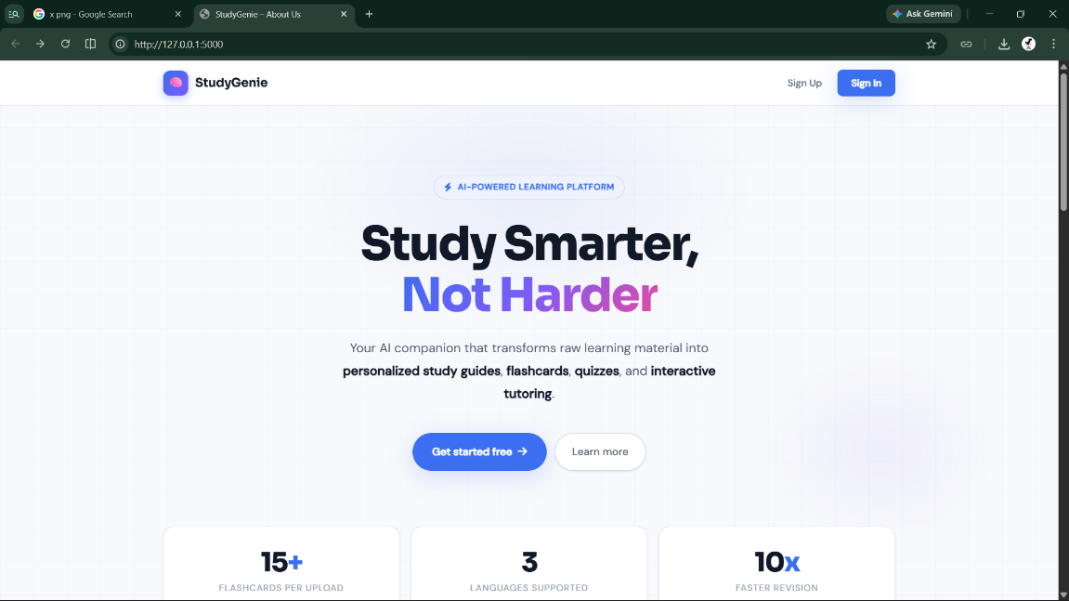
Screens
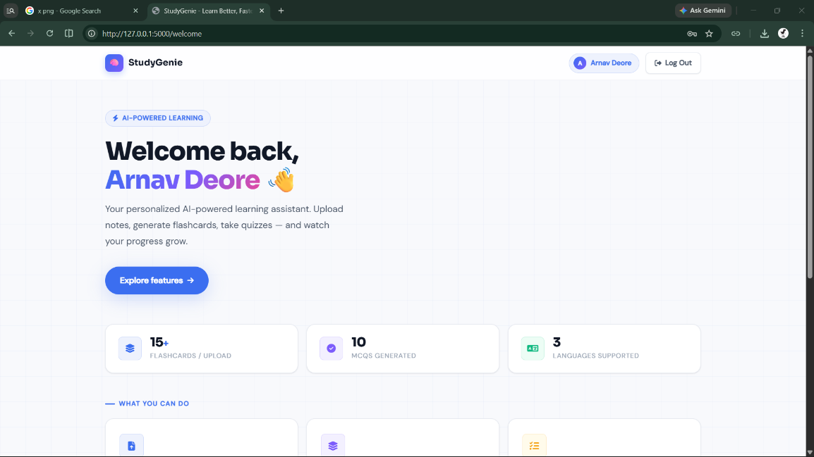
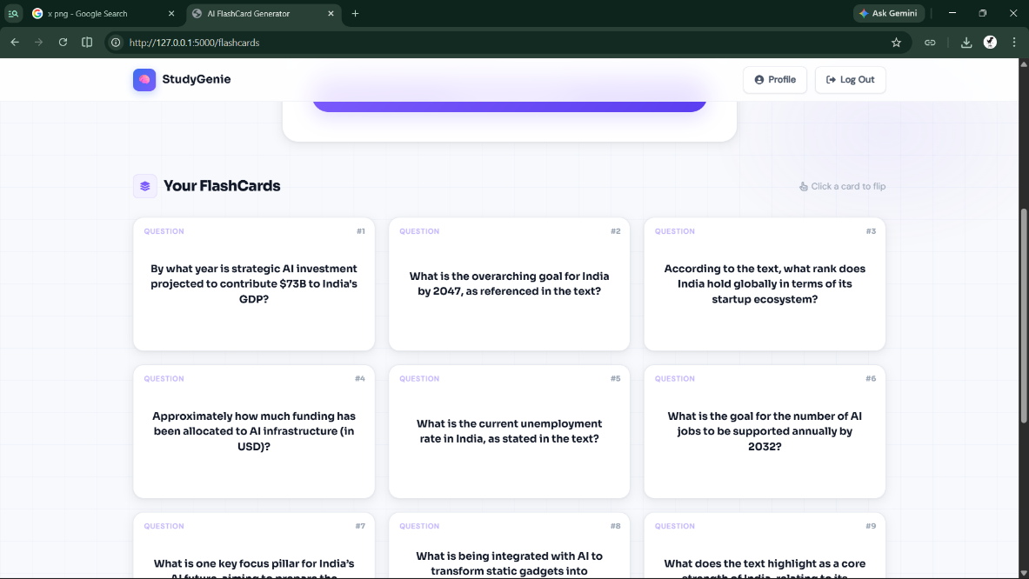
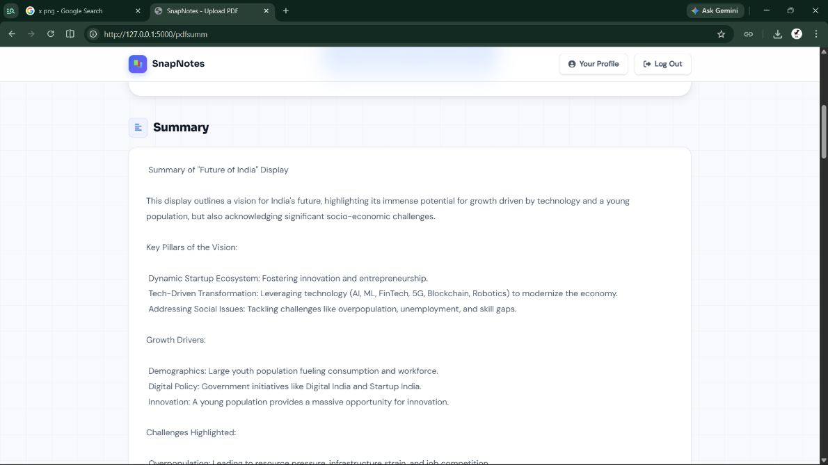
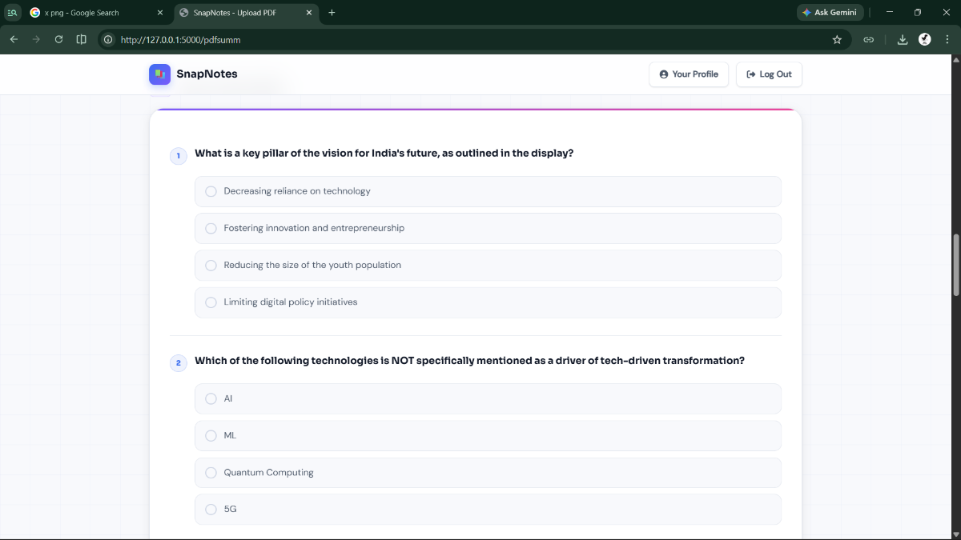
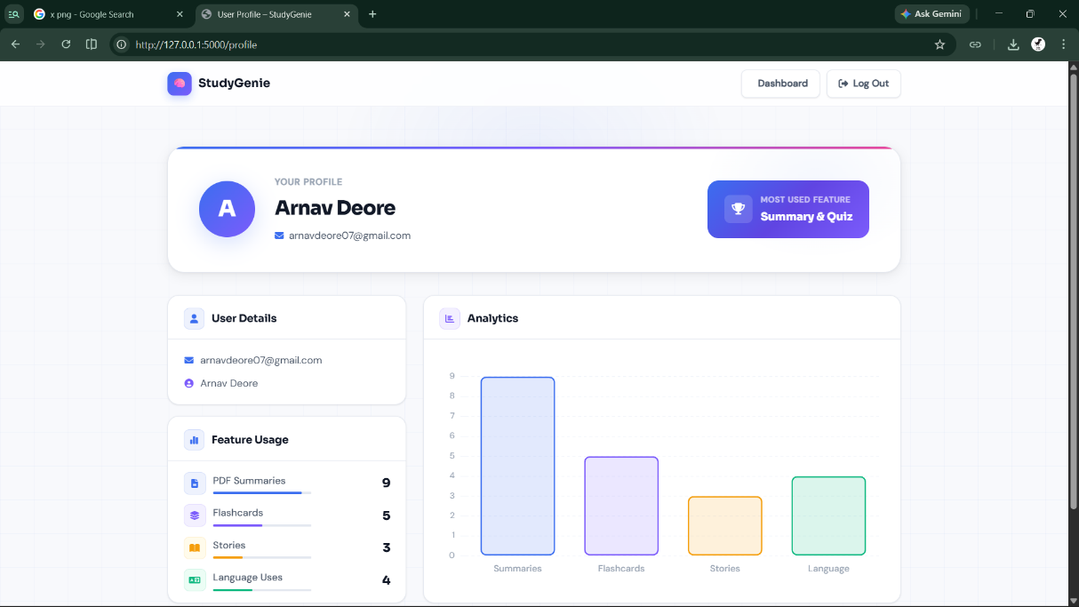
Conclusions and Recommendations

Conclusions
The Study Genie system successfully demonstrates how Artificial Intelligence can be effectively integrated into the field of education to enhance the learning experience. By combining multiple functionalities such as automated note generation, quiz creation, multilingual translation, flashcard generation, and story-based learning, the system provides a unified platform that simplifies academic tasks for students. It reduces the effort required for manual note-making and planning while promoting active and engaging learning methods. The use of AI enables the system to process large amounts of content efficiently and convert it into structured, understandable formats. Overall, Study Genie improves productivity, supports self-learning, and introduces a modern approach to education that aligns with current technological advancements.

Recommendations
To further enhance the effectiveness of the Study Genie system, continuous improvements should be made in terms of accuracy, usability, and scalability. The AI models used for content generation should be regularly updated and fine-tuned to ensure more precise and context-aware outputs. The user interface can be improved to provide a more interactive and visually appealing experience, which will help in increasing user engagement. Additionally, implementing stronger security measures such as encrypted password storage and secure data handling practices will ensure user data protection. The system should also be optimized for faster processing and reduced response time, especially when handling large PDF files. Incorporating user feedback mechanisms can help in identifying areas of improvement and refining the system based on real-world usage.
Future Scope
• Development of a mobile application (Android/iOS) for wider accessibility
• Integration of voice input and voice-based interaction for hands-free usage
• Addition of more language options beyond Hindi and Marathi
• Implementation of AI-based personalized study recommendations
• Integration with online learning platforms and LMS systems
• Addition of real-time collaboration features for group study
• Use of advanced analytics to track student performance and learning patterns
Bibliography and References
• Artificial Intelligence in Education – Research Papers and Journals
• OpenAI Documentation – AI and Natural Language Processing
• Flask Documentation – Python Web Framework
• SQLite Documentation – Database Management System
• Google Translate API / NLP Resources (for multilingual processing)
• Various online educational platforms and AI-based learning tools

