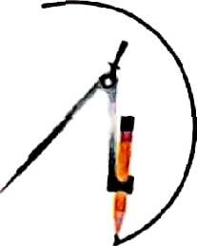
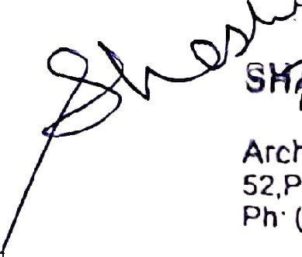


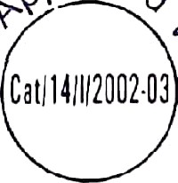



SHASHI SHARMA
B. ARCH., A.I.I.A.,
ARCHITECT INTERIOR DESIGNER VALUER
S T Y L E S
I N
ARCHITECTURE
Ref. No....................
Date : .......,.,. „,
FORM-I
ARCHITECT'S CERTIFICATE
(To be submitted at the time of Registration of ongoing Project and for Withdrawal of money from Designated Account Building/\Ving wise)
Date: 31.12.2025
To,
MR.
MUKUL MAHENDRA
AGRAWAL & OTHERS
B - 101, Poonain Heights, Pande Layout Khamla, Nagpur
Subject: Certificate of percentage of Completion of land development Work of Project [RERA Registration Number: P50500028120] situated on KH No. 59/1 P.H. No. 80, Mouza -Borkhedi (RLY)
Demarcated
by its boundaries (latitude and longitude of the end points) 20.8562111 142,
78.9731209501 to the North-East, 20.8647352 171, 78.9729910243 to the South - East,
20.865283397, 78.9708588198 to the South-west, 20.8658634976, 78.9711257958 to the North- west of Division Tahsil Zilla Nagpur (Gramin), District - Nagpur admeasuring 15600.00sq.mts. area being developed by Mr. Mukul Mahendra Agrawal & Others.
Sir, I/We Ar. Shashi Sharma have undertaken assignment as an Architect of certifying Percentage of Completion of Construction Work of the LAND DEVELOPMENT Project, situated on the KH No. 59/1
P.H. No. 80, Mouza — Borkhedi (RWY). Tehsil Zilha - Nagpur (Gramin) Dist NAGPUR admeasuring 15600.00 sq. mts. area being developed by Mr. Mukul Mahendra Agrawal & Others.
1. Following technical professionals are appointed by Owner Promoters:
- M/s/Shri/ Smt. as Architect Ar. Shashi Sharma
- M/s/Shri/ Smt. as Structural Consultant
- M/s/Shri/ Smt. as MEP Consultant
- M/s/Shri/ Smt. as Site Supervisor
Based on Site Inspection, with respect to each of the Building/Wing of the aforesaid Real Estate Project, I CeHify that as on date of this ceHificate, the Percentage of Woi'k done for each of the building Wing of the Real Estate Project as registered vide number RERA Reg istiation Number: P50500028120 under RERA is as per Table A herein below. The percentage of the work executed with respect to each of the
major activity of the Building/Wing and Overall Percentage of work Building/Wing is detailed in the Table B.
done with respect to each
*,
SHASHI SHARMA
B. ARCH., A.I.I.A. CA/84/08476
NO NM 0/R/2020/APL/008476 N M RDA/CA/8 4/084 76/75
S
>gl BHARMA
B.Arch., A. l.l.A.
Architect, Int. Desiprer Valuer 52,Prema Nagar, Kabul Road, Nagpur Ph’ (0712) 2570190, 989030997 B
9890303378
P. NO. 52, PRERNA NAGAR, KATOL ROAD, NAGPUR. PH.: 8484993547,
› Scanned with OKEN Scanner


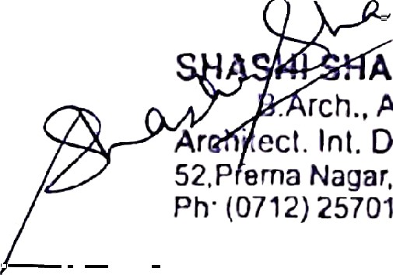




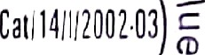
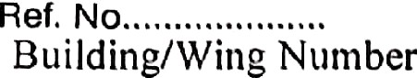

SHASHI SHARMA
B. ARCH., A.I.I.A., ARCHITECT INTERIOR DESIGNER VALUER
S T Y L E S
I N
ARCHITECTURE
TABLE -A
Date : .............................
(to hc preparcd separately for each Building /Wing or the Project)
°”
O
SHASHI SHARMA
B. ARCH., A.I.I.A.
CA/84/08476 NM NM 0/R/2020/APL/008475 NM RDA/CA/84/08476/76
. A.9.EA
rch., A.I.I.A.
Ar
.ecI. Inl. Destpror Valuer
52,P ema Nagar, Katol Road. Nagpur
Ph (0712) 2570190. 9890309978
P
NO. 52,
PRERNA NAGAR, KATOL ROAD,
NAGPUR.
PH.: 8484993547, 9890303378
› Scanned with OKEN Scanner
Sr. to Tasl‹s/Activity

Percentage o£Work
Dons

1. Excavation

N.A.

2. number of Basement(s) and I°linth

N.A.

3. number of Podiums

N.A.

4. Stilt Floor

N.A.

5. nun her of S labs of Super Structure

N.A.

6. Internal walls, Internal Plaster, Floorings within F lats/ Premises, Doors and windows to each of the Flat/Prein ises
N.A.

7. Sanitary Fittings within the Flat/Premises, Electrical Fittings within the Flat/Prem ises
N.A.

8. Staircases, Lifts Wells and Lobbies at each Floor level connecting Staircases and lifts, Overhead and Undergi ound
Water Tank
N.A.

9. The external plumbing and external Plaster, elevation, completion of terraces with waterproofing of the Building/Wing.
' •eqp
N.A.






ll1tCl'ltflÎ @ LXtCFl
«I Dave lO|3l11Ùl1l
Ÿ/OFks ii1 Iles ›ect ol”the cntire îtegistered Phase
S:.
No.
Coi**!** !' !!!'*°>> !!i d I' cilitiüs, Aillcnitics
Pl'opos d (Yes/No)
Details
% où work done
1.
Ilât8fnùl Rofids & l?OO(|9tlt11s
YES
100%
Internal Layout
Ronds
2.
Water Supply
YES
100%
Layout Water Supply
3.
100%
YES
Scwsrage (cliainhui', lii›es, Seçtic 'l’anl‹, STI*)
Sewer line with
chambers
YûS
100%
4.
Storil Wnter Di'aiiis
Storm drsins with
chambers
8.
Lnndsc0ping &’lrccpl«nüng
100%
6.
Stioct Ligliting
N.A,
0%
7.
Comm ii ity Il iil‹liiJgs
0%
YûS
Treatment and ‹lispusnî oI's nnd sullago wat‹
wttge
SHA'S‘HJ*5H‘/ RMA
IARMA
, A
Dc6ignor Valuer
Nn‹jnr, Xatol Rond, Nagpuf
(0712) ”2‘470190, îI890309ù78
B. ARCLJ., A, I.I.A.
CA/84/08476 NN NM O/R/2020/APL/008476
^^ î”î îNWW/ WWg WW/ W W-8 ê W/ * W
Pn
:
Scanned with OKEN Scanne

{j, |Ms(n||ùtÏ0I10Ê IÎÏÏS, wtll\•l'|3\II\1|3s, ) ÏFG Figl1tÏng ri(tings
‹_{l}ild Lqt|i|›i»cnt ns ici‘ CI'O NOC, Elccti°ictil lIttif\g to
_{P}ony›ion Arc‹i, clcctrc, mccl1‹îI1iC(Il CÇLIi|3»ci t Con plian_{C}/
t /›‹Iil ici›s ul'ofivIi‘oi1i11ci1t CItZ N OC, fii1isI1ing to ç|1(t'f}j1CÙ |ÙÈi[3y’5. |3ÎlIttl1 |3l"O(UÛllOl1, |3t1V il1§ g|"QÉC{\ iipt›iirtoi]‹›nttO l3Hi lxl ii1g/Wi i1y, C¢›i11i›oLii tl Weill aii‹l „il
Otlj0l' rÙ¢|\tÎt’ÏJDJ¢îIttS t1S i11t\y |3U t‘C¢|Ll iI'ÙC| IO Ç}|3t\\|)j Ç}CCt1|3gt|O]
/Coi iglction Cei'lilicrtto.

N.A,




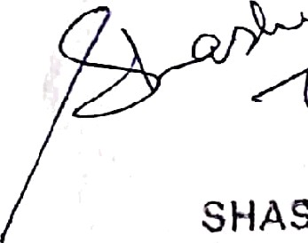

SHASHI SHARIHA
B. AP.CH., A.I.I.A.
CA/84/02476 NM NM 0/R/2020/APL/006478 NM RDA/CA/84/084 76/ 76
SFïASHI Si-IA..ÎŸIA
B.Arch., A.I
I A
er Valuer
Architect. Int. Design
atol Road, Nagp
52. Prema fiôÇäF,
5690309978
Ah (07 12j
257019g.
› Scanned with OKEN Scanner
9.

Solid Waste Manas•rNentalid disposal
YES 90%

10.

Water Conservation, Rain »'ater harvesting
YES 90%

1 l.

Energy Management

N.A. 0%

12.

Fire protection and fire safety requirement
N.A. 0%

13.

Electrical meter room, sub station receiving station
N.A. 0%

14.

Other (OPEN SPACE COMPUND WALL)

YES 100%

Boundaiy wall WÎth gate

