Game Design Document

Fill up the Following document

1. Write the title of your project.

Space Battle

1. What is the goal of the game?

The goal of the game is to safely reach the end and kill the boss space shuttle

1. Write a brief story of your game?

You, being one of the finest astronaut at Earth Space Research Program is asked to venture in the space and destroy the alien ship which is near Jupiter since their intention is no good and will possibly bring an apocalypse if not destroyed in right time.

1. Which are the playing characters of this game?

* Playing characters are the ones which respond to the user based on the input from the user
* Cars, monkeys, dinos, wizards etc, are the playing characters in the game.

|  |  |  |
| --- | --- | --- |
| Number | Character Name | What can this character do? |
| 1 | Space Shuttle | It has got light razers can easily destroy an object which comes near to it. This is the only playing character in this game |
| 2 |  |  |
| 3 |  |  |
| 4 |  |  |
| 5 |  |  |
| 6 |  |  |
| 7 |  |  |
| 8 |  |  |

1. Which are the Non Playing Characters of this game?

* Non Playing characters are the ones which don't have an action or a behaviour when the user interacts with the game.
* Hurdles, stones, bananas, coins, etc are non playing characters in the game.

|  |  |  |
| --- | --- | --- |
| Number | Character Name | What can this character do? |
| 1 | Boosters | These can aid the player and lighten when tension increases in the game |
| 2 | Enemy 1 - 8 | These are the subordinates of the main enemy space shuttle and will defend their boss. They will attack on the playing character. |
| 3 | Obstacles | These are the obstacles in form of meteors and asteroids and can harm the playing character |
| 4 | Group Of Obstacles | These are same as obstacles but in this case it will be a group of it. |
| 5 |  |  |
| 6 |  |  |
| 7 |  |  |
| 8 |  |  |

Draw your imagination of this game. What does this game look like?

* Draw the game either on your computer or on paper,
* Add images of scenes of the game to show each of the playing and non-playing characters at least once.

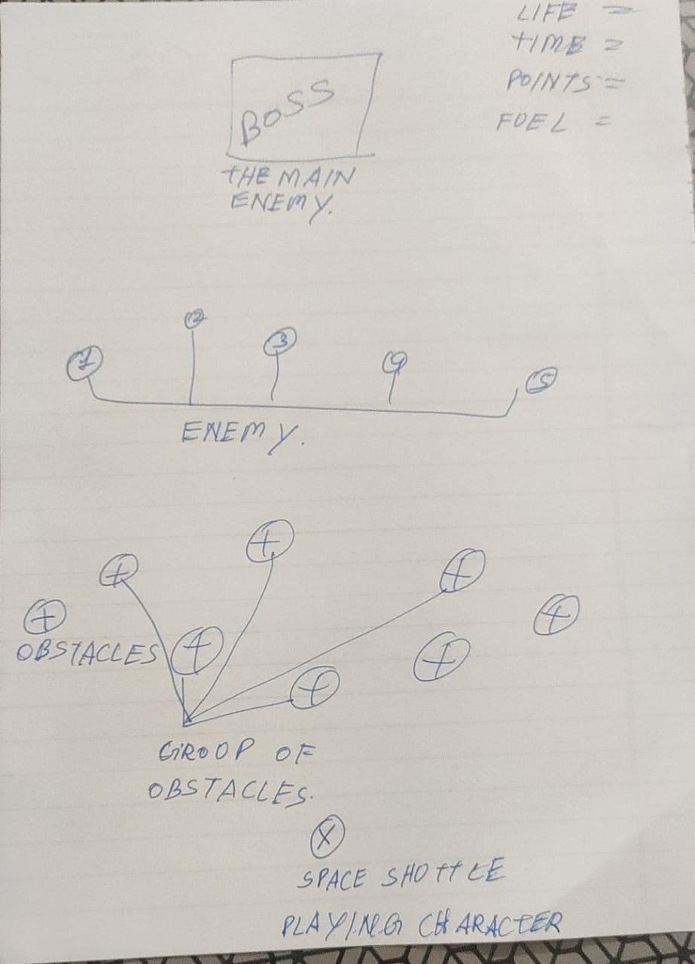

How do you plan to make your game engaging?

As the game continues, more and more obstacles will come and the number of attacks by one enemy will increase and also the concept of fuel here will make sure that the PC gets the fuel tank refilled or else the game will end