COMP2321: Coursework Overview – “CHESS FRAGMENTS”

The coursework is inspired by the game chess.
Read carefully the coursework description and the coursework marking scheme.
The Coursework is worth 40% of the overall module assessment.

This game consists of two players: Agent, your designed algorithm, and Opponent, which represents a set of predefined baseline algorithms. Agent and Opponent compete on an 5x5 grid in a turn-based strategy game inspired by chess.

Rules:
The board consists of several pieces chosen from the set {Right, Knight, Bishop, Queen, King, Pawn}, each with its own movement rules:
- Right: Moves any number of squares horizontally or vertically. They can also move in an L-shape: two squares in one direction, then one square perpendicular. It can jump over other pieces.
- Knight: Moves in an L-shaped: two squares in one direction, then one square perpendicular, jumping over other pieces.
- Bishop: Moves any number of squares diagonally.
- King: Moves one square in any direction.
- Queen: Moves any number of squares diagonally, horizontally, or vertically.
- Pawn: Move one square forward. Pawn captures an opponent piece by moving one square diagonally forward to the occupied square. When pawn can reach the opponent's back rank, pawn is promoted to Queen.
The piece King is always present on the board. Other pieces may or may not appear, depending on our board setup. In each game, Agent can play the white side, and Opponent plays as the black side, or vice versa.

Example of piece movements:
Right (represented as R for white and r for black)
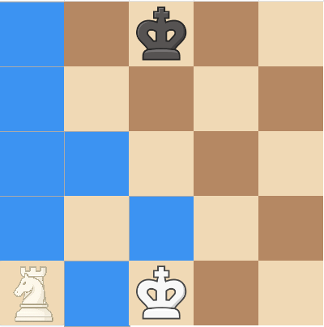

Knight (represented as N for white and n for black)
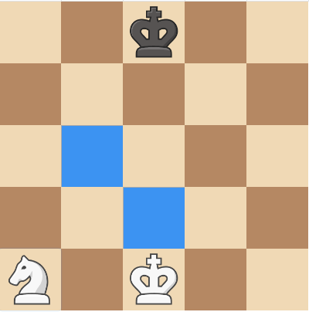
Bishop (represented as B for white and b for black)
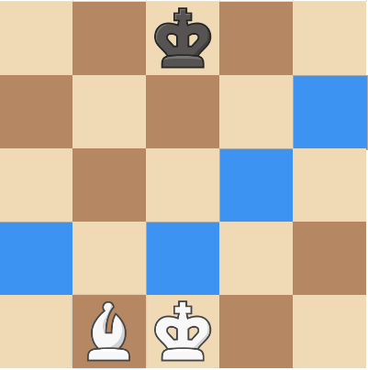
King (represented as K for white and k for black)
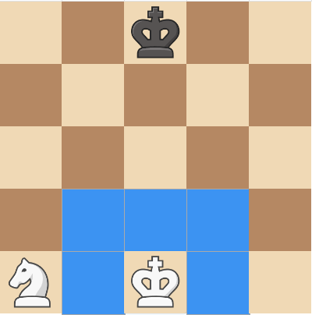
Queen (represented as Q for white and q for black)
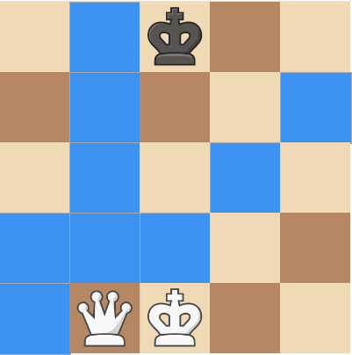

Pawn (represented as P for white and p for black)
- In their first move, Pawn has the option to move either one square or two squares forward if the path is clear.
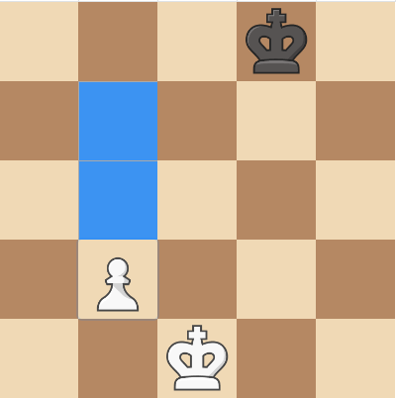
- Starting from their second move, Pawn can only move 1 square forward.
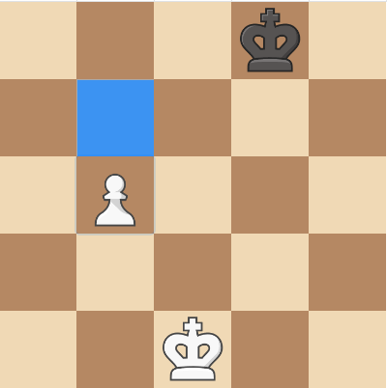
- Pawn captures an opponent piece by moving one square diagonally forward to the occupied square as below:
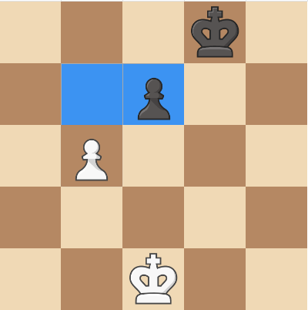
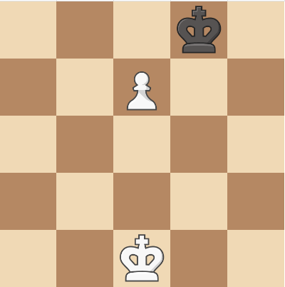
Before moving After moving

- When pawn can reach the opponent's back rank, pawns are promoted to Queen as below:
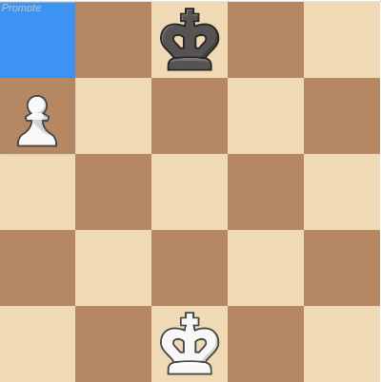
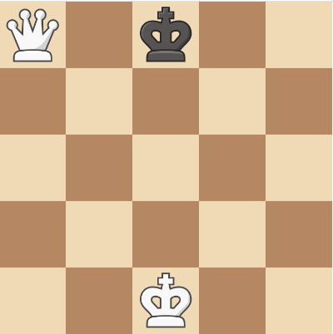
Before moving After moving
- Like standard chess, a pawn can also capture an opponent’s pawn via en passant.

In general, all available move and capture options (for all pieces) can be determined using the legal move checking function provided in the CW Supporting Package.

Board presentation on the Python environment
In the CW support package, the game board is presented by a 2D matrix with the shape of (5,5).
Each chess piece on the board is denoted by a single letter: uppercase letters for white pieces and lowercase letters for black pieces. You can further explore this representation in the provided CW support package.

 | 0 | 1 | 2 | 3 | 4
0 | r | b | k | q | n
1 | p | p | p | p | p
2
3 | P | P | P | P | P
4 | N | Q | K | B | R
A matrix shape of (5,5)

Win, Lose, or Draw:
Win/Lose: The game is lost (and the opponent wins) under one of the following conditions
- Checkmate: your King is checkmated. In other words, it is attacked with no legal escape.
- Stalemate: it is your turn to move, but you have no legal moves available.
- Thinking timeout: your agent fails to decide their next move within the predefined time limit.
- Illegal move: your agent makes an invalid move during their turn.
Draw: A draw can occur under several conditions:
- Only 2 kings remain on board.

- Fivefold repetition: the game ends with a draw if the exact board position occurs five times during the game, regardless of whether the repetitions are consecutive or not.
- Game timeout: the game is declared a draw if neither Player 1 nor Player 2 achieves a win or loss within the predefined time limit.

- Preparing Your Agent (agent.py) for Submission
You are required to design an Agent (implemented in agent.py) following the specified format. The initial positions of the pieces on the game board and Opponent are predefined. In Blackboard, Opponent is implemented with varying difficulty levels, and the board setups also differ in complexity. Therefore, you should design Agent to be as smart as possible to compete effectively in different settings.
You may consider implementing algorithms such as minimax, alpha–beta pruning, etc. to guide Agent decide the best next move. It is recommended to begin with a simple, maybe not-so-
clever algorithm to test against Opponent, and then gradually move to more sophisticated approaches.
You should also evaluate the computational cost (e.g., the number of nodes expanded) when deciding the next move within the predefined time limit to avoid the thinking timeout. This can be done by adjusting the search depth or by applying other optimization techniques, with the goal of producing a solution that is both strong and computationally efficient. Additionally
make sure to monitor the provided thinking time variable provided to ensure your agent selects the most reasonable move before the thinking timeout occurs.
In the CW supporting package, a basic example is provided, including a simple Agent and Opponent, to help you get familiar with the game rules and the required agent.py format. Note that the sample Agent provided is for illustration purposes only and will not be competitive against Opponent in the assessment system. You should complete your own Agent and save it as agent1.py in the required format before submission.

Assessment

Part 1: Agent vs Opponent (80%)
Once you develop your own Agent, prepare it as agent.py in the required format. In Part 1 assessment, your Agent will be tested against Opponent under different difficulty levels varying in both strategy and board setup, starting from the easiest level to the hardest one. The results of this submission will count as your Part 1 marks
Part 2: Agent Strategy Presentation (20%)
You must submit a short presentation explaining how your Agent strategy works. The presentation is assessed across the following criteria:
• Strategy / Technique Used – 4 marks
• Technical Implementation – 8 marks
• Testing & Evaluation – 4 marks
• Clarity & Presentation – 4 marks
Please refer to the Coursework Marking Scheme for the detailed performance descriptors for each criterion. The deadline for the submission for both components is on 16:00 IST Thursday week 11(i.e., 26 November 2026). Presentations will take place in Week 12 (1 December).

Important Things to Consider
- You are allowed to use online references and GenAI tools to support developing your Agent solution.
- You are not permitted to copy another student’s agent.py solution. All submissions will be checked for plagiarism to detect any similarity.
- You should thoroughly test your agent.py solution in your local machine before submitting it to Blackboard.
- The Blackboard may become overloaded close to the submission deadline, especially in week 11, so do not wait until the last minute to submit your agent.py solution.

