Code -:
int findDelayedArrivalTime(int arrivalTime, int delayedTime) {
int final_time;
int temp=arrivalTime+delayedTime;
if(temp>=24){
final_time=temp-24;
}
else{
final_time=temp;
}
return final_time;
}
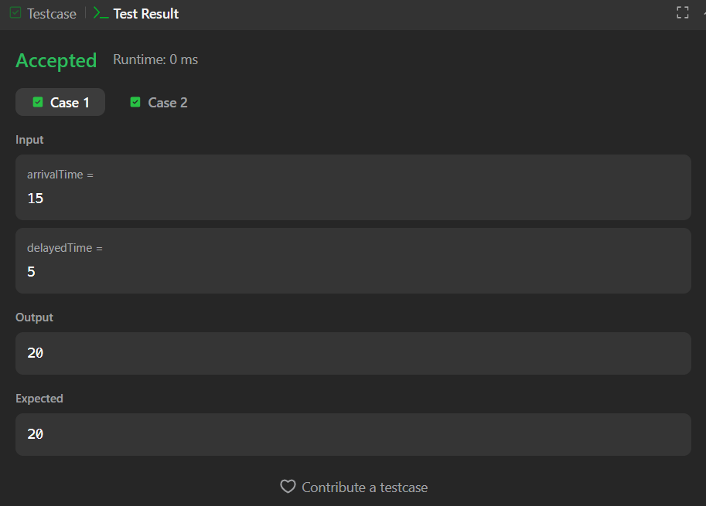
Link to code -:
https://leetcode.com/problems/calculate-delayed-arrival-time/

