MB972 Managing Value-Driven Analytics (Assignment - Group 1).
1. Introduction
Strategic Aid for Health (SAFH) is a global health organisation tasked with making critical decisions on resource allocation to maximise health outcomes. Given the diverse range of health challenges faced across regions, the organisation requires a structured and transparent approach to evaluate and prioritise programs.
This report compares five health interventions to determine five potential health interventions to determine the most impactful and sustainable option for SAFH’s funding priorities. The alternatives considered in the report are:
- Maternal and Neonatal Disorders in Ethiopia
- Maternal and Neonatal Disorders in South Sudan
- HIV in Kenya
- Malaria in Malawi
- Non-Communicable Diseases in Zambia
The alternatives are taken after calibrated assumptions and based on the following six key criteria's reflecting SAFH’s mission to reduce health burdens while ensuring financial sustainability.
- Population Size - the scale of the intervention and number of people impacted.
- Out-of-Pocket Expenditure (OOPS) as % of CHE - financial strain on households.
- External Health Expenditure (EXT) as % of CHE - reliance on external funding.
- Current Health Expenditure (CHE) in million US$ - total health investment.
- All Sources Health Expenditure on Specific Diseases - targeted funding for the disease.
- DALYs (Disability-Adjusted Life Years) - the health burden of the disease.
A Multi-Criteria Decision Analysis (MCDA) framework was employed to structure this process. It has involved developing a value tree, normalising, and scoring the data across six criteria, weighting to introduce SAFH priorities, and conducting sensitivity analysis as an analytical device for testing the strength of a set of recommendations. By adhering to this logical structure, SAFH can make evidence-based decisions that align with its mission to address critical health needs optimally.

2. Qualitative Analysis of the Problem:
The SAFH decision problem is multi-dimensional, involving assessments of five health interventions across multiple countries with diverse burdens of disease and financial considerations.
Each country faces distinct challenges shaped by its population size, disease burden measured in DALYs, and demographics and financial metrics including Current Health Expenditure (CHE) and Out-of-Pocket Expenditure (OOPS) reveals the capacity and fiscal pressures on healthcare systems. To support in the decision-making process, we initially created a mind map to better understand the related factors and perform an initial analysis that promotes a structured analytical solutioning which includes health expenditure, stakeholder priorities, uncertainties, and socio-cultural considerations.
The following are the assumptions that have been taken while ascertaining the criteria for arriving at the alternatives:-
1. Population Size as a Proxy for Scale: Larger populations are assumed to amplify the potential impact of health interventions.
2. DALYs Reflect Health Burden: DALYs are used as a primary indicator to measure the urgency of health issues in each country.
3. OOPS as a Measure of Financial Strain: It is assumed that higher out-of-pocket expenditure signifies greater financial vulnerability for households.
4. EXT Indicates Sustainability Risks: Heavy reliance on external funding is assumed to pose long-term sustainability challenges.
5. CHE as System Readiness: Current health expenditure is assumed to reflect the readiness of a country’s health system to implement scalable interventions.
6. Disease-Specific Funding Alignment: Funding levels for specific diseases are assumed to indicate alignment with national priorities and existing efforts.
7. Stability and Governance Considerations: Political and economic stability are assumed to affect the feasibility and implementation of interventions.
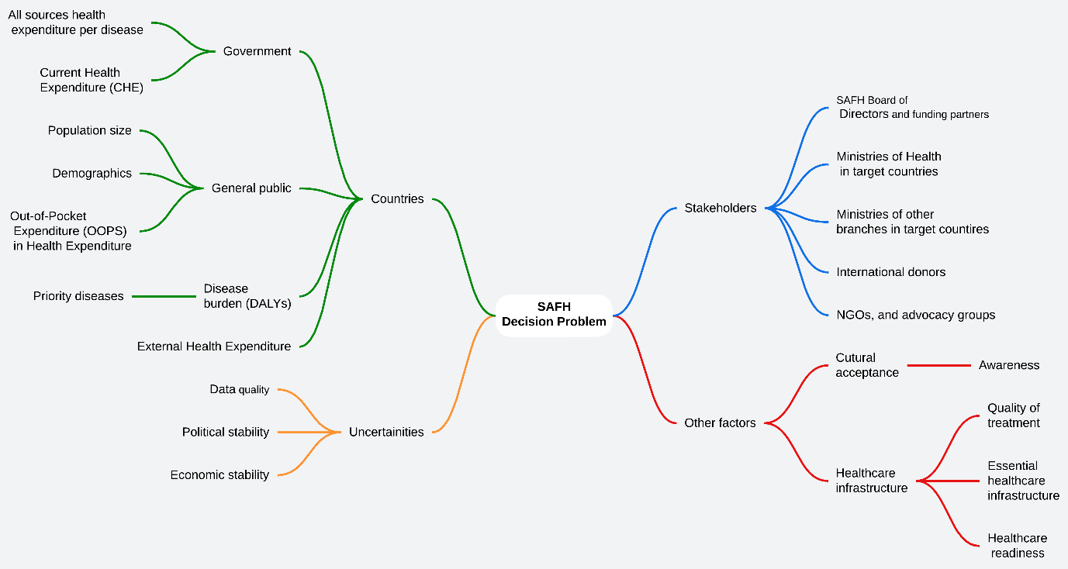 Figure 1: Mind Map of SAFH Decision Problem
The mind map illustrates the interconnected factors shaping the Strategic Aid for Health (SAFH) decision-making process. It identifies key domains influencing the problem, including countries, stakeholders, uncertainties, and other factors. Under the "Countries" domain, essential considerations include population size, disease burden (measured through DALYs), current health expenditure (CHE), out-of-pocket expenditure (OOPS), and external health expenditure, all of which reflect the financial and healthcare capacities of target nations. The "Stakeholders" domain highlights critical entities such as SAFH’s board of directors, Ministries of Health, international donors, NGOs, and advocacy groups that play pivotal roles in aligning resources, policies, and funding.
Uncertainties such as data quality, political stability, and economic resilience are also highlighted, reflecting the complexities of operating in diverse regions. Lastly, "Other Factors" such as cultural acceptance, healthcare infrastructure readiness, and awareness within communities demonstrate the nuanced socio-cultural and systemic influences that must be accounted for in the analysis.
The aforementioned mind map ensures a structured approach to addressing SAFH's decision problem, balancing quantitative metrics with qualitative insights for more informed and impactful decision-making.

3. SUECA Framework:
The CAUSE/SUECA framework provides clarity and focus, ensuring transparency in evaluating alternatives and addressing uncertainties systematically. Following is the SUECA framework:-
3.1 Stakeholders
Collaboration with key stakeholders is essential for the success of any intervention. SAFH’s stakeholders include:
1. SAFH Board of Directors and Funding Partners: Provides financial resources and strategic guidance.
2. Ministries of Health in Target Countries: Act as implementing partners, ensuring alignment with national health plans. Also, Ministries of Other Branches in Target Countries can also act as support partners.
3. NGOs, International Donors, and Advocacy Groups: Offer additional funding, advocacy, and on-the-ground expertise.
3.2 Uncertainties
Several uncertainties may influence SAFH’s decision-making process and program outcomes:
1. Data Quality: Health statistics and expenditure reporting vary across countries, affecting accuracy.
2. Political and Economic Stability: Fragile contexts like South Sudan may face program disruptions due to conflict or governance issues.
3. Stakeholder Priorities: Differences in donor funding preferences and local government priorities could shift resource availability and program feasibility.
3.3 Environment
The broader healthcare environment shapes the feasibility and impact of SAFH’s interventions. Key factors include:
1. Healthcare Infrastructure: The availability, quality, and readiness of healthcare systems vary significantly across countries.
2. Cultural Acceptance: Community receptiveness to interventions is crucial for effectiveness, particularly for diseases with cultural stigmas, such as HIV.
3. Economic Conditions: Variations in GDP and government health expenditure affect the ability of countries to sustain programs long-term.
3.4 Criteria:
1. Population Size: This variable represents the scale of the intervention and connects directly to the Disease Burden focus area. A larger population size indicates a broader reach and higher potential for impact in addressing health challenges.
2. DALYs (Disability-Adjusted Life Years): DALYs are a direct measure of Disease Burden, reflecting the health impact of specific conditions. Higher DALYs indicate a greater need for intervention and alignment with SAFH’s goal to alleviate significant health burdens.
3. OOPS (Out-of-Pocket Expenditure as % of CHE): OOPS aligns with the focus area of Out-of-Pocket Expenses. High OOPS values indicate significant financial strain on households, emphasizing the importance of interventions that reduce direct costs for vulnerable populations.
4. EXT (External Health Expenditure as % of CHE): EXT reflects Vulnerability. High reliance on external funding indicates economic and systemic fragility, highlighting the need for sustainable funding solutions.
5. CHE (Current Health Expenditure in million US$): CHE connects to Vulnerability by indicating system readiness and financial resilience. Higher CHE suggests stronger capacity to implement and sustain interventions.
6. All Sources Health Expenditure on Specific Diseases: This criterion aligns with Disease Burden by showing targeted investments in specific health challenges, indicating potential synergy with SAFH’s priorities.
3.5 Alternatives
The five alternatives were selected based on their relevance to SAFH’s mission, the health challenges they address, and the potential for measurable impact. Each alternative represents a significant health priority in its respective country, as outlined below:
1. Maternal and Neonatal Disorders in Ethiopia:
Ethiopia has one of the highest maternal and neonatal mortality rates globally, with significant DALYs indicating a high health burden. Its large population amplifies the potential impact of interventions. However, high OOPS reflects substantial financial strain on households, making this a priority for SAFH.
2. Maternal and Neonatal Disorders in South Sudan:
South Sudan faces severe challenges in maternal and neonatal health due to weak healthcare infrastructure and political instability. While the population size is smaller, the extreme reliance on external funding (high EXT) highlights the need for sustained interventions.
3. HIV in Kenya:
HIV/AIDS remains a critical health challenge in Kenya, contributing significantly to DALYs. Kenya also demonstrates robust CHE, indicating readiness for scalable interventions. Strong external funding networks enhance feasibility and alignment with SAFH’s objectives.
4. Malaria in Malawi:
Malaria is a leading cause of morbidity and mortality in Malawi, with substantial reliance on external funding (EXT). Despite a smaller population, the targeted nature of malaria interventions offers potential for focused impact.
5. Non-Communicable Diseases in Zambia:
Non-communicable diseases are emerging as a priority in Zambia, contributing significantly to DALYs. Although the population size is modest, interventions can address an unmet need while leveraging Zambia’s moderate CHE for sustainability.
4. Value Tree Development:
The value tree structures SAFH’s decision-making by linking objectives with measurable criteria. This step is critical as it organises the complex decision problem into a clear and logical hierarchy. The value tree ensures clarity in evaluating alternatives against predefined criteria. It provides a roadmap for systematically comparing the alternatives based on their alignment with SAFH’s strategic focus areas—Disease Burden, Out-of-Pocket Expenses, and Vulnerability.

This step is necessary to:
Establish Measurable Objectives: Each criterion is explicitly defined to facilitate data-driven decision-making.
Align with Strategic Goals: The value tree ensures that each alternative is evaluated in the context of SAFH’s mission and priorities.
Simplify Complex Decisions: By visualizing the relationships between criteria and alternatives, the value tree helps in managing the complexity of multi-criteria analysis.
Enhance Transparency: Stakeholders can clearly see how decisions are structured and why certain alternatives are prioritized.

4.1 Visualization
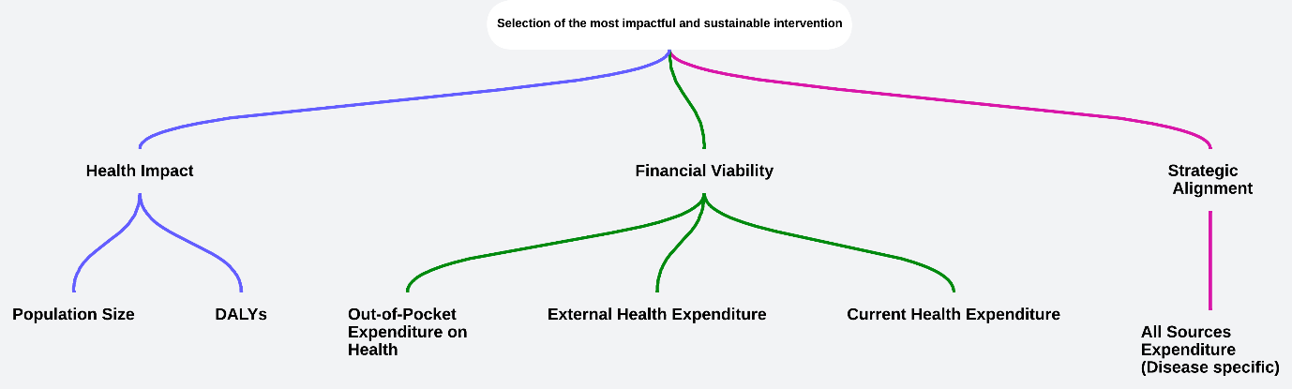 Figure 2: Value Tree of SAFH Decision Problem
The value tree provides a foundation for scoring, weighting, and comparing alternatives. Here, in this case, the Value Tree have been prepared based on following:-
- Health Impact: Measured using Population Size and DALYs, representing the scope of reach and burden of disease in each country. Interventions in Ethiopia and Kenya, for instance, stand out due to their large populations and high health burdens.
- Financial Viability: Focused on Out-of-Pocket Expenses, External Health Expenditure, and Current Health Expenditure, ensuring that the selected interventions are both sustainable and equitable. Countries heavily reliant on external aid, like South Sudan, pose challenges but offer potential alignment with funding initiatives.
- Strategic Alignment: Captured through All Sources Expenditure on Specific Diseases, ensuring that SAFH's investments align with ongoing efforts and targeted health programs.

5. Scoring and Weighting:
5.1 Normalization of Scores
The following is the raw data derived out of the various criteria's taken for the alternatives: -
Country - Disease | DALYs (Disability-Adjusted Life Years) in 2019 | Current Health Expenditure (CHE) in million US$ | External Health Expenditure (EXT) as % of Current Health Expenditure (CHE) | Out-of-pocket (OOPS) as % of Current Health Expenditure (CHE) | Population (in thousands) | All sources health expenditure on: Row level Country and Disease Specific
Ethiopia - Maternal and neonatal disorders | 7753217 | 2993.289 | 34.14991 | 37.92522 | 114120.6 | 69.55268
Kenya - HIV/AIDS and sexually transmitted infections | 2831551 | 4385.281 | 18.50995 | 24.29976 | 50951.45 | 824.8728
Malawi - Malaria | 533799 | 566.3709 | 43.55862 | 16.86334 | 18867.34 | 82.65251
South Sudan - Maternal and neonatal disorders | 855948 | 247.8 | 55.55466 | 22.6499 | 10447.67 | 13.8277
Zambia Non-communicable diseases | 2649688 | 1239.906 | 43.64445 | 10.21756 | 18380.48 | 132.9177
The raw data for each selected criterion has been normalized to a 0–100 scale. This allows comparison across different alternatives with different scales.
Country - Disease | DALYs | CHE (million US$) | EXT (%) | OOPS (%) | Population (in thousands) | All Sources Health Expenditure
Ethiopia - Maternal and Neonatal | 100 | 66.36 | 42.22 | 100 | 100 | 6.87
Kenya - HIV/AIDS | 31.83 | 100 | 0 | 50.82 | 39.07 | 100
Malawi - Malaria | 0 | 7.70 | 67.62 | 23.99 | 8.12 | 8.49
South Sudan - Maternal and Neonatal | 4.46 | 0 | 100 | 44.87 | 0 | 0
Zambia - Non-Communicable Diseases | 29.31 | 23.98 | 67.85 | 0 | 7.65 | 14.68
5.2 Weighting
Weights were assigned to the criteria to reflect SAFH's strategic priorities, balancing health impact, financial sustainability, and scalability: -
Criterion | Weight (%)
Population Size | 20
DALYs | 25
Out-of-Pocket Expenditure | 15
External Health Expenditure | 15
Current Health Expenditure | 15
Disease-Specific Expenditure | 10
5.3 Weighted Scores
Normalized scores for each criterion were multiplied by their respective weights to compute the total weighted score for each alternative. The calculations are shown below:
Country - Disease | Total Weighted Score | Rank
Ethiopia - Maternal and Neonatal | 77.92 | 1
Kenya - HIV/AIDS | 55.46 | 2
Zambia - Non-Communicable Diseases | 29.89 | 3
Malawi - Malaria | 23.48 | 4
South Sudan - Maternal and Neonatal | 16.29 | 5

From the analysis, following is the outcome in respect of different alternatives: -
1. Ethiopia: Ranks first due to high DALYs, large population size, and significant OOPS scores, displaying its health burden and the impact potential of interventions.
2. Kenya: Comes second with robust CHE and targeted disease-specific funding, despite moderate Disease Burden.
3. Zambia: Positioned third, reflecting emerging non-communicable disease challenges and moderate CHE.
4. South Sudan: Ranked fourth because of its reliance on external funding and lower population size.
5. Malawi: Despite significant external funding reliance, its smaller population and lower disease burden places it last in the priority list.
6. Sensitivity Analysis:
6.1 Purpose
Sensitivity analysis was conducted to test the robustness of the rankings by varying weights for key criteria. This ensures that SAFH’s decisions remain reliable under different strategic priorities.
6.2 Scenarios and Key Insights
Three scenarios were tested to evaluate how changes in weight assignments affect the ranking of alternatives:
Scenario 1: Increased Emphasis on Health Burden (DALYs)
- Change: Weight for DALYs increased from 25% to 35%, reducing weights for other criteria proportionally.
- Result: Ethiopia remains ranked first due to its maximum DALYs score (100). Kenya retains its second position, while Zambia, Malawi, and South Sudan remain in the same order.
Country - Disease | Total Weighted Score | Rank
Ethiopia - Maternal and Neonatal | 80.6 | 1
Kenya - HIV/AIDS | 45.7 | 2
Zambia - Non-Communicable | 24.7 | 3
South Sudan - Maternal | 20.3 | 4
Malawi - Malaria | 15.0 | 5

Scenario 2: Focus on Financial Viability (OOPS and EXT)
- Change: Weights for CHE, Out-of-Pocket Expenditure (OOPS) and External Health Expenditure (EXT) increased from 15% to 20% each, reducing weights for other criteria proportionally.
- Result: Ethiopia remains ranked first due to its high OOPS score (100) and moderate EXT score (42.22). Kenya strengthens its position with low EXT (0), and Zambia shows marginal improvement due to high EXT (67.85).
Country - Disease | Total Weighted Score | Rank
Ethiopia - Maternal and Neonatal | 77.1 | 1
Kenya - HIV/AIDS | 46.9 | 2
South Sudan - Maternal | 32.6 | 3
Zambia - Non-Communicable | 26.9 | 4
Malawi - Malaria | 23.1 | 5

Scenario 3: Equal Weighting Across All Criteria
- Change: All six criteria assigned equal weights of approximately 16.67%.
- Result: Still, Ethiopia remains the highest-ranked alternative, with Kenya second. Also, the rankings for the lower-ranked alternatives (Zambia, Malawi, South Sudan) remain unchanged.
Country - Disease | Total Weighted Score | Rank
Ethiopia - Maternal and Neonatal | 69.2 | 1
Kenya - HIV/AIDS | 53.6 | 2
South Sudan - Maternal | 24.8 | 3
Malawi - Malaria | 23.9 | 4
Zambia - Non-Communicable | 19.31 | 5

  - Key Insights from Sensitivity Analysis
1. Ethiopia’s Robustness: Ethiopia consistently ranks first across all scenarios, demonstrating its strong alignment with SAFH’s strategic goals.
2. Kenya’s Stability: Kenya’s robust CHE and low reliance on external funding ensure its consistent second position.
3. Variability in Lower Rankings: Rankings for Zambia, Malawi, and South Sudan show minor variations but consistently remain lower due to limited impact and financial viability.
This section consolidates the insights derived from the analysis and provides actionable recommendations for SAFH’s decision-making process.
7. Key Findings and Recommendations
7.1 Key Findings
1. Ethiopia as the Top Priority:
- Ethiopia ranks first across all scenarios, driven by its maximum scores in DALYs (100), Population Size (100), and Out-of-Pocket Expenditure (100).
- The combination of a significant health burden and large-scale impact makes Ethiopia the most impactful choice for SAFH.
- Although reliance on external funding is moderate (42.22 EXT), Ethiopia’s overall strong alignment with SAFH’s goals positions it as the top priority.
2. Kenya as a Strong Secondary Option:
- Kenya ranks consistently second due to its robust CHE (100) and disease-specific funding (100).
- The moderate DALYs (31.83) and reduced household financial strain (50.82 OOPS) highlight the potential for impactful, scalable HIV/AIDS interventions.
- Kenya’s low reliance on external funding (0 EXT) enhances its financial sustainability.
3. Limited Potential for Other Alternatives:
- Zambia: Ranked third due to moderate scores in DALYs (29.31) and high reliance on external funding (67.85 EXT). Emerging focus on non-communicable diseases provides niche opportunities for SAFH funding.
- Malawi: High external funding reliance (67.62 EXT) and low scores across key criteria limit its suitability for large-scale malaria interventions.
- South Sudan: The lowest-ranked alternative due to weak healthcare infrastructure, low DALYs (4.46), and a negligible population impact.
  - Recommendations
1. Prioritize Ethiopia for Immediate Intervention:
- Allocate SAFH resources to address Maternal and Neonatal Disorders in Ethiopia.
- Collaborate with local stakeholders to strengthen healthcare infrastructure, reduce household financial strain, and ensure sustainability.
- Focus on integrating external funding into national health systems to reduce financial dependencies.
2. Develop a Long-Term Plan for Kenya:
- Focus on HIV/AIDS interventions in Kenya due to its strong CHE and existing funding networks.
- Collaborate with local and international stakeholders to scale efforts, leveraging Kenya’s healthcare system readiness.
- Monitor health trends and prioritise programs addressing underserved populations.
3. Explore Strategic Opportunities in Zambia and Malawi:
- Zambia: SAFH can address emerging non-communicable disease challenges through targeted, cost-effective interventions, leveraging its moderate CHE.
- Malawi: Supplementary donor-driven or smaller-scale programs can address malaria hotspots in a cost-effective manner.
4. Reassess South Sudan:
- South Sudan’s challenges require a re-evaluation of feasibility for smaller-scale or partnership-driven maternal and neonatal health programs.
- Collaborate with international donors to overcome systemic barriers and strengthen foundational healthcare infrastructure.
  - Strategic Considerations
1. Resource Allocation: SAFH should prioritise resource allocation to Ethiopia and Kenya, given their potential for measurable impact and alignment with strategic goals.
2. Stakeholder Engagement: Engage with local governments, NGOs, and international organisations to ensure programs align with national health priorities and secure additional funding.
3. Monitoring and Evaluation: Implement robust frameworks to track progress, assess challenges, and refine interventions based on real-time data.
4. Risk Mitigation: Address uncertainities related to political instability, data quality, and external funding reliance through contingency planning and stakeholder collaboration.
8. Critique of Approach:
This section evaluates the strengths and limitations of the methodology used for SAFH’s decision-making process and provides recommendations for improvement.
  - Strengths of the Approach
1. Systematic and Transparent Decision-Making: The use of the Multi-Criteria Decision Analysis (MCDA) framework ensures a structured, objective, and data-driven approach, aligning with SAFH’s strategic goals.
2. Comprehensive Evaluation: Incorporating six diverse criteria allows a well-rounded assessment of health burden, financial sustainability, and scalability, ensuring alignment with SAFH’s mission.
3. Sensitivity Analysis for Robustness: The analysis tests different scenarios, highlighting how variations in weightings affect rankings. This enhances confidence in the robustness of the recommendations.
4. Focus on Equity and Impact: Emphasizing DALYs and Out-of-Pocket Expenditure ensures that SAFH’s interventions address both significant health burdens and financial equity.
  - Limitations of the Approach
1. Reliance on 2019 Data: The analysis uses data from 2019, which may not reflect recent changes in health burdens, economic conditions, or funding landscapes.
2. Simplification Through Normalization: While normalization enables comparability, it may oversimplify complex data, potentially overlooking nuanced differences between alternatives.
3. Limited Regional and Subnational Analysis: The focus on national-level data may obscure significant regional disparities within countries, affecting the precision of intervention targeting.
4. Subjectivity in Weight Assignments: Weights reflect SAFH’s priorities but may not fully account for diverse stakeholder perspectives or competing priorities.
  - Recommendations for Improvement
1. Enhance Data Accuracy and Relevance:
- Update the analysis with recent data to reflect current health trends, funding landscapes, and economic conditions.
- Incorporate subnational or regional data to capture local disparities and improve intervention targeting.
2. Refine Weighting and Scoring:
- Engage stakeholders in the weight assignment process to ensure alignment with a broader range of perspectives.
- Consider alternative scoring methods to retain granularity and capture subtle differences between alternatives.
3. Expand Sensitivity Analysis:
- Test additional scenarios, including extreme weight variations and alternative criteria combinations, to gain deeper insights into potential outcomes.
4. Incorporate Forecasting Models:
- Use predictive modeling to anticipate future shifts in disease prevalence, funding availability, and economic stability.
5. Broaden the Evaluation Criteria:
- Introduce additional criteria, such as cost-effectiveness, intervention scalability, and healthcare system readiness, for a more holistic assessment.

