ECE 3337 – Lab Report 1
BJT Amplifiers
Arnav Goyal (251244778)

Prelaboratory Preparation
Only final results for each question are shown here, complete work can be found at the end of this report.

Common-Emitter Amplifier

1.1
N/A

1.2
DC Biasing the CE Amplifier as noted in the question gives the following resistor values
Resistor | Expression | Numerical Value [] | Std Lab Value []
 |  | 33.200 k | 33.000 k
 |  | 6.800 k | 6.800 k
 |  | 800 | 820
 |  | 199 | 200

1.3
After Small Signal AC Analysis the following was found for the input/output resistances and voltage/current gains.
Note: All Output resistances are calculated such that we are not considering the load-resistance

Value | Expression | Numerical Value
 |  | 849 []
 |  | 800 []
 |  | -132.765 [V/V]
 |  | -28.902 [A/A]

1.4
Schematic 1, shows the Microcap simulation with standard resistors, and DC bias point results of the BJT with .
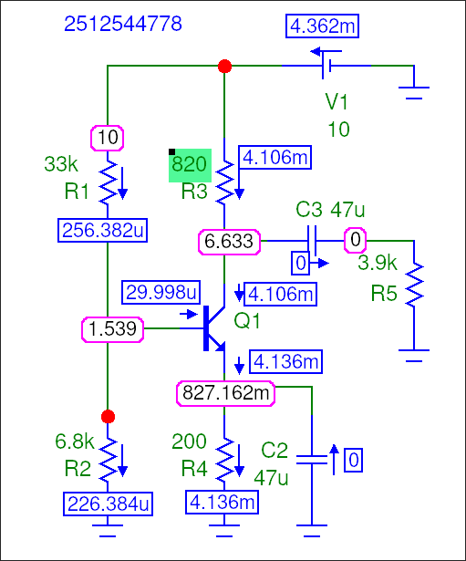

Schematic 1: DC Simulation of the Common-Emitter Amplifier

1.5
Plot 1 shows the Transient Analysis for a 1 kHz sine wave with 20mV amplitude.
Note: The plot in red is the load voltage, and the plot in blue is the AC source voltage
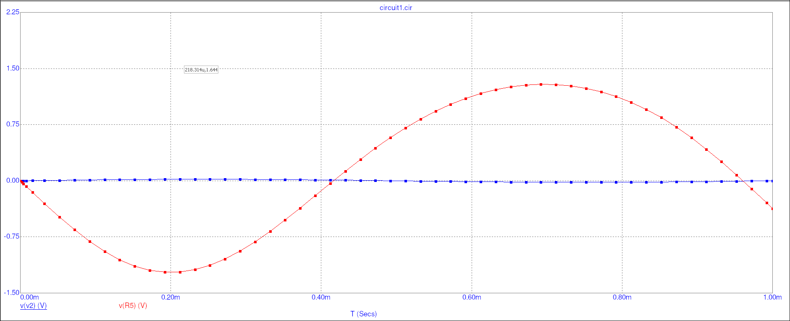
Plot 1: Transient Simulation of the Common-Emitter Amplifier with a 20 mV 1kHz sine input

Common-Collector Amplifier

2.1
DC Biasing the CC Amplifier as noted in the question gives the following resistor values
Resistor | Expression | Numerical Value [] | Std Lab Value []
 |  | 17.200k | 18.000k
 |  | 22.800k | 22.000k
 |  | 995 | 1.000k

2.2
After Small Signal AC Analysis the following was found for the input/output resistances and voltage/current gains.
Note: All Output resistances are calculated such that we are not considering the load-resistance

Value | Expression | Numerical Value
 |  | 9.324k []
 |  | 51.42 []
 |  | 0.9937 [V/V]
 |  | 180.199 [A/A]

2.3
Schematic 2 shows the DC operating point of the Common-Collector amplifier with .
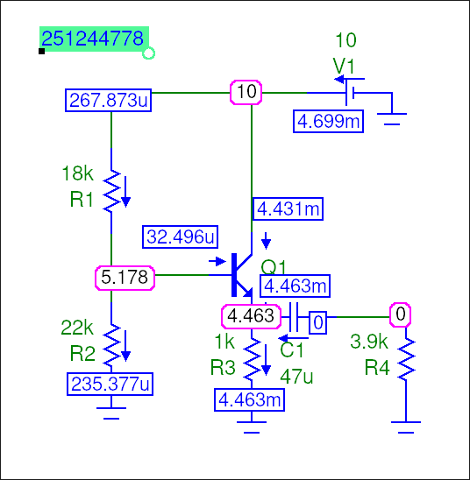
Schematic 2: DC Simulation of the Common-Collector Amplifier

2.4
Plot 2 shows the Transient Analysis for a 1 kHz sine wave with 20mV amplitude.
Note: The plot in red is the load voltage, and the plot in blue is the AC source voltage
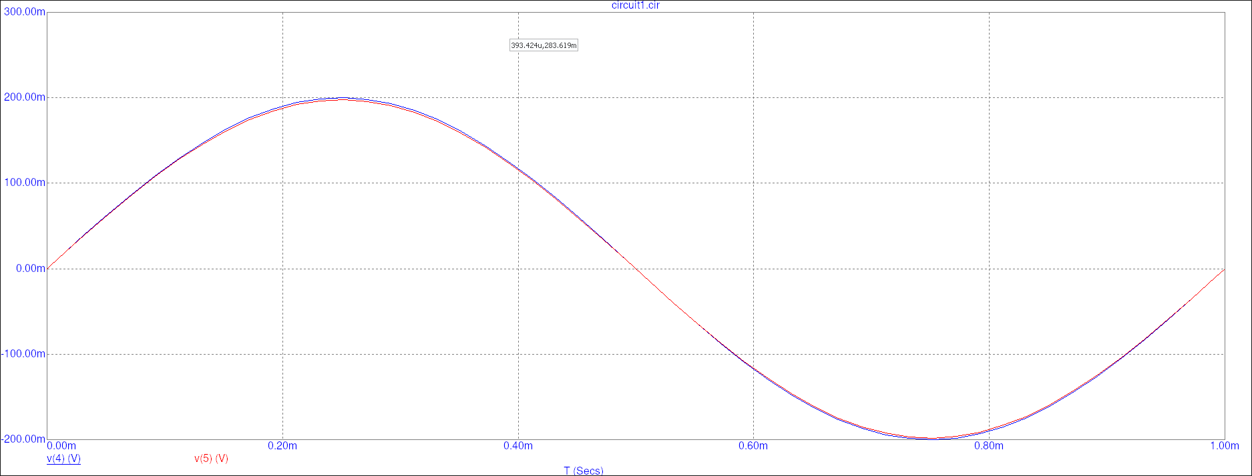
Plot 2: Transient Simulation of the Common-Collector Amplifier with a 0.2 V 1kHz sine input

Procedure

Micro-Cap Simulation | Lab Measurements
  [Hz] | [V] | [V] | [dB]
  50 | 20m | 200.90m
  100 | 20m | 371.71m
  200 | 20m | 675.94m
  500 | 20m | 1.19
  1k | 20m | 1.41
  10k | 20m | 1.52
  20k | 20m | 1.52
  100k | 20m | 1.52
  [V] | [V] | [dB]

Table 1: Common-Emitter Amplifier Frequency Response
Micro-Cap Simulation | Lab Measurements
  [Hz] | [V] | [V] | [dB]
  50 | 200m | 197.903m
  100 | 200m | 197.929m
  200 | 200m | 197.936m
  500 | 200m | 197.938m
  1k | 200m | 197.938m
  10k | 200m | 197.938m
  20k | 200m | 197.938m
  100k | 200m | 197.938m
  [V] | [V] | [dB]

Table 2: Common-Collector Amplifier Frequency Response

