ECE 3337 – Electronic Circuits
Power Amplifiers Lab Report
Arnav Goyal - 251244778

Objectives
The objectives of this lab are:
- To study Class B Amplifier Circuits
- To observe the crossover distortion present in Class B Amplifier Topologies
- To simulate Class B and Class AB Amplifier Topologies in MicroCap
- To design and test DC Biasing and frequency response of a class AB audio (power) amplifier

Prelab Information

Calculations
Some assumptions made during the calculations of the prelab are as follows:
- Since the transistors used in the lab are Darlington Pairs, they have a very high value, this means we can neglect the base current during DC biasing analysis
- The voltage drop across the diodes used to bias the class AB amplifier are assumed to be 0.7 V per diode.
The Class AB Amplifier Configuration used in the lab can be found in Figure 1. With the assumptions above, and the fact that both resistors are to be identical, we can write a KVL and solve it to obtain the resistor values.
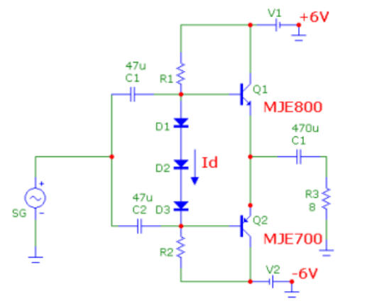

Figure 1: Class AB Amplifier Circuit
We can write the KVL as follows, Note that , and that

Solving this gives the following resistor value.

We can also calculate the theoretical power efficiency of the Class AB amplifier. Here we are assuming that

MicroCap Simulations (Class B Amplifier)

For the Class B Amplifier, the simulated DC biasing values for both transistors are present in Table 1. The MicroCap schematic is also included below for reference.
 | Q1 |  |  | Q2
 | VCE [V] | VBE [V] | IC [A] | VCE [V] | VBE [V] | IC [A]
Simulation | 6 | 0 | 12 E -12 | -6 | 0 | -12 E 12
Experiment | 50m | 70m

Table 1: Class B Amplifier DC Biasing
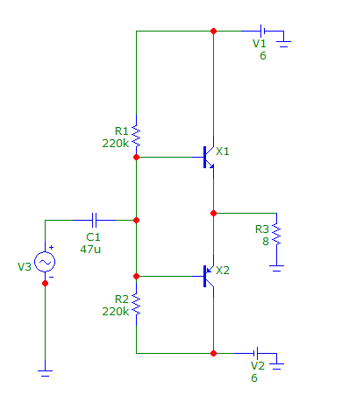

The input/output waveforms for the Class B Amplifier, with 4V sine wave @ 1kHz is shown below.
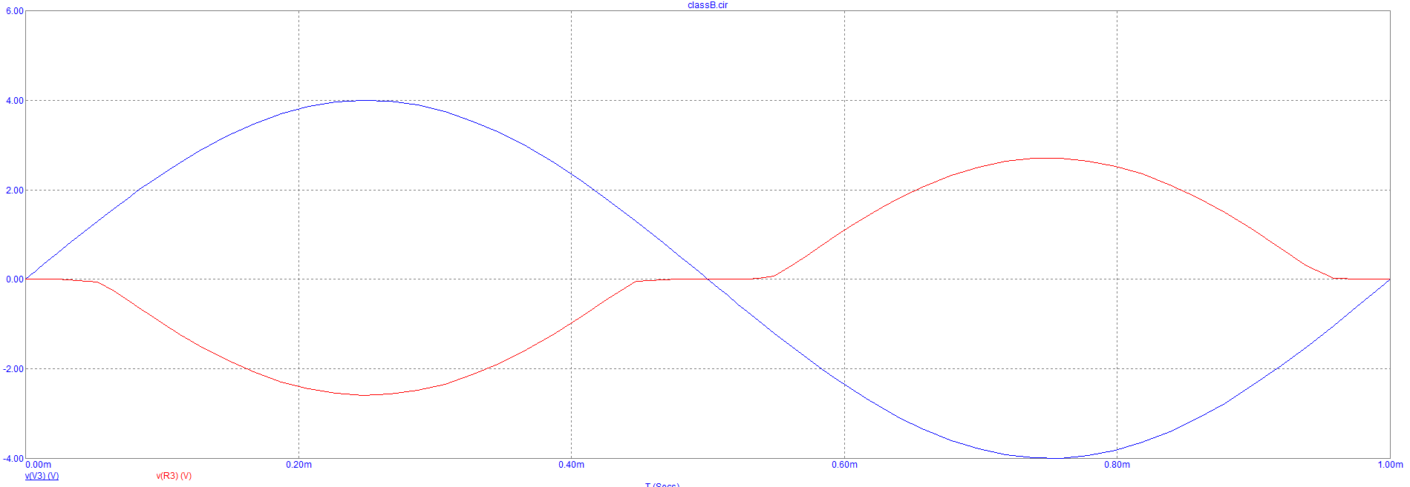

The input/output waveforms for the Class B Amplifier, with 8V sine wave @ 1kHz is shown below. TODO: Compare this to lab seen voltages?
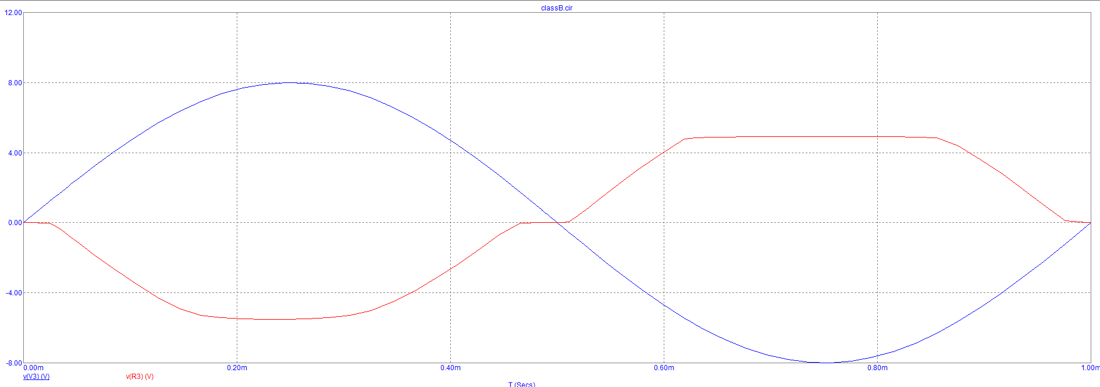

MicroCap Simulations (Class AB Amplifier)

The MicroCap DC Simulation of the Class AB is characterized in Table 2.
 | Q1 |  |  | Q2
 | VCE [V] | VBE [V] | IC [A] | VCE [V] | VBE [V] | IC [A]
Simulation | 6 | 1 | 0 | -6 | 0 | 0
Experiment | 6.054 | 10m | 0 | -6.06 | 0 | 0

Table 2: Class AB Amplifier DC Biasing

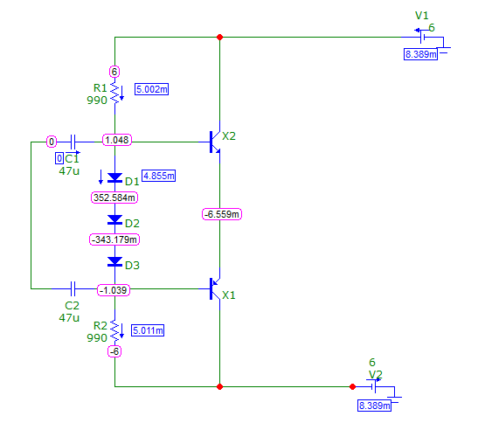

The input/output waveforms for the Class AB Amplifier, with 8V sine wave @ 1kHz is shown below.
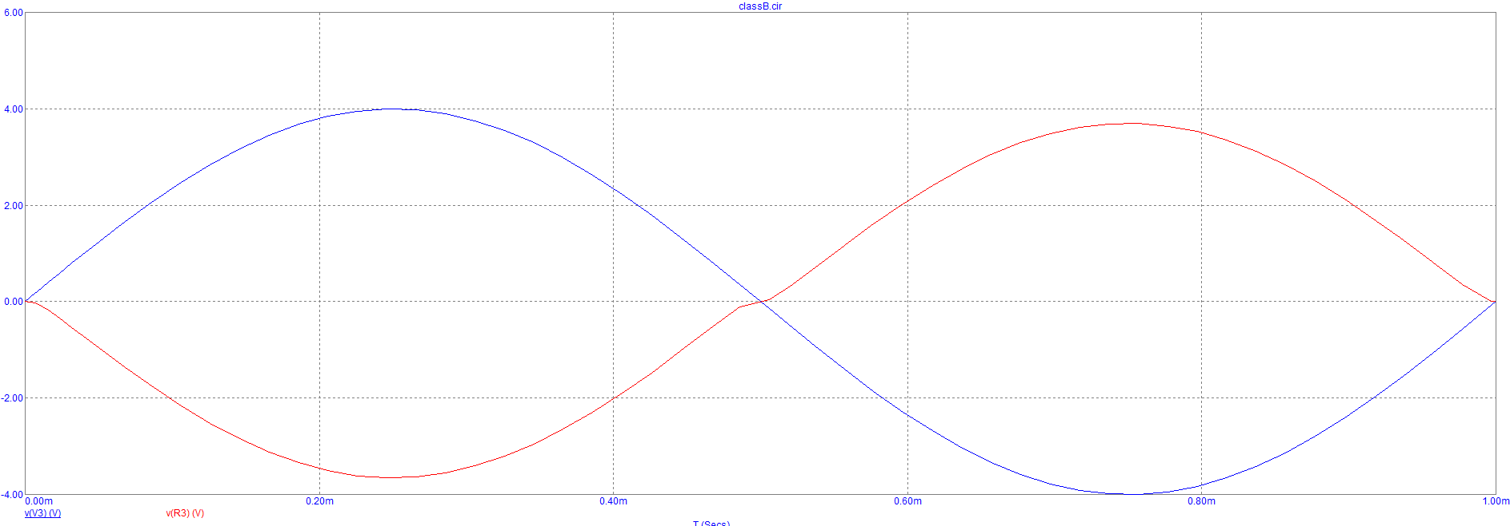
The frequency response for the Class AB amplifier is shown below.

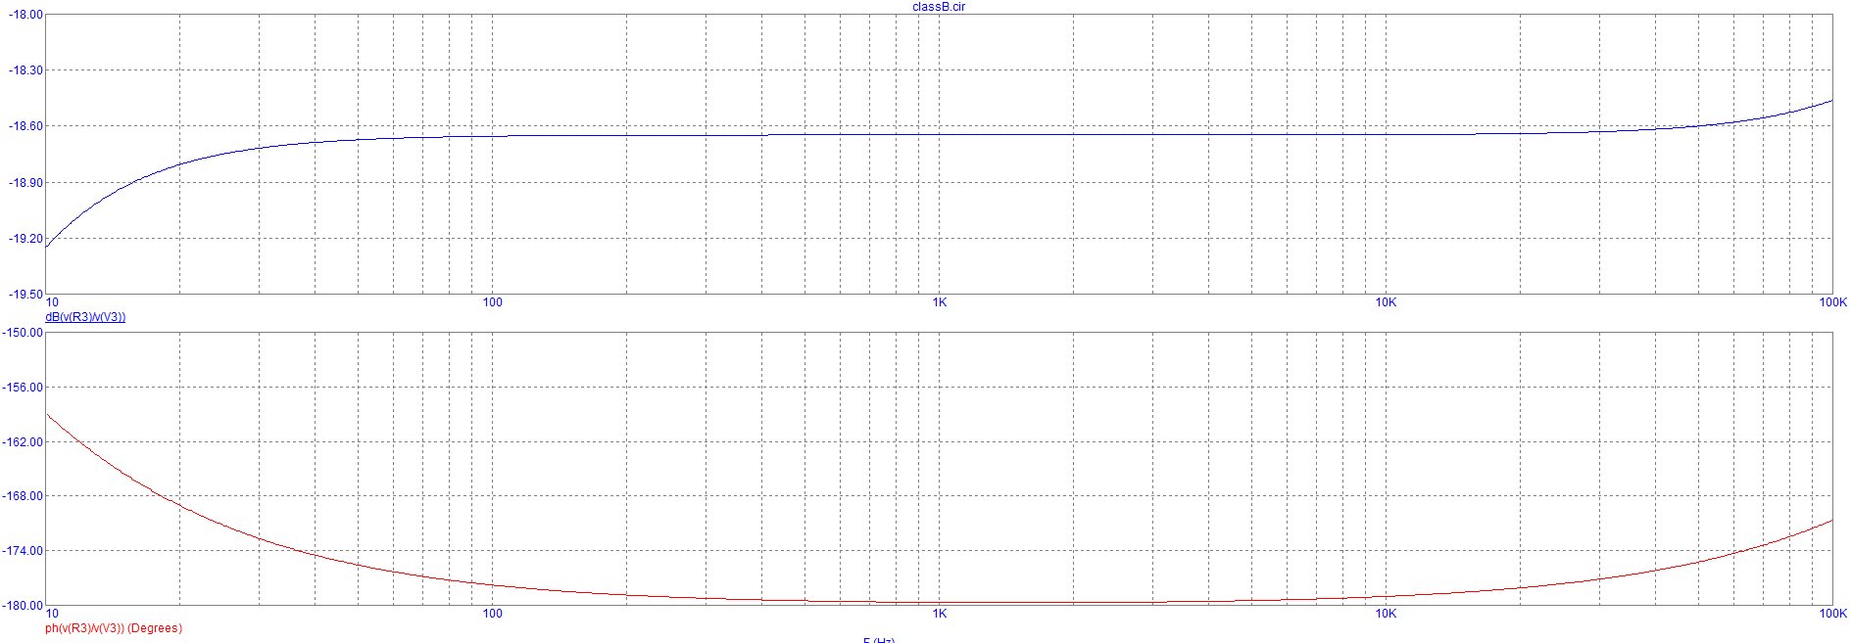
Procedure

AC Input |  |  | AC Output |  | DC Input |  | Calculations
V in  [V] | I in  [A] | P in  [W] | V out pk  [V] | P out AC  [W] | V dc  [V] | P dc  [W] | A v [dB] | Ap  [dB] | [%]
5.80 pp | 0.23m | 1.38 | 1.5 | 0.33 | 6.3 | 0.8 | -11.11 | -6.4 | 22.2
5.13 pp | 0.24m | 1.4 | 1.5 | 0.28 | 6.3 | 0.74 | -11.18 | -7.11 | 19.0

Table 3: Class B Amplifier Measurements

AC Input |  |  | AC Output |  | DC Input |  | Calculations
V in  [V] | I in  [A] | P in  [W] | V out pk  [V] | P out AC  [W] | V dc  [V] | P dc  [W] | A v [dB] | Ap  [dB] | [%]

Table 4: Class AB Amplifier Measurements

