AISE 4430 - Lab 2 Answer Sheet

Arnav Goyal, Fall 2025 Term

Task 2

Q1:
File Transfer Time is 16.355 seconds
There are only UDP packets being sent from h1 to h2. This makes sense as UDP is a unidirectional protocol, it doesn’t support handshake or other full-duplex features.

Q2:
The images are NOT the same, the transferred one has some visual artifacts (maybe due to compression?), the recovered image doesn’t have the same file size as the main either.

Below is the original wallpaper size 2.483 MB

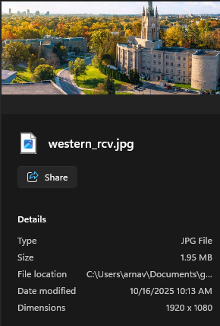
On the left is the transferred version, its file size is < 2 MB

Q3:
Yes, there is a significant difference in the recovered image after adding a 10% loss. I can no longer open the file in windows as it says the file is corrupted, Although the file-size is the same as the non-lossy transfer. This makes sense since UDP is a unidirectional protocol, the RX (h2) cannot send any acks to to TX (h1) side to show some packets were dropped. This is also why the file transfer time is also the same at around 16.367 sec

Task 3

Q4
Using non-lossy TCP to transfer the file, the transfer took about 21.79 sec
And yes this time there is a proper full-duplex link h1 to h2, and h2 to h1. This makes sense as TCP is a full-duplex protocol that allows for bi-directional communication.

Q5
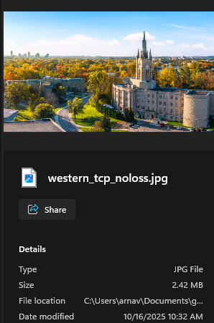


Left (Transffered) Right (Original) Both have the same file-size and they look about the same visually as well.

Q6
Yes there is a significant difference again, this time the wireshark packets that were dropped (guessing) are red, and the file transfer took MUCH longer, now its about 92.195 sec.
The images look about the same visually, and have the same file-size as the original and non-lossy TCP transferred versions

Task 4

Q7
Here are the plots

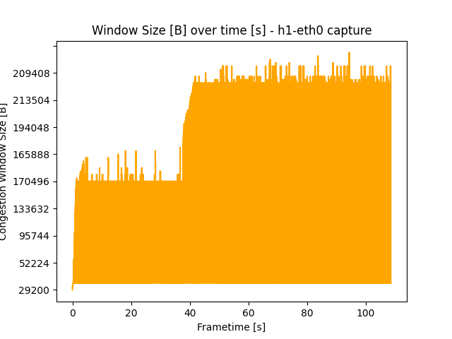

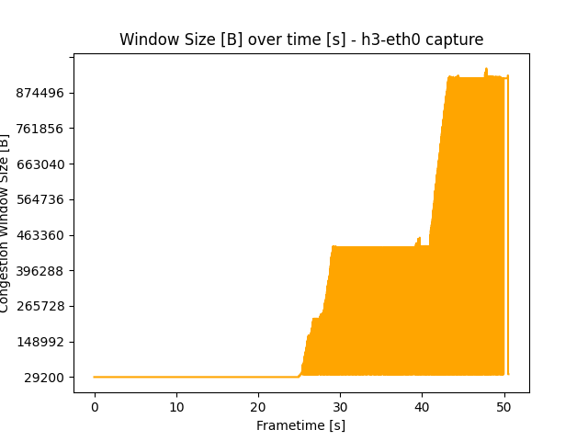
Q8
The plots are different due to the CUBIC algorithm for congestion control. Recall that the h1 loss is 10% and the h3 loss is 1%.
The congestion control algo (CUBIC as specified in lab doc) works by increasing the sending rate until packet loss occurs, we can see that the h3 plot has a much higher peak CWND which means that TCP can push more data through the less lossy h3 link. The more lossy h1 link reaches packet loss first, so it reaches a lower peak CWND, and also has many more spikes due to TCP trying to further push the link, but packet loss is encountered so TCP must go back down to the previous rate.

