ECE 3337 – Electronic Circuits
Differential Amplifiers Lab Report
Arnav Goyal - 251244778

Objectives
The objectives of this lab are:
- To understand how to amplify weak (small) signals in the presence of noise.
- To understand how a differential amplifier rejects noise and common mode signals.
- To evaluate the roles of the components of a differential amplifier.
- To test the operation of a current source in place of an emitter resistor.
- To simulate the dc conditions of various differential amplifier circuits using MicroCap software.

Prelab Information

Calculations (unitless quantities are either mA, kOhm)
Rearranging equation 3.2 to solve for IE1:
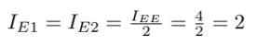
Rearranging equation 3.4 to solve for RE:
Rearranging equation 3.3 to solve for RC1:
Closest Std. Resistor Values are 1.1k, and 3.3k.
Small Signal Parameters
When input of Q2 is grounded:
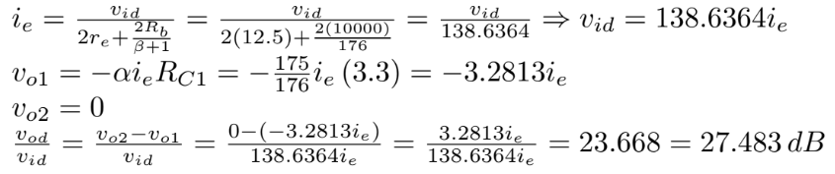
Case where input of Q1 is grounded
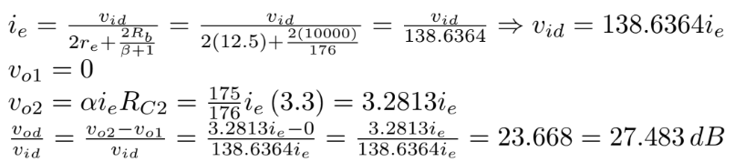
Input Impedance when Q2 is grounded
When Q2 is grounded, currrent still flows through the base resistances. So we include these and the emitter resistance of Q1 and Q2 in the caulcations here.

Plots
Frequency Response of a Diff. Amplifier.
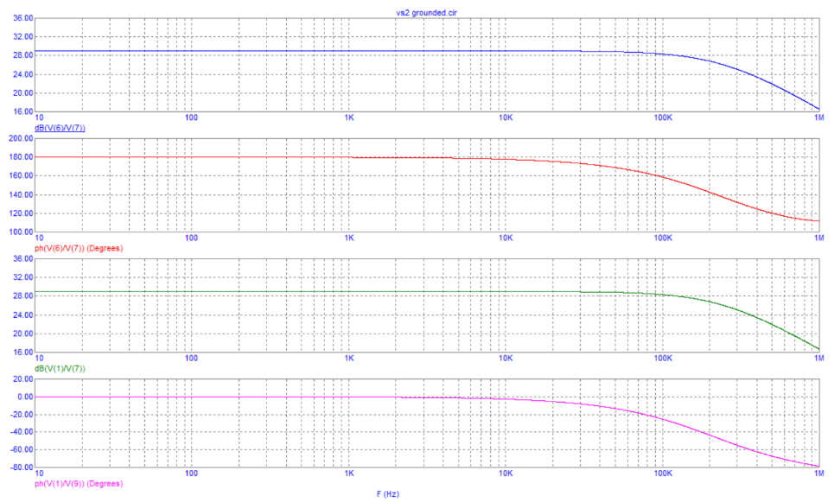
Frequency Response of a Common Mode Diff. Amplifier

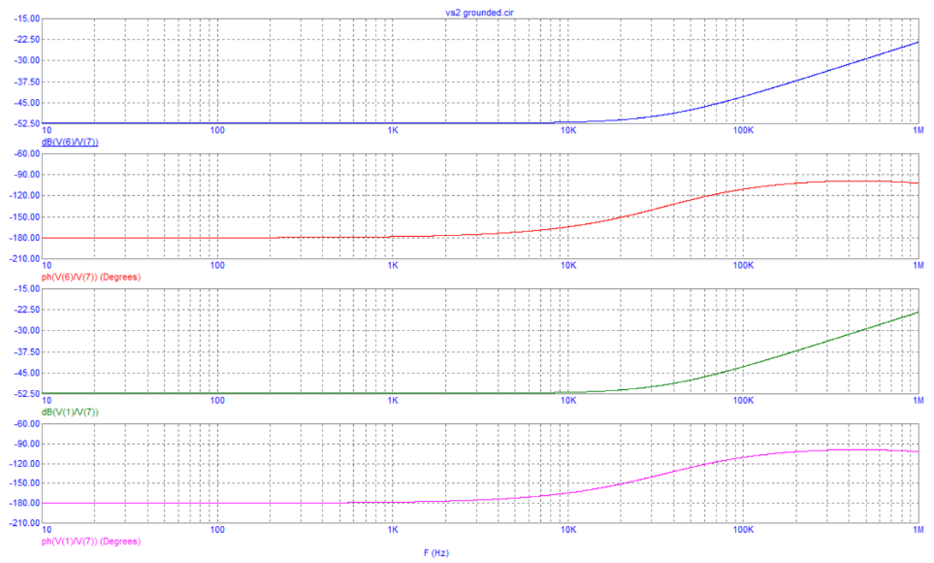

Procedure & Results
1. Connect the differential amplifier shown in Figure 3.3 using calculated values of RC1 = RC2 and Re. You will obtain better results if you ‘match’ the two transistors in the differential pair using the curve tracer output characteristics.
2. Use a dual voltage Power Supply and connect its POS terminal as Vcc, NEG terminal as Vee and COM terminal as a common ground. Set the power supply voltage to 10V DC. Measure the DC quiescent point values. Use Table 1 to compare the voltages and currents from your calculations and from the simulation with the experimental data. If your results are significantly different (more than 15%) from your calculated and simulated values, try to switch positions of the Q2 and Q3 BJTs and find out if the actual DC biasing provides closer to simulated results.
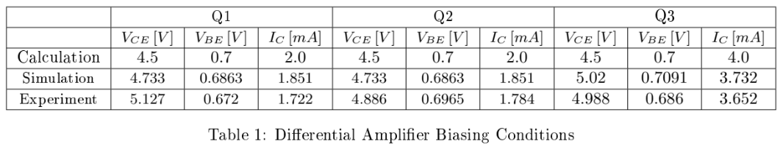
3. Connect the signal generator (FG) to the Q1 input with the Q2 input connected to ground as it is shown in Figure 3.3. Increase the input signal to one input (Q1). Determine the maximum output signal the circuit will produce without distortion. Use a frequency of 1 kHz. Compare this result with the VCE of the two transistors in the differential pair and with VCC.
4. Set the frequency at 1 kHz and determine the input resistance as seen at Q1 with the input of Q2 connected to common ground.
5. With the input signal connected to one input and the second input grounded, determine the frequency response of the voltage gain (magnitude in dB and phase) to the collectors of Q1 and Q2. Set the amplitude of the Function Generator (FG) to 50mV. Sweep a frequency range from 50 Hz to 1 MHz and collect all data in Table 2.
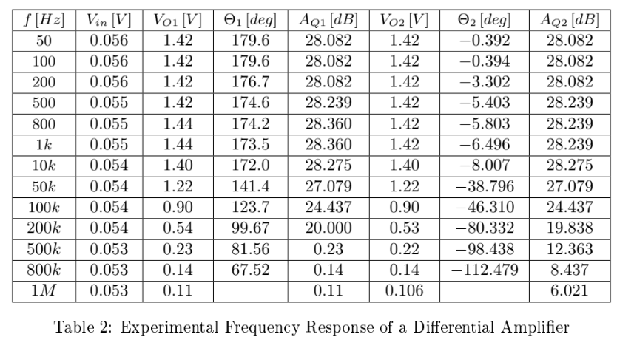
6. Connect both Ch1 of the oscilloscope and the Phase meter in parallel to the input signal. Connect both Ch2 of the oscilloscope and the Phase meter in parallel to the output 1 (Q1) signal. Read both instruments and then switch the “out” measurement terminal to the output 2 (Q2) signal. Change the frequency of the signal generator and repeat the measurements for both outputs. Note which output provides the inverting output and which one the non-inverting output
7. Calculate the voltage gain AQ1[dB] and AQ2[dB] for both outputs of the differential amplifier, using Equation (3.5).
8. Plot obtained voltage gain and phase data on top of your simulated Bode plots and compare the results
9. Set the frequency at 1 kHz and interchange the two input connections. Determine the voltage gain to the collectors of Q1 and Q2.
10. Connect both inputs to the same voltage source as it is shown in Figure 3.4 and make the necessary measurements to plot the frequency response of the common mode signal. Increase the input signal up to 6-7 V to be able to measure the output voltage. Vary the frequency from 50 Hz to 1 MHZ and fill all data in Table 3. These results will give you an indication how well the differential amplifier rejects the common signal.
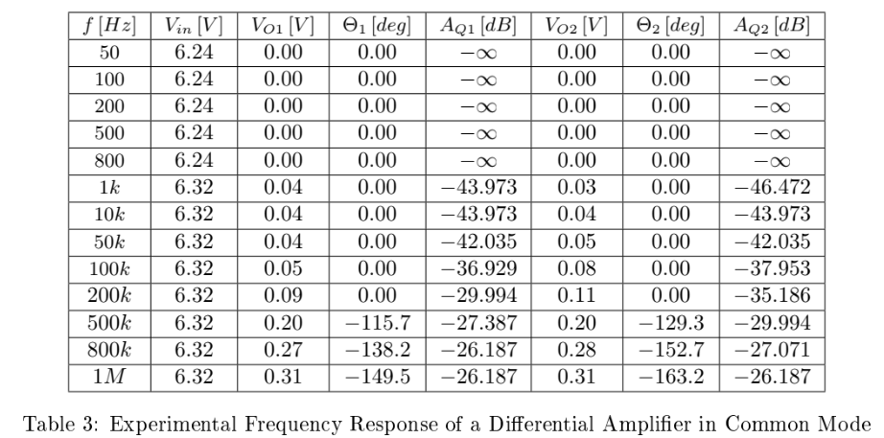
11. Plot obtained voltage gain and phase data on top of your simulated Bode plots and compare the results.

Overall the results aligned very closely with simulation, the drawn lines are orange and are overlayed on top of the prelab plots. The plots are for regular (left) and common mode (right)
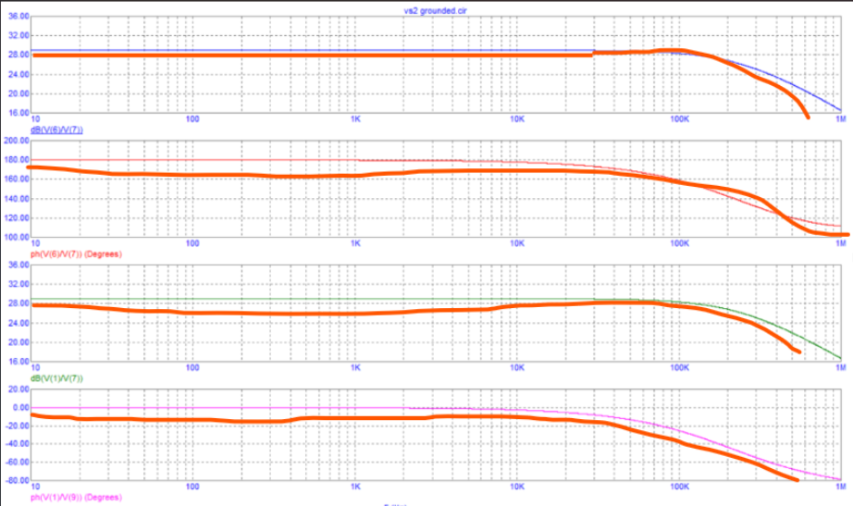
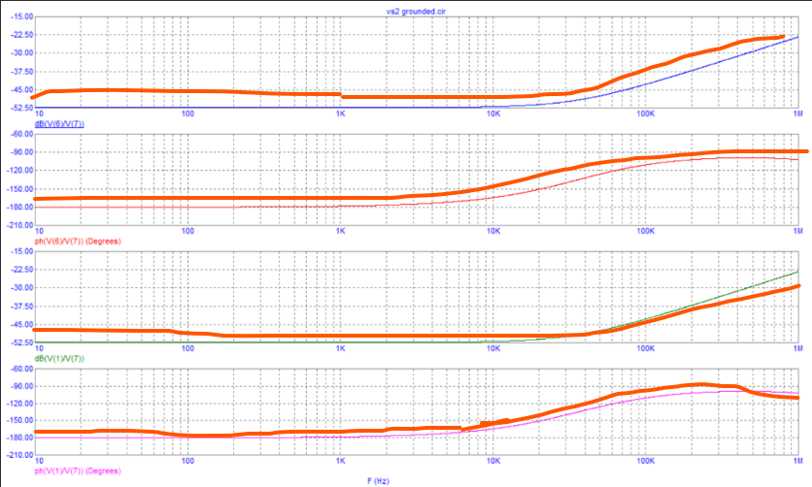

Discussion
From this lab we learned about implementations of a Differential Amplifier in regular and in common-mode. Essentially a differential amplifier is a fuinctional building block in analog design which serves to amplify a differential pair of signals or the difference between them. This basic block is very widely used in industry due to the noise immunity that a differential pair provides. Any EMI received by one trace, will be received by the other, allowing this EMI to cancel out at the convergence point where we only consider the difference between these two traces.

Conclusion
In this lab, the DC Biasing values agreed with the simulated values. The amplifiers also acted in line with the expected theory of each configuration. Leading to good a good set of results discussed in the prior sections.

