Rate Correction Misrepresents Cardiac Risk in Pediatric Psychiatric Polypharmacy
A Mechanistic Action Potential Analysis Separating Genuine Repolarization Change from Heart Rate Artifact
Corresponding author: Arnav Amit, Independent Researcher | Email: arnavamit1@g.ucla.edu | Postal Address: 4241 W Kling St, Burbank CA, 91505 | Phone: (469) 408-3425
Keywords: pediatric psychopharmacology; QTc; rate correction; hERG; action potential duration; polypharmacy; pharmacovigilance

Abstract
Background. Psychiatric polypharmacy is routine in pediatric care, yet cardiac risk assessment relies on hERG centered screening and Bazett corrected QTc extrapolated from adults. Using a mechanistic ventricular model, I show this metric misrepresents repolarization risk in opposite directions across drug classes, and that genuine repolarization change at therapeutic exposure is small and confined to hERG blockers.
Methods. CardioSafe Pediatric couples a validated O'Hara-Rudy 2011 ventricular action potential model with a drug module spanning hERG block, sympathomimetic rate elevation, and alpha-2 modulation. I simulated all 84 combinations of 12 drugs at therapeutic free concentrations, separating genuine change in action potential duration from Bazett and Fridericia correction, and compared output with reporting odds ratios for cardiac events in 552,832 pediatric FAERS cases (2015 to 2024) as concordance, not validation.
Results. Genuine prolongation was small (maximum 11.5 ms, aripiprazole plus nortriptyline). Bazett flagged 29 of 84 combinations at 10 ms or above versus 5 by genuine change, and the two were negatively correlated (r = minus 0.34). Bazett inflated stimulant combinations (methylphenidate plus amphetamine, genuine minus 8.4 ms against 20.0 ms apparent) and masked alpha-2 prolongation. Concordance with FAERS was weak (AUC 0.55 to 0.62). Stimulant signals were 23 to 50 times higher in children 6 to 12 than adolescents.
Conclusions. For rate changing psychotropics, Bazett QTc is unreliable; the uncorrected action potential duration recovers the true effect. Genuine repolarization risk at therapeutic exposure is modest and hERG mediated. CardioSafe Pediatric is mechanistic and hypothesis generating, not a validated clinical predictor.

Introduction
Psychiatric polypharmacy in children and adolescents has grown substantially over the past two decades. Stimulants are prescribed to 10 to 15 percent of school age children for attention deficit hyperactivity disorder. Atypical antipsychotics, including risperidone, aripiprazole, and quetiapine, are increasingly used off label for irritability, aggression, and mood dysregulation. Selective serotonin reuptake inhibitors are routinely prescribed for pediatric anxiety and depression. These classes are regularly co prescribed, making complex polypharmacy the clinical norm rather than the exception in child and adolescent psychiatry.
Each class carries distinct cardiac liabilities. Antipsychotics and tricyclic antidepressants block the hERG potassium channel ^{[1]}, prolonging the action potential and, in principle, increasing the risk of QTc prolongation and torsade de pointes ^{[2]}. Serotonin reuptake inhibitors produce milder hERG block. Stimulants act through sympathomimetic mechanisms, elevating heart rate and blood pressure. Alpha-2 agonists produce bradycardia and PR interval prolongation through autonomic modulation.
Cardiac risk assessment for combined psychiatric medications remains inadequate. Existing computational frameworks, most notably the CiPA initiative supported by the FDA ^{[3,4]}, were designed for screening single new molecular entities in adults, using multiple channel hERG data that are unavailable for most psychiatric drugs. Standard clinical guidance relies on QTc monitoring centered on hERG. No framework characterizes the combined cardiac effects of multiple psychiatric drugs in adolescent populations specifically.
Several gaps compound the problem. Adolescents differ from adults in baseline electrophysiology, with shorter resting QTc, higher heart rate, and developmental variation in the expression of repolarizing currents ^{[5]}. Developmental CYP2D6 ontogeny produces pediatric exposures that differ from adult reference values. Pharmacokinetic interactions between drugs, such as fluoxetine inhibiting the clearance of aripiprazole, are absent from standard models. Most important for the present analysis, the dominant cardiac action of stimulants, heart rate elevation, interacts with the rate correction step itself. The Bazett formula systematically over corrects at high heart rate ^{[6]}, converting a shortened RR interval into an apparent QTc prolongation that does not reflect any change in ventricular repolarization. This confound at the level of the metric is the central subject of this study.
I developed CardioSafe Pediatric to characterize these effects mechanistically. The framework couples a validated O'Hara-Rudy 2011 ventricular action potential model ^{[7]} with a drug effect module spanning three pathways, and rather than trusting corrected QTc, it decomposes each combination's apparent QTc change into a genuine repolarization change, the uncorrected action potential duration, and a rate correction artifact. The central finding is that the standard metric misrepresents risk in opposite directions for stimulants and alpha-2 agonists, and that genuine repolarization risk at therapeutic exposure is small and is mediated by hERG block. The FAERS pharmacovigilance data provide descriptive context, including a striking gradient in stimulant cardiac reporting between children and adolescents.

Methods

Drug list and parameterization
I selected 12 drugs representing the core classes used in adolescent psychiatric polypharmacy: two stimulants (methylphenidate, amphetamine), three atypical antipsychotics (risperidone, quetiapine, aripiprazole), three serotonin reuptake inhibitors (sertraline, fluoxetine, escitalopram), two alpha-2 agonists (clonidine, guanfacine), and two tricyclic antidepressants (imipramine, nortriptyline) (Table 1).
Code | Drug | Class | IC50 quality | Primary mechanism
MPH | Methylphenidate | Stimulant | C | Sympathomimetic HR elevation
AMP | Amphetamine | Stimulant | C | Sympathomimetic HR elevation
RIS | Risperidone | Antipsychotic | A | hERG block
QUE | Quetiapine | Antipsychotic | A | hERG block
ARI | Aripiprazole | Antipsychotic | A | hERG block
SER | Sertraline | SSRI | A | Mild hERG block
FLU | Fluoxetine | SSRI | A | Mild hERG block plus CYP2D6 inhibition
ESC | Escitalopram | SSRI | B | Mild hERG block
CLO | Clonidine | Alpha-2 agonist | B | Autonomic modulation
GUA | Guanfacine | Alpha-2 agonist | C | Autonomic modulation
IMI | Imipramine | TCA | A | hERG block
NOR | Nortriptyline | TCA | A | hERG block
Table 1. The 12 study drugs by class, IC50 data quality, and primary modeled cardiac mechanism. Quality A denotes patch clamp hERG IC50 values, B intermediate, and C estimated values; sympathomimetic parameterization is based on published heart rate effects rather than patch clamp data.
I obtained hERG IC50 values from ChEMBL version 37 (target CHEMBL240, patch clamp electrophysiology assays), supplemented by published literature where ChEMBL coverage was insufficient ^{[1]}, preferring patch clamp values over radioligand binding. Free plasma maximum concentrations at therapeutic doses were derived from published adult pharmacokinetic studies and protein binding fractions; all base case concentrations are adult derived, and adolescent differences are addressed in the Limitations.

O'Hara-Rudy action potential model and validation
I used the O'Hara-Rudy 2011 model of the undiseased human ventricular cardiomyocyte ^{[7]} as the simulation substrate. QTc prolongation is fundamentally a phenomenon of action potential duration, the ventricular myocyte is the cell type responsible for the QT interval, and this model is the CiPA reference ^{[3,4]}, which provides a benchmark relevant to regulators. I implemented the cell model from the canonical formulation, including the full four state sodium potassium pump, the two compartment sodium calcium exchanger, and sarcoplasmic reticulum calcium cycling and buffering. Before any downstream analysis I validated it against physiological action potential morphology (peak plus 40 mV with a stable plateau), steady state convergence of action potential duration, stability of intracellular ion concentrations across beats, and directionally correct drug responses (30 percent hERG block produced a prolongation of 59 ms; upregulation of the slow potassium current shortened the action potential). I froze a converged steady state as a regression baseline. At a fixed cycle length of 1000 ms, the baseline action potential duration and QTc were 263.6 ms, with convergence by approximately beat 100 and stability within 0.5 ms thereafter. Numerical integration used an absolute and relative tolerance appropriate to the stiffness of the system and a maximum step count of 5000; the default step count causes silent integration failure for these stiff equations, returning non finite values without raising an error. Production results used simulations of 500 beats.

Heart rate correction and the genuine versus artifact decomposition
For each simulation the uncorrected action potential duration is the direct readout of ventricular repolarization. I computed two rate corrections from that duration and the effective cycle length expressed as the RR interval in seconds: the Bazett value ^{[6]}, duration divided by the square root of RR, and the Fridericia value ^{[8]}, duration divided by the cube root of RR. I expressed drug induced change three ways for every combination: the genuine change in action potential duration (drug minus baseline), the Bazett change, and the Fridericia change. Because the baseline cycle length is 1000 ms, the baseline Bazett and Fridericia values both equal the baseline action potential duration, giving a common reference. Divergence among the three metrics for a given combination is the quantitative signature of rate correction artifact. The uncorrected duration itself retains the physiological rate dependence of repolarization, so combinations that slow heart rate lengthen the duration partly through rate rather than channel block; isolating pure channel pharmacology from autonomic rate change requires a re run at fixed cycle length, which is in progress. The comparison reported here characterizes the correction artifact, which it does without that re run.

Drug effect architecture
I modeled drug cardiac effects through three parallel pathways. The first is hERG block, using a competitive binding model in which the fractional block for each drug is its free concentration divided by the sum of that concentration and its IC50, combined across drugs under an assumption of independent binding sites and applied as a scaling of the rapid potassium conductance. This is the only concentration dependent pathway. The second is the sympathomimetic pathway, in which stimulants are modeled as a 10 percent reduction in cycle length (a proxy for heart rate elevation, approximately 7 beats per minute, the midpoint of published methylphenidate effects ^{[10,11]}) and a 15 percent increase in L type calcium conductance representing beta adrenergic potentiation ^{[9]}; these effects are present or absent and additive across stimulants and do not scale with concentration. The third is autonomic modulation, in which alpha-2 agonists are modeled as a 10 percent increase in cycle length (bradycardia) and a 5 percent reduction in sodium conductance; the PR and atrioventricular conduction effects of guanfacine are not represented.

Polypharmacy sweep and risk tiers
I simulated all 66 pairwise combinations and 18 clinically defined triple combinations to steady state at therapeutic free concentrations, yielding 84 combinations. I defined risk tiers on the genuine change in action potential duration, the metric relevant to repolarization, anchored to ICH E14 magnitudes: elevated at 10 ms or above, borderline at 5 to 9 ms, and minimal below 5 ms. I report the Bazett and Fridericia changes alongside for comparison and to quantify the rate artifact, but I do not use them for primary tiering, because as the Results show they conflate genuine prolongation with rate artifact and mis rank combinations.

FAERS pharmacovigilance analysis
I parsed the FDA FAERS quarterly files for 2015 through 2024, comprising 16,144,530 cases after deduplication. Pediatric cases, defined as age below 18 with normalization across age units, numbered 552,832; age was unknown for 43 percent of total cases and these were excluded conservatively. Drug identification used substring matching against brand and generic aliases for all 12 drugs. I defined primary cardiac adverse events by a set of MedDRA preferred terms covering QT prolongation, torsade de pointes, ventricular tachycardia and fibrillation, cardiac arrest, sudden cardiac death, long QT syndrome, and ventricular arrhythmia. I computed reporting odds ratios with 95 percent confidence intervals for each drug and pair against the pediatric background, with a 0.5 continuity correction, and defined a signal as a confidence interval lower bound above 1.0. Pairs with fewer than 3 co reported cases were excluded.

Model and FAERS concordance
I assessed concordance, which I distinguish explicitly from validation, by comparing each model metric (genuine change in action potential duration, Bazett change, and hERG block fraction) against the binary FAERS signal across evaluable pairs, using the area under the receiver operating characteristic curve and the Spearman correlation of each continuous metric against the reporting odds ratio. I report results for all pairs, for stimulant containing pairs, and for non stimulant pairs. I removed the composite score used in earlier analysis, which embedded the reporting odds ratio as a component of a predictor whose performance was then evaluated against that same signal, because that construction is circular.

Results

Genuine repolarization risk is small, and Bazett over flags by roughly sixfold
Across 84 combinations at steady state, genuine repolarization prolongation was modest. The genuine change in action potential duration reached 10 ms or above in only 5 combinations and 5 ms or above in 20; the maximum was 11.5 ms, for aripiprazole plus nortriptyline, a pair of hERG blockers with no change in heart rate. By contrast, Bazett corrected QTc reached 10 ms or above in 29 combinations, with a maximum of 22.5 ms. Fridericia fell between the two, with 11 combinations at 10 ms or above. The single metric a clinician would normally use therefore flagged roughly six times as many combinations as genuine repolarization warrants (Table 2).
Metric | 10 ms or above | 5 to 9 ms | Below 5 ms | Maximum
Genuine change in APD | 5 | 15 | 64 | +11.5
Fridericia QTc | 11 | 30 | 43 | +17.6
Bazett QTc | 29 | 12 | 43 | +22.5
Table 2. Number of combinations in each repolarization tier under the genuine change in action potential duration, Fridericia corrected QTc, and Bazett corrected QTc, with the maximum change for each metric in milliseconds.
Genuine change and Bazett change were negatively correlated (r = minus 0.34): the combinations Bazett ranks highest are not the ones with the most genuine prolongation. Genuine change instead correlated with hERG block fraction (r = plus 0.70), confirming that real prolongation in this drug set is mediated by hERG block, whereas Bazett change correlated only weakly with hERG block (r = plus 0.39), diluted by rate artifact (Figure 1).
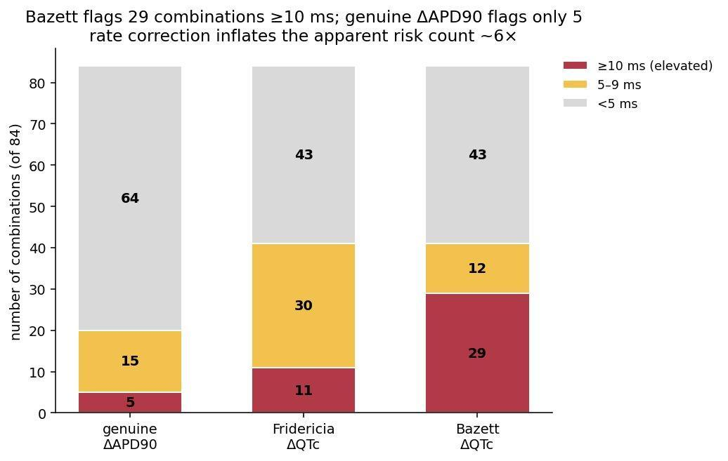
Figure 1. Number of combinations reaching each repolarization tier under three metrics. Bazett corrected QTc classifies 29 of 84 combinations at 10 ms or above, whereas the genuine change in action potential duration classifies only 5. Rate correction inflates the apparent count of elevated combinations roughly sixfold. Bars are stacked counts across the three tiers and sum to 84.

Rate correction misrepresents risk in opposite directions
The negative correlation resolves into two opposite errors, summarized by drug class (Table 3, Figure 2). Stimulant combinations raise heart rate, so Bazett over corrects and manufactures apparent prolongation where none exists. The clearest case is methylphenidate plus amphetamine: a Bazett change of 20.0 ms, the second highest in the entire grid, while the genuine change is minus 8.4 ms, meaning the action potential actually shortens, and hERG block is zero. The mean genuine change across stimulant combinations is 0.3 ms, essentially no repolarization effect. Alpha-2 agonists slow heart rate, so the corrections run the other way and hide prolongation. Clonidine plus guanfacine lengthens the uncorrected interval by 10.6 ms, but Bazett reports minus 14.3 ms, an apparent protection, an error of more than 25 ms in the clinically dangerous direction. Part of that uncorrected lengthening reflects rate dependent restitution at the slower rate rather than channel block; the fixed cycle length decomposition now in progress will partition the two. Combinations that do not change heart rate, such as aripiprazole plus nortriptyline, show identical genuine, Fridericia, and Bazett values, as they must. Fridericia roughly halved the stimulant inflation and the alpha-2 masking but eliminated neither, confirming that no single correction recovers the true direction of effect for drugs that change heart rate.
Class (n) | Genuine APD | Fridericia QTc | Bazett QTc
Stimulant containing (36) | +0.3 | +8.1 | +12.1
Alpha-2 containing (20) | +5.7 | -3.2 | -7.5
hERG, no HR change (28) | +3.8 | +3.8 | +3.8
Table 3. Mean change in milliseconds by drug class under the three metrics. Stimulant containing combinations show large Bazett inflation against a near zero genuine change; alpha-2 containing combinations show Bazett masking of a genuine prolongation; combinations with no heart rate change are identical across metrics.
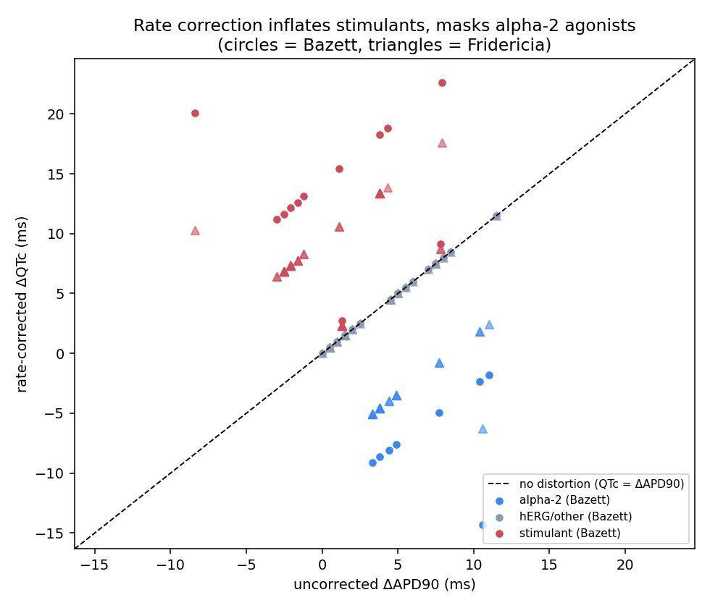
Figure 2. Genuine change in action potential duration against rate corrected change for all combinations. The horizontal axis is the genuine change in action potential duration and the vertical axis the rate corrected change; the diagonal marks agreement. Stimulant combinations sit above the line (inflation), alpha-2 combinations below (masking), and combinations that do not change heart rate on the line. Circles denote Bazett, triangles Fridericia.

The genuine repolarization landscape
The combinations with a genuine change of 5 ms or above were dominated by pairs containing aripiprazole and nortriptyline (Figure 3). The only unambiguous prolongation mediated by channel block at 10 ms or above was aripiprazole plus nortriptyline at 11.5 ms. Aripiprazole pairs with antipsychotics, serotonin reuptake inhibitors, and tricyclics clustered at 7 to 8.5 ms of genuine change. These are the combinations where genuine repolarization risk, while modest at therapeutic exposure, is real and would be expected to scale with exposure.
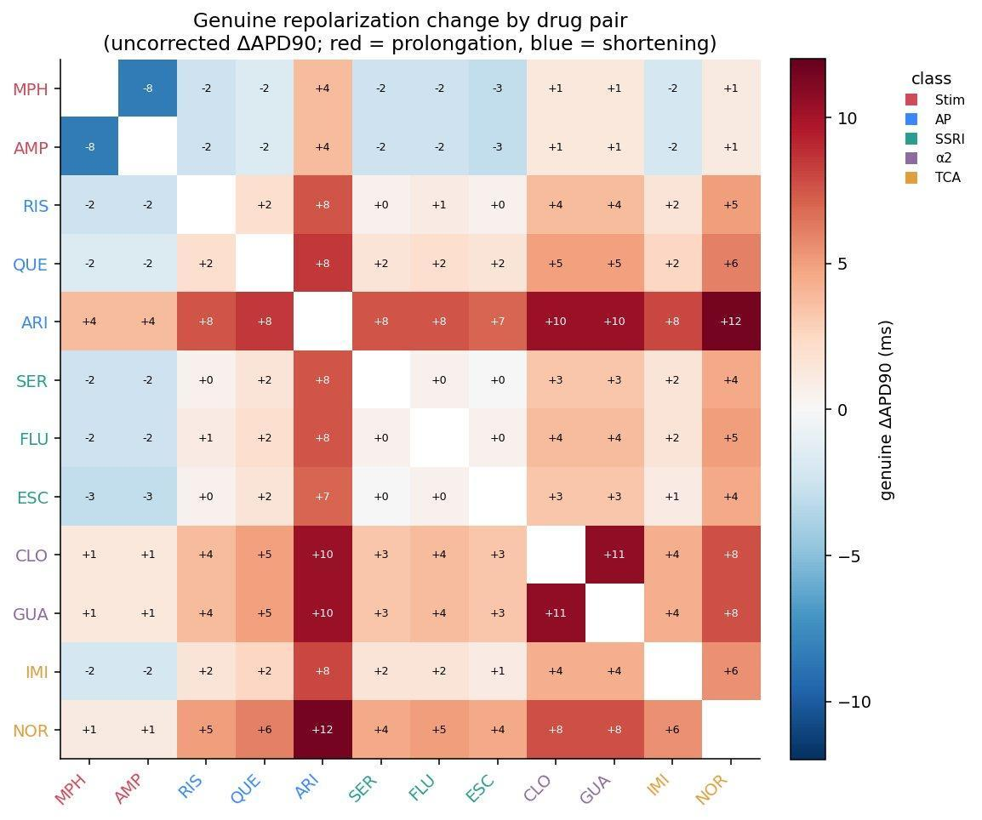
Figure 3. Genuine change in action potential duration for all 66 drug pairs. Red indicates prolongation, blue shortening. Aripiprazole pairs show the largest genuine prolongation; methylphenidate plus amphetamine shortens the action potential. Values are uncorrected interval changes in milliseconds and retain physiological rate dependence for combinations that alter heart rate.

Supratherapeutic exposure narrows the safety margin for hERG blocking combinations
Because genuine prolongation at therapeutic dose was small, I asked at what exposure it becomes clinically meaningful. I scaled the concentration dependent pathway, hERG block, from 1 to 10 times the therapeutic free concentration for the 57 combinations containing at least one hERG active drug, holding the rate based pathways fixed, since the sympathomimetic and autonomic effects do not scale with concentration. This isolates hERG mediated risk under elevated exposure, the regime that pharmacovigilance and therapeutic dose ECG studies cannot see. Pure stimulant pairs such as methylphenidate plus amphetamine are absent by construction, as they carry no concentration dependent component.
The combinations with the narrowest safety margins were precisely the hERG blockers, led by aripiprazole and nortriptyline (Table 4, Figure 4). Aripiprazole plus nortriptyline and the triple nortriptyline plus methylphenidate plus aripiprazole crossed the 10 ms genuine threshold at therapeutic exposure itself and reached 102.6 and 95.9 ms respectively at 10 times exposure. Aripiprazole paired with quetiapine, imipramine, risperidone, or a serotonin reuptake inhibitor crossed at 1.1 to 1.4 times exposure, and nortriptyline pairs at 1.6 to 2.2 times. By contrast the stimulant combinations with only weak hERG block did not reach concern until 6 to 10 times exposure, or never within the tested range. A 1.5 to 3 times increase in exposure, within the range produced by CYP2D6 poor metabolism for aripiprazole, nortriptyline, imipramine, and risperidone, or by fluoxetine inhibition of CYP2D6, therefore moves the aripiprazole and nortriptyline combinations from modest to clearly elevated genuine prolongation. The therapeutic dose null is not reassurance for these specific combinations in poor metabolizers or in overdose.
Combination | Genuine APD at 1x | Genuine APD at 10x | Concern reached at
ARI plus NOR | +12.0 | +102.6 | 1.0x
NOR plus MPH plus ARI | +10.0 | +95.9 | 1.0x
ARI plus FLU plus CLO | +10.6 | +71.1 | 1.0x
ARI plus CLO | +10.0 | +65.6 | 1.0x
ARI plus GUA | +10.0 | +65.6 | 1.0x
QUE plus ARI | +9.0 | +76.5 | 1.1x
ARI plus IMI | +8.5 | +73.5 | 1.2x
RIS plus ARI | +8.0 | +67.5 | 1.3x
QUE plus NOR | +6.0 | +55.5 | 1.7x
FLU plus NOR | +5.0 | +46.0 | 2.0x
Table 4. Genuine change in action potential duration in milliseconds at 1 times and 10 times therapeutic free concentration, and the exposure multiple at which each combination first crosses the 10 ms concern threshold, for the hERG active combinations with the narrowest margins.
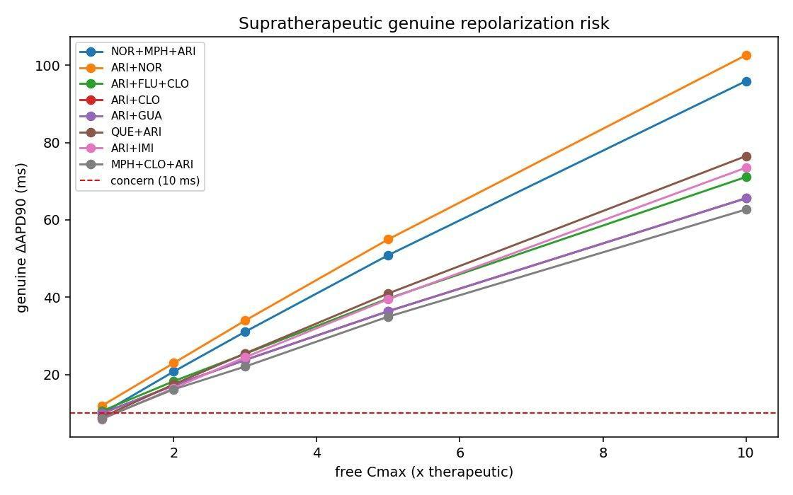
Figure 4. Genuine change in action potential duration as free concentration is scaled from 1 to 10 times therapeutic exposure, for the hERG active combinations. The combinations crossing the 10 ms concern line at the lowest multiple are all hERG blockers led by aripiprazole and nortriptyline; stimulant combinations that Bazett over flags require 6 to 10 times exposure. The dashed line marks the 10 ms concern threshold.
Two caveats. The sweep was run at 150 beats rather than 500 for computational speed, so its values at therapeutic exposure sit a few ms above the converged grid, aripiprazole plus nortriptyline reading 12.0 ms here versus 11.5 ms at 500 beats. And the aripiprazole plus alpha-2 agonist combinations carry the same rate dependent restitution component identified in the rate correction analysis, so their therapeutic exposure values, and therefore their margins, are upper bounds on the pure hERG contribution.

FAERS pharmacovigilance analysis
Among 552,832 pediatric FAERS cases, 5,331 carried a primary cardiac preferred term, and all 12 drugs had pediatric reports (Table 5). Eleven of the 12 drugs showed a signal. Nortriptyline had the highest per drug reporting odds ratio, consistent with the hERG potency of tricyclics. Guanfacine showed an unexpectedly elevated reporting odds ratio despite a modeled protective QTc effect, which suggests a mechanism mediated by conduction rather than repolarization. The second most common cardiac preferred term overall was an increase in heart rate, consistent with the sympathomimetic mechanism, although as the modeling shows, heart rate elevation is a hemodynamic signal rather than a repolarization signal.
Drug | n pediatric | ROR | 95% CI | Signal
Nortriptyline | 200 | 10.44 | 6.47 to 16.86 | Yes
Imipramine | 172 | 4.66 | 2.24 to 9.69 | Yes
Guanfacine | 2,936 | 4.63 | 3.86 to 5.55 | Yes
Quetiapine | 4,936 | 4.21 | 3.63 to 4.88 | Yes
Fluoxetine | 5,894 | 4.08 | 3.55 to 4.68 | Yes
Sertraline | 7,451 | 3.15 | 2.74 to 3.61 | Yes
Aripiprazole | 6,701 | 2.74 | 2.34 to 3.19 | Yes
Escitalopram | 2,658 | 2.41 | 1.86 to 3.11 | Yes
Methylphenidate | 10,523 | 1.70 | 1.46 to 1.99 | Yes
Amphetamine | 5,537 | 1.33 | 1.05 to 1.68 | Yes
Risperidone | 14,000 | 1.19 | 1.01 to 1.39 | Yes
Clonidine | 4,306 | 1.22 | 0.92 to 1.61 | No
Table 5. Per drug reporting odds ratios for primary cardiac adverse events among pediatric FAERS cases, with 95 percent confidence intervals and signal status. A signal is defined as a confidence interval lower bound above 1.0.

Model and FAERS concordance, reported honestly
Across 63 evaluable pairs containing 17 signals, no model metric was more than weakly concordant with the real world signal (Table 6). All values of the area under the curve fell in a band from 0.53 to 0.65. The best single predictor was the raw hERG block fraction, which edged both simulated QTc metrics, meaning that the action potential simulation adds little predictive value over simply asking whether a combination blocks hERG. The Spearman correlations of each metric against the continuous reporting odds ratio were small and positive. The stimulant subset contains only five signals and is underpowered. I therefore report the model as mechanistic and hypothesis generating, not as validated against pharmacovigilance. Several structural reasons explain the weak link and are expected: FAERS cardiac signals are confounded by prescribing rates, reporting bias, indication, and comedication, and are a heterogeneous mixture of repolarization, rate, and conduction events; the genuine modeled effects at therapeutic exposure are small; and the sample is limited.
Subset (n, signals) | Genuine APD AUC | Bazett QTc AUC | hERG block AUC
All (63, 17) | 0.548 | 0.557 | 0.621
Stimulant (20, 5) | 0.620 | 0.540 | 0.547
Non stimulant (43, 12) | 0.527 | 0.634 | 0.649
Table 6. Area under the receiver operating characteristic curve for each model metric against the binary FAERS signal, reported for all pairs and for the stimulant and non stimulant subsets.

Temporal trend, 2015 to 2024
Year by year reporting odds ratios for key combinations showed a striking escalation in 2023 and 2024. Methylphenidate plus sertraline rose to a reporting odds ratio of 111.64 in 2024, methylphenidate plus aripiprazole to 84.54, and quetiapine plus fluoxetine to 48.39. This must be interpreted cautiously, because FAERS reporting is sensitive to safety communication campaigns, integration of reporting with electronic health records, and recency and seriousness biases in case filing, and the 2024 data were only partially filed at the time of download. Nonetheless the simultaneous escalation across three mechanistically distinct combinations is consistent with the documented growth in pediatric polypharmacy after the pandemic. Confirmation with a prescribing database would be required before attributing the escalation to a true change in incidence.

Analysis stratified by age
I stratified pediatric cases into children aged 6 to 12 (170,444 cases) and adolescents aged 13 to 17 (226,409 cases). Stimulant containing combinations showed dramatically higher cardiac signal in younger children: methylphenidate plus sertraline at 43.71 versus 1.86, a roughly 23 fold difference, and methylphenidate plus aripiprazole at 23.71 versus 0.47, a roughly 50 fold difference (Table 7, Figure 5). This is the opposite of what hormonal QTc prolongation around puberty would predict, which would favor adolescents, and it points instead toward higher baseline heart rates amplified by Bazett over correction, higher weight adjusted exposure at standard doses in smaller children, and greater prepubertal sympathetic sensitivity, all hypotheses that require prospective study. In contrast, the combination of quetiapine plus fluoxetine, which reflects a pharmacokinetic interaction at CYP2D6, was higher in adolescents (10.88 versus 3.75), consistent with more mature hepatic CYP2D6 producing a larger relative increase in exposure. These findings suggest that monitoring guidance should be stratified by age: stimulant combinations may warrant heightened surveillance in younger children, and interaction driven combinations in adolescents.
Combination | Children 6 to 12 ROR | Adolescents 13 to 17 ROR | Direction
MPH plus SER | 43.71 | 1.86 | Higher in children
QUE plus GUA | 32.15 | 3.91 | Higher in children
MPH plus ARI | 23.71 | 0.47 | Higher in children
ARI plus GUA | 21.72 | 1.69 | Higher in children
MPH plus QUE | 16.45 | 1.84 | Higher in children
QUE plus FLU | 3.75 | 10.88 | Higher in adolescents
AMP plus SER | 0.89 | 3.12 | Higher in adolescents
MPH plus RIS | 0.86 | 0.78 | Similar
Table 7. Reporting odds ratios for cardiac adverse events in children aged 6 to 12 and adolescents aged 13 to 17 for selected combinations, with the direction of the age difference.
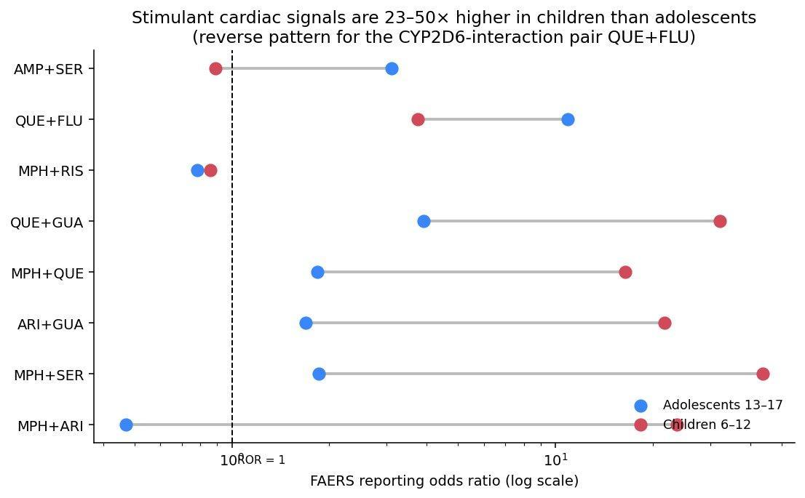
Figure 5. Reporting odds ratios for cardiac adverse events in children aged 6 to 12 and adolescents aged 13 to 17, on a logarithmic scale. Red marks children aged 6 to 12 and blue adolescents aged 13 to 17. Stimulant combinations show 23 to 50 fold higher signal in younger children; the interaction pair quetiapine plus fluoxetine shows the reverse.

Discussion

Rate correction, not hERG block, is the first thing to get wrong
My central finding is methodological and clinically consequential. For psychotropics that change heart rate, the standard risk metric, Bazett corrected QTc, misrepresents repolarization risk, and it does so in opposite directions for the two most common rate changing classes in pediatric psychiatry. For stimulants it manufactures prolongation, with a genuine change near zero against a Bazett change of up to 20 ms; for alpha-2 agonists it masks prolongation, with the uncorrected interval lengthening while Bazett shows an apparent protection. The combinations Bazett ranks highest are anti correlated with those carrying genuine repolarization change. Only the uncorrected action potential duration recovers the true direction and magnitude of effect, and Fridericia, while better than Bazett at high rate, does not fully correct either error.
This reframes a long standing clinical observation. Pediatric methylphenidate studies consistently report heart rate increases of 3 to 8 beats per minute with no significant change in Bazett corrected QTc ^{[10,11]}. The model reproduces this and explains it: the apparent stability hides the fact that Bazett would over correct, and the membrane in fact repolarizes slightly faster, not slower. The clinical implication is that stimulant cardiac risk should be evaluated as a hemodynamic and rate phenomenon, through heart rate and blood pressure, rather than against thresholds for QTc relevant to torsade de pointes.

Genuine repolarization risk at therapeutic exposure is small and is mediated by hERG block
At therapeutic free concentrations, no combination produced alarming genuine prolongation. The maximum was 11.5 ms, for aripiprazole plus nortriptyline, and only five combinations exceeded 10 ms of genuine change. This reassuring null result is itself useful in a field prone to extrapolating alarming adult QTc figures to children. It also relocates the interesting risk to elevated exposure, in poor metabolizers at CYP2D6, in pharmacokinetic interactions, and in overdose, where a mechanistic model, unlike pharmacovigilance or therapeutic dose ECG studies, can make falsifiable predictions. The supratherapeutic analysis bears this out: the aripiprazole combinations reach the 10 ms genuine threshold at only 1.0 to 1.4 times therapeutic exposure, the worst being aripiprazole plus nortriptyline at therapeutic exposure itself, and exceed 60 to 100 ms at 10 times, whereas the stimulant combinations that Bazett over flags require 6 to 10 times exposure or never reach concern. The combinations that look benign at therapeutic dose by the correct metric are the same ones that become dangerous first under the modest exposure increases that CYP2D6 poor metabolism and the fluoxetine interaction routinely produce.

What the model does not do
The model is weakly concordant with FAERS cardiac signals, and the raw hERG block fraction predicts the real world signal at least as well as the full simulation. I therefore make no claim that the simulation is a validated predictor of pharmacovigilance outcomes. This is consistent with the nature of the data: FAERS cardiac signals are confounded and heterogeneous, and the genuine modeled effects at therapeutic dose are small. The contribution of the model is mechanistic interpretation, separating rate artifact from genuine repolarization and identifying exposure thresholds, rather than prediction of real world risk.

Positioning relative to CiPA and CredibleMeds
CardioSafe Pediatric extends the CiPA paradigm ^{[3,4]} to a population and a drug set that CiPA does not cover, and to interactions between multiple drugs rather than screening of single agents for torsade de pointes. The qNet metric of CiPA requires multiple channel block data that are unavailable for most drugs here and is, by construction, a metric of repolarization that would not capture the rate mediated and conduction mediated signals this analysis highlights. Against the CredibleMeds reference, three coverage gaps persist and are clarified rather than contradicted by these results: stimulants are flagged only for congenital long QT syndrome, with no guidance for polypharmacy in the general population; aripiprazole carries only a possible risk designation despite being the dominant source of genuine repolarization prolongation in this drug set and a substrate of CYP2D6; and clonidine and guanfacine are not classified despite a conduction mediated FAERS signal for guanfacine.

Mechanistic interpretation of discordances
Two clusters of discordance between model and FAERS point to specific modeling gaps rather than to general failure, and they remain valid as hypotheses. Combinations involving guanfacine show a FAERS signal despite a modeled protective QTc effect: guanfacine slows atrioventricular conduction and prolongs the PR interval, which the model based on QTc does not represent, so combined conduction slowing with antipsychotics or serotonin reuptake inhibitors may produce bradyarrhythmia or heart block that appear as cardiac events but are invisible to repolarization modeling. Combinations involving fluoxetine reflect inhibition of CYP2D6 raising substrate exposure, a pharmacokinetic effect independent of the cell model that the fixed monotherapy concentrations do not capture. Both gaps are clinically actionable, through conduction aware monitoring for guanfacine polypharmacy and through genotyping at CYP2D6 and exposure aware monitoring when fluoxetine is added to aripiprazole or nortriptyline.

Considerations specific to adolescents
No validated computational model of the adolescent human ventricular action potential exists, and the adult ventricular model used here is the closest validated reference. Developmental data suggest that the rapid potassium current rises toward adult levels through childhood ^{[12]}, implying that the adult model may slightly overestimate repolarization reserve in early adolescents, a conservative direction for predictions driven by hERG block. All base case concentrations are adult derived; for stimulants, the higher weight adjusted dosing in children makes adult concentrations conservative. The pediatric specificity of the framework therefore rests on pediatric pharmacokinetic inputs and on the pediatric pharmacovigilance analysis, not on a pediatric model of the ion channels, a scope I state explicitly.

Clinical implications
The most actionable message is a reframing. Cardiac monitoring for stimulant containing pediatric polypharmacy should center on heart rate and blood pressure, and where relevant on catecholaminergic arrhythmia risk, not on Bazett QTc, which will both over flag these regimens and under flag the rate slowing alpha-2 combinations. The strongest epidemiological signal, the 23 to 50 fold gradient between children and adolescents in stimulant cardiac reporting, argues for vigilance stratified by age independent of the model. Prospective ECG monitoring, and where indicated monitoring of the PR interval, in children initiating the combinations with the highest genuine risk, particularly aripiprazole with nortriptyline and aripiprazole containing regimens in poor metabolizers at CYP2D6, is the natural next study. An open source interactive simulator implementing the framework is available in the repository; its predictions now run on the validated engine and report the genuine change in action potential duration alongside the Bazett value, though it remains a research and exploration tool rather than a validated clinical instrument.

Limitations
- The model represents undiseased adult ventricular electrophysiology, and no validated adolescent specific model exists. The use of the genuine change in action potential duration mitigates but does not eliminate this; pediatric specificity rests on pharmacokinetic inputs and the pharmacovigilance analysis.
- All base case concentrations are adult derived. Developmental variation at CYP2D6 may shift the exposures of risperidone, aripiprazole, fluoxetine, nortriptyline, and imipramine by 1.5 to 3 times.
- The uncorrected action potential duration retains rate dependence, so the apparent prolongation in alpha-2 combinations partly reflects rate rather than channel block; a decomposition at fixed cycle length, in progress, is required to fully isolate channel pharmacology.
- The sympathomimetic and autonomic pathways are present or absent and do not scale with concentration, so the supratherapeutic analysis probes risk mediated by hERG block specifically.
- There is no modeling of the PR interval or atrioventricular conduction, so the conduction effects of guanfacine and the related discordances are not captured.
- The cell model uses fixed monotherapy concentrations and does not include pharmacokinetic interaction at CYP2D6 directly.
- Active metabolites such as norfluoxetine are not included.
- Combined hERG block assumes independent binding sites, an upper bound; competition at a shared site would reduce combined block slightly and would not change tier assignments.
- Concordance with FAERS is weak; the simulation is not a validated predictor of real world signals, and the raw hERG block fraction predicts at least as well.
- FAERS captures voluntary reports rather than confirmed diagnoses, is subject to confounding by indication, excludes the 43 percent of cases with unknown age, and measures disproportionate reporting rather than absolute risk.
- Sex differences in repolarization are not modeled.

Declarations
Funding. This research did not receive any specific grant from funding agencies in the public, commercial, or not-for-profit sectors.
Declaration of competing interests. I have no competing interests to declare.
Declaration of generative AI and AI-assisted technologies in the manuscript preparation process. During the preparation of this work the author used Claude for manuscript drafting and revision. After using this tool, the author reviewed and edited the content as needed and takes full responsibility for the content of the published article.
CRediT author statement. Arnav Amit: Conceptualization, Methodology, Software, Formal analysis, Investigation, Data curation, Visualization, Writing - original draft, Writing - review and editing.
Data and code availability. All code, data, and results are openly available at github.com/arnava25/cardiosafe-pediatric, including the validated cell engine, the drug effect module, the polypharmacy sweep, the rate correction and concordance analyses, the FAERS pipeline, and the drug parameterization table.

References
[1] Kongsamut S, Kang J, Chen XL, Roehr J, Rampe D. A comparison of the receptor binding and HERG channel affinities for a series of antipsychotic drugs. Eur J Pharmacol. 2002;450(1):37-41.
[2] Redfern WS, Carlsson L, Davis AS, et al. Relationships between preclinical cardiac electrophysiology, clinical QT interval prolongation and torsade de pointes for a broad range of drugs. Cardiovasc Res. 2003;58(1):32-45.
[3] Colatsky T, Fermini B, Gintant G, et al. The Comprehensive in Vitro Proarrhythmia Assay (CiPA) initiative: update on progress. J Pharmacol Toxicol Methods. 2016;81:15-20.
[4] Dutta S, Chang KC, Beattie KA, et al. Optimization of an in silico cardiac cell model for proarrhythmia risk assessment. Front Physiol. 2017;8:616.
[5] Rijnbeek PR, van Herpen G, Bots ML, et al. Normal values of the electrocardiogram for ages 16-90 years. J Electrocardiol. 2014;47(6):914-921.
[6] Bazett HC. An analysis of the time relations of electrocardiograms. Heart. 1920;7:353-370.
[7] O'Hara T, Virag L, Varro A, Rudy Y. Simulation of the undiseased human cardiac ventricular action potential: model formulation and experimental validation. PLoS Comput Biol. 2011;7(5):e1002061.
[8] Fridericia LS. Die Systolendauer im Elektrokardiogramm bei normalen Menschen und bei Herzkranken. Acta Med Scand. 1920;53:469-486.
[9] Soltis AR, Saucerman JJ. Synergy between CaMKII substrates and beta-adrenergic signaling in regulation of cardiac myocyte Ca2+ handling. Biophys J. 2010;99(7):2038-2047.
[10] Guerriero RM, Galli J, Croker A, et al. Acute cardiovascular effects of immediate-release methylphenidate in children and adolescents with attention-deficit hyperactivity disorder. Curr Drug Saf. 2015;10(2):152-158.
[11] Ilgenli TF, Akpinar O, Bulut S. The acute effects of methylphenidate on the QT interval. Adv Ther. 2007;24(1):182-188.
[12] Developmental adaptations in the human pediatric myocardium: connecting transcriptomics with computational modeling [preprint]. bioRxiv. 2024. doi:10.1101/2024.04.19.589826.

