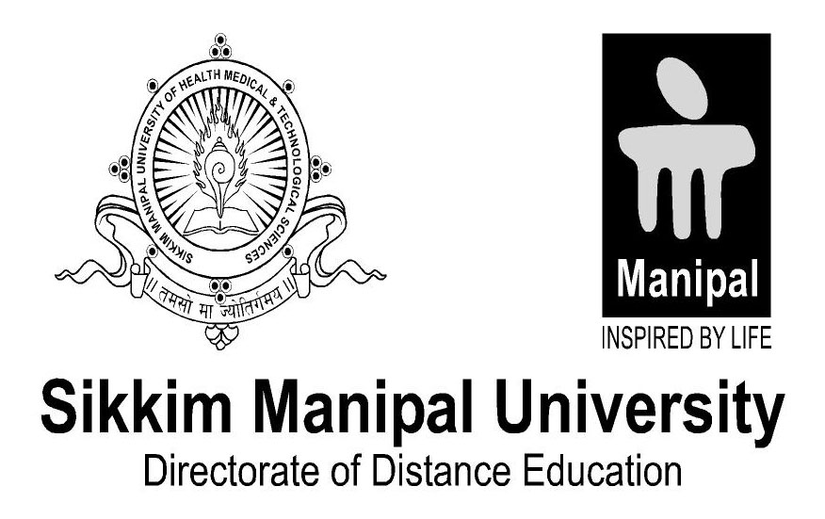

Student declaration
I here by declare that the project report entitled
Online Examination System
Submitted in partial fulfillment of the requirements for the degree of
Bsc.IT 6th Semester
To Sikkim-Manipal University, India, is my original work and not submitted for the award of any other degree, diploma, fellowship, or any other similar title or prizes

Place: Kandevsthan,Lalitpur. Prakash Tamang
Date: 28/10/2014 Roll Number- 571115419

