Experiment 1
1. Experiment Title
Demonstrate Inline, Internal, and External JavaScript; Use Console Methods; Create a Webpage Showing User Information and a Welcome Message.

2. Software/Tools Required
- Visual Studio Code (VS Code)
- Google Chrome / Mozilla Firefox / Microsoft Edge
- HTML5
- CSS3
- JavaScript
- Windows Operating System

3. Experiment Program Code
The experiment consists of the following files:
- index.html
- styles.css
- script.js

<!DOCTYPE html>
<html lang="en">
<head>
<meta charset="UTF-8">
<meta name="viewport" content="width=device-width, initial-scale=1.0">
<title>Exp 1: Web Integration Portal</title>

<!-- [1] EXTERNAL CSS LINK -->
<link rel="stylesheet" href="style.css">

<!-- [2] INTERNAL CSS -->
<style>
@import url('https://fonts.googleapis.com/css2?family=Fira+Code:wght@400;500&family=Inter:wght@400;600;700&display=swap');

body {
background-color: #0f172a; /* Deep Slate Tech Background */
font-family: 'Inter', sans-serif;
color: #f8fafc;
margin: 0;
padding: 40px 20px;
}

.header {
text-align: center;
margin-bottom: 40px;
border-bottom: 1px solid #1e293b;
padding-bottom: 20px;
}

.header h1 {
font-size: 2.2em;
background: linear-gradient(to right, #38bdf8, #818cf8);
-webkit-background-clip: text;
-webkit-text-fill-color: transparent;
margin: 0;
}

.grid-container {
display: grid;
grid-template-columns: repeat(auto-fit, minmax(320px, 1fr));
gap: 25px;
max-width: 1200px;
margin: 0 auto;
}

.tech-card {
background: #1e293b;
border: 1px solid #334155;
border-radius: 16px;
padding: 25px;
position: relative;
overflow: hidden;
transition: transform 0.3s ease, border-color 0.3s ease;
}

.tech-card:hover {
transform: translateY(-5px);
border-color: #38bdf8;
box-shadow: 0 10px 30px -10px rgba(56, 189, 248, 0.2);
}

.method-badge {
font-family: 'Fira Code', monospace;
font-size: 0.75em;
background: #0f172a;
color: #38bdf8;
padding: 6px 12px;
border-radius: 6px;
border: 1px solid #0369a1;
display: inline-block;
margin-bottom: 15px;
}

h3 {
margin: 0 0 10px 0;
font-size: 1.2em;
color: #f1f5f9;
}

p {
color: #94a3b8;
font-size: 0.9em;
line-height: 1.6;
margin-bottom: 25px;
}

.btn-tech {
background: #38bdf8;
color: #0f172a;
border: none;
padding: 12px 20px;
border-radius: 8px;
font-weight: 600;
cursor: pointer;
width: 100%;
transition: all 0.2s ease;
margin-bottom: 10px;
}

.btn-tech:hover {
background: #7dd3fc;
box-shadow: 0 0 15px rgba(56, 189, 248, 0.4);
}

.btn-alt {
background: transparent;
color: #38bdf8;
border: 1px solid #38bdf8;
}

.btn-alt:hover {
background: rgba(56, 189, 248, 0.1);
}

.console-box {
background: #0b0f19;
border: 1px dashed #475569;
border-radius: 8px;
padding: 15px;
margin-top: 15px;
font-family: 'Fira Code', monospace;
font-size: 0.85em;
color: #10b981;
display: none;
}
</style>
</head>
<body>

<div class="header">
<!-- [3] INLINE CSS: Directly applied via style attribute -->
<h1 style="letter-spacing: -1px;">Experiment No. 01</h1>
<p style="color: #64748b; font-family: 'Fira Code', monospace;">// CSS & JS Integration Architecture</p>
</div>

<div class="grid-container">
<!-- METHOD 1 -->
<div class="tech-card">
<div class="section-tag method-badge">METHOD_01 :: INLINE</div>
<h3>Inline Architecture</h3>
<p>Styles and scripts embedded directly inside the HTML element attributes for localized, priority execution.</p>

<button class="btn-tech" onclick="alert('⚡ Inline JS Triggered Successfully!')">
Execute Inline Script
</button>
</div>

<!-- METHOD 2 -->
<div class="tech-card">
<div class="section-tag method-badge">METHOD_02 :: INTERNAL</div>
<h3>Internal DOM & Console</h3>
<p>Page-specific styles in head section. Scripts execute dynamic DOM insertion and backend console logs.</p>

<button class="btn-tech" onclick="showUserInfo()">Render Student Data</button>
<button class="btn-tech btn-alt" onclick="triggerConsoleDemo()">Trigger Console Debug</button>

<div id="userInfoBox" class="console-box"></div>
</div>

<!-- METHOD 3 -->
<div class="tech-card external-card-style">
<div class="section-tag method-badge">METHOD_03 :: EXTERNAL</div>
<h3>External Modular Files</h3>
<p>Production-grade separation of concerns using independent .css stylesheets and .js logic files.</p>

<button class="btn-tech" onclick="showWelcomeMessage()">Fetch External Response</button>

<div id="welcomeBox" class="console-box" style="color: #38bdf8;"></div>
</div>
</div>

<!-- INTERNAL JAVASCRIPT -->
<script>
function showUserInfo() {
const infoBox = document.getElementById('userInfoBox');
infoBox.innerHTML = `
<span style="color:#64748b;">// STUDENT_META_DATA</span><br>
> NAME: Arnav Band<br>
> PRN : 223<br>
> DEPT: Computer Science & Engineering<br>
> STATUS: <span style="color:#38bdf8;">ACTIVE_ENROLLMENT</span>
`;
infoBox.style.display = 'block';
}

function triggerConsoleDemo() {
console.log("%c[LOG] System initialization started.", "color: #38bdf8; font-weight:bold;");
console.info("[INFO] Modular DOM elements mounted successfully.");
console.warn("[WARN] Memory usage optimal. Debug mode enabled.");
console.error("[ERROR] Simulated error loop for testing inspection methods.");
alert("🛠️ Console diagnostics executed! Open DevTools (F12) -> Console tab to inspect.");
}
</script>

<!-- [4] EXTERNAL JAVASCRIPT LINK -->
<script src="script.js"></script>

</body>
</html>

Output:

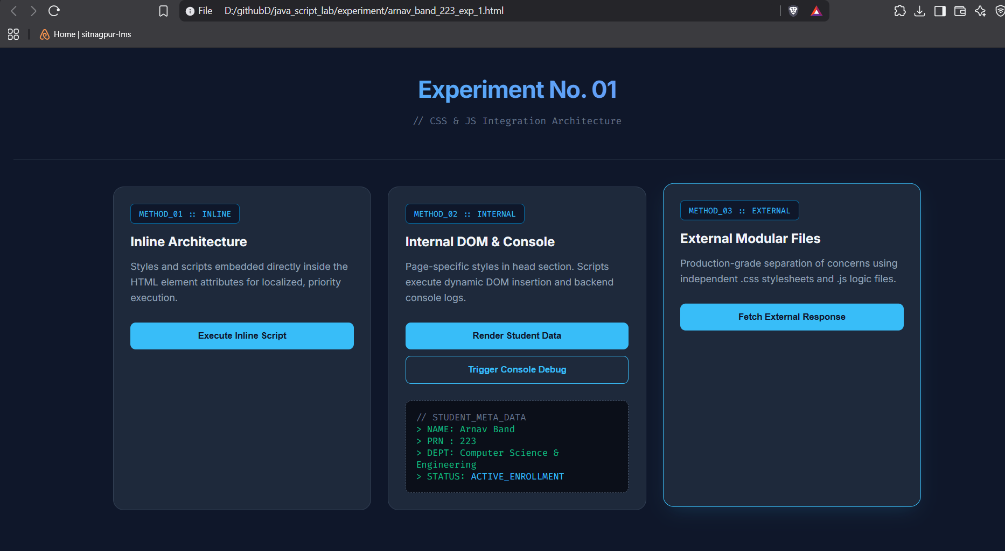

Case Study 1
1. Case Study Title
Create a Webpage for College Department and Link the Student Information Page with It and Write a JavaScript Program to Display "Welcome to SIT Nagpur" in an Alert Box.

2. Case Study Program Code
The case study consists of the following files:
- index.html – Displays the college department information and shows the alert message "Welcome to SIT Nagpur" using JavaScript.
- students.html – Displays the student information page linked from the department webpage.

<!DOCTYPE html>
<html lang="en">
<head>
<meta charset="UTF-8" />
<meta name="viewport" content="width=device-width, initial-scale=1.0" />
<meta name="description" content="SIT Nagpur - Department of Computer Science & Engineering. Explore our programs, faculty, and student resources." />
<title>SIT Nagpur | Department of Computer Science & Student Portal</title>

<link rel="preconnect" href="https://fonts.googleapis.com" />
<link rel="preconnect" href="https://fonts.gstatic.com" crossorigin />
<!-- Swapped to Poppins for modern UI and Fira Code for data/numbers -->
<link href="https://fonts.googleapis.com/css2?family=Fira+Code:wght@400;500;600&family=Poppins:wght@300;400;500;600;700;800&display=swap" rel="stylesheet" />

<style>
/* =========================================================
1. GLOBAL & VARIABLES (MODERN DARK THEME)
========================================================= */
*, *::before, *::after { margin: 0; padding: 0; box-sizing: border-box; }

:root {
--primary: #06b6d4; /* Cyber Cyan */
--primary-dark: #0891b2;
--accent: #8b5cf6; /* Neon Purple */
--secondary: #f43f5e; /* Rose */
--gold: #fbbf24;
--green: #10b981;
--orange: #f97316;

/* Dark Theme Backgrounds */
--bg-dark: #0f172a; /* Deep Slate */
--bg-card: #1e293b; /* Lighter Slate for Cards */
--bg-card2: #334155; /* Hover/Input States */

/* Dark Theme Typography */
--text-main: #f8fafc; /* Crisp Off-White */
--text-muted: #94a3b8; /* Slate Gray */
--border: #334155;

--shadow: 0 10px 40px rgba(0, 0, 0, 0.4);
--radius: 16px;
--transition: 0.35s cubic-bezier(0.4, 0, 0.2, 1);
}

html { scroll-behavior: smooth; }

body {
font-family: 'Poppins', sans-serif;
background: var(--bg-dark);
color: var(--text-main);
overflow-x: hidden;
min-height: 100vh;
}

/* Updated Background Glowing Orbs for Dark Mode */
body::before {
content: '';
position: fixed;
inset: 0;
background:
radial-gradient(ellipse 80% 60% at 20% 10%, rgba(6, 182, 212, 0.1) 0%, transparent 60%),
radial-gradient(ellipse 60% 50% at 80% 80%, rgba(139, 92, 246, 0.1) 0%, transparent 60%),
radial-gradient(ellipse 50% 40% at 50% 50%, rgba(244, 63, 94, 0.05) 0%, transparent 70%);
pointer-events: none;
z-index: 0;
}

/* Font Utility for Numbers/Code */
.mono-font {
font-family: 'Fira Code', monospace;
}

/* =========================================================
2. NAVBAR
========================================================= */
nav {
position: sticky; top: 0; z-index: 100;
backdrop-filter: blur(20px);
background: rgba(15, 23, 42, 0.85); /* Dark transparent nav */
border-bottom: 1px solid var(--border);
padding: 0 5%;
display: flex; align-items: center; justify-content: space-between;
height: 70px;
animation: slideDown 0.6s ease;
}

@keyframes slideDown {
from { transform: translateY(-100%); opacity: 0; }
to { transform: translateY(0); opacity: 1; }
}

.nav-logo {
display: flex; align-items: center; gap: 12px;
text-decoration: none;
}

.logo-icon {
width: 42px; height: 42px;
background: linear-gradient(135deg, var(--primary), var(--accent));
border-radius: 10px;
display: grid; place-items: center;
font-size: 20px; font-weight: 800; color: #fff;
box-shadow: 0 4px 18px rgba(6, 182, 212, 0.4);
}

.nav-logo span {
font-weight: 700; font-size: 1.1rem; color: var(--text-main);
}

.nav-links { display: flex; gap: 6px; list-style: none; }

.nav-links a {
color: var(--text-muted); text-decoration: none;
font-size: 0.9rem; font-weight: 500;
padding: 8px 16px; border-radius: 8px;
transition: var(--transition);
cursor: pointer;
}

.nav-links a:hover { color: var(--text-main); background: rgba(255,255,255,0.05); }
.nav-links a.active { color: var(--primary); background: rgba(6, 182, 212, 0.1); }

.nav-cta {
background: linear-gradient(135deg, var(--primary), var(--accent)) !important;
color: #fff !important;
border-radius: 10px !important;
box-shadow: 0 4px 16px rgba(139, 92, 246, 0.3);
}

/* =========================================================
3. DEPARTMENT VIEW STYLES
========================================================= */
.hero {
position: relative; z-index: 1;
min-height: calc(100vh - 70px);
display: flex; flex-direction: column; align-items: center; justify-content: center;
text-align: center; padding: 80px 5% 60px;
}

.hero-badge {
display: inline-flex; align-items: center; gap: 8px;
background: rgba(6, 182, 212, 0.1);
border: 1px solid rgba(6, 182, 212, 0.2);
border-radius: 50px; padding: 8px 20px;
font-size: 0.82rem; font-weight: 600;
color: var(--primary); letter-spacing: 0.06em; text-transform: uppercase;
margin-bottom: 28px;
animation: fadeUp 0.8s ease 0.2s both;
}

.hero-badge::before {
content: '●'; font-size: 8px; color: var(--primary);
animation: pulse 2s infinite;
}

@keyframes pulse { 0%,100%{opacity:1} 50%{opacity:0.3} }

.hero h1 {
font-size: clamp(2.4rem, 6vw, 4.8rem);
font-weight: 800; line-height: 1.1;
margin-bottom: 24px;
animation: fadeUp 0.8s ease 0.35s both;
}

.highlight {
background: linear-gradient(to right, var(--primary), var(--accent));
-webkit-background-clip: text;
-webkit-text-fill-color: transparent;
}

.hero p {
max-width: 620px; color: var(--text-muted);
font-size: 1.08rem; line-height: 1.8;
margin-bottom: 44px;
animation: fadeUp 0.8s ease 0.5s both;
}

.hero-btns {
display: flex; gap: 16px; flex-wrap: wrap; justify-content: center;
animation: fadeUp 0.8s ease 0.65s both;
}

@keyframes fadeUp {
from { opacity:0; transform:translateY(30px); }
to { opacity:1; transform:translateY(0); }
}

.btn-primary {
background: linear-gradient(135deg, var(--primary), var(--primary-dark));
color: #fff; border: none;
padding: 16px 36px; border-radius: 14px;
font-size: 1rem; font-weight: 600; cursor: pointer;
text-decoration: none; display: inline-flex; align-items: center; gap: 10px;
box-shadow: 0 6px 28px rgba(6, 182, 212, 0.25);
transition: var(--transition);
}

.btn-primary:hover { transform: translateY(-3px); box-shadow: 0 12px 40px rgba(6, 182, 212, 0.4); }

.btn-secondary {
background: var(--bg-card);
color: var(--text-main);
border: 1px solid var(--border);
padding: 16px 36px; border-radius: 14px;
font-size: 1rem; font-weight: 600; cursor: pointer;
text-decoration: none; display: inline-flex; align-items: center; gap: 10px;
backdrop-filter: blur(10px);
transition: var(--transition);
}

.btn-secondary:hover { background: var(--bg-card2); border-color: var(--primary); transform: translateY(-3px); }

/* STATS STRIP */
.stats-strip {
position: relative; z-index: 1;
display: flex; justify-content: center; flex-wrap: wrap;
background: rgba(30, 41, 59, 0.6);
border-top: 1px solid var(--border);
border-bottom: 1px solid var(--border);
backdrop-filter: blur(12px);
}

.stat-item {
flex: 1; min-width: 160px;
padding: 32px 20px; text-align: center;
border-right: 1px solid var(--border);
transition: var(--transition);
}

.stat-item:last-child { border-right: none; }
.stat-item:hover { background: rgba(255,255,255,0.02); }

.stat-num {
font-size: 2.4rem; font-weight: 800;
color: var(--primary);
display: block;
}

.stat-label { font-size: 0.85rem; color: var(--text-muted); font-weight: 500; margin-top: 4px; }

/* SECTION COMMON */
section { position: relative; z-index: 1; padding: 90px 5%; }

.section-tag {
display: inline-block;
background: rgba(139, 92, 246, 0.1);
border: 1px solid rgba(139, 92, 246, 0.2);
color: var(--accent);
font-size: 0.78rem; font-weight: 700;
letter-spacing: 0.1em; text-transform: uppercase;
padding: 6px 16px; border-radius: 50px; margin-bottom: 18px;
}

.section-title {
font-size: clamp(1.8rem, 3.5vw, 2.8rem);
font-weight: 800; margin-bottom: 14px;
}

.section-sub {
color: var(--text-muted); font-size: 1rem;
line-height: 1.7; max-width: 560px; margin-bottom: 56px;
}

/* ABOUT */
#about {
display: grid; grid-template-columns: 1fr 1fr;
gap: 64px; align-items: center;
}

.about-visual { position: relative; }

.about-card-main {
background: var(--bg-card);
border: 1px solid var(--border);
border-radius: 24px; padding: 40px;
box-shadow: var(--shadow);
}

.about-icon {
width: 60px; height: 60px;
background: linear-gradient(135deg, var(--primary), var(--accent));
border-radius: 14px;
display: grid; place-items: center;
font-size: 28px; margin-bottom: 20px; color: white;
box-shadow: 0 8px 24px rgba(6, 182, 212, 0.3);
}

.about-card-main h3 { font-size: 1.4rem; font-weight: 700; margin-bottom: 12px; }
.about-card-main p { color: var(--text-muted); line-height: 1.7; font-size: 0.95rem; }

.floating-badge {
position: absolute;
background: linear-gradient(135deg, var(--gold), #f59e0b);
color: #1a1400; font-weight: 700; font-size: 0.82rem;
padding: 10px 18px; border-radius: 50px;
box-shadow: 0 8px 24px rgba(251,191,36,0.3);
}

.floating-badge.top-right { top: -18px; right: -18px; }
.floating-badge.bot-left { bottom: -18px; left: -18px; }

.feature-list { list-style: none; display: flex; flex-direction: column; gap: 14px; }

.feature-list li {
display: flex; align-items: center; gap: 12px;
font-size: 0.95rem; color: var(--text-muted);
}

.feature-list li::before {
content: '✓';
width: 26px; height: 26px;
background: rgba(6, 182, 212, 0.15);
border: 1px solid rgba(6, 182, 212, 0.3);
color: var(--primary); border-radius: 50%;
display: grid; place-items: center;
font-size: 0.7rem; font-weight: 800; flex-shrink: 0;
}

/* PROGRAMS */
#programs { background: rgba(255,255,255,0.01); }

.programs-list {
display: flex; flex-direction: column; gap: 16px;
max-width: 1000px; margin: 0 auto;
}

.program-row {
display: grid; grid-template-columns: auto 1fr auto; gap: 40px;
align-items: center; padding: 32px 40px;
background: var(--bg-card); border: 1px solid var(--border);
border-radius: 16px; transition: var(--transition); cursor: pointer;
}

.program-row:hover {
border-color: var(--primary);
box-shadow: var(--shadow);
transform: translateX(4px);
}

.prog-number {
font-size: 2.5rem; font-weight: 800; color: var(--border);
transition: var(--transition);
}

.program-row:hover .prog-number { color: var(--primary); }

.prog-content h3 { font-size: 1.3rem; font-weight: 700; margin-bottom: 8px; color: var(--text-main); }
.prog-content p { color: var(--text-muted); font-size: 0.95rem; line-height: 1.6; max-width: 600px; }

.prog-meta { text-align: right; }
.prog-duration { display: block; color: var(--primary); font-size: 0.95rem; font-weight: 700; margin-bottom: 4px; }
.prog-seats { color: var(--text-muted); font-size: 0.85rem; font-weight: 500; }

@media (max-width: 768px) {
.program-row { grid-template-columns: 1fr; gap: 16px; padding: 24px; }
.prog-meta { text-align: left; }
.prog-number { display: none; }
}

/* FACULTY */
.faculty-list {
display: flex; flex-direction: column; gap: 16px; max-width: 900px; margin: 0 auto;
}

.faculty-row {
display: flex; align-items: center; gap: 24px; padding: 24px 32px;
background: var(--bg-card); border: 1px solid var(--border);
border-radius: 16px; transition: var(--transition); cursor: pointer;
}

.faculty-row:hover { border-color: var(--accent); transform: translateX(4px); box-shadow: var(--shadow); }

.faculty-avatar {
width: 56px; height: 56px; border-radius: 50%; display: grid; place-items: center;
font-size: 1.1rem; font-weight: 700; flex-shrink: 0; color: #fff;
}

.faculty-info { flex: 1; display: flex; flex-direction: column; gap: 4px; }
.faculty-row h4 { font-weight: 700; font-size: 1.15rem; color: var(--text-main); margin: 0; }

.faculty-meta { display: flex; justify-content: space-between; align-items: center; width: 100%; }
.designation { color: var(--primary); font-size: 0.9rem; font-weight: 600; margin: 0; }
.specialization { color: var(--text-muted); font-size: 0.85rem; font-weight: 500; }

@media (max-width: 600px) {
.faculty-row { flex-direction: column; align-items: flex-start; gap: 16px; }
.faculty-meta { flex-direction: column; align-items: flex-start; gap: 8px; }
}

/* STUDENT BANNER */
.student-banner {
position: relative; z-index: 1; margin: 0 5% 80px;
background: linear-gradient(135deg, rgba(6, 182, 212, 0.1), rgba(139, 92, 246, 0.1));
border: 1px solid rgba(139, 92, 246, 0.3);
border-radius: 24px; padding: 56px 60px;
display: flex; align-items: center; justify-content: space-between; gap: 40px; overflow: hidden;
}

.student-banner::before {
content: '🎓'; position: absolute; right: 60px; top: 50%; transform: translateY(-50%);
font-size: 140px; opacity: 0.05; pointer-events: none;
}

.banner-content h2 { font-size: clamp(1.4rem, 3vw, 2rem); font-weight: 800; margin-bottom: 12px; }
.banner-content p { color: var(--text-muted); font-size: 0.95rem; line-height: 1.7; max-width: 500px; }

/* DEPT FOOTER */
footer.dept-footer {
position: relative; z-index: 1; background: var(--bg-card);
border-top: 1px solid var(--border); padding: 56px 5% 28px;
}

.footer-grid { display: grid; grid-template-columns: 2fr 1fr 1fr 1fr; gap: 48px; margin-bottom: 48px; }
.footer-brand p { color: var(--text-muted); font-size: 0.88rem; line-height: 1.7; margin-top: 14px; max-width: 280px; }
.footer-col h5 { font-weight: 700; font-size: 0.95rem; margin-bottom: 16px; color: var(--text-main); }
.footer-col ul { list-style: none; display: flex; flex-direction: column; gap: 10px; }
.footer-col ul a { color: var(--text-muted); text-decoration: none; font-size: 0.88rem; transition: var(--transition); }
.footer-col ul a:hover { color: var(--primary); }
.footer-bottom {
border-top: 1px solid var(--border); padding-top: 24px;
display: flex; align-items: center; justify-content: space-between;
color: var(--text-muted); font-size: 0.82rem;
}

/* =========================================================
4. STUDENT PORTAL VIEW STYLES
========================================================= */
.page-header {
position: relative; z-index: 1;
background: linear-gradient(135deg, rgba(6, 182, 212, 0.1), rgba(15, 23, 42, 0.8));
border-bottom: 1px solid var(--border);
padding: 60px 5% 48px; text-align: center;
}

.page-header .section-tag {
display: inline-block; background: rgba(6, 182, 212, 0.1);
border: 1px solid rgba(6, 182, 212, 0.3); color: var(--primary);
font-size: 0.78rem; font-weight: 700; letter-spacing: 0.1em; text-transform: uppercase;
padding: 6px 18px; border-radius: 50px; margin-bottom: 20px;
animation: fadeUp 0.7s ease 0.1s both;
}

.page-header h1 {
font-size: clamp(2rem, 5vw, 3.5rem);
font-weight: 900; margin-bottom: 14px; animation: fadeUp 0.7s ease 0.25s both;
}

.page-header h1 span { color: var(--primary); }
.page-header p {
color: var(--text-muted); font-size: 1rem; max-width: 520px;
margin: 0 auto; line-height: 1.7; animation: fadeUp 0.7s ease 0.4s both;
}

/* SEARCH & FILTER */
.search-bar-wrap {
position: relative; z-index: 1; padding: 32px 5%;
display: flex; gap: 16px; flex-wrap: wrap;
align-items: center; justify-content: center;
}

.search-input-wrap { position: relative; flex: 1; max-width: 480px; min-width: 240px; }
.search-input-wrap input {
width: 100%; background: var(--bg-card2); border: 1px solid var(--border);
border-radius: 12px; padding: 14px 20px 14px 48px; color: var(--text-main);
font-size: 0.95rem; font-family: 'Poppins', sans-serif; outline: none; transition: var(--transition);
}
.search-input-wrap input:focus { border-color: var(--primary); box-shadow: 0 0 0 3px rgba(6, 182, 212, 0.2); }
.search-input-wrap input::placeholder { color: var(--text-muted); }
.search-icon { position: absolute; left: 16px; top: 50%; transform: translateY(-50%); font-size: 1rem; pointer-events: none; color: var(--text-muted); }

.filter-select {
background: var(--bg-card2); border: 1px solid var(--border);
border-radius: 12px; padding: 14px 20px; color: var(--text-main);
font-size: 0.9rem; font-family: 'Poppins', sans-serif; outline: none; cursor: pointer;
transition: var(--transition); appearance: none; min-width: 160px;
}
.filter-select:focus { border-color: var(--primary); }

/* STATS ROW */
.stats-row {
position: relative; z-index: 1; display: grid; grid-template-columns: repeat(auto-fit, minmax(180px, 1fr));
gap: 20px; padding: 0 5% 48px;
}
.mini-stat {
background: var(--bg-card); border: 1px solid var(--border); border-radius: var(--radius);
padding: 24px 20px; display: flex; align-items: center; gap: 16px; transition: var(--transition);
}
.mini-stat:hover { border-color: var(--primary); transform: translateY(-3px); box-shadow: var(--shadow); }
.mini-stat-icon { width: 48px; height: 48px; border-radius: 12px; display: grid; place-items: center; font-size: 1.4rem; flex-shrink: 0; color: #fff; }
.mini-stat-data strong { font-size: 1.6rem; font-weight: 800; display: block; color: var(--text-main); }
.mini-stat-data span { color: var(--text-muted); font-size: 0.82rem; font-weight: 500; }

/* STUDENT TABLE */
.table-section { position: relative; z-index: 1; padding: 0 5% 80px; }
.table-wrap { background: var(--bg-card); border: 1px solid var(--border); border-radius: 20px; overflow: hidden; box-shadow: var(--shadow); }
.table-header-row { padding: 20px 28px; display: flex; align-items: center; justify-content: space-between; border-bottom: 1px solid var(--border); background: rgba(255,255,255,0.02); }
.table-header-row h3 { font-weight: 700; font-size: 1.1rem; }
.table-header-row span { color: var(--text-muted); font-size: 0.85rem; }

table { width: 100%; border-collapse: collapse; }
thead tr { background: rgba(255,255,255,0.03); }
thead th { padding: 14px 20px; text-align: left; font-size: 0.78rem; font-weight: 700; color: var(--text-muted); letter-spacing: 0.06em; text-transform: uppercase; border-bottom: 1px solid var(--border); }
tbody tr { border-bottom: 1px solid var(--border); transition: var(--transition); }
tbody tr:last-child { border-bottom: none; }
tbody tr:hover { background: rgba(255,255,255,0.02); }
tbody td { padding: 16px 20px; font-size: 0.9rem; vertical-align: middle; }

.student-avatar {
width: 38px; height: 38px; border-radius: 50%; display: inline-grid; place-items: center;
font-size: 0.85rem; font-weight: 700; color: #fff; margin-right: 10px; vertical-align: middle;
}
.student-name { font-weight: 600; color: var(--text-main); }
.student-id { color: var(--text-muted); font-size: 0.8rem; }

.badge { display: inline-block; padding: 4px 12px; border-radius: 50px; font-size: 0.76rem; font-weight: 700; }
.badge-blue { background: rgba(6, 182, 212, 0.2); color: #22d3ee; border: 1px solid rgba(6, 182, 212, 0.3); }
.badge-green { background: rgba(16, 185, 129, 0.2); color: #34d399; border: 1px solid rgba(16, 185, 129, 0.3); }
.badge-orange { background: rgba(249, 115, 22, 0.2); color: #fb923c; border: 1px solid rgba(249, 115, 22, 0.3); }
.badge-red { background: rgba(244, 63, 94, 0.2); color: #fb7185; border: 1px solid rgba(244, 63, 94, 0.3); }
.badge-teal { background: rgba(139, 92, 246, 0.2); color: #a78bfa; border: 1px solid rgba(139, 92, 246, 0.3); }

.progress-bar-wrap { background: var(--bg-card2); border-radius: 50px; height: 8px; width: 100px; overflow: hidden; }
.progress-bar { height: 100%; border-radius: 50px; background: linear-gradient(90deg, var(--primary), var(--accent)); transition: width 1s ease; }
.cgpa-val { font-weight: 700; color: var(--accent); font-size: 0.95rem; }

.pagination { padding: 24px 28px; display: flex; align-items: center; justify-content: center; gap: 8px; border-top: 1px solid var(--border); }
.page-btn {
width: 38px; height: 38px; border-radius: 10px; display: grid; place-items: center;
background: none; border: 1px solid var(--border); color: var(--text-muted); cursor: pointer;
font-size: 0.88rem; transition: var(--transition);
}
.page-btn:hover, .page-btn.active { background: var(--primary); border-color: var(--primary); color: #fff; }

/* PROFILE CARDS */
.profile-section { position: relative; z-index: 1; padding: 0 5% 80px; }
.profile-section-title { font-size: 1.5rem; font-weight: 800; margin-bottom: 28px; }
.profile-list { display: flex; flex-direction: column; gap: 16px; max-width: 1000px; margin: 0 auto; }
.profile-row {
display: flex; align-items: center; gap: 32px; padding: 24px 32px;
background: var(--bg-card); border: 1px solid var(--border); border-radius: 16px; transition: var(--transition); cursor: pointer;
}
.profile-row:hover { border-color: var(--accent); transform: translateX(4px); box-shadow: var(--shadow); }
.profile-ava { width: 64px; height: 64px; border-radius: 50%; display: grid; place-items: center; font-size: 1.2rem; font-weight: 800; color: #fff; flex-shrink: 0; }
.profile-info { flex: 1; display: flex; flex-direction: column; gap: 4px; }
.profile-row h4 { font-weight: 700; font-size: 1.15rem; margin: 0; color: var(--text-main); }
.profile-row .roll { color: var(--text-muted); font-size: 0.85rem; }
.profile-tags { display: flex; gap: 6px; flex-wrap: wrap; margin-top: 4px; }
.profile-stats { display: flex; gap: 32px; text-align: right; }
.pstat { display: flex; flex-direction: column; align-items: flex-end; }
.pstat strong { font-size: 1.15rem; font-weight: 800; color: var(--text-main); }
.pstat span { color: var(--text-muted); font-size: 0.75rem; font-weight: 600; text-transform: uppercase; letter-spacing: 0.05em; }

@media (max-width: 768px) {
.profile-row { flex-direction: column; align-items: flex-start; gap: 16px; }
.profile-stats { justify-content: space-between; width: 100%; text-align: left; }
.pstat { align-items: flex-start; }
}

/* NOTICES */
.notices-section { position: relative; z-index: 1; padding: 0 5% 80px; }
.notices-list { display: flex; flex-direction: column; gap: 16px; max-width: 1000px; margin: 0 auto; }
.notice-card {
display: flex; align-items: center; gap: 24px; background: var(--bg-card);
border: 1px solid var(--border); border-left: 4px solid var(--primary);
border-radius: 12px; padding: 24px 32px; transition: var(--transition);
}
.notice-card:hover { transform: translateX(4px); box-shadow: var(--shadow); }
.notice-card.urgent { border-left-color: var(--secondary); }
.notice-card.success { border-left-color: var(--green); }
.notice-card.info { border-left-color: var(--accent); }
.notice-content { flex: 1; }
.notice-head { display: flex; align-items: center; gap: 10px; margin-bottom: 8px; }
.notice-head .tag { font-size: 0.72rem; font-weight: 700; text-transform: uppercase; padding: 4px 12px; border-radius: 50px; }
.notice-card h4 { font-weight: 700; font-size: 1.1rem; margin-bottom: 6px; color: var(--text-main); }
.notice-card p { color: var(--text-muted); font-size: 0.9rem; line-height: 1.6; max-width: 800px; margin: 0; }
.notice-date-container { text-align: right; min-width: 100px; }
.notice-date { color: var(--text-muted); font-size: 0.85rem; font-weight: 500; }

/* STUDENT FOOTER */
footer.student-footer {
position: relative; z-index: 1; background: var(--bg-card); border-top: 1px solid var(--border);
padding: 28px 5%; display: flex; align-items: center; justify-content: space-between;
flex-wrap: wrap; gap: 16px;
}
footer.student-footer p { color: var(--text-muted); font-size: 0.85rem; }
.footer-links { display: flex; gap: 20px; }
.footer-links a { color: var(--text-muted); text-decoration: none; font-size: 0.85rem; transition: var(--transition); cursor: pointer; }
.footer-links a:hover { color: var(--primary); }

/* =========================================================
5. UTILITY & RESPONSIVE
========================================================= */
.reveal { opacity: 0; transform: translateY(30px); transition: opacity 0.7s ease, transform 0.7s ease; }
.reveal.visible { opacity: 1; transform: translateY(0); }
.student-row.hidden { display: none; }

@media (max-width: 900px) {
#about { grid-template-columns: 1fr; }
.footer-grid { grid-template-columns: 1fr 1fr; }
.student-banner { flex-direction: column; text-align: center; }
.notices-grid { grid-template-columns: 1fr; }
}

@media (max-width: 700px) {
.nav-links { display: none; }
.footer-grid { grid-template-columns: 1fr; }
.hero-btns { flex-direction: column; align-items: center; }
table thead { display: none; }
tbody td { display: block; }
}
</style>

<script src="https://unpkg.com/lucide@latest"></script>
<style>
i[data-lucide] {
width: 1.2em;
height: 1.2em;
vertical-align: text-bottom;
display: inline-block;
}
</style>
</head>
<body>

<!-- NAVBAR -->
<nav id="main-nav">
<a href="#" onclick="switchView('department'); return false;" class="nav-logo">
<div class="logo-icon">S</div>
<span>SIT Nagpur</span>
</a>
<ul class="nav-links">
<li><a href="#about" class="nav-item active" onclick="goToSection('#about'); return false;">About</a></li>
<li><a href="#programs" class="nav-item" onclick="goToSection('#programs'); return false;">Programs</a></li>
<li><a href="#faculty" class="nav-item" onclick="goToSection('#faculty'); return false;">Faculty</a></li>
<li><a href="#" class="nav-cta" id="nav-student-btn" onclick="switchView('students'); return false;">Student Info</a></li>
</ul>
</nav>

<!-- =========================================================
VIEW 1: DEPARTMENT CONTENT
========================================================= -->
<div id="view-department">
<!-- HERO -->
<section class="hero">
<div class="hero-badge">Affiliated to RTMNU &middot; AICTE Approved</div>
<h1>
Department of<br>
<span class="highlight">Computer Science</span><br>
&amp; Engineering
</h1>
<p>
Empowering the next generation of innovators at
<strong>Symbiosis Institute of Technology, Nagpur</strong>.
Excellence in education, research, and industry collaboration.
</p>
<div class="hero-btns">
<a href="#" onclick="switchView('students'); return false;" class="btn-primary" id="student-info-btn">
<i data-lucide="terminal"></i> Student Information
</a>
<a href="#programs" onclick="goToSection('#programs'); return false;" class="btn-secondary">
<i data-lucide="book-open"></i> Explore Programs
</a>
</div>
</section>

<!-- STATS -->
<div class="stats-strip">
<div class="stat-item">
<span class="stat-num mono-font">1200+</span>
<span class="stat-label">Students Enrolled</span>
</div>
<div class="stat-item">
<span class="stat-num mono-font">48</span>
<span class="stat-label">Expert Faculty</span>
</div>
<div class="stat-item">
<span class="stat-num mono-font">95%</span>
<span class="stat-label">Placement Rate</span>
</div>
<div class="stat-item">
<span class="stat-num mono-font">25+</span>
<span class="stat-label">Years of Excellence</span>
</div>
<div class="stat-item">
<span class="stat-num mono-font">150+</span>
<span class="stat-label">Research Papers</span>
</div>
</div>

<!-- ABOUT -->
<section id="about">
<div class="about-visual reveal">
<div class="about-card-main">
<div class="about-icon"><i data-lucide="cpu"></i></div>
<h3>Vision of the Department</h3>
<p>
To be a globally recognized centre of excellence in Computer Science
&amp; Engineering education, producing competent graduates who contribute
meaningfully to society through innovation and ethical practice.
</p>
</div>
<div class="floating-badge top-right"><i data-lucide="shield-check"></i> NAAC Accredited</div>
<div class="floating-badge bot-left"><i data-lucide="award"></i> NBA Approved</div>
</div>

<div class="about-text reveal">
<div class="section-tag">About Us</div>
<h2 class="section-title">Shaping Tomorrow's<br>Tech Leaders</h2>
<p class="section-sub" style="max-width:100%; margin-bottom:28px;">
The Department of Computer Science &amp; Engineering at SIT Nagpur has been
at the forefront of technological education since its establishment. We foster
a culture of learning, research, and innovation.
</p>
<ul class="feature-list">
<li>State-of-the-art Computing Laboratories</li>
<li>Industry-integrated Curriculum &amp; Live Projects</li>
<li>Research Collaborations with IITs &amp; NITs</li>
<li>Active Placement Cell with 200+ Company Tie-ups</li>
<li>Student Clubs: Coding, AI/ML, Robotics, Cybersecurity</li>
<li>Merit Scholarships &amp; Financial Aid Programs</li>
</ul>
</div>
</section>

<!-- PROGRAMS -->
<section id="programs">
<div style="text-align:center; margin-bottom:56px;">
<div class="section-tag">Academics</div>
<h2 class="section-title">Our Programs</h2>
<p class="section-sub" style="margin:0 auto;">
Choose from a diverse range of undergraduate and postgraduate programs
designed to meet global industry standards.
</p>
</div>
<div class="programs-list">
<div class="program-row reveal">
<div class="prog-number mono-font">01</div>
<div class="prog-content">
<h3>B.E. Computer Science &amp; Engineering</h3>
<p>Comprehensive 4-year program covering algorithms, OS, networks, databases, AI/ML, and software engineering.</p>
</div>
<div class="prog-meta">
<span class="prog-duration mono-font">4 Years</span>
<span class="prog-seats">60 Seats</span>
</div>
</div>
<div class="program-row reveal">
<div class="prog-number mono-font">02</div>
<div class="prog-content">
<h3>B.E. AI &amp; Machine Learning</h3>
<p>Specialized program focusing on deep learning, data science, computer vision, and intelligent systems.</p>
</div>
<div class="prog-meta">
<span class="prog-duration mono-font">4 Years</span>
<span class="prog-seats">60 Seats</span>
</div>
</div>
<div class="program-row reveal">
<div class="prog-number mono-font">03</div>
<div class="prog-content">
<h3>B.E. Cybersecurity</h3>
<p>Modern curriculum covering ethical hacking, network security, cryptography, and digital forensics.</p>
</div>
<div class="prog-meta">
<span class="prog-duration mono-font">4 Years</span>
<span class="prog-seats">30 Seats</span>
</div>
</div>
<div class="program-row reveal">
<div class="prog-number mono-font">04</div>
<div class="prog-content">
<h3>B.E. Information Technology</h3>
<p>Broad-based program in software development, web technologies, cloud computing, and enterprise systems.</p>
</div>
<div class="prog-meta">
<span class="prog-duration mono-font">4 Years</span>
<span class="prog-seats">60 Seats</span>
</div>
</div>
<div class="program-row reveal">
<div class="prog-number mono-font">05</div>
<div class="prog-content">
<h3>M.Tech Computer Science</h3>
<p>Advanced 2-year postgraduate program with research opportunities and specializations in cutting-edge areas.</p>
</div>
<div class="prog-meta">
<span class="prog-duration mono-font">2 Years</span>
<span class="prog-seats">24 Seats</span>
</div>
</div>
<div class="program-row reveal">
<div class="prog-number mono-font">06</div>
<div class="prog-content">
<h3>M.Tech Data Science</h3>
<p>Data-driven postgraduate program with hands-on industry projects, big data, and analytics specialization.</p>
</div>
<div class="prog-meta">
<span class="prog-duration mono-font">2 Years</span>
<span class="prog-seats">24 Seats</span>
</div>
</div>
</div>
</section>

<!-- FACULTY -->
<section id="faculty">
<div style="text-align:center; margin-bottom:56px;">
<div class="section-tag">Our Team</div>
<h2 class="section-title">Meet the Faculty</h2>
<p class="section-sub" style="margin:0 auto;">
Learn from experienced academicians and industry experts who are passionate
about shaping your future.
</p>
</div>
<div class="faculty-list">
<div class="faculty-row reveal">
<div class="faculty-avatar" style="background:linear-gradient(135deg,var(--primary),var(--primary-dark));">DR</div>
<div class="faculty-info">
<h4>Dr. Rajesh Sharma</h4>
<div class="faculty-meta">
<span class="designation">Head of Department</span>
<span class="specialization">Ph.D &middot; AI &amp; Machine Learning</span>
</div>
</div>
</div>
<div class="faculty-row reveal">
<div class="faculty-avatar" style="background:linear-gradient(135deg,var(--accent),#6d28d9);">PM</div>
<div class="faculty-info">
<h4>Prof. Priya Mehta</h4>
<div class="faculty-meta">
<span class="designation">Associate Professor</span>
<span class="specialization">M.Tech &middot; Data Science</span>
</div>
</div>
</div>
<div class="faculty-row reveal">
<div class="faculty-avatar" style="background:linear-gradient(135deg,var(--secondary),#be123c);">AK</div>
<div class="faculty-info">
<h4>Prof. Amit Kumar</h4>
<div class="faculty-meta">
<span class="designation">Assistant Professor</span>
<span class="specialization">Ph.D &middot; Cybersecurity</span>
</div>
</div>
</div>
<div class="faculty-row reveal">
<div class="faculty-avatar" style="background:linear-gradient(135deg,var(--orange),#c2410c);">SP</div>
<div class="faculty-info">
<h4>Dr. Sneha Patil</h4>
<div class="faculty-meta">
<span class="designation">Associate Professor</span>
<span class="specialization">Ph.D &middot; Cloud Computing</span>
</div>
</div>
</div>
</div>
</section>

<!-- STUDENT BANNER -->
<div class="student-banner reveal">
<div class="banner-content">
<h2><i data-lucide="terminal"></i> Access Student Information Portal</h2>
<p>
View student profiles, academic records, attendance, results, and
important notices — all in one place. Click below to explore the
student information dashboard.
</p>
</div>
<a href="#" onclick="switchView('students'); return false;" class="btn-primary" style="flex-shrink:0;">
Launch Dashboard <i data-lucide="chevron-right"></i>
</a>
</div>

<!-- DEPT FOOTER -->
<footer class="dept-footer">
<div class="footer-grid">
<div class="footer-brand">
<a href="#" onclick="switchView('department'); return false;" class="nav-logo" style="display:inline-flex; margin-bottom:8px;">
<div class="logo-icon">S</div>
<span>SIT Nagpur</span>
</a>
<p>Symbiosis Institute of Technology, Nagpur.<br>
Department of Computer Science &amp; Engineering.<br>
Committed to excellence in technical education.</p>
</div>
<div class="footer-col">
<h5>Quick Links</h5>
<ul>
<li><a href="#" onclick="goToSection('#about'); return false;">About Us</a></li>
<li><a href="#" onclick="goToSection('#programs'); return false;">Programs</a></li>
<li><a href="#" onclick="goToSection('#faculty'); return false;">Faculty</a></li>
<li><a href="#" onclick="switchView('students'); return false;">Student Info</a></li>
</ul>
</div>
<div class="footer-col">
<h5>Resources</h5>
<ul>
<li><a href="#">Library</a></li>
<li><a href="#">E-Learning</a></li>
<li><a href="#">Research Lab</a></li>
<li><a href="#">Placement Cell</a></li>
</ul>
</div>
<div class="footer-col">
<h5>Contact</h5>
<ul>
<li><a href="#"><i data-lucide="map-pin"></i> Nagpur, Maharashtra</a></li>
<li><a href="#"><i data-lucide="phone"></i> +91 712 000 0000</a></li>
<li><a href="#"><i data-lucide="mail"></i> cse@sitnagpur.edu.in</a></li>
</ul>
</div>
</div>
<div class="footer-bottom">
<span>&copy; 2026 SIT Nagpur &mdash; Department of CSE. All rights reserved.</span>
<span>Designed with <i data-lucide="terminal"></i> and excellence</span>
</div>
</footer>
</div>

<!-- =========================================================
VIEW 2: STUDENT INFORMATION PORTAL
========================================================= -->
<div id="view-students" style="display: none;">
<!-- PAGE HEADER -->
<div class="page-header">
<div class="section-tag"><i data-lucide="database"></i> System Logs</div>
<h1>Student <span>Information</span> Dashboard</h1>
<p>
Access comprehensive academic profiles, performance records, attendance data,
and important notices for all enrolled students.
</p>
</div>

<!-- SEARCH & FILTER -->
<div class="search-bar-wrap">
<div class="search-input-wrap">
<span class="search-icon"><i data-lucide="search"></i></span>
<input
type="text"
id="student-search"
placeholder="Search by name, PRN, or branch..."
/>
</div>
<select class="filter-select" id="branch-filter">
<option value="">All Branches</option>
<option value="CSE">CSE</option>
<option value="AI/ML">AI/ML</option>
<option value="IT">IT</option>
<option value="Cyber">Cybersecurity</option>
</select>
<select class="filter-select" id="year-filter">
<option value="">All Years</option>
<option value="1st">1st Year</option>
<option value="2nd">2nd Year</option>
<option value="3rd">3rd Year</option>
<option value="4th">4th Year</option>
</select>
</div>

<!-- MINI STATS -->
<div class="stats-row reveal">
<div class="mini-stat">
<div class="mini-stat-icon" style="background:rgba(6,182,212,0.15); color:#22d3ee;"><i data-lucide="users"></i></div>
<div class="mini-stat-data">
<strong class="mono-font">1,247</strong>
<span>Total Students</span>
</div>
</div>
<div class="mini-stat">
<div class="mini-stat-icon" style="background:rgba(16,185,129,0.15); color:#34d399;"><i data-lucide="check-circle"></i></div>
<div class="mini-stat-data">
<strong class="mono-font">87.3%</strong>
<span>Avg. Attendance</span>
</div>
</div>
<div class="mini-stat">
<div class="mini-stat-icon" style="background:rgba(139,92,246,0.15); color:#a78bfa;"><i data-lucide="star"></i></div>
<div class="mini-stat-data">
<strong class="mono-font">7.94</strong>
<span>Average CGPA</span>
</div>
</div>
<div class="mini-stat">
<div class="mini-stat-icon" style="background:rgba(249,115,22,0.15); color:#fb923c;"><i data-lucide="trophy"></i></div>
<div class="mini-stat-data">
<strong class="mono-font">342</strong>
<span>Placed This Year</span>
</div>
</div>
<div class="mini-stat">
<div class="mini-stat-icon" style="background:rgba(244,63,94,0.15); color:#fb7185;"><i data-lucide="book-open"></i></div>
<div class="mini-stat-data">
<strong class="mono-font">96</strong>
<span>Backlogs Active</span>
</div>
</div>
</div>

<!-- STUDENT TABLE -->
<div class="table-section reveal">
<div class="table-wrap">
<div class="table-header-row">
<h3><i data-lucide="table"></i> All Student Records</h3>
<span id="record-count">Showing records</span>
</div>
<div style="overflow-x:auto;">
<table id="student-table">
<thead>
<tr>
<th>Student</th>
<th>PRN / Roll No.</th>
<th>Branch</th>
<th>Year</th>
<th>Attendance</th>
<th>CGPA</th>
<th>Status</th>
</tr>
</thead>
<tbody id="student-tbody">
<!-- Rows injected by JS -->
</tbody>
</table>
</div>
<div class="pagination">
<button class="page-btn active" id="page-1">1</button>
<button class="page-btn" id="page-2">2</button>
<button class="page-btn" id="page-3">3</button>
<button class="page-btn"><i data-lucide="chevron-right"></i></button>
</div>
</div>
</div>

<!-- PROFILE CARDS -->
<div class="profile-section">
<h3 class="profile-section-title reveal"><i data-lucide="medal"></i> Top Performers</h3>
<div class="profile-list">
<div class="profile-row reveal">
<div class="profile-ava" style="background:linear-gradient(135deg,var(--primary),var(--primary-dark));">AR</div>
<div class="profile-info">
<h4>Arnav</h4>
<div class="roll mono-font">24070521223</div>
<div class="profile-tags"><span class="badge badge-blue">CSE</span>
<span class="badge badge-teal">1st Year</span>
<span class="badge badge-green">Gold</span></div>
</div>
<div class="profile-stats">
<div class="pstat"><strong class="mono-font">9.7</strong><span>CGPA</span></div>
<div class="pstat"><strong class="mono-font">98%</strong><span>Attend.</span></div>
<div class="pstat"><strong class="mono-font">5</strong><span>Awards</span></div>
</div>
</div>

<div class="profile-row reveal">
<div class="profile-ava" style="background:linear-gradient(135deg,var(--accent),#6d28d9);">PR</div>
<div class="profile-info">
<h4>Priya Raut</h4>
<div class="roll mono-font">SIT/AI/2022/012</div>
<div class="profile-tags"><span class="badge badge-teal">AI/ML</span>
<span class="badge badge-teal">4th Year</span>
<span class="badge badge-green">Silver</span></div>
</div>
<div class="profile-stats">
<div class="pstat"><strong class="mono-font">9.5</strong><span>CGPA</span></div>
<div class="pstat"><strong class="mono-font">95%</strong><span>Attend.</span></div>
<div class="pstat"><strong class="mono-font">3</strong><span>Awards</span></div>
</div>
</div>

<div class="profile-row reveal">
<div class="profile-ava" style="background:linear-gradient(135deg,var(--gold),#d97706);">RK</div>
<div class="profile-info">
<h4>Rahul Kamble</h4>
<div class="roll mono-font">SIT/CSE/2023/031</div>
<div class="profile-tags"><span class="badge badge-blue">CSE</span>
<span class="badge badge-orange">3rd Year</span>
<span class="badge badge-green">Bronze</span></div>
</div>
<div class="profile-stats">
<div class="pstat"><strong class="mono-font">9.2</strong><span>CGPA</span></div>
<div class="pstat"><strong class="mono-font">91%</strong><span>Attend.</span></div>
<div class="pstat"><strong class="mono-font">2</strong><span>Awards</span></div>
</div>
</div>

<div class="profile-row reveal">
<div class="profile-ava" style="background:linear-gradient(135deg,var(--secondary),#be123c);">SN</div>
<div class="profile-info">
<h4>Sanvi Naik</h4>
<div class="roll mono-font">SIT/IT/2023/044</div>
<div class="profile-tags"><span class="badge badge-orange">IT</span>
<span class="badge badge-orange">3rd Year</span></div>
</div>
<div class="profile-stats">
<div class="pstat"><strong class="mono-font">9.0</strong><span>CGPA</span></div>
<div class="pstat"><strong class="mono-font">93%</strong><span>Attend.</span></div>
<div class="pstat"><strong class="mono-font">1</strong><span>Awards</span></div>
</div>
</div>
</div>
</div>

<!-- NOTICES -->
<div class="notices-section">
<h3 class="profile-section-title reveal"><i data-lucide="bell"></i> Important Notices</h3>
<div class="notices-list">
<div class="notice-card reveal">
<div class="notice-content">
<div class="notice-head"><span class="tag badge badge-blue">Academic</span></div>
<h4>End Semester Examination Schedule — Nov 2026</h4>
<p>The end-semester examination timetable for all programmes has been released. Students are advised to check their hall tickets on the portal.</p>
</div>
<div class="notice-date-container">
<div class="notice-date"><i data-lucide="calendar"></i> 05 Jul 2026</div>
</div>
</div>

<div class="notice-card urgent reveal">
<div class="notice-content">
<div class="notice-head"><span class="tag badge badge-red">Urgent</span></div>
<h4>Last Date for Fee Payment — 15 July 2026</h4>
<p>All students with pending dues are requested to clear their fees before 15th July to avoid de-barring from examinations.</p>
</div>
<div class="notice-date-container">
<div class="notice-date"><i data-lucide="calendar"></i> 01 Jul 2026</div>
</div>
</div>

<div class="notice-card success reveal">
<div class="notice-content">
<div class="notice-head"><span class="tag badge badge-green">Placement</span></div>
<h4>TCS &amp; Infosys Campus Drive — 20 July 2026</h4>
<p>Eligible final year students may register for the upcoming campus placement drive by TCS and Infosys. Registration closes on 12th July.</p>
</div>
<div class="notice-date-container">
<div class="notice-date"><i data-lucide="calendar"></i> 28 Jun 2026</div>
</div>
</div>

<div class="notice-card info reveal">
<div class="notice-content">
<div class="notice-head"><span class="tag badge badge-teal">Event</span></div>
<h4>TechFest 2026 — Annual National Technical Fest</h4>
<p>SIT TechFest 2026 is scheduled for 25–27 July. Students can participate in hackathons, robotics, paper presentations, and more.</p>
</div>
<div class="notice-date-container">
<div class="notice-date"><i data-lucide="calendar"></i> 25 Jun 2026</div>
</div>
</div>
</div>
</div>

<!-- STUDENT FOOTER -->
<footer class="student-footer">
<p>&copy; 2026 SIT Nagpur &mdash; Student Information Portal</p>
<div class="footer-links">
<a href="#" onclick="switchView('department'); return false;"><i data-lucide="arrow-left"></i> Back to Department</a>
<a href="#">Privacy Policy</a>
<a href="#">Support</a>
</div>
</footer>
</div>

<!-- =========================================================
6. UNIFIED JAVASCRIPT
========================================================= -->
<script>
// ===============================================
// SPA ROUTING LOGIC
// ===============================================
function switchView(view) {
if (view === 'students') {
document.getElementById('view-department').style.display = 'none';
document.getElementById('view-students').style.display = 'block';
document.querySelectorAll('.nav-item').forEach(el => el.classList.remove('active'));
document.getElementById('nav-student-btn').classList.add('active');
} else {
document.getElementById('view-department').style.display = 'block';
document.getElementById('view-students').style.display = 'none';
document.getElementById('nav-student-btn').classList.remove('active');
}
window.scrollTo(0, 0);
}

function goToSection(sectionId) {
switchView('department'); // Ensure we are on the department view
setTimeout(() => {
const target = document.querySelector(sectionId);
if (target) {
target.scrollIntoView({ behavior: 'smooth', block: 'start' });
}
}, 50);
}

// ============================================================
// STUDENT DATA
// ============================================================
const students = [
{ name:'Arnav', roll:'24070521223', branch:'CSE', year:'1st', attend:98, cgpa:9.7, status:'Active' },
{ name:'Priya Raut', roll:'SIT/AI/22/012', branch:'AI/ML', year:'4th', attend:95, cgpa:9.5, status:'Active' },
{ name:'Rahul Kamble', roll:'SIT/CSE/23/031', branch:'CSE', year:'3rd', attend:91, cgpa:9.2, status:'Active' },
{ name:'Sanvi Naik', roll:'SIT/IT/23/044', branch:'IT', year:'3rd', attend:93, cgpa:9.0, status:'Active' },
{ name:'Karan Deshmukh', roll:'SIT/CY/24/008', branch:'Cyber', year:'2nd', attend:85, cgpa:8.4, status:'Active' },
{ name:'Neha Joshi', roll:'SIT/CSE/24/019', branch:'CSE', year:'2nd', attend:78, cgpa:7.8, status:'Backlog' },
{ name:'Rohit Sharma', roll:'SIT/AI/25/003', branch:'AI/ML', year:'1st', attend:88, cgpa:8.0, status:'Active' },
{ name:'Pooja Wankhede', roll:'SIT/IT/22/055', branch:'IT', year:'4th', attend:72, cgpa:7.1, status:'Backlog' },
{ name:'Arjun Patil', roll:'SIT/CSE/23/062', branch:'CSE', year:'3rd', attend:96, cgpa:8.8, status:'Active' },
{ name:'Divya Bhatt', roll:'SIT/CY/24/017', branch:'Cyber', year:'2nd', attend:90, cgpa:8.5, status:'Active' },
{ name:'Siddharth Rao', roll:'SIT/AI/22/028', branch:'AI/ML', year:'4th', attend:82, cgpa:8.2, status:'Active' },
{ name:'Meera Kulkarni', roll:'SIT/IT/25/011', branch:'IT', year:'1st', attend:94, cgpa:8.9, status:'Active' },
];

const branchColors = {
CSE: 'badge-blue',
'AI/ML':'badge-teal',
IT: 'badge-orange',
Cyber: 'badge-red',
};

const avatarColors = [
'linear-gradient(135deg,#06b6d4,#0891b2)',
'linear-gradient(135deg,#8b5cf6,#6d28d9)',
'linear-gradient(135deg,#f43f5e,#be123c)',
'linear-gradient(135deg,#fbbf24,#b45309)',
'linear-gradient(135deg,#10b981,#047857)',
];

function initials(name) {
return name.split(' ').map(w => w[0]).join('').toUpperCase();
}

// ============================================================
// RENDER TABLE
// ============================================================
function renderTable(data) {
const tbody = document.getElementById('student-tbody');
document.getElementById('record-count').textContent = 'Showing ' + data.length + ' records';
tbody.innerHTML = '';

data.forEach((s, i) => {
const color = avatarColors[i % avatarColors.length];
const attend = s.attend;
const attendColor = attend >= 90 ? '#34d399' : attend >= 75 ? '#fbbf24' : '#fb7185';
const statusClass = s.status === 'Active' ? 'badge-green' : 'badge-red';

const tr = document.createElement('tr');
tr.classList.add('student-row');
tr.dataset.branch = s.branch;
tr.dataset.year = s.year;

tr.innerHTML = `
<td>
<span class="student-avatar" style="background:${color};">${initials(s.name)}</span>
<span class="student-name">${s.name}</span>
</td>
<td><span class="student-id mono-font">${s.roll}</span></td>
<td><span class="badge ${branchColors[s.branch] || 'badge-blue'}">${s.branch}</span></td>
<td>${s.year}</td>
<td>
<div style="display:flex; align-items:center; gap:10px;">
<div class="progress-bar-wrap">
<div class="progress-bar" style="width:${attend}%; background:linear-gradient(90deg,${attendColor},${attendColor}cc);"></div>
</div>
<span class="mono-font" style="color:${attendColor}; font-weight:700; font-size:0.85rem;">${attend}%</span>
</div>
</td>
<td><span class="cgpa-val mono-font">${s.cgpa.toFixed(1)}</span></td>
<td><span class="badge ${statusClass}">${s.status}</span></td>
`;
tbody.appendChild(tr);
});
}

renderTable(students);

// ============================================================
// SEARCH & FILTER
// ============================================================
function applyFilters() {
const searchVal = document.getElementById('student-search').value.toLowerCase();
const branchVal = document.getElementById('branch-filter').value;
const yearVal = document.getElementById('year-filter').value;

const filtered = students.filter(s => {
const matchSearch = s.name.toLowerCase().includes(searchVal) ||
s.roll.toLowerCase().includes(searchVal) ||
s.branch.toLowerCase().includes(searchVal);
const matchBranch = !branchVal || s.branch === branchVal;
const matchYear = !yearVal || s.year === yearVal;
return matchSearch && matchBranch && matchYear;
});

renderTable(filtered);
}

document.getElementById('student-search').addEventListener('input', applyFilters);
document.getElementById('branch-filter').addEventListener('change', applyFilters);
document.getElementById('year-filter').addEventListener('change', applyFilters);

// ===============================================
// Scroll Reveal Animation
// ===============================================
const revealObserver = new IntersectionObserver(
(entries) => {
entries.forEach((entry) => {
if (entry.isIntersecting) {
entry.target.classList.add('visible');
revealObserver.unobserve(entry.target);
}
});
},
{ threshold: 0.1 }
);
document.querySelectorAll('.reveal').forEach((el) => revealObserver.observe(el));

// ===============================================
// Active Nav on Scroll
// ===============================================
const navItems = document.querySelectorAll('.nav-item');
const navObserver = new IntersectionObserver(
(entries) => {
entries.forEach((entry) => {
if (entry.isIntersecting && document.getElementById('view-department').style.display !== 'none') {
navItems.forEach((link) => {
link.classList.remove('active');
if (link.getAttribute('onclick') && link.getAttribute('onclick').includes(entry.target.id)) {
link.classList.add('active');
}
});
}
});
},
{ threshold: 0.4 }
);
document.querySelectorAll('section[id]').forEach((sec) => navObserver.observe(sec));

// ============================================================
// PAGINATION (UI only)
// ============================================================
document.querySelectorAll('.page-btn').forEach(btn => {
btn.addEventListener('click', function () {
document.querySelectorAll('.page-btn').forEach(b => b.classList.remove('active'));
this.classList.add('active');
});
});

</script>
<script>
lucide.createIcons();
</script>
</body>
</html>

3. Output
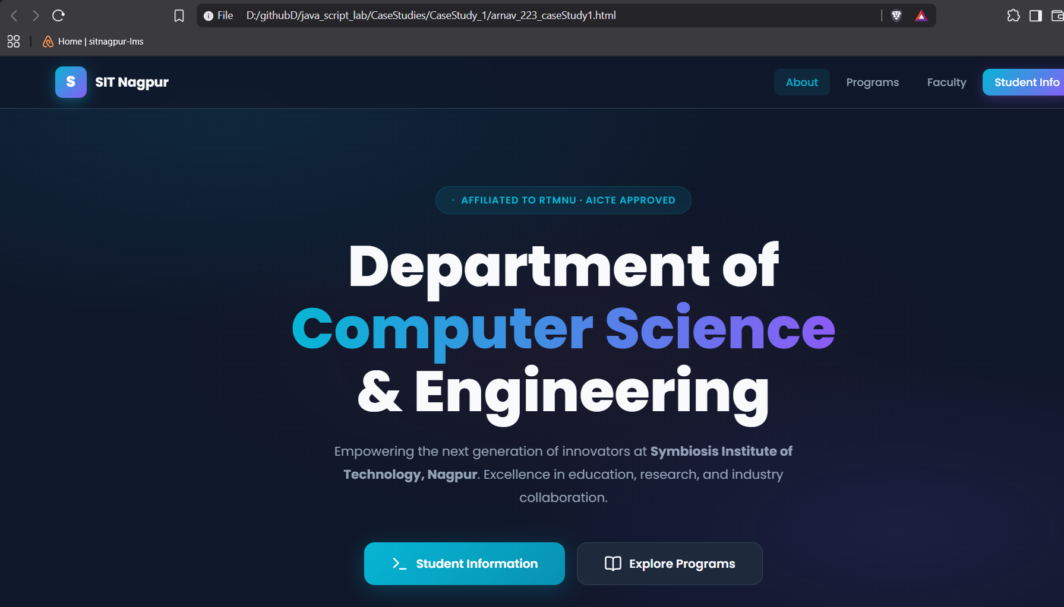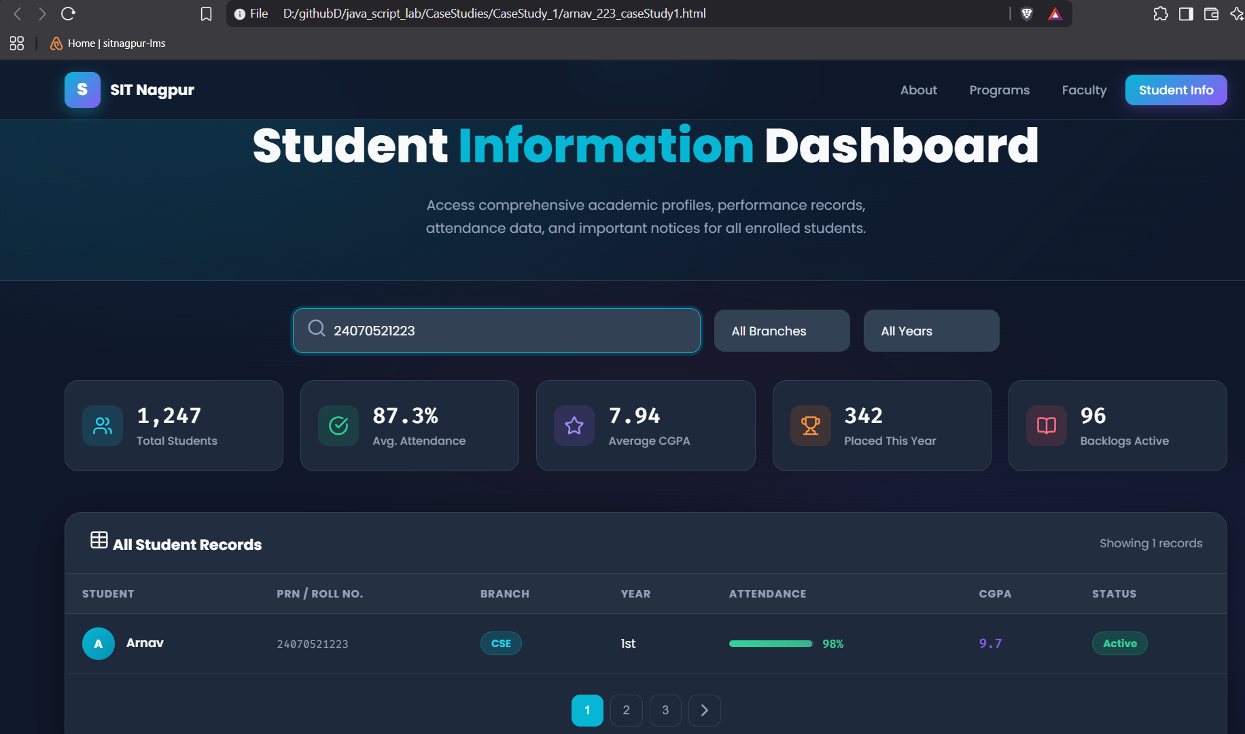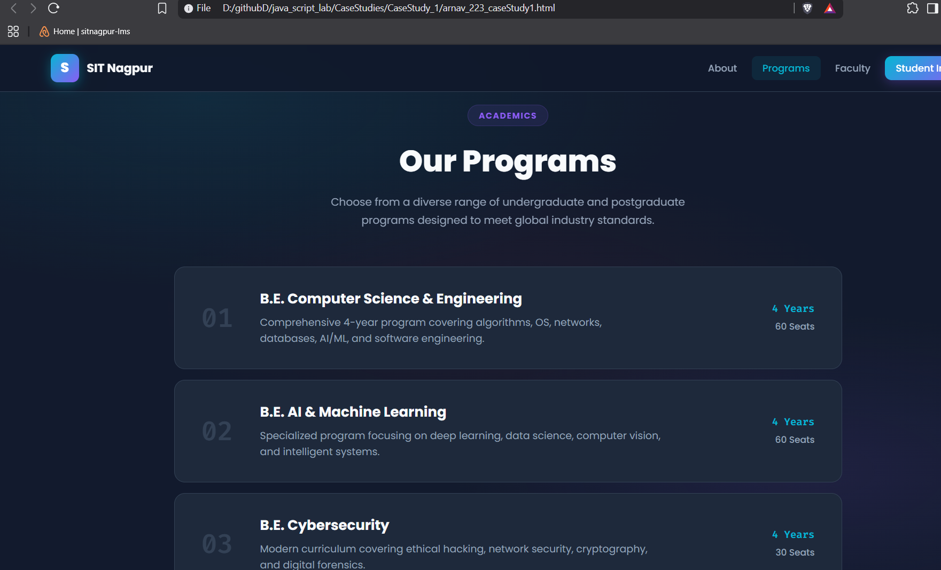

4. Result / Conclusion
The case study was successfully implemented by creating a college department webpage and linking it to a student information page. JavaScript was used to display the welcome message "Welcome to SIT Nagpur" in an alert box. The webpages were designed using HTML and CSS, while JavaScript provided the required interactivity. The objectives of the case study were successfully achieved.

Experiment 2
1. Experiment Title
Use var, let, const, and demonstrate basic features like template literals and destructuring; build a billing calculator with user input.

2. Software/Tools Required
- Visual Studio Code (VS Code)
- Google Chrome / Mozilla Firefox / Microsoft Edge
- HTML5
- CSS3
- JavaScript
- Windows Operating System

3. Experiment Program Code
The experiment consists of the following files:
- index.html
- styles.css
- script.js

<!DOCTYPE html>
<html lang="en">
<head>
<meta charset="utf-8">
<meta name="viewport" content="width=device-width, initial-scale=1.0">
<title>Exp 2: Smart Invoice Terminal</title>
<style>
@import url('https://fonts.googleapis.com/css2?family=Plus+Jakarta+Sans:wght@400;500;600;700&family=Space+Mono&display=swap');

body {
font-family: 'Plus Jakarta Sans', sans-serif;
background-color: #f1f5f9;
margin: 0;
padding: 40px 20px;
display: flex;
justify-content: center;
align-items: center;
min-height: 100vh;
color: #0f172a;
}

.checkout-container {
display: flex;
background: #ffffff;
border-radius: 20px;
box-shadow: 0 20px 40px rgba(0,0,0,0.06);
overflow: hidden;
width: 100%;
max-width: 900px;
border: 1px solid #e2e8f0;
}

/* Left Side: Form */
.form-section {
flex: 1.2;
padding: 40px;
}

.form-section h2 {
margin: 0 0 5px 0;
font-size: 1.6em;
color: #0f172a;
}

.form-section p {
color: #64748b;
font-size: 0.9em;
margin-bottom: 30px;
}

.input-row {
display: flex;
gap: 15px;
margin-bottom: 20px;
}

.input-field {
flex: 1;
}

label {
display: block;
font-size: 0.8em;
font-weight: 700;
text-transform: uppercase;
color: #475569;
margin-bottom: 6px;
letter-spacing: 0.5px;
}

input {
width: 100%;
padding: 12px 15px;
border: 1.5px solid #cbd5e1;
border-radius: 10px;
font-size: 0.95em;
font-family: inherit;
box-sizing: border-box;
transition: all 0.2s;
background: #f8fafc;
}

input:focus {
outline: none;
border-color: #4f46e5;
background: #ffffff;
box-shadow: 0 0 0 4px rgba(79, 70, 229, 0.1);
}

.btn-generate {
background: #4f46e5;
color: white;
border: none;
padding: 15px;
border-radius: 10px;
font-size: 1em;
font-weight: 600;
cursor: pointer;
width: 100%;
margin-top: 10px;
transition: all 0.2s;
box-shadow: 0 4px 12px rgba(79, 70, 229, 0.3);
}

.btn-generate:hover {
background: #4338ca;
transform: translateY(-2px);
}

/* Right Side: Live Receipt Preview */
.receipt-section {
flex: 1;
background: #0f172a;
color: #f8fafc;
padding: 40px;
display: flex;
flex-direction: column;
justify-content: space-between;
position: relative;
}

.receipt-header h3 {
margin: 0;
font-size: 1.2em;
font-family: 'Space Mono', monospace;
color: #818cf8;
letter-spacing: 1px;
}

.receipt-header p {
color: #64748b;
font-size: 0.8em;
margin: 5px 0 0 0;
font-family: 'Space Mono', monospace;
}

.invoice-body {
background: #1e293b;
border: 1px dashed #334155;
border-radius: 12px;
padding: 20px;
margin: 20px 0;
font-family: 'Space Mono', monospace;
font-size: 0.85em;
min-height: 180px;
display: flex;
flex-direction: column;
justify-content: center;
}

.placeholder-text {
text-align: center;
color: #475569;
font-style: italic;
}

.invoice-row {
display: flex;
justify-content: space-between;
margin-bottom: 12px;
color: #cbd5e1;
}

.invoice-divider {
border-top: 1px dashed #475569;
margin: 15px 0;
}

.invoice-total {
display: flex;
justify-content: space-between;
font-size: 1.2em;
font-weight: 700;
color: #38bdf8;
}
</style>
</head>
<body>

<div class="checkout-container">
<!-- Left Column: Input Form -->
<div class="form-section">
<h2>Invoice Terminal</h2>
<p>Enter order items to compute GST and generate a receipt.</p>

<div class="input-field" style="margin-bottom: 20px;">
<label>Customer Name</label>
<input type="text" id="cName" placeholder="e.g., Arnav Band">
</div>

<div class="input-field" style="margin-bottom: 20px;">
<label>Product Description</label>
<input type="text" id="pName" placeholder="e.g., Gaming Mouse">
</div>

<div class="input-row">
<div class="input-field">
<label>Quantity</label>
<input type="number" id="qty" placeholder="0" min="1">
</div>
<div class="input-field">
<label>Unit Price (₹)</label>
<input type="number" id="price" placeholder="0.00" min="1">
</div>
</div>

<button class="btn-generate" onclick="generateInvoice()">Compute & Issue Invoice</button>
</div>

<!-- Right Column: Live Receipt -->
<div class="receipt-section">
<div class="receipt-header">
<h3>// INVOICE_PREVIEW</h3>
<p>STATUS: AWAITING_CALCULATION</p>
</div>

<div class="invoice-body" id="invoiceDisplay">
<div class="placeholder-text">
Fill out the form and click generate to view the invoice summary.
</div>
</div>

<div style="font-size: 0.75em; color: #475569; font-family: 'Space Mono', monospace; text-align: center;">
SYSTEM: ES6 DESTRUCTURING ENGINE ACTIVE
</div>
</div>
</div>

<script>
function generateInvoice() {
const GST_RATE = 0.18;

let customerName = document.getElementById("cName").value;
let productName = document.getElementById("pName").value;
let quantity = Number(document.getElementById("qty").value);
let price = Number(document.getElementById("price").value);

if (!customerName || !productName || quantity <= 0 || price <= 0) {
alert("Please provide valid inputs for all fields.");
return;
}

let total = quantity * price;
let gstAmount = total * GST_RATE;
let finalBill = total + gstAmount;

// JS Object logic
const bill = {
customer: customerName,
product: productName,
quantity,
price,
total,
gstAmount,
finalBill
};

// ES6 Object Destructuring logic
const {
customer,
product,
quantity: qtyVal,
price: priceVal,
gstAmount: gst,
finalBill: amount
} = bill;

// DOM Manipulation
const invoiceHTML = `
<div class="invoice-row"><span>CLIENT:</span> <strong>${customer}</strong></div>
<div class="invoice-row"><span>ITEM:</span> <span>${product}</span></div>
<div class="invoice-row"><span>QTY & PRICE:</span> <span>${qtyVal} x ₹${priceVal.toFixed(2)}</span></div>
<div class="invoice-divider"></div>
<div class="invoice-row"><span>SUBTOTAL:</span> <span>₹${total.toFixed(2)}</span></div>
<div class="invoice-row"><span>GST (18%):</span> <span>₹${gst.toFixed(2)}</span></div>
<div class="invoice-divider"></div>
<div class="invoice-total"><span>TOTAL:</span> <span>₹${amount.toFixed(2)}</span></div>
`;

document.getElementById("invoiceDisplay").innerHTML = invoiceHTML;
}
</script>

</body>
</html>

Output: 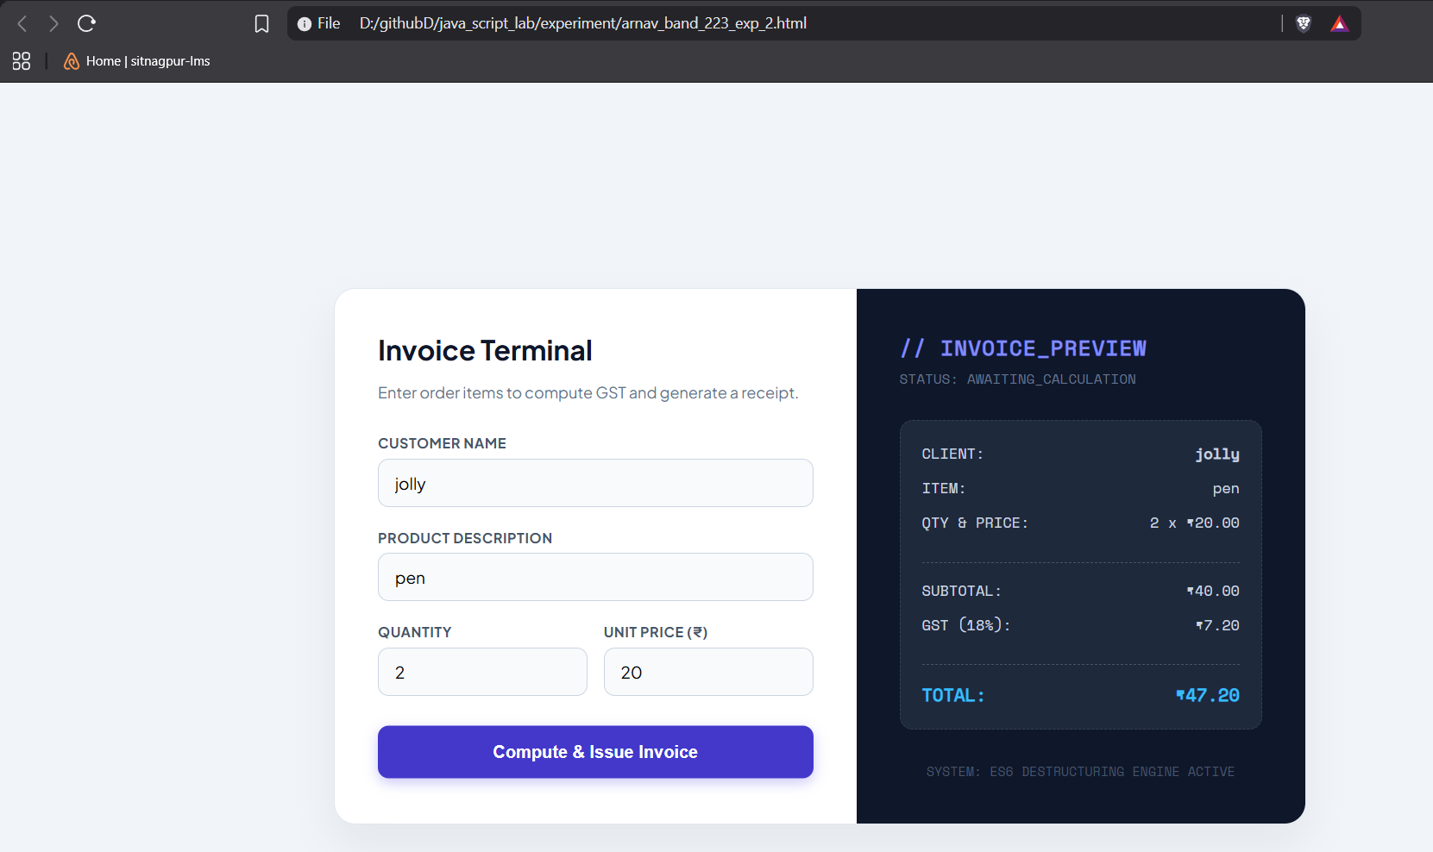

Case Study 2
1. Case Study Title
Develop the webpage for an online shopping website with using HTML CSS and HTML5 tags and calculate the bill.

2. Case Study Program Code
The case study consists of the following files:
• index.html – Displays the Premium Bill Calculator webpage containing a form to input customer and product details for generating an invoice.

• script.js – Processes the form data, performs calculations (like base amount, discount, GST, and final total) by demonstrating various data types and type coercions, and dynamically updates the invoice summary on the webpage.

• style.css – Contains the styling rules for the layout, typography, and visual elements of the bill calculator application.

Output:
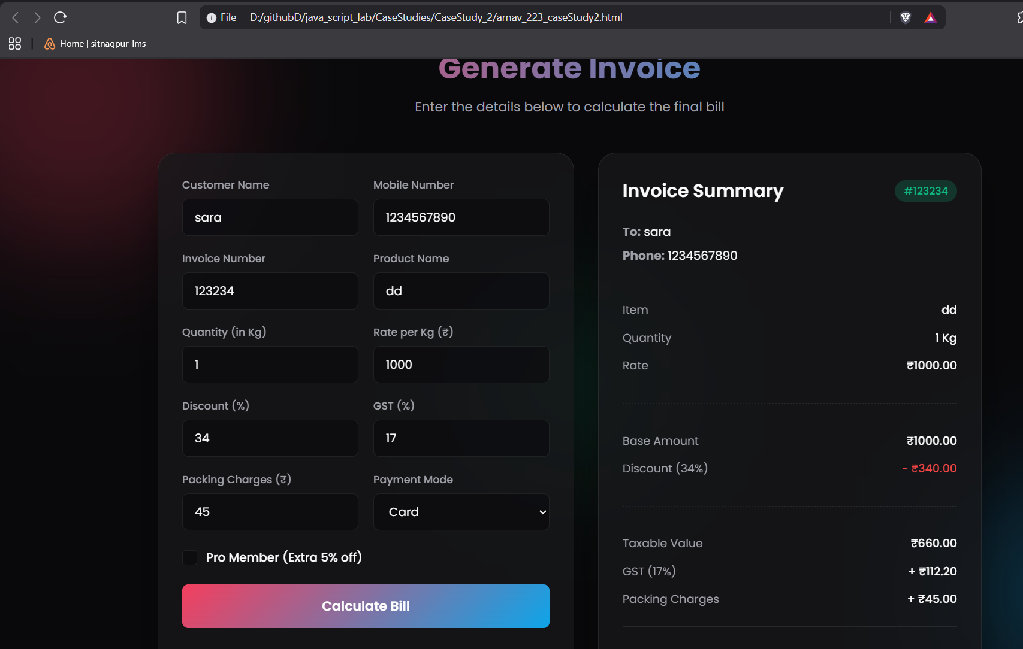

Result/Conclusion:
Hence, we have successfully developed the Premium Bill Calculator webpage. Through this case study, we practically learned how to declare variables using var, let, and const, utilize various primitive data types (such as strings, numbers, and booleans), and perform type coercion and explicit type conversions in JavaScript to compute the final bill amount and dynamically display the generated invoice.

Experiment 3
1. Experiment Title
Implement control structures and form validation; create a grading system based on user-entered marks.

2. Software/Tools Required
- Visual Studio Code (VS Code)
- Google Chrome / Mozilla Firefox / Microsoft Edge
- HTML5
- CSS3
- JavaScript
- Windows Operating System

3. Experiment Program Code
The experiment consists of the following files:
- jashchauhan_242.html
- styles.css
- script.js

<!DOCTYPE html>
<html lang="en">
<head>
<meta charset="UTF-8">
<meta name="viewport" content="width=device-width, initial-scale=1.0">
<title>Exp 3: Academic Analytics Portal</title>
<style>
@import url('https://fonts.googleapis.com/css2?family=Outfit:wght@400;500;600;700&display=swap');

body {
font-family: 'Outfit', sans-serif;
background-color: #f8fafc;
color: #1e293b;
margin: 0;
padding: 40px 20px;
}

.portal-container {
max-width: 1000px;
margin: 0 auto;
}

.portal-header {
display: flex;
justify-content: space-between;
align-items: center;
margin-bottom: 30px;
border-bottom: 2px solid #e2e8f0;
padding-bottom: 20px;
}

.portal-header h1 {
margin: 0;
font-size: 1.8em;
color: #0f172a;
}

.portal-header span {
background: #e0f2fe;
color: #0369a1;
padding: 6px 14px;
border-radius: 20px;
font-size: 0.85em;
font-weight: 600;
}

/* Top KPI Metric Cards */
.metrics-grid {
display: grid;
grid-template-columns: repeat(4, 1fr);
gap: 15px;
margin-bottom: 30px;
}

.metric-card {
background: #ffffff;
border: 1px solid #e2e8f0;
border-radius: 14px;
padding: 20px;
box-shadow: 0 4px 6px -1px rgba(0,0,0,0.02);
text-align: center;
}

.metric-label {
font-size: 0.8em;
color: #64748b;
text-transform: uppercase;
letter-spacing: 0.5px;
margin-bottom: 8px;
font-weight: 600;
}

.metric-value {
font-size: 1.8em;
font-weight: 700;
color: #0f172a;
}

/* Form Area */
.panel {
background: #ffffff;
border: 1px solid #e2e8f0;
border-radius: 16px;
padding: 30px;
margin-bottom: 30px;
box-shadow: 0 10px 15px -3px rgba(0,0,0,0.03);
}

.panel h3 {
margin: 0 0 20px 0;
font-size: 1.1em;
color: #334155;
}

.input-grid {
display: grid;
grid-template-columns: repeat(auto-fit, minmax(160px, 1fr));
gap: 15px;
margin-bottom: 25px;
}

.field label {
display: block;
font-size: 0.8em;
font-weight: 600;
color: #475569;
margin-bottom: 6px;
}

.field input {
width: 100%;
padding: 10px 12px;
border: 1.5px solid #cbd5e1;
border-radius: 8px;
font-size: 0.95em;
font-family: inherit;
box-sizing: border-box;
outline: none;
}

.field input:focus {
border-color: #0284c7;
box-shadow: 0 0 0 3px rgba(2, 132, 199, 0.1);
}

.btn-action {
background: #0284c7;
color: white;
border: none;
padding: 12px 25px;
border-radius: 8px;
font-weight: 600;
cursor: pointer;
transition: background 0.2s;
}

.btn-action:hover {
background: #0369a1;
}

/* Analytics Table */
table {
width: 100%;
border-collapse: collapse;
margin-top: 10px;
}

th {
text-align: left;
padding: 12px;
font-size: 0.8em;
text-transform: uppercase;
color: #64748b;
border-bottom: 2px solid #e2e8f0;
}

td {
padding: 14px 12px;
border-bottom: 1px solid #f1f5f9;
font-size: 0.95em;
}

.status-pill {
padding: 4px 10px;
border-radius: 12px;
font-size: 0.8em;
font-weight: 600;
}

.pill-pass {
background: #dcfce7;
color: #166534;
}

.pill-fail {
background: #fee2e2;
color: #991b1b;
}

#analyticsPanel {
display: none;
}
</style>
</head>
<body>

<div class="portal-container">
<div class="portal-header">
<h1>Academic Analytics Portal</h1>
<span>EXP_03 :: CONTROL STRUCTURES</span>
</div>

<!-- Metric KPI Cards -->
<div class="metrics-grid">
<div class="metric-card">
<div class="metric-label">Total Score</div>
<div class="metric-value" id="kpiTotal">--/500</div>
</div>
<div class="metric-card">
<div class="metric-label">Percentage</div>
<div class="metric-value" id="kpiPerc">0.0%</div>
</div>
<div class="metric-card">
<div class="metric-label">Grade Assigned</div>
<div class="metric-value" id="kpiGrade" style="color: #0284c7;">--</div>
</div>
<div class="metric-card">
<div class="metric-label">Final Status</div>
<div class="metric-value" id="kpiStatus">--</div>
</div>
</div>

<!-- Input Form -->
<div class="panel">
<h3>Enter Student Evaluation Data</h3>

<div class="input-grid" style="grid-template-columns: 2fr 1fr; margin-bottom: 15px;">
<div class="field">
<label>Student Name</label>
<input type="text" id="sName" placeholder="e.g. Arnav band">
</div>
<div class="field">
<label>Roll Number</label>
<input type="text" id="rNo" placeholder="e.g. 223">
</div>
</div>

<div class="input-grid">
<div class="field">
<label>Maths</label>
<input type="number" class="sub-mark" min="0" max="100">
</div>
<div class="field">
<label>JavaScript</label>
<input type="number" class="sub-mark" min="0" max="100">
</div>
<div class="field">
<label>Python</label>
<input type="number" class="sub-mark" min="0" max="100">
</div>
<div class="field">
<label>Physics</label>
<input type="number" class="sub-mark" min="0" max="100">
</div>
<div class="field">
<label>C Language</label>
<input type="number" class="sub-mark" min="0" max="100">
</div>
</div>

<button class="btn-action" onclick="runAnalytics()">Compute Evaluation</button>
</div>

<!-- Analytical Breakdown Table -->
<div class="panel" id="analyticsPanel">
<h3>Subject Performance Breakdown</h3>
<table>
<thead>
<tr>
<th>Subject Name</th>
<th>Marks Obtained</th>
<th>Max Marks</th>
<th>Evaluation Status</th>
</tr>
</thead>
<tbody id="breakdownBody">
<!-- Dynamic Rows -->
</tbody>
</table>
</div>
</div>

<script>
function runAnalytics() {
const name = document.getElementById('sName').value;
const roll = document.getElementById('rNo').value;
const inputs = document.querySelectorAll('.sub-mark');
const subjects = ['Maths', 'JavaScript', 'Python', 'Physics', 'C Language'];

// Concept: if-else (Form Validation)
if (!name.trim() || !roll.trim()) {
alert("Please input both Student Name and Roll Number.");
return;
}

let total = 0;
let hasFailed = false;
let marks = [];

// Concept: for loop (Scoping & Validation)
for (let i = 0; i < inputs.length; i++) {
let val = Number(inputs[i].value);
if (inputs[i].value === "" || val < 0 || val > 100) {
alert(`Invalid mark entry for ${subjects[i]}. Must be between 0 and 100.`);
return;
}
marks.push(val);
total += val;
if (val < 35) hasFailed = true;
}

let percentage = (total / 500) * 100;
let grade = "";

// Concept: switch statement (Grading Logic)
switch (true) {
case (percentage >= 90): grade = "O (Outst.)"; break;
case (percentage >= 80): grade = "A+"; break;
case (percentage >= 70): grade = "A"; break;
case (percentage >= 60): grade = "B+"; break;
case (percentage >= 50): grade = "B"; break;
case (percentage >= 35): grade = "C"; break;
default: grade = "F"; break;
}

if (hasFailed) grade = "F (Backlog)";
let finalStatus = hasFailed ? "FAIL" : "PASS";

// Concept: while loop (Counting Distinctions)
let distinctions = 0;
let idx = 0;
while (idx < marks.length) {
if (marks[idx] >= 75) distinctions++;
idx++;
}
console.log(`[SYSTEM LOG]: Student achieved distinction in ${distinctions} subject(s).`);

// DOM Update: KPI Cards
document.getElementById('kpiTotal').innerText = `${total}/500`;
document.getElementById('kpiPerc').innerText = `${percentage.toFixed(1)}%`;
document.getElementById('kpiGrade').innerText = grade;

const statusCard = document.getElementById('kpiStatus');
statusCard.innerText = finalStatus;
statusCard.style.color = hasFailed ? "#ef4444" : "#16a34a";

// DOM Update: Table Rows
let tableHTML = "";
for (let i = 0; i < subjects.length; i++) {
let isPass = marks[i] >= 35;
tableHTML += `
<tr>
<td style="font-weight: 600;">${subjects[i]}</td>
<td>${marks[i]}</td>
<td>100</td>
<td><span class="status-pill ${isPass ? 'pill-pass' : 'pill-fail'}">${isPass ? 'PASS' : 'FAIL'}</span></td>
</tr>
`;
}
document.getElementById('breakdownBody').innerHTML = tableHTML;
document.getElementById('analyticsPanel').style.display = 'block';
}
</script>

</body>
</html>
Output:
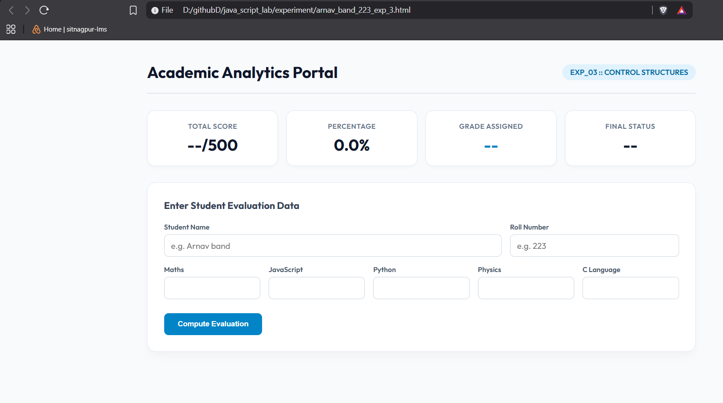

Case Study 3
1. Case Study Title
Write a Javascript program that accepts students marks and displays the scholarship category.

2. Case Study Program Code
The case study consists of the following files:

• jashchauhan_242.html – Displays the Scholarship Eligibility Checker webpage, containing an input form for students to enter their marks and a section outlining the various scholarship criteria.

• script.js – Processes the entered marks, validates the input, and utilizes if-else conditional statements to determine the corresponding scholarship category (Not Eligible, Bronze, Silver, Gold, Platinum). It dynamically updates the UI to show the correct result and corresponding custom SVG icon.

• style.css – Contains the styling rules for the layout, typography, animations, and overall visual presentation of the eligibility checker application.

<!DOCTYPE html>
<html lang="en">
<head>
<meta charset="UTF-8">
<meta name="viewport" content="width=device-width, initial-scale=1.0">
<meta name="description" content="Scholarship Eligibility Checker - Enter your marks to find your scholarship category">
<title>Scholarship Eligibility Checker</title>

<!-- Updated Font: Montserrat -->
<link rel="preconnect" href="https://fonts.googleapis.com">
<link rel="preconnect" href="https://fonts.gstatic.com" crossorigin>
<link href="https://fonts.googleapis.com/css2?family=Montserrat:wght@400;500;600;700;800&display=swap" rel="stylesheet">

<style>
/* ===== Reset & Base ===== */
*,
*::before,
*::after {
margin: 0;
padding: 0;
box-sizing: border-box;
}

:root {
/* Updated Color Palette */
--bg-primary: #0f172a; /* Deep Slate */
--bg-card: rgba(30, 41, 59, 0.5); /* Transparent Slate */
--bg-card-hover: rgba(30, 41, 59, 0.8);
--text-primary: #f8fafc;
--text-secondary: #94a3b8;
--border-color: rgba(148, 163, 184, 0.15);
--white: #ffffff;
--primary-accent: #3b82f6; /* Vibrant Blue */
--shadow-glow: 0 10px 40px rgba(0, 0, 0, 0.3);

/* Scholarship tier colors */
--not-eligible: #f43f5e;
--bronze: #d97706;
--silver: #94a3b8;
--gold: #fbbf24;
--platinum: #e2e8f0;
}

body {
font-family: 'Montserrat', system-ui, -apple-system, sans-serif;
background-color: var(--bg-primary);
color: var(--text-primary);
min-height: 100vh;
display: flex;
justify-content: center;
align-items: flex-start;
padding: 40px 20px;
overflow-x: hidden;
position: relative;
}

/* ===== Colorful Background Glow ===== */
.background-orbs {
position: fixed;
inset: 0;
overflow: hidden;
pointer-events: none;
z-index: 0;
}

.orb {
position: absolute;
border-radius: 50%;
filter: blur(100px);
opacity: 0.15;
animation: float 24s ease-in-out infinite;
}

.orb-1 {
width: 500px;
height: 500px;
top: -10%;
right: -10%;
background: linear-gradient(135deg, #3b82f6, #8b5cf6); /* Blue to Purple */
}

.orb-2 {
width: 400px;
height: 400px;
bottom: -5%;
left: -5%;
background: linear-gradient(135deg, #ec4899, #f43f5e); /* Pink to Rose */
animation-delay: -8s;
}

.orb-3 {
width: 300px;
height: 300px;
top: 40%;
left: 50%;
background: linear-gradient(135deg, #10b981, #3b82f6); /* Emerald to Blue */
animation-delay: -16s;
}

@keyframes float {
0%, 100% { transform: translate(0, 0) scale(1); }
25% { transform: translate(40px, -30px) scale(1.05); }
50% { transform: translate(-20px, 20px) scale(0.95); }
75% { transform: translate(30px, 40px) scale(1.03); }
}

/* ===== Container ===== */
.container {
position: relative;
z-index: 1;
width: 100%;
max-width: 600px;
}

/* ===== Header ===== */
.header {
text-align: center;
margin-bottom: 32px;
}

.logo {
display: flex;
align-items: center;
justify-content: center;
gap: 14px;
margin-bottom: 10px;
}

.logo-icon {
display: flex;
align-items: center;
animation: bounce 2.5s ease-in-out infinite;
}

.logo-icon svg {
width: 42px;
height: 42px;
}

@keyframes bounce {
0%, 100% { transform: translateY(0); }
50% { transform: translateY(-5px); }
}

.header h1 {
font-size: 2rem;
font-weight: 800;
color: var(--white);
letter-spacing: -0.03em;
}

.subtitle {
color: var(--text-secondary);
font-size: 0.95rem;
font-weight: 500;
}

/* ===== Main Card ===== */
.main-card {
background: var(--bg-card);
border: 1px solid var(--border-color);
border-radius: 20px;
padding: 36px 32px;
backdrop-filter: blur(20px);
-webkit-backdrop-filter: blur(20px);
box-shadow: var(--shadow-glow);
margin-bottom: 28px;
}

/* ===== Input Section ===== */
.input-section {
display: flex;
flex-direction: column;
gap: 16px;
}

.input-label {
font-size: 0.8rem;
font-weight: 700;
text-transform: uppercase;
letter-spacing: 0.1em;
color: var(--text-secondary);
}

.input-wrapper {
position: relative;
display: flex;
align-items: center;
}

.input-wrapper input {
width: 100%;
padding: 16px 80px 16px 20px;
font-size: 1.6rem;
font-weight: 700;
font-family: 'Montserrat', sans-serif;
color: var(--text-primary);
background: rgba(15, 23, 42, 0.6);
border: 2px solid var(--border-color);
border-radius: 14px;
outline: none;
transition: border-color 0.3s ease, box-shadow 0.3s ease;
-moz-appearance: textfield;
}

.input-wrapper input::-webkit-outer-spin-button,
.input-wrapper input::-webkit-inner-spin-button {
-webkit-appearance: none;
margin: 0;
}

.input-wrapper input::placeholder {
color: rgba(255, 255, 255, 0.15);
font-weight: 600;
}

.input-wrapper input:focus {
border-color: var(--primary-accent);
box-shadow: 0 0 0 4px rgba(59, 130, 246, 0.2);
}

.input-suffix {
position: absolute;
right: 20px;
color: var(--text-secondary);
font-size: 1.1rem;
font-weight: 600;
pointer-events: none;
}

/* ===== Button ===== */
#checkBtn {
display: flex;
align-items: center;
justify-content: center;
gap: 10px;
width: 100%;
padding: 16px;
font-size: 1.05rem;
font-weight: 700;
font-family: 'Montserrat', sans-serif;
color: var(--white);
background: linear-gradient(135deg, #3b82f6, #2563eb);
border: none;
border-radius: 14px;
cursor: pointer;
transition: transform 0.2s ease, box-shadow 0.2s ease;
}

#checkBtn:hover {
transform: translateY(-2px);
box-shadow: 0 8px 25px rgba(59, 130, 246, 0.4);
}

#checkBtn:active {
transform: translateY(0);
}

/* ===== Result Section ===== */
.result-section {
margin-top: 28px;
display: none;
}

.result-section.visible {
display: block;
animation: slideUp 0.5s cubic-bezier(0.16, 1, 0.3, 1);
}

@keyframes slideUp {
from { opacity: 0; transform: translateY(20px); }
to { opacity: 1; transform: translateY(0); }
}

.result-card {
text-align: center;
padding: 32px 24px;
border-radius: 16px;
border: 1px solid var(--border-color);
background: rgba(15, 23, 42, 0.4);
position: relative;
overflow: hidden;
}

.result-card::before {
content: '';
position: absolute;
top: 0;
left: 0;
right: 0;
height: 4px;
}

.result-card.not-eligible::before { background: var(--not-eligible); }
.result-card.bronze::before { background: var(--bronze); }
.result-card.silver::before { background: var(--silver); }
.result-card.gold::before { background: var(--gold); }
.result-card.platinum::before { background: var(--platinum); }

.result-icon {
margin-bottom: 16px;
display: flex;
justify-content: center;
animation: popIn 0.4s cubic-bezier(0.16, 1, 0.3, 1) 0.15s both;
}

.result-icon svg {
width: 64px;
height: 64px;
}

@keyframes popIn {
from { opacity: 0; transform: scale(0.5); }
to { opacity: 1; transform: scale(1); }
}

.result-title {
font-size: 1.5rem;
font-weight: 800;
margin-bottom: 6px;
letter-spacing: -0.01em;
}

.result-card.not-eligible .result-title { color: var(--not-eligible); }
.result-card.bronze .result-title { color: var(--bronze); }
.result-card.silver .result-title { color: var(--silver); }
.result-card.gold .result-title { color: var(--gold); }
.result-card.platinum .result-title { color: var(--platinum); }

.result-marks {
font-size: 1rem;
color: var(--text-secondary);
margin-bottom: 8px;
font-weight: 600;
}

.result-message {
font-size: 0.95rem;
color: var(--text-primary);
line-height: 1.5;
font-weight: 500;
}

/* ===== Criteria Section ===== */
.criteria-section {
margin-bottom: 40px;
}

.criteria-heading {
font-size: 0.85rem;
font-weight: 700;
text-transform: uppercase;
letter-spacing: 0.1em;
color: var(--text-secondary);
margin-bottom: 16px;
text-align: center;
}

.criteria-grid {
display: flex;
flex-direction: column;
gap: 8px;
}

.criteria-item {
display: flex;
align-items: center;
gap: 14px;
padding: 14px 20px;
background: var(--bg-card);
border: 1px solid var(--border-color);
border-radius: 12px;
backdrop-filter: blur(10px);
transition: transform 0.2s ease, background 0.2s ease;
position: relative;
overflow: hidden;
}

.criteria-item:hover {
transform: translateX(4px);
background: var(--bg-card-hover);
}

.criteria-bar {
position: absolute;
left: 0;
top: 0;
bottom: 0;
width: 4px;
}

.criteria-item.not-eligible .criteria-bar { background: var(--not-eligible); }
.criteria-item.bronze .criteria-bar { background: var(--bronze); }
.criteria-item.silver .criteria-bar { background: var(--silver); }
.criteria-item.gold .criteria-bar { background: var(--gold); }
.criteria-item.platinum .criteria-bar { background: var(--platinum); }

.criteria-icon {
display: flex;
align-items: center;
flex-shrink: 0;
}

.criteria-icon svg {
width: 24px;
height: 24px;
}

.criteria-range {
font-size: 0.95rem;
font-weight: 700;
color: var(--text-primary);
min-width: 80px;
}

.criteria-label {
font-size: 0.9rem;
font-weight: 600;
}

.criteria-item.not-eligible .criteria-label { color: var(--not-eligible); }
.criteria-item.bronze .criteria-label { color: var(--bronze); }
.criteria-item.silver .criteria-label { color: var(--silver); }
.criteria-item.gold .criteria-label { color: var(--gold); }
.criteria-item.platinum .criteria-label { color: var(--platinum); }

/* ===== Shake Animation ===== */
@keyframes shake {
0%, 100% { transform: translateX(0); }
20% { transform: translateX(-8px); }
40% { transform: translateX(8px); }
60% { transform: translateX(-4px); }
80% { transform: translateX(4px); }
}

.shake {
animation: shake 0.4s ease;
}

/* ===== Responsive ===== */
@media (max-width: 480px) {
body { padding: 24px 16px; }
.header h1 { font-size: 1.5rem; }
.main-card { padding: 28px 20px; border-radius: 16px; }
.input-wrapper input { font-size: 1.3rem; padding: 14px 70px 14px 16px; }
.result-icon svg { width: 48px; height: 48px; }
.result-title { font-size: 1.3rem; }
}
</style>
</head>
<body>
<div class="background-orbs">
<div class="orb orb-1"></div>
<div class="orb orb-2"></div>
<div class="orb orb-3"></div>
</div>

<div class="container">
<header class="header">
<div class="logo">
<span class="logo-icon">
<!-- Graduation Cap -->
<svg viewBox="0 0 48 48" fill="none" xmlns="http://www.w3.org/2000/svg">
<path d="M24 6L2 18L24 30L46 18L24 6Z" fill="#e8e8ed" stroke="#ffffff" stroke-width="1"/>
<path d="M12 24V36L24 42L36 36V24L24 30L12 24Z" fill="#b0b0be" stroke="#d0d0d8" stroke-width="0.5"/>
<line x1="40" y1="18" x2="40" y2="38" stroke="#d0d0d8" stroke-width="1.5" stroke-linecap="round"/>
<path d="M37 38C37 36.3 38.3 35 40 35C41.7 35 43 36.3 43 38C43 39.7 41.7 42 40 42C38.3 42 37 39.7 37 38Z" fill="#d0d0d8"/>
</svg>
</span>
<h1>Scholarship Eligibility</h1>
</div>
<p class="subtitle">Enter your marks to discover your scholarship category</p>
</header>

<main class="main-card" id="mainCard">
<div class="input-section">
<label for="marksInput" class="input-label">Enter Your Marks</label>
<div class="input-wrapper">
<input
type="number"
id="marksInput"
min="0"
max="100"
placeholder="0 – 100"
autocomplete="off"
>
<span class="input-suffix">/ 100</span>
</div>
<button id="checkBtn" onclick="checkScholarship()">
<span>Check Eligibility</span>
<svg width="20" height="20" viewBox="0 0 24 24" fill="none" stroke="currentColor" stroke-width="2.5" stroke-linecap="round" stroke-linejoin="round">
<path d="M5 12h14M12 5l7 7-7 7"/>
</svg>
</button>
</div>

<div class="result-section" id="resultSection">
<div class="result-card" id="resultCard">
<div class="result-icon" id="resultIcon"></div>
<h2 class="result-title" id="resultTitle"></h2>
<p class="result-marks" id="resultMarks"></p>
<p class="result-message" id="resultMessage"></p>
</div>
</div>
</main>

<section class="criteria-section">
<h2 class="criteria-heading">Scholarship Criteria</h2>
<div class="criteria-grid">
<div class="criteria-item not-eligible">
<div class="criteria-bar"></div>
<div class="criteria-icon">
<!-- Shield with X -->
<svg viewBox="0 0 24 24" fill="none" xmlns="http://www.w3.org/2000/svg">
<path d="M12 2L4 6V12C4 16.42 7.4 20.56 12 22C16.6 20.56 20 16.42 20 12V6L12 2Z" fill="#2a1215" stroke="#ef4444" stroke-width="1.5"/>
<path d="M9.5 9.5L14.5 14.5M14.5 9.5L9.5 14.5" stroke="#ef4444" stroke-width="2" stroke-linecap="round"/>
</svg>
</div>
<div class="criteria-range">Below 50</div>
<div class="criteria-label">Not Eligible</div>
</div>
<div class="criteria-item bronze">
<div class="criteria-bar"></div>
<div class="criteria-icon">
<!-- Bronze Medal -->
<svg viewBox="0 0 24 24" fill="none" xmlns="http://www.w3.org/2000/svg">
<path d="M8 2H16L14.5 7H9.5L8 2Z" fill="#a0522d"/>
<path d="M10 2L8 7" stroke="#8b4513" stroke-width="0.5"/>
<path d="M14 2L16 7" stroke="#8b4513" stroke-width="0.5"/>
<circle cx="12" cy="14.5" r="7" fill="#cd7f32" stroke="#a0622a" stroke-width="0.8"/>
<circle cx="12" cy="14.5" r="5.2" fill="none" stroke="#daa06d" stroke-width="0.6"/>
<path d="M10 13L11.5 15L14.5 11.5" stroke="#fff" stroke-width="1.5" stroke-linecap="round" stroke-linejoin="round"/>
</svg>
</div>
<div class="criteria-range">50 – 69</div>
<div class="criteria-label">Bronze</div>
</div>
<div class="criteria-item silver">
<div class="criteria-bar"></div>
<div class="criteria-icon">
<!-- Silver Medal -->
<svg viewBox="0 0 24 24" fill="none" xmlns="http://www.w3.org/2000/svg">
<path d="M8 2H16L14.5 7H9.5L8 2Z" fill="#8a8a98"/>
<path d="M10 2L8 7" stroke="#707080" stroke-width="0.5"/>
<path d="M14 2L16 7" stroke="#707080" stroke-width="0.5"/>
<circle cx="12" cy="14.5" r="7" fill="#c0c0c0" stroke="#a8a8b0" stroke-width="0.8"/>
<circle cx="12" cy="14.5" r="5.2" fill="none" stroke="#d8d8e0" stroke-width="0.6"/>
<path d="M10 13L11.5 15L14.5 11.5" stroke="#fff" stroke-width="1.5" stroke-linecap="round" stroke-linejoin="round"/>
</svg>
</div>
<div class="criteria-range">70 – 84</div>
<div class="criteria-label">Silver</div>
</div>
<div class="criteria-item gold">
<div class="criteria-bar"></div>
<div class="criteria-icon">
<!-- Gold Medal -->
<svg viewBox="0 0 24 24" fill="none" xmlns="http://www.w3.org/2000/svg">
<path d="M8 2H16L14.5 7H9.5L8 2Z" fill="#daa520"/>
<path d="M10 2L8 7" stroke="#b8860b" stroke-width="0.5"/>
<path d="M14 2L16 7" stroke="#b8860b" stroke-width="0.5"/>
<circle cx="12" cy="14.5" r="7" fill="#ffd700" stroke="#daa520" stroke-width="0.8"/>
<circle cx="12" cy="14.5" r="5.2" fill="none" stroke="#ffe44d" stroke-width="0.6"/>
<path d="M10 13L11.5 15L14.5 11.5" stroke="#fff" stroke-width="1.5" stroke-linecap="round" stroke-linejoin="round"/>
</svg>
</div>
<div class="criteria-range">85 – 94</div>
<div class="criteria-label">Gold</div>
</div>
<div class="criteria-item platinum">
<div class="criteria-bar"></div>
<div class="criteria-icon">
<!-- Diamond/Trophy -->
<svg viewBox="0 0 24 24" fill="none" xmlns="http://www.w3.org/2000/svg">
<path d="M5 4H19L21 8L12 20L3 8L5 4Z" fill="#e5e4e2" stroke="#c8c8c6" stroke-width="0.8"/>
<path d="M3 8H21" stroke="#d0d0ce" stroke-width="0.6"/>
<path d="M12 20L8.5 8L10 4" stroke="#c8c8c6" stroke-width="0.5"/>
<path d="M12 20L15.5 8L14 4" stroke="#c8c8c6" stroke-width="0.5"/>
<path d="M8.5 8L10 4H14L15.5 8" fill="#f0efed" stroke="none"/>
</svg>
</div>
<div class="criteria-range">95 – 100</div>
<div class="criteria-label">Platinum</div>
</div>
</div>
</section>
</div>

<script>
// Scholarship Eligibility Checker
// Detailed custom SVG icons for each scholarship tier
const ICONS = {
'not-eligible': `
<svg viewBox="0 0 64 64" fill="none" xmlns="http://www.w3.org/2000/svg">
<!-- Shield body -->
<path d="M32 4L8 16V32C8 44.84 18.8 56.12 32 60C45.2 56.12 56 44.84 56 32V16L32 4Z" fill="#2a1215" stroke="#ef4444" stroke-width="2.5"/>
<!-- Inner shield highlight -->
<path d="M32 10L14 19V32C14 42.2 22.4 51.2 32 54.4C41.6 51.2 50 42.2 50 32V19L32 10Z" fill="#1f0a0d" stroke="#ef4444" stroke-width="0.5" opacity="0.4"/>
<!-- X mark -->
<path d="M23 23L41 41" stroke="#ef4444" stroke-width="4.5" stroke-linecap="round"/>
<path d="M41 23L23 41" stroke="#ef4444" stroke-width="4.5" stroke-linecap="round"/>
<!-- Corner accents -->
<circle cx="32" cy="14" r="1.5" fill="#ef4444" opacity="0.5"/>
</svg>`,

'bronze': `
<svg viewBox="0 0 64 64" fill="none" xmlns="http://www.w3.org/2000/svg">
<!-- Ribbon -->
<path d="M22 4H42L38 18H26L22 4Z" fill="#a0522d"/>
<path d="M26 4L22 18" stroke="#8b4513" stroke-width="0.8"/>
<path d="M32 4V18" stroke="#8b4513" stroke-width="0.5" opacity="0.4"/>
<path d="M38 4L42 18" stroke="#8b4513" stroke-width="0.8"/>
<!-- Medal body -->
<circle cx="32" cy="38" r="20" fill="#cd7f32" stroke="#a0622a" stroke-width="2"/>
<!-- Inner ring -->
<circle cx="32" cy="38" r="15" fill="none" stroke="#daa06d" stroke-width="1.2"/>
<!-- Star in center -->
<polygon points="32,25 35,33 43,33 37,38 39,46 32,42 25,46 27,38 21,33 29,33" fill="#e8a848" stroke="#b8762a" stroke-width="0.5"/>
<!-- Shine -->
<path d="M22 28C24 24 28 22 32 22" stroke="#e8c088" stroke-width="1" stroke-linecap="round" opacity="0.6"/>
</svg>`,

'silver': `
<svg viewBox="0 0 64 64" fill="none" xmlns="http://www.w3.org/2000/svg">
<!-- Ribbon -->
<path d="M22 4H42L38 18H26L22 4Z" fill="#8a8a98"/>
<path d="M26 4L22 18" stroke="#707080" stroke-width="0.8"/>
<path d="M32 4V18" stroke="#707080" stroke-width="0.5" opacity="0.4"/>
<path d="M38 4L42 18" stroke="#707080" stroke-width="0.8"/>
<!-- Medal body -->
<circle cx="32" cy="38" r="20" fill="#c0c0c0" stroke="#a8a8b0" stroke-width="2"/>
<!-- Inner ring -->
<circle cx="32" cy="38" r="15" fill="none" stroke="#d8d8e0" stroke-width="1.2"/>
<!-- Star in center -->
<polygon points="32,25 35,33 43,33 37,38 39,46 32,42 25,46 27,38 21,33 29,33" fill="#d8d8e0" stroke="#a0a0a8" stroke-width="0.5"/>
<!-- Shine -->
<path d="M22 28C24 24 28 22 32 22" stroke="#e8e8f0" stroke-width="1" stroke-linecap="round" opacity="0.7"/>
</svg>`,

'gold': `
<svg viewBox="0 0 64 64" fill="none" xmlns="http://www.w3.org/2000/svg">
<!-- Ribbon -->
<path d="M22 4H42L38 18H26L22 4Z" fill="#daa520"/>
<path d="M26 4L22 18" stroke="#b8860b" stroke-width="0.8"/>
<path d="M32 4V18" stroke="#b8860b" stroke-width="0.5" opacity="0.4"/>
<path d="M38 4L42 18" stroke="#b8860b" stroke-width="0.8"/>
<!-- Medal body -->
<circle cx="32" cy="38" r="20" fill="#ffd700" stroke="#daa520" stroke-width="2"/>
<!-- Inner ring -->
<circle cx="32" cy="38" r="15" fill="none" stroke="#ffe44d" stroke-width="1.2"/>
<!-- Star in center -->
<polygon points="32,25 35,33 43,33 37,38 39,46 32,42 25,46 27,38 21,33 29,33" fill="#ffe866" stroke="#d4a800" stroke-width="0.5"/>
<!-- Shine -->
<path d="M22 28C24 24 28 22 32 22" stroke="#fff4a0" stroke-width="1" stroke-linecap="round" opacity="0.8"/>
</svg>`,

'platinum': `
<svg viewBox="0 0 64 64" fill="none" xmlns="http://www.w3.org/2000/svg">
<!-- Diamond top facets -->
<path d="M12 20H52L32 56L12 20Z" fill="#e5e4e2" stroke="#c8c8c6" stroke-width="1.5"/>
<!-- Top edge -->
<path d="M8 20L16 8H48L56 20H8Z" fill="#f0efed" stroke="#d0d0ce" stroke-width="1"/>
<!-- Center facets -->
<path d="M8 20L32 56L24 20Z" fill="#d8d7d5"/>
<path d="M56 20L32 56L40 20Z" fill="#d8d7d5"/>
<!-- Top inner facets -->
<path d="M16 8L24 20H8Z" fill="#e0dfdd"/>
<path d="M48 8L40 20H56Z" fill="#e0dfdd"/>
<path d="M16 8H48L40 20H24Z" fill="#f5f4f2"/>
<!-- Center vertical line -->
<path d="M32 56L32 20" stroke="#c8c8c6" stroke-width="0.6"/>
<path d="M32 20L16 8" stroke="#c8c8c6" stroke-width="0.5"/>
<path d="M32 20L48 8" stroke="#c8c8c6" stroke-width="0.5"/>
<!-- Sparkle highlights -->
<circle cx="28" cy="16" r="1" fill="#fff" opacity="0.8"/>
<circle cx="38" cy="14" r="0.7" fill="#fff" opacity="0.6"/>
<path d="M20 26L22 24" stroke="#fff" stroke-width="0.8" stroke-linecap="round" opacity="0.5"/>
</svg>`
};

function checkScholarship() {
const input = document.getElementById('marksInput');
const resultSection = document.getElementById('resultSection');
const resultCard = document.getElementById('resultCard');
const resultIcon = document.getElementById('resultIcon');
const resultTitle = document.getElementById('resultTitle');
const resultMarks = document.getElementById('resultMarks');
const resultMessage = document.getElementById('resultMessage');

const marks = parseFloat(input.value);

// Validate input
if (isNaN(marks) || marks < 0 || marks > 100) {
input.classList.add('shake');
setTimeout(() => input.classList.remove('shake'), 400);
resultSection.classList.remove('visible');
alert('Please enter valid marks between 0 and 100.');
return;
}

let category, message, cssClass;

if (marks < 50) {
category = 'Not Eligible';
message = 'Score below 50. Keep working hard — you can improve!';
cssClass = 'not-eligible';
} else if (marks >= 50 && marks <= 69) {
category = 'Bronze Scholarship';
message = 'Great start! You\'ve earned a Bronze Scholarship.';
cssClass = 'bronze';
} else if (marks >= 70 && marks <= 84) {
category = 'Silver Scholarship';
message = 'Impressive performance! You\'ve earned a Silver Scholarship.';
cssClass = 'silver';
} else if (marks >= 85 && marks <= 94) {
category = 'Gold Scholarship';
message = 'Outstanding! You\'ve earned a Gold Scholarship.';
cssClass = 'gold';
} else if (marks >= 95 && marks <= 100) {
category = 'Platinum Scholarship';
message = 'Exceptional! You\'ve earned the prestigious Platinum Scholarship!';
cssClass = 'platinum';
}

// Update the result card
resultCard.className = 'result-card ' + cssClass;
resultIcon.innerHTML = ICONS[cssClass];
resultTitle.textContent = category;
resultMarks.textContent = 'Your Marks: ' + marks + ' / 100';
resultMessage.textContent = message;

// Show result with animation
resultSection.classList.remove('visible');
// Force reflow to restart animation
void resultSection.offsetWidth;
resultSection.classList.add('visible');
}

// Allow pressing Enter to check
document.getElementById('marksInput').addEventListener('keydown', function (e) {
if (e.key === 'Enter') {
checkScholarship();
}
});
</script>
</body>
</html>

Output:
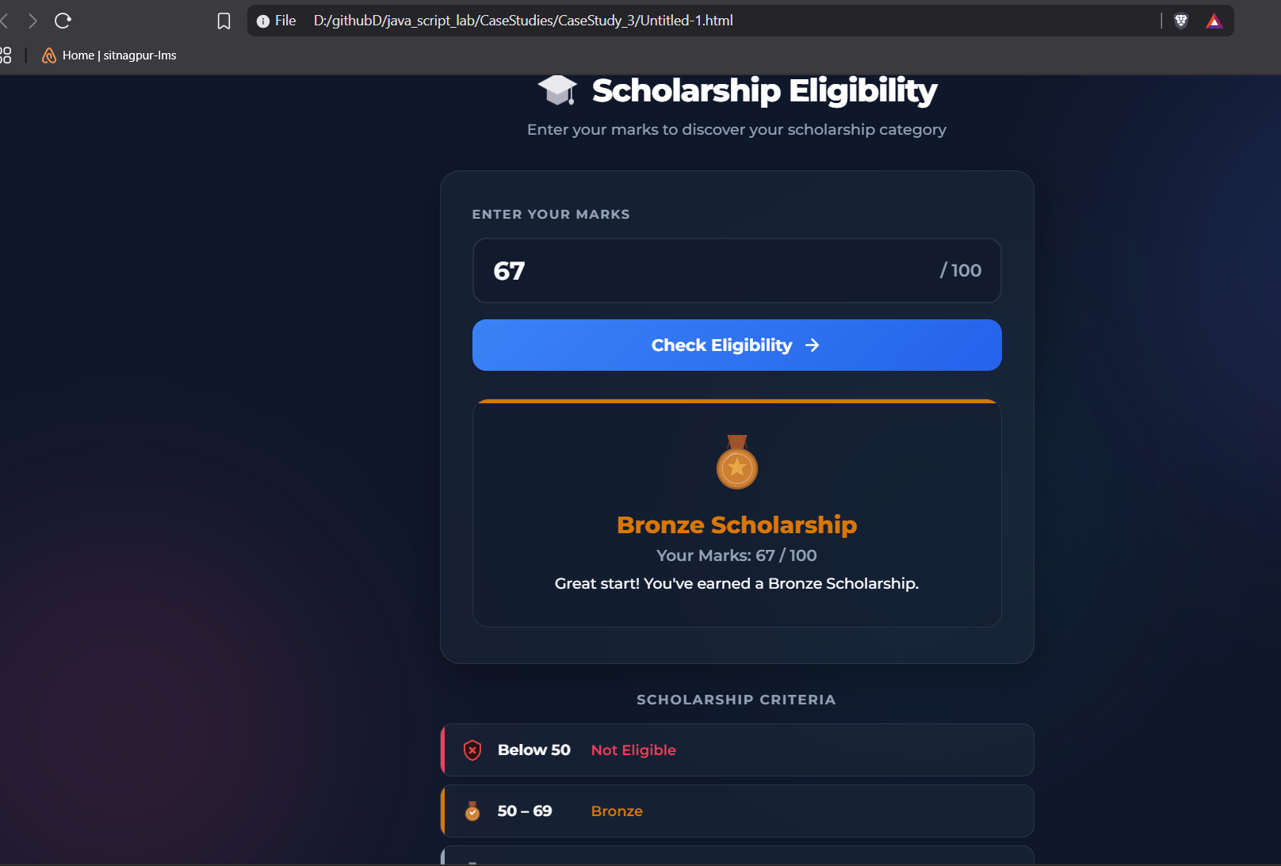

Result / Conclusion:
Hence, we have successfully developed the Scholarship Eligibility Checker webpage. Through this case study, we practically learned how to implement control structures, specifically if-else conditional statements in JavaScript, to evaluate user input, make logical decisions, and dynamically update the webpage's UI to display the appropriate scholarship category based on the provided marks.

Experiment 4
1. Experiment Title
Use function types, scope, and closures; apply try-catch; build a palindrome checker.

2. Software/Tools Required
- Visual Studio Code (VS Code)
- Google Chrome / Mozilla Firefox / Microsoft Edge
- HTML5
- CSS3
- JavaScript
- Windows Operating System

3. Experiment Program Code
The experiment consists of the following files:
- jash_chauhan_242.html
- styles.css
- script.js

<!DOCTYPE html>
<html lang="en">
<head>
<meta charset="UTF-8">
<meta name="viewport" content="width=device-width, initial-scale=1.0">
<title>Advanced Palindrome Checker</title>
<style>
:root {
--primary: #6366F1;
--primary-hover: #4F46E5;
--secondary: #EC4899;
--bg-gradient: linear-gradient(135deg, #e0e7ff 0%, #fce7f3 100%);
--card-bg: rgba(255, 255, 255, 0.85);
--text-main: #1F2937;
--text-muted: #6B7280;
}

body {
font-family: 'Inter', system-ui, -apple-system, sans-serif;
background: var(--bg-gradient);
min-height: 100vh;
display: flex;
justify-content: center;
align-items: center;
margin: 0;
padding: 20px;
box-sizing: border-box;
}

.card {
background: var(--card-bg);
backdrop-filter: blur(12px);
-webkit-backdrop-filter: blur(12px);
padding: 40px 30px;
border-radius: 20px;
border: 1px solid rgba(255, 255, 255, 0.5);
box-shadow: 0 20px 40px rgba(0,0,0,0.08);
width: 100%;
max-width: 450px;
text-align: center;
transition: transform 0.3s ease;
}

.card:hover {
transform: translateY(-2px);
}

h2 {
margin-top: 0;
margin-bottom: 8px;
background: linear-gradient(to right, var(--primary), var(--secondary));
-webkit-background-clip: text;
-webkit-text-fill-color: transparent;
font-size: 28px;
font-weight: 800;
}

.subtitle {
color: var(--text-muted);
font-size: 14px;
margin-bottom: 24px;
}

.input-group {
display: flex;
gap: 10px;
margin-bottom: 20px;
}

input[type="text"] {
flex: 1;
padding: 14px 16px;
font-size: 16px;
border: 2px solid #E5E7EB;
border-radius: 12px;
transition: all 0.3s ease;
outline: none;
background: rgba(255, 255, 255, 0.9);
}

input[type="text"]:focus {
border-color: var(--primary);
box-shadow: 0 0 0 4px rgba(99, 102, 241, 0.15);
}

.btn-group {
display: flex;
gap: 10px;
margin-bottom: 24px;
}

button {
flex: 1;
padding: 14px 24px;
font-size: 16px;
border: none;
border-radius: 12px;
cursor: pointer;
font-weight: 600;
transition: all 0.2s ease;
}

#checkBtn {
background-color: var(--primary);
color: white;
box-shadow: 0 4px 12px rgba(99, 102, 241, 0.3);
}

#checkBtn:hover {
background-color: var(--primary-hover);
transform: translateY(-1px);
box-shadow: 0 6px 16px rgba(99, 102, 241, 0.4);
}

#clearBtn {
background-color: #F3F4F6;
color: var(--text-main);
flex: 0.4;
}

#clearBtn:hover {
background-color: #E5E7EB;
}

button:active {
transform: scale(0.96) !important;
}

/* Styling for the new Options Section */
.options-panel {
display: flex;
justify-content: space-between;
background: rgba(255,255,255,0.6);
padding: 12px 16px;
border-radius: 12px;
margin-bottom: 24px;
font-size: 14px;
color: var(--text-main);
border: 1px solid #E5E7EB;
}

.checkbox-label {
display: flex;
align-items: center;
gap: 8px;
cursor: pointer;
user-select: none;
}

.checkbox-label input[type="checkbox"] {
accent-color: var(--primary);
width: 16px;
height: 16px;
cursor: pointer;
}

/* Animated Result Box */
.message {
font-weight: 500;
padding: 16px;
border-radius: 12px;
transition: all 0.3s cubic-bezier(0.4, 0, 0.2, 1);
font-size: 15px;
line-height: 1.5;
opacity: 0;
transform: scale(0.95);
}

.message.show {
opacity: 1;
transform: scale(1);
}

.error {
background: #FEF2F2;
color: #991B1B;
border: 1px solid #F87171;
box-shadow: 0 4px 12px rgba(239, 68, 68, 0.1);
}
.success {
background: #F0FDF4;
color: #166534;
border: 1px solid #4ADE80;
box-shadow: 0 4px 12px rgba(34, 197, 94, 0.1);
}
.neutral {
background: #F8FAFC;
color: #475569;
border: 1px dashed #CBD5E1;
opacity: 1;
transform: scale(1);
}

.stats {
margin-top: 24px;
font-size: 13px;
color: var(--text-muted);
text-transform: uppercase;
letter-spacing: 0.5px;
font-weight: 600;
}
</style>
</head>
<body>

<div class="card">
<h2>Palindrome Pro</h2>
<div class="subtitle">Check words, phrases, or numbers</div>

<div class="options-panel">
<label class="checkbox-label">
<input type="checkbox" id="optCaseSensitive"> Case Sensitive
</label>
<label class="checkbox-label">
<input type="checkbox" id="optKeepPunct"> Keep Punctuation
</label>
</div>

<div class="input-group">
<input type="text" id="wordInput" placeholder="Enter text here..." autocomplete="off">
</div>

<div class="btn-group">
<button id="checkBtn">Analyze Text</button>
<button id="clearBtn">Clear</button>
</div>

<div id="result" class="message neutral">Awaiting input...</div>
<div id="stats" class="stats">Total checks: 0</div>
</div>

<script>
const inputEl = document.getElementById('wordInput');
const resultEl = document.getElementById('result');
const statsEl = document.getElementById('stats');

// New option elements
const optCaseSensitive = document.getElementById('optCaseSensitive');
const optKeepPunct = document.getElementById('optKeepPunct');

const createAnalyzer = function() {
let checksPerformed = 0;

// Updated cleanText to accept user options
const cleanText = (str, isCaseSensitive, keepPunctuation) => {
let processed = str;

if (!keepPunctuation) {
// Remove anything that isn't a letter or number
processed = processed.replace(/[^A-Za-z0-9]/g, '');
}

if (!isCaseSensitive) {
processed = processed.toLowerCase();
}

return processed;
};

return {
check: function(text, options) {
checksPerformed++;
updateStats(checksPerformed);

try {
if (!text || text.trim() === '') {
throw new Error("Whoops! The input cannot be blank.");
}
if (text.length < 2) {
throw new Error("Please enter at least 2 characters.");
}

const cleaned = cleanText(text, options.isCaseSensitive, options.keepPunctuation);
const reversed = cleaned.split('').reverse().join('');

if (cleaned === reversed) {
return {
isPalindrome: true,
msg: `🎉 <strong>Yes!</strong><br>"${text}" is a palindrome.`
};
} else {
return {
isPalindrome: false,
msg: `❌ <strong>No.</strong><br>"${text}" is not a palindrome.`
};
}

} catch (error) {
return { isError: true, msg: error.message };
}
}
};
};

const analyzer = createAnalyzer();

function updateStats(count) {
statsEl.textContent = `Total checks: ${count}`;
}

// Animation helper
function displayResult(result) {
// Briefly remove the 'show' class to reset the animation
resultEl.classList.remove('show');

setTimeout(() => {
resultEl.innerHTML = result.msg;
if (result.isError) {
resultEl.className = 'message error show';
} else if (result.isPalindrome) {
resultEl.className = 'message success show';
} else {
resultEl.className = 'message error show'; // Use error style for non-palindromes to make it pop
}
}, 50); // Tiny delay to allow DOM to register the class removal
}

// Event Listeners
inputEl.addEventListener('keypress', (e) => {
if (e.key === 'Enter') {
document.getElementById('checkBtn').click();
}
});

document.getElementById('checkBtn').addEventListener('click', () => {
const userInput = inputEl.value;

// Gather current options from checkboxes
const currentOptions = {
isCaseSensitive: optCaseSensitive.checked,
keepPunctuation: optKeepPunct.checked
};

const result = analyzer.check(userInput, currentOptions);
displayResult(result);
});

// Clear functionality
document.getElementById('clearBtn').addEventListener('click', () => {
inputEl.value = '';
inputEl.focus();
resultEl.className = 'message neutral';
resultEl.textContent = 'Awaiting input...';
});
</script>
</body>
</html>

Output:
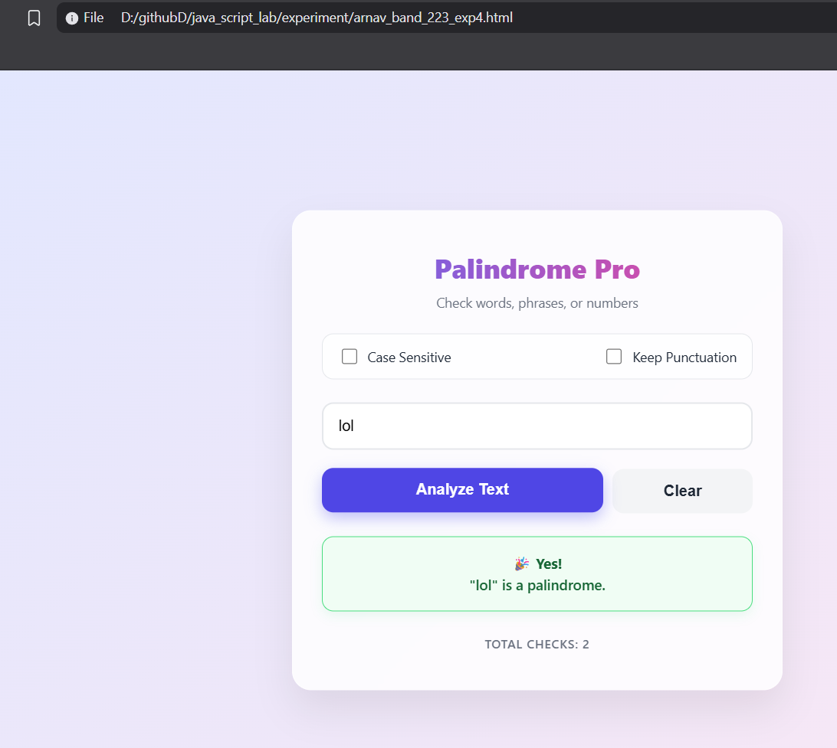

Case Study 4
1. Case Study Title
Real-Time Case Study: ATM Card PIN Verification Using JavaScript Functions to verify whether a customer's PIN is a palindrome. Use function declaration, function expression, arrow function, and demonstrate scope and closure concepts.

2. Case Study Program Code
The case study consists of the following files:

- jashchauhan_242.html – Displays the ATM interface webpage containing a digital screen and a keypad to securely enter the PIN.

• script.js – Implements the PIN verification logic using function declarations, function expressions, and arrow functions, while demonstrating scope and closures to securely track failed attempts.

• style.css – Contains the styling rules to create a realistic, responsive ATM layout with premium visual elements.

<!DOCTYPE html>
<html lang="en">
<head>
<meta charset="UTF-8">
<meta name="viewport" content="width=device-width, initial-scale=1.0">
<title>ATM PIN Verification</title>
<!-- Updated Fonts: Space Mono for the screen and Outfit for general UI -->
<link href="https://fonts.googleapis.com/css2?family=Outfit:wght@400;500;600&family=Space+Mono:wght@400;700&display=swap" rel="stylesheet">

<style>
/* ==========================================
Updated CSS Styling (Dark/Neon Theme)
========================================== */
:root {
/* Dark metallic ATM body */
--atm-bg: #2a2a35;
--atm-shadow: #1c1c23;
--atm-highlight: #383847;

/* Neon Screen */
--screen-bg: #09090c;
--screen-text: #00ffcc; /* Neon Cyan */
--screen-text-error: #ff2a5f; /* Neon Pink/Red */
--screen-text-success: #00ff66; /* Neon Green */

/* Dark Keypad */
--key-bg: #363645;
--key-text: #ffffff;
--btn-cancel: #e63946;
--btn-clear: #f4a261;
--btn-enter: #2a9d8f;
}

* {
margin: 0;
padding: 0;
box-sizing: border-box;
}

body {
font-family: 'Outfit', sans-serif;
background-color: #121216; /* Deep dark background */
display: flex;
justify-content: center;
align-items: center;
min-height: 100vh;
padding: 20px;
}

.atm-container {
background: var(--atm-bg);
padding: 40px;
border-radius: 25px;
/* Dark Neumorphism shadows */
box-shadow:
12px 12px 24px var(--atm-shadow),
-12px -12px 24px var(--atm-highlight);
width: 100%;
max-width: 500px;
}

.atm-machine {
display: flex;
flex-direction: column;
gap: 30px;
}

/* --- Screen Styling --- */
.atm-screen {
background: var(--screen-bg);
padding: 20px;
border-radius: 12px;
border: 4px solid #1a1a24;
box-shadow: inset 0 0 25px rgba(0, 255, 204, 0.05);
position: relative;
height: 260px;
display: flex;
flex-direction: column;
overflow: hidden;
}

/* Scanline effect */
.atm-screen::after {
content: " ";
display: block;
position: absolute;
top: 0;
left: 0;
bottom: 0;
right: 0;
background: linear-gradient(rgba(18, 16, 16, 0) 50%, rgba(0, 0, 0, 0.4) 50%), linear-gradient(90deg, rgba(255, 0, 0, 0.03), rgba(0, 255, 0, 0.01), rgba(0, 0, 255, 0.03));
z-index: 2;
background-size: 100% 3px, 3px 100%;
pointer-events: none;
}

.bank-logo {
font-family: 'Space Mono', monospace;
color: #4a6c72;
font-size: 1.1rem;
text-transform: uppercase;
letter-spacing: 3px;
text-align: center;
margin-bottom: 20px;
}

.screen-content {
font-family: 'Space Mono', monospace;
color: var(--screen-text);
flex-grow: 1;
display: flex;
flex-direction: column;
align-items: center;
justify-content: center;
text-align: center;
text-shadow: 0 0 8px rgba(0, 255, 204, 0.6);
z-index: 1;
}

.welcome-text {
font-size: 1.6rem;
font-weight: 700;
margin-bottom: 10px;
letter-spacing: 2px;
}

.instruction {
font-size: 0.95rem;
margin-bottom: 25px;
opacity: 0.85;
}

.pin-display {
display: flex;
gap: 12px;
height: 30px;
margin-bottom: 20px;
}

.pin-dot {
width: 18px;
height: 18px;
background-color: var(--screen-text);
border-radius: 50%;
box-shadow: 0 0 12px var(--screen-text);
animation: pulse-glow 1s infinite alternate;
}

@keyframes pulse-glow {
0% { opacity: 0.6; transform: scale(0.9); }
100% { opacity: 1; transform: scale(1.1); }
}

.message-area {
font-size: 0.85rem;
min-height: 40px;
line-height: 1.5;
transition: color 0.3s ease;
max-width: 90%;
}

.msg-error {
color: var(--screen-text-error);
text-shadow: 0 0 8px rgba(255, 42, 95, 0.7);
}

.msg-success {
color: var(--screen-text-success);
text-shadow: 0 0 8px rgba(0, 255, 102, 0.7);
}

/* --- Keypad Styling --- */
.atm-keypad {
display: grid;
grid-template-columns: repeat(4, 1fr);
gap: 18px;
background: #23232c;
padding: 25px;
border-radius: 15px;
border: 1px solid #383847;
box-shadow: inset 0 0 15px rgba(0,0,0,0.5);
}

.key {
background: var(--key-bg);
border: none;
border-radius: 10px;
height: 65px;
font-size: 1.6rem;
font-weight: 600;
font-family: 'Space Mono', monospace;
color: var(--key-text);
cursor: pointer;
box-shadow:
4px 4px 10px rgba(0,0,0,0.3),
-2px -2px 8px rgba(255,255,255,0.05);
transition: all 0.1s ease;
display: flex;
justify-content: center;
align-items: center;
}

.key:active {
box-shadow:
inset 4px 4px 8px rgba(0,0,0,0.4),
inset -2px -2px 6px rgba(255,255,255,0.02);
transform: scale(0.96);
color: var(--screen-text);
}

.action-key {
font-family: 'Outfit', sans-serif;
font-size: 0.8rem;
font-weight: 700;
letter-spacing: 1px;
color: white;
text-shadow: 1px 1px 2px rgba(0,0,0,0.6);
}

.cancel { background: var(--btn-cancel); }
.clear { background: var(--btn-clear); }
.enter { background: var(--btn-enter); }

.cancel:active { background: #b02a36; }
.clear:active { background: #c8814a; }
.enter:active { background: #1f7a6f; }

.empty-key {
visibility: hidden;
}

/* --- Card Slot --- */
.card-slot {
align-self: flex-end;
width: 140px;
height: 45px;
background: #1f1f27;
border-radius: 8px;
display: flex;
flex-direction: column;
align-items: center;
justify-content: center;
gap: 6px;
box-shadow:
inset 2px 2px 6px rgba(0,0,0,0.6),
inset -1px -1px 4px rgba(255,255,255,0.05);
border: 1px solid #333342;
}

.slot-opening {
width: 110px;
height: 6px;
background: #050505;
border-radius: 3px;
box-shadow: inset 0 2px 5px rgba(0,0,0,1);
}

.card-indicator {
width: 50px;
height: 3px;
background: var(--screen-text-success);
border-radius: 2px;
box-shadow: 0 0 8px var(--screen-text-success);
animation: indicator-blink 1.5s infinite;
}

@keyframes indicator-blink {
0% { opacity: 0.2; }
50% { opacity: 1; }
100% { opacity: 0.2; }
}

/* Responsive */
@media (max-width: 480px) {
.atm-container {
padding: 25px;
}
.atm-keypad {
gap: 12px;
padding: 15px;
}
.key {
height: 55px;
font-size: 1.3rem;
}
.action-key {
font-size: 0.65rem;
}
.atm-screen {
height: 230px;
}
}
</style>
</head>
<body>
<div class="atm-container">
<div class="atm-machine">
<div class="atm-screen">
<div class="bank-logo">SecureBank</div>
<div id="screen-content" class="screen-content">
<p class="welcome-text">WELCOME</p>
<p class="instruction">PLEASE ENTER YOUR PIN</p>
<div class="pin-display" id="pin-display">
<!-- Dots will appear here -->
</div>
<div class="message-area" id="message-area"></div>
</div>
</div>

<div class="atm-keypad">
<button class="key num-key" data-val="1">1</button>
<button class="key num-key" data-val="2">2</button>
<button class="key num-key" data-val="3">3</button>
<button class="key action-key cancel" id="btn-cancel">CANCEL</button>

<button class="key num-key" data-val="4">4</button>
<button class="key num-key" data-val="5">5</button>
<button class="key num-key" data-val="6">6</button>
<button class="key action-key clear" id="btn-clear">CLEAR</button>

<button class="key num-key" data-val="7">7</button>
<button class="key num-key" data-val="8">8</button>
<button class="key num-key" data-val="9">9</button>
<button class="key action-key enter" id="btn-enter">ENTER</button>

<button class="key empty-key"></button>
<button class="key num-key" data-val="0">0</button>
<button class="key empty-key"></button>
<button class="key empty-key"></button>
</div>

<div class="card-slot">
<div class="slot-opening"></div>
<div class="card-indicator"></div>
</div>
</div>
</div>

<script>
// ==========================================
// JavaScript Logic: ATM Card PIN Verification
// ==========================================

// --- 1. Function Declaration (Scope: Global) ---
// Reverses a string
function reverseString(str) {
return str.split('').reverse().join('');
}

// --- 2. Function Expression (Scope: Global) ---
// Checks if original and reversed strings are identical
const isPalindrome = function(original, reversed) {
return original === reversed;
};

// --- 3. Arrow Function & 4. Closure (Scope: Global & Local) ---
// Factory function demonstrating closure to keep track of secure attempts
const createATMSystem = () => {
// Scope: Local variables to createATMSystem
let attempts = 0;
const MAX_ATTEMPTS = 3;

// The returned arrow function creates a closure, retaining access to 'attempts' and 'MAX_ATTEMPTS'
return (pin) => {
attempts++;

if (attempts > MAX_ATTEMPTS) {
return {
status: 'BLOCKED',
message: 'CARD BLOCKED. TOO MANY FAILED ATTEMPTS.'
};
}

const reversedPin = reverseString(pin);
const valid = isPalindrome(pin, reversedPin);

if (valid) {
// Reset attempts on success
attempts = 0;
return {
status: 'SUCCESS',
message: 'SECURITY VERIFIED: PIN IS PALINDROME. ACCESS GRANTED.'
};
} else {
return {
status: 'ERROR',
message: `INVALID PIN. ATTEMPT ${attempts} OF ${MAX_ATTEMPTS}.`
};
}
};
};

// Initialize the secure verifier instance (closure is active)
const verifyPin = createATMSystem();

// ==========================================
// UI Interaction Logic
// ==========================================
document.addEventListener("DOMContentLoaded", () => {
let currentPin = "";

// DOM Elements
const pinDisplay = document.getElementById("pin-display");
const messageArea = document.getElementById("message-area");
const numKeys = document.querySelectorAll(".num-key");
const btnClear = document.getElementById("btn-clear");
const btnCancel = document.getElementById("btn-cancel");
const btnEnter = document.getElementById("btn-enter");

// Update the visual dots on the ATM screen
function updateDisplay() {
pinDisplay.innerHTML = "";
for (let i = 0; i < currentPin.length; i++) {
const dot = document.createElement("div");
dot.className = "pin-dot";
pinDisplay.appendChild(dot);
}
}

// Display messages on the screen
function showMessage(msg, type) {
messageArea.textContent = msg;
messageArea.className = `message-area ${type === 'error' ? 'msg-error' : (type === 'success' ? 'msg-success' : '')}`;

// Clear success/error message after 3 seconds, unless it's a block message
if (!msg.includes("BLOCKED") && !msg.includes("GRANTED")) {
setTimeout(() => {
messageArea.textContent = "";
messageArea.className = "message-area";
}, 3000);
}
}

// Number pad click events
numKeys.forEach(key => {
key.addEventListener("click", () => {
// Max 6 digits PIN
if (currentPin.length < 6) {
currentPin += key.getAttribute("data-val");
updateDisplay();
}
});
});

// Clear key (removes last entered digit)
btnClear.addEventListener("click", () => {
currentPin = currentPin.slice(0, -1);
updateDisplay();
});

// Cancel key (clears entire input)
btnCancel.addEventListener("click", () => {
currentPin = "";
updateDisplay();
showMessage("OPERATION CANCELLED", "error");
});

// Enter key (Submits PIN for verification)
btnEnter.addEventListener("click", () => {
if (currentPin.length === 0) {
showMessage("PLEASE ENTER A PIN", "error");
return;
}

// Execute PIN Verification using our closure
const result = verifyPin(currentPin);

if (result.status === 'BLOCKED') {
showMessage(result.message, "error");
// Visually disable keypad
document.querySelectorAll(".key").forEach(btn => {
btn.style.opacity = "0.4";
btn.style.pointerEvents = "none";
});
currentPin = "";
updateDisplay();
} else if (result.status === 'SUCCESS') {
showMessage(result.message, "success");
currentPin = "";
updateDisplay();
} else {
showMessage(result.message, "error");
currentPin = "";
updateDisplay();
}
});
});
</script>
</body>
</html>

Output:
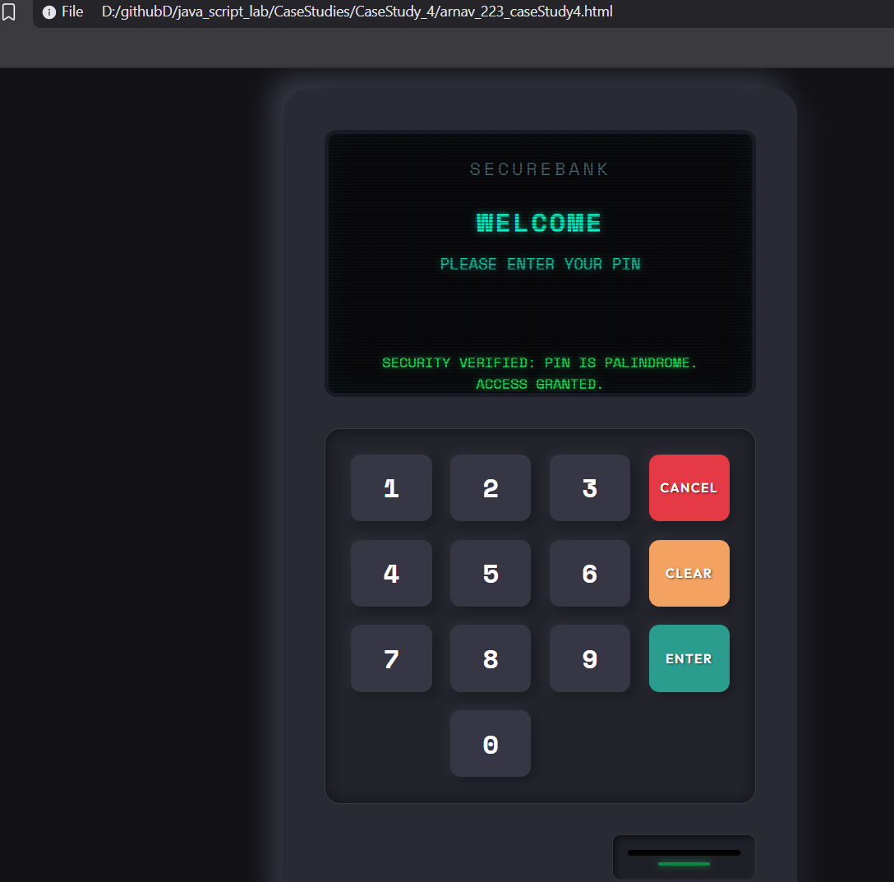
Result/Conclusion:
Case Study 4 successfully demonstrates how to use closures in JavaScript to securely maintain private data (like tracking failed PIN attempts) without exposing it to the global scope. It provides a functional ATM interface that validates palindromic PINs and securely blocks the user after 3 invalid attempts.

Experiment 5
1. Experiment Title
Apply array methods and object handling; create a cart total calculator with discount logic.

2. Software/Tools Required
- Visual Studio Code (VS Code)
- Google Chrome / Mozilla Firefox / Microsoft Edge
- HTML5
- CSS3
- JavaScript
- Windows Operating System

3. Experiment Program Code
The experiment consists of the following files:
- Jashchauhan_242.html
- styles.css
- script.js
<!DOCTYPE html>
<html lang="en">

<head>
<meta charset="UTF-8">
<meta name="viewport" content="width=device-width, initial-scale=1.0">
<title>Cart Total Calculator</title>

<!-- Font Awesome Icons -->
<link rel="stylesheet" href="https://cdnjs.cloudflare.com/ajax/libs/font-awesome/6.5.2/css/all.min.css">

<style>
* {
margin: 0;
padding: 0;
box-sizing: border-box;
font-family: Arial, Helvetica, sans-serif;
}

body {
background: #f5f5f5;
display: flex;
justify-content: center;
align-items: flex-start;
min-height: 100vh;
padding: 40px 20px;
}

.container {
width: 800px;
background: white;
padding: 28px;
border: 1px solid #ddd;
border-radius: 14px;
}

h2 {
font-size: 24px;
margin-bottom: 20px;
}

h2 i {
margin-right: 6px;
}

/* ─── Add-Item Form ─── */

.form-row {
display: flex;
gap: 10px;
margin-bottom: 12px;
flex-wrap: wrap;
}

.form-row input,
.form-row select {
padding: 11px 13px;
font-size: 15px;
border: 1px solid #ccc;
border-radius: 10px;
outline: none;
}

.form-row input:focus,
.form-row select:focus {
border-color: #222;
}

#item-name {
flex: 2;
min-width: 140px;
}

#item-price {
flex: 1;
min-width: 100px;
}

#item-qty {
width: 70px;
}

#item-category {
flex: 1;
min-width: 120px;
cursor: pointer;
}

/* ─── Buttons ─── */

button {
background: #111;
color: white;
border: none;
padding: 11px 18px;
border-radius: 10px;
cursor: pointer;
font-size: 15px;
transition: .3s;
white-space: nowrap;
}

button:hover {
background: #333;
}

/* ─── Discount Row ─── */

.discount-row {
display: flex;
gap: 10px;
margin-bottom: 8px;
}

.discount-row input {
flex: 1;
padding: 11px 13px;
font-size: 15px;
border: 1px solid #ccc;
border-radius: 10px;
outline: none;
}

.discount-row input:focus {
border-color: #222;
}

#apply-discount-btn {
background: #7c3aed;
}

#apply-discount-btn:hover {
background: #6d28d9;
}

.discount-msg {
font-size: 14px;
min-height: 20px;
margin-bottom: 14px;
padding-left: 2px;
}

.discount-msg.success {
color: #16a34a;
}

.discount-msg.error {
color: #ef4444;
}

/* ─── Table ─── */

.table-wrap {
margin-bottom: 18px;
}

table {
width: 100%;
border-collapse: collapse;
}

thead th {
text-align: left;
padding: 10px 12px;
font-size: 14px;
color: #555;
border-bottom: 2px solid #e5e5e5;
}

tbody td {
padding: 10px 12px;
font-size: 15px;
border-bottom: 1px solid #f0f0f0;
}

tbody tr:hover {
background: #fafafa;
}

.category-badge {
display: inline-block;
padding: 3px 10px;
border-radius: 20px;
font-size: 12px;
font-weight: 600;
text-transform: uppercase;
letter-spacing: .3px;
}

.badge-electronics {
background: #dbeafe;
color: #1d4ed8;
}

.badge-clothing {
background: #fce7f3;
color: #be185d;
}

.badge-grocery {
background: #dcfce7;
color: #15803d;
}

.badge-general {
background: #f3f4f6;
color: #374151;
}

.delete-btn {
background: none;
color: #ef4444;
padding: 6px 10px;
font-size: 16px;
}

.delete-btn:hover {
background: #fef2f2;
color: #dc2626;
}

.empty-msg {
text-align: center;
color: #999;
padding: 32px 0;
font-size: 16px;
}

.empty-msg i {
margin-right: 6px;
}

/* ─── Summary ─── */

.summary {
background: #fafafa;
border: 1px solid #e5e5e5;
border-radius: 12px;
padding: 18px 22px;
margin-bottom: 18px;
}

.summary-line {
display: flex;
justify-content: space-between;
padding: 7px 0;
font-size: 15px;
color: #444;
}

.discount-line {
color: #16a34a;
}

.total-line {
border-top: 2px solid #e5e5e5;
margin-top: 6px;
padding-top: 12px;
font-size: 20px;
font-weight: 700;
color: #111;
}

/* ─── Filter Section ─── */

.filter-section {
display: flex;
align-items: center;
gap: 8px;
flex-wrap: wrap;
margin-bottom: 14px;
}

.filter-label {
font-size: 14px;
color: #555;
margin-right: 4px;
}

.filter-btn {
background: #f3f4f6;
color: #333;
padding: 7px 14px;
font-size: 13px;
border-radius: 8px;
}

.filter-btn:hover {
background: #e5e7eb;
}

.filter-btn.active {
background: #111;
color: white;
}

/* ─── Highlight Box ─── */

.highlight {
background: #fffbeb;
border: 1px solid #fbbf24;
border-radius: 12px;
padding: 14px 18px;
font-size: 15px;
color: #92400e;
}

.highlight i {
margin-right: 6px;
color: #f59e0b;
}

/* ─── Utility ─── */

.hidden {
display: none !important;
}
</style>
</head>

<body>

<div class="container">
<h2><i class="fa-solid fa-cart-shopping"></i> Cart Total Calculator</h2>

<!-- Add Item Form -->
<div class="form-row">
<input type="text" id="item-name" placeholder="Item name">
<input type="number" id="item-price" placeholder="Price (₹)" min="0" step="0.01">
<input type="number" id="item-qty" placeholder="Qty" min="1" value="1">
<select id="item-category">
<option value="general">General</option>
<option value="electronics">Electronics</option>
<option value="clothing">Clothing</option>
<option value="grocery">Grocery</option>
</select>
<button onclick="addItem()" id="add-btn">
<i class="fa-solid fa-plus"></i> Add
</button>
</div>

<!-- Discount Code -->
<div class="discount-row">
<input type="text" id="discount-code" placeholder="Discount code (e.g. SAVE10, FLAT50, ELEC20)">
<button onclick="applyDiscount()" id="apply-discount-btn">
<i class="fa-solid fa-tag"></i> Apply
</button>
</div>

<div id="discount-msg" class="discount-msg"></div>

<!-- Cart Table -->
<div class="table-wrap">
<table id="cart-table">
<thead>
<tr>
<th>#</th>
<th>Item</th>
<th>Category</th>
<th>Price (₹)</th>
<th>Qty</th>
<th>Subtotal (₹)</th>
<th></th>
</tr>
</thead>
<tbody id="cart-body">
<!-- Rows rendered by JS -->
</tbody>
</table>

<p id="empty-msg" class="empty-msg">
<i class="fa-solid fa-basket-shopping"></i> Your cart is empty. Add items above.
</p>
</div>

<!-- Summary -->
<div id="summary" class="summary hidden">
<div class="summary-line">
<span>Items in cart</span>
<span id="total-items">0</span>
</div>
<div class="summary-line">
<span>Total quantity</span>
<span id="total-qty">0</span>
</div>
<div class="summary-line">
<span>Subtotal</span>
<span id="subtotal">₹0.00</span>
</div>
<div class="summary-line discount-line hidden" id="discount-summary">
<span id="discount-label">Discount</span>
<span id="discount-amount">−₹0.00</span>
</div>
<div class="summary-line total-line">
<span>Grand Total</span>
<span id="grand-total">₹0.00</span>
</div>
</div>

<!-- Filter Buttons -->
<div id="filter-section" class="filter-section hidden">
<span class="filter-label">Filter by category:</span>
<button class="filter-btn active" onclick="filterByCategory('all')">All</button>
<button class="filter-btn" onclick="filterByCategory('electronics')">Electronics</button>
<button class="filter-btn" onclick="filterByCategory('clothing')">Clothing</button>
<button class="filter-btn" onclick="filterByCategory('grocery')">Grocery</button>
<button class="filter-btn" onclick="filterByCategory('general')">General</button>
</div>

<!-- Most Expensive Item -->
<div id="highlight" class="highlight hidden"></div>
</div>

<script>
// ============================================================
// Experiment 05 – Cart Total Calculator with Discount Logic
// Demonstrates: Array methods (map, filter, reduce, find,
// forEach, findIndex) and Object handling
// ============================================================

// ─── Cart state (array of item objects) ───

let cart = [];
let nextId = 1;

// Active discount object (null when none applied)
let activeDiscount = null;

// Current category filter
let activeFilter = "all";

// ─── Discount code definitions (array of objects) ───

const discountCodes = [
{
code: "SAVE10",
type: "percent",
value: 10,
label: "10% off entire cart",
},
{
code: "FLAT50",
type: "flat",
value: 50,
label: "₹50 flat off",
},
{
code: "ELEC20",
type: "category-percent",
value: 20,
category: "electronics",
label: "20% off Electronics items",
},
];

// ──────────────────────────────────────────────────────────
// Add Item (Object creation + Array.push)
// ──────────────────────────────────────────────────────────

function addItem() {

try {

const name = document.getElementById("item-name").value.trim();
const price = parseFloat(document.getElementById("item-price").value);
const qty = parseInt(document.getElementById("item-qty").value, 10);
const category = document.getElementById("item-category").value;

if (!name) throw "Please enter an item name.";
if (isNaN(price) || price <= 0) throw "Please enter a valid price.";
if (isNaN(qty) || qty < 1) throw "Quantity must be at least 1.";

// Create an item object
const item = {
id: nextId++,
name: name,
price: price,
qty: qty,
category: category,
};

// Array.push – add item to cart
cart.push(item);

// Clear inputs
document.getElementById("item-name").value = "";
document.getElementById("item-price").value = "";
document.getElementById("item-qty").value = 1;

renderCart();

} catch (error) {
alert(error);
}
}

// ──────────────────────────────────────────────────────────
// Remove Item (Array.findIndex + Array.splice)
// ──────────────────────────────────────────────────────────

function removeItem(id) {

// Array.findIndex – locate item by id
const index = cart.findIndex(function (item) {
return item.id === id;
});

if (index !== -1) {
// Array.splice – remove one element at index
cart.splice(index, 1);
renderCart();
}
}

// ──────────────────────────────────────────────────────────
// Apply Discount (Array.find on discountCodes)
// ──────────────────────────────────────────────────────────

function applyDiscount() {

const input = document.getElementById("discount-code").value.trim().toUpperCase();
const msgEl = document.getElementById("discount-msg");

if (!input) {
msgEl.className = "discount-msg error";
msgEl.textContent = "Please enter a discount code.";
return;
}

// Array.find – search for matching code object
const found = discountCodes.find(function (d) {
return d.code === input;
});

if (!found) {
activeDiscount = null;
msgEl.className = "discount-msg error";
msgEl.textContent = 'Invalid code "' + input + '". Try SAVE10, FLAT50, or ELEC20.';
} else {
activeDiscount = found;
msgEl.className = "discount-msg success";
msgEl.textContent = 'Code "' + found.code + '" applied — ' + found.label + "!";
}

renderCart();
}

// ──────────────────────────────────────────────────────────
// Calculate Discount (Array.filter + Array.reduce)
// ──────────────────────────────────────────────────────────

function calculateDiscount(subtotal) {

if (!activeDiscount) return 0;

if (activeDiscount.type === "percent") {
// Percentage off entire subtotal
return subtotal * (activeDiscount.value / 100);
}

if (activeDiscount.type === "flat") {
// Flat amount off (cannot exceed subtotal)
return Math.min(activeDiscount.value, subtotal);
}

if (activeDiscount.type === "category-percent") {

// Array.filter – pick items matching the discount category
const eligible = cart.filter(function (item) {
return item.category === activeDiscount.category;
});

// Array.reduce – sum subtotals of eligible items
const eligibleTotal = eligible.reduce(function (sum, item) {
return sum + item.price * item.qty;
}, 0);

return eligibleTotal * (activeDiscount.value / 100);
}

return 0;
}

// ──────────────────────────────────────────────────────────
// Filter by Category (Array.filter)
// ──────────────────────────────────────────────────────────

function filterByCategory(category) {

activeFilter = category;

// Update active button
var btns = document.querySelectorAll(".filter-btn");
btns.forEach(function (btn) {
btn.classList.remove("active");
});

// Find the clicked button using event-less approach
var allBtns = document.querySelectorAll(".filter-btn");
allBtns.forEach(function (btn) {
if (btn.textContent.trim().toLowerCase() === category) {
btn.classList.add("active");
}
});

renderCart();
}

// ──────────────────────────────────────────────────────────
// Render Cart (Array.forEach, Array.map, Array.filter,
// Array.reduce, Object destructuring-style
// property access)
// ──────────────────────────────────────────────────────────

function renderCart() {

var tbody = document.getElementById("cart-body");
var emptyMsg = document.getElementById("empty-msg");
var summaryEl = document.getElementById("summary");
var filterSection = document.getElementById("filter-section");
var highlightEl = document.getElementById("highlight");
var table = document.getElementById("cart-table");

// Decide which items to show (Array.filter)
var displayItems;
if (activeFilter === "all") {
displayItems = cart;
} else {
displayItems = cart.filter(function (item) {
return item.category === activeFilter;
});
}

// Empty state
if (cart.length === 0) {
table.classList.add("hidden");
emptyMsg.classList.remove("hidden");
summaryEl.classList.add("hidden");
filterSection.classList.add("hidden");
highlightEl.classList.add("hidden");
return;
}

table.classList.remove("hidden");
emptyMsg.classList.add("hidden");
summaryEl.classList.remove("hidden");
filterSection.classList.remove("hidden");

// ── Build table rows (Array.map to create HTML strings) ──

var rowsHtml = displayItems.map(function (item, index) {

var subtotal = item.price * item.qty;

return (
"<tr>" +
"<td>" + (index + 1) + "</td>" +
"<td>" + escapeHtml(item.name) + "</td>" +
'<td><span class="category-badge badge-' + item.category + '">' +
item.category +
"</span></td>" +
"<td>" + item.price.toFixed(2) + "</td>" +
"<td>" + item.qty + "</td>" +
"<td>" + subtotal.toFixed(2) + "</td>" +
'<td><button class="delete-btn" onclick="removeItem(' + item.id + ')">' +
'<i class="fa-solid fa-trash"></i></button></td>' +
"</tr>"
);

}).join("");

tbody.innerHTML = rowsHtml;

// ── Summary calculations ──

// Array.reduce – total subtotal of ALL cart items
var subtotal = cart.reduce(function (sum, item) {
return sum + item.price * item.qty;
}, 0);

// Array.reduce – total quantity
var totalQty = cart.reduce(function (sum, item) {
return sum + item.qty;
}, 0);

var discountAmt = calculateDiscount(subtotal);
var grandTotal = subtotal - discountAmt;

document.getElementById("total-items").textContent = cart.length;
document.getElementById("total-qty").textContent = totalQty;
document.getElementById("subtotal").textContent = "₹" + subtotal.toFixed(2);
document.getElementById("grand-total").textContent = "₹" + grandTotal.toFixed(2);

// Show / hide discount line
var discountSummary = document.getElementById("discount-summary");
if (discountAmt > 0) {
discountSummary.classList.remove("hidden");
document.getElementById("discount-label").textContent =
"Discount (" + activeDiscount.label + ")";
document.getElementById("discount-amount").textContent =
"−₹" + discountAmt.toFixed(2);
} else {
discountSummary.classList.add("hidden");
}

// ── Highlight most expensive item (Array.reduce as max-finder) ──

var mostExpensive = cart.reduce(function (max, item) {
return item.price * item.qty > max.price * max.qty ? item : max;
}, cart[0]);

highlightEl.classList.remove("hidden");
highlightEl.innerHTML =
'<i class="fa-solid fa-crown"></i> Most expensive item: <strong>' +
escapeHtml(mostExpensive.name) +
"</strong> — ₹" +
(mostExpensive.price * mostExpensive.qty).toFixed(2);
}

// ─── Helper: escape HTML to prevent XSS ───

function escapeHtml(text) {
var div = document.createElement("div");
div.appendChild(document.createTextNode(text));
return div.innerHTML;
}
</script>
</body>
</html>

OUTPUT:
