Oops Assignment 4

Made by : Arnav Bansal

SID : 23103046

Group : CSE - G1

1. C++ Program to Find the Highest of Two Given Numbers in Two Different Classes Using a Friend Function

#include <bits/stdc++.h>

using namespace std;

class B; // Forward declaration

class A {

int x;

public:

A(int a) : x(a) {}

friend void findMax(A, B);

};

class B {

int y;

public:

B(int b) : y(b) {}

friend void findMax(A, B);

};

void findMax(A objA, B objB) {

if (objA.x > objB.y)

cout << "The maximum number is: " << objA.x << endl;

else

cout << "The maximum number is: " << objB.y << endl;

}

int main() {

A objA(10);

B objB(20);

findMax(objA, objB);

return 0;

}

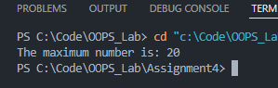

2. C++ Program to Demonstrate the Use of a Friend Function with Inline Assignment

#include <bits/stdc++.h>

using namespace std;

class Sample {

int a, b;

public:

Sample(int x, int y) : a(x), b(y) {}

friend int sum(Sample);

};

inline int sum(Sample obj) {

return obj.a + obj.b;

}

int main() {

Sample obj(5, 10);

cout << "The sum is: " << sum(obj) << endl;

return 0;

}

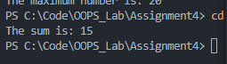

3. C++ Program to Enter Any Number, Find Its Factorial and Display It Using Constructor

#include <bits/stdc++.h>

using namespace std;

class Factorial {

int number;

long long fact;

public:

Factorial(int n) : number(n) {

fact = 1;

for (int i = 1; i <= number; ++i)

fact \*= i;

}

void display() {

cout << "Factorial of " << number << " is: " << fact << endl;

}

};

int main() {

int num;

cout << "Enter a number: ";

cin >> num;

Factorial obj(num);

obj.display();

return 0;

}

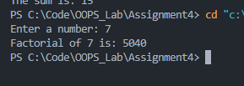

4. C++ Program to Enter Two Operands Using Constructors and Perform Arithmetic Operations

#include <bits/stdc++.h>

using namespace std;

class Arithmetic {

int a, b;

public:

Arithmetic(int x, int y) : a(x), b(y) {}

void add() {

cout << "Addition: " << a + b << endl;

}

void subtract() {

cout << "Subtraction: " << a - b << endl;

}

void multiply() {

cout << "Multiplication: " << a \* b << endl;

}

void divide() {

if (b != 0)

cout << "Division: " << (float)a / b << endl;

else

cout << "Division by zero error!" << endl;

}

};

int main() {

int x, y;

cout << "Enter two numbers: ";

cin >> x >> y;

Arithmetic obj(x, y);

obj.add();

obj.subtract();

obj.multiply();

obj.divide();

return 0;

}

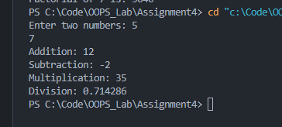

5. C++ Program to Model a Ticket Selling Booth

#include <bits/stdc++.h>

using namespace std;

class TicBooth {

int people;

float totalMoney;

const float ticketPrice = 2.50;

public:

TicBooth() : people(0), totalMoney(0.0) {}

void ticketNotSold() {

people++;

}

void ticketSold() {

people++;

totalMoney += ticketPrice;

}

void displayTotals() {

cout << "Total people visited: " << people << endl;

cout << "Total amount of money collected: Rs." << totalMoney << endl;

}

void displayTicketsSold() {

cout << "Total tickets sold: " << totalMoney / ticketPrice << endl;

}

};

int main() {

TicBooth booth;

booth.ticketNotSold(); // A person visited but did not buy a ticket

booth.ticketSold(); // A person visited and bought a ticket

booth.ticketSold(); // Another person bought a ticket

booth.displayTotals();

booth.displayTicketsSold();

return 0;

}

