1. In the below elements which of them are values or an expression? eg:- values can be integer or string and expressions will be mathematical operators.

* -> Expression

'hello' -> Value

-87.8 -> Value

- =>Expression

/ ->Expression

* -> Expression

6 -> Value

2. What is the difference between string and variable?

**ANS:** A Variable is a store of information, and a String is a type of information you would store in a Variable.

Eg. A = “Hello”

Here A is a variable and “Hello” is a string that is stored in variable A

3. Describe three different data types.

**Ans:** The three different types of Data Types are:

Integers: Whole numbers. Eg. 6,7,8

Float: Number with decimal point. Eg. 6.5, 7.55, 0.77

Boolean: Representing logical values. TRUE, FALSE.

4. What is an expression made up of? What do all expressions do?

An expression is a combination of operators and operands that is interpreted to produce some other value.

Eg: a = 2 + 3 and expressions are used to evaluate the values or represent the result on the screen.

5. This assignment statements, like spam = 10. What is the difference between an expression and a statement?

Expression is made up of values, containers, and mathematical operators (operands) and the statement is just like a command that a python interpreter executes like print.

6. After running the following code, what does the variable bacon contain?

bacon = 22

bacon + 1

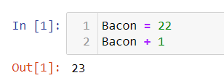

7. What should the values of the following two terms be?

'spam' + 'spamspam'

'spam' * 3

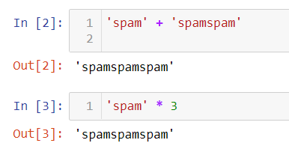

8. Why is eggs a valid variable name while 100 is invalid?

**Ans:** We cannot start the variable name with an integer. Me can start a variable with a string alphabet. Eg: a7 = 5

9. What three functions can be used to get the integer, floating-point number, or string version of a value?

**Ans:** str(), int(), float()

10. Why does this expression cause an error? How can you fix it?

'I have eaten ' + 99 + ' burritos.'

**Ans:** 99 is an integer it cannot be concatenated with strings, if we have to concatenate it we need to do typecasting.