PRACTICAL JOURNAL
Presentation Design
Slide Layouts, Themes, and Master Slides for Consistent Design

A Comprehensive Guide to Professional Presentation Design

Date: _______________
Student Name: _______________________________
Institution: _________________________________

TABLE OF CONTENTS
1. Introduction to Presentation Design
2. Understanding Slide Layouts
3. Master Slides Explained
4. Themes and Color Palettes
5. Typography in Presentations
6. Maintaining Design Consistency
7. Assignment Questions (1-10)

INTRODUCTION TO PRESENTATION DESIGN

What is Presentation Design?
Presentation design is the art and science of creating visually compelling and professionally coherent slide decks. It encompasses the strategic use of layouts, color schemes, typography, and visual elements to communicate ideas effectively. A well-designed presentation ensures that your message is not only heard but remembered.

Key Objectives:
• Communicate complex ideas clearly
• Maintain visual consistency across all slides
• Enhance audience engagement and retention
• Project professionalism and credibility

Why Consistency Matters
Consistent design strengthens brand identity and creates a professional impression. When slides follow a unified design system, audiences can focus on content rather than being distracted by visual inconsistencies. Master slides and themes are the foundation of this consistency.

UNDERSTANDING SLIDE LAYOUTS

What are Slide Layouts?
Slide layouts are pre-designed templates that organize content in specific ways. They define placeholder positions for text, images, and other elements. Standard presentation software includes multiple built-in layouts for different content types.

Common Slide Layout Types:
Layout Type | Use Case
Title Slide | Opening slide with presentation title and presenter name
Title & Content | Title at top with bullet points or content below
Two Content | Title with two columns for side-by-side comparison
Blank | Completely empty for custom designs
Picture with Caption | Large image with smaller text area

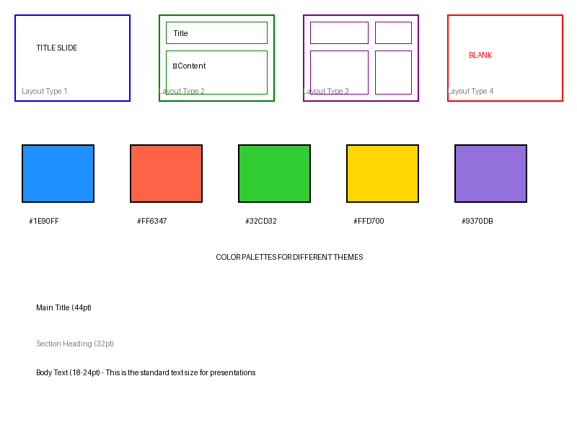

Benefits of Using Predefined Layouts:
✓ Saves time in design process
✓ Ensures alignment and spacing consistency
✓ Maintains professional appearance
✓ Reduces cognitive load on audience

MASTER SLIDES EXPLAINED

What are Master Slides?
Master slides are the underlying templates that control the overall look and feel of your presentation. Any changes made to a master slide automatically apply to all slides using that layout. They contain the default formatting, placeholder positions, logos, and design elements.

Master Slide Hierarchy:
1. Main Master Slide – Controls the overall presentation design
2. Layout Masters – Variations of the main master for different content types
3. Individual Slides – Based on selected layout masters
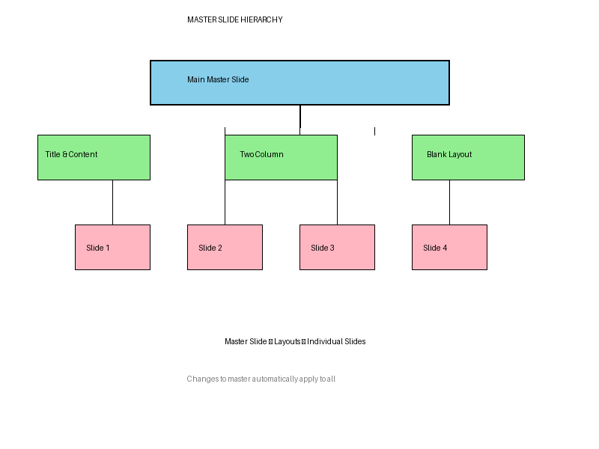

What Can You Customize in Master Slides?
• Background colors and images
• Logo placement and sizing
• Font families and sizes for titles and body text
• Placeholder positions and dimensions
• Color schemes and accent colors
• Footer information (date, page number, company name)

Steps to Access and Edit Master Slides:
1. Go to View menu → Select "Master" or "Master Slide" option
2. Select the main master or a specific layout master
3. Make your desired changes (fonts, colors, layout)
4. Close master slide view to apply changes globally

THEMES AND COLOR PALETTES

Understanding Design Themes
A theme is a unified design system that includes color schemes, fonts, effects, and layout principles. Themes ensure that all visual elements work harmoniously together.

Color Psychology in Presentations:
Color | Psychological Effect
Blue | Trust, stability, professionalism
Red | Energy, urgency, passion
Green | Growth, health, balance
Yellow | Optimism, creativity, attention
Purple | Innovation, luxury, creativity

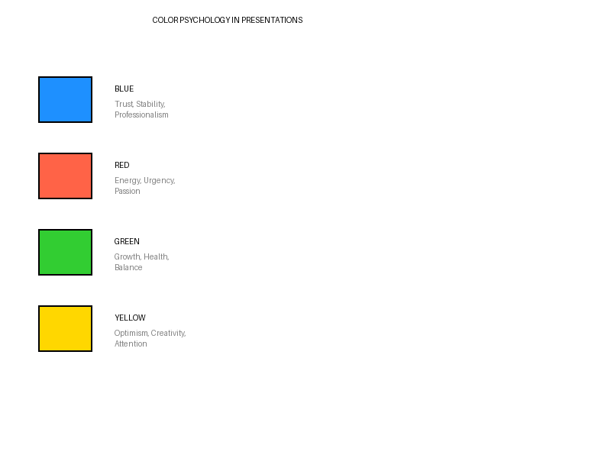

Creating a Cohesive Color Palette:
• Select 1 primary color (main brand color)
• Choose 2-3 secondary colors for variety
• Include neutral colors (white, gray, black) for balance
• Test color combinations for accessibility
• Maintain sufficient contrast for readability

TYPOGRAPHY IN PRESENTATIONS

Selecting Appropriate Fonts
Typography plays a crucial role in presentation readability and professionalism. The right font choice can enhance your message, while poor font selection can distract or confuse your audience.

Font Categories:
Serif Fonts (e.g., Times New Roman, Georgia)
Traditional, formal, good for body text in printed materials
Sans-serif Fonts (e.g., Arial, Helvetica, Calibri)
Clean, modern, highly readable on screens, ideal for presentations
Display Fonts (e.g., Impact, Brush Script)
Creative, attention-grabbing, use sparingly for titles only
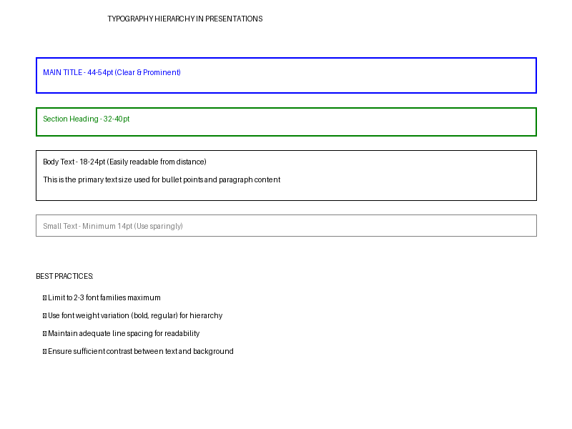

Font Size Guidelines:
• Title: 44-54 pt (clear, prominent)
• Heading: 32-40 pt
• Body Text: 18-24 pt (easily readable from distance)
• Small Text: Minimum 14 pt

Typography Best Practices:
✓ Limit to 2-3 font families maximum
✓ Use font weight variation (bold, regular) for hierarchy
✓ Maintain adequate line spacing for readability
✓ Avoid all-caps text for body content
✓ Ensure sufficient contrast between text and background

MAINTAINING DESIGN CONSISTENCY

The Consistency Framework
A consistent presentation demonstrates professionalism and aids audience comprehension. When viewers see repeated design patterns, they can predict where information will appear and focus on content.

Key Areas for Consistency:
Layout Consistency:
Keep title positions, text alignment, and content placement consistent across slides
Color Consistency:
Use the same color palette throughout; apply colors predictably
Typography Consistency:
Maintain the same fonts and sizing patterns for similar elements
Visual Element Consistency:
Use consistent styles for icons, images, and decorative elements
Branding Consistency:
Place logos, headers, and footers in consistent locations

Practical Tips for Maintaining Consistency:
1. Always use the master slide for any global changes
2. Create a style guide document for your presentation
3. Use slide templates for repeated content types
4. Review entire presentation in Slide Sorter view
5. Test your design on different screens/projectors

ASSIGNMENT QUESTIONS & PRACTICAL EXERCISES

Assignment 1: Identify and Categorize Slide Layouts
Task: Examine a professional presentation and identify at least 5 different slide layouts used. Describe the purpose of each layout and explain why the designer chose it for that particular slide.
Your Response:
_________________________________________________________________
_________________________________________________________________
_________________________________________________________________

Assignment 2: Create a Master Slide Design
Task: Design a master slide for a corporate presentation on "Sustainable Business Practices." Include: company logo placement, color palette selection (justify your color choices), font selections for titles and body text, and header/footer design.
Your Design Specifications:
_________________________________________________________________
_________________________________________________________________
_________________________________________________________________

Assignment 3: Color Palette Analysis
Task: Select 3 presentations from different industries (e.g., tech, healthcare, finance). Analyze their color palettes and explain how the colors support the presentation's message and industry standards.
Industry Analysis:
_________________________________________________________________
_________________________________________________________________
_________________________________________________________________

Assignment 4: Typography Hierarchy Design
Task: Create a typography hierarchy system for a presentation. Define font families, sizes, weights, and colors for: Main Title, Section Heading, Body Text, and Callout/Emphasis. Sketch or describe how each level differs visually.
Typography System:
_________________________________________________________________
_________________________________________________________________
_________________________________________________________________

Assignment 5: Layout Template Customization
Task: Take a standard "Title & Content" layout and customize it. Document all changes made including: placeholder positions, sizing adjustments, added design elements, and the rationale behind each change.
Customization Details:
_________________________________________________________________
_________________________________________________________________
_________________________________________________________________

Assignment 6: Consistency Audit
Task: Review a presentation that lacks consistency and identify at least 10 inconsistencies (different fonts, colors, alignments, etc.). Create a revision plan to fix these issues using master slides and themes.
Inconsistencies Found & Fixes:
_________________________________________________________________
_________________________________________________________________
_________________________________________________________________

Assignment 7: Responsive Layout Design
Task: Design slide layouts that work well in both 16:9 widescreen and 4:3 standard formats. Explain how you adjust element placement and sizing for each format while maintaining design integrity.
Responsive Design Approach:
_________________________________________________________________
_________________________________________________________________
_________________________________________________________________

Assignment 8: Brand Identity in Presentations
Task: Select a company's brand guidelines. Create 3 different presentation master slides that all adhere to the brand identity while varying in style. Explain how you maintained brand consistency while allowing design flexibility.
Brand-Aligned Designs:
_________________________________________________________________
_________________________________________________________________
_________________________________________________________________

Assignment 9: Accessibility in Design
Task: Design presentation slides that meet accessibility standards (WCAG 2.0). Address: color contrast ratios, font legibility, text size, alternative text for images, and logical slide structure. Document your accessibility features.
Accessibility Features:
_________________________________________________________________
_________________________________________________________________
_________________________________________________________________

Assignment 10: Complete Presentation System
Task: Create a complete presentation system for a client (real or fictional) including: master slide design, 5 different layout templates, color palette (with hex codes), typography guide, logo placement guidelines, and a sample 5-slide presentation demonstrating all elements. Include a written summary of design decisions.
Complete System Documentation:
_________________________________________________________________
_________________________________________________________________
_________________________________________________________________

REFLECTION & NOTES

Key Learnings:
Reflect on what you've learned about presentation design. What concepts were most valuable? How will you apply these principles in future presentations?
_________________________________________________________________
_________________________________________________________________
_________________________________________________________________

Challenges Faced:
What challenges did you encounter during the assignments? How did you overcome them?
_________________________________________________________________
_________________________________________________________________
_________________________________________________________________

Future Applications:
How will you use these presentation design skills in your professional or academic work?
_________________________________________________________________
_________________________________________________________________
_________________________________________________________________

QUICK REFERENCE GUIDE

Master Slide Editing Checklist:
☐ Access master slide view (View → Master/Slide Master)
☐ Select main master or specific layout master
☐ Adjust background and color scheme
☐ Place and format logos and brand elements
☐ Set default fonts and text formatting
☐ Configure placeholder positions and sizes
☐ Add header and footer information
☐ Exit master view and test changes

Design Consistency Checklist:
☐ All slides use layouts from master slides
☐ Color palette consistent throughout
☐ Font selections match style guide
☐ Image styles and filters are uniform
☐ Logo placement consistent across all slides
☐ Text alignment follows established patterns
☐ Spacing and margins are uniform
☐ Transitions and animations are consistent (or minimal)

Recommended Resources:
• Presentation Software Tutorials (Microsoft Office, Google Slides, Keynote)
• Color Theory Resources (Coolors.co, Adobe Color Wheel)
• Typography Resources (Google Fonts, Font Pairing Guide)
• Design Inspiration (Dribbble, Behance, Unsplash)
• Accessibility Guidelines (WCAG 2.0, WebAIM)

