**Project 2 Part 2 (square with min area)**

Name: Arnav Jain Period: 3

Date: 9/30/21

Is your lab name l022?(lowercase L followed by digits 022) yes

Did you comment out the call to part1 method? yes

Did you create a class for a Point? yes

Did you create a class for a Line? yes

List all classes you created in this project: Point, Line

Did you use the precision for the points like in the sample? yes

Did you test your file on a school computer using jupyterhub/ssh? yes

Did your file compile and run on school computer (jupyterhub)? yes

Paste here **2 sets of clear picture/content** of the points.txt, output.txt and output.ppm you created when running 2 times your lab :

* one of the runs should be on the sample provided by Mr. Jurj;
* 
* Points.txt
* 
* output.txt



* the other run on a random set of points.txt your part1 generated!! :
* 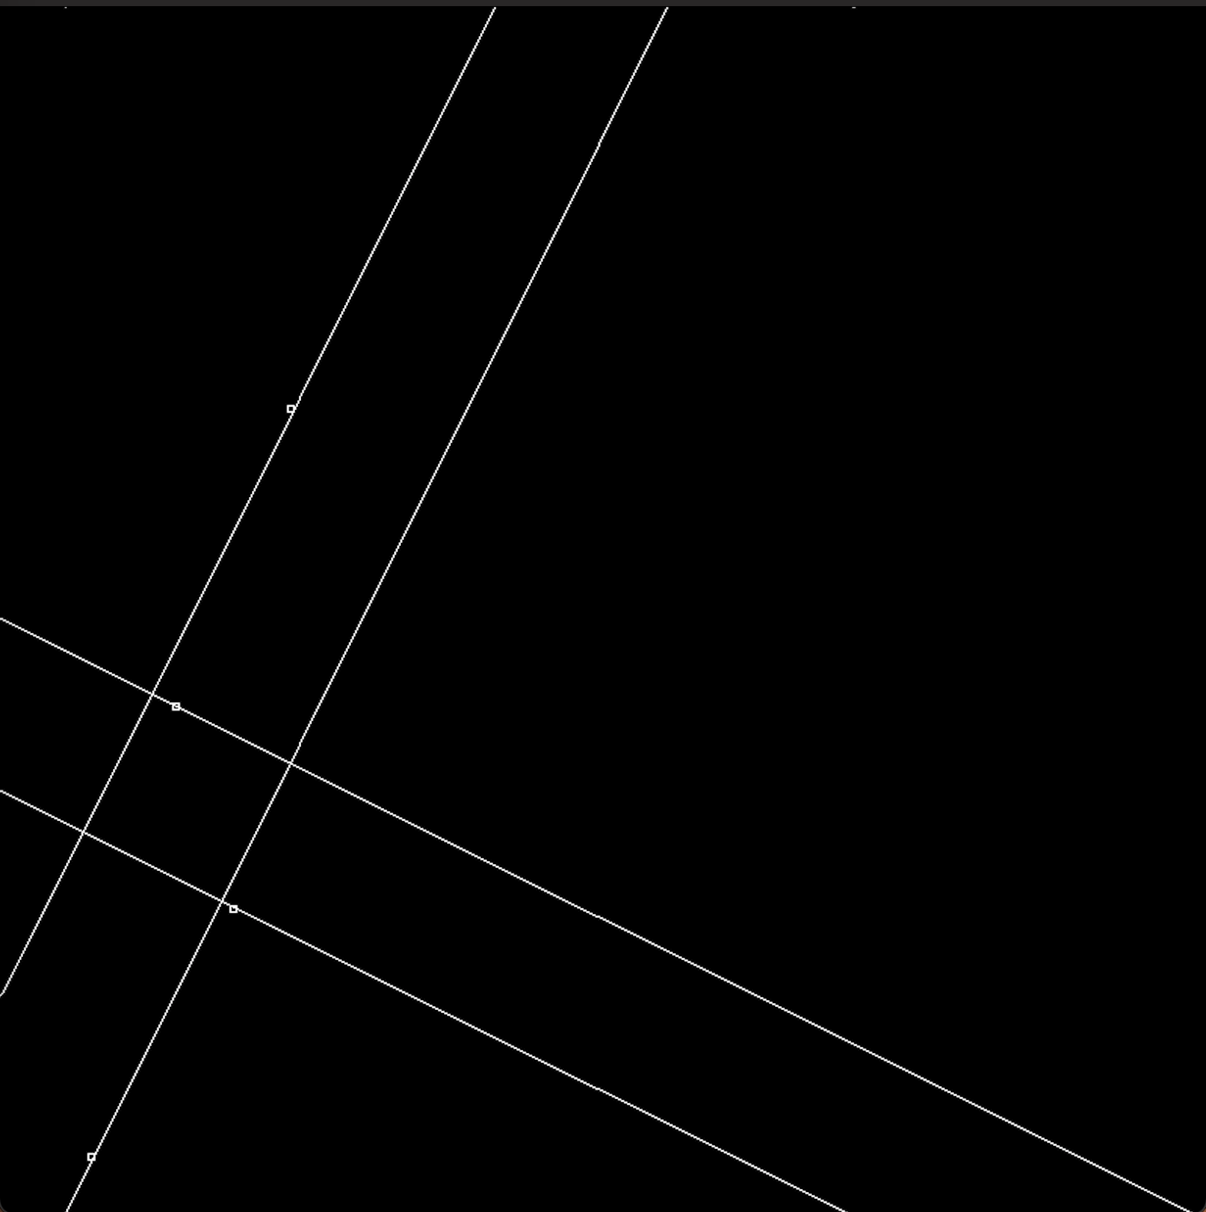
* (output.txt)
* 
* (points.txt)
* 