**Project 8 Rotating a platonic solid with OpenCV**

Name: Arnav Jain Period: 3 Date: 04/21

Did you name your file l081.cpp (Lower case L, then 071)? yes

Does your file compile & run on terminals/jupyterhub? yes

Did you use a rotation matrix? yes

Did you do orthographic rendering? yes

Did you start from the coordinates I provided for the cube?? yes

Describe here in words all the transformations you applied to vertices, for each describe how you implemented it in your code (by multiplying with a matrix, what was the matrix, or by adding a matrix, what was that matrix… be specific):

I scaled up by multiplying the coordinates by 100 using an homogenous matrix, I then added a rotation that rotated the matrix down by 30 degrees.

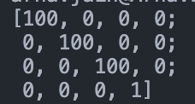

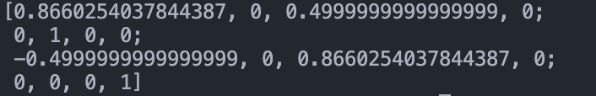

Did you use homogenous coordinates? yes

(that allows you to combine all transformations into one matrix)

Did you combine all those transformations into one single matrix? no

If you used only one transformation matrix, what was it?

Did you name your video rotation.avi? yes

What functions/methods from OpenCV did you use?

I used Mat for the matrices, VideoCapture to convert the matrices to a .avi video, a line and circle to represent vertices and edges, Points to represent the vertices, and Scalars/Vec3b to represent colors.

What functions/methods from OpenCV did you experiment with but ended not using?

I experimented with the * operator to multiply matrices, but I decided to implement my own matrix multiplication method to get more experience with accessing and manipulating values in the Mat matrix type.

Obs.: feel free to rotate any platonic solid, around any line.