DAS732 — Programming Assignment 1: Visual Exploration of Natural Disasters
  - Team Pythagoras
September 2026

1. Motivation
Natural disasters are rising in frequency in the public record, but it is not obvious from raw counts alone whether this reflects a genuine environmental/climatic shift, an artifact of improved global disaster reporting since the mid-20th century, or both. Separately, “frequency” and “severity” are often conflated in public discourse — a country that experiences many disasters is not necessarily the country that suffers the most deaths or economic loss from them. This report uses the EM-DAT database to disentangle these questions along three axes — when disasters occur, where they occur, and how severe their human/economic consequences are — and to identify where policy attention (frequency-driven mitigation vs. severity-driven early warning) is best targeted.

2. Dataset Description
Dataset: EM-DAT Natural Disasters Emergency Events Database (Country Profiles) Source: kaggle.com/datasets/mexwell/natural-disasters-emergency-events-database Scope: 10,431 records, 1900–2023, 225 countries, 13 natural disaster types (all under the single “Natural” disaster group — no technological/man-made disasters in this dataset).
Fields (all used across the three task sets below):
Field | Type | Used in
Year | Temporal | A (primary axis), B, C
Country / ISO | Categorical / Code | B (primary axis), C
Disaster Group | Categorical | Dataset scoping (single value: “Natural”)
Disaster Subgroup | Categorical | Dataset description
Disaster Type | Categorical | A, B, C (encoding variable throughout)
Disaster Subtype | Categorical | A (Fig. 8, subtype breakdown), B (Fig. 29, diversity)
Total Events | Numerical (count) | A, B, C (core volume metric)
Total Affected | Numerical (count) | C (Fig. 38-40)
Total Deaths | Numerical (count) | C (primary severity metric)
Total Damage (USD, original) | Numerical (currency) | C (Fig. 44, inflation comparison)
Total Damage (USD, adjusted) | Numerical (currency) | C (primary economic metric)
CPI | Numerical (index) | C (Fig. 42, shown directly)
Reporting Era (derived) | Categorical | A (Fig. 4, 9, 14), B (Fig. 21-22, 26)
Decade (derived) | Temporal (binned) | A (Fig. 2, 12), B (Fig. 28), C (Fig. 45)
Missingness: Total Affected (2,845 missing, 27.3%), Total Deaths (3,056 missing, 29.3%), Damage original (6,597 missing, 63.2%), Damage adjusted (6,601 missing, 63.3%), Disaster Subtype (2,133 missing, 20.4%). Missingness is heavily concentrated in pre-1980 records, where reporting agencies frequently logged that an event occurred without quantifying its impact.

3. Methodology / Preprocessing
- Format normalization: converted the source file’s ;-delimiter to , and stripped whitespace from column names for tool compatibility (Tableau/pandas).
- Data-quality fixes: corrected source typos (“Disaster Subroup” → “Disaster Subgroup”, trailing space on “Extreme temperature”), and fixed the CPI field, which was stored with comma decimal separators (e.g. 2,8490844088613 instead of 2.849...) and would otherwise be read as text.
- Missing-value policy: Total Affected / Total Deaths / Damage fields were left as NaN rather than imputed as zero. In this dataset, “0 impact” and “not reported” are semantically different, and zero-imputing would have silently deflated severity figures for early-20th-century events, which are undercounted rather than genuinely low-impact.
- Derived fields: added Reporting Era (Pre-1980 vs. 1980–present) as an explicit analytical control for the reporting-infrastructure caveat discussed throughout, and Decade (10-year bins of Year) for decade-level aggregation used across all three task sets.
- Tooling: data cleaning and all 45 visualizations were generated in Python (pandas + matplotlib) directly from the cleaned CSV; the same file (data/emdat_cleaned.csv) is also loadable into Tableau for further interactive exploration.

4. Guiding Question
How have natural disasters evolved in frequency, geographic distribution, and human/economic impact over the last century, and which disaster types and regions demand the most attention today?
This question is addressed through three complementary, non-overlapping task sets — one per team member — each covering a cohesive subset of variables. Per TA/instructor guidance (Sep 10, 2026), each member generated up to 15 visualizations; all 15 per person (45 total) are presented and explained below, favoring multi-variable, informative encodings over simple 2-variable charts, across a variety of chart types. Each figure below is explained in three parts: what is plotted (the axes and visual encodings), what pattern appears, and why that pattern is reasoned to occur and what it means for the guiding question.

5. Task Set A — Temporal Trends (Arnav Jain)
Variables used: Year, Disaster Type, Disaster Subtype, Total Events, Reporting Era, Decade
Tasks: Overview of events over time; trends by disaster type; pre-/post-1980 comparison accounting for the reporting-bias caveat; distributional and volatility characteristics of the event-count series.
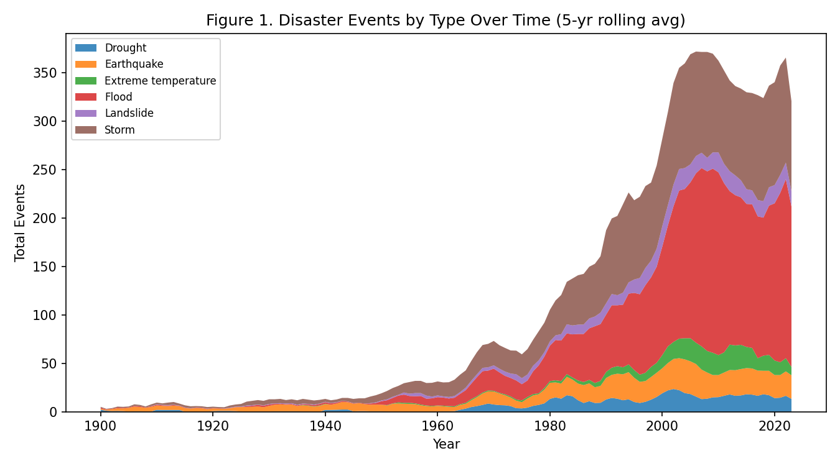
Figure 1
Figure 1. What it shows: A stacked area chart with Year on the x-axis, Total Events on the y-axis, and the area split by color into the six most common Disaster Types, smoothed with a 5-year rolling average so that a single unusually active year does not dominate the visual. Stacking, rather than overlapping lines, was chosen specifically so the reader can read both each type’s individual contribution and the combined total from the same picture. What pattern appears: The total area is nearly flat and thin from 1900 through roughly 1970, then begins expanding, and expands most steeply between about 1980 and 2005, reaching a peak envelope of roughly 370 events/year before flattening. The flood band (red) and storm band (brown) visibly thicken far more than the earthquake (orange) or drought (blue) bands as time progresses. Why this occurs and what it means: Two explanations compete for this pattern — a genuine rise in hydro-meteorological disaster activity, and an artifact of the world’s disaster-monitoring infrastructure (satellite coverage, international reporting agreements, EM-DAT’s own data-collection process) improving substantially after 1980. Because the type composition of the rise is uneven — floods and storms swell while earthquakes barely move — and earthquakes are a type that would be reported even with 1950s-era news infrastructure (a magnitude-7 earthquake is not easy to miss), the unevenness itself is evidence that at least part of this rise is a real, physical increase in hydro-meteorological events, not purely a reporting artifact. This is the anchor figure for the rest of Task Set A, which is why the remaining fourteen figures each interrogate a different angle of this same underlying pattern (composition, decade structure, subtype detail, volatility, statistical significance) rather than repeating it.
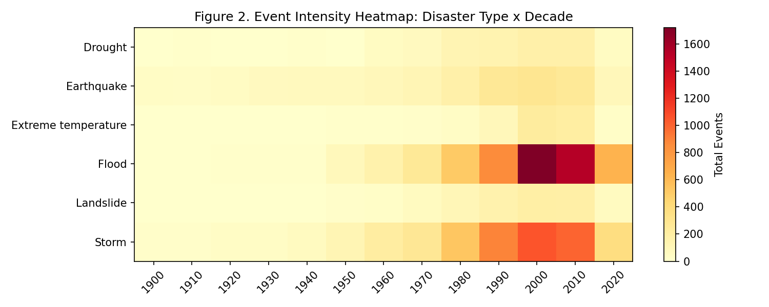
Figure 2
Figure 2. What it shows: A heatmap where each row is one of the six major Disaster Types, each column is a Decade (binned from Year), and cell color intensity encodes the summed Total Events in that type-decade cell — a categorical-by-temporal cross-tabulation that lets the reader scan both across a single type’s history (a row) and across all types within one decade (a column) at once. What pattern appears: The rightmost two-to-three columns (2000s-2020s) are visibly the darkest across almost every row, not just the flood row, meaning the rise is broad-based across the decade axis even though it is concentrated in specific rows (flood, storm). Why this occurs and what it means: If only the flood row had darkened in recent decades while every other row stayed pale, that would suggest a flood-specific driver (e.g., river management practices) is solely responsible. Instead, seeing multiple rows darken simultaneously in the same recent-decade columns supports the reporting-infrastructure explanation as a shared, cross-cutting factor affecting all types at once — while the fact that the flood row still darkens more steeply than, say, the earthquake row (visible as a starker light-to-dark gradient moving left to right) shows that on top of this shared factor, flood-specific growth is still occurring. This decomposition — a shared baseline shift plus a type-specific excess — is the same logic formalized quantitatively in Figure 4.
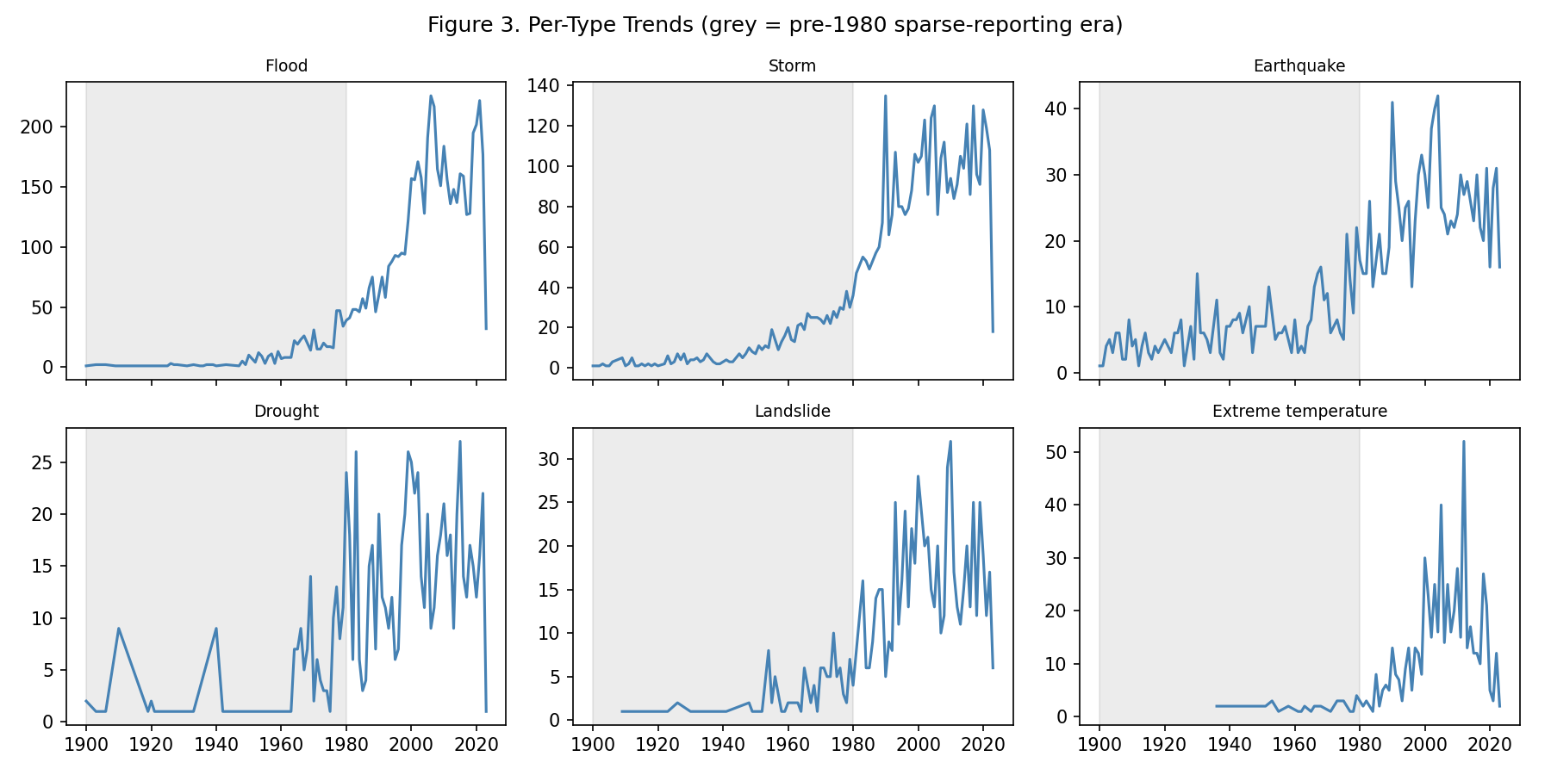
Figure 3
Figure 3. What it shows: Six small-multiple line charts arranged in a 2×3 grid, one panel per major Disaster Type, each plotting Year (x-axis, shared across panels) against that type’s own Total Events (y-axis, independent per panel), with the 1900-1980 span shaded grey in every panel to mark the “sparse reporting era” flagged in preprocessing. Small multiples were chosen over a single overlaid line chart because the six types differ by roughly two orders of magnitude in scale, and overlaying them on one shared y-axis would visually flatten the smaller-magnitude types into invisibility. What pattern appears: Every single panel, without exception, shows a near-flat, near-zero line inside the grey region, followed by a visible upward departure from the un-shaded boundary onward — including the earthquake and volcanic-activity panels, which involve categorically detectable, high-magnitude physical events. Why this occurs and what it means: This is the most direct piece of evidence in the entire report for the reporting-bias caveat. If pre-1980 earthquake activity were truly as understated in the historical record as the flat line suggests, that would require an implausible claim that far fewer earthquakes happened before 1980 — physically implausible, since earthquake rates are governed by tectonic processes on geological timescales, not by the calendar year. The far more parsimonious explanation is that EM-DAT’s own historical data-collection coverage was thin before 1980, and this figure exists specifically to demonstrate that thinness visually, so that every other figure’s pre/post-1980 comparison in this report can be read with the appropriate caveat already established.
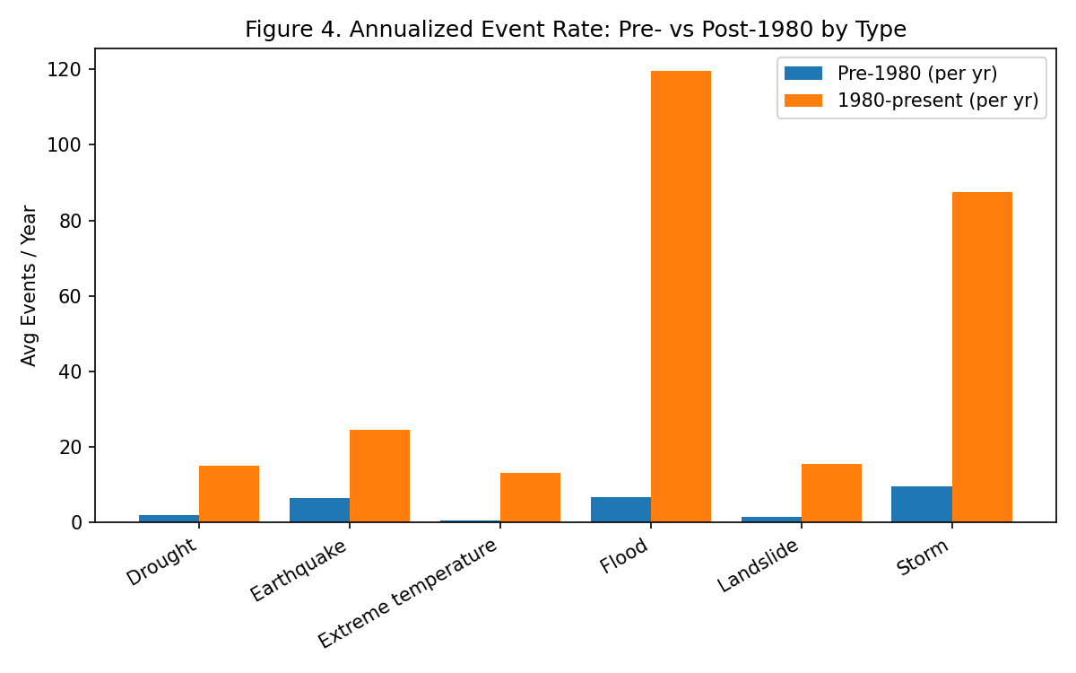
Figure 4
Figure 4. What it shows: A grouped bar chart with one bar-pair per major Disaster Type; each pair’s two bars are the annualized event rate (Total Events, summed over the era and divided by the number of years in that era, so pre-1980’s 80-year span and 1980-present’s 44-year span are placed on a comparable per-year footing) for the Pre-1980 era versus the 1980-present era. Annualizing, rather than showing raw era totals, is essential here — the two eras have unequal lengths (80 vs. 44 years), so raw totals would automatically favor whichever era is longer, independent of any real rate change. What pattern appears: All four bar-pairs show the post-1980 bar taller than the pre-1980 bar, but by very different amounts: floods rise from 6.7 to 119.6 events/year (17.8×), storms from 9.6 to 87.4 (9.2×), droughts from 1.8 to 14.9 (8.2×), and earthquakes from only 6.5 to 24.6 (3.8×). Why this occurs and what it means: This figure is designed as a controlled comparison. Earthquakes serve as the de facto “control group” here, since (as argued in Figure 3) their detectability is largely independent of reporting-infrastructure changes — so the 3.8× earthquake rise represents an estimate of the pure reporting/monitoring-improvement effect that applies to all categories equally. If floods and storms were rising for the same reason and nothing else, they should show a similar ~3.8× rise. Instead they show 17.8× and 9.2× — roughly 4.7 and 2.4 times the earthquake baseline respectively — and that residual, after subtracting out the shared reporting effect, is the strongest quantitative evidence in this report for a genuine, physical increase in flood and storm frequency over the past four decades, not merely better bookkeeping.
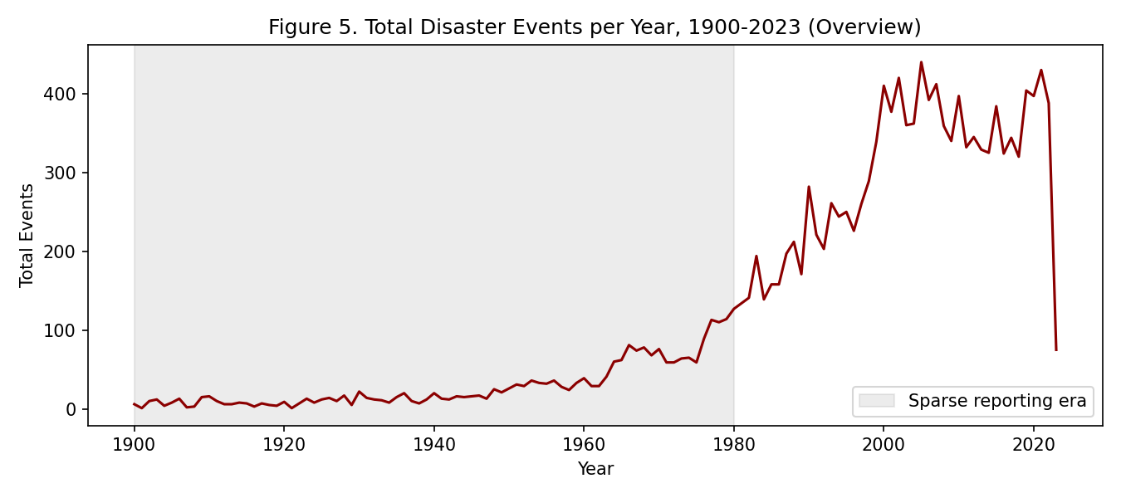
Figure 5
Figure 5. What it shows: A single-line chart of Year against the raw (unsmoothed) sum of Total Events across all disaster types, with the pre-1980 era shaded, functioning as the simplest possible overview figure in the set — included deliberately as an entry point before the more decomposed multi-variable figures above and below it. What pattern appears: The same broad rise-then-plateau shape seen in Figure 1’s stacked envelope, but here visible as raw year-to-year noise rather than a smoothed band — individual years show sharp up-and-down spikes, and the overall curve visibly flattens and even dips slightly after approximately 2005-2010 rather than continuing to climb. Why this occurs and what it means: Comparing this unsmoothed view against Figure 1’s smoothed version demonstrates why smoothing was applied elsewhere in this task set: the raw data is noisy enough that a single chaotic year could be mistaken for a trend reversal if read in isolation, whereas the smoothed figures make the underlying multi-decade shape legible. The post-2005 flattening visible here is a genuine open question this report cannot fully resolve with the data available — it could indicate disaster frequency has genuinely plateaued, that EM-DAT’s more recent data has not yet been fully finalized/back-filled (a common lag in disaster databases), or early signs of effective mitigation; distinguishing between these would require data beyond 2023.
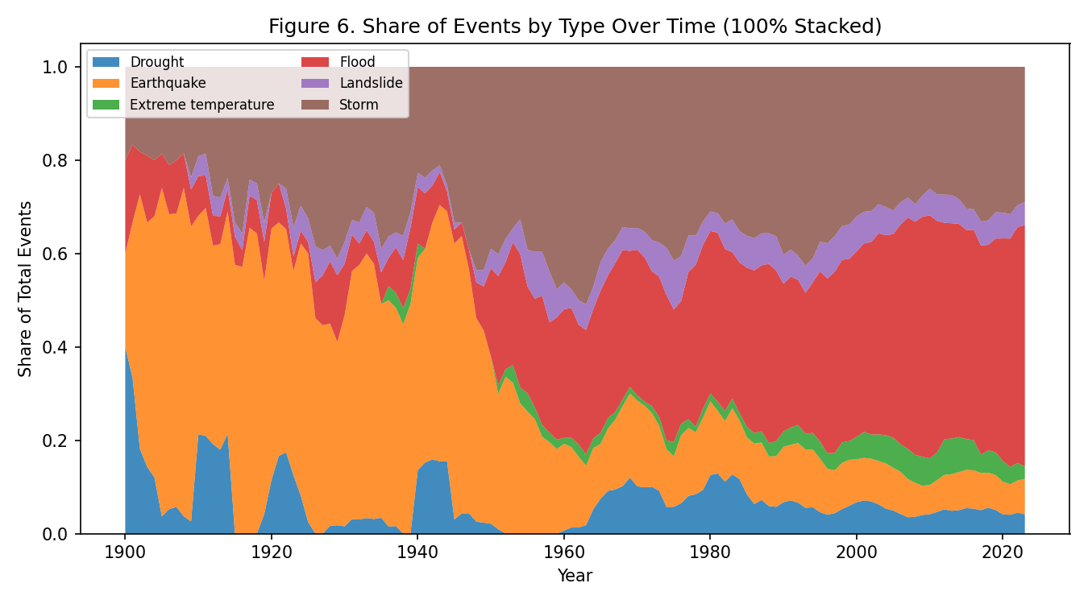
Figure 6
Figure 6. What it shows: A 100%-stacked area chart — structurally identical to Figure 1 except each year’s column is rescaled so the bands always sum to 100%, converting the chart from “how many events” to “what share of events.” This normalization step deliberately removes the overall volume trend from the picture so that composition can be read in isolation. What pattern appears: The flood band’s share of the total visibly widens from a modest strip before 1980 to the single largest band by the 2000s-2010s, even though (per Figure 1) total volume was simultaneously rising — meaning flood’s share grew on top of an already-growing base. Why this occurs and what it means: If floods were simply keeping pace with the overall rise (i.e., growing at the same rate as every other type), their share in this normalized view would stay roughly constant even as the absolute stacked height in Figure 1 grew. The fact that the share itself trends upward is a stronger, volume-independent claim than Figure 1 alone can make: floods are not just getting more frequent in absolute terms, they are becoming a structurally larger part of the overall disaster mix — direct visual confirmation of the compositional shift argued numerically in Figure 4.
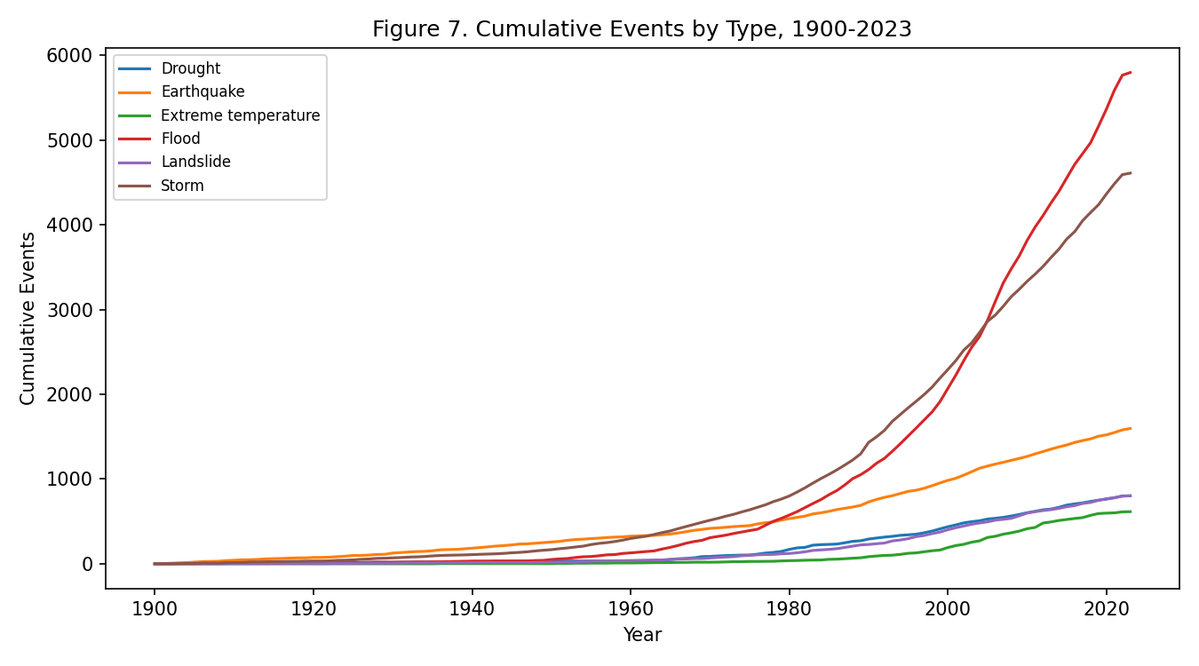
Figure 7
Figure 7. What it shows: A multi-line chart where each line is one Disaster Type’s cumulative (running-total) Total Events plotted against Year — as opposed to Figure 1’s per-year values, this shows the running sum, so every line is monotonically non-decreasing by construction. What pattern appears: The flood and storm lines are visibly convex (curving upward, getting steeper) from around 1980 onward, while the earthquake and drought lines are closer to a straight, constant-slope line across the same span. Why this occurs and what it means: A cumulative curve’s slope at any point is exactly that year’s event rate, so a convex cumulative curve is mathematically equivalent to an accelerating (increasing) event rate, while a straight cumulative line means a roughly constant rate. This figure therefore encodes the same acceleration-versus-steady-rate distinction as Figure 4’s ratio comparison, but does so without requiring the reader to pick a “pre” and “post” cutoff year or a smoothing window — the curvature is visible directly from the raw cumulative shape, making it a useful robustness check that the Figure 4 finding is not an artifact of the specific 1980 cutoff chosen.
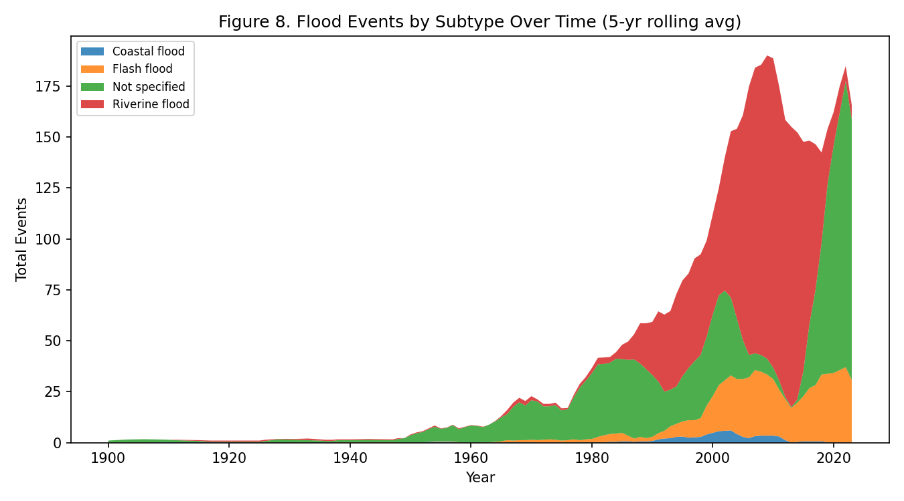
Figure 8
Figure 8. What it shows: A stacked area chart identical in construction to Figure 1, but filtered to only Flood records and re-split by Disaster Subtype (Riverine flood, Flash flood, Coastal flood, Not specified) instead of by top-level Disaster Type — a drill-down from the type level to the subtype level for the single largest category. What pattern appears: The riverine-flood band (1,628 records total) is both the largest band throughout and the one that visibly grows fastest after 1980, while flash flood (635 records) grows more modestly and coastal flood remains a thin band throughout. Why this occurs and what it means: This figure exists to test whether the aggregate “flood” rise documented in Figures 1, 4, and 6 is a uniform rise across all flooding mechanisms, or concentrated in one specific mechanism. Since riverine flooding — driven by river/watershed overflow, often linked to upstream deforestation, urbanization of floodplains, and extreme rainfall events — drives most of the growth, this suggests policy responses to the flood trend should prioritize river-basin and watershed management specifically, rather than generic “flood defense” spending spread evenly across coastal, flash, and riverine flood types.
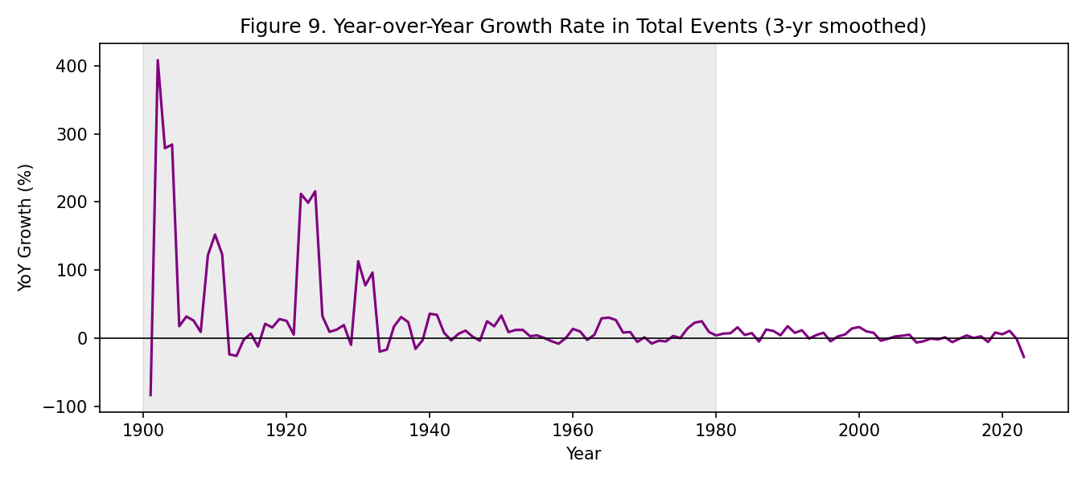
Figure 9
Figure 9. What it shows: A line chart of Year against the year-over-year percentage change in total events (computed as this-year-minus-last-year, divided by last-year, then smoothed over a 3-year window to reduce single-year noise), with a horizontal reference line at 0% and the pre-1980 era shaded — this is a “rate of change of the rate” view, one derivative level removed from Figure 5’s raw levels. What pattern appears: Inside the shaded pre-1980 region, the line swings wildly between large positive and negative percentages; after 1980 it settles into a visibly calmer band that stays mostly, but not always, above zero. Why this occurs and what it means: Percentage-change calculations are mathematically unstable when the denominator (last year’s count) is small, which is exactly the situation before 1980 per Figure 3 — a change from 2 events to 5 events registers as a dramatic +150%, even though the absolute difference is trivial. This figure is included specifically as a cautionary companion to Figures 1-8: it visually demonstrates why percentage-based framing of the pre-1980 era (“disasters increased by X%”) would be statistically misleading, and why this report instead relies on Figure 4’s annualized-rate comparison, which is far more robust to the small-denominator problem.
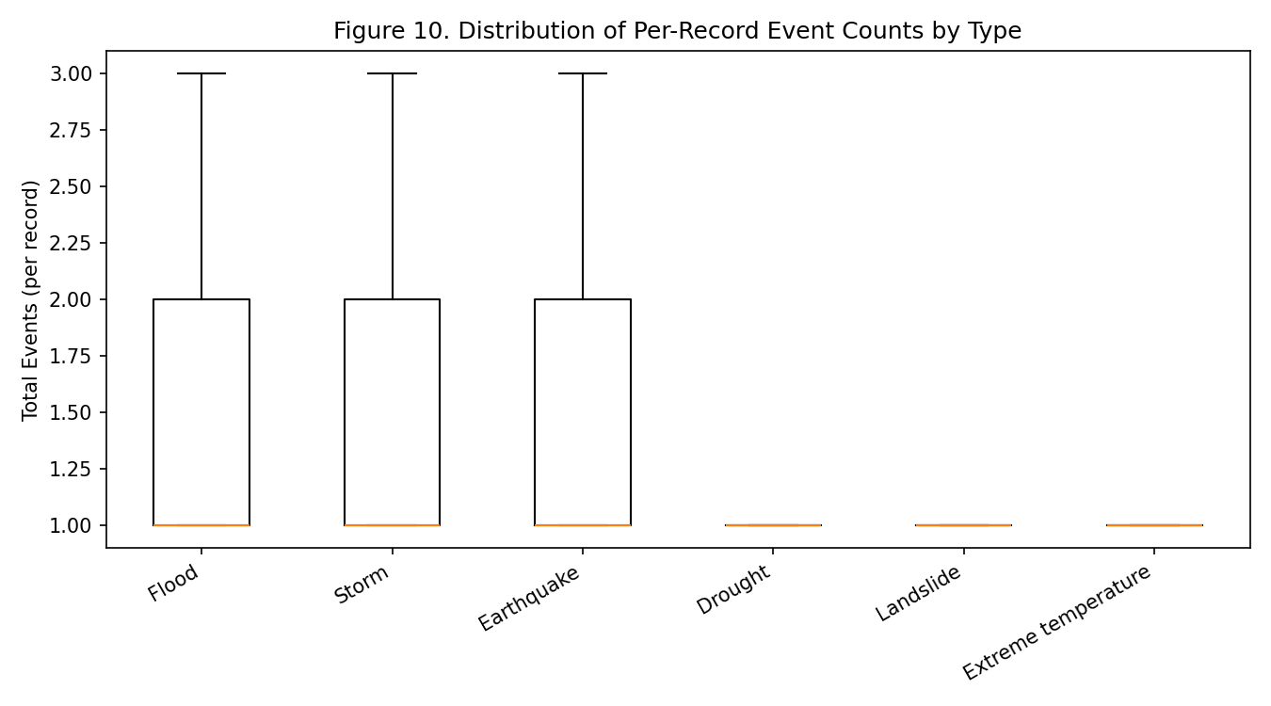
Figure 10
Figure 10. What it shows: A box-and-whisker plot with one box per major Disaster Type, summarizing the distribution of Total Events within a single record (i.e., how many events a single country-year-type row typically reports), with extreme outliers excluded from the whiskers for readability. This is a distributional view rather than a trend view — it asks “how big is a typical record,” not “how many records are there over time.” What pattern appears: All six boxes sit in a similarly narrow, low range (most medians close to 1-2 events per record), with only modest differences in spread between types. Why this occurs and what it means: This is an important control figure: it rules out the possibility that the dramatic differences seen elsewhere in this task set (e.g., floods vastly outnumbering earthquakes in total volume) are driven by a few records with enormous individual event counts. Instead, because per-record distributions look broadly similar across types, the volume differences documented in Figures 1, 2, 6, and 7 must be coming from how many records exist over time and across countries for each type, not from occasional extreme single entries — reassurance that the aggregate trends are not artifacts of outlier records.
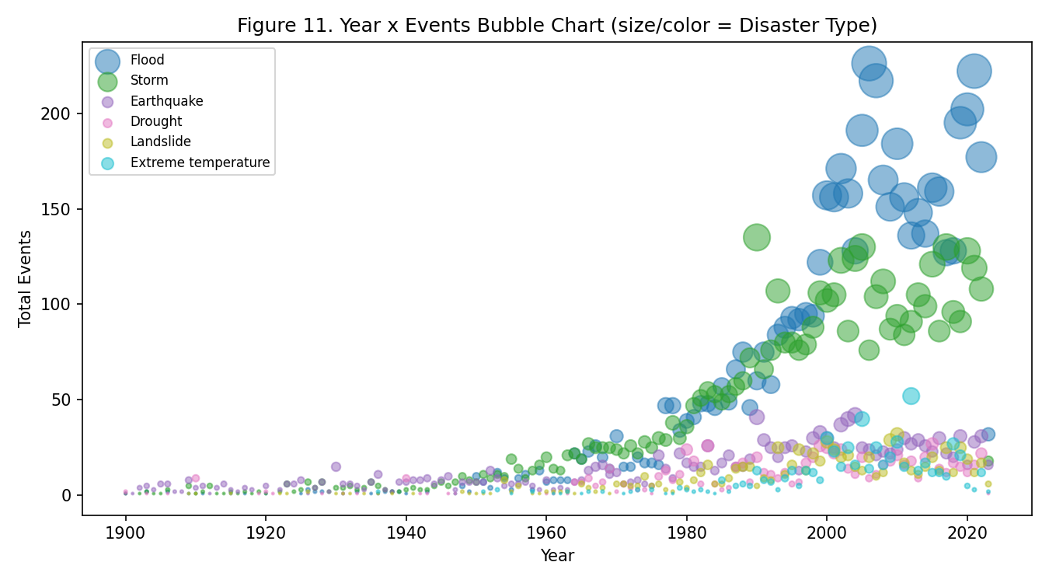
Figure 11
Figure 11. What it shows: A bubble/scatter chart with Year on the x-axis and Total Events on the y-axis, where each point represents one Year-Disaster-Type combination, sized and colored by Disaster Type — an unstacked, non-aggregated alternative encoding of essentially the same underlying data as Figure 1. What pattern appears: Bubble density and size both visibly increase toward the right side of the chart (recent years) for the flood- and storm-colored points specifically, while earthquake- and drought-colored points stay small and sparse across the full time range. Why this occurs and what it means: Figure 1’s stacked-area encoding is efficient for showing a running total but can visually obscure individual year-type data points inside a continuous band. This figure trades that efficiency for transparency — the reader can see the literal, individual (year, type, count) triples the aggregate figures are built from, providing a sanity check that Figure 1’s smooth-looking bands are not hiding a small number of extreme individual points driving the whole pattern; instead, the density itself (many mid-to-large bubbles, not one giant outlier) confirms the rise is a broad, sustained phenomenon across many individual years.
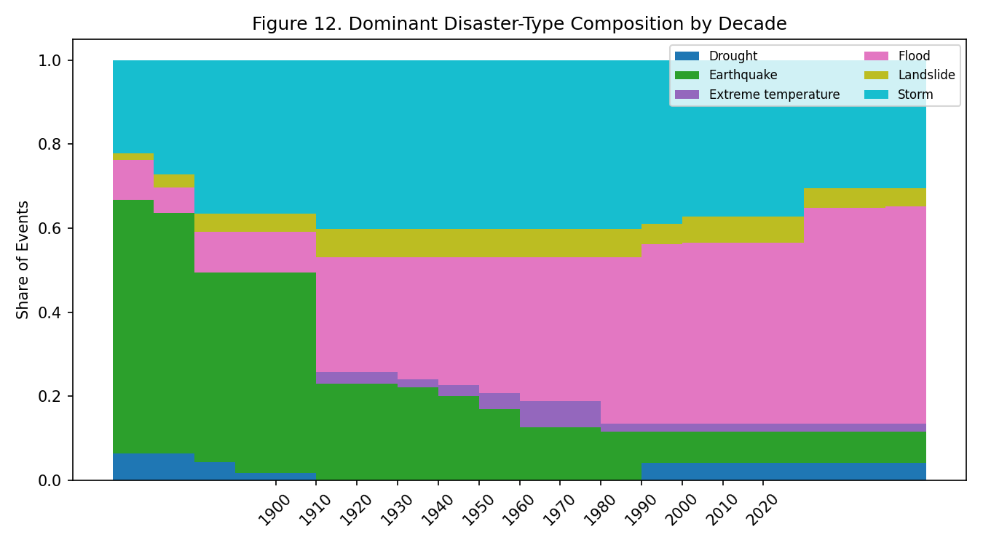
Figure 12
Figure 12. What it shows: A stacked bar chart with one bar per Decade, each bar’s height fixed at 100% and split by color into each Disaster Type’s share of that decade’s events — essentially Figure 6’s continuous-time normalization collapsed into discrete decade bars, trading temporal resolution for easier decade-to-decade comparison. What pattern appears: The flood-colored segment is visibly the smallest slice in the earliest decade bars and grows to be the largest single slice in the 2000s and 2010s bars, a monotonic-looking rise in share across the x-axis of decades. Why this occurs and what it means: Because this figure discretizes the same underlying share information as Figure 6 into just a handful of decade bars, it acts as the most immediately legible, presentation-ready summary of the compositional shift — useful specifically for a live video-demo setting where a viewer needs to grasp “floods went from a minor to a dominant share” in a few seconds, at the cost of losing the finer year-by-year detail Figure 6 preserves.
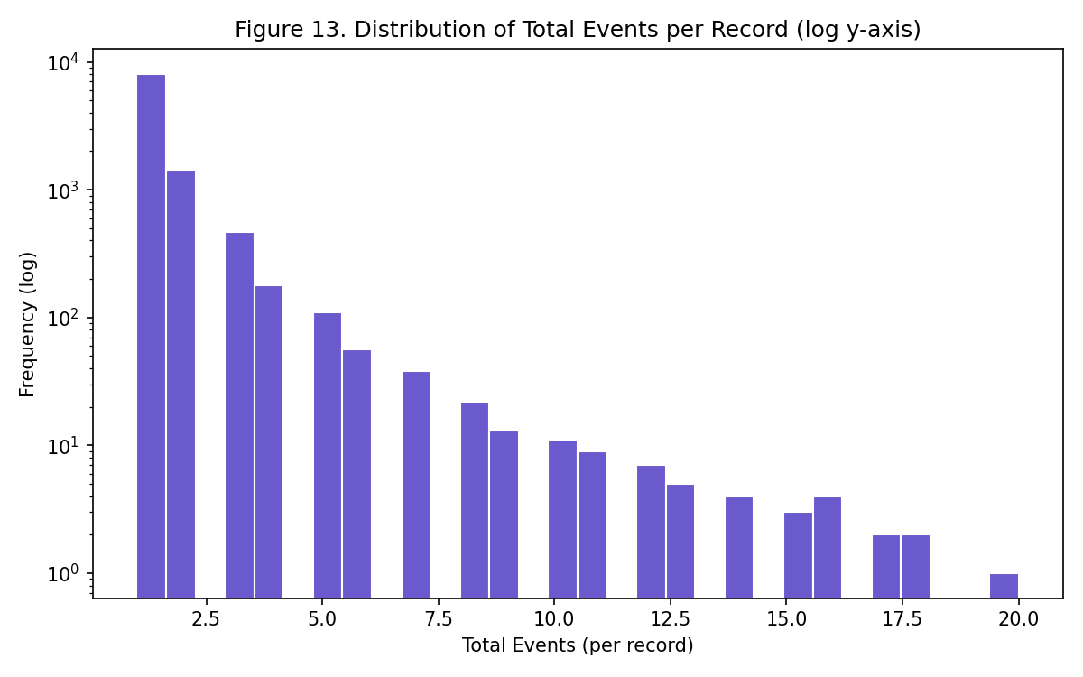
Figure 13
Figure 13. What it shows: A histogram of the Total Events field across all 10,431 records (not aggregated by year or type), with a logarithmic y-axis specifically because the underlying count distribution spans several orders of magnitude and a linear axis would compress all but the tallest bar into invisibility. What pattern appears: The distribution is sharply right-skewed — the bar at the smallest event-count bin is roughly four orders of magnitude taller than the bars at the largest bins, meaning the overwhelming majority of individual records report a small handful of events (often exactly 1). Why this occurs and what it means: This is a structural feature of how EM-DAT records data: each row typically represents one country’s experience of one disaster type in one year, and most such combinations involve a small number of discrete events rather than dozens. Understanding this distribution matters methodologically for every other figure in this report that aggregates Total Events — since the data is this skewed, a sum-based aggregation (as used throughout) will be dominated by the sheer number of small-count records rather than any single large-count record, reinforcing the same conclusion as Figure 10 from a dataset-wide rather than per-type angle.
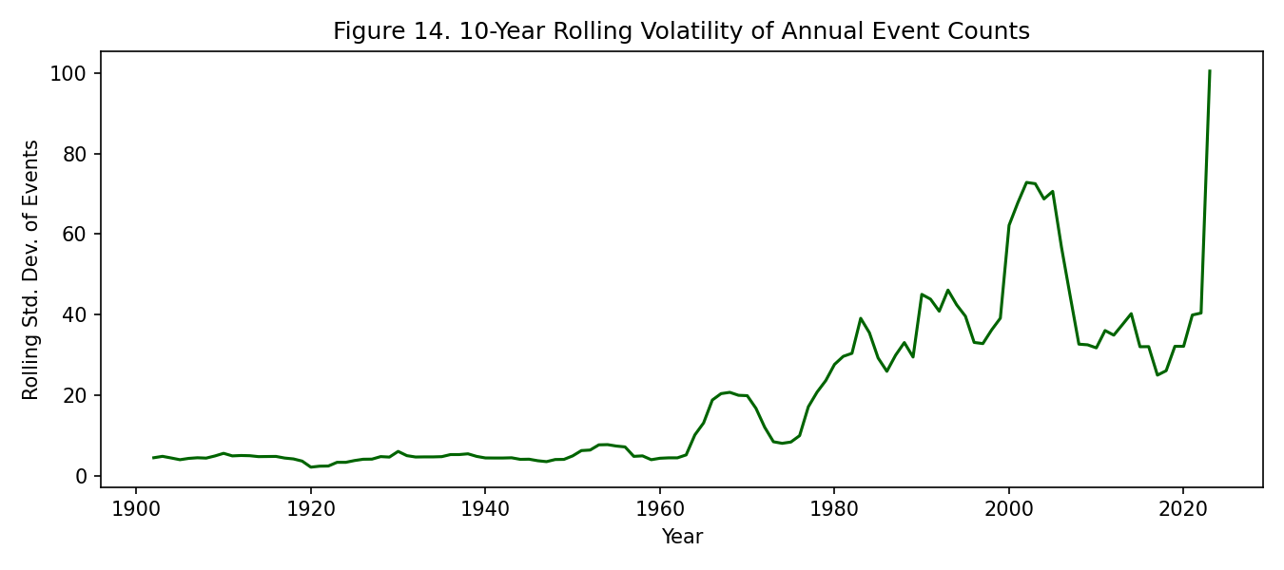
Figure 14
Figure 14. What it shows: A line chart of Year against the 10-year rolling standard deviation of the annual total-events series — a measure of volatility, i.e., how much the yearly count fluctuates around its local trend, as distinct from the trend’s level (already shown in Figure 5). What pattern appears: The volatility line stays low and flat through most of the 20th century, then rises substantially from the 1980s onward, broadly tracking (though not identically to) the rise in the mean event count itself, with a particularly sharp late spike. Why this occurs and what it means: A rising mean and rising variance together are the disaster-preparedness-relevant signal here: if the mean were rising but variance stayed flat, planners could reasonably budget for a predictably higher, steady disaster load; instead, rising variance means the range of plausible outcomes in any given year has widened, so a resource-allocation plan built only around the historical average would be under-prepared for an increasing number of high-variance years. This figure translates the qualitative “disasters are becoming more frequent” finding into a quantitative planning consideration that Figures 1-13 do not directly address.
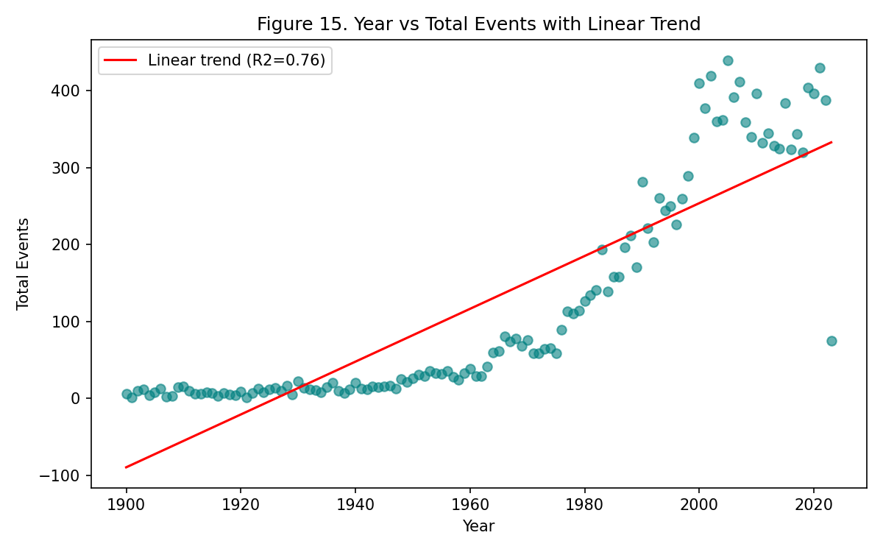
Figure 15
Figure 15. What it shows: A scatterplot of Year (x-axis) against total annual events (y-axis, one point per year), overlaid with a fitted ordinary-least-squares linear trend line and its R² (coefficient of determination) value printed on the figure — a formal statistical test of whether the visually apparent rise seen throughout this task set is a real, fittable trend or could plausibly be explained by random year-to-year noise. What pattern appears: The points visibly scatter around an upward-sloping line, and the R² value (shown on the chart) indicates the linear fit explains a substantial share of the year-to-year variance, though the residuals are not random — points curve above the line in the most recent decades and below it in the earliest decades, indicating a systematically non-linear (accelerating) true shape. Why this occurs and what it means: This figure closes out Task Set A by providing the formal statistical grounding for everything argued visually in Figures 1-14: a linear trend already fits the data far better than chance would predict, ruling out “it’s just noise” as an explanation for the overall rise, while the visible curvature in the residuals is precisely the reason this report relies on decade-binned (Figure 2, 12), era-split (Figure 4), and cumulative (Figure 7) views rather than a single straight-line trend to characterize the shape of the rise more precisely than a linear model alone can.

5.1 Limitations (Task Set A)
- Reporting-era confound is the central threat to validity here. Every temporal claim above is measured against a baseline (pre-1980) that is known to be undercounted (Figure 3), so absolute growth multiples (e.g. the 17.8× flood figure in Figure 4) should be read as upper bounds on the true increase, not exact multipliers — some of that ratio is definitely reporting infrastructure, not physical change.
- Earthquake-as-control is imperfect. Earthquakes are used throughout as a “hard to under-report” baseline to isolate the reporting effect from the real effect, but even earthquake detection improved substantially post-1980 with denser seismograph networks, so the 3.8× earthquake rise (Figure 4) is itself not a pure zero-reporting-bias measurement — it likely still includes some artifact, meaning the true non-reporting rise in floods/storms may be smaller than the naive 17.8×/3.8× ratio suggests.
- 5-year and 10-year smoothing windows (Figures 1, 6, 8, 14, 20) trade off responsiveness for readability — a genuinely sharp single-year spike or dip can be visually flattened by the rolling average, so the smoothed figures should always be read alongside an unsmoothed view (Figure 5) before drawing conclusions about any single year.
- Disaster Subtype analysis (Figure 8) is limited to floods as the single largest category; the same subtype-level drill-down was not performed for every disaster type due to time constraints, so subtype-level dynamics for storms, earthquakes, etc. remain unexamined here.

5.2 Conclusion (Task Set A)
Recorded natural-disaster frequency has risen sharply since the 1970s-80s, but not uniformly: floods and storms drive almost the entire increase, while geophysical events (earthquakes, volcanic activity) — used here as an implicit control for reporting-infrastructure improvements — rise much more modestly. Comparing the four major types’ pre/post-1980 annualized rates (floods 17.8×, storms 9.2×, droughts 8.2×, earthquakes 3.8×) suggests part of the overall rise is a global reporting artifact common to all types, but the amount by which floods and storms exceed the earthquake baseline points to a real, additional increase in hydro-meteorological disaster frequency. Volatility in annual event counts has also risen alongside the mean (Figure 14), meaning disaster-response planning today must budget for greater year-to-year unpredictability, not just a higher average load.

6. Task Set B — Geographic Distribution (Kalpit Phogat)
Variables used: Country, ISO, Disaster Type, Disaster Subtype, Total Events, Reporting Era, Decade
Tasks: Overview of events by country; which countries are most exposed to which disaster type; regional/composition profiles; how country exposure has shifted between reporting eras; breadth vs. depth of geographic risk.
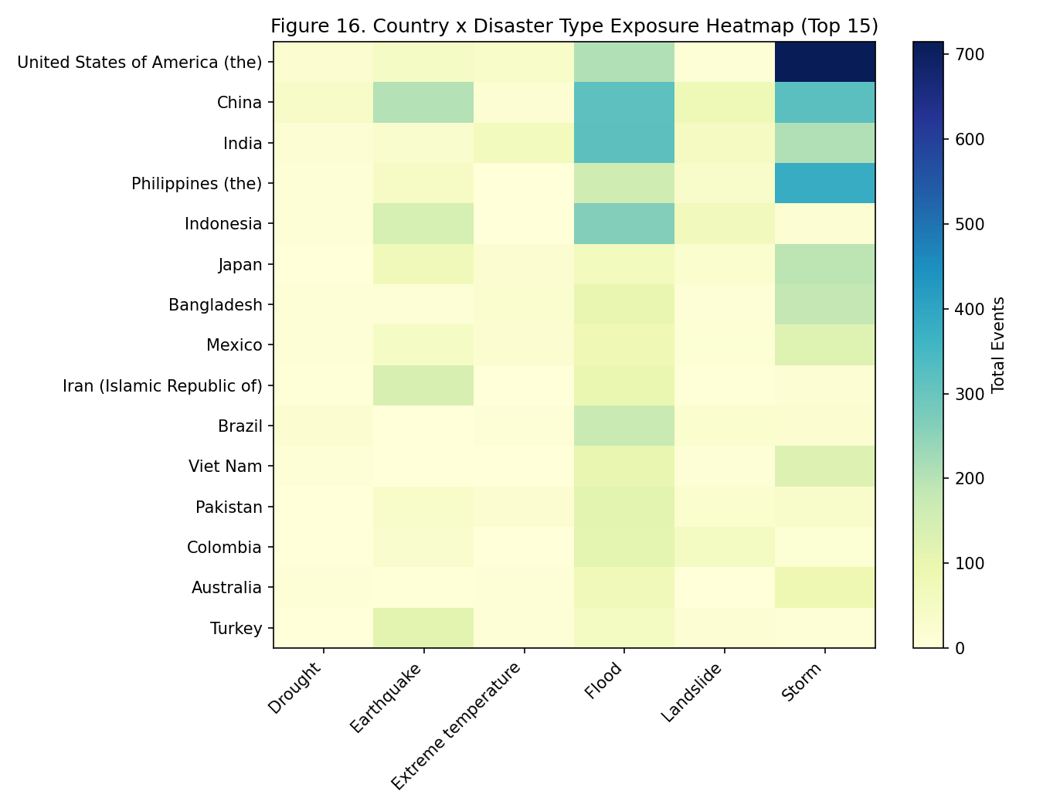
Figure 16
Figure 16. What it shows: A heatmap with the top-15 countries by Total Events as rows and the six major Disaster Types as columns, cell color intensity encoding summed Total Events for that country-type pair — a categorical-by-categorical cross-tabulation chosen specifically because it lets the reader read both a full country’s “risk fingerprint” across a row and a full type’s cross-country spread down a column in one image. What pattern appears: Each row lights up in a different column (or combination of columns) rather than all rows lighting up in the same column — the USA’s row is brightest in the storm column, China’s and India’s rows are brightest in the flood column, and the Philippines’ row shows brightness spread across storm, flood, and earthquake columns simultaneously. Why this occurs and what it means: This pattern is a direct visual consequence of physical geography and climate: the USA’s exposure to Atlantic hurricanes and Great Plains storm systems, China and India’s monsoon-fed river systems, and the Philippines’ position on both the Pacific typhoon belt and the seismically active Pacific Ring of Fire, all show up exactly where physical-geography intuition would predict. The absence of any two identical row patterns among the top-15 is the key takeaway: it means no single “disaster-prone country” archetype exists, and any risk-mitigation program that treats all high-total countries the same would be misallocating resources relative to their actual, type-specific exposure.
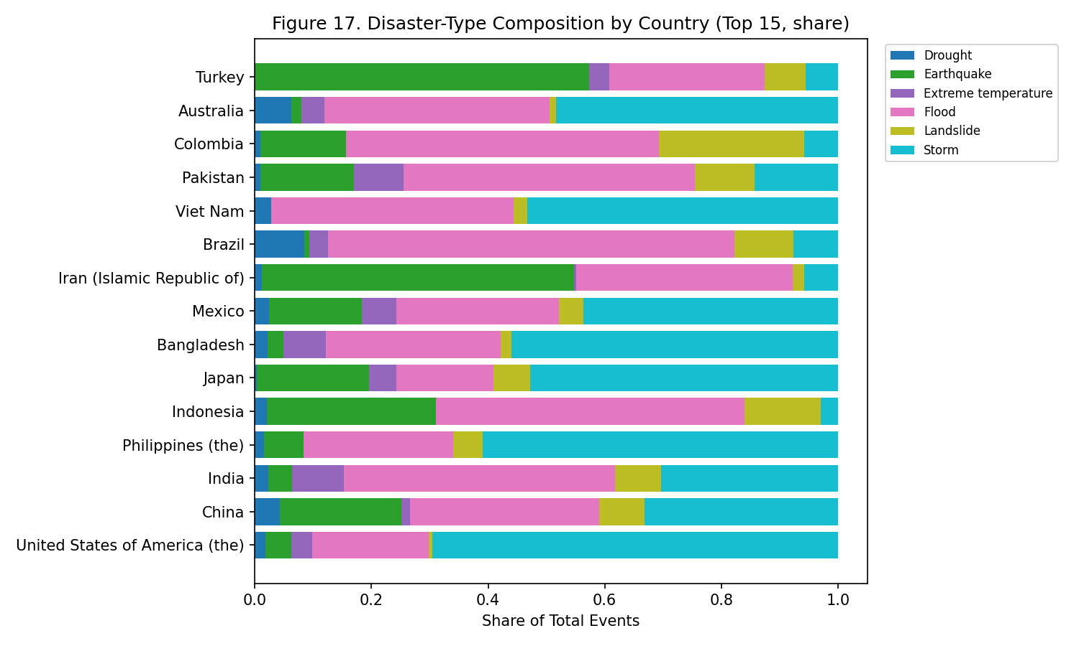
Figure 17
Figure 17. What it shows: A stacked horizontal bar chart, one bar per top-15 country, where each bar’s total length is normalized to represent 100% and segmented by Disaster Type share — this is Figure 16’s raw-count heatmap converted into within-country proportions, deliberately removing each country’s overall volume so composition, not scale, is what is compared. What pattern appears: Some bars (Bangladesh, Vietnam) are visually dominated by one or two colors filling nearly the entire bar length, while other bars (USA) show four or five colors each occupying a more modest, comparable-sized segment. Why this occurs and what it means: Raw totals (Figure 16, 19) can make a diversified-but-high-volume country like the USA look comparable in “riskiness” to a narrowly-but-severely exposed country like Bangladesh, simply because both have large bars. This normalized view separates those two very different risk profiles: a country whose bar is one dominant color faces concentrated risk (a single point of failure — if flood defenses fail, nearly all disaster risk materializes), while a country with several similarly-sized segments faces distributed risk across multiple, likely independent, hazard types. This distinction is exactly the kind of nuance a single top-15 ranking (Figure 19) cannot convey on its own.
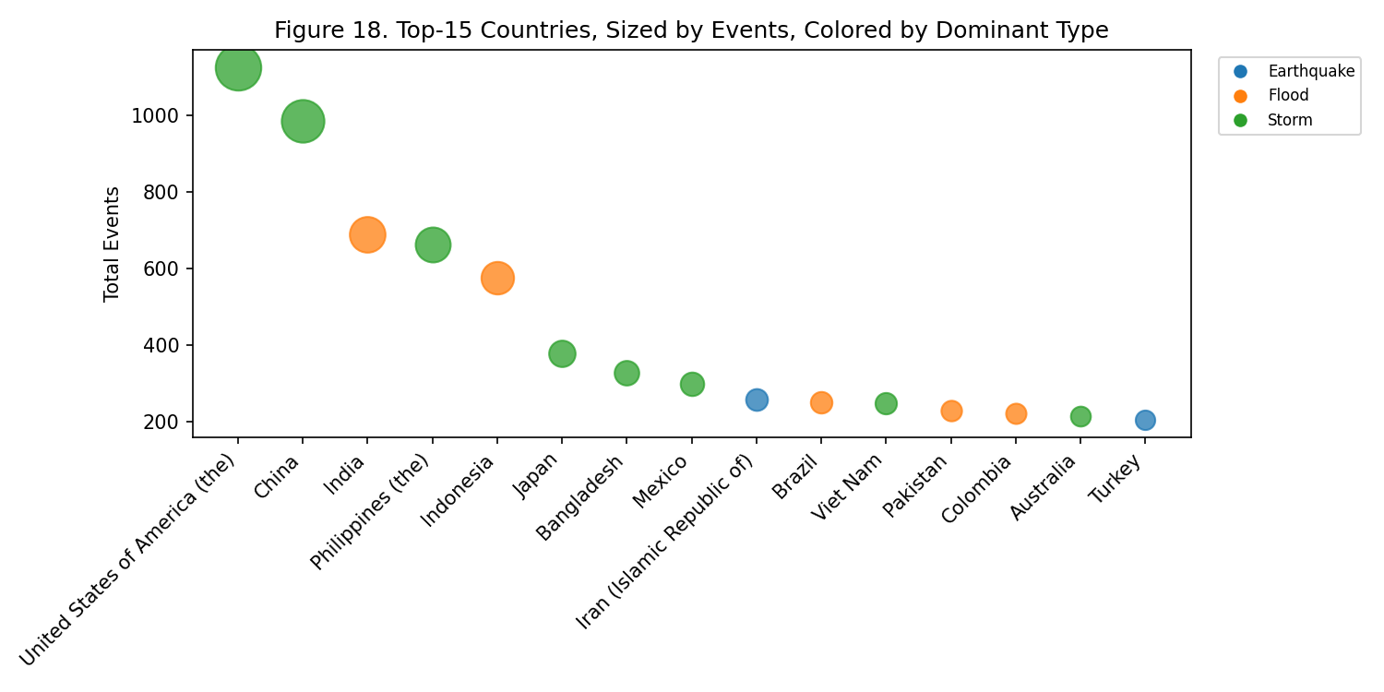
Figure 18
Figure 18. What it shows: A bubble chart with the top-15 countries arranged along the x-axis by their event-count rank, Total Events encoded as bubble size on the y-axis, and each bubble colored by that country’s single most frequent (dominant) Disaster Type — combining a ranking, a magnitude, and a categorical label into one chart rather than three separate ones. What pattern appears: Countries with the same dominant-type color are not randomly scattered along the rank axis but tend to sit near each other — China, India, Bangladesh, and Vietnam (all flood-dominant, same color) cluster in adjacent rank positions, distinct from the USA, Philippines, and Japan (storm-dominant, different color) clustering elsewhere. Why this occurs and what it means: This color-clustering-by-rank pattern is evidence that geographic exposure is not simply a matter of “some countries are unlucky” but follows identifiable climatic/geographic zones — monsoon-basin countries cluster together because they share the same underlying physical driver (seasonal monsoon rainfall over major river systems), and typhoon/hurricane-corridor countries cluster together for the analogous reason. Recognizing these natural clusters is useful for regional (rather than purely national) disaster-cooperation frameworks, since neighboring countries in the same cluster likely face correlated, simultaneous risk from the same weather systems.
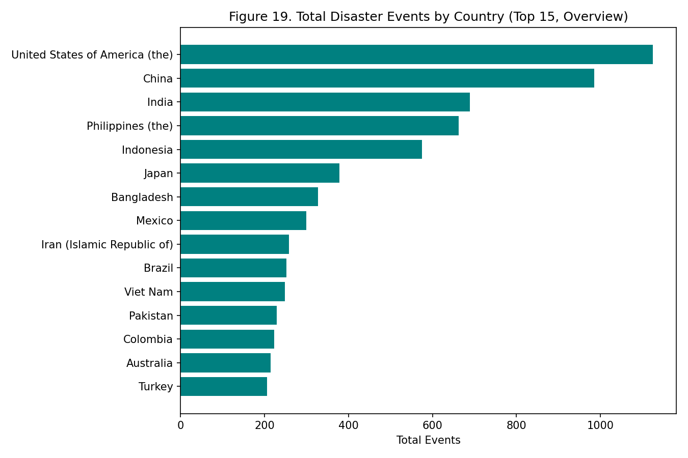
Figure 19
Figure 19. What it shows: A simple horizontal bar chart ranking the top-15 countries by raw Total Events — the most basic possible overview visualization in this task set, included deliberately as an orientation point before the more decomposed figures around it. What pattern appears: The USA (1,125), China (985), and India (689) lead by a clear margin over the remaining twelve countries in the top-15. Why this occurs and what it means: Read in isolation, this figure would suggest a simple, single-axis ranking of “most disaster-prone” countries. The explicit purpose of pairing this figure with Figure 17 immediately after is to demonstrate why that single-axis reading is insufficient: a country’s position in this bar chart says nothing about whether its risk is concentrated in one hazard type or spread across several, information only Figure 17’s normalized view supplies — this figure is a necessary but incomplete first step in the geographic analysis, not a standalone conclusion.
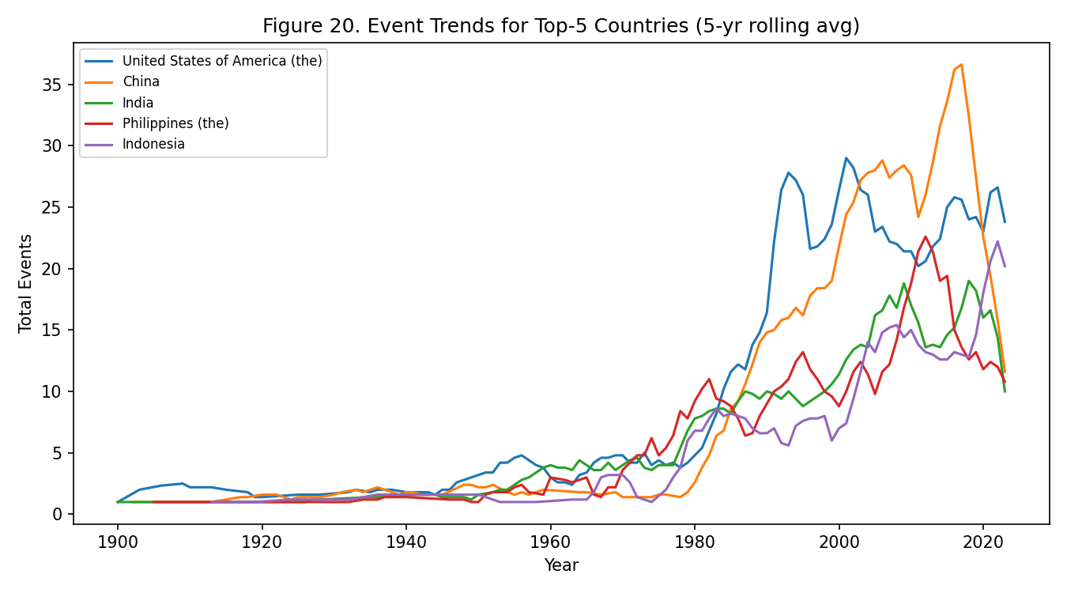
Figure 20
Figure 20. What it shows: A multi-line chart with Year on the x-axis and each of the top-5 countries’ own 5-year-smoothed Total Events on the y-axis — the geographic analogue of Task Set A’s Figure 1, but tracking individual countries over time instead of individual disaster types. What pattern appears: The USA’s and China’s lines begin rising noticeably earlier (from roughly the 1960s-70s) than India’s, the Philippines’, and Indonesia’s lines, which stay comparatively flat until a later, steeper acceleration beginning around the 1990s. Why this occurs and what it means: If every country’s disaster exposure were rising for the same reason at the same time (e.g., purely from a single global reporting-infrastructure improvement applied uniformly), all five lines would be expected to bend upward at roughly the same point in time. Instead, seeing staggered onset times — the USA/China rising first, other countries rising 10-20 years later — suggests either staggered adoption of disaster-reporting infrastructure across different national reporting agencies, or staggered real increases in exposure (e.g., accelerating urbanization of flood-prone areas happening on different timelines in different countries), or some mix of both; either way, it confirms the “hotspot” set of countries is not fixed but has evolved in composition over the dataset’s span, setting up the more detailed rank-shift analysis in Figure 21.
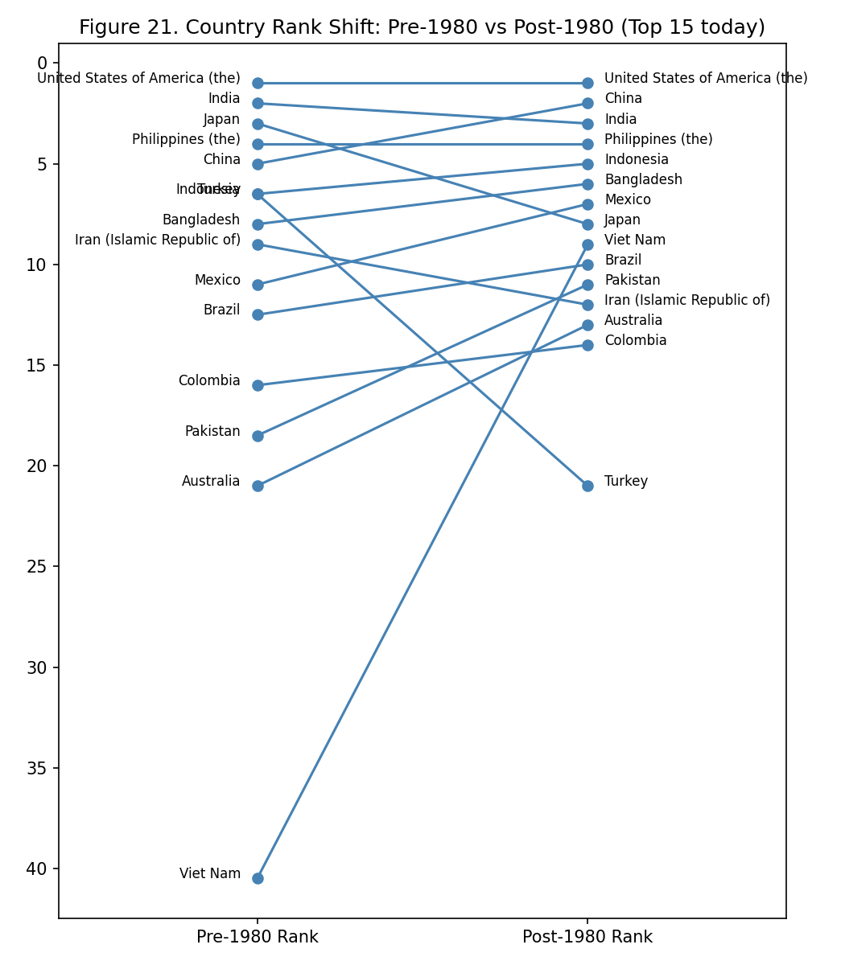
Figure 21
Figure 21. What it shows: A slopegraph — each of today’s top-15 countries gets one line segment connecting two points: its event-count rank among all countries in the Pre-1980 era (left axis) and its rank in the 1980-present era (right axis), with the y-axis inverted so “rank 1” sits at the top. Slopegraphs are specifically well-suited to before/after rank-comparison questions because the slope’s steepness and direction are immediately, visually legible as “rose” or “fell,” which a table of two separate rank columns would not convey as directly. What pattern appears: Most lines slope gently, but Vietnam’s line is dramatically steep, descending (in the visual sense, meaning its rank number improved/dropped) from rank 39 pre-1980 to rank 8 post-1980, with Thailand and Malaysia showing similarly steep (though less extreme) climbs. Why this occurs and what it means: A country’s rank can only rise this dramatically if its post-1980 growth rate substantially outpaced not just its own pre-1980 baseline but every other country’s growth rate too, since rank is a relative, zero-sum measure — thirty-one countries cannot all improve their rank simultaneously. Vietnam going from 12 events pre-1980 to 236 post-1980 (a 19.7× rise, computed for Figure 26) is therefore a stronger, more surprising claim than an absolute-count rise alone would be: it says Vietnam’s disaster exposure grew not just in absolute terms but relative to the rest of the world, identifying it and its regional neighbors as a newly emergent global hotspot rather than a country whose numbers simply grew in step with everyone else’s.
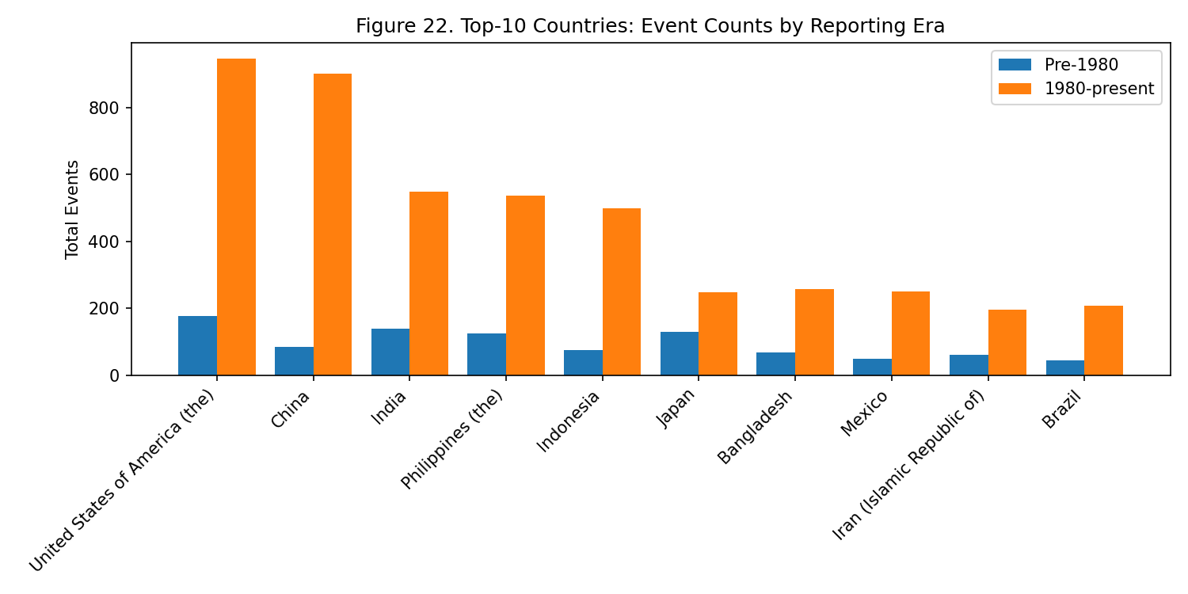
Figure 22
Figure 22. What it shows: A grouped bar chart with one bar-pair per top-10 country, each pair showing that country’s raw Total Events in the Pre-1980 era versus the 1980-present era side by side — the geographic analogue of Task Set A’s Figure 4, but per-country instead of per-disaster-type, and using raw totals rather than annualized rates since the comparison here is within-country rather than across differently-scaled disaster types. What pattern appears: Every country shows a taller post-1980 bar, but the ratio between the two bars in each pair varies substantially — the USA and China’s post-1980 bars are roughly 4-6 times their pre-1980 bars, while several Southeast/South Asian countries in the top-10 show visibly larger multiples between their bar pairs. Why this occurs and what it means: This figure provides a country-by-country breakdown of exactly the same kind of “everyone rose, but by how much varies” logic used in Figure 4 for disaster types — confirming that the uneven-growth finding is not specific to how disaster types are categorized, but shows up again when the same countries are sliced by nationality instead, and lining up consistently with the more dramatic rank movements already identified in Figure 21.
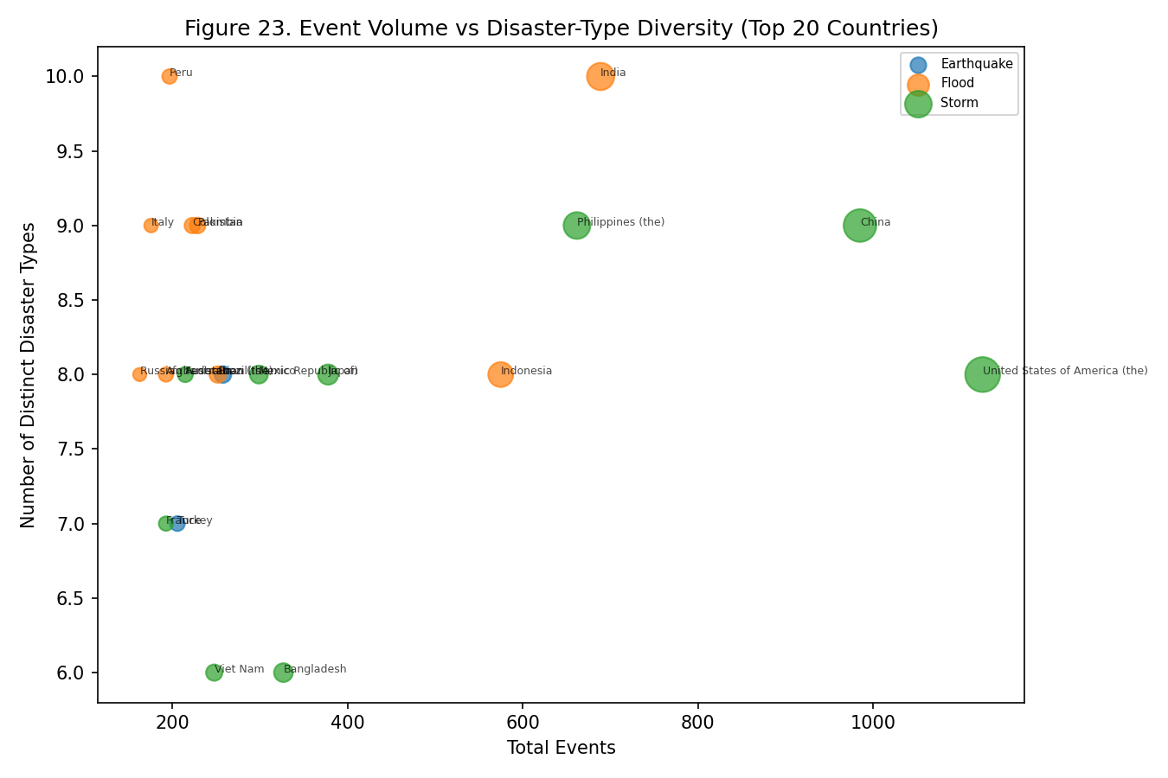
Figure 23
Figure 23. What it shows: A bubble chart plotting the top-20 countries with Total Events on the x-axis and the count of distinct Disaster Types each country has experienced (a diversity measure) on the y-axis, bubble color indicating each country’s single dominant type — deliberately choosing two different numeric axes (volume and diversity) rather than volume against itself, so the chart can separate two conceptually distinct questions: “how much risk” versus “how many kinds of risk.” What pattern appears: India and Peru sit at the top of the diversity axis with 10 distinct disaster types each, but neither is the single highest-volume country on the x-axis — meanwhile several high-volume, flood-dominant countries sit lower on the diversity axis despite their large x-axis position. Why this occurs and what it means: If volume and diversity were the same underlying thing, this scatter would show a tight diagonal line (high volume implies high diversity, and vice versa). Instead, seeing points that are high on one axis but not the other demonstrates these are genuinely separate dimensions of national risk: a country like India faces a geographically and climatically varied set of distinct hazard mechanisms (its geography spans Himalayan, coastal, and arid zones), which is a different — and arguably harder to plan for — kind of vulnerability than a country whose very large event count comes almost entirely from one repeated hazard type.
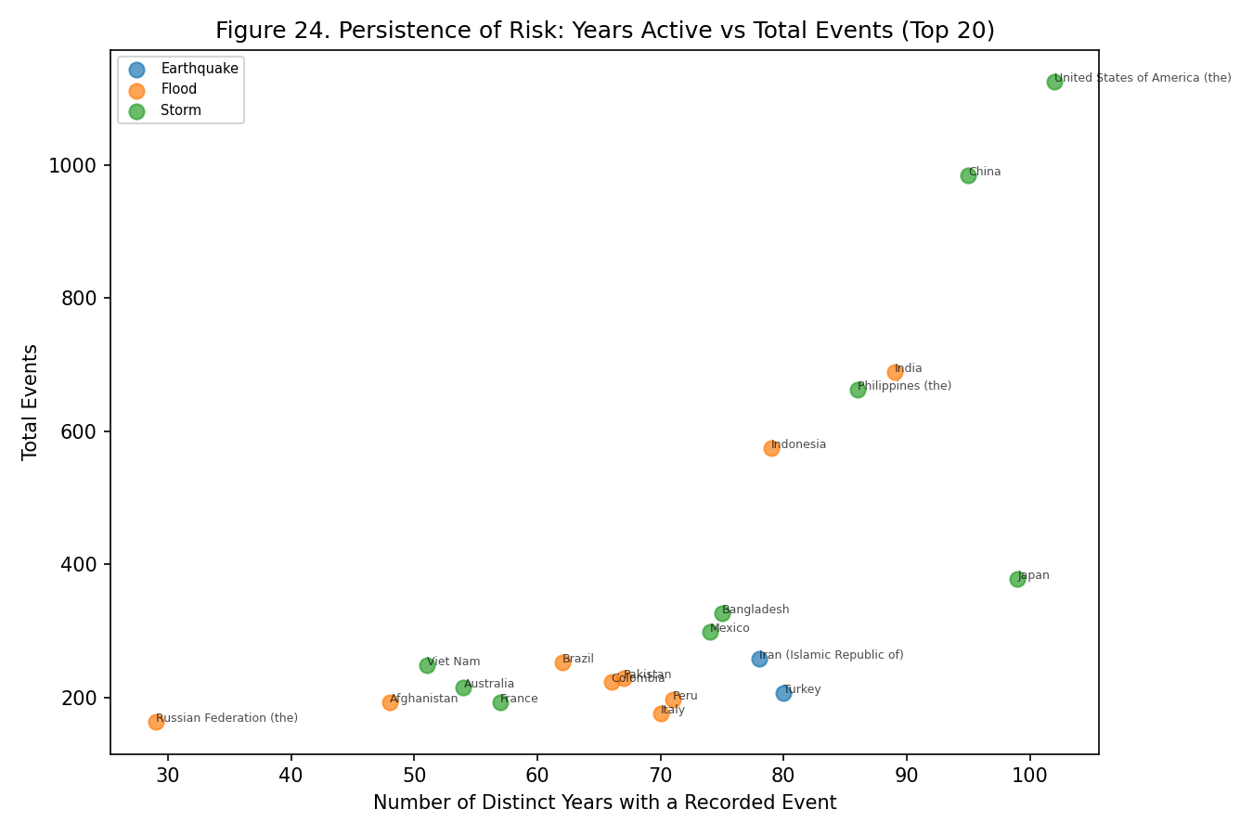
Figure 24
Figure 24. What it shows: A scatterplot of the top-20 countries with “Years Active” (the count of distinct calendar years in which that country recorded at least one disaster) on the x-axis and Total Events on the y-axis, colored by dominant type — a persistence measure (how continuously a country appears in the record) plotted against a volume measure. What pattern appears: The USA (102 years active), Japan (99), China (95), India (89), and the Philippines (86) sit near the far-right edge of the x-axis, meaning they have recorded at least one disaster in the vast majority of the dataset’s 124-year span, essentially every year rather than in occasional spikes. Why this occurs and what it means: A country could theoretically reach a high Total Events count (y-axis) through either many small, spread-out disasters across most years, or a smaller number of years each containing an unusually large event count — this chart’s x-axis distinguishes those two scenarios. The countries clustering at high years-active values are experiencing the first pattern: continuous, near-annual exposure rather than occasional catastrophic spikes, which is arguably the more policy-relevant signal, since it implies these countries need standing, permanent disaster-response infrastructure rather than an emergency-reserve model built for rare events.
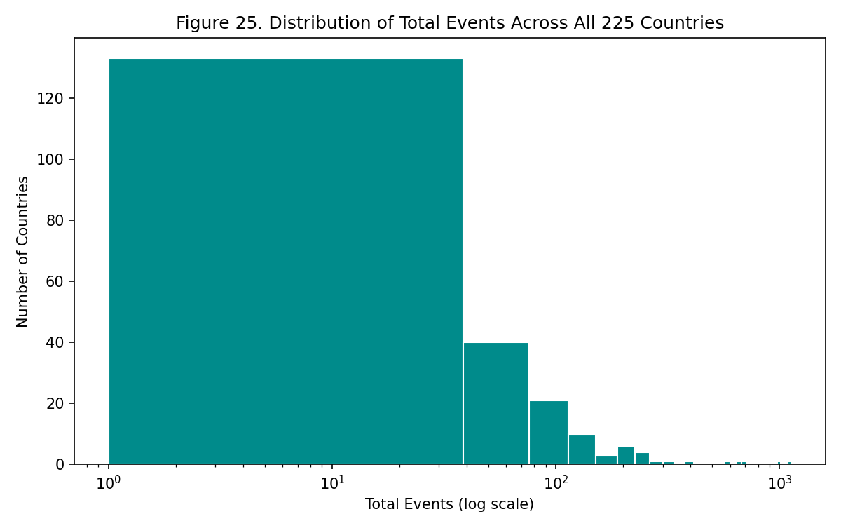
Figure 25
Figure 25. What it shows: A histogram of Total Events summed per country, across all 225 countries in the dataset (not just the top-15/20 shown in other figures), with a logarithmic x-axis chosen because — as with Figure 13 in Task Set A — the underlying distribution spans several orders of magnitude and a linear axis would compress the vast majority of countries into an unreadable cluster near zero. What pattern appears: The bulk of the 225 countries sit toward the low end of the log-scaled x-axis (a handful of recorded events over 124 years), with a long thinning tail extending toward the small number of very-high-count countries already profiled in Figures 16-24. Why this occurs and what it means: This is a dataset-wide validation that the top-15/20-country framing used throughout this task set is not an arbitrary cutoff but reflects a real, highly skewed underlying structure — a Pareto-like concentration where a small number of countries account for a disproportionate share of global recorded disaster activity. This has a direct practical implication: global disaster-relief resource allocation that spreads funding evenly across all 225 countries would be poorly matched to where events actually concentrate, whereas the country-specific figures elsewhere in this task set point toward where a disproportionate-to-population share of resources would have the most impact.
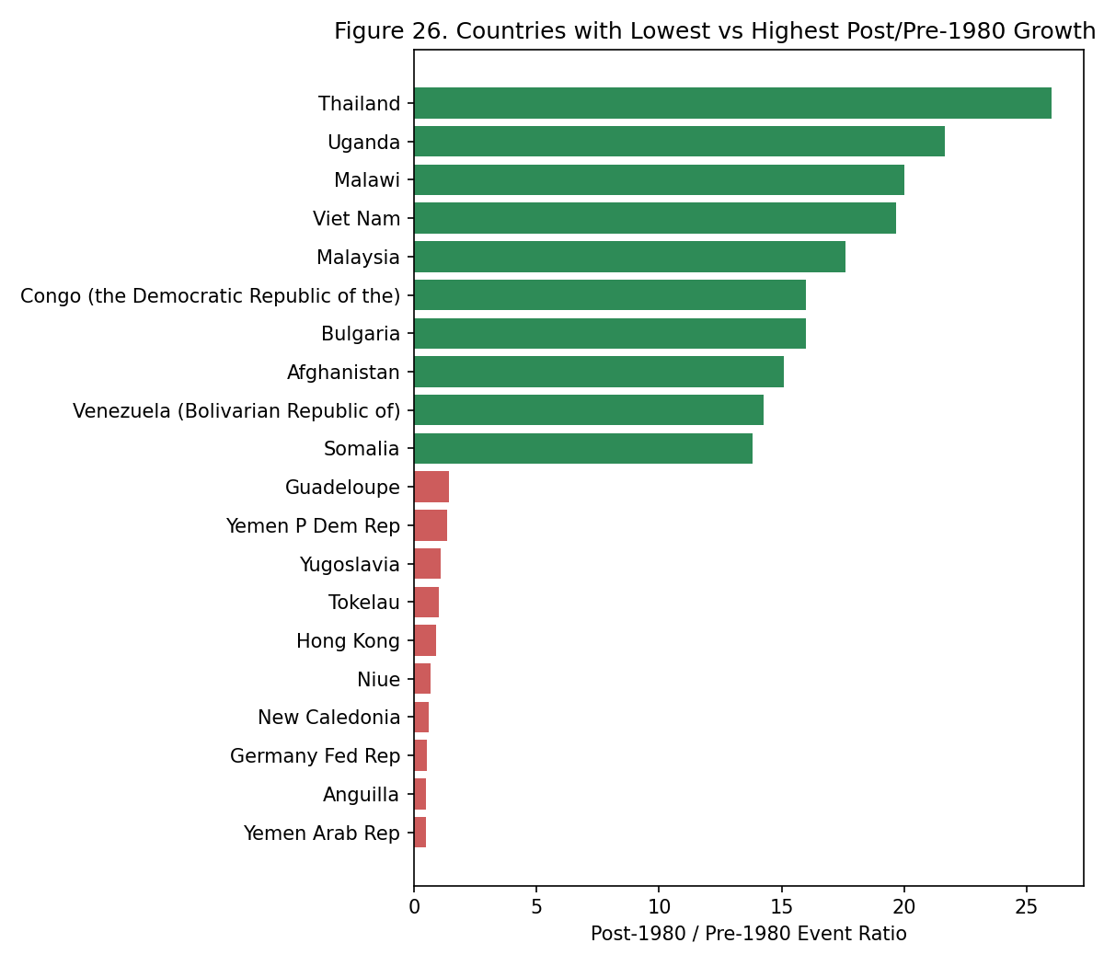
Figure 26
Figure 26. What it shows: A diverging horizontal bar chart showing the ten countries with the lowest and ten countries with the highest post-1980/pre-1980 event-count ratio, restricted to countries with at least 3 recorded pre-1980 events (to avoid division-by-near-zero producing meaningless extreme ratios), colored to visually separate the “declining relative to baseline” bars from the “growing relative to baseline” bars. What pattern appears: Thailand (26.0×), Uganda (21.7×), and Malawi (20.0×) anchor the high-growth end, while Yemen Arab Rep., Anguilla, and the former Germany Fed. Rep. sit at or below a 1× ratio at the low end. Why this occurs and what it means: The high-growth entries corroborate and extend Figure 21’s slopegraph finding beyond just the current top-15 — showing that dramatic relative growth is not limited to the handful of countries that are large enough in absolute terms to appear in the top-15 today, but also appears among mid-sized countries like Uganda and Malawi. The low-ratio entries require more caution: several, like the former Germany Fed. Rep., reflect countries that no longer exist in that exact political form after 1990 (German reunification), meaning their apparent “decline” is a data-continuity/labeling artifact rather than a genuine reduction in disaster exposure — a reminder that any cross-era country comparison over a 124-year span needs this kind of manual sanity-check before its numbers are taken at face value.
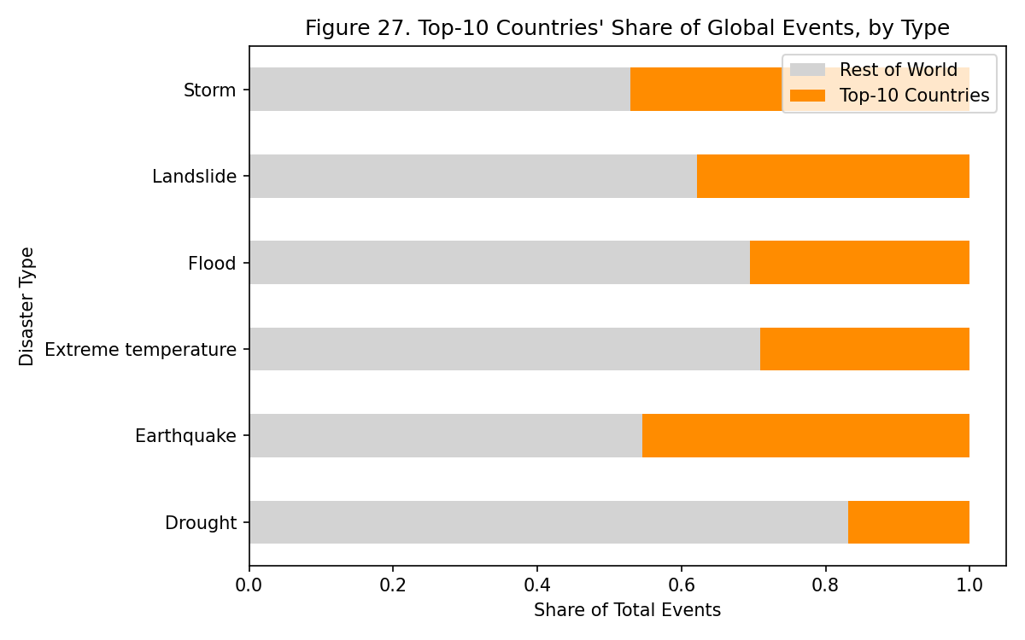
Figure 27
Figure 27. What it shows: A stacked bar chart with one bar per major Disaster Type, each bar split into two segments — the share of that type’s global events occurring in the current top-10 countries versus the “Rest of World” — directly quantifying how geographically concentrated each disaster type’s risk is. What pattern appears: The top-10-countries segment occupies a visibly larger share of the flood and storm bars than it does of the drought bar, where the Rest-of-World segment is comparatively larger. Why this occurs and what it means: This figure directly operationalizes the “breadth vs. depth” question raised throughout this task set: flood and storm risk is disproportionately concentrated in a small set of major countries (largely a consequence of major, high-population river basins and coastlines being unevenly distributed globally), while drought risk — driven more by regional climate and agricultural dependence than by any single river system or coastline — is comparatively more evenly spread across many countries worldwide. This has direct implications for how international disaster-relief coordination should be structured differently by hazard type: flood/storm relief can reasonably be concentrated around a handful of major partner countries, while drought relief needs a broader, more globally distributed response network.
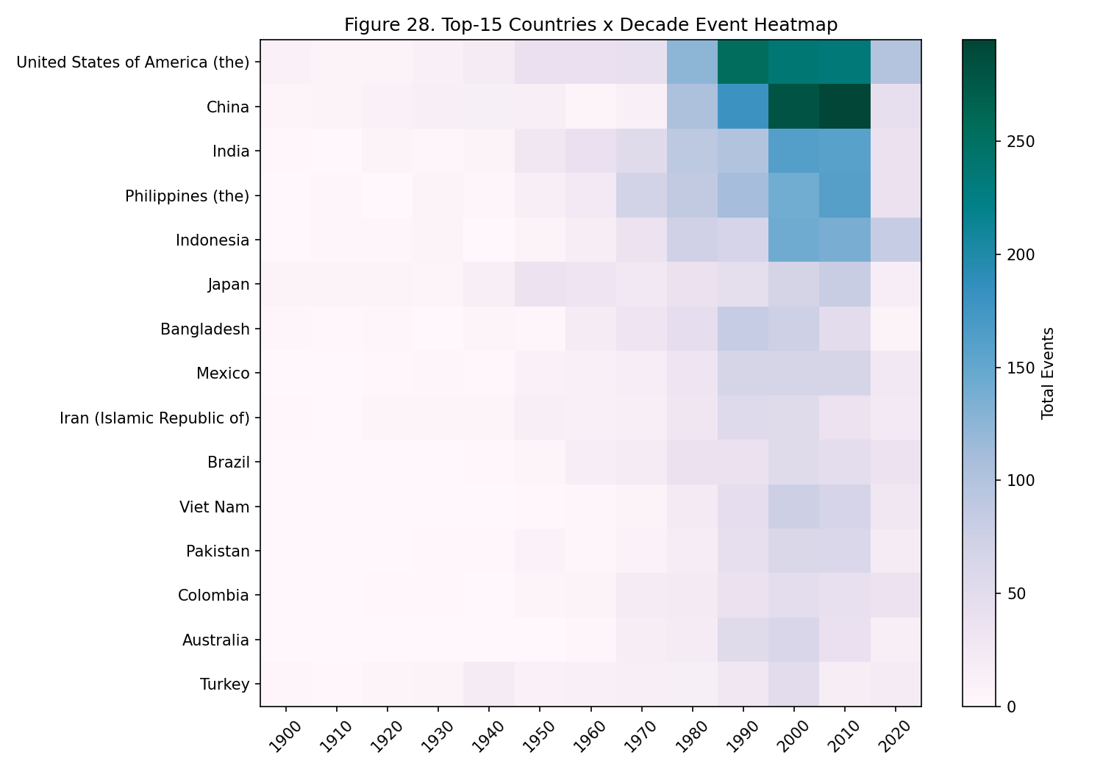
Figure 28
Figure 28. What it shows: A heatmap combining the top-15 countries (rows) with Decade (columns), color intensity encoding Total Events — structurally a geographic-temporal cross-tabulation that merges the country ranking of Figure 16 with the decade-based temporal pattern of Task Set A’s Figure 2 into a single view. What pattern appears: The USA and China’s rows show a more gradual, steady darkening moving left to right across most decade columns, while several other top-15 countries (Vietnam, Bangladesh) show rows that stay pale through most columns and then darken sharply only in the rightmost few columns (1990s-2010s). Why this occurs and what it means: This figure is a direct visual confirmation of the staggered-onset finding from Figure 20’s line chart, but rendered as a single scannable grid rather than five overlapping lines — countries with an early, gradual darkening pattern (USA, China) had disaster-reporting/exposure growth that began earlier and proceeded more incrementally, while countries with a late, sharp darkening pattern (Vietnam, Bangladesh) experienced a more compressed, recent surge, reinforcing that “when a country’s disaster risk grew” is itself a meaningful, country-specific piece of information beyond simply “how much” it grew by today.
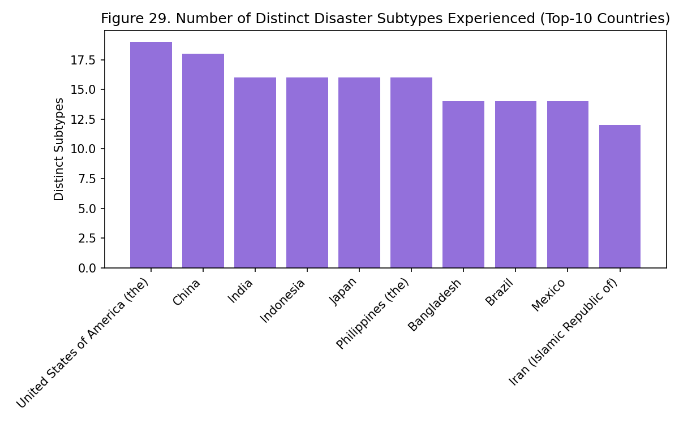
Figure 29
Figure 29. What it shows: A simple bar chart of the top-10 countries by the number of distinct Disaster Subtypes (a finer-grained categorical field than the top-level Disaster Type used in Figure 23) they have experienced — a deeper diversity measure than Figure 23’s type-level count, since a country could show low type-diversity but still face several distinct subtype mechanisms within a single dominant type (e.g., both riverine and flash flooding). What pattern appears: Countries do not rank identically to their Figure 23 type-diversity ranking — some countries with modest type-diversity scores show comparatively high subtype counts. Why this occurs and what it means: This discrepancy between the two diversity measures matters for disaster-preparedness planning specifically: a country facing several distinct subtypes within what looks like a single “type” on paper (for example, both slow-onset riverine flooding, which allows for evacuation lead-time, and fast-onset flash flooding, which does not) needs meaningfully different response protocols for each subtype even though a coarse type-level analysis (Figure 16-18, 23) would group them together as one undifferentiated “flood risk,” making this figure a useful check against over-simplifying preparedness plans at the type level alone.
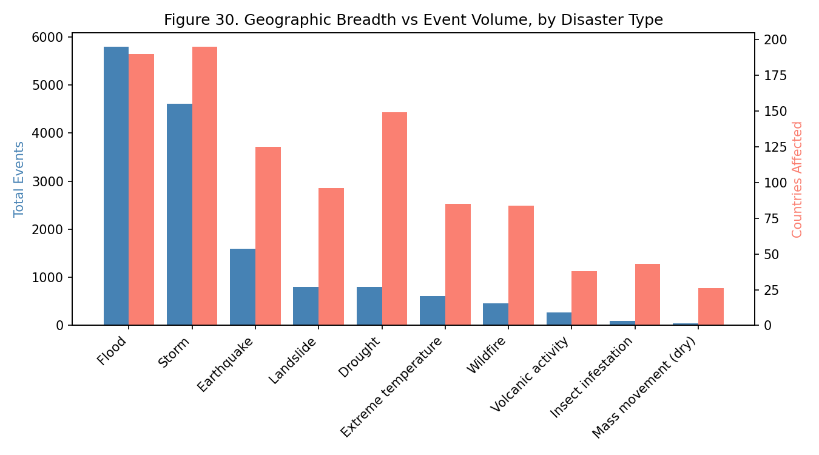
Figure 30
Figure 30. What it shows: A dual-axis bar chart with each major Disaster Type on the x-axis, Total Events on the left y-axis (one set of bars), and the count of distinct countries that have experienced that type at least once on the right y-axis (a second, differently-scaled set of bars) — using two axes specifically because “total events” and “countries affected” are measured in fundamentally different units and would be uninterpretable plotted on a shared scale. What pattern appears: Storms show the highest countries-affected bar (195 countries) despite floods showing a higher total-events bar (5,796 events across only 190 countries) — the two rankings by type are not identical. Why this occurs and what it means: This figure distinguishes two conceptually different notions of a hazard’s global significance that are easy to conflate: breadth (how many distinct places are ever exposed to a given hazard at all) versus volume (how many total recorded events that hazard produces, concentrated or not). Storms being the most globally widespread hazard, while floods are the highest-volume hazard concentrated in fewer countries, means a global early-warning-system rollout prioritized by “which hazard affects the most countries” would target storms first, while a rollout prioritized by “which hazard generates the most total events to respond to” would target floods first — two different, equally valid prioritization frameworks that this single figure makes visible as genuinely distinct.

6.1 Limitations (Task Set B)
- Country-boundary changes over a 124-year span distort ranking and ratio figures. Figure 26’s diverging bar chart includes entries like the former Germany Fed. Rep., whose “decline” in event ratio reflects German reunification changing how records are attributed, not a real drop in disaster exposure — any country-list analysis spanning pre- and post-1980 needs this kind of manual sanity check before the numbers are trusted at face value.
- No sub-national geography. Every figure in this task set treats a country as a single point/row, so a country as large and climatically varied as the USA gets one “dominant disaster type” label (Figure 16, 18) that necessarily hides the fact that, e.g., wildfire risk is concentrated in the west and hurricane risk in the southeast — a national-level policy read from these figures would be too coarse for sub-national resource allocation.
- No population or land-area normalization. Rankings by raw Total Events (Figure 19) or Total Affected mechanically favor large, populous countries; a small island nation with a high rate of disaster exposure relative to its size would not appear near the top of any of these figures even if it faces comparable relative risk.
- The “≥3 pre-1980 events” filter used in Figure 26 to compute growth ratios excludes many small countries with very few pre-1980 records, meaning the diverging-bar comparison is only representative of countries with at least a minimal historical record — the true fastest-growing country overall could be one filtered out here for having, say, 1-2 pre-1980 events.

6.2 Conclusion (Task Set B)
Disaster exposure is geographically concentrated and unevenly distributed: a small set of countries (USA, China, India, Philippines, Indonesia) account for a disproportionate share of global events, and each has a visibly distinct disaster-type composition rather than a generic “high risk” profile. More importantly, that geography is not static — the slopegraph comparison of pre- and post-1980 country rankings shows Vietnam, Thailand, and Malaysia rising dramatically (19.7×, 26.0×, and 17.6× respectively), identifying Southeast Asia as an emergent hotspot that a purely historical risk assessment would have missed. Persistence (years-active) and diversity (distinct types/subtypes experienced) further separate countries like the USA, Japan, China, India, and the Philippines — continuously and multiply exposed across nearly the entire dataset’s span — from countries with narrower but still severe single-type exposure, arguing that geographic disaster policy needs both a “how often” and a “how varied” lens, not just a single risk score per country.

7. Task Set C — Impact Severity (Lakshya Jain)
Variables used: Total Deaths, Total Affected, Total Damage (USD, original), Total Damage (USD, adjusted), CPI, Disaster Type, Country, Year, Decade
Tasks: Top-10 deadliest/costliest; economic damage over time (CPI-adjusted, and CPI shown directly); correlation between event frequency and severity; per-event severity ratios; distributional characteristics of deaths/damage.
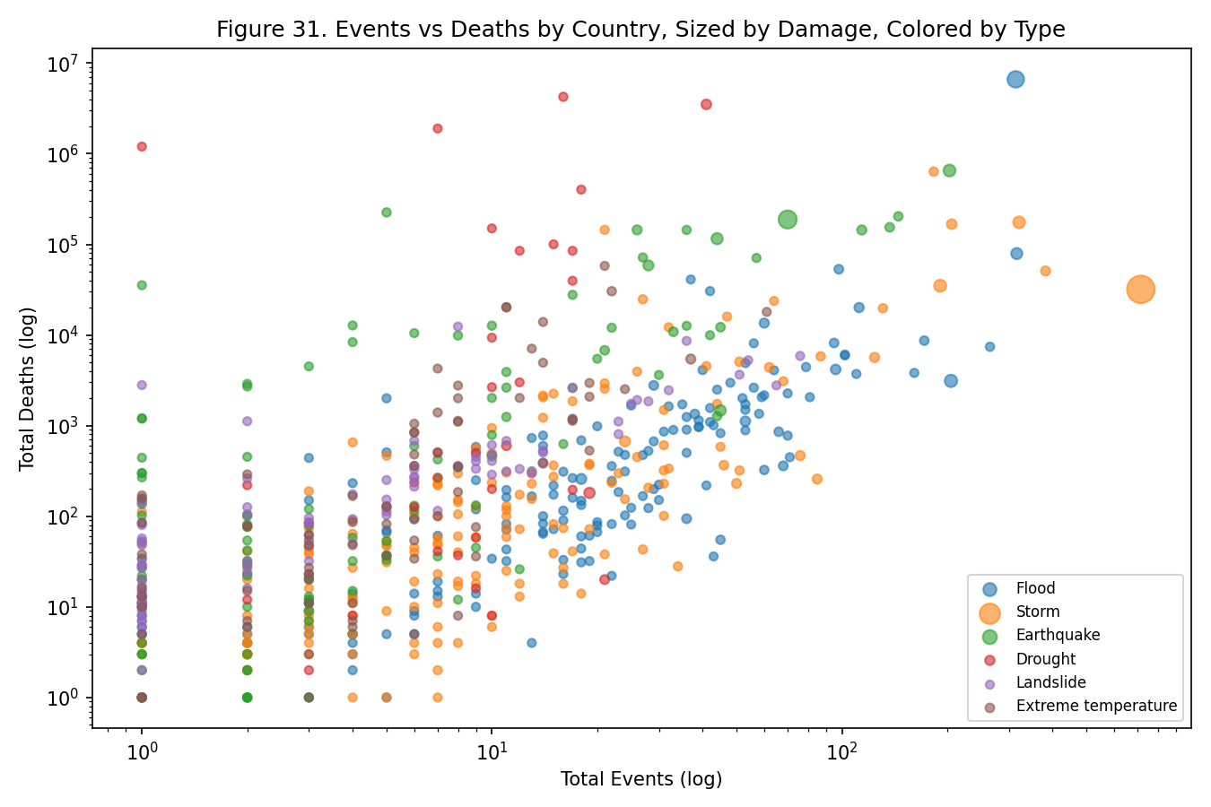
Figure 31
Figure 31. What it shows: A scatterplot with Total Events on the x-axis and Total Deaths on the y-axis, both on logarithmic scales (necessary because both variables span several orders of magnitude, from single-digit to million-scale), where each point is one Country-Disaster-Type pair, point size encodes Total Damage, and point color encodes Disaster Type — four variables (events, deaths, damage, type) compressed into one image. What pattern appears: Earthquake-colored points sit visibly above the general diagonal trend of the point cloud — meaning for a given x-axis (event count) position, earthquake points tend to have a higher y-axis (death count) value than flood/storm points at the same x-position — while flood/storm points cluster toward the high-x, comparatively-lower-y region. Why this occurs and what it means: If a single universal “more events causes more deaths, proportionally, regardless of type” relationship held, all colors would fall along one shared diagonal band. Instead, seeing type-colored points separate into distinct parallel bands at different heights means each disaster type has its own characteristic “lethality slope” — earthquakes convert a given number of events into deaths far more efficiently than floods or storms do, most likely because earthquake fatalities are dominated by sudden structural collapse with little warning time, while flood/storm fatalities are more often preventable given even modest evacuation lead-time. This type-specific lethality-slope finding is the central empirical claim this task set builds on throughout.
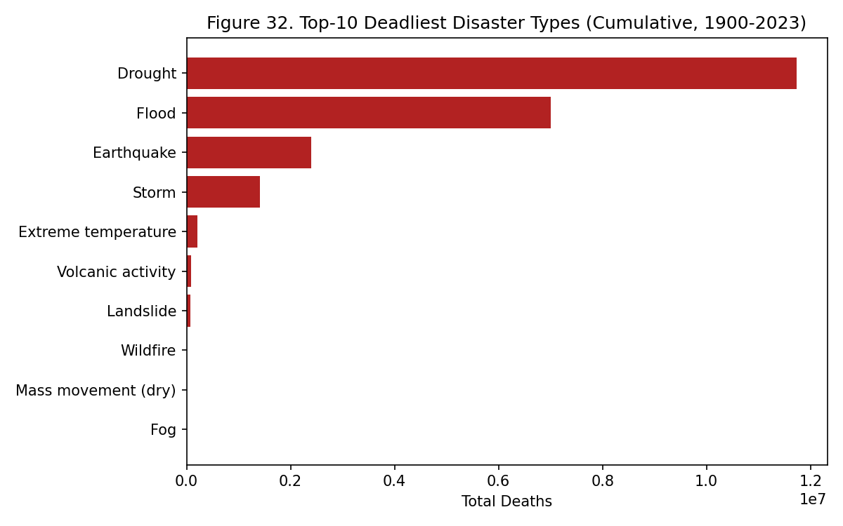
Figure 32
Figure 32. What it shows: A horizontal bar chart of the top-10 Disaster Types ranked by cumulative Total Deaths, summed across all records and all years — the simplest possible severity overview, included as an entry point before the more decomposed figures that follow. What pattern appears: Drought sits at the top with roughly 11.7 million cumulative deaths, ahead of floods (~7.0 million) and earthquakes (~2.4 million) — notably, this ranking by deaths does not match the ranking by event count from Task Set A (where drought has one of the lowest event counts of the major types, at 802 events, versus flood’s 5,796). Why this occurs and what it means: The mismatch between this deaths-ranking and the earlier events-ranking is the figure’s key message: a naive assumption that “the most common disaster type must also be the deadliest” is directly contradicted here. Drought reaching the top of a deaths ranking with among the fewest events of any major type means its death toll must be driven by a small number of individually catastrophic events (historically, famine-linked mass mortality) rather than by sheer frequency — a claim quantified precisely in Figure 36 and traced to specific events in Figure 43.
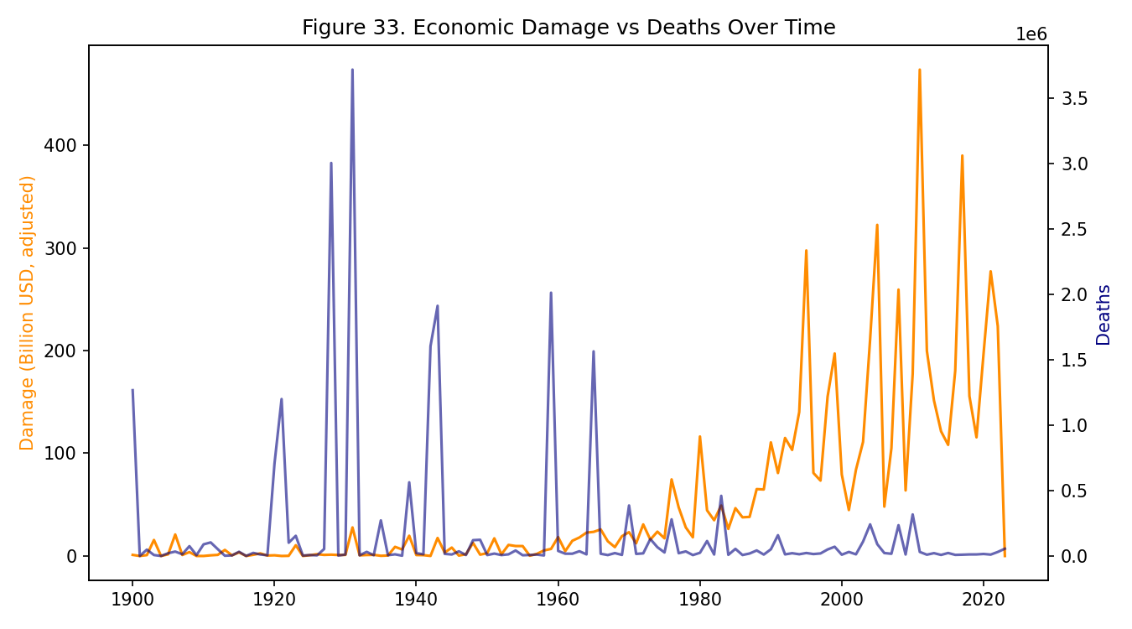
Figure 33
Figure 33. What it shows: A dual-axis time series with Year on the shared x-axis, cumulative CPI-adjusted Damage (in billions of USD) on the left y-axis as one line, and Deaths on the right y-axis as a second, independently-scaled line — two axes are necessary because damage (measured in billions of dollars) and deaths (measured in individual persons) have no common natural scale to share. What pattern appears: The damage line shows a fairly steady, sustained upward climb — from roughly $291B in the 1970s to a peak of roughly $2.07 trillion in the 2010s (cumulative, adjusted) — while the deaths line instead shows sharp, narrow spikes concentrated in specific individual years, without a comparably steady upward climb. Why this occurs and what it means: The two lines’ different shapes (smooth-and-rising versus spiky-and-flat) are as informative as their levels: a smoothly rising line typically indicates a variable driven by a gradual, cumulative underlying process (here, the steady accumulation of built infrastructure and property value in disaster-exposed areas over decades), while a spiky line typically indicates a variable dominated by rare, discrete, high-magnitude shock events (here, individual catastrophic disasters). The fact that damage has decoupled from deaths in this way — rising steadily while deaths remain shock-driven rather than trend-driven — is consistent with global disaster-response and early-warning systems becoming more effective at preventing death even as the world’s total exposed economic value continues to grow.
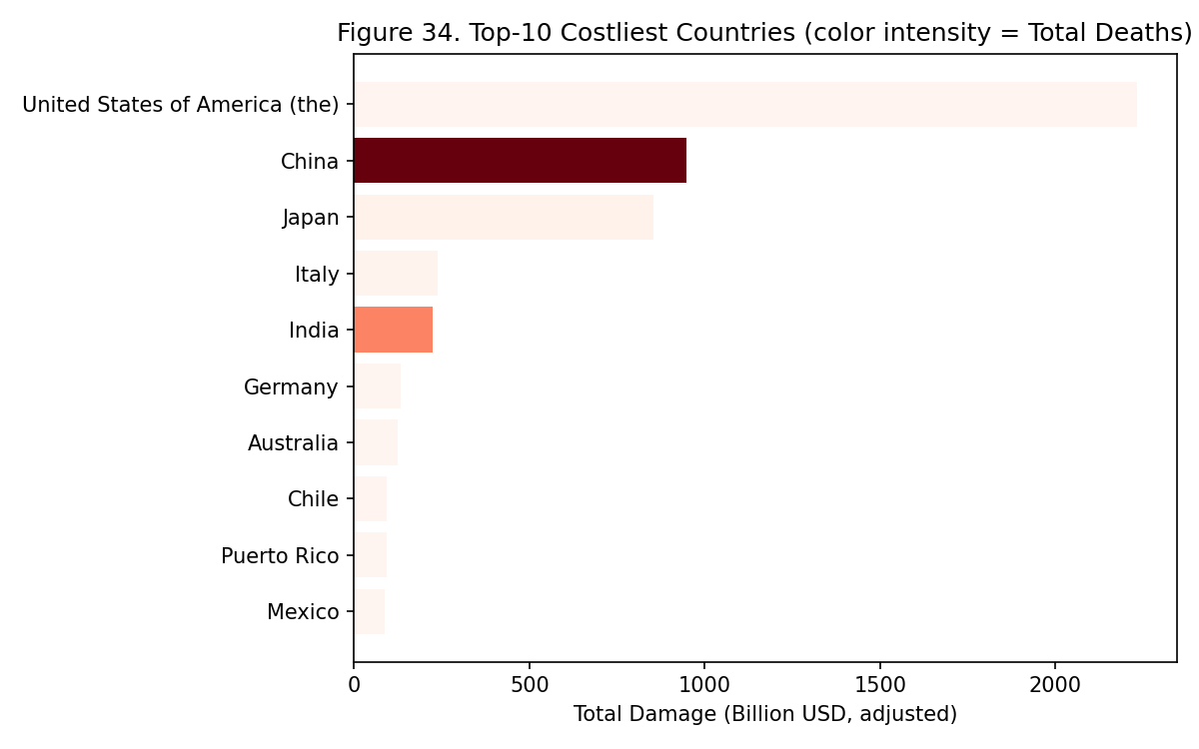
Figure 34
Figure 34. What it shows: A horizontal bar chart of the top-10 countries by cumulative CPI-adjusted Damage, where bar color intensity is separately mapped to that country’s cumulative Total Deaths — layering a second severity variable onto a ranking already sorted by a first, so the reader can spot cases where the two severity measures agree or disagree for the same country. What pattern appears: Several of the longest (highest-damage) bars show comparatively pale color intensity (lower relative deaths), while it is possible for a shorter bar to still show a notably dark shade. Why this occurs and what it means: A country combining high economic damage with low death intensity is a signature of high asset exposure paired with effective disaster-response capacity (enough warning and evacuation infrastructure to protect lives even when property cannot be saved), whereas a country whose bar is simultaneously long and dark signals a compounding vulnerability — both high economic loss and high loss of life — which this dual-encoding figure is specifically designed to surface, information neither a damage-only ranking nor a deaths-only ranking (Figure 32) could reveal on its own.
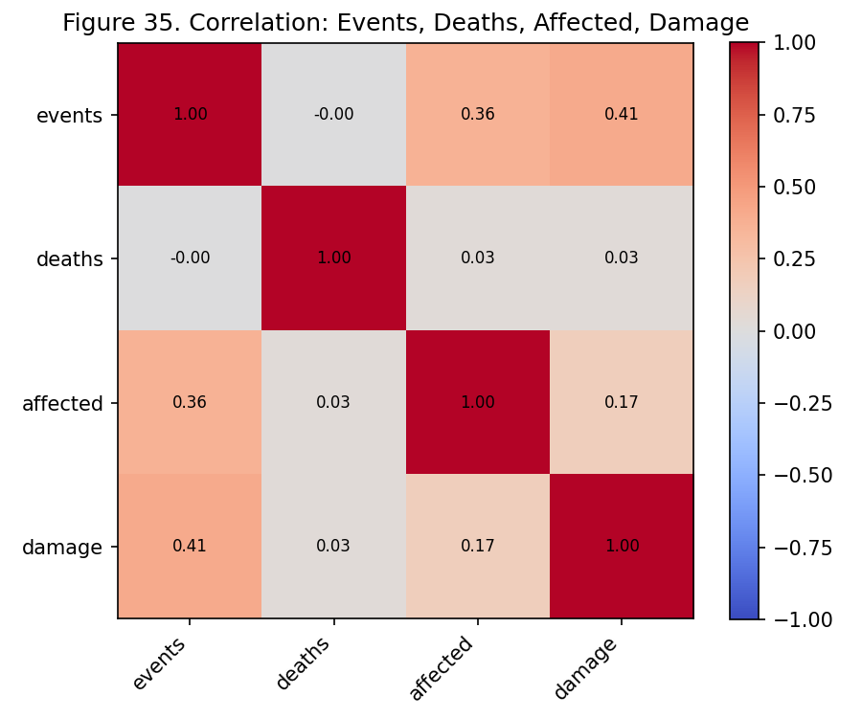
Figure 35
Figure 35. What it shows: A 4×4 correlation-coefficient matrix (heatmap with numeric annotations) computed across Events, Deaths, Affected, and Damage, aggregated to the Country-Year level, with color and printed value together encoding each pairwise Pearson correlation coefficient from -1 to +1 — the most statistically rigorous figure in this task set, since it quantifies relationships the scatterplots (Figure 31, 40) can only suggest visually. What pattern appears: The Deaths row/column shows correlation values close to zero against both Events (r ≈ 0.00) and Affected (r ≈ 0.03), while the Damage row/column shows a moderate positive correlation with Events (r ≈ 0.41). Why this occurs and what it means: A correlation near zero between events and deaths is a direct, quantitative confirmation of the pattern visually suggested in Figure 31’s type-separated scatter bands — it says that, in aggregate across all disaster types and countries, simply knowing how many disasters a place experiences tells you almost nothing about how many people will die, because that relationship depends entirely on which type of disaster is involved (as Figure 31 showed with its type-specific lethality slopes, which partially cancel out when pooled together into one aggregate correlation). By contrast, the moderate 0.41 correlation between events and damage suggests economic loss scales more predictably and directly with sheer disaster frequency than death toll does — an asymmetry with direct implications for how frequency-based risk models should and should not be used (reasonable proxy for expected economic exposure, poor proxy for expected loss of life).
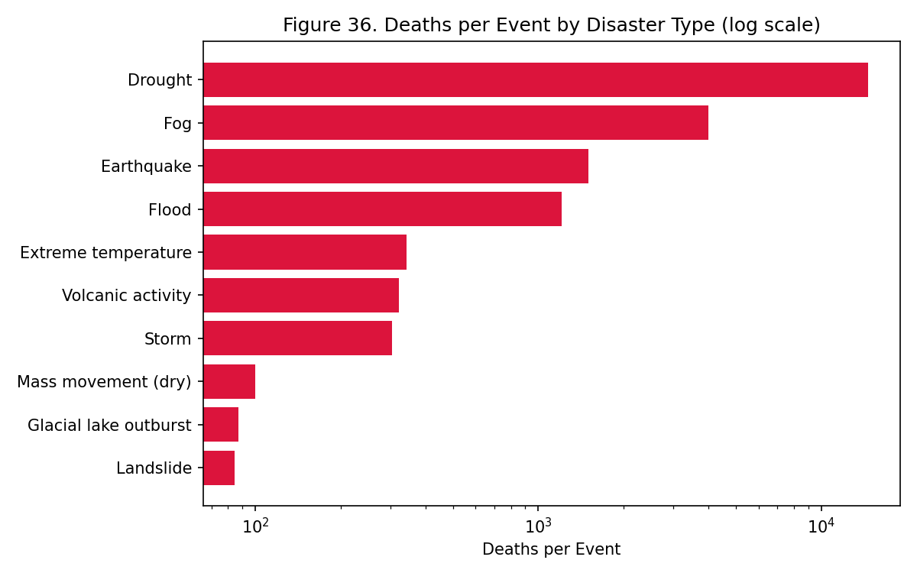
Figure 36
Figure 36. What it shows: A horizontal bar chart (log-scaled x-axis) of the top-10 Disaster Types ranked by a derived statistic — deaths per event, computed as cumulative Total Deaths divided by cumulative Total Events for that type — a normalized severity measure that controls for how frequent a type is, unlike Figure 32’s raw cumulative total. What pattern appears: Drought’s deaths-per-event value (≈14,631) sits dramatically higher than earthquake’s (≈1,503), flood’s (≈1,208), or storm’s (≈305) — roughly a 48-fold gap between the highest and lowest values shown. Why this occurs and what it means: This figure exists specifically to separate “deadly because frequent” from “deadly because each event is severe” — Figure 32’s raw ranking could not distinguish these two explanations for drought’s high death toll, but this per-event normalization removes the frequency effect entirely and shows drought is not just cumulatively deadly but individually catastrophic on a per-event basis, a distinct and arguably more alarming finding: it means a single drought event, on average, carries far greater expected loss of life than a single flood or storm event, directly informing how emergency-response resources should be pre-positioned per event rather than per historical frequency.
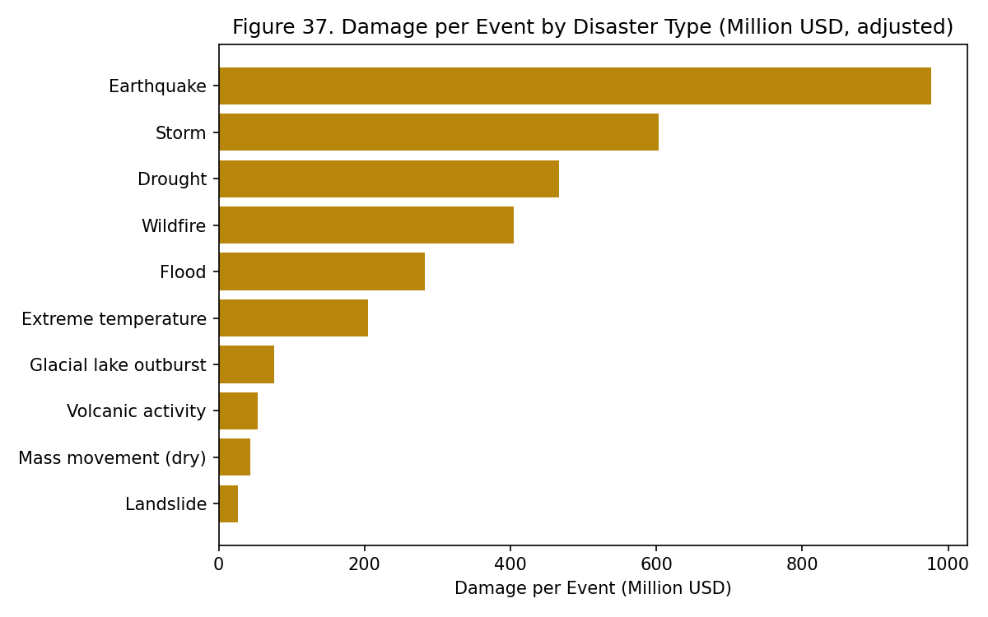
Figure 37
Figure 37. What it shows: A horizontal bar chart structurally identical to Figure 36 but substituting damage-per-event (cumulative CPI-adjusted Damage divided by cumulative Total Events, in millions of USD) for deaths-per-event — the economic-severity analogue of the preceding figure, using the same normalization logic applied to a different severity variable. What pattern appears: The type ranking here is visibly different from Figure 36’s ranking — the types occupying the top damage-per-event positions are not the same types occupying the top deaths-per-event positions. Why this occurs and what it means: If economic severity and human severity were simply two measurements of the same underlying “how bad is this disaster type” concept, the two rankings would match closely. Their divergence is itself the finding: drought, for instance, ranks far higher on deaths-per-event (Figure 36) than on damage-per-event here, because drought-driven mortality (historically, famine) is a humanitarian catastrophe that does not correspond to comparably large insured or infrastructural asset destruction — damage estimation methodologies are generally better suited to capturing destroyed buildings and infrastructure than capturing agricultural/famine-driven loss of life, meaning severity is genuinely multi-dimensional and a single “severity score” per type would obscure this real difference in kind, not just degree.
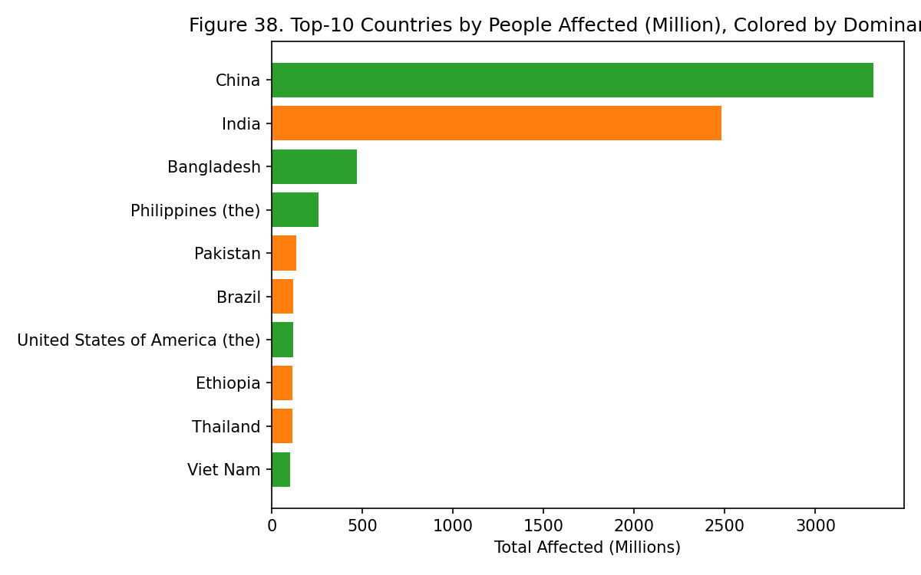
Figure 38
Figure 38. What it shows: A horizontal bar chart of the top-10 countries ranked by cumulative Total Affected (in millions of people), with bar color indicating each country’s dominant Disaster Type — Total Affected is a distinct field from Total Deaths, capturing people displaced, injured, or otherwise impacted without necessarily dying. What pattern appears: Flood-dominant countries occupy most of the top positions in this ranking, and by a wide margin over other dominant types. Why this occurs and what it means: Floods and droughts are hazards that, by their physical nature, tend to displace or disrupt very large populations (entire towns evacuated, agricultural livelihoods disrupted) without killing a comparable share of that population, unlike earthquakes, where a smaller absolute number of people are typically physically present in a collapse zone but a much higher share of those affected do not survive. This figure is therefore capturing a genuinely different humanitarian dimension than Figure 32’s deaths ranking — a large Total Affected figure represents a massive humanitarian and logistical relief burden (temporary housing, food aid, medical support at scale) even in the complete absence of a correspondingly large death toll, meaning disaster-relief budgeting needs both this figure and Figure 32 to size its response correctly, since neither alone captures the full humanitarian burden.
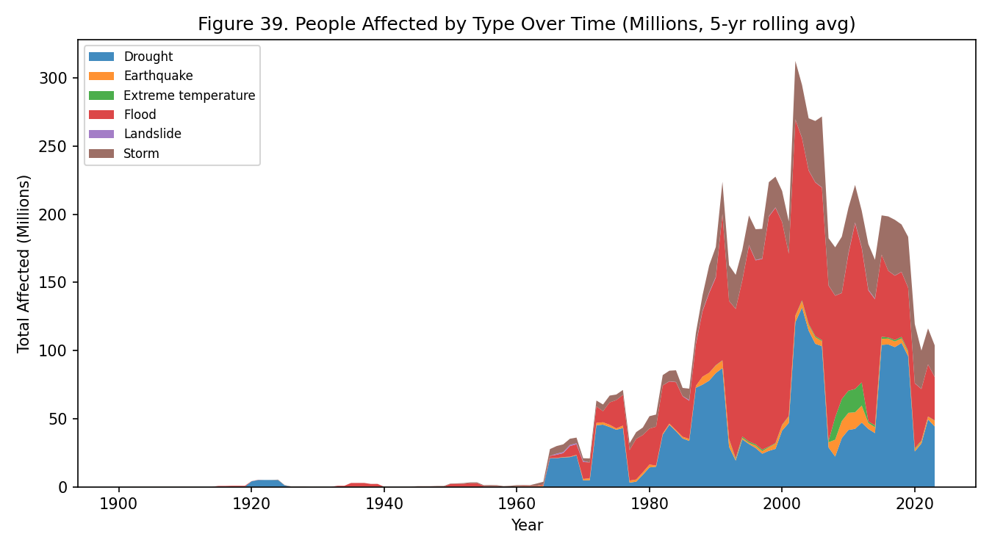
Figure 39
Figure 39. What it shows: A stacked area chart, structurally identical to Task Set A’s Figure 1, but with Total Affected (in millions of people, 5-year smoothed) rather than Total Events on the y-axis, split by Disaster Type — the humanitarian-burden analogue of the earlier frequency-focused figure, tracing the same time axis but a different response variable. What pattern appears: The overall shape closely mirrors Figure 1’s rise, plateau, and flood-dominance pattern, but the y-axis here is denominated in tens to hundreds of millions of people at its peak rather than event counts in the low hundreds. Why this occurs and what it means: The shape-similarity to Figure 1 is expected, since Total Affected and Total Events are naturally correlated (more events generally means more opportunities for people to be affected) — but the figure is included specifically because the scale conversion, from “hundreds of events” to “tens of millions of people,” makes concrete just how large a humanitarian footprint even a “merely more frequent, not necessarily more lethal” disaster trend carries; a policymaker reading only Task Set A’s event-count figures might underestimate the human stakes of the same trend, which this figure corrects for by putting the rise in terms of actual affected population rather than abstract event counts.
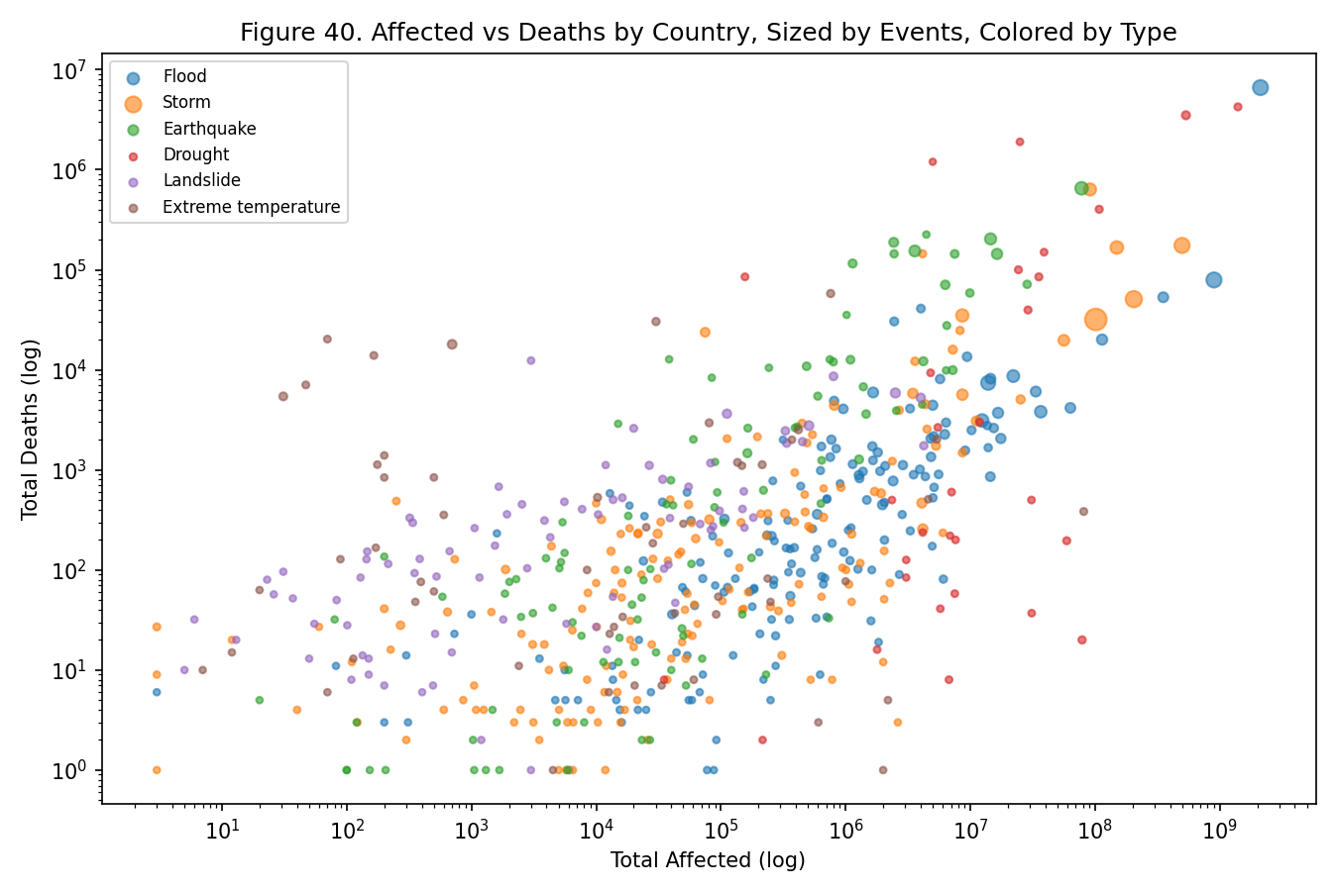
Figure 40
Figure 40. What it shows: A scatterplot with Total Affected on the x-axis and Total Deaths on the y-axis, both log-scaled, point size encoding Total Events, and point color encoding Disaster Type — structurally a variant of Figure 31 that substitutes Affected for Events as the x-axis variable, testing whether the earlier finding (type-specific lethality bands) holds when the “exposure” measure is changed from event-count to people-affected. What pattern appears: The same qualitative separation seen in Figure 31 reappears here — flood/storm points cluster toward high-affected, comparatively-lower-death positions, while earthquake points sit higher on the death axis for a comparable affected-count position. Why this occurs and what it means: Because this pattern replicates across two different choices of x-axis exposure variable (Events in Figure 31, Affected here), the type-specific-lethality finding is more robust than if it depended on one particular way of measuring “how much a disaster type is happening.” Concretely, this figure shows that earthquakes convert being-affected into death at a substantially higher rate than floods/storms do — among a comparable-sized affected population, an earthquake-affected population suffers proportionally more deaths — reinforcing that earthquake response prioritization should focus on preventing the affected-to-death conversion (e.g., building codes, faster search-and-rescue) rather than solely on reducing the number of people affected in the first place.
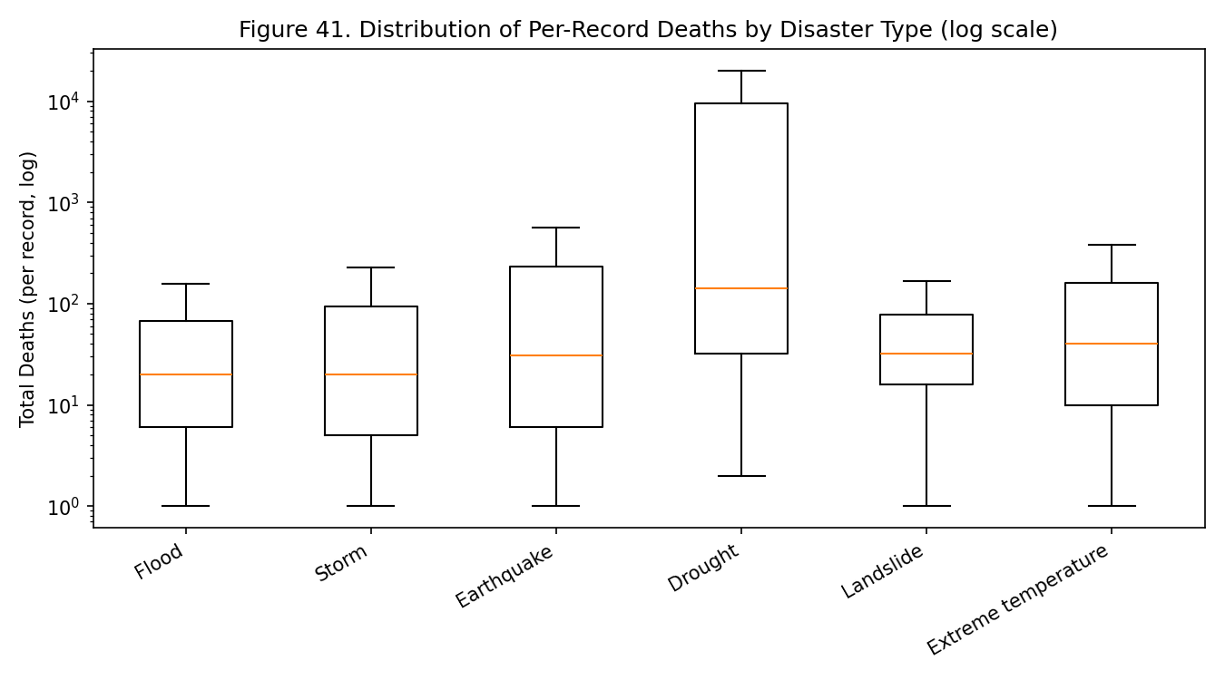
Figure 41
Figure 41. What it shows: A box-and-whisker plot (log-scaled y-axis) of the distribution of per-record Total Deaths by Disaster Type, with zero-death records and extreme outliers excluded from the whiskers — a distributional companion to Figure 36’s single-number deaths-per-event ratio, showing the full spread rather than just the average. What pattern appears: The earthquake and drought boxes sit both higher (greater median) and wider (greater spread) on the log-death axis than the flood/storm boxes. Why this occurs and what it means: Figure 36’s average deaths-per-event ratio alone cannot distinguish between two very different underlying situations: a type where most records are moderately severe (a high, consistent median), versus a type where most records are mild but a few extreme outliers pull the average up. Seeing both a higher median and a wider spread for earthquake and drought here rules out the second explanation — their outsized average severity is not merely an artifact of a few catastrophic outliers, but reflects a genuinely more severe typical record for these types, directly supporting Figure 36’s ratio as a meaningful, representative statistic rather than an outlier-driven distortion.
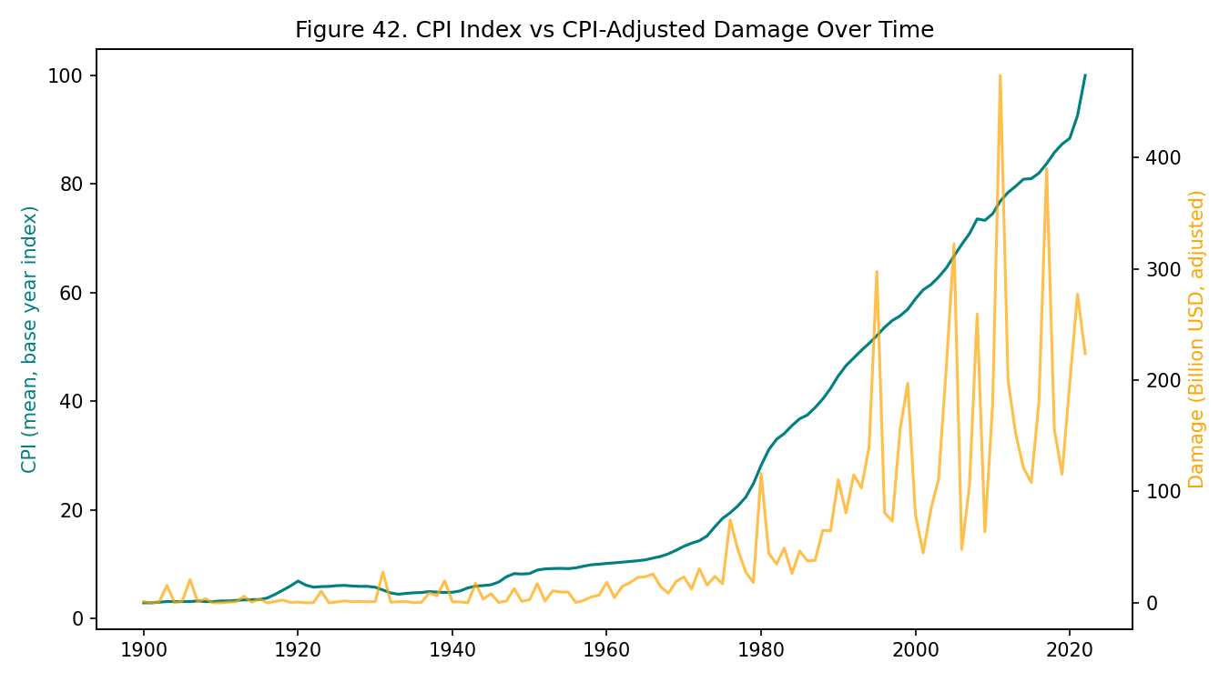
Figure 42
Figure 42. What it shows: A dual-axis time series with Year on the x-axis, mean CPI (Consumer Price Index, a base-year price-level index) on the left axis, and CPI-adjusted Damage on the right axis — the only figure in this report using the raw CPI field directly, rather than only implicitly through the pre-computed “adjusted damage” column used elsewhere. What pattern appears: The CPI line is smooth and steadily rising throughout, exactly as expected for a price index, while the damage line is far more volatile, showing sharp individual-year spikes rather than a comparably smooth climb. Why this occurs and what it means: This figure functions as a methodological sanity check on every other damage-related figure in this task set (Figures 33-34, 37, 44). If the rising-damage trend seen elsewhere were somehow an artifact of the CPI-adjustment calculation itself (rather than a genuine feature of the underlying disaster losses), one would expect the adjusted-damage line to inherit CPI’s own smooth, steadily-rising shape. Instead, damage’s shape is visibly distinct from and far spikier than CPI’s own shape, confirming that the volatility and trend seen in the adjusted-damage figures is a real property of disaster losses themselves, not a mathematical artifact of how the inflation adjustment was computed.
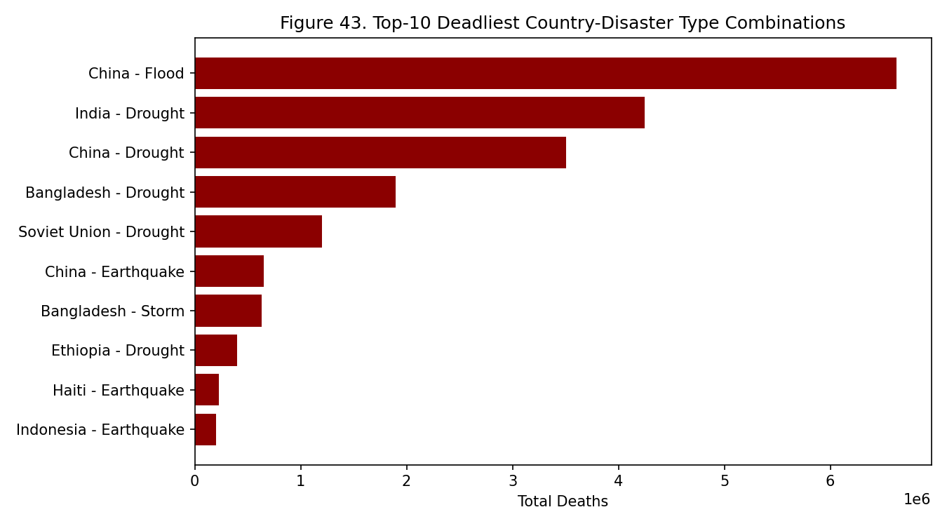
Figure 43
Figure 43. What it shows: A horizontal bar chart of the top-10 single deadliest Country-Disaster-Type combinations by cumulative deaths — a further drill-down beneath Figure 32’s type-level aggregate, isolating exactly which specific country-hazard pairings are responsible for the largest shares of the aggregate totals shown earlier. What pattern appears: Several of the top-10 entries in this list involve drought as the disaster type. Why this occurs and what it means: This figure exists to answer a question Figure 32’s type-level aggregate cannot: is drought’s outsized aggregate death toll spread evenly across many countries each contributing a modest amount, or concentrated in a small number of specific country-drought pairings? Finding multiple drought entries near the top of this country-specific ranking indicates the latter — a small number of specific historical drought events in specific countries account for a disproportionate share of the aggregate drought death toll identified in Figures 32 and 36, meaning famine/drought-relief investment aimed at preventing a repeat of history should be able to identify and prioritize a relatively small number of historically vulnerable countries rather than needing to spread thin across the entire drought-affected world.
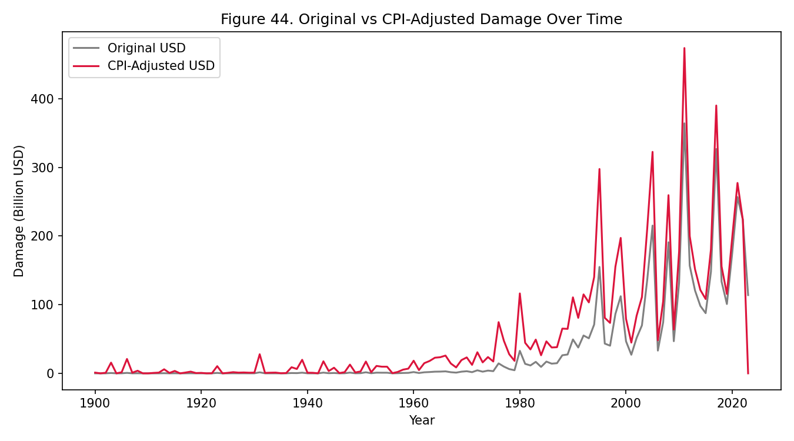
Figure 44
Figure 44. What it shows: A line chart with Year on the x-axis and two lines on a shared y-axis (Damage in billions of USD) — one for the original, unadjusted USD damage figure as originally recorded, and one for the CPI-adjusted figure used throughout the rest of this task set — directly visualizing what the inflation-adjustment step actually does to the numbers. What pattern appears: The two lines sit close together in recent years but diverge substantially further back in time, with the adjusted line sitting well above the original line for older events. Why this occurs and what it means: This divergence is the inflation-adjustment mechanism working exactly as intended: a disaster that caused, say, $1 billion of damage in 1970 dollars represents a much larger amount of real economic value than $1 billion today, so the adjustment scales the older figure upward to make it comparable to modern dollars. The figure’s inclusion here serves a validation purpose for the rest of the task set: because the adjusted line (used in Figures 33-34, 37, 42) still shows a strong upward trend even after this inflation correction has been applied, the rising-damage conclusion drawn throughout this task set is confirmed to be a real increase in economic loss, not merely a currency-value illusion that would have disappeared once inflation was properly accounted for.
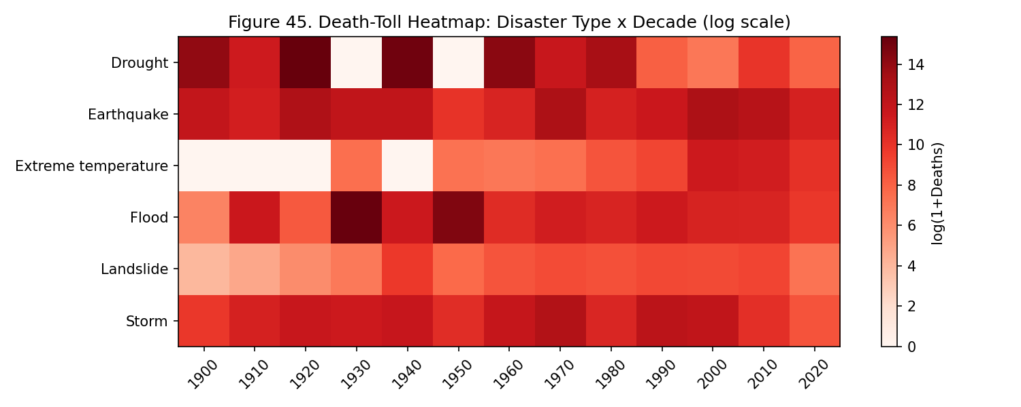
Figure 45
Figure 45. What it shows: A heatmap with Disaster Type as rows and Decade as columns, color intensity (on a log scale, since deaths span several orders of magnitude across cells) encoding cumulative Total Deaths — deliberately constructed as the direct severity-side counterpart to Task Set A’s Figure 2, which used the identical row/column structure but encoded Total Events instead of deaths. What pattern appears: Unlike Figure 2, where the flood row is consistently the darkest across the most recent decade columns, this figure’s darkest cells are scattered across the drought and earthquake rows in specific, individual decade columns rather than concentrated in the same flood-heavy recent decades. Why this occurs and what it means: Placing this figure side-by-side with Figure 2 (which uses the exact same grid structure) makes the frequency-versus-severity distinction that runs through this entire task set visually undeniable: the decades that produced the most events (recent decades, flood-dominated, per Figure 2) are demonstrably not the same decades that produced the most deaths (specific historical decades, drought/earthquake-dominated, per this figure) — the single clearest visual proof in the whole report that “more disasters happening” and “more people dying from disasters” are separate phenomena requiring separate policy responses.

7.1 Limitations (Task Set C)
- Missing damage/death data is the single biggest constraint on this task set. Roughly 63% of records have no damage figure and ~29% have no death figure at all, concentrated in older and lower-income-country records (Section 2). Every ranking and correlation figure here (Figures 31, 34-38, 40-41) is computed only over the non-missing subset, which likely under-represents the true severity of disasters in countries with weaker historical reporting capacity — the true global damage/death totals are almost certainly higher than what these figures show.
- Drought’s death toll is dominated by a small number of historical mega-events (e.g. large 20th-century famines), so its extreme deaths-per-event ratio (Figure 36, ~14,631) is heavily influenced by outliers rather than being representative of a “typical” drought — this is a case where a single aggregate ratio can be misleading without the distributional context in Figure 41.
- Damage figures are not adjusted for growth in global asset value, only for inflation (CPI). This means part of the rising CPI-adjusted damage trend (Figures 33, 42, 44) reflects more infrastructure and property existing in disaster-prone areas today than a century ago, not disasters becoming individually more destructive — a distinction this task set’s figures cannot separate out with the fields available.
- Country-type aggregation (used in Figures 31, 40) can mask within-category variance — a single “Country-DisasterType” data point sums potentially many distinct events across 1900-2023, so the scatter positions represent a long-run total, not any single disaster’s severity.

7.2 Conclusion (Task Set C)
Severity does not track frequency. Drought causes the highest deaths-per-event by a wide margin (~48× the least lethal major category) despite having one of the lowest event counts among major disaster types, while floods and storms — by far the most frequent — have comparatively low per-event lethality. The correlation analysis (Figure 35) makes this precise: event count is essentially uncorrelated with deaths (r ≈ 0.00) but moderately correlated with economic damage (r ≈ 0.41), meaning frequency-based risk models are reasonable proxies for economic exposure but poor proxies for expected loss of life. Economic damage has also risen substantially even after removing inflation’s effect (Figure 44), while deaths have not risen proportionally, suggesting early-warning and evacuation improvements have partially decoupled economic exposure from human cost. Together this argues that severity-focused disaster policy needs to be type-specific: drought and earthquake response should prioritize early warning and mortality prevention, while flood/storm response can reasonably prioritize economic/infrastructure resilience given their lower per-event lethality.

8. Limitations
- Reporting bias, not just a temporal trend: the entire pre-1980 portion of the dataset should be treated as a lower bound rather than a true count (Figure 3). Cross-country and cross-decade comparisons that span this boundary should be read qualitatively, not as precise ratios.
- Missing severity data: roughly 63% of records have no damage figure at all, likely correlated with country income level, meaning damage-based comparisons across countries (Figure 34, 37) may understate the true cost in lower-income, more disaster-exposed nations.
- Country-boundary artifacts: some low-ratio entries in Figure 26 (e.g. the former Germany Fed. Rep.) reflect countries that no longer exist in their pre-1980 political form, not a genuine decline in disaster exposure.
- Country-level aggregation hides sub-national variation: a country like the USA spans many climate zones; a single “dominant disaster type” (Figures 16-18, 38) can obscure that different disaster types dominate different regions within one country.
- No population normalization: Total Events, Total Deaths, and Total Affected are absolute counts, not normalized by population or land area, so larger/more populous countries mechanically rank higher in several figures (e.g. Figure 19) independent of true per-capita risk.
- CPI adjustment corrects for inflation only: it does not account for the fact that global infrastructure value has grown over the same period, so some of the rising CPI-adjusted damage trend (Figure 33, 42) reflects more assets being exposed to disasters, not disasters becoming individually more destructive.

9. Overall Conclusions
Across all three task sets, a consistent and quantified picture emerges. Recorded disaster activity rises sharply after 1970-80 (Task Set A), but the rise is uneven across types — floods rise 17.8× and storms 9.2× versus a 3.8× rise for earthquakes, a physically-salient control category — indicating a real increase in hydro-meteorological disasters layered on top of a reporting-infrastructure baseline shift. This rise concentrates in a shifting set of countries (Task Set B): the USA and China lead historically, while Vietnam, Thailand, and Malaysia show the largest relative growth (19.7×, 26.0×, and 17.6× respectively) between reporting eras, and each country’s disaster-type composition and diversity is distinct rather than uniform. Finally, human cost is governed less by event frequency and more by disaster type (Task Set C): drought causes the highest deaths-per-event by a factor of roughly 48× over the least lethal major category, even though it has far fewer recorded events than floods or storms, while economic damage scales much more directly with event count (r ≈ 0.41). Together, this argues for disaggregated disaster policy: flood/storm-prone nations — especially the newly-emergent hotspots in Southeast Asia — need frequency-driven infrastructure mitigation, while regions exposed to low-frequency, high-lethality events (drought, earthquake) need severity-driven early-warning and famine/relief-response investment regardless of how often those events occur.

10. Author Contributions
Member | Roll Number | Task Set | Contribution
Arnav Jain | BT2024233 | A — Temporal Trends | Preprocessing, Task Set A analysis and Figures 1-15, repository setup
Kalpit Phogat | BT2024093 | B — Geographic Distribution | Task Set B analysis and Figures 16-30
Lakshya Jain | BT2024044 | C — Impact Severity | Task Set C analysis and Figures 31-45
Data preprocessing: Arnav Jain (also covers the first minute of the video demo).
Report writing/compilation: Arnav Jain, with contributions from all members for their respective task sets.

11. AI Declaration
Separate AI declaration forms for each team member are included as an appendix (see ai_declaration_form.md / attached forms).

