Idea Submission Template for AI Unlocked

Name of your Institute : IIT Delhi
Challenge Area: Track 4 Agent Teamwork
Your Team Name: LiveLong.ai
Registered Email ID of your Team Lead: ms1240729@iitd.ac.in

Project Title

The Team
Why We Built LiveLong.ai

The inspiration for LiveLong.ai started at home. My 80-year-old grandfather is a survivor of heart surgery, a kidney transplant, and knee surgery. For him, managing health isn't just about recovering; it’s an "administrative marathon." He has to juggle different advice and prescriptions from a cardiologist, a nephrologist, and an orthopedic surgeon—none of whom talk to each other.

At the same time, my mother works in hospital administration. She sees firsthand how doctors are buried under paperwork and how patients lose out because their medical data is scattered across different systems.

Our team—five 2nd-year students from IIT Delhi—decided to bridge this gap. We realized that while advanced AI is growing, there isn't a simple system that helps both the elderly patient and the busy hospital staff work together. We built LiveLong.ai to turn that "marathon" into a simple, guided walk.

The Concept

LiveLong.ai is a unified, autonomous health navigation system designed to bridge the gap between clinical intent and daily patient adherence. The primary problem we are solving is the "Coordination Tax"—the dangerous administrative burden placed on patients and doctors when medical data is siloed across different providers and platforms. This fragmentation leads to medication errors, missed appointments, and poor health outcomes.

LiveLong.ai solves this by creating a Central Health Data Hub built on Azure Health Data Services (FHIR). We utilize a distributed AI architecture of three specialized agents—The Planner, The Retriever, and The Executor.

The Patient Experience: "Care Navigation"

Medical Chart & Lab Retrieval: Patients can instantly pull historical trends (e.g., "Show me my hemoglobin levels over the last 6 months") via the Retriever Agent.

Automated Care Plans: The Planner Agent ingests complex discharge summaries or chronic management goals to generate structured, daily schedules for medications, therapy, and check-ups.

Autonomous Scheduling: The Executor Agent acts as a "Calendar Negotiator," using the Microsoft Graph API to sync with clinic calendars and book appointments that fit the patient’s life.

The Shopping Scout: The Executor identifies required supplies (e.g., knee braces, glucose strips) from the chart and provides a real-time price comparison from online retailers.

The Doctor Experience: "Clinical Command"

Central Record Management: The Executor Agent automates the data pipeline, writing doctor-uploaded transcriptions directly into the patient's central FHIR record to ensure all specialists see the same data.

Active Plan Edits: Doctors can update a patient’s roadmap (e.g., "Increase insulin dosage") through the Planner Agent, which immediately updates the patient's daily checklist.

Multi-Doctor Mediation (Clash Detection): This is our "Safety Gatekeeper." The Planner compares prescriptions from multiple providers to detect drug-drug interactions, alerting both doctors and the patient before a dose is taken.

Automated Monitoring: The system performs Background Orchestration. If the Retriever notices a lab result trending out of range, the Planner triggers the Executor to send a high-priority alert to the doctor and prompt an immediate follow-up.

Target Audience or Market
Our solution is designed for the entire healthcare ecosystem, democratizing advanced AI orchestration for providers and patients alike. This inclusive approach ensures that high-quality, automated care coordination is accessible regardless of the facility's size or the patient's age and condition.

Health care Providers

Healthcare Providers: From Hospitals to Small Clinics, we target a diverse range of medical professionals and facilities:

Large Hospital Systems: Seeking to reduce clinician burnout (with over 80% of hospitals already adopting AI for efficiency) and manage high patient volumes.

Small & Rural Clinics: Providing "force multiplier" tools for small teams where staff shortages are critical. While only 37% of independent hospitals currently use predictive AI, our scalable cloud-native approach lowers the barrier to entry.

Patient Demographic: All Ages and Conditions

The system is built to support patients throughout their entire life journey, regardless of whether they are managing a short-term illness or a chronic long-term condition.

All Age Groups: From tech-native younger generations to older adults (65+) who increasingly rely on digital tools to manage multiple medications and chronic diseases.

Illness Spectrum: Supports everything from simple acute-care reminders to complex, multi-year treatment plans for chronic conditions like diabetes or heart failure.

Market Size and Opportunity (2026)

The market for this "universal" healthcare technology is expanding rapidly

AI in Healthcare: Projected to be a $56.01 billion market in 2026, driven by the need for scalable support systems to bridge workforce gaps.

Source: Data derived from World Health Organization (WHO), Grand View Research, and Fortune Business Insights reports for 2025–2026.

Personas
Medical Professional Personas

Dr. Yash (Small Clinic GP): Needs to automate administrative tasks and patient follow-ups to manage high daily volumes with a small staff. The agents act as a "digital assistant" to draft treatment plans and check drug interactions.

Dr. Payal (Hospital Specialist): Manages complex, long-term oncology cycles that require multi-departmental coordination. She uses the orchestration system to sync surgery, lab, and chemo schedules without manual errors.

Patient Personas

Aditya (Young Adult): A tech-native patient recovering from a short-term sports injury who needs mobile-first reminders. He relies on automated notifications for physical therapy and medication to ensure a fast, efficient recovery.

Soumya (Senior Patient): Manages multiple chronic conditions like diabetes and hypertension that require constant monitoring. The system simplifies her care by providing unified, easy-to-read daily schedules and large-print reminders.

Aid Giver Personas

Amit (Family Caregiver): Diya’s son who monitors her health status remotely to ensure she adheres to her treatment. He receives automated alerts if a medication dose is missed, providing peace of mind from a distance.

Apurva (Home Health Aide): A professional caregiver who needs clear, up-to-date daily task lists for different patients. The system provides her with real-time instructions and clinical updates directly from the patients' doctors.

How it works:

Develop: Build the agent logic (Planner, Retriever, Executor) using the AutoGen SDK to define their roles and communication protocols.

Containerize: Package each agent as a Docker container and store them in the Azure Container Registry.

Deploy: Launch the containers into an Azure Container Apps environment, enabling them to scale dynamically based on patient request volume.

Connect: Integrate with Azure OpenAI for reasoning and Azure Health Data Services for secure patient record access.
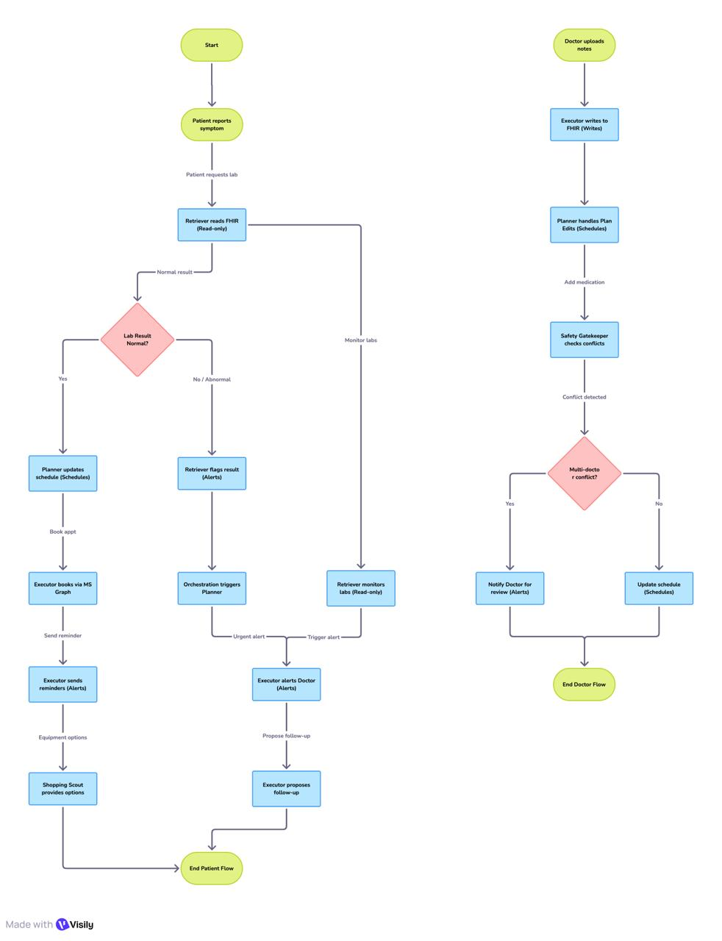

Core Technologies
1. AI Orchestration: Microsoft Agent Framework (AutoGen & Semantic Kernel)
This is the "brain" of your system. The Microsoft Agent Framework combines the innovative multi-agent patterns of AutoGen with the enterprise-grade stability of Semantic Kernel.

Role: It allows your specialized agents (Planner, Retriever, Executor) to collaborate through natural language "hand-offs" rather than rigid code.
Benefit: This framework simplifies complex clinical workflows by treating tasks as a multi-turn conversation between specialized digital helpers.

2. Intelligence & Retrieval: Azure OpenAI & Azure AI Search
These services provide the medical reasoning and the "long-term memory" for your Retriever agent.

Azure OpenAI: Provides the Large Language Models (LLMs) like GPT-4o that power the reasoning and decision-making for each agent.
Azure AI Search (Agentic Retrieval): Enables the Retriever to perform Retrieval-Augmented Generation (RAG). It breaks complex medical queries into focused subqueries to find the most relevant, grounded data from medical journals or patient records.

3. Scalable Deployment: Azure Container Apps (ACA)
ACA is the "engine room" where your agents live and work.

Serverless Orchestration: It allows you to run each agent in its own secure, serverless container that scales automatically based on demand.
Healthcare Feasibility: For small clinics, ACA’s scale-to-zero feature ensures they only pay for the computing power they use. For large hospitals, it provides the high availability and security needed for critical care.

4. Healthcare Data Standard: Azure Health Data Services (FHIR)
To be successful in a medical context, the system must speak the "universal language" of healthcare.

FHIR Service: Uses the Fast Healthcare Interoperability Resources (FHIR) standard to securely ingest, store, and exchange patient health information (PHI).
Impact: This ensures your agents can communicate with existing Electronic Health Records (EHR) systems used by both large hospitals and small practices.

The Business Plan:
Step 1: Incubation & Prototyping (Months 1–6)
Action: Apply for incubation at the IIT Delhi Foundation for Innovation and Technology Transfer (FITT) and the CMIE (Center for Medical Innovation & Entrepreneurship) at AIIMS.

Objective: Develop the Minimum Viable Product (MVP) with high clinical accuracy.

Infrastructure: Use Microsoft's Azure for Startups credits to set up the containerized backend on Azure Container Apps.

Success Metric: Successful extraction of 95%+ accuracy from handwritten Indian prescriptions using Azure AI Document Intelligence.

Step 2: Clinical Pilot at AIIMS (Months 6–12)
Action: Under the mentorship of AIIMS faculty, launch a "Closed-Loop" pilot in a high-complexity department (e.g., Nephrology or Cardiology).

Implementation:
1. Staff Portal: Nurses upload real, anonymized prescriptions to the CareSync staff portal.
2. Safety Validation: The AI Retriever and Planner cross-check these against patient history.
3. Human-in-the-Loop: Doctors review the AI's "Safety Flags" before they reach the patient app.

