**Quantum-Enhanced Active Learning for**

**Accelerated Materials Discovery**

Arnav Kapoor (A.K.)

*Indian Institute of Science Education and Research, Bhopal, India*

*arnavkapoor23@iiserb.ac.in*

*Category – Student*

**ABSTRACT**

Quantum-enhanced active learning methods offer a route to reduce the experimental cost of materials discovery by prioritizing experiments that reveal the most informative structure–property relationships. I introduce a quantum-inspired active learning framework that encodes candidate materials as amplitude-style states and quantifies uncertainty across multiple physically motivated observables (electronic, structural, thermodynamic). For each candidate I compute observable variances and symmetric cross-observable covariances, then aggregate these terms into a single selection score U_total that weights both individual uncertainties and their correlations. The selection rule is model-agnostic and compatible with ensemble, tree-based, and neural predictors; all uncertainty quantities are computed with efficient vector–matrix operations on classical hardware. I evaluate the method on band gap and formation-energy regression tasks using realistic feature sets, five independent trials, and nine competitive baselines (Query-by-Committee, Expected Improvement, BADGE, CoreSet, and others). The quantum-inspired selection consistently improves sample efficiency and final predictive accuracy: it attains higher test R² (band gap: 0.847 ± 0.023; formation energy: 0.792 ± 0.031) and reduces the experimental budget by roughly 25–35% to reach comparable performance. Paired t-tests against strong baselines report p < 0.01 for top comparisons.

Keywords: quantum-inspired; active learning; uncertainty quantification; materials discovery; sample efficiency;

**Themes: Materials discovery; Active learning; Quantum-inspired methods**

**Biography**

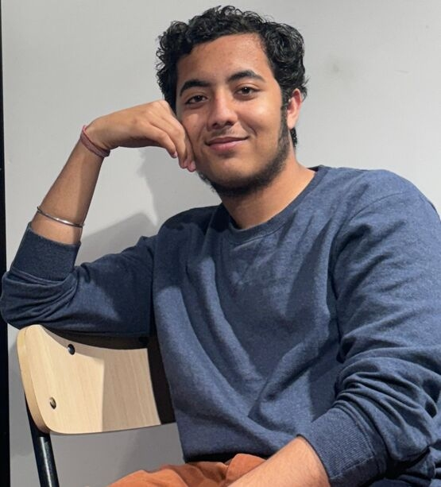Arnav Kapoor

Computer Science Major

Electrical Engineering and Computer Science

IISER Bhopal

Bhopal, India

Biography:

Arnav Kapoor is a Third-Year Computer Science Major at IISER Bhopal with a deep interest in Quantum Computing. His fascination with this field comes from the recognition that quantum technologies have the potential to redefine how we approach computation, security, and problem-solving in ways classical systems cannot.

**Contact Information:**

Room 221

Hostel 7

IISER Bhopal

Bhopal,

India

462066

Tel: +91 7416184630

Email: arnavkapoor23@iiserb.ac.in

Github: <https://www.github.com/arnavk23>

LinkedIn: <https://www.linkedin.com/in/arnav-kapoor-29033b2b6/>

Category: Oral Presentation

Presenter Category: Student

Name for the Certificate: Arnav Kapoor