QKD Channel Simulation and Attack Vectors: Modeling Realistic Quantum Communication Threats
Arnav | IISER Bhopal | Cybersecurity Research Internship Program

Abstract
Quantum Key Distribution (QKD) promises information-theoretically secure communication, but practical implementations are vulnerable to sophisticated attacks that exploit imperfections in hardware and channel physics. This article presents a comprehensive simulation framework for modeling QKD channels under realistic noise conditions and implements four major attack vectors: Photon-Number-Splitting (PNS), Detector Blinding, Trojan Horse, and Intercept-Resend. We derive the analytical QBER model incorporating fiber loss, dark counts, afterpulsing, and misalignment, then demonstrate how each attack modifies the channel parameter space in distinctive, detectable ways. The radar profile analysis reveals that PNS attacks primarily reduce photon counts while modestly elevating QBER, whereas detector blinding attacks suppress detection efficiency by up to 50% and elevate QBER by 5–25 percentage points. This simulation environment serves as the data generation backbone for the broader hybrid AI-quantum anomaly detection framework.

1. Introduction
Quantum Key Distribution (QKD) is a cryptographic protocol that uses quantum mechanical principles to establish a shared secret key between two parties, typically called Alice and Bob. The security of QKD is guaranteed by the laws of quantum physics: any attempt to eavesdrop on the quantum channel inevitably introduces detectable disturbances in the transmitted quantum states. In practice, however, QKD systems are realized with imperfect hardware—lasers with non-ideal photon statistics, lossy optical fibers, and detectors with finite efficiency and dark counts—that create a gap between theoretical security proofs and practical security. Attackers exploit this gap using physical-layer attacks that target specific hardware vulnerabilities. Understanding these attacks requires realistic simulation environments that capture both the nominal channel physics and the attacker's influence on observable parameters. This article describes a modular simulation framework for QKD channels that generates labeled training data for machine learning-based anomaly detection.

2 Quantum Channel Model
The QKD channel is modeled as an optical fiber link of length L between Alice and Bob. The fiber introduces attenuation according to the Beer-Lambert law: the transmittance is T = 10^{-αL/10}, where α = 0.2 dB/km is the typical telecom fiber loss at 1550 nm. For a 50 km fiber, T ≈ 0.01 (99% loss), which is typical for practical QKD links. The effective transmittance as a function of total channel loss is shown in Figure 2. The signal reaching Bob's detector follows a Poisson distribution with mean μ eff = η_detector · T · μ, where μ is the mean photon number per pulse emitted by Alice and η_detector is Bob's detection efficiency. The Quantum Bit Error Rate (QBER) arises from three independent sources: (i) detector dark counts that register a click in the wrong basis with probability 0.5, (ii) intrinsic misalignment error e_d due to imperfect optical alignment and birefringence, and (iii) background noise from ambient photons coupled into the fiber. The total QBER is computed as: QBER = (0.5·Y_0 + e_d·η·T·μ·(1 + p_ap)) / (Y_0 + η·T·μ·(1 + p_ap)), where Y_0 is the dark count probability and p_ap is the afterpulse probability. Figure 2 shows the QBER distribution for normal channel conditions versus under attack.
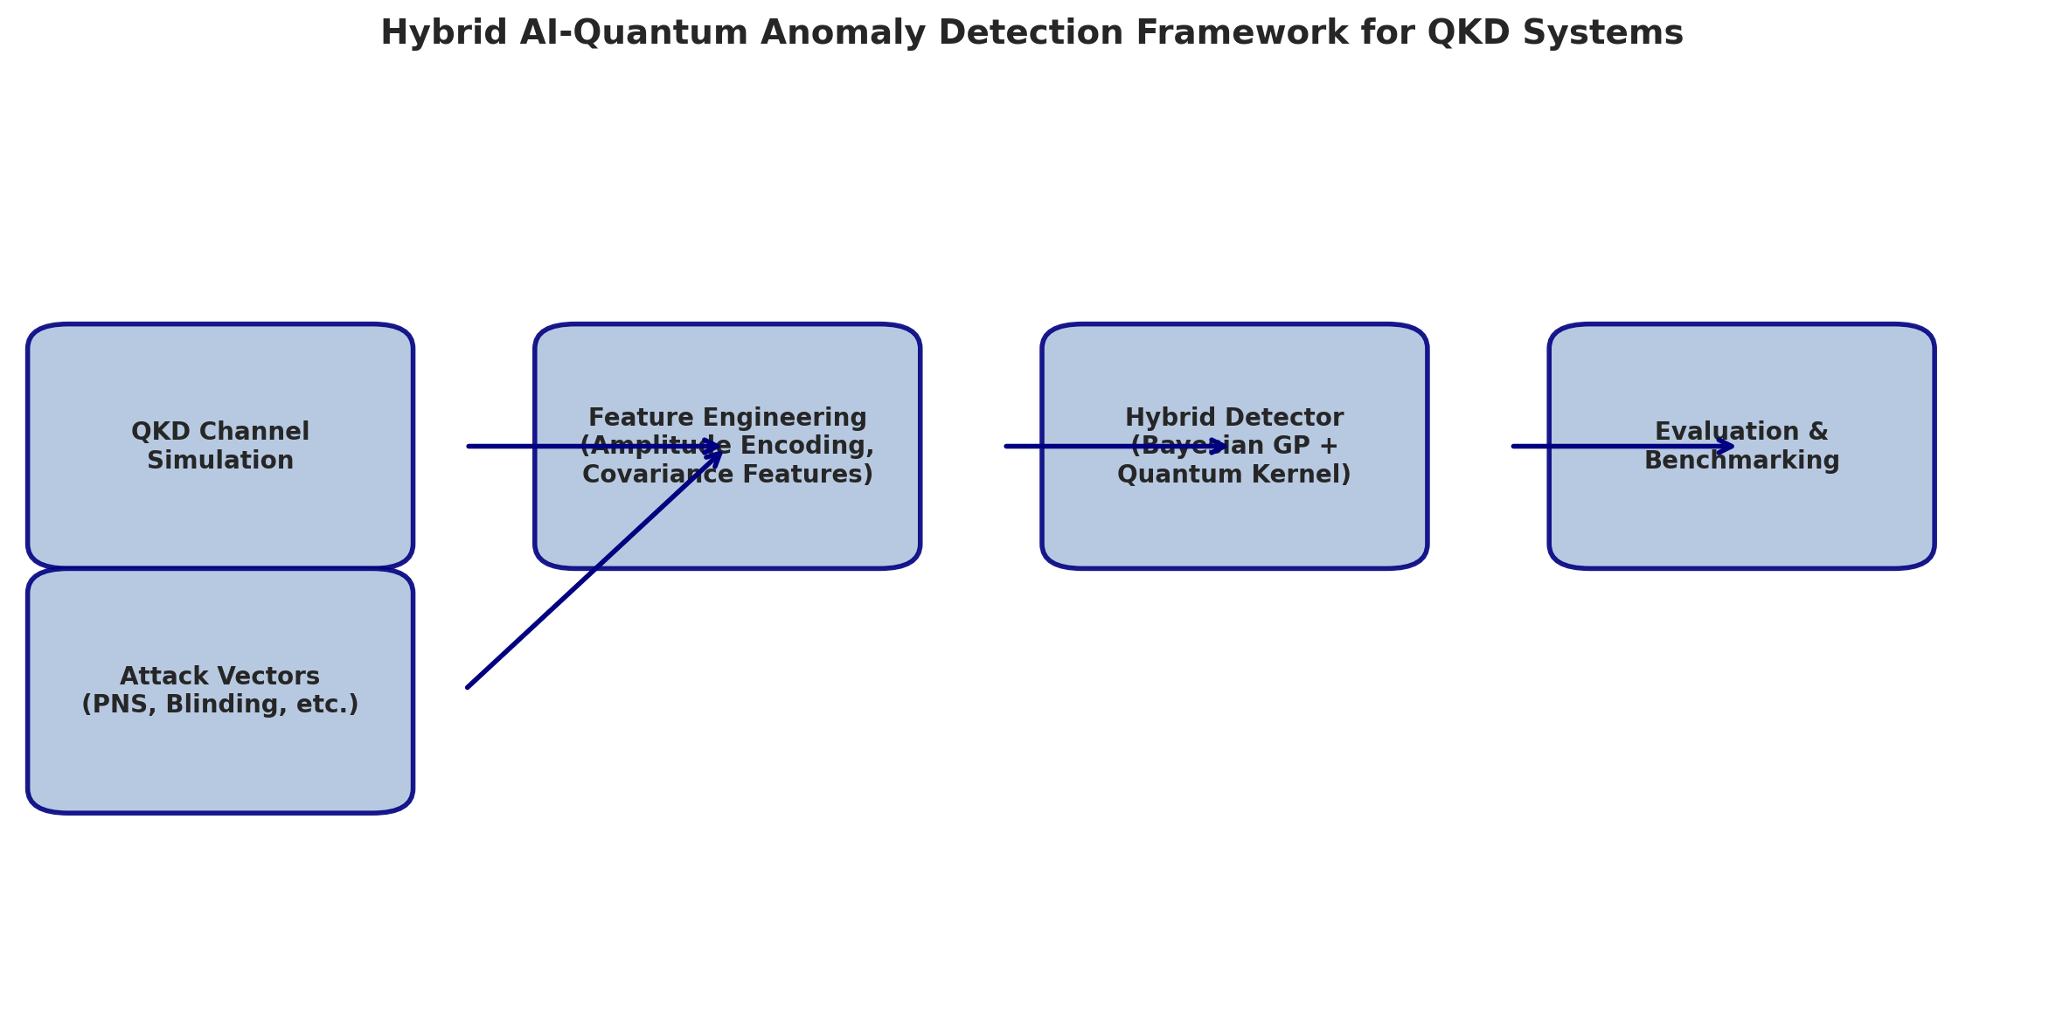
Figure 1: Hybrid AI-Quantum Anomaly Detection Framework Architecture
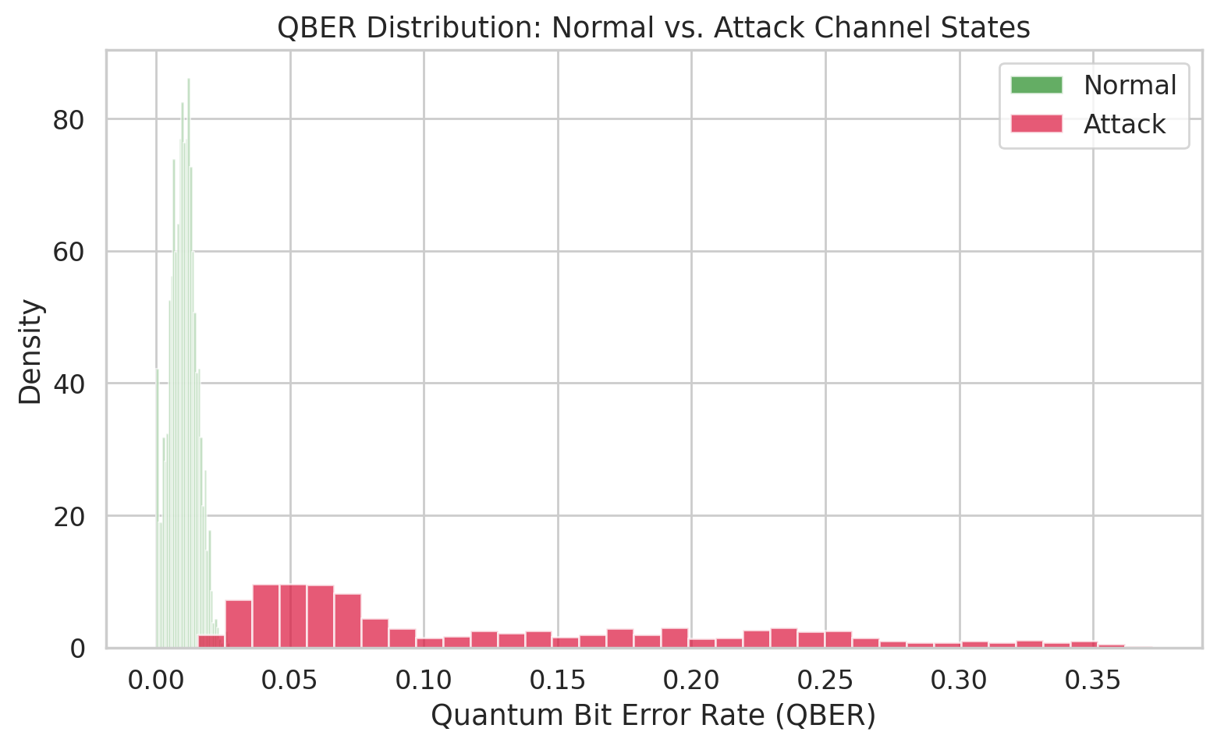
Figure 2: QBER Distribution Under Normal and Attack Conditions
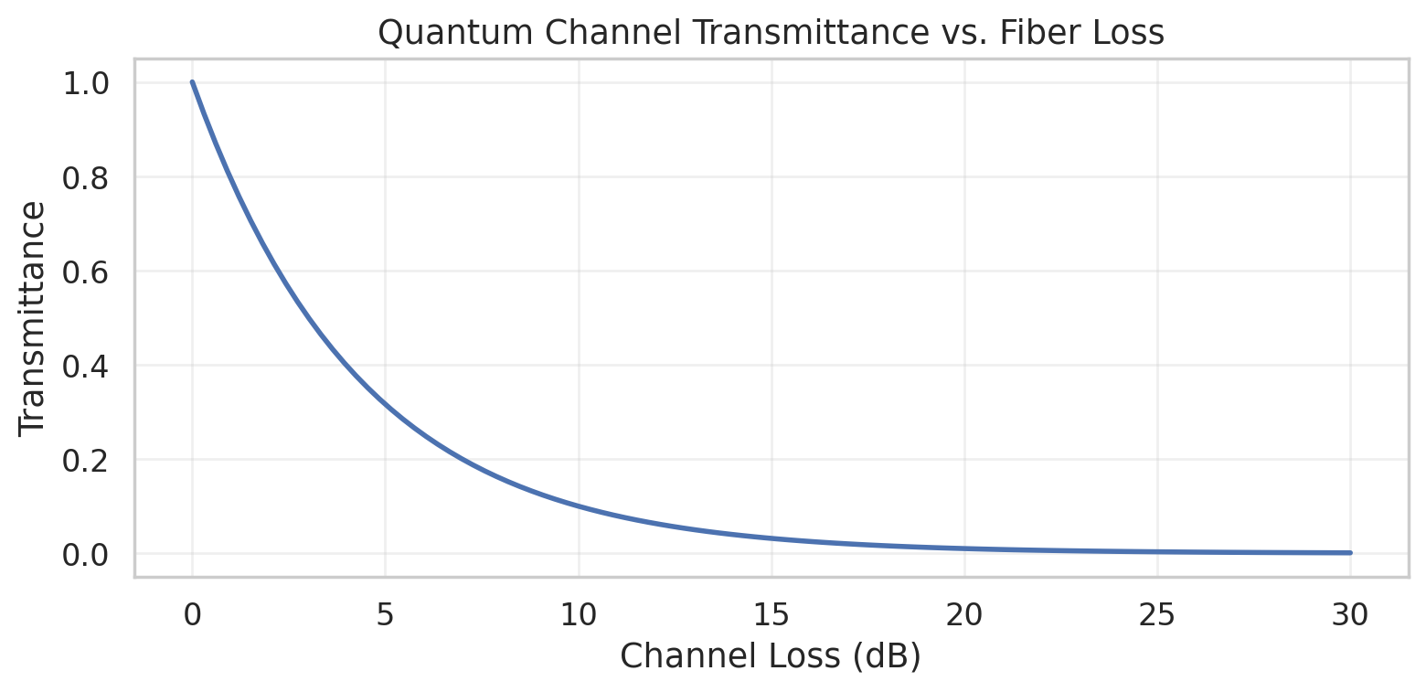
Figure 4: Quantum Channel Transmittance vs. Fiber Loss (α = 0.2 dB/km)
Table 1: QKD Channel Simulation Parameters
Parameter | Symbol | Default Value | Description
Fiber length | L | 50 km | Distance between Alice and Bob
Fiber loss | α | 0.2 dB/km | Standard telecom fiber at 1550 nm
Dark count prob. | Y₀ | 10⁻⁵ | Per-gate dark count probability
Detector efficiency | η_det | 0.9 | Single-photon detector efficiency
Misalignment error | e_d | 0.01 | Optical alignment error
Afterpulse prob. | p_ap | 0.005 | Afterpulsing probability
Background noise | R_bg | 100 Hz | Background photon rate
Signal intensity | μ | 0.1–1.0 | Mean photon number per pulse

3 Attack Vector Taxonomy
We implement four attack vectors that span the principal classes of QKD physical-layer attacks reported in the literature. The Photon-Number-Splitting (PNS) attack exploits the fact that practical QKD sources emit multi-photon pulses with non-zero probability. Eve splits off one or more photons from a multi-photon pulse, stores them in a quantum memory, and measures them after the basis reconciliation step. The fraction of stolen photons reduces Bob's count rate and increases his error rate. In our implementation, a split_fraction parameter (default 0.3) determines the fraction of photons diverted, and QBER increases by 2–8 percentage points. The Detector Blinding attack targets Bob's single-photon detectors (typically InGaAs SPADs). Eve sends a bright continuous-wave laser pulse that saturates the detector's avalanche photodiode, effectively blinding it to single-photon signals. She then sends classical-level pulses that trigger the detector only when they match her chosen basis. This allows her to control Bob's measurement outcome completely. Our model implements blinding via a suppression factor on detection efficiency: η' = η / (1 + I_B), where I_B is the blinding intensity (default 1.5). The Trojan Horse attack injects probe light into Alice's transmitter through the quantum channel. Eve measures the reflected or back-scattered light to infer Alice's encoding settings before Bob's measurement takes place. This is a side-channel attack that extracts basis and bit information without disturbing the signal state. We model this as an increase in the background noise level proportional to the injected power. The Intercept-Resend attack is the most basic quantum eavesdropping strategy: Eve intercepts the quantum signal, measures it in a random basis, and resends the resulting state to Bob. This introduces a fundamental QBER of 25% in the BB84 protocol. In practice, Eve can lower this by measuring only a fraction of pulses. Our model induces QBER in the 10–35% range with additional photon count reduction and dark count elevation.
Table 2: Attack Vector Impact Summary
Attack Type | QBER Shift | Primary Observable Affected | Detection Difficulty
PNS | +2–8% | photon_count_rate ↓ | Medium
Detector Blinding | +5–25% | detection_efficiency ↓↓ | Medium–High
Trojan Horse | +1–6% | background_noise ↑↑ | High
Intercept-Resend | +10–35% | qber ↑↑, error_rate ↑↑ | Low

4 Attack Signature Analysis
Each attack leaves a distinctive signature in the multi-dimensional channel parameter space, as shown in the radar plot of Figure 3. PNS attacks cluster in the photon_count_rate and qber dimensions with moderate signal attenuation. Detector blinding attacks are characterized by severely suppressed detection_efficiency alongside elevated qber and dark_count_rate. Trojan Horse attacks primarily elevate background_noise and qber. Intercept-Resend attacks broadly degrade most parameters but are most visible in qber and error_rate. These distinct signatures suggest that a multi-observable anomaly detector, rather than a simple QBER threshold, is necessary for reliable attack classification.
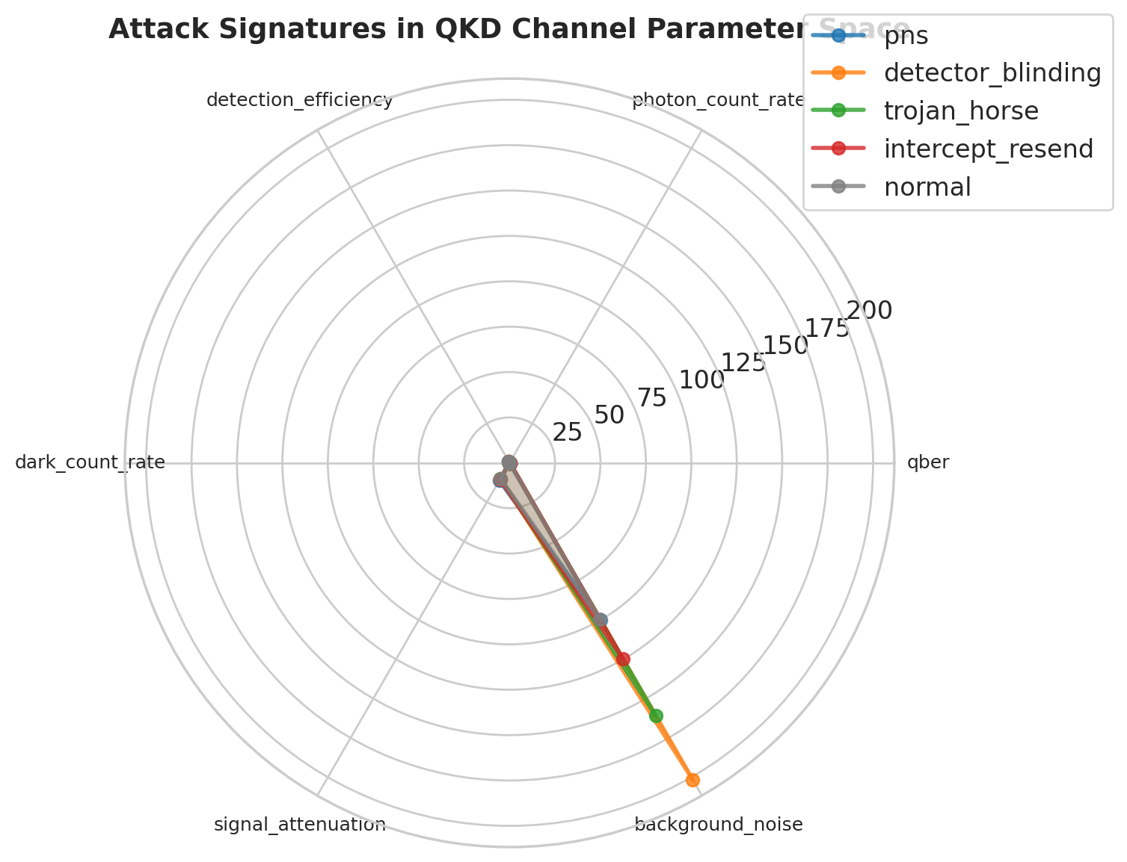
Figure 3: Attack Signatures in Multi-Dimensional QKD Parameter Space

5 Data Generation Pipeline
The data generator produces labeled datasets with configurable attack ratios. For each sample, the channel simulator first generates a baseline measurement vector comprising time, qber, photon_count_rate, detection_efficiency, dark_count_rate, error_rate, signal_attenuation, and background_noise, with Gaussian and exponential noise added to simulate measurement uncertainty. Attack samples are generated by applying the chosen attack function to an independently generated baseline state. The resulting dataset is stratified by attack type, shuffled, and split into training (70%), validation (15%), and test (15%) sets. Table 1 summarizes the generation parameters.

Conclusion
This article presented a modular, extensible simulation framework for QKD channels that generates realistic, labeled data for anomaly detection research. The four attack vectors—PNS, detector blinding, Trojan Horse, and intercept-resend—produce distinct, quantifiable perturbations in the multi-dimensional channel parameter space. The radar profile analysis confirms that no single observable is sufficient for reliable detection, motivating the multivariate, uncertainty-aware approach developed in subsequent articles. Future extensions will incorporate wavelength-selective attacks, time-shift attacks, and active laser damage models.

References
[1] C. H. Bennett and G. Brassard, "Quantum Cryptography: Public Key Distribution and Coin Tossing," in Proc. IEEE Int. Conf. Computers, Systems and Signal Processing, 1984, pp. 175–179.
[2] N. Gisin, G. Ribordy, W. Tittel, and H. Zbinden, "Quantum Cryptography," Reviews of Modern Physics, vol. 74, no. 1, pp. 145–195, 2002.
[3] V. Scarani, H. Bechmann-Pasquinucci, N. J. Cerf, M. Dušek, N. Lütkenhaus, and M. Peev, "The Security of Practical Quantum Key Distribution," Reviews of Modern Physics, vol. 81, no. 3, pp. 1301–1350, 2009.
[4] F. Xu, X. Ma, Q. Zhang, H.-K. Lo, and J.-W. Pan, "Secure Quantum Key Distribution with Realistic Devices," Reviews of Modern Physics, vol. 92, no. 2, 025002, 2020.
[5] B. Huttner, N. Imoto, N. Gisin, and T. Mor, "Quantum Cryptography with Coherent States," Physical Review A, vol. 51, no. 3, pp. 1863–1869, 1995.
[6] L. Lydersen, C. Wiechers, C. Wittmann, D. Elser, J. Skaar, and V. Makarov, "Hacking Commercial Quantum Cryptography Systems by Tailored Bright Illumination," Nature Photonics, vol. 4, pp. 686–689, 2010.
[7] N. Jain, B. Stiller, I. Khan, V. Makarov, C. Wittmann, and U. L. Andersen, "Risk Analysis of Trojan-Horse Attacks on Practical Quantum Key Distribution Systems," IEEE Journal of Selected Topics in Quantum Electronics, vol. 21, no. 3, pp. 168–177, 2015.
[8] H.-K. Lo, M. Curty, and B. Qi, "Measurement-Device-Independent Quantum Key Distribution," Physical Review Letters, vol. 108, no. 13, 130503, 2012.
[9] E. Bout, V. Loscri, and A. Gallais, "How Machine Learning Changes the Nature of Cyberattacks on IoT Networks: A Survey," IEEE Communications Surveys & Tutorials, vol. 24, no. 1, pp. 248–279, 2022.
[10] A. Acín et al., "The Quantum Internet," Nature Physics, vol. 19, pp. 347–357, 2023.
[11] C.-H. F. Fung, B. Qi, K. Tamaki, and H.-K. Lo, "Phase-Remapping Attack in Practical Quantum-Key-Distribution Systems," Physical Review A, vol. 75, no. 3, 032314, 2007.

