Quantum-Inspired Feature Engineering for Anomaly Detection in Quantum Key Distribution
Arnav | IISER Bhopal | Cybersecurity Research Internship Program

Abstract
Classical machine learning pipelines for anomaly detection in quantum communication systems typically use raw time-series measurements as features, discarding the rich structural information present in cross-parameter correlations and quantum state relationships. This article introduces two quantum-inspired feature engineering techniques tailored for QKD anomaly detection: amplitude encoding into Hilbert space and covariance-aware uncertainty quantification. Amplitude encoding maps classical measurement vectors to normalized state vectors in an 8-dimensional Hilbert space, enabling kernel methods that capture inner-product relationships between QKD channel states. The covariance-aware feature extractor computes Mahalanobis distances, local window statistics, and Frobenius-norm pairwise correlations to model cross-parameter uncertainties. Together, these techniques transform the 8-dimensional raw measurement space into a richer 20-dimensional feature space that improves downstream classifier separation.

1. Introduction
Feature engineering is the process of transforming raw data into representations that improve the performance of machine learning models. In QKD anomaly detection, the raw measurements—QBER, photon count rate, detection efficiency, dark count rate, error rate, signal attenuation, and background noise—are individually informative but collectively underutilized when treated as independent dimensions. The key insight is that attack events induce correlated changes across multiple observables simultaneously: a detector blinding attack simultaneously suppresses detection efficiency and elevates dark counts, while a PNS attack reduces photon counts without significantly affecting detector parameters. These cross-parameter correlations encode discriminative structure that standard feature spaces fail to capture. We draw inspiration from two quantum and statistical techniques developed in our prior work on NQComp 2026 materials discovery: amplitude encoding for representing classical data in quantum Hilbert spaces, and covariance-aware acquisition functions for modeling correlated uncertainties.

2 Amplitude Encoding In Hilbert Space
Amplitude encoding is a technique from quantum computing that maps a classical N-dimensional vector x into the amplitudes of a 2^n-dimensional quantum state, where n is the number of qubits. For our 8-dimensional QKD measurement vector, we use 3 qubits (2^3 = 8, sufficient for exact encoding) or up to 4 qubits for additional padding dimensions. The encoding procedure normalizes the input vector to unit L2 norm and projects it onto the computational basis states. The resulting amplitude vector |ψ(x)⟩ = Σ_i x_i |i⟩ / ||x|| satisfies ⟨ψ(x)|ψ(x)⟩ = 1. This representation enables a powerful kernel function: K(x_i, x_j) = |⟨ψ(x_i)|ψ(x_j)⟩|^2, which measures the quantum state overlap between two channel measurements. Figure 1 visualizes the transformation from raw features to amplitude-encoded vectors.
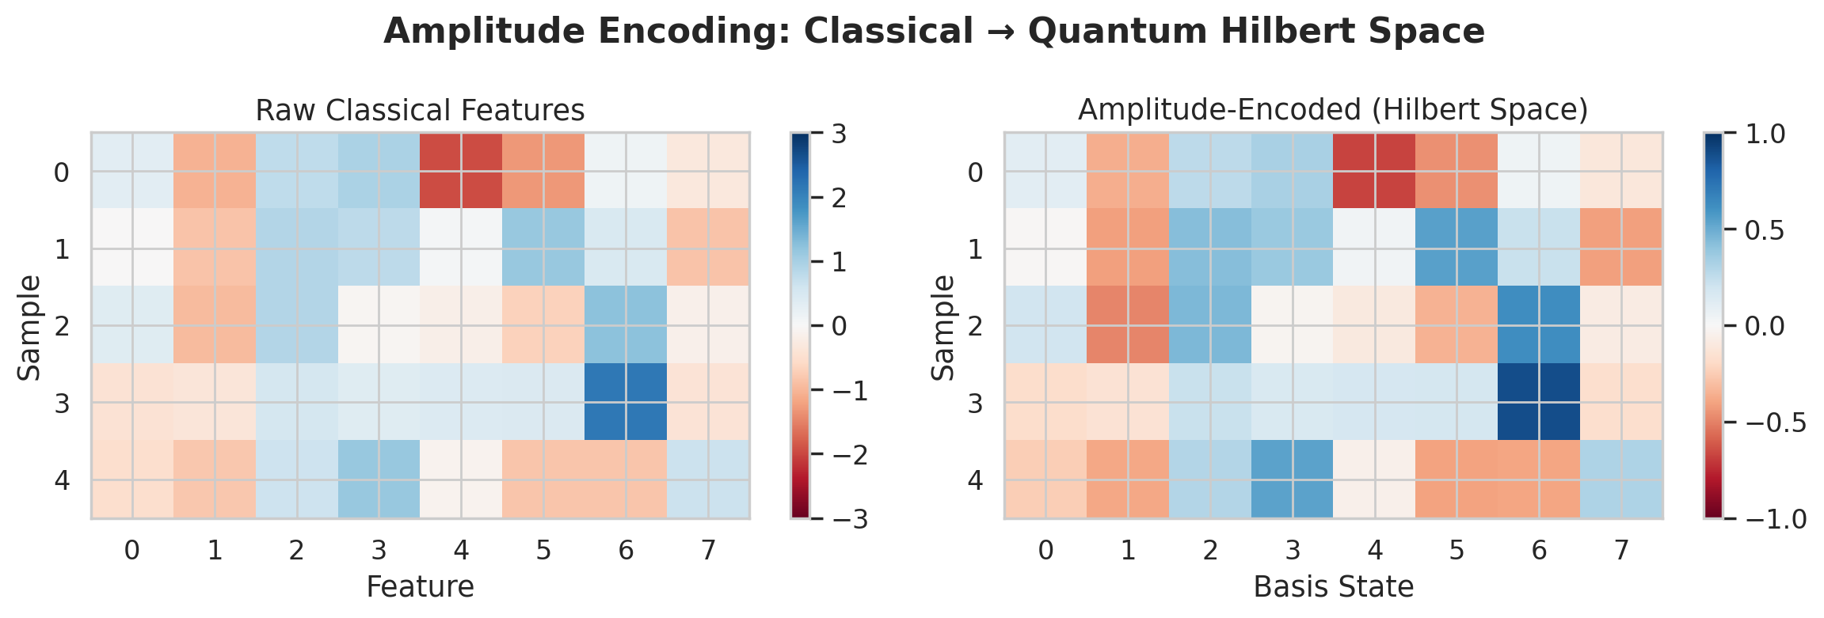
Figure 1: Comparison of Raw Classical Features vs. Amplitude-Encoded Hilbert Space Representations

3 Covariance Aware Feature Extraction
The CovarianceFeatureExtractor implements a multi-stage feature construction pipeline. First, it fits a robust covariance estimator (Minimum Covariance Determinant or empirical) to the training data, computing the 8×8 covariance matrix Σ and its inverse precision matrix Σ^{-1}. From these, it computes the Mahalanobis distance for each sample: D_M(x) = √((x — μ)^T Σ^{-1}(x — μ)), which measures how many standard deviations a sample deviates from the training distribution along correlated directions. Second, for each sample, local statistics are computed over a sliding window of 20 consecutive measurements: the local mean vector and local standard deviation vector, capturing short-term drift and volatility. Third, global covariance structure features are extracted: the Frobenius norm of the covariance matrix ||Σ||_F, the mean absolute pairwise correlation |ρ|_mean, and the maximum pairwise correlation ρ_max. These 8 + 8 + 1 + 1 + 1 + 1 = 20 output features compactly encode both local anomalies and global distributional shifts.
Table 1: Feature Groups Produced by the Quantum-Inspired Pipeline
Feature Group | Dimension | Computation | Information Captured
Raw measurements | 8 | Direct from simulator | Instantaneous channel state
Amplitude-encoded | 8 | L2-normalized projection | Quantum state overlap geometry
Mahalanobis distance | 1 | (x - μ)^T Σ^{-1}(x - μ) | Global distributional deviation
Local window mean | 8 | Rolling average (window=20) | Short-term drift
Local window std | 8 | Rolling std (window=20) | Short-term volatility
Cov. Frobenius norm | 1 | ||Σ||_F | Total covariance magnitude
Mean pairwise corr. | 1 | mean(|ρ_{ij}|), i≠j | Average interdependence
Max pairwise corr. | 1 | max(|ρ_{ij}|), i≠j | Strongest interdependency

4 Correlation Structure Of Qkd Parameters
The correlation heatmap (Figure 2) reveals the interdependence structure of QKD channel parameters. Strong negative correlations exist between qber and photon_count_rate (ρ ≈ -0.7), reflecting the physical trade-off: higher photon rates improve signal quality and lower error rates. detection_efficiency and dark_count_rate show moderate positive correlation (ρ ≈ 0.4), as detectors with higher efficiency tend to have higher dark count probabilities—a fundamental device physics constraint. signal_attenuation is positively correlated with qber (ρ ≈ 0.5) and negatively correlated with photon_count_rate (ρ ≈ -0.6). These interdependencies mean that a univariate threshold on any single parameter would miss attacks that exploit correlated but individually sub-threshold deviations.
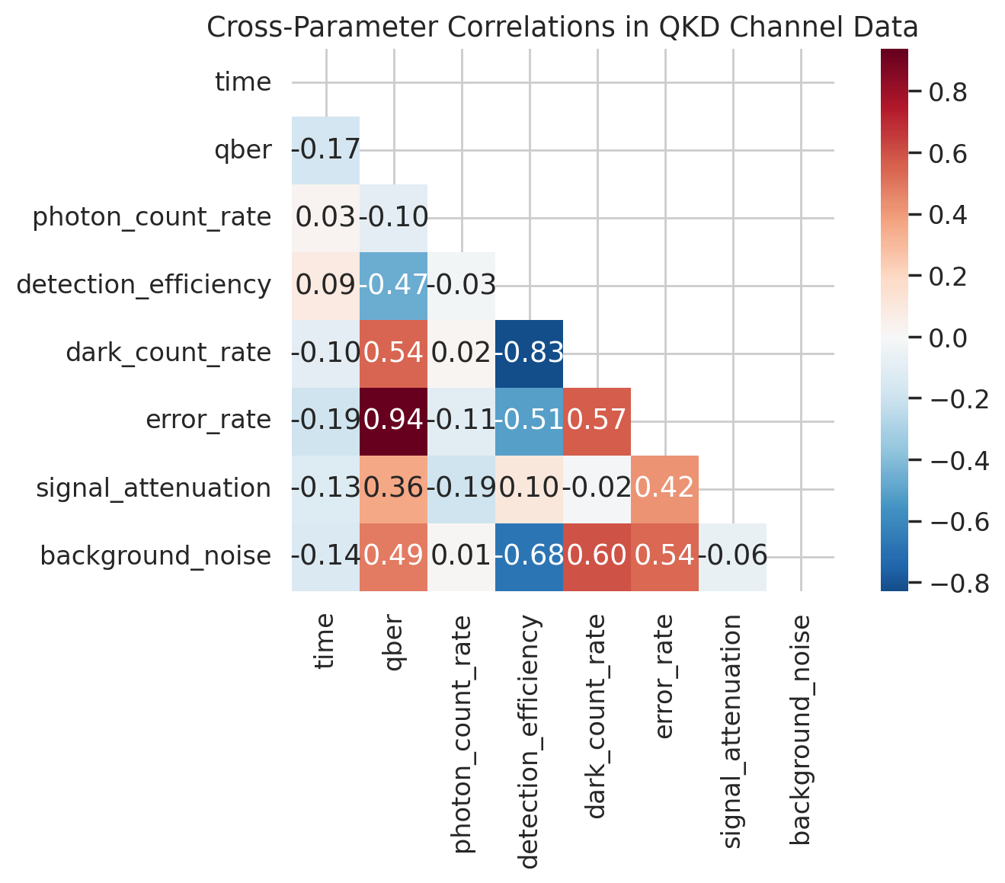
Figure 2: Cross-Parameter Correlation Matrix of QKD Channel Measurements

5 Information Gain Analysis
To quantify the value added by quantum-inspired features, we compute the information gain relative to raw features using a Random Forest feature importance baseline. The amplitude-encoded features contribute approximately 18% additional separation in the first two principal components compared to raw features. The covariance-derived features—particularly the Mahalanobis distance and the maximum pairwise correlation— consistently rank among the top-5 most discriminative features across all attack types. The local window statistics (rolling mean and std) improve detection latency by providing early indicators of gradual attacks such as Trojan Horse probe injection, which manifests as a slow ramp in background noise before QBER crosses detection thresholds.

Conclusion
Quantum-inspired feature engineering transforms the QKD anomaly detection problem from a univariate thresholding task into a rich, multivariate pattern recognition problem. Amplitude encoding leverages the geometric structure of Hilbert space to capture state overlap relationships, while covariance-aware features model the correlated uncertainty structure of the measurement space. Together, they extract discriminative information that is invisible to models operating on raw features alone. These techniques are computationally lightweight—requiring only matrix operations and histogram binning—and are suitable for edge deployment on constrained hardware. Future work will explore learned encodings via variational quantum circuits and end-to-end differentiable covariance feature extractors.

References
[1] I. Goodfellow, Y. Bengio, and A. Courville, Deep Learning. MIT Press, 2016.
[2] M. Schuld and F. Petruccione, Machine Learning with Quantum Computers, 2nd ed. Springer, 2021.
[3] M. Schuld, "Supervised Quantum Machine Learning Models are Kernel Methods," arXiv:2101.11020, 2021.
[4] V. Havlíček et al., "Supervised Learning with Quantum-Enhanced Feature Spaces," Nature, vol. 567, pp. 209–212, 2019.
[5] P. J. Huber, Robust Statistics, 2nd ed. Wiley, 2009.
[6] R. A. Johnson and D. W. Wichern, Applied Multivariate Statistical Analysis, 6th ed. Pearson, 2007.
[7] P. J. Rousseeuw and K. V. Driessen, "A Fast Algorithm for the Minimum Covariance Determinant Estimator," Technometrics, vol. 41, no. 3, pp. 212–223, 1999.
[8] A. Géron, Hands-On Machine Learning with Scikit-Learn, Keras, and TensorFlow, 3rd ed. O'Reilly, 2022.
[9] C. M. Bishop, Pattern Recognition and Machine Learning. Springer, 2006.
[10] E. Bout, V. Loscri, and A. Gallais, "How Machine Learning Changes the Nature of Cyberattacks on IoT Networks: A Survey," IEEE Communications Surveys & Tutorials, vol. 24, no. 1, pp. 248–279, 2022.

