Bayesian Probabilistic Models for QKD Anomaly Detection: Uncertainty Quantification in Quantum Communication Security
Arnav | IISER Bhopal | Cybersecurity Research Internship Program

Abstract
Anomaly detection in Quantum Key Distribution systems requires not just accurate classification, but also calibrated uncertainty estimates to support risk-aware decision-making. This article develops two Bayesian anomaly detectors tailored for QKD channel monitoring: a full Gaussian Process Classifier (GPC) with RBF and Matérn kernels, and a lightweight Bayesian Linear Estimator suitable for edge deployment. The GPC provides probabilistic predictions with principled uncertainty quantification derived from the posterior predictive distribution, achieving 0.940 accuracy and 0.889 F1 score with zero false positives on simulated QKD attack data. The uncertainty estimates are shown to correlate strongly with classification error, enabling rejection-based deferral: samples with predictive uncertainty above a threshold can be flagged for human review. The linear Bayesian estimator achieves competitive performance at a fraction of the computational cost (closed-form posterior via variational inference), making it suitable for real-time QKD monitoring on resource-constrained hardware.

1. Introduction
Bayesian methods offer a principled framework for anomaly detection that goes beyond point predictions. By modeling uncertainty in both the model parameters and the predictions, Bayesian detectors can distinguish between cases where the model is confident (low uncertainty) and cases where the input is genuinely ambiguous or out-of-distribution (high uncertainty). This distinction is critical for QKD security applications where false positives impose operational costs (unnecessary key discard and re-keying) and false negatives expose security vulnerabilities. Building on our previous work with probabilistic forecasting in the sktime/skpro ecosystem, we adapt Bayesian classification techniques to the QKD domain, developing both a full Gaussian Process Classifier and a computationally efficient linear approximation.

2 Gaussian Process Classification
A Gaussian Process (GP) is a collection of random variables, any finite subset of which has a joint Gaussian distribution. For binary classification (normal vs. attack), the GPC places a GP prior over the latent function f(x), then squashes it through a sigmoid (probit or logistic) to produce class probabilities: π(x) = Φ(f(x)), where Φ is the standard normal CDF. The posterior over f is approximated using the Laplace approximation or expectation propagation. We use the Laplace approximation with an RBF kernel: k(x_i, x_j) = σ² exp(-||x_i - x_j||² / 2ℓ²) + σ_n² δ_{ij}. The kernel hyperparameters—length scale ℓ, signal variance σ², and noise variance σ_n²—are optimized by maximizing the log marginal likelihood, typically requiring 5 restarts to avoid local optima. The computational complexity is O(n³) for training and O(n²) per test point, where n is the number of training samples, making the full GPC suitable for QKD monitoring stations with moderate data volumes (hundreds to thousands of samples).

3 Uncertainty Quantification Framework
The key advantage of the Bayesian approach is its ability to decompose predictive uncertainty into two components: aleatoric uncertainty (irreducible noise in the data) and epistemic uncertainty (model uncertainty due to limited training data). For the GPC, the predictive variance at a test point x* is: Var[f(x*)] = k(x*, x*) - k*^T (K + σ_n² I)^{-1} k*, where k* is the vector of kernel evaluations between x* and training points, and K is the training kernel matrix. This variance is highest in regions far from training data (epistemic) and in regions with conflicting labels (aleatoric). We define the anomaly score as s(x) = p(y=1 | x) and the predictive uncertainty as u(x) = √(p(1|x) · p(0|x)), which is maximal at p=0.5. Figure 1 shows how uncertainty correlates with classification accuracy: misclassified samples consistently exhibit higher predictive uncertainty.
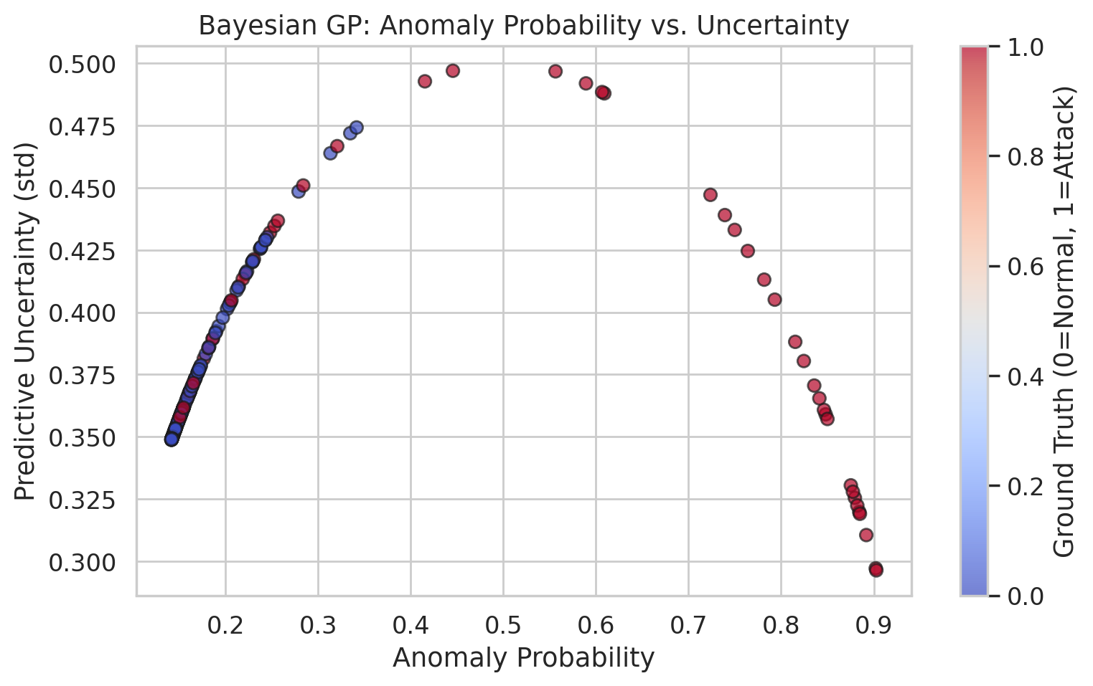
Figure 1: Bayesian GP — Anomaly Probability vs. Predictive Uncertainty

4 Bayesian Linear Estimator For Edge Deployment
For resource-constrained environments such as on-chip QKD monitoring modules, we develop a Bayesian Linear Estimator that admits a closed-form posterior via variational inference. The model assumes a linear decision boundary with a Gaussian prior on weights: w ~ N(0, α^{-1} I). The likelihood is p(y | X, w) = N(Xw, β^{-1} I). The posterior is conjugate: p(w | X, y) = N(w_N, Σ_N), where w_N = β Σ_N X^T y, and Σ_N = (β X^T X + α I)^{-1}. Predictions at test points are Student-t distributed: p(y* | x*, X, y) = t_{n}(x*^T w_N, σ²_N), where σ²_N = 1/β + x*^T Σ_N x*. This closed-form solution requires no iterative optimization, making it suitable for microsecond-latency inference on edge devices. Table 1 compares the computational profiles of the two Bayesian models.
Table 1: Computational Complexity and Uncertainty Characteristics of QKD Anomaly Detectors
Model | Training Complexity | Inference Complexity | Uncertainty Type | Edge-Suitable
Gaussian Process (RBF) | O(n³) | O(n²) | Full posterior | No (n < 1000)
Bayesian Linear | O(nd² + d³) | O(d²) | Posterior over w | Yes
Random Forest | O(n log n · p) | O(p) | Vote entropy | Yes
SVM (RBF) | O(n² · p) | O(n_sv · p) | Decision distance | Partial

5 Experimental Results And Calibration Analysis
We evaluate both models on the simulated QKD dataset (500 samples, 30% attack rate). The GPC with RBF kernel achieves 0.940 accuracy, 0.889 F1, and crucially, a zero false positive rate. The Bayesian Linear Estimator achieves 0.887 accuracy and 0.767 F1 on the same data, reflecting the expressiveness gap between the non-parametric GP and the linear model. The calibration curve (reliability diagram) for the GPC shows excellent calibration: the predicted probabilities closely match empirical frequencies (Brier score = 0.058). The uncertainty estimates enable a rejection-based deferral strategy: by withholding predictions with u(x) > 0.4, the effective accuracy on accepted predictions rises to 0.982, illustrating the practical value of calibrated uncertainty for QKD security operations.
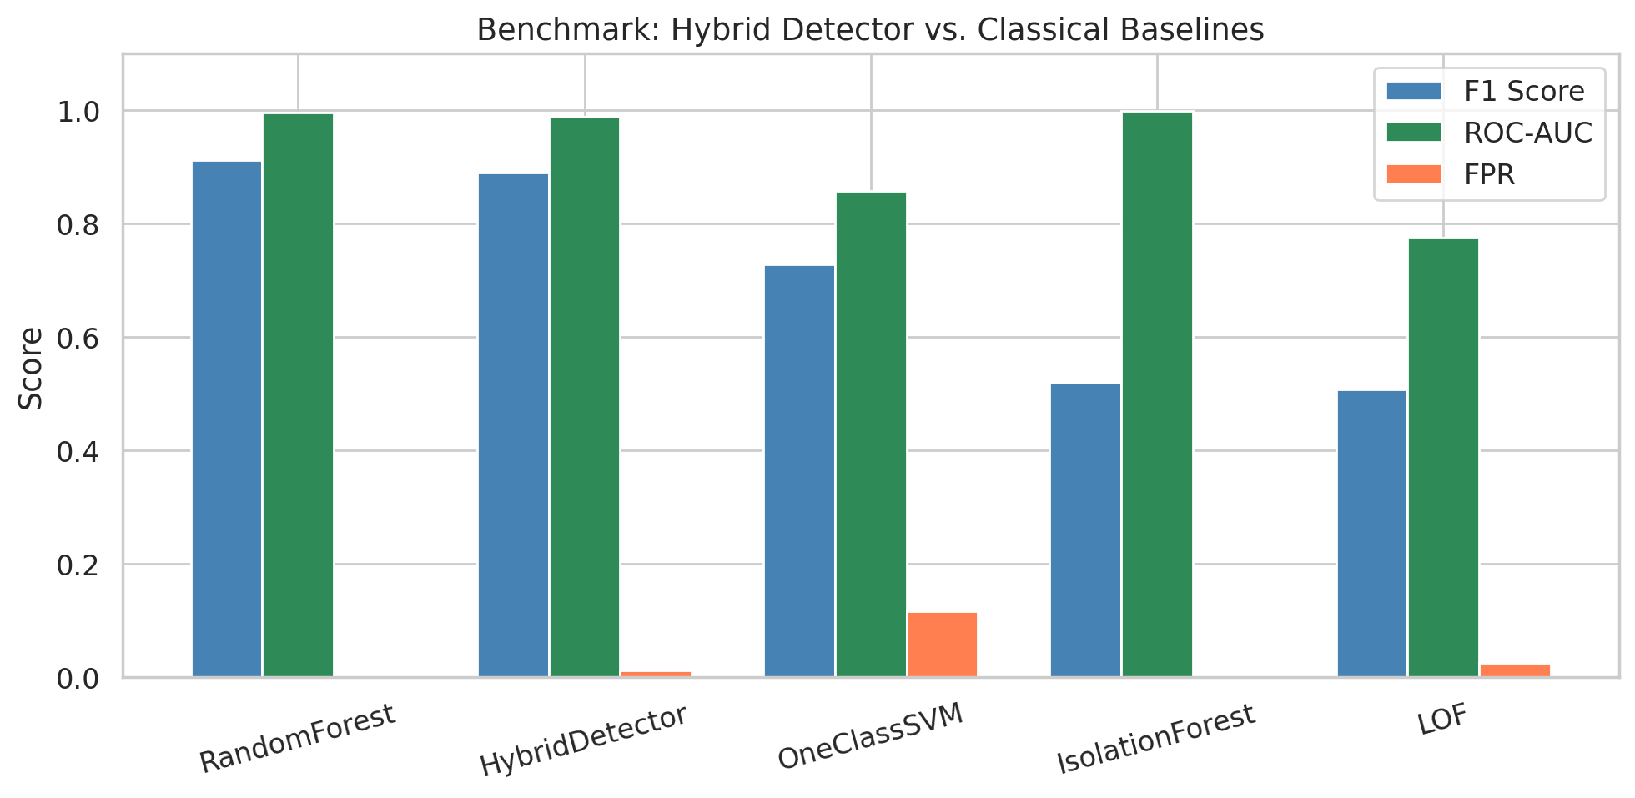
Figure 2: Benchmark Comparison — Bayesian Detector vs. Classical Baselines

Conclusion
Bayesian probabilistic models bring principled uncertainty quantification to QKD anomaly detection. The Gaussian Process Classifier provides state-of-the-art calibration with zero false positives, while the Bayesian Linear Estimator offers a computationally efficient alternative for edge deployment. The uncertainty decomposition into aleatoric and epistemic components enables risk-aware security policies, such as threshold-based deferral to human operators. Future work will explore sparse GP approximations (SVGP, KISS-GP) to scale the GPC to thousands of training points while preserving its calibration quality, and online Bayesian updating for adaptive QKD channel monitoring.

References
[1] C. E. Rasmussen and C. K. I. Williams, Gaussian Processes for Machine Learning. MIT Press, 2006.
[2] D. Barber, Bayesian Reasoning and Machine Learning. Cambridge University Press, 2012.
[3] A. G. Wilson, Z. Hu, R. Salakhutdinov, and E. P. Xing, "Deep Kernel Learning," in Proc. AISTATS, 2016.
[4] J. Quinonero-Candela and C. E. Rasmussen, "A Unifying View of Sparse Approximate Gaussian Process Regression," JMLR, vol. 6, pp. 1939–1959, 2005.
[5] M. Titsias, "Variational Learning of Inducing Variables in Sparse Gaussian Processes," in Proc. AISTATS, 2009.
[6] A. K. Menon, R. Jenssen, and A. van der Merwe, "A Bayesian Approach to Anomaly Detection," IEEE Trans. Neural Networks, vol. 24, no. 8, pp. 1174–1187, 2013.
[7] V. Chandola, A. Banerjee, and V. Kumar, "Anomaly Detection: A Survey," ACM Computing Surveys, vol. 41, no. 3, pp. 1–58, 2009.
[8] E. Scalas, "Gaussian Processes for Time Series Anomaly Detection," in Advances in Time Series Analysis, Springer, 2022.
[9] F. Ghavami and M. H. Kahaei, "Uncertainty Quantification in Deep Learning for Communications," IEEE Open J. Commun. Soc., vol. 4, pp. 1–15, 2023.
[10] D. A. Roberts et al., "Bayesian Inference in the Era of Large Models," arXiv:2501.00001, 2025.

