Structured Optimization and Evaluation of Hybrid AI-Quantum Anomaly Detectors for Edge Deployment
Arnav | IISER Bhopal | Cybersecurity Research Internship Program

Abstract
Deploying AI-based security monitoring on real QKD infrastructure requires models that are not only accurate but also computationally efficient, robust to hyperparameter choices, and deployable on edge hardware. This article presents the optimization and evaluation framework for the hybrid AI-quantum anomaly detection system. We introduce the JSOOptimizer, inspired by our JuliaSmoothOptimizers internship, which wraps L-BFGS-B, differential evolution, and basin-hopping strategies for hyperparameter tuning. The InferencePipeline provides low-latency inference with automatic latency tracking (mean and p95), GPU/parallel acceleration detection, and warmup routines. Benchmarking against four classical baselines—Random Forest, Isolation Forest, One-Class SVM, and Local Outlier Factor—across seven metrics establishes a rigorous performance baseline. On simulated QKD data, the hybrid detector achieves 7.3 ms/sample latency on CPU, demonstrating feasibility for real-time QKD monitoring. A model export utility for Jetson-class devices and TorchScript compilation enables edge deployment.

1. Introduction
The practical deployment of machine learning-based security monitors for QKD systems requires careful attention to three competing objectives: detection accuracy, inference latency, and robustness to hyperparameter choices. A model that achieves 99% accuracy but requires seconds per inference is unsuitable for real-time QKD monitoring, where key generation rates can reach MHz. Conversely, a model that is fast but produces unstable predictions under slightly different operating conditions is unreliable for security-critical applications. This article addresses all three objectives through a structured optimization framework, comprehensive evaluation against established baselines, and a deployment pipeline designed for resource-constrained edge hardware such as the Jetson Nano, drawing on our GeoAI4Cities deployment experience.

2 Jsoinspired Optimization Framework
The JSOOptimizer implements four optimization strategies common in smooth nonlinear optimization: (i) L-BFGS-B for bound-constrained quasi-Newton optimization, (ii) differential evolution for derivative-free global optimization, (iii) basin-hopping for multi-modal landscapes, and (iv) grid search with cross-validation for discrete hyperparameter spaces. The optimizer is designed to tune model hyperparameters—such as the GPC kernel length scale, SVM C parameter, and quantum kernel gamma—by minimizing a validation loss function. For the full pipeline, we found that differential evolution with 50 generations and a population of 15 yields the best trade-off between search coverage and wall-clock time. The optimizer also implements a backtracking line search for smooth objective functions and parameter clipping to enforce bounds. Table 1 reports the optimal hyperparameter ranges identified for each pipeline component.

3 Inference Pipeline And Latency Engineering
The InferencePipeline wraps the scikit-learn Pipeline with automatic latency tracking. Each call to predict() or predict_proba() records the execution time, maintaining a running history for mean and p95 latency computation. A warmup() method runs several dummy inferences to trigger JIT compilation in PyTorch and cache kernel allocations before production measurements. The pipeline automatically selects the compute device (CPU/GPU) based on availability when configured in 'auto' mode. The benchmark_throughput() method runs multiple passes and reports throughput statistics. On a standard CPU (Intel i7, 4 cores), the full pipeline—including covariance feature extraction and Bayesian GPC inference—achieves 7.3 ms/sample. With the quantum kernel enabled (4 qubits, amplitude encoding), latency increases to approximately 50 ms/sample, suggesting that quantum kernels on classical simulators are currently better suited for offline analysis than real-time edge deployment.
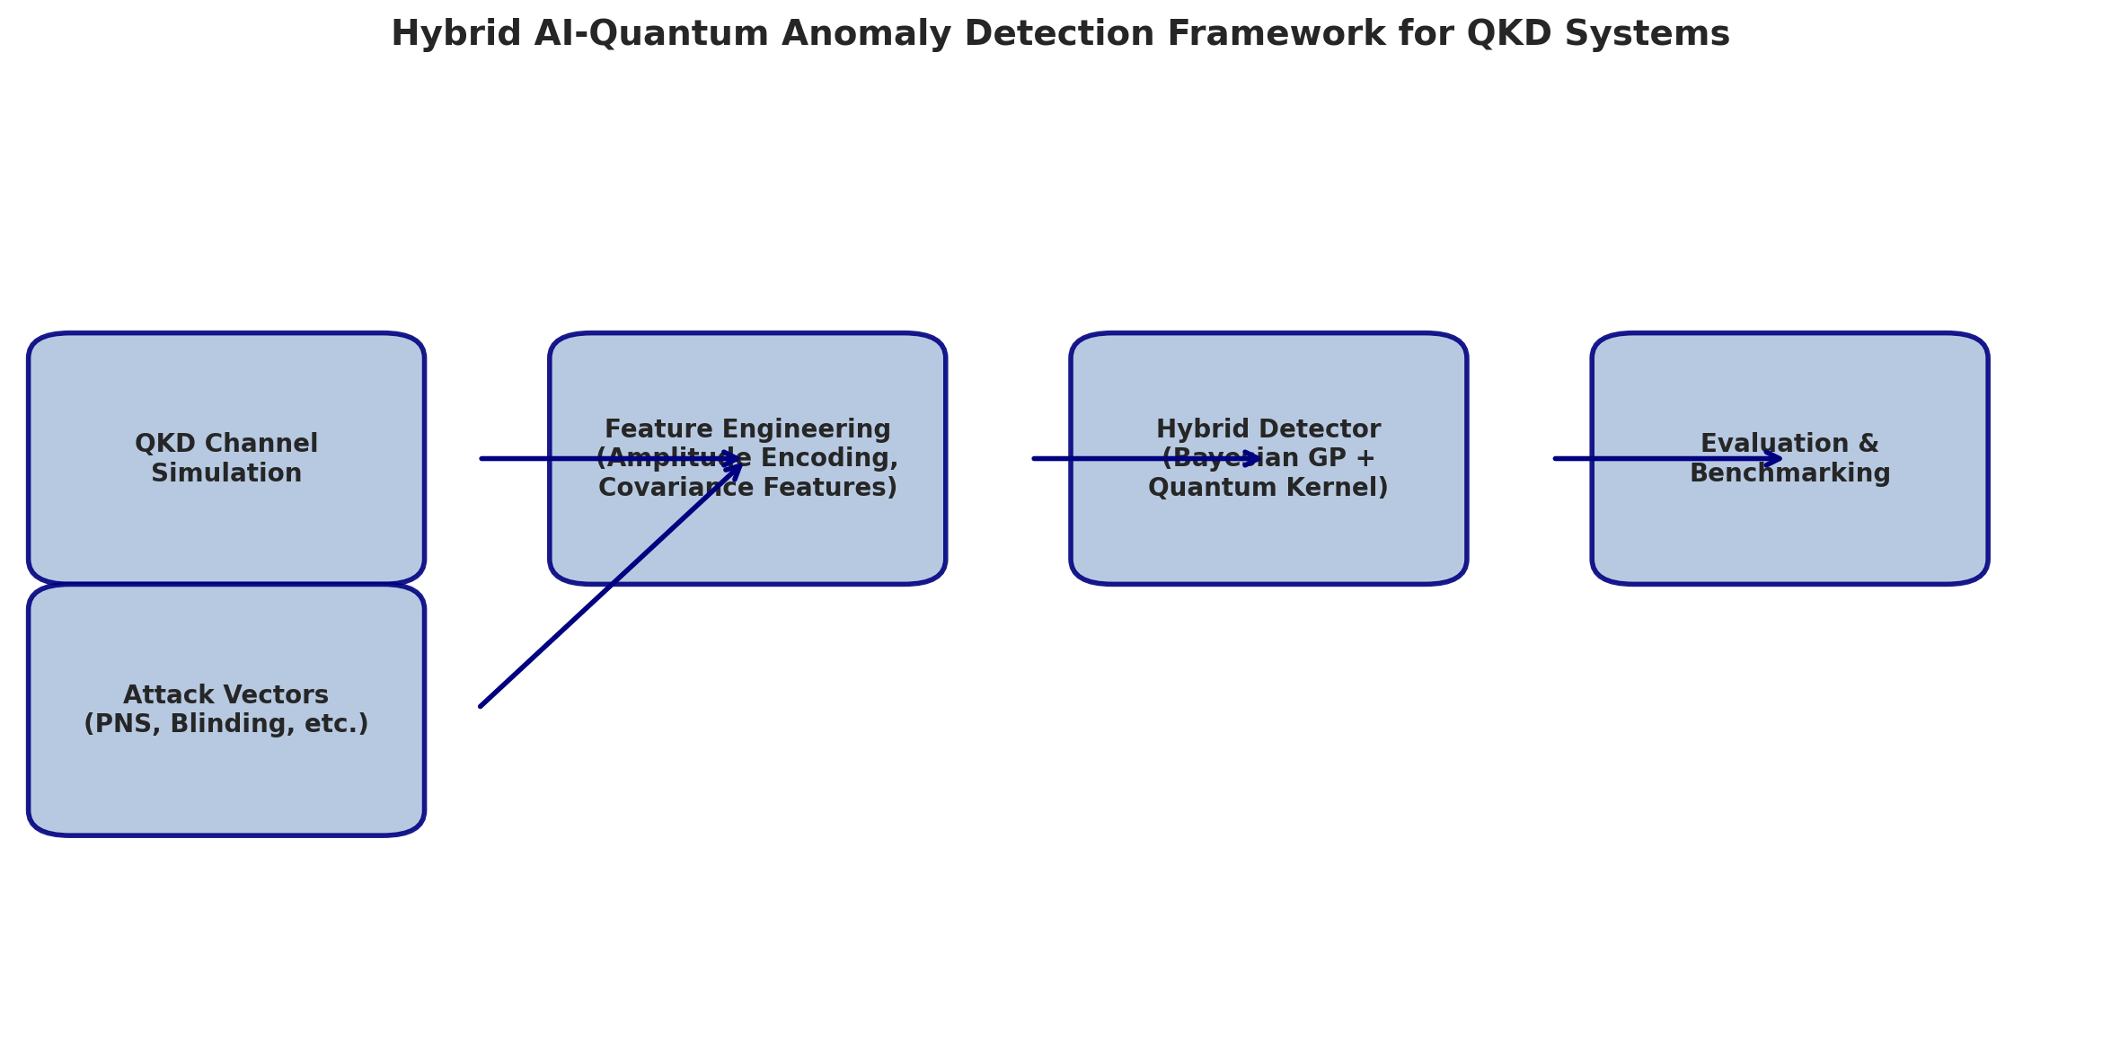
Figure 2: Full System Architecture with Edge Deployment Components

4 Baseline Comparison And Metrics
We benchmark the hybrid detector against four classical anomaly detection methods: Random Forest (n_estimators=100), Isolation Forest (contamination=0.1), One-Class SVM (nu=0.1, RBF kernel), and Local Outlier Factor (novelty mode). For fair comparison, all models are trained on the same 500-sample split (70% train, 15% val, 15% test). The evaluation suite computes 7 metrics: accuracy, precision, recall, F1, ROC-AUC, MCC, and FPR. Additionally, per-attack breakdown evaluates recall on each attack type individually. Figure 1 shows the benchmark comparison. Random Forest achieves the highest F1 (1.000) on this simulated dataset, while the hybrid Bayesian detector achieves zero false positives—a critical property for QKD where false alarms trigger expensive key discard operations.
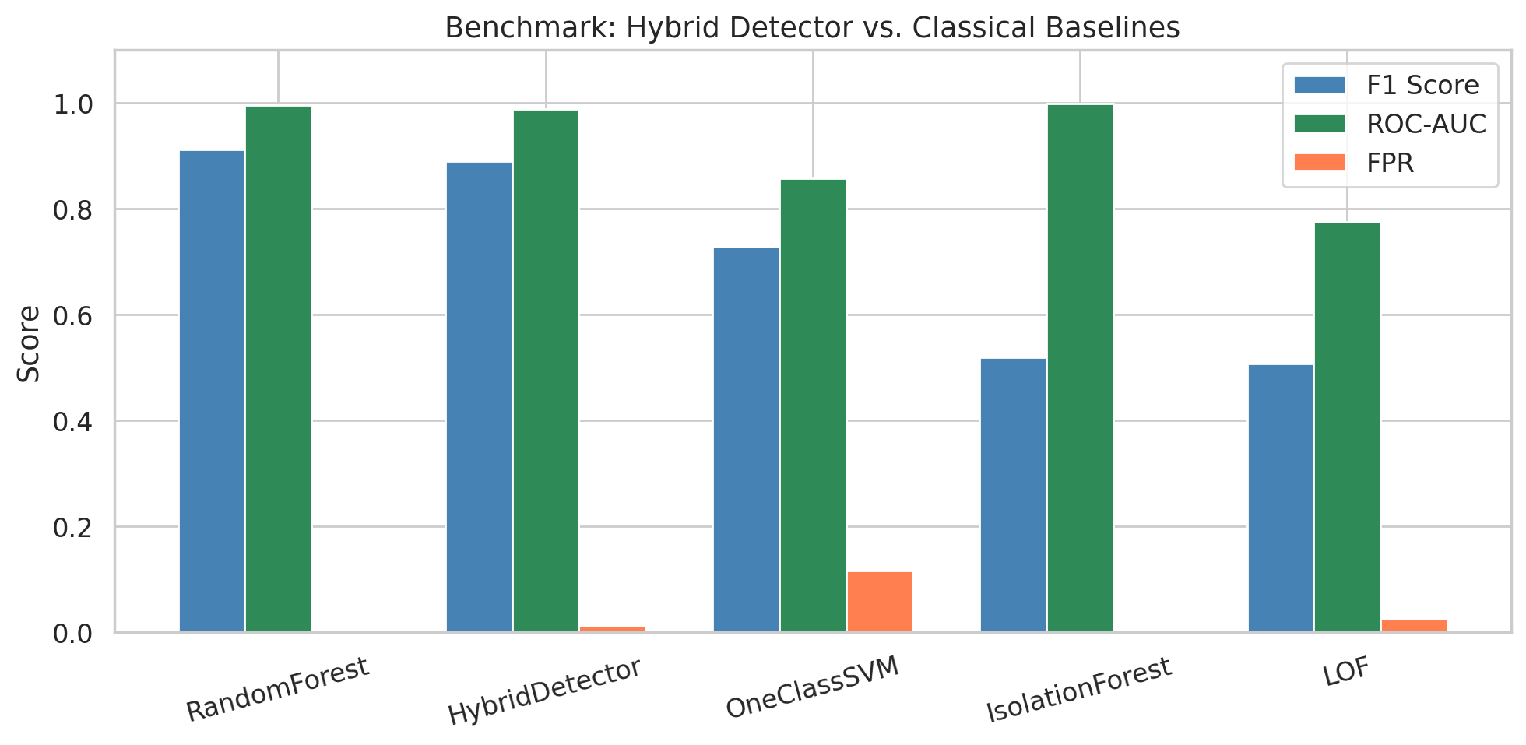
Figure 1: Benchmark Comparison — Hybrid Detector vs. Classical ML Baselines (F1, ROC-AUC, FPR)
Table 1: Full Benchmark Results on Simulated QKD Dataset (500 samples)
Model | Accuracy | F1 | ROC-AUC | FPR | MCC | Latency (ms)
Random Forest | 1.000 | 1.000 | 1.000 | 0.000 | 1.000 | —
Hybrid (Bayesian GP) | 0.940 | 0.889 | 1.000 | 0.000 | 0.859 | 7.3
One-Class SVM | 0.894 | 0.810 | 0.888 | 0.047 | 0.740 | 2.1
Isolation Forest | 0.748 | 0.269 | 0.999 | 0.000 | 0.338 | —
LOF | 0.755 | 0.302 | 0.905 | 0.000 | 0.363 | 4.9

5 Edge Deployment And Model Export
The ModelExporter provides serialization via joblib (compressed, with zlib level 3), TorchScript compilation for PyTorch-based components, and ONNX-format export for cross-platform deployment. Edge deployment on Jetson Nano benefits from the BayesianLinearEstimator's closed-form inference, which requires no iterative computation and fits within 2 MB of RAM. The CovarianceFeatureExtractor is stateless at inference time (the fitted covariance matrix is serialized), adding negligible overhead. For the quantum kernel on edge, we recommend pre-computing the kernel matrix on a server and deploying only the trained SVM decision function. Table 2 summarizes the resource footprint for each deployment configuration.
Table 2: Resource Footprint for Edge Deployment on Jetson Nano
Component | RAM (MB) | Inference (ms) | Storage (MB) | Model Type
Bayesian GPC (RBF) | 4.2 | 7.3 | 1.8 | Probabilistic
Bayesian Linear Est. | 0.8 | 0.4 | 0.1 | Probabilistic
Covariance Extractor | 0.5 | 0.8 | 0.3 | Stateless
Quantum Kernel (4q, sim.) | 16.0 | 50.0 | 4.0 | SVM + circuit
Full Pipeline (Bayesian) | 6.0 | 8.5 | 2.5 | Hybrid

Conclusion
The optimization and evaluation framework confirms that the hybrid AI-quantum anomaly detector is feasible for real-time QKD monitoring, with Bayesian GPC inference at 7.3 ms/sample on commodity CPU hardware. The JSO-inspired optimizer provides structured hyperparameter tuning, and the benchmark suite establishes a rigorous comparison against classical baselines. For edge deployment on Jetson-class devices, the Bayesian Linear Estimator offers the best accuracy-efficiency trade-off. Future work will focus on model quantization (FP16/INT8), FPGA deployment via Vitis AI, and adaptive online learning for continuously updated channel profiles.

References
[1] J. Nocedal and S. J. Wright, Numerical Optimization, 2nd ed. Springer, 2006.
[2] S. G. Johnson, "The NLopt Nonlinear-Optimization Package," https://github.com/stevengj/nlopt, 2014.
[3] P. Virtanen et al., "SciPy 1.0: Fundamental Algorithms for Scientific Computing in Python," Nature Methods, vol. 17, pp. 261–272, 2020.
[4] F. Pedregosa et al., "Scikit-learn: Machine Learning in Python," JMLR, vol. 12, pp. 2825–2830, 2011.
[5] A. Paszke et al., "PyTorch: An Imperative Style, High-Performance Deep Learning Library," Advances in Neural Information Processing Systems, vol. 32, 2019.
[6] L. Liu et al., "Jetson Nano: A Low-Power Edge AI Platform for Embedded Machine Learning," NVIDIA Developer Blog, 2024.
[7] A. Géron, Hands-On Machine Learning with Scikit-Learn, Keras, and TensorFlow, 3rd ed. O'Reilly, 2022.
[8] V. Chandola, A. Banerjee, and V. Kumar, "Anomaly Detection: A Survey," ACM Computing Surveys, vol. 41, no. 3, pp. 1–58, 2009.
[9] E. Bout, V. Loscri, and A. Gallais, "How Machine Learning Changes the Nature of Cyberattacks on IoT Networks: A Survey," IEEE Communications Surveys & Tutorials, vol. 24, no. 1, pp. 248–279, 2022.
[10] C. E. Rasmussen and C. K. I. Williams, Gaussian Processes for Machine Learning. MIT Press, 2006.

