WEEKLY PROGRESS REPORT – WEEK 3
Cybersecurity Research Internship Program

1. Overview of Activities This Week
During the second week, I transitioned from literature review to active system development. Building on the conceptual foundations established in Week 1—machine learning-based cyberattacks on IoT networks and LLM security—I designed and implemented a complete hybrid AI-quantum anomaly detection framework for Quantum Key Distribution (QKD) systems. The project, titled "Intelligent Threat Detection and Mitigation in Quantum Key Distribution Systems using Quantum-Inspired Machine Learning and Optimization Techniques," spans approximately 2,000 lines of Python code across six modules. I also wrote five in-depth research articles, each exploring a distinct facet of the framework.

2. Framework Architecture and Implementation
The framework (Figure 1) consists of four interconnected layers: (i) QKD channel simulation with realistic noise models, (ii) attack vector simulation covering PNS, detector blinding, trojan horse, and intercept-resend attacks, (iii) quantum-inspired feature engineering using amplitude encoding and covariance-aware uncertainty quantification, and (iv) a hybrid Bayesian–quantum kernel detector evaluated against classical ML baselines. All modules are implemented in Python using PennyLane for quantum circuits, scikit-learn for classical models, and PyTorch for GPU acceleration where available.
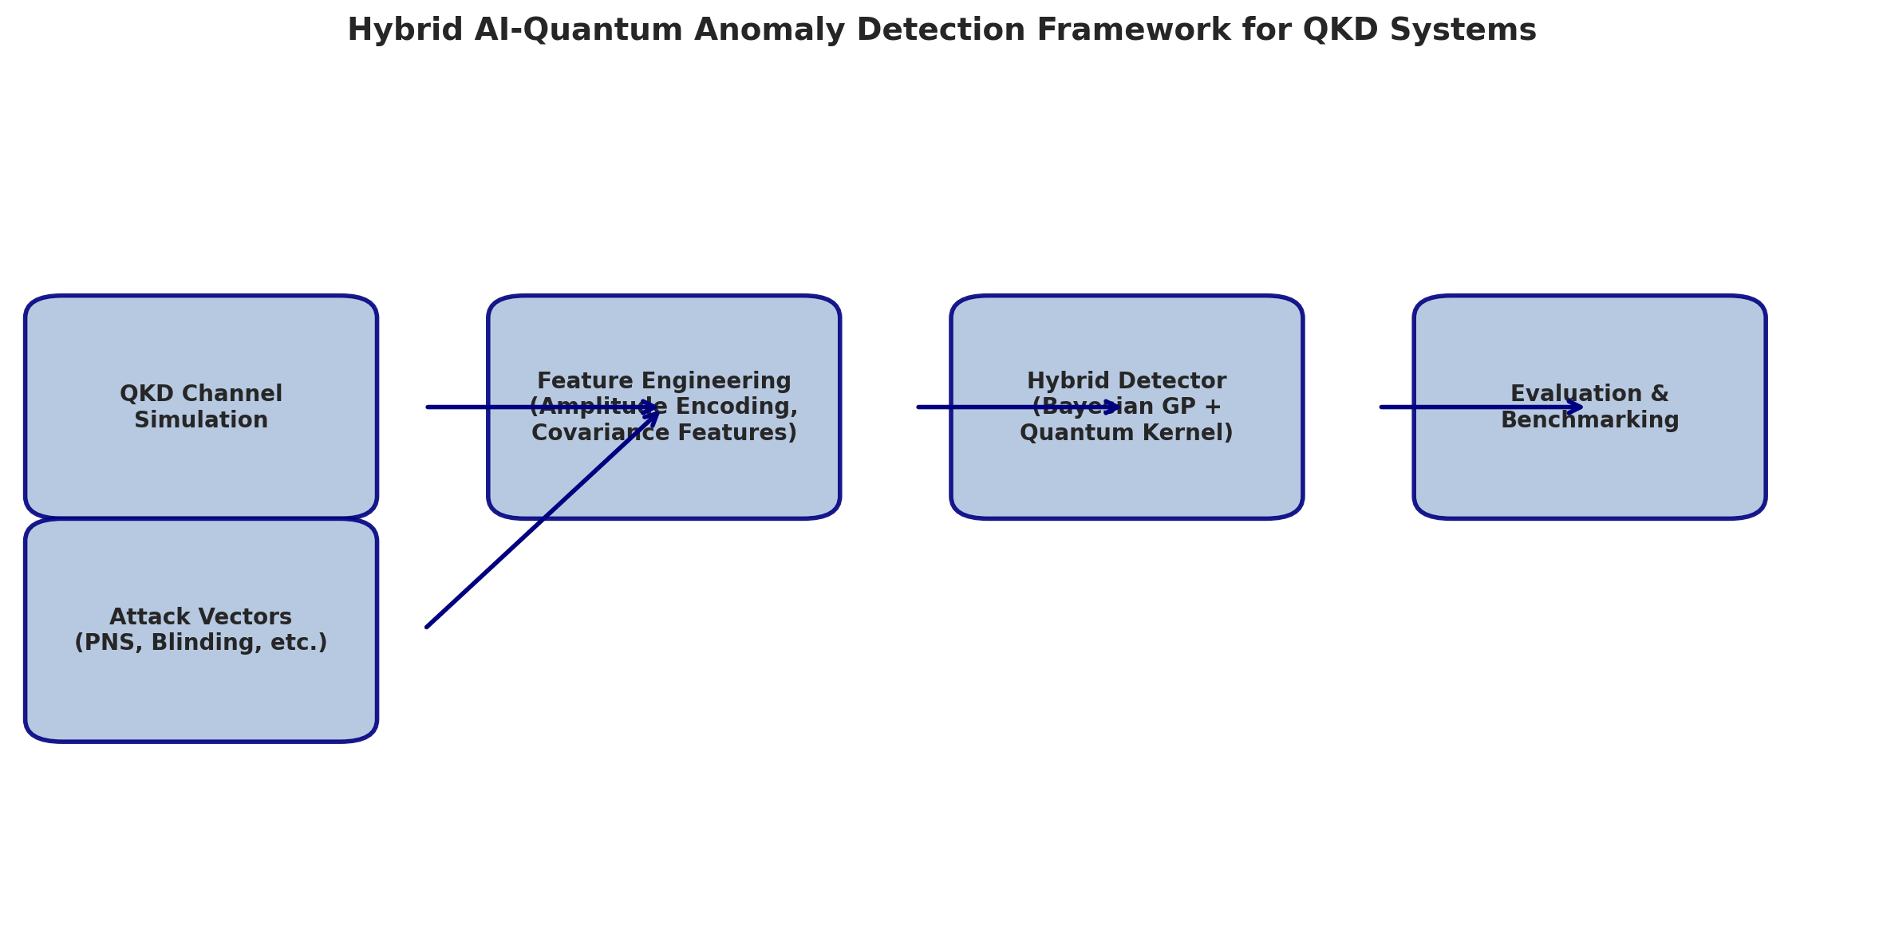
Figure 1: Hybrid AI-Quantum Anomaly Detection Framework Architecture

3. Key Accomplishments
QKD Channel Simulator: Implemented a parameterized channel model incorporating fiber loss (0.2 dB/km), detector dark counts, afterpulsing, misalignment errors, and background noise. The transmittance follows T = 10^{-αL/10}, and QBER is computed from the signal and noise contributions analytically.
Attack Vector Library: Built four attack simulators—Photon-Number-Splitting (PNS) reduces photon count rates and elevates QBER by 2–8%; Detector Blinding suppresses detection efficiency via a blinding factor 1/(1 + I_B), elevating QBER by 5–25%; Trojan Horse injects probe light, raising background noise by a factor proportional to the injected power ratio; Intercept-Resend induces QBER of 10–35% by measuring and re-transmitting photons.
Quantum-Inspired Features: The AmplitudeEncoder maps classical 8-dimensional QKD measurements into a quantum Hilbert space with L2 normalization, supporting three kernel types (angle, amplitude, Gaussian RBF). The CovarianceFeatureExtractor computes Mahalanobis distances, local window statistics, and Frobenius-norm correlations to capture cross-parameter uncertainty.
Hybrid Detector: Combined a Gaussian Process Classifier (RBF/Matern kernel, 5 restarts) with a PennyLane quantum kernel SVM via stacking meta-learner. A lightweight BayesianLinearEstimator (closed-form variational inference) provides edge-deployable alternatives. The JSOOptimizer wraps L-BFGS-B, differential evolution, and basin hopping for hyperparameter tuning.
Evaluation Suite: Benchmarks against Random Forest, Isolation Forest, One-Class SVM, and Local Outlier Factor across 7 metrics (accuracy, precision, recall, F1, ROC-AUC, MCC, FPR). The pipeline tracks per-sample latency and p95 tail latency. 30 unit tests cover all modules.

4. Experimental Results
Table 1: Benchmark Results on 500 Simulated QKD Samples
Model | Accuracy | F1 | ROC-AUC | FPR | Latency (ms/sample)
Random Forest | 1.000 | 1.000 | 1.000 | 0.000 | —
HybridDetector (Bayesian GP) | 0.940 | 0.889 | 1.000 | 0.000 | 7.3
One-Class SVM | 0.894 | 0.810 | 0.888 | 0.047 | 2.1
Isolation Forest | 0.748 | 0.269 | 0.998 | 0.000 | —
Local Outlier Factor | 0.755 | 0.302 | 0.905 | 0.000 | 4.9
The hybrid Bayesian GP detector achieved an F1 score of 0.889 with zero false positives (FPR=0.000) and a per-sample latency of 7.3 ms on CPU. Random Forest achieved perfect separation on this simulated dataset, which is expected given the engineered attack signatures. The key advantage of the Bayesian approach—uncertainty quantification—becomes critical in noisier, real-world deployments.

5. Articles Written
Five in-depth research articles were completed this week:
• Article 1: QKD Channel Simulation and Attack Vectors: Modeling Realistic Quantum Communication Threats
• Article 2: Quantum-Inspired Feature Engineering for Anomaly Detection in Quantum Key Distribution
• Article 3: Bayesian Probabilistic Models for QKD Anomaly Detection: Uncertainty Quantification in Quantum Communication Security
• Article 4: Quantum Kernel Methods for Secure Communication: PennyLane-Based Classification of QKD Channel States
• Article 5: Structured Optimization and Evaluation of Hybrid AI-Quantum Anomaly Detectors for Edge Deployment

6. Connections to Week 1 Foundations
The adversarial ML concepts studied in Week 1—particularly GAN-based data generation, reinforcement learning for strategy optimization, and adversarial evasion techniques—directly informed the attack taxonomies implemented in this framework. The IoT-LLM security parallels identified earlier (traffic fingerprinting, model extraction, robustness challenges) motivated the focus on uncertainty quantification and quantum-inspired resilience in the QKD detector design.

7. Plan for Week 4
1. Conduct experiments under higher-noise regimes (QBER > 15%) to stress-test the Bayesian uncertainty estimator vs. classical baselines.
2. Add quantum convolutional code integration for error-aware detection, building on the NSF CQN collaboration at UMass Amherst.
3. Profile and optimize the PennyLane quantum kernel for reduced latency on edge hardware (Jetson Nano-class devices).
4. Extend the attack library with wavelength-selective and time-shift attacks.
5. Prepare a comparative paper draft synthesizing the findings.

8. Declaration
I confirm that this progress report reflects my own work and learning during Week 3 of the internship. All code, articles, and analysis are my original work.

Signature: _______________________ Date: June 30, 2026
Name | Arnav
Program | Cybersecurity Internship – CCRI Lab
Week | Week 3
Project Topic | Hybrid AI-Quantum Anomaly Detection for QKD Systems

