Assignment 1 Submitted by Arnav Loonker

Q1) WAP to create 5 threads in C

#include<stdio.h>
#include<pthread.h>
void *t1()
{
printf("1\n");
}
void *t2()
{
printf("2\n");
}
void *t3()
{
printf("3\n");
}
void *t4()
{
printf("4\n");
}
void *t5()
{
printf("5\n");
}
int main()
{
pthread_t tid1,tid2,tid3,tid4,tid5;
pthread_create(&tid1,NULL,t1,NULL);
pthread_create(&tid2,NULL,t2,NULL);
pthread_create(&tid3,NULL,t3,NULL);
pthread_create(&tid4,NULL,t4,NULL);
pthread_create(&tid5,NULL,t5,NULL);
// printf("main\n");
pthread_join(tid1,NULL);
pthread_join(tid2,NULL);
pthread_join(tid3,NULL);
pthread_join(tid4,NULL);
pthread_join(tid5,NULL);
return 0;
}

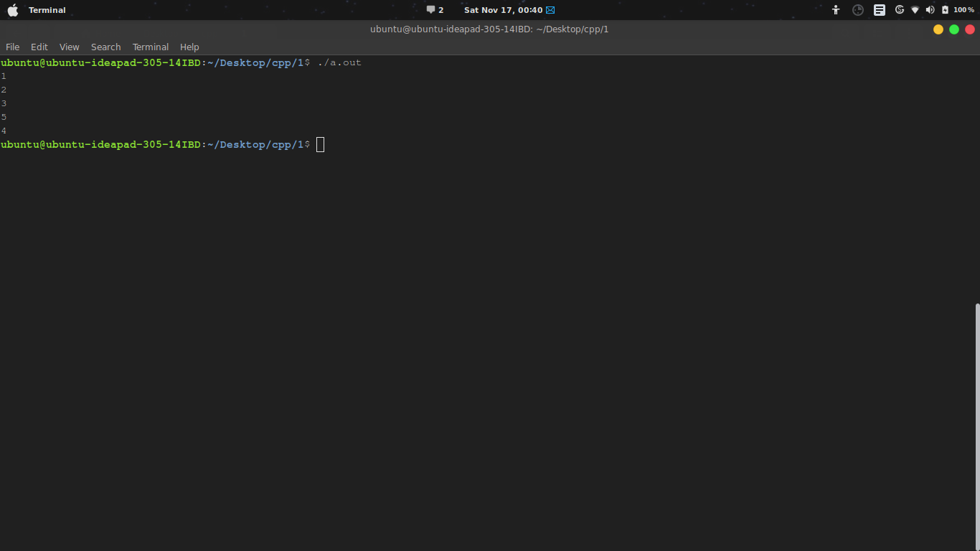

Q2) WAP to print "Hello World" using threads

#include<stdio.h>
#include<pthread.h>
void *f1()
{
printf("Hello World\n");
}
int main()
{
pthread_t p1;
pthread_create(&p1,NULL,f1,NULL);
pthread_join(p1,NULL);
return 0;
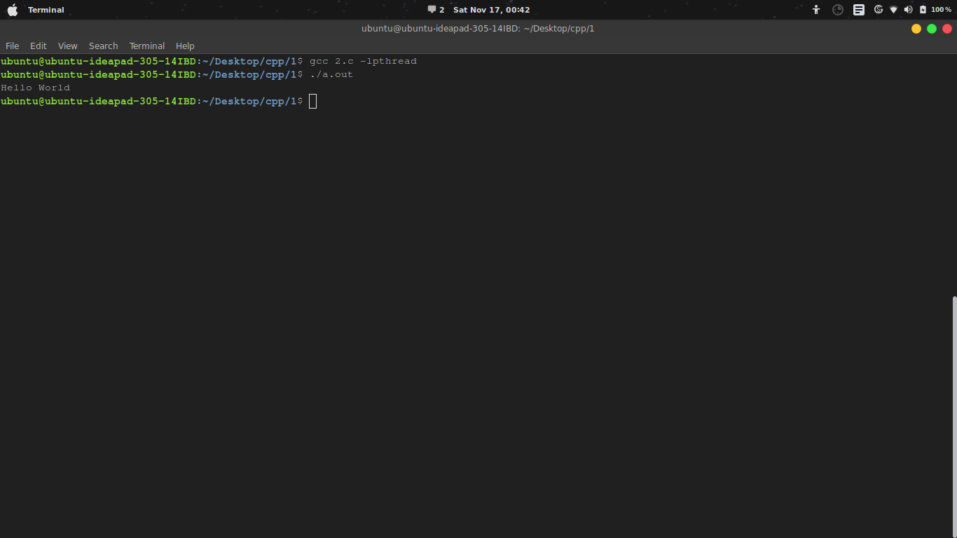
}

Q3)

WAP that computes the square roots of the integers from 0 to 99 in a separate thread
and returns an array of doubles containing the * results.
In the meantime the main thread should display a short message to the user
and then display the results of the computation

#include<stdio.h>
#include<stdlib.h>
#include<pthread.h>
#include<math.h>
#define N 100
double* arr;
void *root()
{
arr = (double*)malloc(sizeof(double)*N);
int i;
for(i=0;i<N;i++)
{
arr[i]=(double)sqrt(i);
}
return (void*)arr;
}

int main()
{
pthread_t calc;
double *roots;
void *rootX;
pthread_create(&calc,NULL,root,NULL);
printf("Computing Square roots of numbers from 0 to %d...\n",N);
pthread_join(calc,&rootX);
roots=(double*)rootX;
int i;
for(i=0;i<N;i++)
{
printf("Square root of %d is %lf\n",i,(double)roots[i]);
}
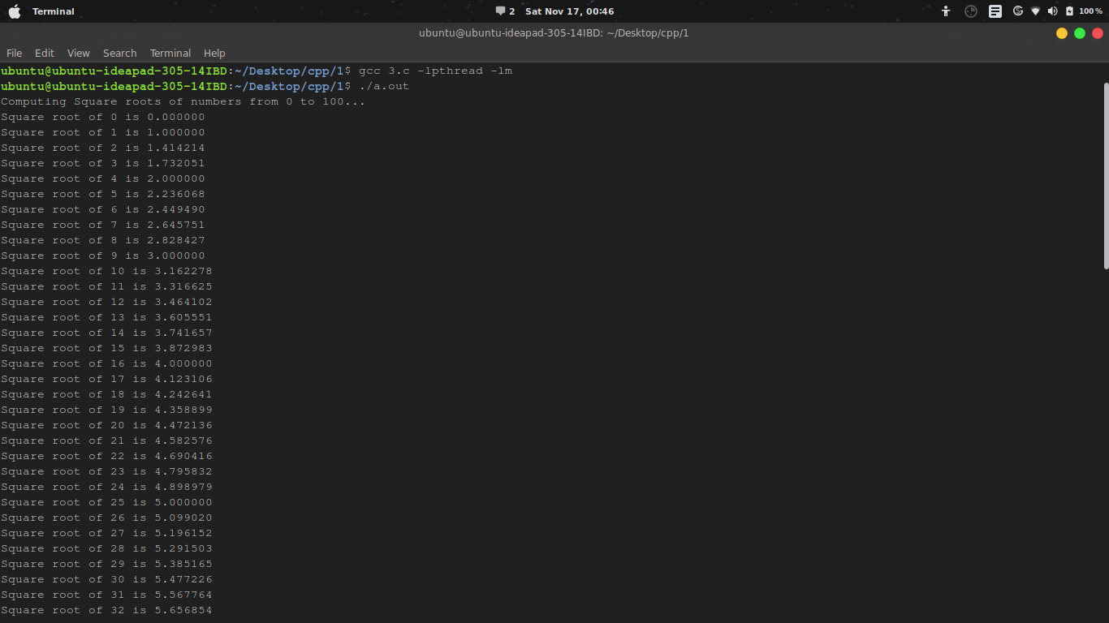
return 0;}
q4)Implement a linked list as a Parallel program (based on Pthreads)
with Mutex locks for the entire linked list Implementation should
support Search( ), Insert( ), and Delete( ) functions.

#include<stdio.h>
#include<pthread.h>
#include<stdlib.h>

#define MAXVAL 10
#define CALLS 20
pthread_mutex_t m;

struct node
{
int value;
struct node *next;
};

struct node *root=NULL;

struct node *create(int value)
{
struct node *temp;
temp=(struct node*)malloc(sizeof(struct node));
temp->value=value;
temp->next=NULL;
return temp;
}

void insert(int value)
{
struct node *temp=create(value);
temp->next=root;
root=temp;
printf("\tElement %d inserted.\n",value);
}

int search(int value)
{
struct node *temp=NULL;
temp=(struct node*)malloc(sizeof(struct node));
temp=root;
while(temp!=NULL)
{
if(temp->value == value)
{
printf("\tElement %d found!\n",value);
return 1;
}
temp=temp->next;
}
printf("\tElement %d not found!\n",value);
return 0;
}

void delete(int value)
{
if(search(value)==0)
{
printf("\tElement %d can not be deleted.\n",value);
}
else
{
struct node *temp=NULL;
temp=(struct node*)malloc(sizeof(struct node));
struct node *prev=NULL;
temp=(struct node*)malloc(sizeof(struct node));
if(root->value==value)
{
root=root->next;
}
else
{
prev=root;
temp=prev->next;
while(temp->value!=value)
{
prev=temp;
temp=temp->next;
}
prev->next=temp->next;
}
printf("\tElement %d deleted.\n",value);
}
}

void choose(int choice, int value)
{
//pthread_t calc;
switch(choice)
{
case 0:
// pthread_create(&calc,NULL,insert,NULL);
insert(value);
break;
case 1:
// pthread_create(&calc,NULL,delete,NULL);
delete(value);
break;
case 2:
// pthread_create(&calc,NULL,search,NULL);
search(value);
break;
default:
printf("\tInvalid selection\n");
}
//p_thread.join(calc,NULL);
}
void* thread()
{
choose(rand() % 3,rand() % MAXVAL);
}
int main()
{
int i=0;
srand(time(0));
for(i=0; i<CALLS;i++)
{
printf("%d:\n",i+1);
pthread_mutex_lock(&m);
pthread_t calc;
pthread_create(&calc,NULL,&thread,NULL);
pthread_join(calc,NULL);
pthread_mutex_unlock(&m);
}
return 0;
}
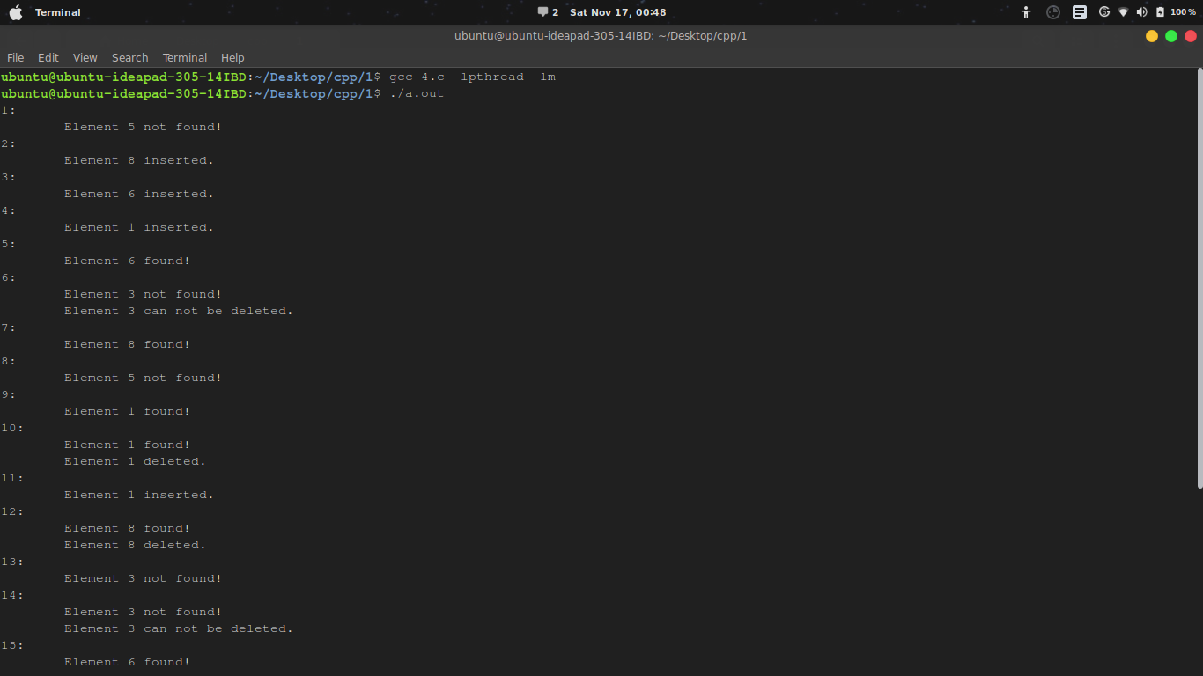
q5)
/*
Program to computes the total of the values of the matrix
using thread and mutex lock on global variable total
*/

#include<stdio.h>
#include<pthread.h>
#include<stdlib.h>

#define ROW 10
#define COL 10
#define MAX_NUM 100

int arr[ROW][COL];
long long int sum=0;
pthread_mutex_t m;
int i;
void *add()
{
int j;
pthread_mutex_lock(&m);
int id=i;
pthread_mutex_unlock(&m);
long long int row_sum=0;
for(j=0;j<COL;j++)
{
row_sum+=arr[id][j];
}
pthread_mutex_lock(&m);
sum+=row_sum;
pthread_mutex_unlock(&m);
}

int main()
{
int j;
srand(time(0));
for(i=0; i<ROW; i++)
for(j=0; j<COL; j++)
arr[i][j]=rand()%MAX_NUM;
// printf((j==COL-1)?"%d\n":"%d ", arr[i][j]=rand()%MAX_NUM);
pthread_mutex_init(&m,NULL);
pthread_t t[ROW];
for(i=0; i<ROW; i++)
pthread_create(&t[i],NULL,add,NULL);
for(i=0; i<ROW; i++)
pthread_join(t[i],NULL);
printf("Sum: %lld\n", sum);
return 0;
}

