Assignment 2 Submitted by Arnav Loonker

1)#include <stdio.h>
#include <pthread.h>

void * thread_sum(void *);
int sum=0;
pthread_mutex_t mVar=PTHREAD_MUTEX_INITIALIZER;

int main()
{
int n,i;
pthread_t tid;
printf("Enter n:");
scanf("%d",&n);
pthread_create(&tid,NULL,thread_sum,(void *)&n);
for(i=1;i<=n;i=i+2)
{
pthread_mutex_lock(&mVar);
sum=sum + i;
pthread_mutex_unlock(&mVar);
}

pthread_join(tid,NULL);

printf("Sum: %d \n",sum);
return 0;
}

void *thread_sum(void *no)
{
int *n,i;
n=(int*)no;

for(i=2;i<=*n;i=i+2)
{
pthread_mutex_lock(&mVar);
sum=sum + i;
pthread_mutex_unlock(&mVar);
}
pthread_exit(NULL);
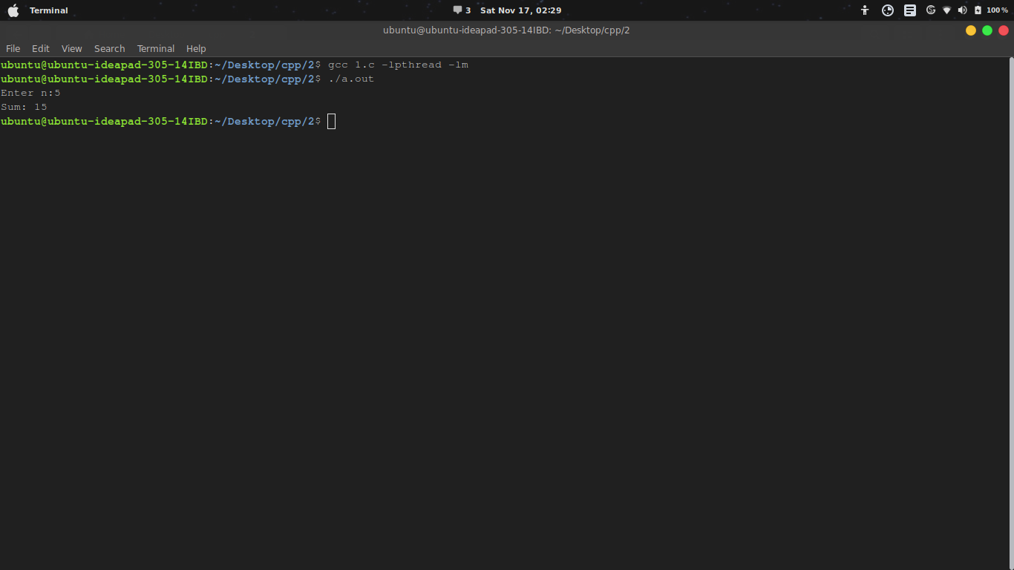
}

2)# include <stdio.h>
# include <pthread.h>

#define N_THREAD 5
long long int ans=1;
pthread_mutex_t mutex1=PTHREAD_MUTEX_INITIALIZER;
void *fact(void *no)
{
int *x = (int*)no;
int i = *x;
pthread_mutex_lock(&mutex1);
ans = ans * i;
pthread_mutex_unlock(&mutex1);

pthread_exit(NULL);
}
int main()
{
int i,n,j;
pthread_t tid[N_THREAD];
printf("Enter Number:");
scanf("%d",&n);
for(i=1;i<=n;){
for(j=0;j<N_THREAD && i<=n;j++,i++){
pthread_create(&tid[j],NULL,fact,(void*)&i);
pthread_join(tid[j],NULL);
}
}
printf("Factorial : %lld \n",ans);
return 0;
}

3)# include <stdio.h>
# include <pthread.h>

#define N_THREAD 5
int min=10000,max=0;
pthread_mutex_t mutex1=PTHREAD_MUTEX_INITIALIZER;
void *f(void *no)
{
int *x = (int*)no;
int i = *x;

pthread_mutex_lock(&mutex1);
if(i<min) min=i;
if(i>max) max = i;
pthread_mutex_unlock(&mutex1);

pthread_exit(NULL);
}

int main()
{
int i,n,j;
pthread_t tid[N_THREAD];
printf("Enter N:");

scanf("%d",&n);
int arr[n];
for(i=0;i<n;i++){
scanf("%d",&arr[i]);
}
for(i=0;i<n;){
for(j=0;j<N_THREAD && i<n;j++,i++){
pthread_create(&tid[j],NULL,f,(void*)&arr[i]);
pthread_join(tid[j],NULL);
}
}

printf("Final ans is : \nmax= %d \nmin = %d \n",max,min);
return 0;
}
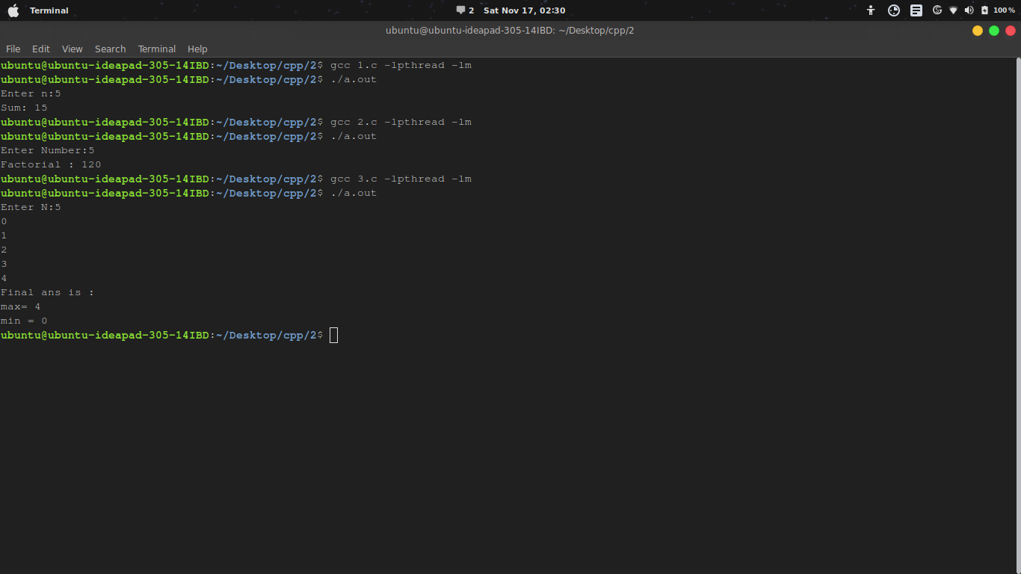

4)
#include <stdio.h>
#include<pthread.h>

struct student
{
char name[50];
int roll;
int marks[5];
};

void* func(void* arr){
int* x = (int*)arr;
int sum = 0;
int i=0;
for(i=0;i<5;i++){
sum += *(x+i);
}
printf("Ans : %f\n",(sum/5.0));
pthread_exit(NULL);
}

int main()
{
struct student s;
printf("Enter name,roll number and marks in 5 subjects\n");
pthread_t tid;
scanf("%s",&s.name);
scanf("%d",&s.roll);
int i=0;
for(i=0;i<5;i++){
scanf("%d",&s.marks[i]);
}
pthread_create(&tid,NULL,func,(void*)&s.marks);
pthread_join(tid,NULL);
return 0;

}
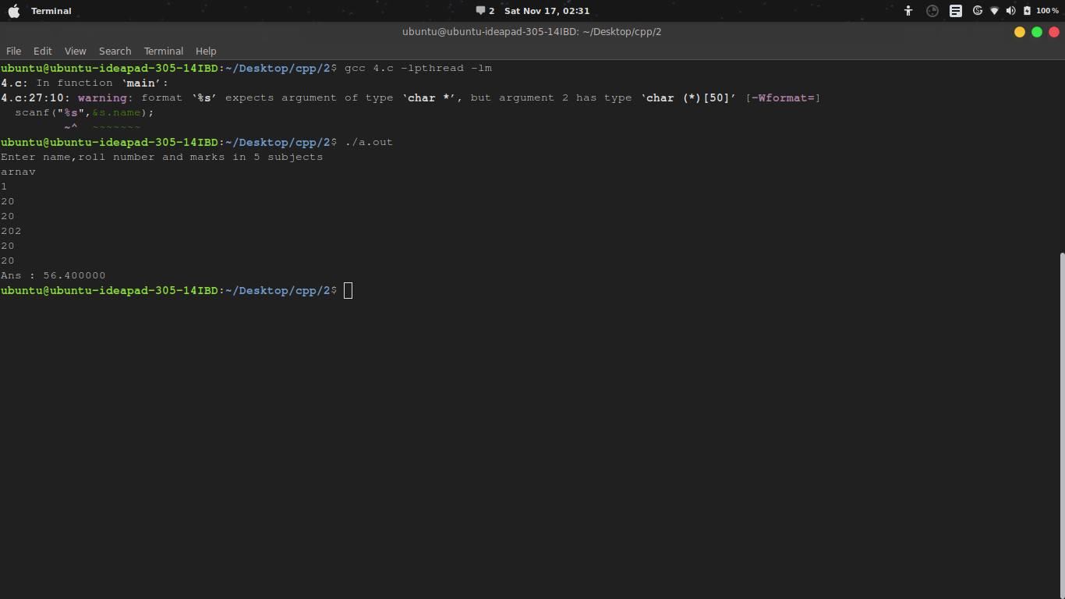
5)
#include <stdio.h>
#include<pthread.h>
struct employee
{
char name[50];
int id;
int salary[5];
};

void* func(void* arr){
int* x = (int*)arr;
int sum = 0;
int i=0;
int a = *(x+4);
int b = *(x);

printf("Hike % = %f\n",((a-b)*100.0)/b);
pthread_exit(NULL);
}

int main()
{
struct employee s;
printf("enter name,id number and salary in 5 years\n");
pthread_t tid;
scanf("%s",&s.name);
scanf("%d",&s.id);
int i=0;
for(i=0;i<5;i++){
scanf("%d",&s.salary[i]);
}
pthread_create(&tid,NULL,func,(void*)&s.salary);
pthread_join(tid,NULL);
return 0;
}
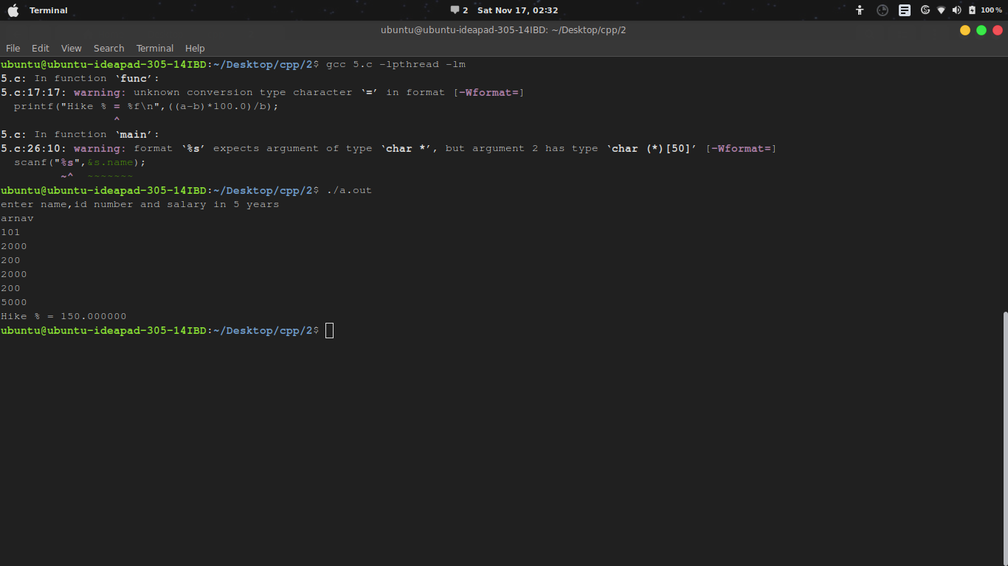
6)#include <stdio.h>
# include<pthread.h>

void* fib(void* no){
int* temp = (void*)no;
int n = *temp;

int i,c=0;
int a=0;
int b=1;
printf("Fibonacci:\n");
while(c<=n){
printf("%d ",c);
a=b;
b=c;
c=a+b;
}
printf("\n");
}
void * prime(void* no){
int* temp = (void*)no;
int n = *temp;
int i,j,fact;
printf("Prime:\n");
for(i=1; i<=n; i++){
fact=0;
for(j=1; j<=n; j++){
if(i%j==0)
fact++;
}
if(fact==2)
printf("%d " ,i);
}
printf("\n");
}

int main(){

int n ;
scanf("%d",&n);
pthread_t f,p;
pthread_create(&f,NULL,fib,(void*)&n);
pthread_join(f,NULL);
pthread_create(&p,NULL,prime,(void*)&n);
pthread_join(p,NULL);

}
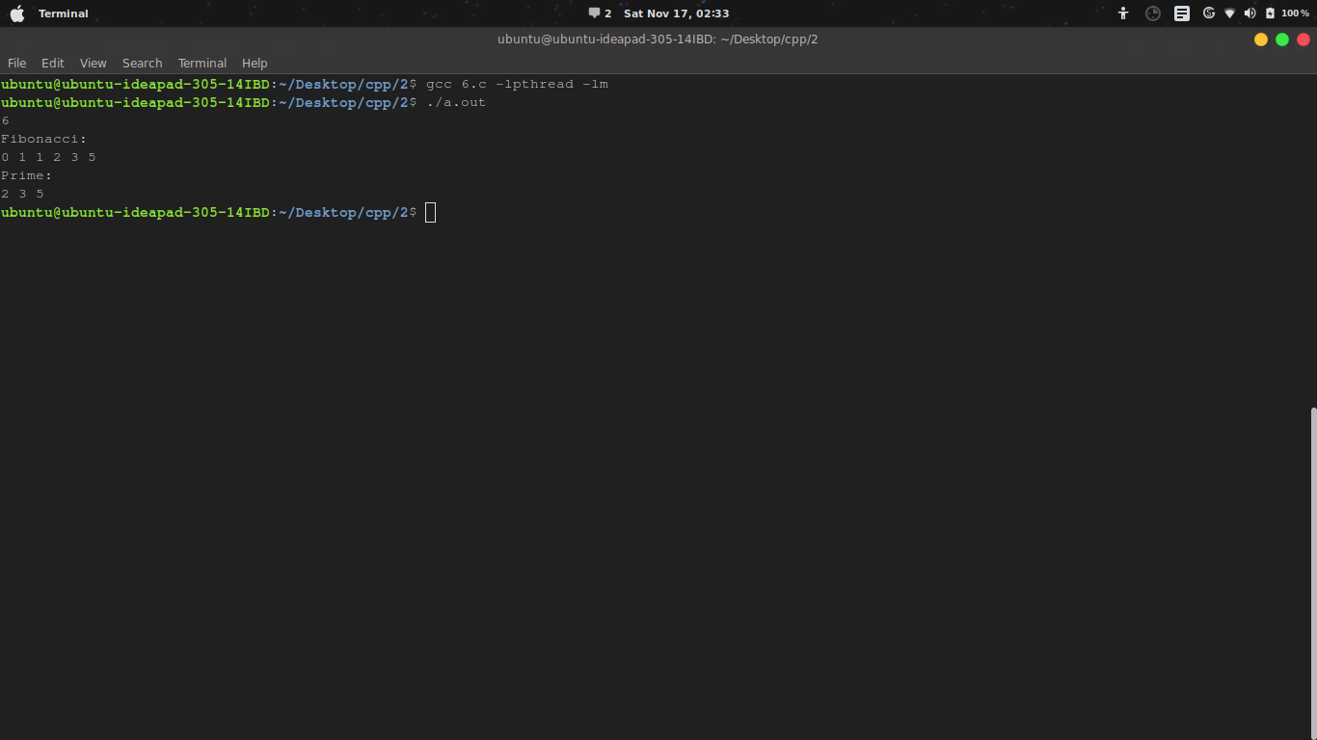
7) #include <stdio.h>
#include <pthread.h>

#define M 5
#define N 10
int matrix[N][M];
int total=0;
pthread_mutex_t mutex;

void *SumValues(void *i)
{
int *k = (int*)i;
int n = *k;
int my_total = 0;
int j;
for (j = 0; j < M; j++)
my_total += matrix[n][j];
printf("sum of elements of row %d : %d\n", n, my_total);
pthread_mutex_lock(&mutex);
total += my_total;
pthread_mutex_unlock(&mutex);
pthread_exit(NULL);
}
int main(int argc, char *argv[]) {
int i, j;
pthread_t threads[N];
for (i = 0; i < N; i++)
for (j = 0; j < M; j++)
matrix[i][j] = (i * M + j)%10;
pthread_mutex_init(&mutex, NULL);
int values[N];
for(i=0;i<N;i++) values[i]=i;

for(i = 0; i < N; i++)
if (pthread_create(&threads[i], NULL, SumValues, &values[i]))
{
printf("Can not create a thread\n");

}
for (i = 0; i < N; i++){
pthread_join(threads[i], NULL);
}
printf("Sum of matrix: %d\n", total);
pthread_mutex_destroy(&mutex);
return 0;
}
