Assignment 3 Submitted by Arnav Loonker

1)
#include <stdio.h>
#include<pthread.h>
#define n 4

#define n_thread 4

int arr1[n][n];
int arr2[n][n];
int res[n][n];
int step_i = 0;

void* multi(void* arg)
{
int core = step_i++;

int i=0,j=0,k=0;
for (i = core * n / 4; i < (core + 1) * n / 4; i++)
for (j = 0; j < n; j++)
for (k = 0; k < n; k++)
res[i][j] += arr1[i][k] * arr2[k][j];
}

int main()
{
int i=0,j=0;
for (i = 0; i < n; i++) {
for (j = 0; j < n; j++) {
arr1[i][j] = rand() % 10;
arr2[i][j] = rand() % 10;
}
}

printf("Matrix A\n");
for (i = 0; i < n; i++) {
for (j = 0; j < n; j++)
printf("%d ",arr1[i][j]);
printf("\n");
}

printf("Matrix B\n");
for ( i = 0; i < n; i++) {
for ( j = 0; j < n; j++)
printf("%d ",arr2[i][j]);
printf("\n");
}

pthread_t threads[n_thread];

for (i = 0; i < n_thread; i++) {
int* p;
pthread_create(&threads[i], NULL, multi, (void*)(p));
}

for (i = 0; i < n_thread; i++)
pthread_join(threads[i], NULL);

printf("Matrix result\n");
for (i = 0; i < n; i++) {
for (j = 0; j < n; j++)
printf("%d ",res[i][j]);
printf("\n");
}
return 0;
}

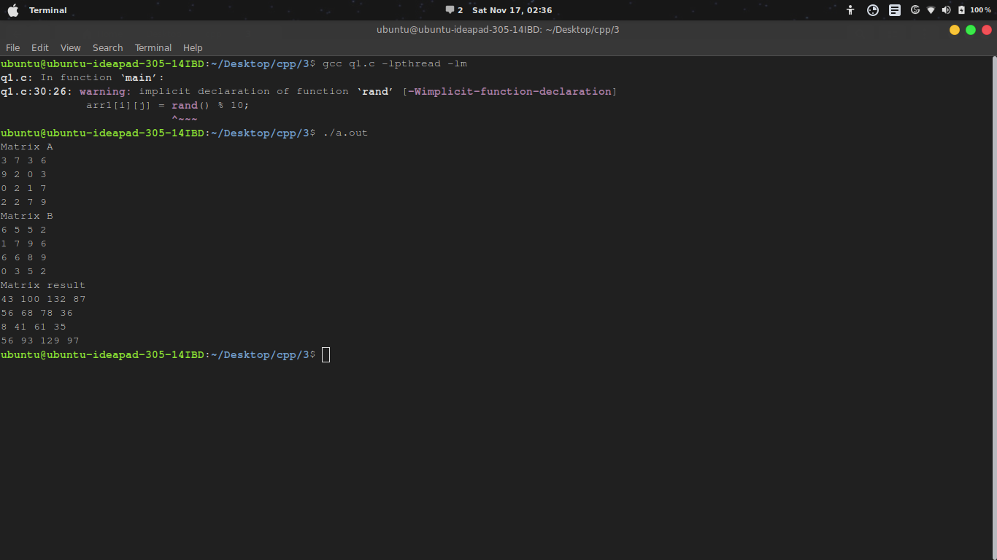
2)
#include <stdio.h>
#include <error.h>
#include <stdlib.h>

void main(int argc, char *argv[])
{
FILE *fp;

if (argc == 1) {
printf("No filename provided\n");
exit(0);
}

fp = fopen(argv[1], "r");

if (fp == NULL) {
perror("File Open error");
exit(0);
}
printf("File successfully opened\n");
}

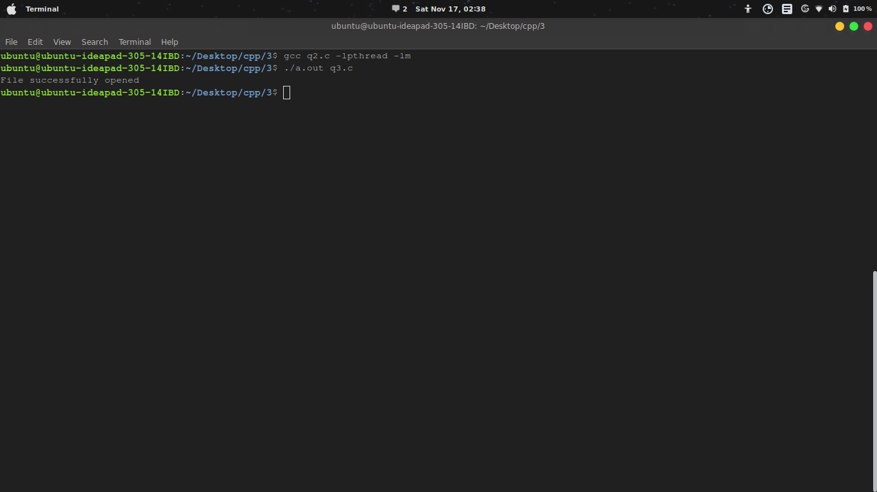
3)
#include<stdio.h>
#include<sys/types.h>
#include<signal.h>
#include<sys/ipc.h>
#include<stdlib.h>
#include<sys/shm.h>

void SIGINT_handler(int);
void SIGQUIT_handler(int);

int ShmID;
pid_t *ShmPTR;

void main(void)
{
int i;
pid_t pid = getpid();
key_t MyKey;

if (signal(SIGINT, SIGINT_handler) == SIG_ERR) {
printf("SIGINT install error\n");
exit(1);
}
if (signal(SIGQUIT, SIGQUIT_handler) == SIG_ERR) {
printf("SIGQUIT install error\n");
exit(2);
}

MyKey = ftok(".", 's');
ShmID = shmget(MyKey, sizeof(pid_t), IPC_CREAT | 0666);
ShmPTR = (pid_t *) shmat(ShmID, NULL, 0);
*ShmPTR = pid;

for (i = 0; ; i++) {
printf("From process %d: %d\n", pid, i);
sleep(1);
}
}

void SIGINT_handler(int sig)
{
signal(sig, SIG_IGN);
printf("From SIGINT: just got a %d (Ctrl + C) signal\n", sig);

signal(sig, SIGINT_handler);
exit(1);
}

void SIGQUIT_handler(int sig)
{
signal(sig, SIG_IGN);
printf("From SIGQUIT: just got a %d (SIGQUIT ^\\) signal"
" and is about to quit\n", sig);
shmdt(ShmPTR);
shmctl(ShmID, IPC_RMID, NULL);

exit(3);
}
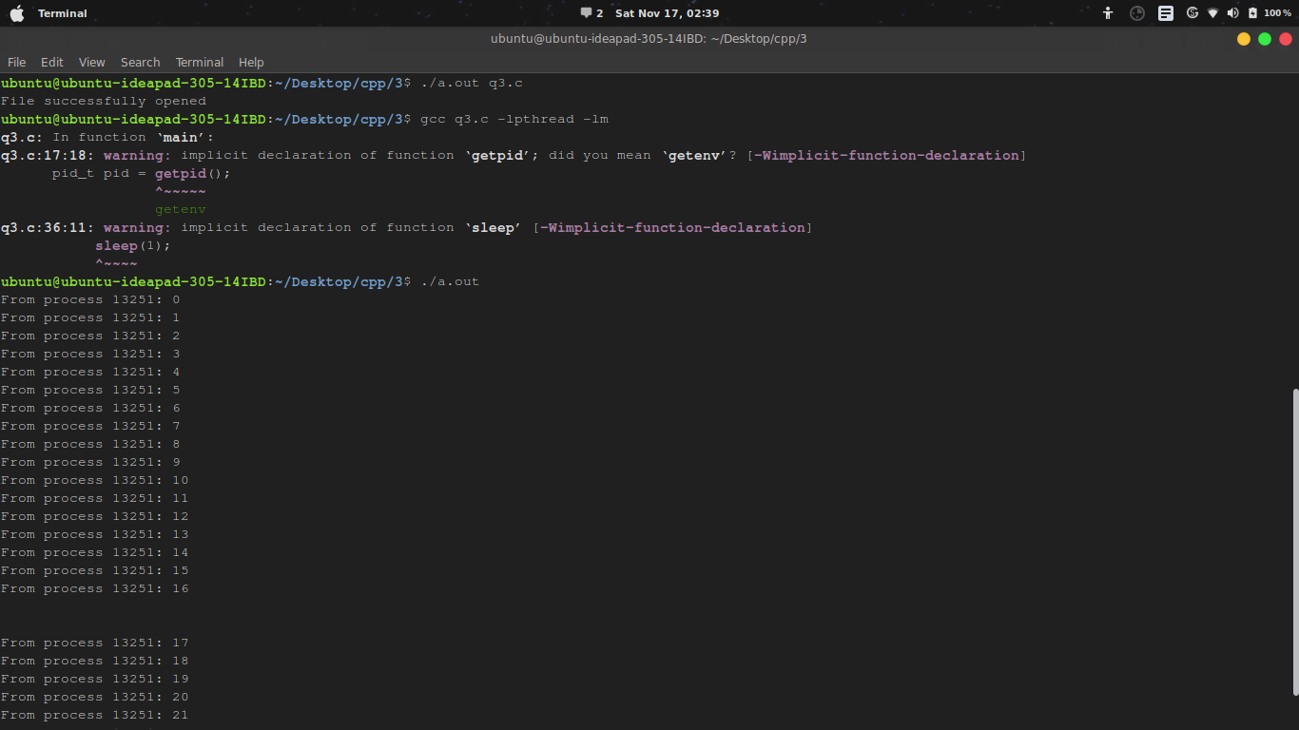

4)# include<stdio.h>
# include<pthread.h>

int TotalSum=0;
pthread_mutex_t mutex1=PTHREAD_MUTEX_INITIALIZER;
void *thread_sum(void *no)
{
int *x = (int*)no;
int i = *x;

pthread_mutex_lock(&mutex1);
TotalSum = TotalSum + i*i;
pthread_mutex_unlock(&mutex1);

pthread_exit(NULL);
}
int main()
{
int i,n,j;
pthread_t tid[5];
printf("Enter n:\n");
scanf("%d",&n);
for(i=0;i<=n;i++){
for(j=0;j<5 && i<=n;j++,i++){
pthread_create(&tid[j],NULL,thread_sum,(void*)&i);
pthread_join(tid[j],NULL);
}
i--;
}
printf("Final Sum is : %d \n",TotalSum);
return 0;
}
