Assignment 4 Submitted by Arnav

1)
#include <stdio.h>
#include<pthread.h>
#include <semaphore.h>
#include <unistd.h>
sem_t sema;
void* func(void* arg)
{
int* k = (int*)arg;
int i = *k;
sem_wait(&sema);
printf("\tIn the critical section of thread %d\n\tGoing to sleep for 5s\n",i);

//critical section
sleep(5);

//signal
printf("\tSignalling end of critical section\n");
sem_post(&sema);
}

int main(){

sem_init(&sema, 0, 1);
pthread_t t1,t2;
while(1) {
printf("\n\n\n\n Inside Loop\n");
int i =1;
pthread_create(&t1,NULL,func,(void*)(&i));
printf("\tGoing to sleep for 2s\n");
sleep(2);
i = 2;
pthread_create(&t2,NULL,func,(void*)(&i));
pthread_join(t1,NULL);
pthread_join(t2,NULL);
printf("Ending this iteration\n");
}
sem_destroy(&sema);

}

2)
#include <stdio.h>
#include<pthread.h>
#include <semaphore.h>
#include <unistd.h>
sem_t sema;
void* func(void* arg)
{
int* k = (int*)arg;
int i = *k;
sem_wait(&sema);
printf("\tIn the critical section of thread %d\n\t\tGoing to sleep for 2s\n",i);

//critical section
sleep(2);

//signal
printf("\tSignalling end of critical section\n");
sem_post(&sema);
}

int main(){

sem_init(&sema, 0, 1);
pthread_t t[5];
while(1) {
printf("\n\n\n\nInside Loop\n");
int i =1;
for(i=1;i<=5;i++){
pthread_create(&t[i],NULL,func,(void*)(&i));
printf("\tGoing to sleep for 1s\n");
sleep(1);
pthread_join(t[i],NULL);
}

printf("Ending this iteration\n");
}
sem_destroy(&sema);

}
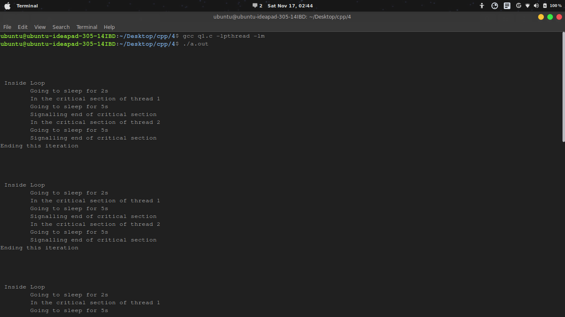

3)
#include <stdio.h>
#include<pthread.h>
#include <semaphore.h>
#include <unistd.h>
sem_t sema;
void* func(void* arg)
{
int* k = (int*)arg;
int i = *k;
sem_wait(&sema);
printf("\tIn the critical section of thread %d\n\t\tGoing to sleep for 2s\n",i);

//critical section
sleep(2);

//signal
printf("\tSignalling end of critical section\n");
sem_post(&sema);
}

int main(){

sem_init(&sema, 0, 1);
pthread_t t[5];
while(1) {
printf("\n\n\n\nInside Loop\n");
int i =1;
for(i=1;i<=5;i++){
pthread_create(&t[i],NULL,func,(void*)(&i));
printf("\tGoing to sleep for 1s\n");
sleep(1);
pthread_join(t[i],NULL);
}

printf("Ending this iteration\n");
}
sem_destroy(&sema);

}
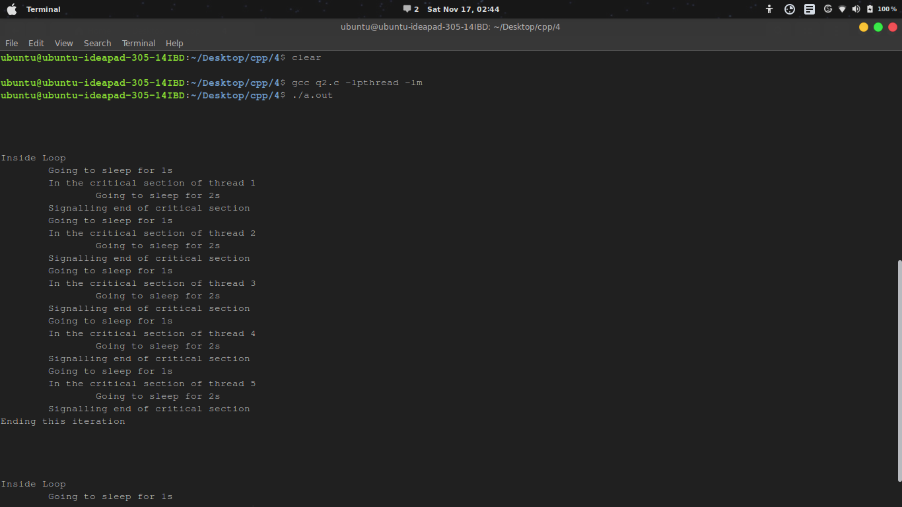

4)
#include <stdio.h>
#include <stdlib.h>
#include <time.h>
#include <string.h>
#include <unistd.h>
#include <pthread.h>
#include <semaphore.h>

pthread_t producers[5];
pthread_t consumers[5];

sem_t mutex,empty,full;

int ind=-1,prod = 5,con = 5,buf_len = 4;
int buf[4];

int produce(pthread_t self){
int i = 0;
int p = 1 + rand()%40;
while(!pthread_equal(producers[i],self) && i < prod){
i++;
}
printf("Producer %d produced %d \n",i+1,p);
return p;
}

void consume(int p,pthread_t self){
int i = 0;
while(!pthread_equal(consumers[i],self) && i < con){
i++;
}

//printf("Buffer:");
/*for(i=0;i<=ind;++i)
printf("%d ",*(buf+i));*/
printf("Consumer %d consumed %d\n",i+1,p);

}

void* producer(void *args){

while(1){
int p = produce(pthread_self());
sem_wait(&empty);
sem_wait(&mutex);
++ind; // critical section
buf[ind] = p;
sem_post(&mutex);
sem_post(&full);
sleep(1 + rand()%3);
}

return NULL;
}

void* consumer(void *args){
int c;
while(1){
sem_wait(&full);
sem_wait(&mutex);
c = buf[ind];
consume(c,pthread_self());
--ind;
sem_post(&mutex);
sem_post(&empty);
sleep(1+rand()%5);
}

return NULL;
}

int main(){

int i,err;

srand(time(NULL));

sem_init(&mutex,0,1);
sem_init(&full,0,0);

sem_init(&empty,0,buf_len);

for(i=0;i<prod;i++){
pthread_create(&producers[i],NULL,&producer,NULL);

}

for(i=0;i<con;i++){
pthread_create(&consumers[i],NULL,&consumer,NULL);

}

for(i=0;i<prod;i++){
pthread_join(producers[i],NULL);
}
for(i=0;i<con;i++){
pthread_join(consumers[i],NULL);
}

return 0;
}

