Assignment 5 Submitted by Arnav Loonker

1)

MPI_Init
MPI_Finalize
MPI_Comm_size
MPI_Comm_rank
MPI_Send
MPI_Recv
are used in the program below

/* This program sums all rows in an array using MPI parallelism.
* The root process acts as a master and sends a portion of the
* array to each child process. Master and child processes then
* all calculate a partial sum of the portion of the array assigned
* to them, and the child processes send their partial sums to
* the master, who calculates a grand total.
*/

#include <stdio.h>
#include <mpi.h>

#define max_rows 100000
#define send_data_tag 2001
#define return_data_tag 2002

int array[max_rows];
int array2[max_rows];

main(int argc, char **argv)
{
long int sum, partial_sum;
MPI_Status status;
int my_id, root_process, ierr, i, num_rows, num_procs,
an_id, num_rows_to_receive, avg_rows_per_process,
sender, num_rows_received, start_row, end_row, num_rows_to_send;

ierr = MPI_Init(&argc, &argv);

root_process = 0;
ierr = MPI_Comm_rank(MPI_COMM_WORLD, &my_id);
ierr = MPI_Comm_size(MPI_COMM_WORLD, &num_procs);

if(my_id == root_process) {

printf("please enter the number of numbers to sum: ");
scanf("%i", &num_rows);

if(num_rows > max_rows) {
printf("Too many numbers.\n");
exit(1);
}

avg_rows_per_process = num_rows / num_procs;

for(i = 0; i < num_rows; i++) {
array[i] = i + 1;
}

for(an_id = 1; an_id < num_procs; an_id++) {
start_row = an_id*avg_rows_per_process + 1;
end_row = (an_id + 1)*avg_rows_per_process;

if((num_rows - end_row) < avg_rows_per_process)
end_row = num_rows - 1;

num_rows_to_send = end_row - start_row + 1;

ierr = MPI_Send( &num_rows_to_send, 1 , MPI_INT,
an_id, send_data_tag, MPI_COMM_WORLD);

ierr = MPI_Send( &array[start_row], num_rows_to_send, MPI_INT,
an_id, send_data_tag, MPI_COMM_WORLD);
}

sum = 0;
for(i = 0; i < avg_rows_per_process + 1; i++) {
sum += array[i];
}

printf("sum %i calculated by root process\n", sum);

for(an_id = 1; an_id < num_procs; an_id++) {

ierr = MPI_Recv( &partial_sum, 1, MPI_LONG, MPI_ANY_SOURCE,
return_data_tag, MPI_COMM_WORLD, &status);

sender = status.MPI_SOURCE;

printf("Partial sum %i returned from process %i\n", partial_sum, sender);

sum += partial_sum;
}

printf("The grand total is: %i\n", sum);
}

else {

ierr = MPI_Recv( &num_rows_to_receive, 1, MPI_INT,
root_process, send_data_tag, MPI_COMM_WORLD, &status);

ierr = MPI_Recv( &array2, num_rows_to_receive, MPI_INT,
root_process, send_data_tag, MPI_COMM_WORLD, &status);

num_rows_received = num_rows_to_receive;

partial_sum = 0;
for(i = 0; i < num_rows_received; i++) {
partial_sum += array2[i];
}

ierr = MPI_Send( &partial_sum, 1, MPI_LONG, root_process,
return_data_tag, MPI_COMM_WORLD);
}
ierr = MPI_Finalize();
}

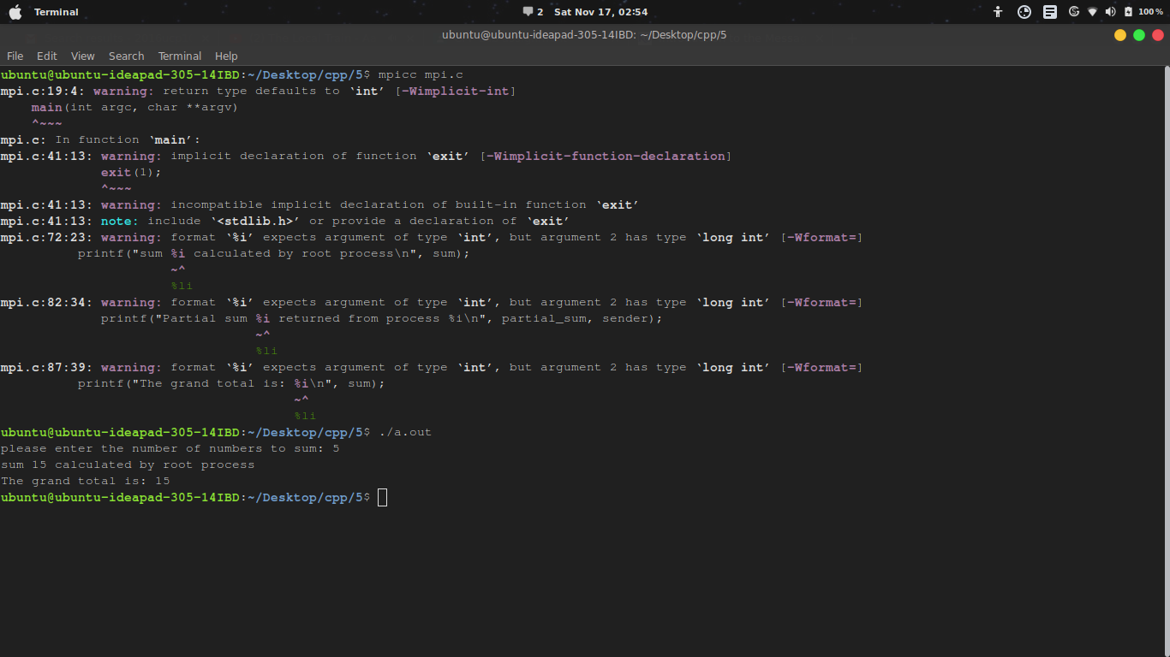

MPI BCAST

#include <stdio.h>
#include "mpi.h"

int main(argc, argv)
int argc;
char **argv;
{
int rank, value;

MPI_Init(&argc, &argv);

MPI_Comm_rank(MPI_COMM_WORLD, &rank); //what rank is the current processor

if (rank == 0) {
// if root process we read the value to broadcast
printf("Enter a number to broadcast:\n");
scanf("%d", &value);
} else {
printf("process %d: Before MPI_Bcast, value is %d\n", rank, value);
}

/
MPI_Bcast(&value, 1, MPI_INT, 0, MPI_COMM_WORLD);

printf("process %d: After MPI_Bcast, value is %d\n", rank, value);

MPI_Finalize();

return 0;
}

